# Script Demo for EEG/MEG based on NeuroRA

by [Zitong Lu](zitonglu1996.github.io)

April 09, 2020

Users can learn how to use [NeuroRA](https://zitonglu1996.github.io/NeuroRA/) to do research by representational analysis based on EEG/MEG data.

This demo is based on the publicly available visual-92-categories-task MEG datasets. (*Reference:* [Cichy, R. M., Pantazis, D., & Oliva, A. “Resolving human object recognition in space and time.” Nature neuroscience (2014): 17(3), 455-462.](https://www.nature.com/articles/nn.3635)) [MNE-Python](https://mne.tools/stable/index.html) has been used to load this dataset.

# -*- coding: utf-8 -*-

' a demo based on visual-92-categories-task MEG data '

# Users can learn how to use Neurora to do research based on EEG/MEG etc data.

__author__ = 'Zitong Lu'

**import** **numpy** **as** **np**

**import** **os.path** **as** **op**

**from** **pandas** **import** read_csv

**import** **mne**

**from** **mne.io** **import** read_raw_fif

**from** **mne.datasets** **import** visual_92_categories

**from** **neurora.nps_cal** **import** nps

**from** **neurora.rdm_cal** **import** eegRDM

**from** **neurora.rdm_corr** **import** rdm_correlation_spearman

**from** **neurora.corr_cal_by_rdm** **import** rdms_corr

**from** **neurora.rsa_plot** **import** plot_rdm, plot_corrs_by_time, plot_nps_hotmap, plot_corrs_hotmap

"""********** Section 1: loading example data **********"""

""" Here, we use MNE-Python toolbox for loading data and processing """

""" you can learn this process from MNE-Python (https://mne-tools.github.io/stable/index.html) """

data_path = visual_92_categories.data_path()

fname = op.join(data_path, 'visual_stimuli.csv')

conds = read_csv(fname)

conditions = []

**for** c **in** conds.values:

cond_tags = list(c[:**2**])

cond_tags += [('not-' **if** i == **0** **else** '') + conds.columns[k]

**for** k, i **in** enumerate(c[**2**:], **2**)]

conditions.append('/'.join(map(str, cond_tags)))

event_id = dict(zip(conditions, conds.trigger + **1**))

print(event_id)

sub_id = [**0**, **1**, **2**]

megdata = np.zeros([**3**, **92**, **306**, **1101**], dtype=np.float32)

subindex = **0**

**for** id **in** sub_id:

fname = op.join(data_path, 'sample_subject_'+str(id)+'_tsss_mc.fif')

raw = read_raw_fif(fname)

events = mne.find_events(raw, min_duration=.**002**)

events = events[events[:, **2**] <= **92**]

subdata = np.zeros([**92**, **306**, **1101**], dtype=np.float32)

**for** i **in** range(**92**):

epochs = mne.Epochs(raw, events=events, event_id=i + **1**, baseline=**None**,

tmin=-**0.1**, tmax=**1**, preload=**True**)

data = epochs.average().data

subdata[i] = data

megdata[subindex] = subdata

subindex = subindex + **1**

# the shape of MEG data: megdata is [3, 92, 306, 1101]

# n_subs = 3, n_conditions = 92, n_channels = 306, n_timepoints = 1101 (-100ms to 1000ms)

"""********** Section 2: Preprocessing **********"""

# shape of megdata: [n_subs, n_cons, n_chls, n_ts] -> [n_cons, n_subs, n_chls, n_ts]

megdata = np.transpose(megdata, (**1**, **0**, **2**, **3**))

# shape of megdata: [n_cons, n_subs, n_chls, n_ts] -> [n_cons, n_subs, n_trials, n_chls, n_ts]

# here data is averaged, so set n_trials = 1

megdata = np.reshape(megdata, [**92**, **3**, **1**, **306**, **1101**])

"""**** Section 2: Calculating the neural pattern similarity ****"""

# Get data under different condition

# Here we calculate the neural pattern similarity (NPS) between two stimulus

# Seeing Humanface vs. Seeing Non-Humanface

# get data under "humanface" condtion

megdata_humanface = megdata[**12**:**24**]

# get data under "nonhumanface" condition

megdata_nonhumanface = megdata[**36**:**48**]

# Average the data

avg_megdata_humanface = np.average(megdata_humanface, axis=**0**)

avg_megdata_nonhumanface = np.average(megdata_nonhumanface, axis=**0**)

# Create NPS input data

# Here we extract the data from first 5 channels between 0ms and 1000ms

nps_data = np.zeros([**2**, **3**, **1**, **5**, **1000**]) # n_cons=2, n_subs=3, n_chls=5, n_ts=1000

nps_data[**0**] = avg_megdata_humanface[:, :, :**5**, **100**:**1100**] # the start time of the data is -100ms

nps_data[**1**] = avg_megdata_nonhumanface[:, :, :**5**, **100**:**1100**] # so 100:1200 corresponds 0ms-1000ms

# Calculate the NPS with a 10ms time-window

# (raw sampling requency is 1000Hz, so here time_win=10ms/(1s/1000Hz)/1000=10)

nps = nps(nps_data, time_win=**10**)

# Plot the NPS results

plot_nps_hotmap(nps, time_unit=[**0**, **0.01**], abs=**True**)

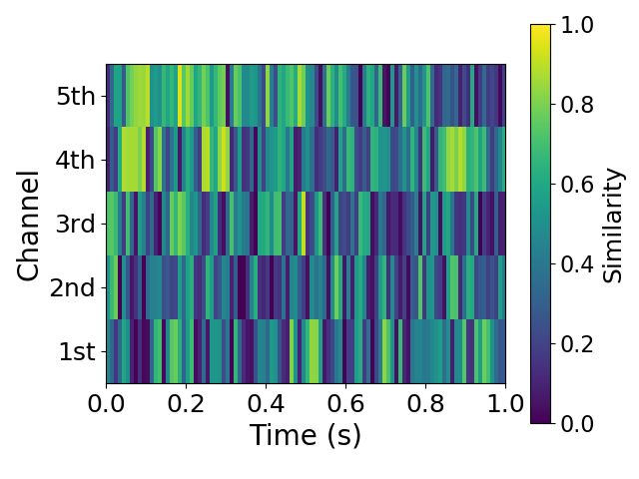

# Smooth the results and plot

plot_nps_hotmap(nps, time_unit=[**0**, **0.01**], abs=**True**, smooth=**True**)

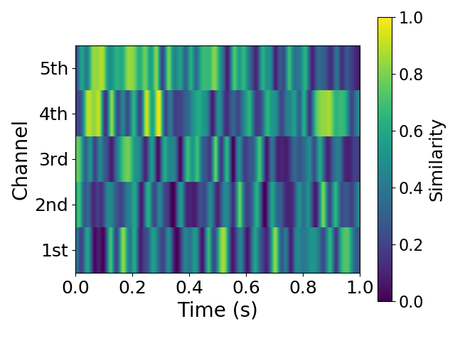

"""***** Section 3: Calculating single RDM and Plotting *****"""

# Calculate the RDM based on the data during 190ms-210ms

rdm = eegRDM(megdata[:, :, :, :, **290**:**310**])

# Plot this RDM

plot_rdm(rdm, rescale=**True**)

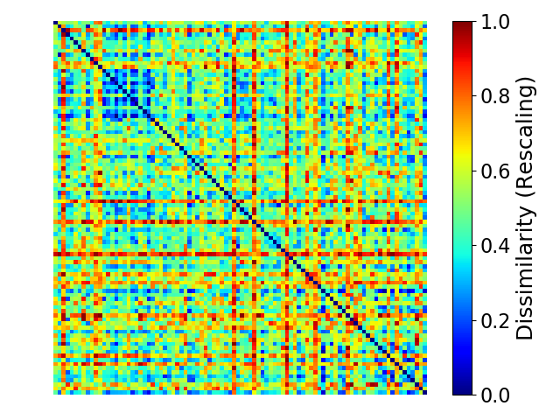

"""******** Section 4: Calculating RDMs and Plotting ********"""

# Calculate the RDMs by a 10ms time-window

# (raw sampling requency is 1000Hz, so here time_win=10ms/(1s/1000Hz)/1000=10)

rdms = eegRDM(megdata, time_win=**10**, time_opt=**1**)

# Plot the RDM of 0ms, 50ms, 100ms, 150ms, 200ms

times = [**0**, **10**, **20**, **30**, **40**, **50**]

**for** t **in** times:

plot_rdm(rdms[t], rescale=**True**)

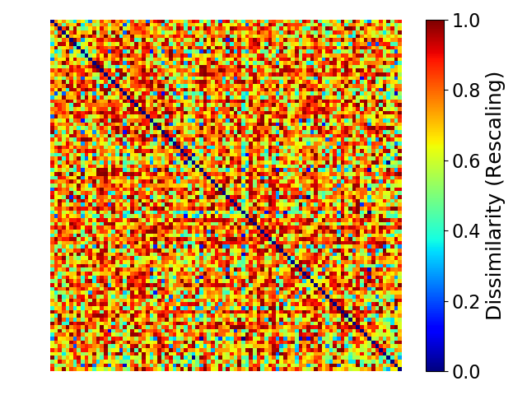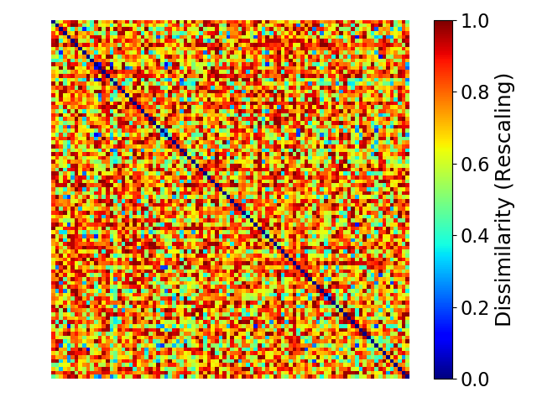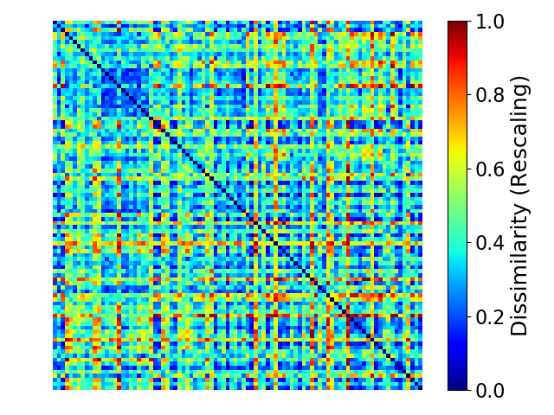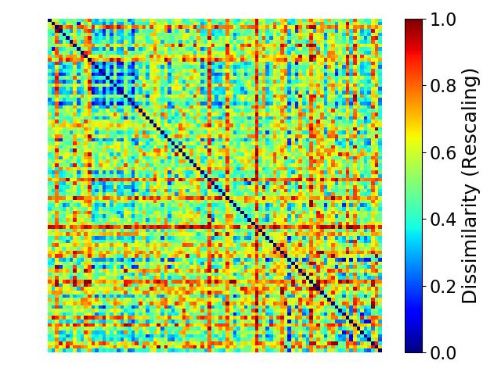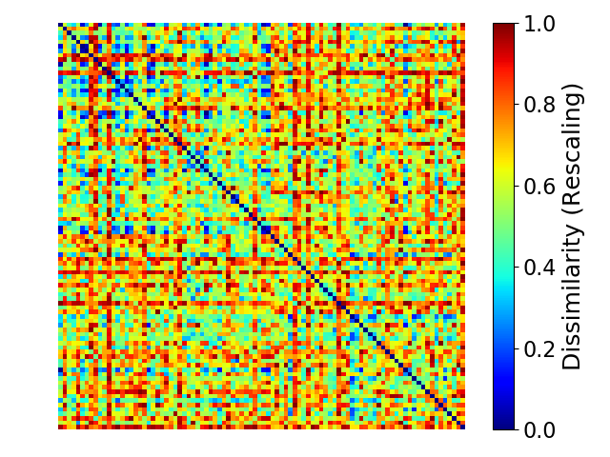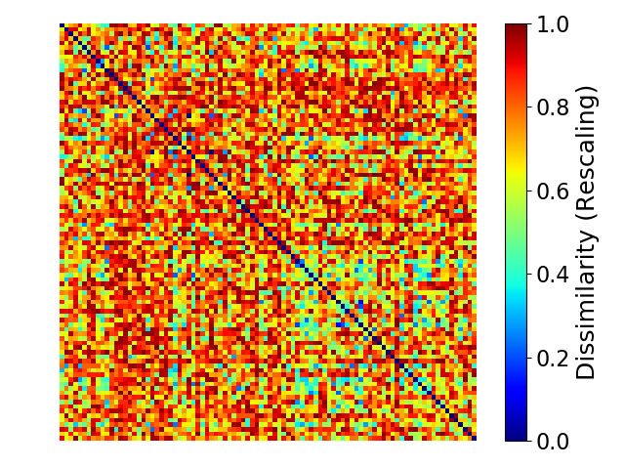

"""**** Section 5: Calculating the Similarity between two RDMs ****"""

# RDM of 200ms

rdm_sample1 = rdms[**30**]

# RDM of 800ms

rdm_sample2 = rdms[**90**]

# calculate the correlation coefficient between these two RDMs

corr = rdm_correlation_spearman(rdm_sample1, rdm_sample2, rescale=**True**)

print(corr)

SpearmanrResult(correlation=0.02665680483550596, pvalue=0.08462337954774739)

"""***** Section 6: Calculating the Similarity and Plotting *****"""

# Calculate the representational similarity between 200ms and all the time points

corrs1 = rdms_corr(rdm_sample1, rdms)

# Plot the corrs1

corrs1 = np.reshape(corrs1, [**1**, **110**, **2**])

plot_corrs_by_time(corrs1, time_unit=[-**0.1**, **0.01**])

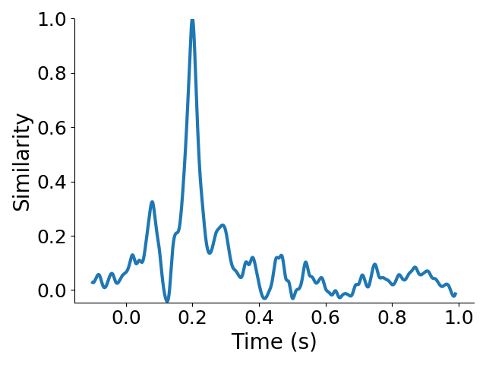

# Calculate and Plot multi-corrs

corrs2 = rdms_corr(rdm_sample2, rdms)

corrs = np.zeros([**2**, **110**, **2**])

corrs[**0**] = corrs1

corrs[**1**] = corrs2

labels = ["by 200ms's data", "by 800ms's data"]

plot_corrs_by_time(corrs, labels=labels, time_unit=[-**0.1**, **0.01**])

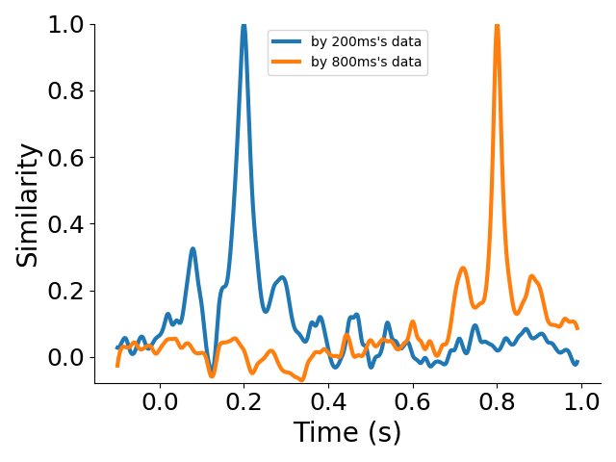

"""***** Section 7: Calculating the RDMs for each channels *****"""

# Calculate the RDMs for the first six channels by a 10ms time-window between 0ms and 1000ms

rdms_chls = eegRDM(megdata[:, :, :, :**6**, **100**:**1100**], chl_opt=**1**, time_opt=**1**, time_win=**10**)

# Create a 'human-related' coding model RDM

model_rdm = np.ones([**92**, **92**])

**for** i **in** range(**92**):

**for** j **in** range(**92**):

**if** (i < **24**) **and** (j < **24**):

model_rdm[i, j] = **0**

model_rdm[i, i] = **0**

# Plot this coding model RDM

plot_rdm(model_rdm)

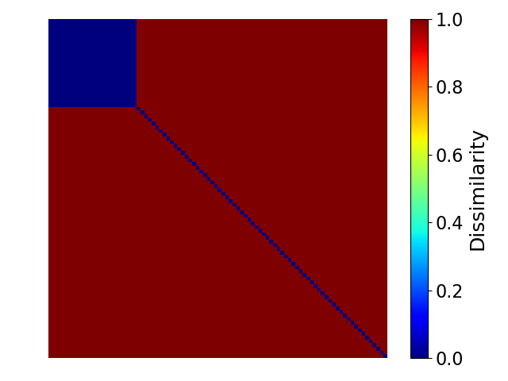

# Calculate the representational similarity between the neural activities and the coding model for each channel

corrs_chls = rdms_corr(model_rdm, rdms_chls)

# Plot the representational similarity results

plot_corrs_hotmap(corrs_chls, time_unit=[**0**, **0.01**])

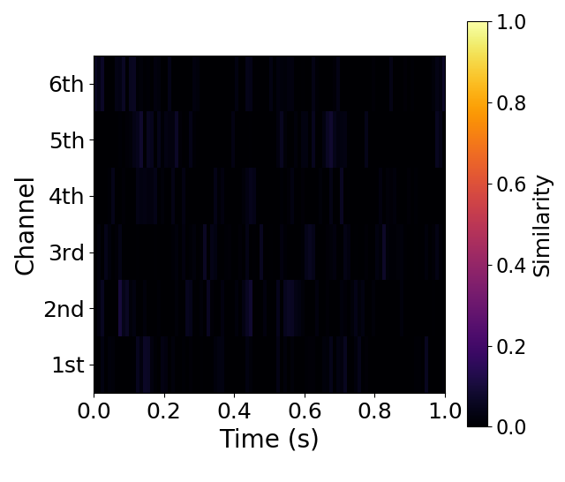

# Set more parameters and re-plot

plot_corrs_hotmap(corrs_chls, time_unit=[**0**, **0.01**], lim=[-**0.15**, **0.15**], smooth=**True**, cmap='bwr')

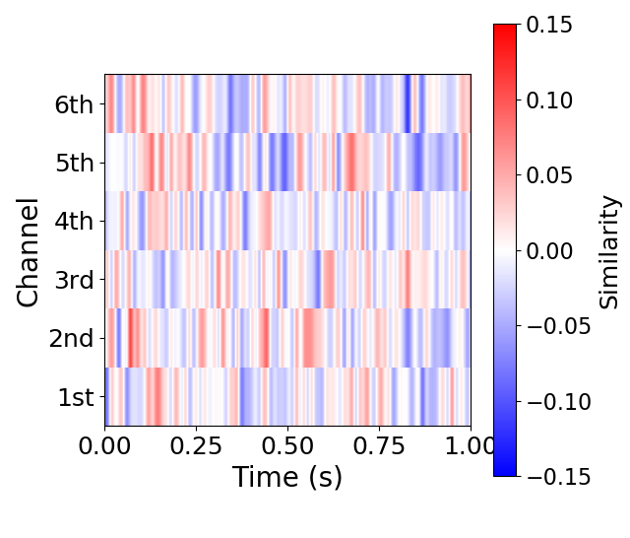

Users can see more details below:

GitHub Website: <https://github.com/neurora/NeuroRA>

NeuroRA Website: <https://neuroragithub.io/NeuroRA/>

PyPi Website: <https://pypi.org/project/neurora/>

BioRxiv Paper: <https://doi.org/10.1101/2020.03.25.008086>