## Scrum Masters are only effective when they are co-located with their teams

by [Irma Kelly](https://www.previousnext.com.au/about/team/irma-kelly)

Browsing through the interweb I happened across this bold statement a few weeks ago. A statement so bold, it inspired me to write a blog post in response.

Scrum Masters being co-located with their teams, sure it is the best and most favourable scenario for teams working on complex projects, but to go as far as to say that Scrum Masters are ONLY effective in this instance - nope. Sorry, I have to graciously disagree.

Obviously there are different challenges that come with facilitating Agile ceremonies and interacting with the team remotely as opposed to face-to-face. A completely different approach needs to be taken on my behalf to keep the team engine purring away.

Personally for me, the “different approach” I take with managing remote teams, as opposed to co-located teams is to ensure uber transparency and over-communication on my part in regards to the all of the work that the team currently have in-flight. On my part this includes:

Ensuring that work in flight includes “Acceptance Criteria” and a “Definition of Done” agreed to by both the team and the client. This ensures that both the client and the team have an agreed vision of the product we are building. More importantly, it removes the need to make assumptions about a solution on both sides.

The use of an online and up-to-date Kanban board that both the client and the team can freely access. Complete honesty with the client and the team in regards to all aspects of the project. Especially during the trickier and stressful moments of project delivery. If something is starting to go pear shaped, call it out early - don’t hide it!​

There are a plethora of tools now available that help enable remote collaboration. I thought it might be worthwhile sharing some of the tools that the teams at PNX use to make remote collaboration simpler.

# Slack / Go To Meetings / Google Hangouts

With a large percentage of our internal staff located across Australia, these are PNX’s go-to tools for remote collaboration. We utilise both GoToMeeting and Google Hangouts (depending on individual client preferences) as tools to enable our daily stand-ups with our clients. Daily stand-ups and the ability to quickly ask via a hangout or GoToMeeting has drastically reduced the amount of email correspondence between PNX and our clients. The result? A reduction in idle time, as questions can be answered relatively quickly instead of waiting for a reply via email.

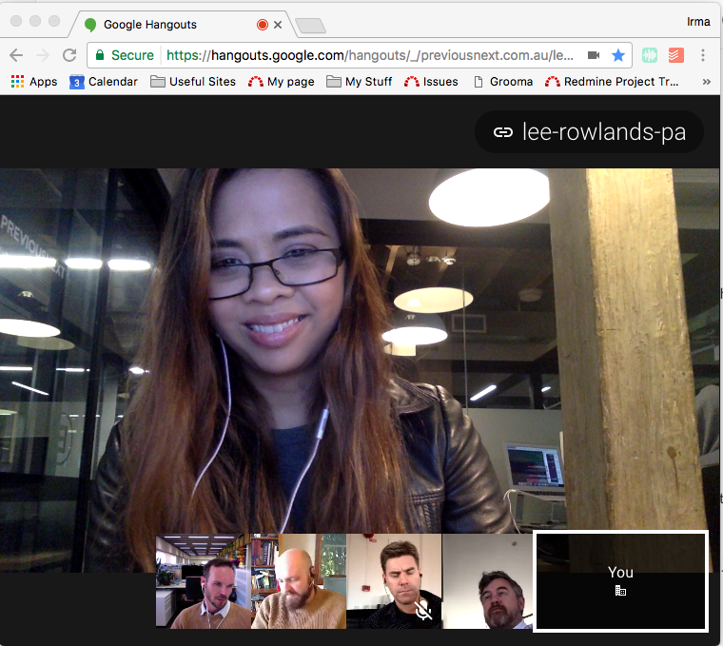

# Access to an online Kanban board

The ultimate in uber transparency. There is nothing more satisfying for an Agile Delivery Manager than to see tickets move to the right of the board. Likewise for our clients! Each ticket on the board details who the work is assigned to and the status of the task. At a glance, anyone with access to the project kanban board can see the status of work for a given sprint.

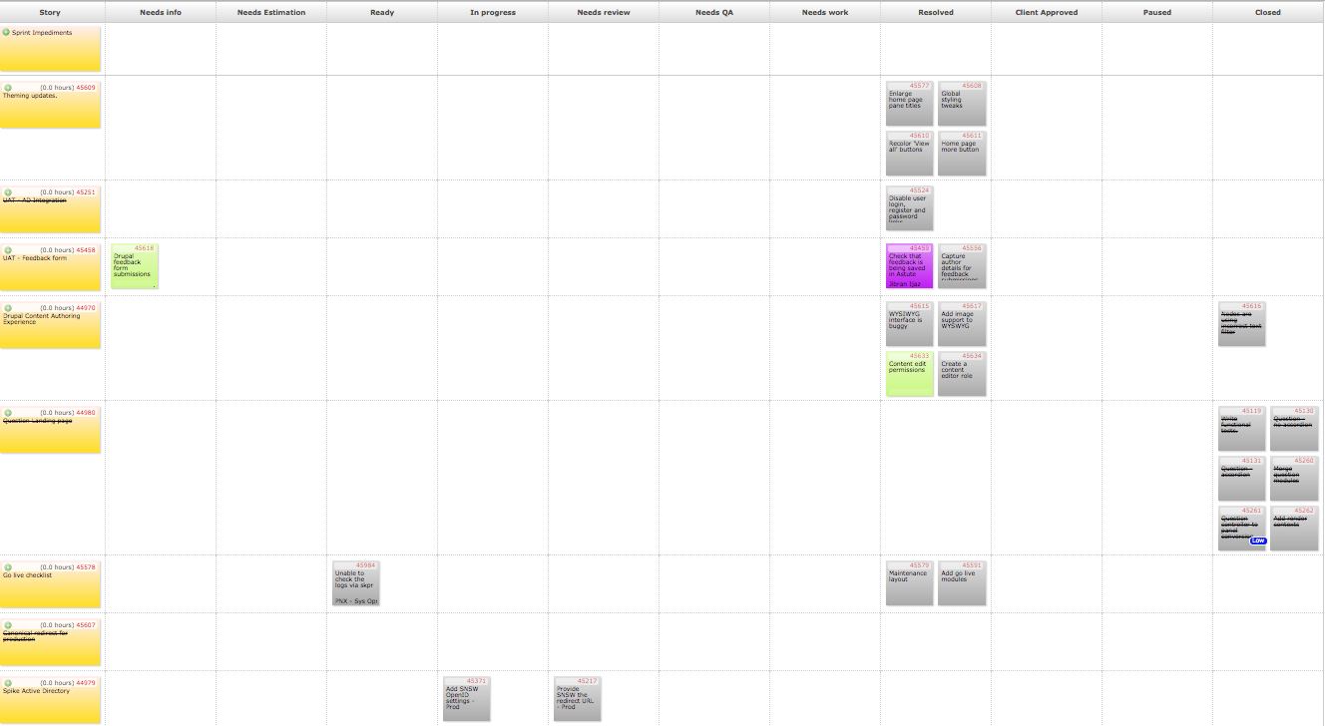

Google Sheets - My favourite go-to tool, when it comes to interactive Agile ceremonies

The most common question I’m asked about working with remote teams is “how do you facilitate an Agile ceremony like a Retrospective with a remote team?” My favourite go-to tool for this is Google Sheets. Before each retro, I spend a half hour putting the retro board together on a Sheet. I try and mix it up every retro as well, using different Retro [techniques](https://trello.com/b/40BwQg57/retrospective-techniques-for-coaches-scrum-masters-and-other-facilitators) to keep things interesting.  I mark defined spaces on the sheet where comments are to go, and I share the sheet with the team. Facilitating the Retrospective via a video conference (if possible), I timebox the retro using a timer app shared on my desktop. The team then fill in the Google Sheet in real time. The virtual equivalent of walking up to a physical board, and placing a post-it up there! I have replaced all of the original text captured during the retro with lorem ipsum text. What's said in retro - stays in retro! We had a little fun with the below retro as you can see!

d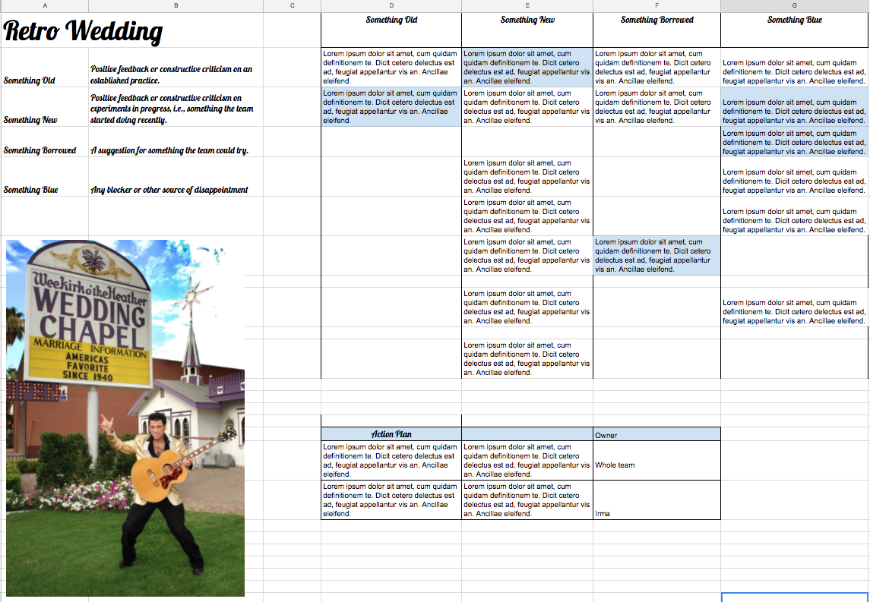

# For sensitive conversations - A video conference (or the phone)

The tools above are handy for enabling remote collaboration but for sensitive conversations with a colleague or client in a remote location, a video conference (where you can see each other) is a must. Sensitive conversations are fraught with danger via chat or email and a neutral tone is difficult to convey when we’re in the thick of things. If a video conference is not possible, though, simply pick up the phone.

**I’d love to hear about some of the tools you use with your team to enable remote working. What are your recommended tools of choice?**

Posted by [Irma Kelly](https://www.previousnext.com.au/about/team/irma-kelly)  
Agile Delivery Manager

Dated 22 August 2017

Source: Previous Next