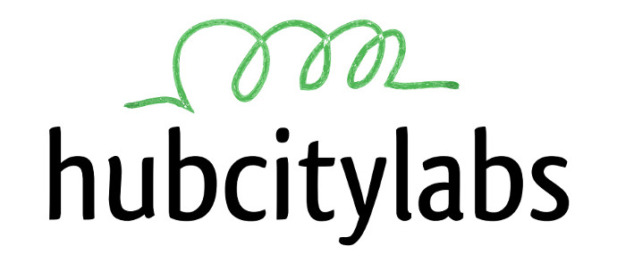

**<http://hubcitylabs.org>**

HubCityLabs Hackerspace

Open Night Every Saturday, 6PM

232 Botsford St, Moncton

--[----->+<]>++.++++++++++++..----.[-->+<]>++.-----------..[--->+<]>++.++++++++..[->+++++<]>+++.+[--->+<]>++.+++++.[-->+<]>-------.-[-->+++<]>--.--[--->+<]>--.[--->++<]>++.+.-------.

--[----->+<]>++.++++++++++++..----.[-->+<]>++.-----------..[--->+<]>++.++++++++..[->+++++<]>+++.+[--->+<]>++.+++++.[-->+<]>-------.-[-->+++<]>--.--[--->+<]>--.[--->++<]>++.+.-------.

At a typical hackerspace meeting people might work on: Arduino and Raspberry Pis, Amateur (Ham) Radio software and hardware, digital music, OLPC, learning Python or Go, iPhone app development, surface mount electronics, Web GUI design, Linux kernel hacking, embedded Asterisk (VOIP) hardware and even electric cars. In the background there are many great conversations in a casual and friendly social environment.

We generally meet twice a fortnight, on Saturday nights from 6-9pm.

hackerspace [/ˈhakərspās/]

A hackerspace is a place where people with common interests, often in technology, science, digital/electronics art and also in many other realms, can meet, socialize and collaborate.

Hackerspaces can be viewed as open community labs incorporating elements of machine shops, workshops and studios where hackers can come together to share resources and knowledge to make things happen.

**So, what is a hackerspace?**