# Analysis

## Case description

### Actors of the solution

|  |
| --- |
| Teacher |
| Student |
| Administrator |
| Company partner |

### Tasks of actors

|  |  |
| --- | --- |
| Actor | Role |
| Teacher | Has ability to create, modify and delete surveys.  Teacher should be able hide the surveys based on group or by explicitly selecting allowed students. |
| Student | Can list and answer the surveys which are not hidden from the group the student is assigned to. |
| Administrator | Has ability to create, modify and delete user accounts.  Administrator also has access to the answers of the surveys. |
| Company partner | Has ability to create, modify and delete surveys.  Company partner should be able hide the surveys based on group or by explicitly selecting allowed students. |

### Data input

Data is inserted by the means of the user interface provided by web application and stored in the remote database.

### Output data type

Output data is in the remote database and could be fetched by external service. It is also possible to list the output data by means of user interface.

## Table of functional requirements

## 

## Project schedule

## Use case diagram

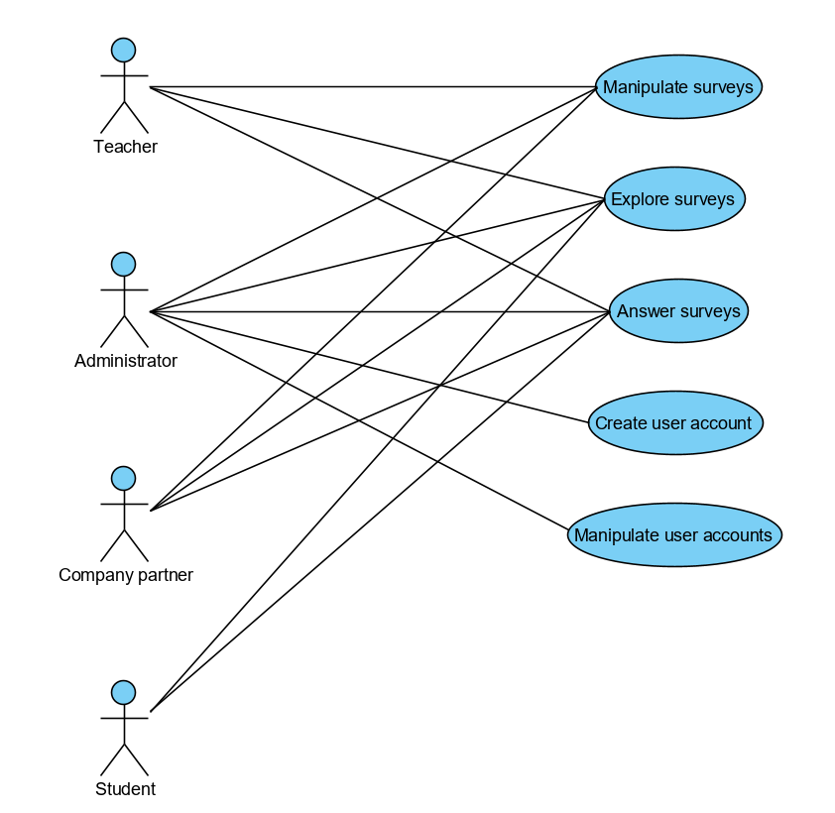

## Test plan

### Test cases

* Survey is created correctly
* Questions are created correctly
* Answers are saved
* Surveys are displayed correctly
* ­­User is created correctly