# Visual Studio Code Installation Guidelines

This document is part of the course: ["JavaScript Advanced" course @ SoftUni](https://softuni.bg/modules/76).

The following information serves as a guide for installing and configuring **Node.js**  и **Visual Studio Code**.   
**Visual Studio Code** is a source code editor which runs on your desktop and is available for Windows, macOS and Linux. It comes with built-in support for **JavaScript**, **TypeScript** and **Node.js** and has a rich ecosystem of extensions for other languages (such as C++, C#, Java, Python, PHP, Go) and runtimes (such as .NET and Unity).

# Part I: Install Node.js

## Download Node.js

Download Node.js from here: <https://nodejs.org/en/download/>

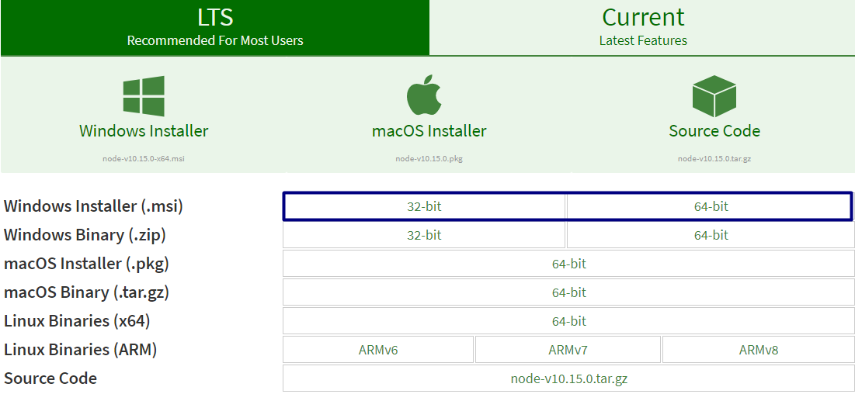

## Install Node.js

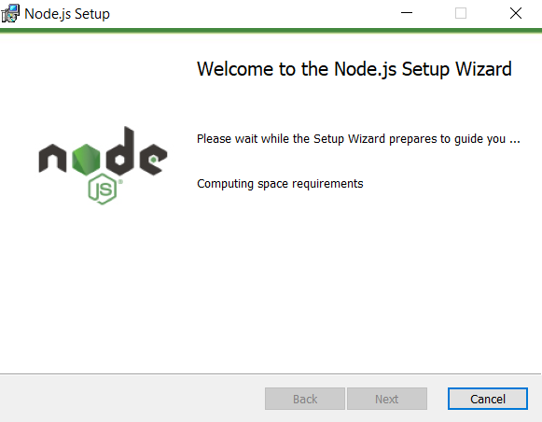

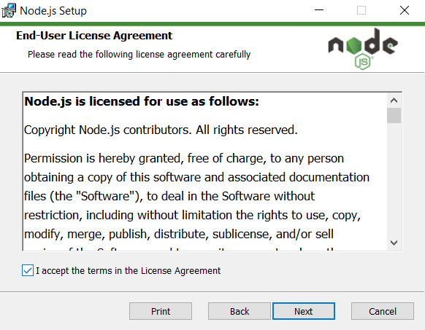

Install **Node.js** in a custom directory.

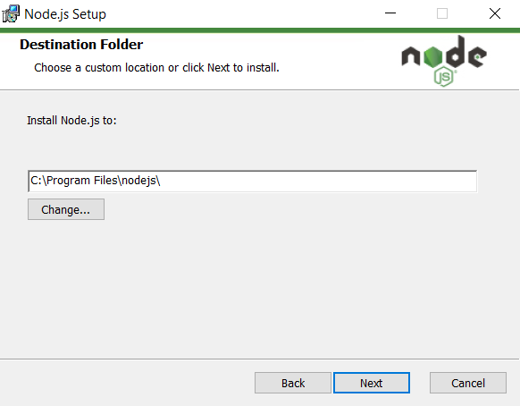

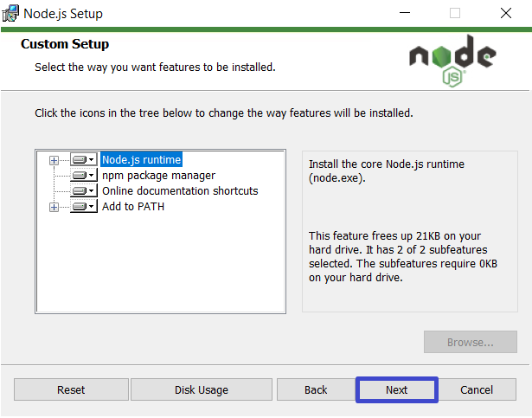

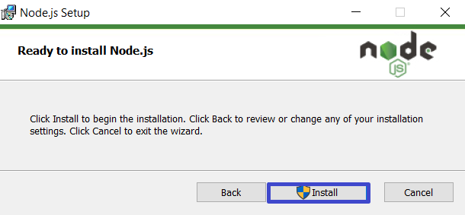

**Important: After a successful installation of Node.js, be sure to restart your computer before proceeding with Part II!**

# Part II: Install Visual Studio Code

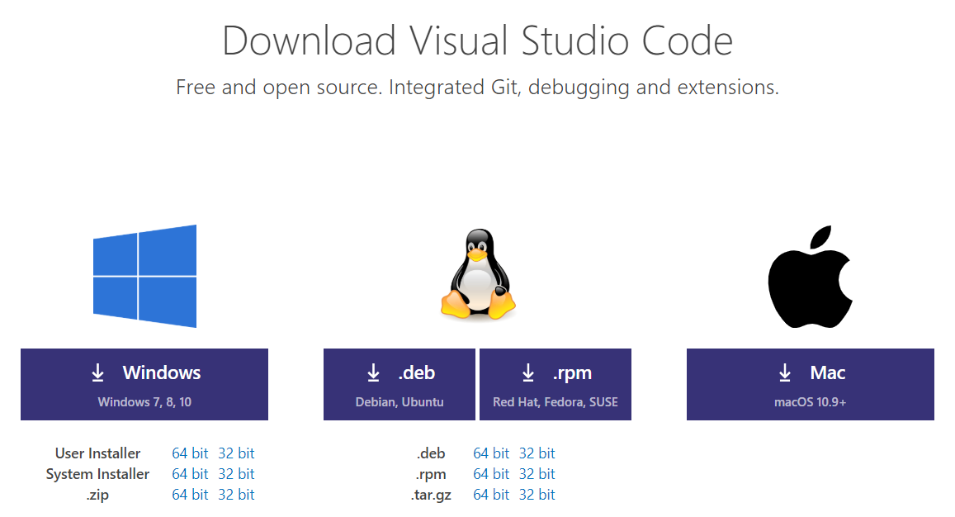

## Download Visual Studio Code

Download the Visual Studio Code installer from: <https://code.visualstudio.com/download>.

## 2. Install Visual Studio Code

The pictures below show the steps required to successfully install **Visual Studio Code** for **Windows 10**.

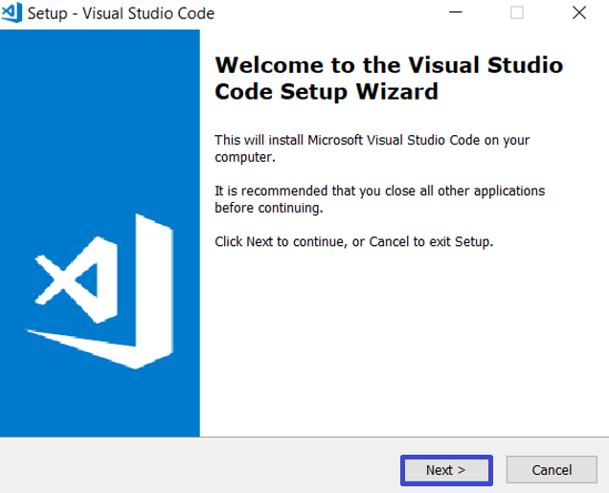

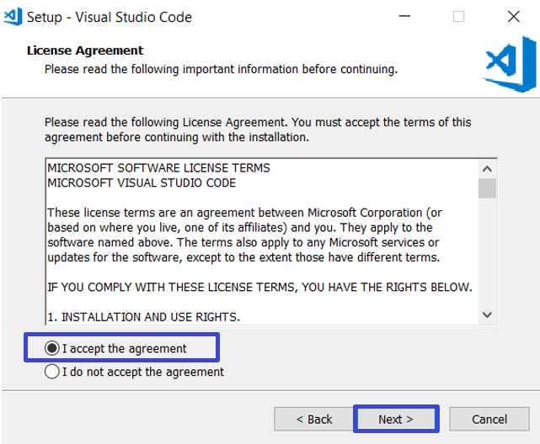

Install **Visual Studio Code** in a custom directory.

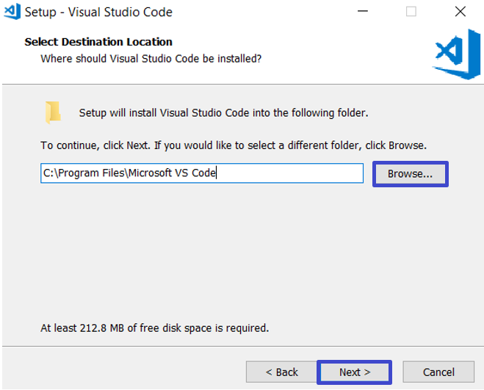

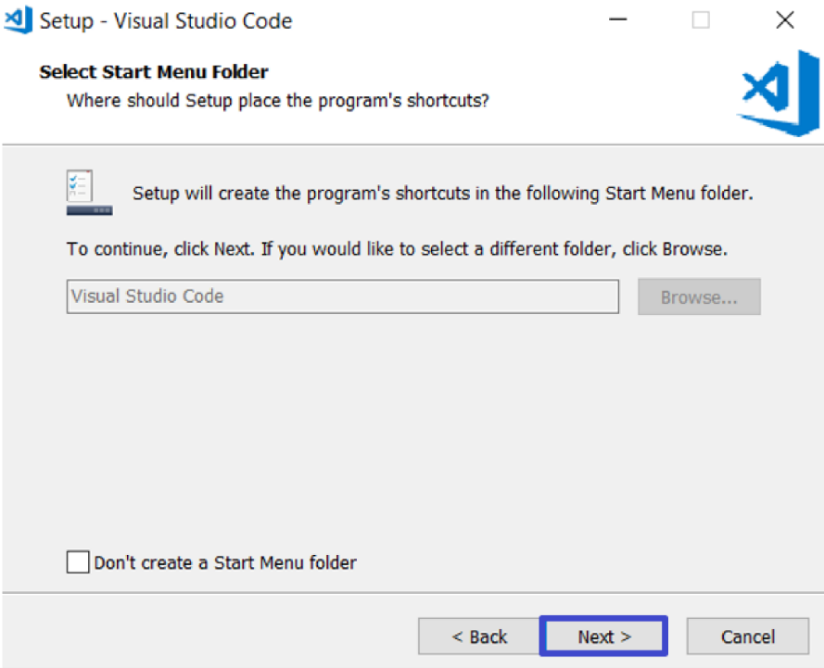

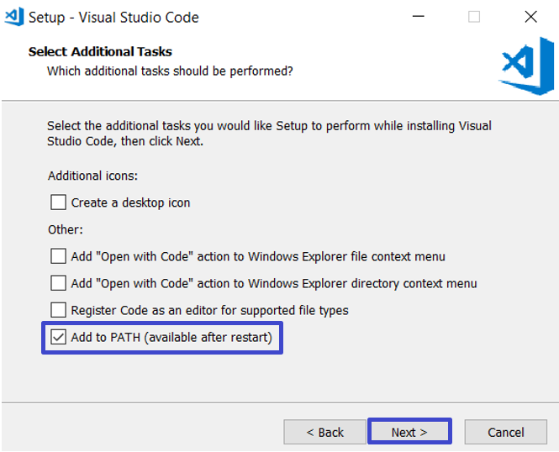

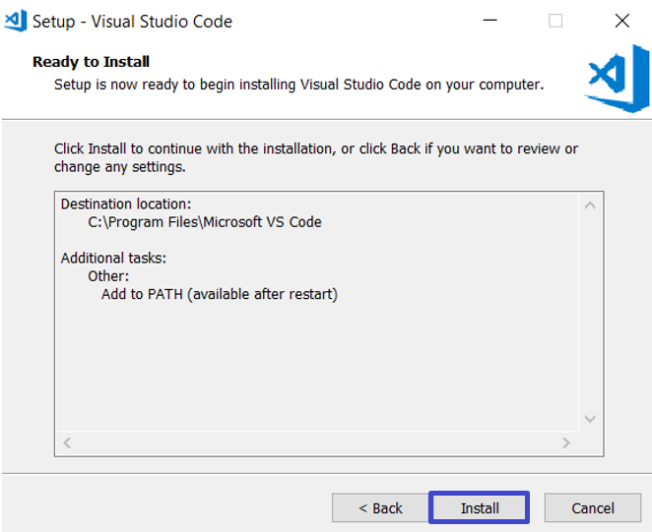

If the installation is successful, you should see the following final screen:

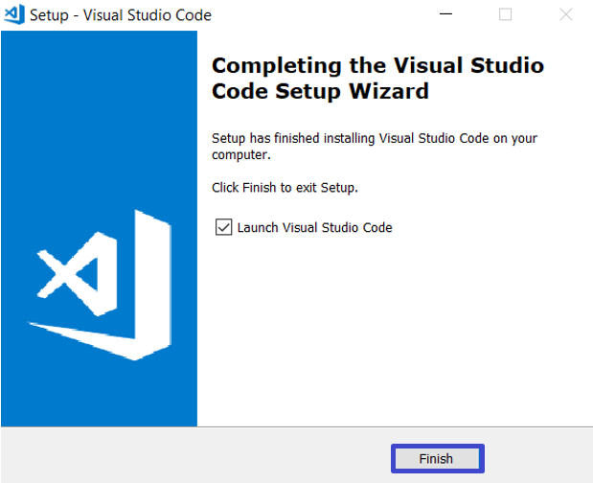

When you start Visual Studio Code, you should see the following window: