Important Tests and Annual Check up

"Doctor, we did all the tests as you suggested but honestly speaking, I could not understand some of them. In my 40 years of a medical career, this is the first child with type1diabetes that I have seen and that too, my own grandson! Can you please help me understand what these investigations mean? Your diabetes team has taught us basic survival skills but how shall we monitor him to prevent complications in the future?" Siddhi's grandfather was a famous old-time doctor. He was the support to Siddhi's disheartened parents.

The number of children with type 1 diabetes is less compared to other diseases. As a result, often children, especially who stay far away from the city do not get adequate medical guidance. To be self-reliant in diabetes management, you will now come to know details about what investigations to do, why and when.

You already know the importance of blood glucose testing on glucometer in your daily routine of diabetes. When blood glucose is more than 300 glucometer shows a message "ketone testing". You must have heard during diabetes treatment that you are admitted to the emergency department because "ketones are seen in your blood". But later, it has hardly been talked about. It is important to know when and how to check ketones.

When fat is used as energy some amount of ketones are formed in a small amounts even in the normal body. But in deficiency of insulin, body cannot use glucose for energy, so fat is used in large amount as an energy source and the formed ketones get deposited in blood. If not taken care of in time, a serious situation can occur.

When you are sick there are 2 reasons for increased ketones

1) No food intake or vomiting

2) Confusion as to whether Insulin dose is to be taken or not (insulin requirement increase in sickness). Sometimes either insulin dose is not given or insufficiently given resulting in the increase of ketones in the blood.

Ketones value can be tested in urine, for which ketostix strips are available.

Testing Method-

1. Collect urine in plastic Cup

2. dip the ketostixstrip in that and take out immediately

3. After 15 seconds match the changed colour with colour strip on the box.

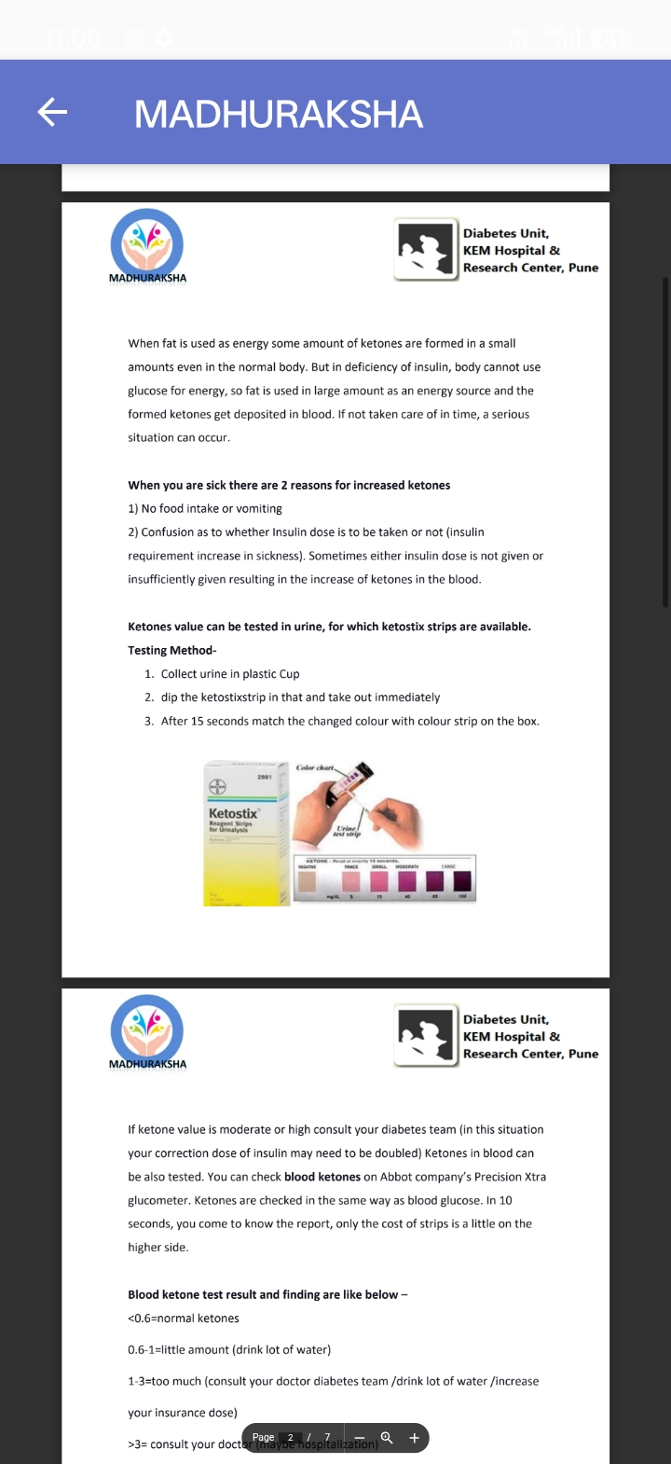
If ketone value is moderate or high consult your diabetes team (in this situation your correction dose of insulin may need to be doubled) Ketones in blood can be also tested. You can check blood ketones on Abbot company's Precision Xtra glucometer. Ketones are checked in the same way as blood glucose. In 10 seconds, you come to know the report, only the cost of strips is a little on the higher side.

Blood ketone test result and finding are like below -

<0.6=normal ketones

0.6-1-little amount (drink lot of water)

1-3-too much (consult your doctor diabetes team/drink lot of water/increase your insurance dose)

>3= consult your doctor (maybe hospitalization)

If you check ketones regularly or at the right time you might prevent going to the hospital or being seriously sick.

When diabetes is detected some tests are done among them GAD/IA/ICA antibody and C-peptides are important.
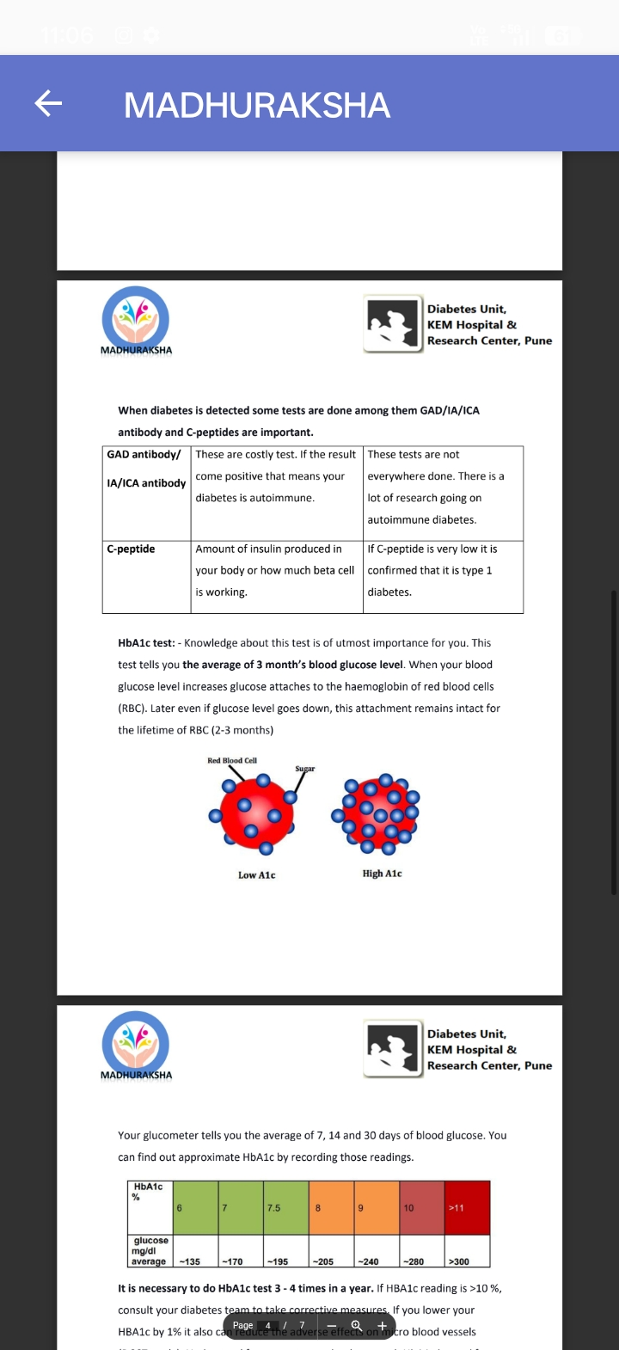

HbA1c test: - Knowledge about this test is of utmost importance for you. This

test tells you the average of 3 month's blood glucose level. When your blood glucose level increases glucose attaches to the haemoglobin of red blood cells (RBC). Later even if glucose level goes down, this attachment remains intact for the lifetime of RBC (2-3 months)


Your glucometer tells you the average of 7, 14 and 30 days of blood glucose. You can find out approximate HbA1c by recording those readings.
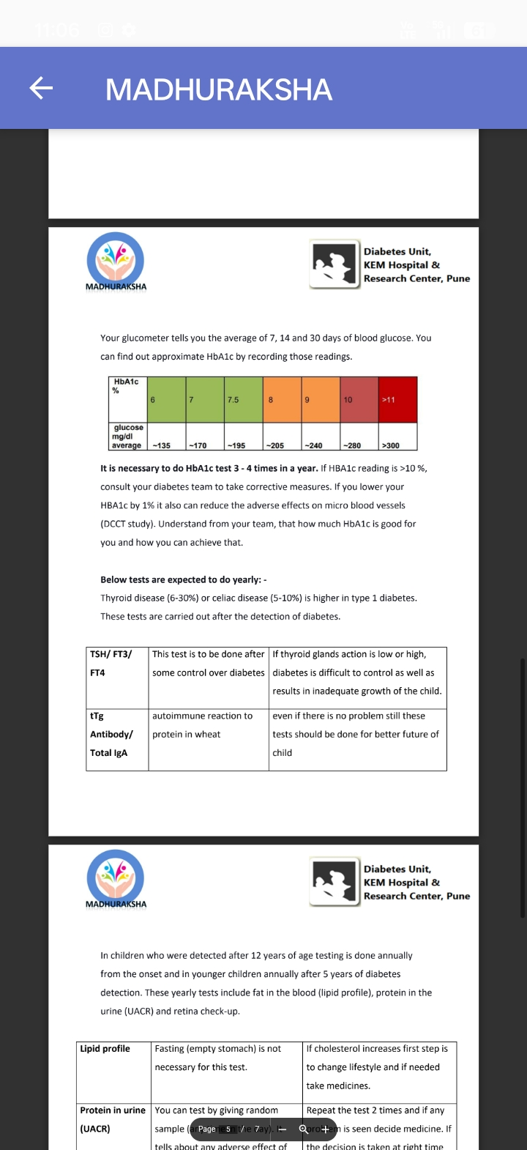
It is necessary to do HbA1c test 3-4 times in a year. If HBA1c reading is >10%, consult your diabetes team to take corrective measures. If you lower your HBA1c by 1% it also can reduce the adverse effects on micro blood vessels (DCCT study). Understand from your team, that how much HbA1c is good for you and how you can achieve that.

Below tests are expected to do yearly: -

Thyroid disease (6-30%) or celiac disease (5-10%) is higher in type 1 diabetes.

These tests are carried out after the detection of diabetes..
In children who were detected after 12 years of age testing is done annually from the onset and in younger children annually after 5 years of diabetes detection. These yearly tests include fat in the blood (lipid profile), protein in the urine (UACR) and retina check-up.

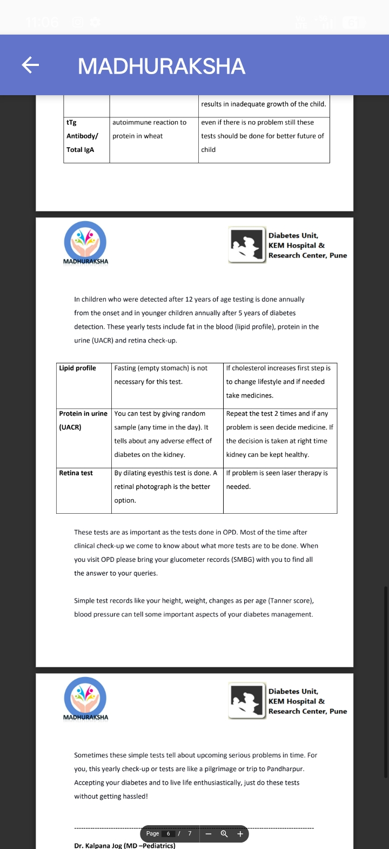
These tests are as important as the tests done in OPD. Most of the time after clinical check-up we come to know about what more tests are to be done. When you visit OPD please bring your glucometer records (SMBG) with you to find all the answer to your queries.

Simple test records like your height, weight, changes as per age (Tanner score), blood pressure can tell some important aspects of your diabetes management.

Sometimes these simple tests tell about upcoming serious problems in time. For you, this yearly check-up or tests are like a pilgrimage or trip to Pandharpur. Accepting your diabetes and to live life enthusiastically, just do these tests without getting hassled!

Dr. Kalpana Jog (MD-Pediatrics)

Tid Consultant, Diabetes Unit, KEM Hospital, Pune

[The original article is in Marathi and it was published in 'Madhumitra' - a Magazine by Diabetic Association of India]

