SMBG- Self monitoring of blood glucose

"Doctor, Aniket's report" Aniket's mom handed over all the medical reports to the doctor. "First, see my annual school report!" Aniket, with a great sense of pride, handed over his school report to the doctor. Aniket was 14-year-old, in 8th standard and had passed in all his papers. His medical reports were also good with HbA1c of 8.5%. He was diagnosed at the age of 12, but due to his poor financial condition and being from a remote village in Konkan, he was not able to get right medical supervision from any doctor. One year ago, when he had come in theOPD, he did not know anything about diabetes except taking insulin twice a day. Repeatedly, he used to get admitted ingovernment hospital in critical condition. His growth had also stalled. Although he wanted to study but due to frequent hospitalisation and lack of attendance in school, he could not pursue his studies.

These kinds of situations are common for children with T1D. To change this situation self-competency is a must in diabetes management. And in the process of being self-competent, "Glucometer" is your best friend.

Until a few years back, blood sugar was examined through urine samples. But there were so many complications in doing that and the results were not perfect as well. In the last 30 to 40 years advanced technologies have changed the face of diabetes management. "Gluometer" is a gift by which you can check your sugar level anytime anywhere very easily.

During 1983-1993, the Diabetes Control and Complication Trial (DCCT) was conducted on people with T1D in America and Canada. The outcome of that trial shows that better diabetes control is possible in T1D if these 3 things followed.

- Frequent blood sugar testing on glucometer

- Insulin injection to be taken2-4-times

- Following a proper diet

If diabetes is controlled, growth of a child with T1D is normal like other children.

Trial outcome also shows that if in initial years of T1D Diabetes Management is proper then a child can live a long healthy life with less complications of Diabetes. For that Glucometer is going to be your best friend.

How to choose a Glucometer?

- Strips should be affordable and easily available in the market. Most of the time it is seen that glucometer is being given free but matching strips are very costly.

- Required blood drop on the strip for sugar check should be very tiny and it should be taken up through capillary action as it’s really difficult for younger children to place their blood drop on the strip.

- Glucometer should have a memory (at least 100 records).

- Data from glucometer should be easily downloadable on the computer.

- Glucometer should be simple to use. Date/Day/Time/Year should be simple to set in glucometer.

Lancet comes with a glucometer, which can be used to prick the finger lightly to get a blood drop. To adjust the length of the pricking needle, there is a dial in the lancet. When used with younger children, the dial should be at 1 or 2. If the needle is longer than it can hurt children. Before using lancet wash your hands properly (if possible, with lukewarm water) and dry them. If by any chance there is a food particle on finger, blood sugar can be on the higher side. Do not wipe your fingers with spirit. Even if a very small amount of spirit stays on your finger, the result on the meter may be incorrect. Too much use of spirit on your finger can damage the softness of your finger and it can become rough and hard enough to hurt you. When you are out of home keep spirit free wipes with you. To get a blood drop from your finger it should be pricked on the side of a finger, neither in the middle and nor on top (Figure -1).

Figure -1:

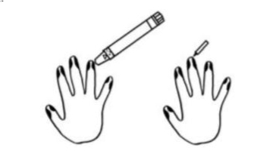

When blood from a finger is taken by squeezing the finger, fluid from the tissue can mix with blood but it causes incorrect blood sugar reading on the glucometer. Children like to use the same finger for the prick, but it causes

Damage to the tissue of that finger and it starts hurting. So, use a different finger daily for blood sugar checking. You can use the fingers of your feet as well and the mid lower portion of your thumb too.

In some glucometers there is facility of alternate site testing. That means you can take blood from different part of body, normally the pain is bare minimum.

(Figure –2
Figure 2:

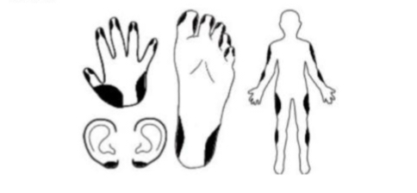
Keep two things in mind while taking blood from these sites. Firstly, keep the dial of lancet on 4 to 5, secondly, when you are in doubt of hypoglycaemia do not take blood from these sites as correct reading is hard to achieve.

Glucometer and strips should not be kept at too cold or too hot places. Keep them at room temperature. While in travel keep in mind that glucometer and strips should not get heated up. Do not keep them in the fridge.

The glucometers which required coding, match the code with the code on the bottle of strips. Sometimes it happens that you have a glucometer, but you are not aware of how to use the glucometer and what to do with the information from it.

The first question is – Why do children with Type 1 Diabetes need frequent blood sugar checking?
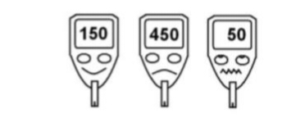

- The most important thing is “your safety”. It is impossible to know blood sugar levels from outside. It is not necessary that every time symptoms would be seen of low or high sugar. Especially in younger children it is very uncertain. Parent must check blood sugar of their child before sleep at night (bedtime). If sugar level is 130-150 mg/dL (in younger children 180 mg/dL) then late night chance of hypo is less. If correct insulin dose has been taken, then in night (empty stomach) normally 30-50 mg fluctuation is seen. (if while sleeping blood sugar is 160 mg/dL then in morning fasting blood sugar can range 130-180 mg/dL). Possibility of late-night hypo is high in younger children. Many times, we come to know about this only when child goes into convulsions. Such a situation can be avoided if you take good care of the child from the beginning itself.

- After lot of studies, it is found that at least 4 times sugar check in a day can minimise the complications of Diabetes in children. Blood sugar check, before & after meal can tell you a lot of things. It is easy to titrate the dose of insulin if you come to know about impact of your food on your blood sugar. If you can control your diabetes, your motivation level also increases.

- Biggest benefit of diabetes management is that you start living a normal life. You slowly come to know that there are lot of daily routine activities which can impact your blood sugar. For example, sports, exercise, exam, travel, few medicine, menstrual cycle of girls, weather change etc. With the help of a glucometer, you come to know the correct sugar level and you can prepare yourself (Think Ahead Strategy).

- When there was no glucometer, children used to get hospitalized with every episode of hypo or hyperglycaemia. There was no way to find out what is happening inside body. But with glucometer now you can plan everything. So many times, you see the symptoms of hypoglycaemia but when you check your blood sugar level, it does not show low blood sugar. This is because if blood sugar level comes down extremely fast (300-200-100), you feel like it is a hypo. Hence with the help of glucometer you can take right decision. Blood sugar & ketones can increase when you are sick. In this kind of situation, you can avoid serious complications by checking your blood sugar frequently.

Self-monitoring of blood glucose (SMBG) has a very important place in your diabetes management. Due to SMBG, a child can pursue a better career in future. Nowadays, there are new machines (CGMS) which can check your blood sugar every 5 minutes.

In your day to day diabetes management at least 4 times blood sugar check is a must. Before each meal like before breakfast, before lunch, before dinner and particularly important is before sleep at night. All these sugar checks can help you to decide the correct dose of Insulin. In the last few years irrational restrictions in meals have been removed from children’s daily routine and a normal meal like other children has been added. It is called Dose Adjusted For Normal Eating (DAFNE).

There is a lot of variety in Indian food which causes changes in blood sugar. So, to know which food product is responsible for how much change in blood sugar post meal (after2-3 hr) sugar check is necessary to know the correct dose of insulin. Play, exercise can also cause blood sugar changes, so in school while in PT class, before game start, during game and post-game blood sugar check can improve diabetes management. It has an impact on performance of child.

Keeping all the blood sugar records is necessary because these records can

Guide for better judgement. (Chart 1)

Chart -1
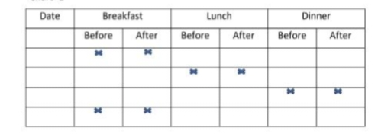

If there is no one educated in house, then it is difficult to interpret the blood sugar readings on glucometer. In this situation if there are 2 digits (50) on meter it is understood that blood sugar is low. And if if there are 3 digits then seeing the first digit insulin dose is being corrected. If there is ‘HI’ on meter that means >600 and if there is ‘LO’ that mean <40 or data is not recordable. Many times, lack of knowledge can lead to misunderstanding. If family is unable to understand data on meter, Diabetes team needs to work like a teacher. In diabetes treatment lot of things need to be taken care of. Keeping blood sugar level in control is a fine balance, specially avoiding hypoglycemia.

American Diabetes Association had made different guidelines depending upon age which were changed in 2015.
Blood sugar target range in Type 1 Diabetes and HbA1c value


(American Diabetes Association, 2015)

Diabetes Team should interact with Type 1 Diabetes child and her family to set the target range of blood sugar. Normally in SMBG record 65%-time blood sugar stays in range. Even after much effort 10-12% time hypoglycaemia and 25%-time hyperglycaemia can occur.
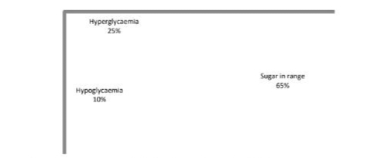

In these situations, none of the family members should give a negative comment, rather they should support the child. Frequent blood sugar checking gives crucial information and commenting in negative way on those data can lead to psychological rejection a feeling that glucometer is not her friend. It is not necessary that blood sugar will always be normal in spite of all the proper steps taken.

Please keep this serenity prayer with you from Diabetes team.

God grant me the serenity

To accept the things I cannot change;

Courage to change the things I can;

And wisdom to know the difference!

QUIZ – As per above write up find out if below statement are right or wrong.

- Blood sugar checked on glucometer is not trustworthy.

- Handwash is necessary before blood sugar check.

- Glucometer need to be calibrated/crosscheck 5-6 times in a month.

- Before blood sugar check apply spirit on your hand.

- Glucose strips can be used even after expiry date.

- While sugar check if blood is not adequate squeeze your finger.

- Prick middle portion of finger for sugar check.

- For sugar check always use same finger.

- If HbA1c is in correct range no need to do frequent sugar check.

- If you check blood sugar frequently at home, Hospitalisation can be avoided in case of emergency like Hypoglycaemia/Diabetic Ketosis.

- Blood sugar can fluctuate with so many reasons of your daily routine work. With the help of Glucometer, Diabetes Management is possible.

- When Sick, check every 2-3 hr your blood sugar.

- Due to SMBG Type 1 Diabetes child can make changes in her daily routine, diet and insulin dose.

- Along with Type 1 Diabetes her family should also know in detail about Glucometer.

15. If Glucometer is showing HI or LO that means glucometer is damaged.

Dr. Kalpana Jog (MD-Pediatrics)

T1d Consultant,

Diabetes Unit, KEM Hospital, Pune

[The original article is in Marathi and it was published in ‘Madhumitra’ – a Magazine by Diabetic Association of India]

Quiz – SMBG

State whether True or False.

- Blood sugar checked on glucometer is not trustworthy.

- Handwashing is necessary before blood sugar check.

- Glucometer needs to be calibrated / cross-checked 5-6 times in a mont

- Before blood sugar check apply spirit on your fingers.

- Glucose strips can be used even after expiry date.

- While sugar check, if blood is not adequate, squeeze your finger.

- Prick middle portion of finger for sugar check.

- For sugar check always use same finger.

- If HbA1c is in the correct range, no need to do frequent sugar check.

- If you check blood sugar frequently at home, hospitalisation due to hypoglycaemia or diabetic keto acidosis (DKA) an be avoided.

- Blood sugar can fluctuate with so many reasons of your daily routine work. With the help of Glucometer, Diabetes Management is possible.

- When sick, check your blood sugar every 2-3 hourly.

- Due to SMBG, a person with Type 1 Diabetes can make changes in the daily routine, diet and insulin dose.

- Along with the person having Type 1 Diabetes, his/her family should al know in detail about a glucometer and blood sugar monitoring.

- If Glucometer is showing HI or LO that means glucometer is damaged.

Diabetes Unit Team

Diabetes Unit, KEM Hospital, Pune

[This quiz was published in ‘Madhumitra’ a Magazine by Diabetic Association of India]
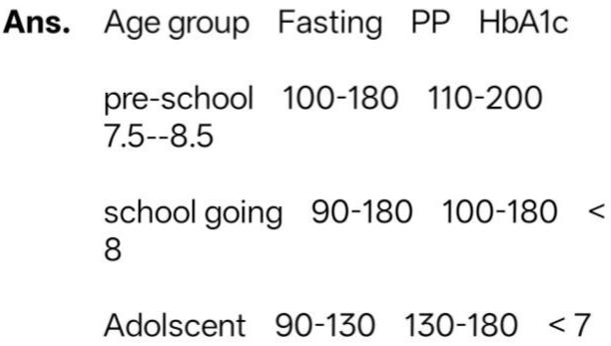
Q.What are the blood sugar targets for my kid?
Q. What should be bed time sugar levels?

Ans. You must talk to your doctor to decide a safe target, which can be modified based on your individual experience. For children it is recommended to keep bedtime blood sugars above 150 mg/dl.

Q. What should be the difference between the bed time (pp3) sugar & fasting sugar?

Ans. It should be around 30 to 50 mg/dl indicating that the basal insulin is working fine.

Q. Why a child’s fasting sugar goes high inspite of night sugar being normal?

Ans. Basal insulin would be less or not

Working. Change injection site. Check expiry of basal. Check Bed time sugars, 3 am sugars and fasting sugars consecutively for 2-3 days. Then take appropriate action.

Q. Does taking blood from other sites such as palm or toes, arm etc. give correct BG levels ?

Ans.Yes the readings are quite accurate. Common alternative blood testing sites include the palm, forearm, upper arm, thigh and calf. It may not give an accurate result when glucose levels are changing rapidly. E.g. after a meal, after taking insulin, during exercise or when you are sick or experiencing stress. When you need an immediate, present-moment result, such as when you suspect low blood sugar, always use a finger test site.

Q. Does weather affect blood glucose levels?

Ans.Yes it does. Hot weather generaly leads to more hypos.

Q. Where are Glucose monitoring and insulin administration products available?

Ans. Please visit KEM diabetes educator. http://www.gluco-wise.com /https://in.abbott-diabetescare.com /freestyle-libre-pro.php

Q. Where can we buy glucometer strips online?

Ans. Amazon, Ebay, shopclues.com, netmeds.com, medlife.com and others

Q. Which apps can be used for logging blood sugars, food etc?

Ans.MySugr, Diabetes:M, OnTrack and several others

Q. What does CGM stand for?

Ans. Continous Glucose Monitoring

Q. What exactly is the Libre?

Ans. The Libre Pro is a FGM – Flash Continuous Glucose Monitoring System.

Q. Where all on the body can the libre pro be used?

Ans. It’s recommended by Abbott to use it on the outer arm. It can also be used on the inner arm, outer thighs, inner thighs and stomach as per user feedback

Q. Does site variation for libre affect the accuracy?

Ans. No it does not (as per feedback)

Q. Are there tapes or stickers to put over the libre?

Ans. Tegaderm is an option

Q.Does the libre take 24 hours to warm up and give proper readings?

Ans. Not necessarily, usually 3-4 hours warm up (and calibrations if using Glimp) does the trick. It might take longer with just the reader.

Q.Is it necessary to have reader for using libre pro sensor?

Ans.We need reader to activate the sensor. Once the sensor is activated we can eighter read the data from reader or an NFC enabled Android phone using Glimp App.Glimp App shows the actual glucose value. The reader shows only sugar graph & not the value. For seeing the values you have to download it to PC or laptop.

Q. Can Libre Pro reports be downloaded or accessed without a reader?

Ans. No, a reader is needed to read the sensor and generate reports through a software on a computer.
Q. Can the Libre Pro be used for taking a reading with a phone if the Abbott reader is not working / available?

Ans. Yes, it’s possible on NFC enabled Android mobile phones. A third party app called “Glimp” needs to be downloaded and used to scan the reading

Q. Which phone model has the facility for reading of libre sensor?

Ans. There is an app called Glimp. Glimp is supported on devices which have NFC (Near Field Communication).

Q. Which glucose reading is generally closer to the actual glucometer value, the Libre reader or Glimp?

Ans. Usually, Glimp – since calibration is possible (unlike the reader)
Q.How to check compatibility of a device on the Glimp app?

Ans.Options > Info > List of Compatible Devices

Q.Which phones in the Indian market are known to be compatible with the app Glimp to read the Libre Pro sensor?

Ans.LG G3 D855, LG watch Urbane 2nd edition, LG watch Urbane, LG Q Stylus, Samsung galaxy A3 GT S7270, SM A300, S3 GT-I9300, S3 Neo GT 19301, S4 GT 11905, S4 Mini GT 19195, S7 Edge, SMG935, S8, One Plus 3T/5/5T/6, Motorola XPlay, Lenovo X3A40, Motorola G5 Plus, Motorola One action, Nokia 3TA1032, Xiomi MI 5, Nokia 6.1

Q. What do you like about libre?

Ans.It is relatively affordable (compared to other available options), it’s sticky and doesn’t fall out, it gives a lot of blood sugar data to study and it is much superior compared to 5-6 meter tests a day – it covers all blind spots over 24 hours. It is helpful to understand trends and useful overnight too. It is important to check against a glucometer though

Q. What are the drawbacks of the libre?

Ans.It’s more expensive than meter tests, if it falls off, it’s a complete waste, it could be 20-30 mg/dl lesser than meter values due to it measuring interstitial fluid and the meter measuring capillary fluid (therefore affecting dosing), the libre is more unpredictable and far from meter values when sugars are either too high or too low.

Q. Does Libre work more than 14 days?

Ans. No it doesn’t

Q. What is the worth of Dixcom CGM. Who uses it. What is Dixcom G5. Can it be given to a 4 year old?

Ans. It is an alteranate to Libre. It is a CGM as opposed to Libre which monitors every 15 mins or so. https://www.dexcom.com/en-IN

Q. What is duration & level of blood glucose for starting ketone production in our body?

Ans.There is no cut off number of BSL for ketone generation in our body.It is multifactorial. Ketone starts generating in following conditions *New onset Diabetes *Acute illness & infections *Dehydration *Starvation *Irregular/Skipping insulin *High BSL.

Q. Which ketones strips should I use?

Ans. Bayer is a known and trusted brand to use.

Q. Which is the best and affordable glucometer?

Ans. There are many glucometers available in the market. While buying a meter, one must consider:

- Strip cost (recurring expenditure) and not the meter cost (one time expenditure). Presently average strip cost is around 10 per strip (Abbott optium neo H: 9/-, Accucheck Active: 12.5/-, Alere 8.5/-)

- Accuracy of the meter: it is calculated as difference between meter and lab values or reference values (MARD) It should be less than 10% (Abbott freestyle meters, Bayer Countour Next, One touch, Roche -Accucheck).

