Insulin-Types, Storage

"Doctor it's Ganesh's mother. I am calling from the medicine shop. You prescribed a yellow labelled insulin, but the shopkeeper is giving us a green labelled insulin and saying it is the same. What should I do?" Ganesh's mom asked in a confused voice.

Uneducated but smart mother of 4-year-old Ganesh takes care of her son's diabetes very efficiently. Often it is seen in the OPD that parents do not know which insulin they take and that the pharmacist is giving them the wrong insulin. All types of insulin lower blood sugar level but each insulin has a different way of working. Lack of awareness and using a different insulin can make the blood sugar level drop drastically or shoot up to avoid this situation and to have complete control over diabetes management you need to have basic information about all kinds of insulin available in the market.

Insulin Research&Formation: In January 1922, 14-year-old Lenard Thomson was given insulin first time and a new chapter began in the history of diabetes. The equation that Type 1 diabetes means death simply vanished. Since then in the last 100 years, a lot of changes happened in insulin production and in insulin delivery technique. Due to the developed biological system, pure insulin is available in large amount nowadays. With the changes in amino acid of insulin structure, designer insulins are developed. To inject insulin, disposable syringes, insulin pens, a less painful small needle (6mm/8mm) and insulin pumps are
available nowadays. All these new treatment options are helping to make the life of children with T1D normal like other children.

Bolus and Basal insulin: in a healthy body after every meal, insulin is secreted through the pancreas, called bolus insulin. 3-4 hour after a meal slowly the release of insulin lowers down because blood sugar is also in control by then. Insulin reduces but does not end fully. In very less amount it always (24 hours) exists in blood, called basal insulin. (Due to this basal insulin, glucose level stay in the proper amount in fasting state too).

In keeping with this physiology, insulin is being produced in the laboratory with ongoing improvement with time. Insulin division is based on their onset and time of action. Short and rapid acting insulin is used as prandial/ meal (bolus] insulin. Intermediate and long-acting insulin is used as basal insulin. It is not necessary that in each child insulin action will be same. In fact, in the same child insulin action can vary at a different time and even on different days.
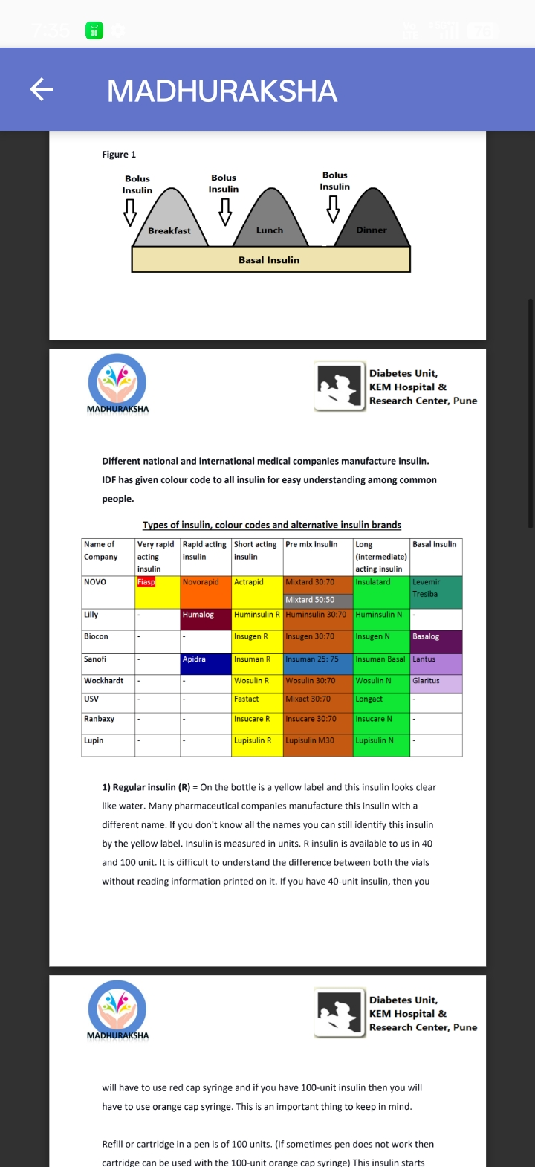
Different national and international medical companies manufacture insulin.
IDF has given colour code to all insulin for easy understanding among common people.

Types of insulin, colour codes and alternative insulin brands

1).Regular insulin (R) = On the bottle is a yellow label and this insulin looks clear like water. Many pharmaceutical companies manufacture this insulin with a different name. If you don't know all the names you can still identify this insulin by the yellow label. Insulin is measured in units. R insulin is available to us in 40 and 100 unit. It is difficult to understand the difference between both the vials without reading information printed on it. If you have 40-unit insulin, then youwill have to use red cap syringe and if you have 100-unit insulin then you will have to use orange cap syringe. This is an important thing to keep in mind.

Refill or cartridge in a pen is of 100 units. (If sometimes pen does not work then cartridge can be used with the 100-unit orange cap syringe) This insulin starts working after 30 to 45 minutes. So, if you want to match the blood sugar level and insulin you should take the insulin at least 30 minutes before your meal. Sometimes when post-meal sugar is high this gap itself can help you to control better. The effect of this insulin stays for 4-6 hours (Please note that in every child action curve of insulin may differ). Generally, every hour 15 to 20% insulin is consumed. For example, if you have injected 10 unit of R insulin then normally after 2-hours 40% insulin (4 unit) will be consumed, and 6 unit will be remaining. For this PP glucose test can be done after 3 hrs and not after 2 hours to know if more insulin is required or not. R insulin is affordable and available, but it should be taken a half-hour before the meal and its effect stays for a longer period, hence the need for newer insulins.
Figure -3:

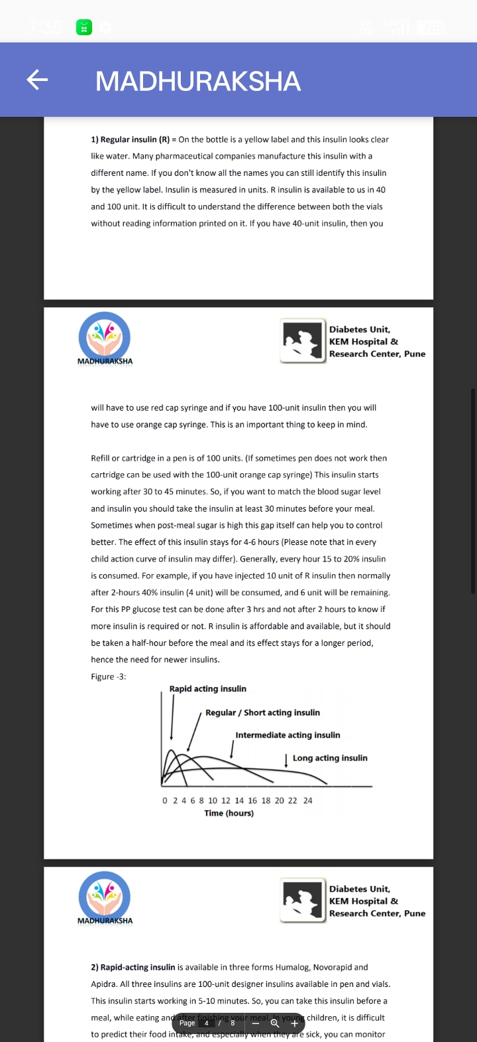

2) Rapid-acting insulin is available in three forms Humalog, Novorapid and Apidra. All three insulins are 100-unit designer insulins available in pen and vials. This insulin starts working in 5-10 minutes. So, you can take this insulin before a meal, while eating and after finishing your meal. In young children, it is difficult to predict their food intake, and especially when they are sick, you can monitor their food intake and depending upon that you can fix insulin dose. The effect of this insulin lasts for 2-3 hours which reduces the chances of a late hypo. For best outcomes in PP blood sugar levels this insulin should be taken 15-20 minutes before a meal.

3) Intermediate-acting insulin (NPH insulin) N insulin - This insulin's label is of green colour andlooks milky. Before taking this insulin gently roll the vial on your palm and make it homogeneous. If you shake the vial forcefully bubbles will come, and your dose of insulin can go wrong. This insulin starts working after 4-6 hours. Those children who cannot take insulin in school can take N insulin in the morning so that post-tiffin their sugar level does not increase. N insulin and R insulin can be given mixed together and is called split mix. With this method doses of both insulins can be altered as per requirement. For example, if there is a physical education class in school N insulin dose can be minimised. Effect of N insulin lasts for 12-13 hours. When N insulin is given as basal insulin at night then it is safe to have 1 or 2 biscuits before sleep. The peak of insulin reaches in 4-6 hours. So, it is necessary to check blood glucose around 2:00 to 3:00 AM because at that time chances of hypos are high.

In younger children, it is difficult to predict N insulin's action profile. Unexpected hypo can trouble any time making frequent glucose check the only safe option.

In combination with N insulin, rapid insulin and R insulin are available as premixed insulins in the market. (30/70 Mixtard, 25/75 Humalog mix, 30/70 Novolog mix)premixed insulin is normally not recommended for children as it takes away not only the flexibility of eating and playing but also shows great glycaemic variability. However, if needed, with proper guidance, this insulin can be used.

4) Long-acting designer insulin is available in three forms Lantus, Levemir and Tresiba. The job of this insulin is to control fasting blood glucose level which means it works like basal insulin. It is important to have the correct dose of basal insulin. If your fasting blood glucose is in control and normal, then insulin dose throughout the day is correctly manageable. That is why we can call it our foundation insulin.

Lantus insulin is available as 100 unit in pen and while. You can fix the time of injection, but it is necessary to keep the same time every day. Lantus looks like water so you should not get confused with R insulin. Do keep this in mind. This injection can hurt sometimes because of its acidic nature. So, in young children injection should be given on backside on their seat so it should not pain as much. Lantus stays for 22-24 hour in blood. For most people one injection is sufficienthowever sometimes in young children, Lantus is divided into 2 doses.
Irrespective of Lantus injection time, to know the effect of Lantus, fasting blood glucose should be checked. In all recent studies, it has been seen that Lantus is safe in children.

Most of the time Levemir insulin is taken twice. In obese children with this insulin, weight can be better controlled. Tresiba is just launched and there are limited number of studies about the safety of this insulin in children. (Tresiba is 3 times costlier than Lantus.)

Most of the time one wonders which insulin is good for use and the answer is-One shoe does not fit all. The insulin which controls your diabetes is the best insulin for you. If you understand the working of insulin you can choose insulin as per your need. Your diabetes team will guide you regarding this.

Extra insulin can be stored in the fridge (not in freezer) till its expiry date.

Insulin which you are currently using can be kept outside at room temperature (area that does not heat up). In this insulin, comparatively no bubbles are formed, and it causes less pain. If the colour of insulin is changed or small particles or crust appears, then this insulin is damaged. The medical companies advise to change the insulin in use within a month. In young children and toddlers due to very small dose wastage of insulin may beseen. (One option to this situation is the availability of vial and pen with less ml of insulin.)

All insulin measurement is in the unit. If one unit of insulin lowers 50 mg blood sugar in your body, then every insulin's 1 unit will reduce the blood sugar by 50 mg. Only difference would be the time taken to do that. Rapid insulin will lower the blood glucose fast and long acting insulin wil lower the blood glucose slow. This knowledge will help you to adjust the dose of insulin and to have a better.
limited number of studies about the safety of this insulin in children. (Tresiba is 3 times costlier than Lantus.)

Most of the time one wonders which insulin is good for use and the answer is-One shoe does not fit all. The insulin which controls your diabetes is the best insulin for you. If you understand the working of insulin you can choose insulin as per your need. Your diabetes team will guide you regarding this.

Extra insulin can be stored in the fridge (not in freezer) till its expiry date. Insulin which you are currently using can be kept outside at room temperature (area that does not heat up). In this insulin, comparatively no bubbles are formed, and it causes less pain. If the colour of insulin is changed or small particles or crust appears, then this insulin is damaged. The medical companies advise to change the insulin in use within a month. In young children and toddlers due to very small dose wastage of insulin may beseen. (One option to this situation is the availability of vial and pen with less ml of insulin.

All insulin measurement is in the unit. If one unit of insulin lowers 50 mg blood sugar in your body, then every insulin's 1 unit will reduce the blood sugar by 50 mg. Only difference would be the time taken to do that. Rapid insulin will lower the blood glucose fast and long-acting insulin will lower the blood glucose slow. This knowledge will help you to adjust the dose of insulin and to have a better control of your diabetes!

QUIZ: Write down correct insulin as per their type:-

1. Baselog

2. Actrapid

3. Insulatard

4. Wosulin-N

5.Humalog

6. Fastact

7. Glaritus

8. Apidra

9. Insugen-R

10. Insucare-N

11. Novorapid

12. Wayosulin-N

13. Lantus

14.Insuman-R

15.Levemir

16. Mixtard 30/70

17. Huminsulin 50/50
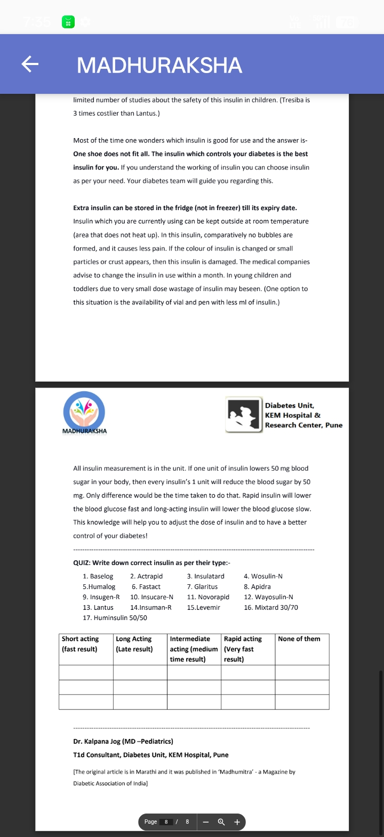
Dr. Kalpana Jog (MD-Pediatrics)
T1d Consultant, Diabetes Unit, KEM Hospital, Pune
[The original article is in Marathi and it was published in 'Madhumitra - a Magazine by
Diabetic Association of India]

Insulin Injection Technique

"Doctor I don't know what has happened to Rohit's diabetes in last 3 months. His blood sugar is not controlled at all, sometimes very low and sometimes goes very high. Our family physician has suggested going for an insulin pump for better control. We thought of consulting you before taking the final decision. 10-year-old Rohit's father was in OPD after a year. Rohit's family was taking care of his diabetes very well. In fact, in the last 3 to 4 years he had no complications related to diabetes. For 10 years of age, in last one year, he had shown good growth as well. On studying his blood glucose record it was difficult to come to any conclusion.

In a diabetes clinic, it is important to check the insulin injection site while doing the physical examination of children. We found an abnormal mass of fat under the skin of Rohit's injection site on his thighs. Since the past few months, Rohit was taking his insulin shots by himself and this injection site did not hurt, so he did not bother to change the injection site. Repeated insulin injection in the same location or too much use of the same syringe can cause thickness in the skin and abnormal fat under the skin resulting in no sensation of injection and no pain. This is called Lipohypertrophy a commonly seen problem.

At this site injected insulin does not go into the blood properly. Sometimes it holds up at the same place causing an increase in blood glucose level and after some time the whole quantity of insulin goes into the blood at one go causing a
sudden lowering of blood glucose. To prevent this kind of situation, change of insulin injection site and change of needle is important. By avoiding lipohypertrophy sites and injecting at other sites not only uncontrolled blood glucose can be controlled, but sometimes insulin requirement comes down as well. Lipohypertrophy can take 3 to 6 months to heal. The only solution is not to give the injection at that site. Due to analogue insulin and biological insulin, the injection site can show lipoatrophy. Comparatively very few incidences of this kind have been seen.

It is therefore important to have complete knowledge of insulin, insulin injecting technique, insulin storage technique and much more to be self-sufficient in diabetes management.
What is the right place to inject insulin?

Insulin is given under the skin in the fat [subcutaneous). By mistake, if insulin is given in skin it will hurt and can create a red swollen area. If by mistake it is given in veins, besides hurting it will lower the blood glucose extremely fast and can cause unexpected hypo. While giving insulin injection if blood comes or small bubbles go with insulin, it is not to be worried about.
acting (R) and intermediate acting (NPH) insulin can vary with their injection site depending on the site. Learn about and keep changing the injection site.

Figure-1
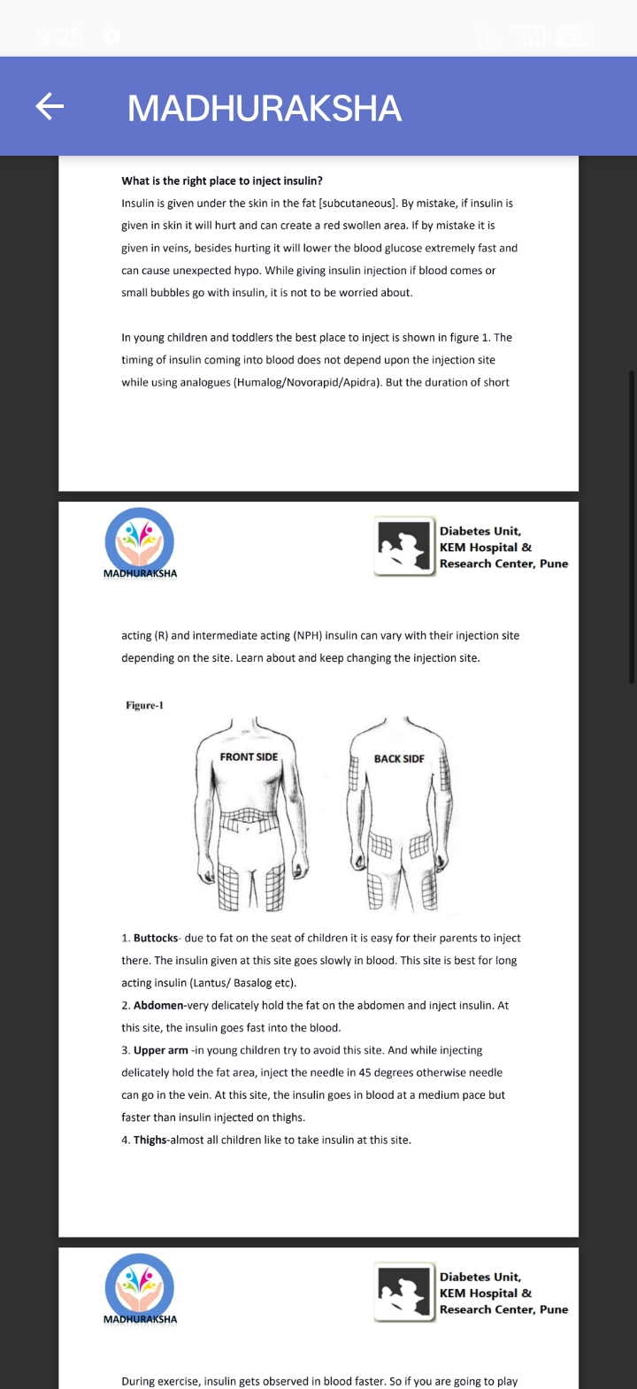

1. Buttocks- due to fat on the seat of children it is easy for their parents to inject there. The insulin given at this site goes slowly in blood. This site is best for long acting insulin (Lantus/ Basalog etc).

2. Abdomen-very delicately hold the fat on the abdomen and inject insulin. At this site, the insulin goes fast into the blood.

3. Upper arm -in young children try to avoid this site. And while injecting delicately hold the fat area, inject the needle in 45 degrees otherwise needle can go in the vein. At this site, the insulin goes in blood at a medium pace but faster than insulin injected on thighs.

4. Thighs-almost all children like to take insulin at this site.

During exercise, insulin gets observed in blood faster. So if you are going to play football, take insulin on arm and not on thighs. Similarly, if you are going to play tennis take insulin on thighs and not on arm. Another precaution is do not bathe with hot water or don't go into a hot water tub after taking insulin injection because hot water results in faster absorption of insulin in the blood which can cause hypoglycaemia.

Correct technique to take insulin with syringe/Pen/pump:-

Syringe 1 ml 40 IU (red cap, per 1-unit marking)

Syringe 1 ml 100 IU (orange cap, per 2-unit marking)

Insulin strength (40 unit/ml or 100 unit/ml) should match the same strength syringe.

Figure-2
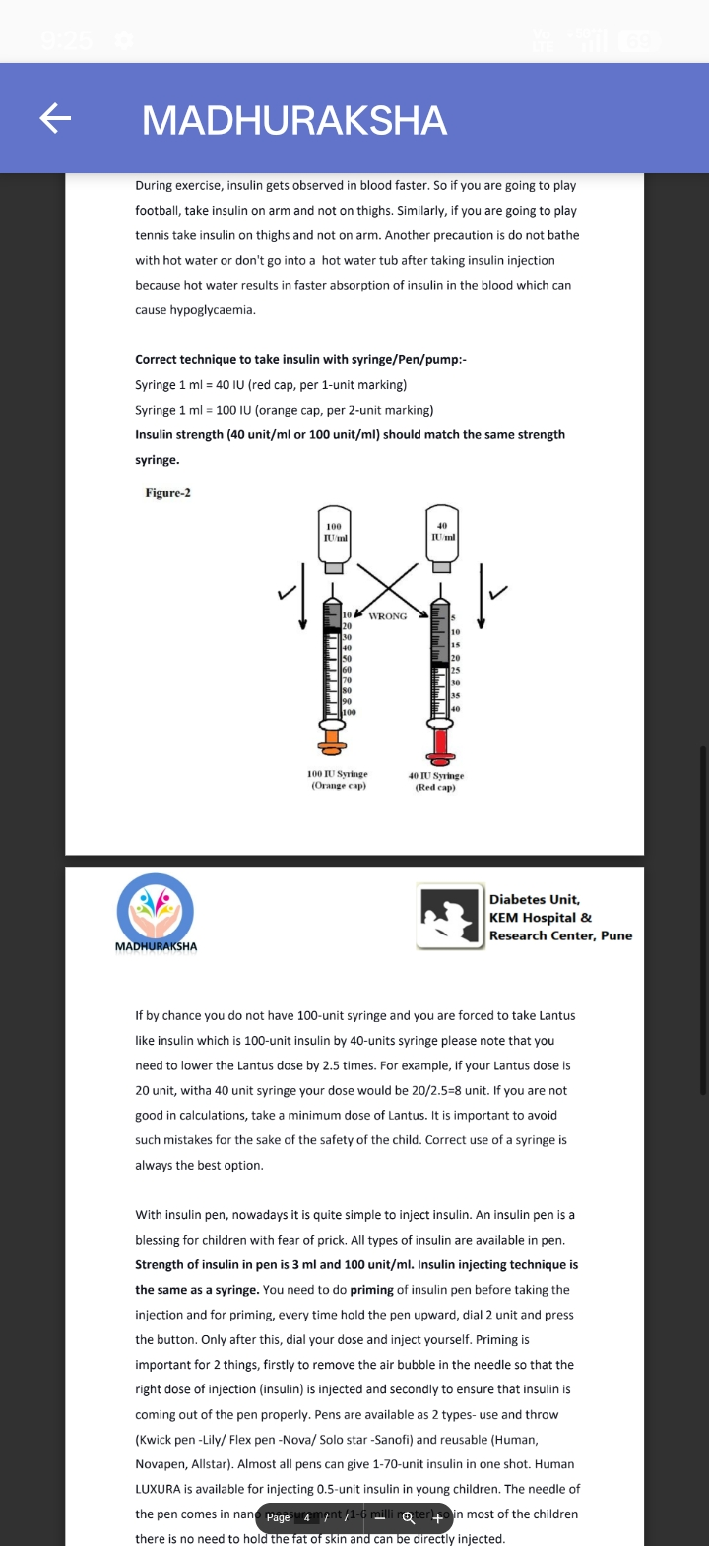

If by chance you do not have 100-unit syringe and you are forced to take Lantus like insulin which is 100-unit insulin by 40-units syringe please note that you need to lower the Lantus dose by 2.5 times. For example, if your Lantus dose is 20 unit, witha 40 unit syringe your dose would be 20/2.5-8 unit. If you are not good in calculations, take a minimum dose of Lantus. It is important to avoid such mistakes for the sake of the safety of the child. Correct use of a syringe is always the best option.

With insulin pen, nowadays it is quite simple to inject insulin. An insulin pen is a blessing for children with fear of prick. All types of insulin are available in pen. Strength of insulin in pen is 3 ml and 100 unit/ml. Insulin injecting technique is the same as a syringe. You need to do priming of insulin pen before taking the injection and for priming, every time hold the pen upward, dial 2 unit and press the button. Only after this, dial your dose and inject yourself. Priming is important for 2 things, firstly to remove the air bubble in the needle so that the right dose of injection (insulin) is injected and secondly to ensure that insulin is coming out of the pen properly. Pens are available as 2 types- use and throw (Kwick pen-Lily/Flex pen-Nova/ Solo star-Sanofi) and reusable (Human, Novapen, Allstar). Almost all pens can give 1-70-unit insulin in one shot. Human LUXURA is available for injecting 0.5-unit insulin in young children. The needle of the pen comes in nano Page u mynt 71-6 milli roter) coin most of the children there is no need to hold the fat of skin and can be directly injected.
In some of the countries, I-Port or Insuflon is available for injecting insulin. This tiny cannula can be kept below the skin for 4 to 5 days and through that insulin can be injected.
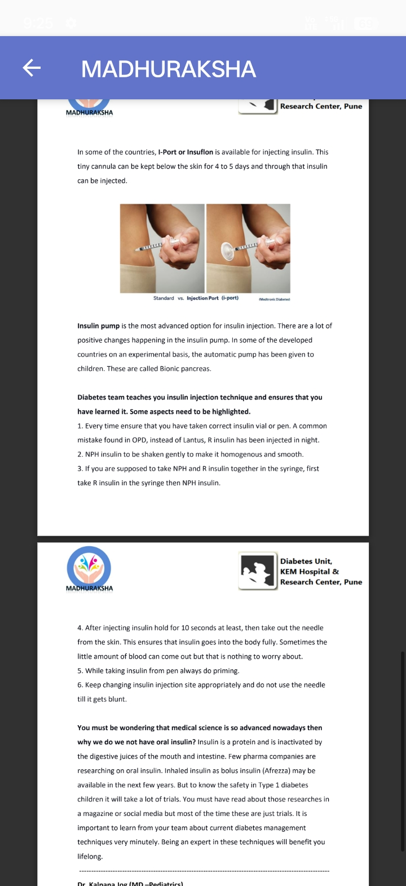
Insulin pump is the most advanced option for insulin injection. There are a lot of positive changes happening in the insulin pump. In some of the developed countries on an experimental basis, the automatic pump has been given to children. These are called Bionic pancreas.

Diabetes team teaches you insulin injection technique and ensures that you have learned it. Some aspects need to be highlighted.

1. Every time ensure that you have taken correct insulin vial or pen. A common mistake found in OPD, instead of Lantus, R insulin has been injected in night.

2. NPH insulin to be shaken gently to make it homogenous and smooth.

3. If you are supposed to take NPH and R insulin together in the syringe, first take R insulin in the syringe then NPH insulin.

4. After injecting insulin hold for 10 seconds at least, then take out the needle from the skin. This ensures that insulin goes into the body fully. Sometimes the little amount of blood can come out but that is nothing to worry about.

5. While taking insulin from pen always do priming.

6. Keep changing insulin injection site appropriately and do not use the needle till it gets blunt.

You must be wondering that medical science is so advanced nowadays then why we do we not have oral insulin? Insulin is a protein and is inactivated by the digestive juices of the mouth and intestine. Few pharma companies are researching on oral insulin. Inhaled insulin as bolus insulin (Afrezza) may be available in the next few years. But to know the safety in Type 1 diabetes children it will take a lot of trials. You must have read about those researches in a magazine or social media but most of the time these are just trials. It is important to learn from your team about current diabetes management techniques very minutely. Being an expert in these techniques will benefit you lifelong.

Insulin Regimen

"Doctor there is protein in Shobha's urine, so we have come to you. Our village doctor told us that her diabetes is not controlled, and it can damage her kidney". Shobha's dad was anxious. Shobha was diagnosed with type 1 diabetes at the age of 9. She is 17-year-old today. Her family always thought that 2 times pre-mix insulin injection is sufficient. Some days, due to complication and problems she used to get hospitalised, at that time doctors used to tell them about the increasing the number of insulin injection and frequent checking of blood glucose on glucometer but the family was against this. Actually, this unacceptance came from lack of awareness.

If blood glucose is not controlled well then after some years micro blood vessels fail and can cause deterioration of organs. When micro blood vessels of the kidney are affected then urine has small amount of protein (microscopic albuminuria). At this juncture, if blood glucose is controlled adequately and with the use of ACE inhibitor medicines then kidneys function can be restored. But if not controlled at the right time kidney may fail, resulting in high blood pressure. which may finally end up with dialysis or kidney transplantation. Diabetes team explained everything in detail to Shobha and her family. For better control of blood glucose basal and bolus insulin was started and every month she was called for a regular check-up in OPD.
When insulin was first discovered it was impure and doses and timing of insulin injection was decided by patients' symptoms. For example, frequent urination meant an insulin shot and in symptoms of hypo avoid insulin. Injection syringe and needle used to be quite big. After repetitive boiling, the needle used to get blunt which hurt the children and it was mental trauma for the family. But this was the only option to survive. Later new options became available in insulin, syringes, and needles to achieve minimal injection numbers.

Now once or twice in 24 hours insulin injections were being given but there was no clarity as to what is needed to control diabetes and have a normal life.

In 1993 DCCT (Diabetes Control and complications trial) published their research which dramatically changed type 1 diabetes management. Due to uncontrolled diabetes children had retinopathy which causes blindness, neuropathy, kidney failure and sometimes at a very young age heart attack or paralytic attack. After DCCT research those children who went through their guided diabetes management as given below had lesser complications.

1.3 to 4 times blood page check-Goat home by zlucometer.
2. Diet and exercise should be well planned.
3. Insulin injection need to be taken twice or more in a day. This was called multiple daily injections (MDI).

MDI regimen is just like insulin secreted in a healthy body. In this basal and bolus insulin concept was incorporated. Rapid-acting insulin for each meal as

MADHURAKSHA

Diabetes Unit, KEM Hospital&Research Center, Pune

per need to be taken and one long-acting basal insulin without fail which will control fasting blood glucose. The insulin pump is also based on this theory. The only difference is that in this short or rapid-acting insulin injected digitally.

The benefits of MDI regimen are undisputed but practically in some children trial and error needs to be done to fix the insulin regimen (number of insulin injection per day). Family support is the centre point of diabetes treatment. If 3 to 4 times insulin injection is not acceptable to the family then mutually insulin regimen needs to be finalised. In this kind of situation, a group discussion can be helpful. These children need to be handled sensitively. Any kind of insulin regimen used should be based on the concept of basal and bolus insulin.

Basal insulin: Healthy pancreas secrets insulin 24 hours that is called basal

insulin. Body cells require this basal insulin to convert glucose secreted from the liver into energy. If by any reason basal insulin is not secreted blood sugar will shoot up suddenly. Then the job of basal insulin is to control fasting blood glucose (in between meals and in sleep) and when you are not doing any exercise. Hence it is important to have the correct dose of basal insulin to control your diabetes. Basal insulin requirement varies from person to person. You will have to fix your basal dose by frequent checking of blood glucose on the glucometer.

Some observations have been made after examining children in different age groups.

1. Basal insulin is required mostly in the night especially after 3:00 AM till 10:00 AM It is called dawn phenomena. At this time counter-regulatory hormones which work against insulin are secreted. If your sleeping time blood sugar is normal but, in the morning, fasting blood glucose is high, ir baral inculin doce if in afternoon basal insulin requirement is less, then maybe in the daytime your physical activity is helping you to increase the action of insulin.

2. Young people need (till 21 yr.) more basal insulin due to sex hormones. Young children below 10 years need more basal insulin in the evening which is called as dusk phenomena. After 60 years, the dose of basal insulin lowers down drastically.

You can use NPH insulin (Insulatard) as basal insulin, its effect stays for 12 to 14 hours. In blood this insulin's level is not constant. After 4 to 6 hour it increases causing chances of hypo. After taking bedtime N insulin it is particularly important to check blood sugar level after 4 to 6 hours. In young children, severe hypo can happen. New designer basal insulin (Lantus, detemir and Tresiba) stays at a constant level in blood so chances of a hypo are very less.

Bolus insulin: The other partner in insulin regimen is bolus insulin which needs

to be taken as per meal. There are a lot of things to be considered while fixing the dose of bolus insulin. First check your blood glucose level before a meal then calculate carbohydrates in your meal and depending upon these 2 things consult your dietician to fix your bolus insulin dose. Dr Davidson has given a formula in 1980 to know either 1-unit insulin lowers how much blood glucose or 1-unit insulin lowers how many carbs.

Insulin: carb ratio = 500/required insulin in 24 hrs (If your total requirement of basal and bolus insulin is 25 unit then by this formula 500/25 20. This means for 20-gram carb in your food 1-unit insulin is required.)

Insulin sensitivity factor (correction ratio) =1500 for short-acting insulin and 1800 for rapid-acting insulin/insulin required in 24 hours (if your total insulin requirement is 25 basal plus bolus then the calculation should be 1500/25=60. that means to reduce 60-milligram glucose, 1-unit insulin is required.)

The most important thing is not that these formulas are absolutely correct, but this may be used as stepping stones. You can start with this formula or calculation and for each Page 4 t/s 10 carton Quot For food items with on labels you can take help of nutritionist to calculate insulin: carbs.
Insulin: carb ratio = 500/required insulin in 24 hrs (If your total requirement of basal and bolus insulin is 25 unit then by this formula 500/25-20. This means for 20-gram carb in your food 1-unit insulin is required.)

Insulin sensitivity factor (correction ratio) =1500 for short-acting insulin and 1800 for rapid-acting insulin/insulin required in 24 hours (if your total insulin requirement is 25 basal plus bolus then the calculation should be 1500/25-60. that means to reduce 60-milligram glucose, 1-unit insulin is required.)

The most important thing is not that these formulas are absolutely correct, but this may be used as stepping stones. You can start with this formula or calculation and for each person, this calculation will differ. For food items with nutrition labels, you can take help of nutritionist to calculate insulin: carb ratio. Keeping a food diary and the blood sugar levels after different meals, you can learn to bolus accurately.
Giving your child the pleasure of different food without compromising in diabetes control is essential part of management.

In a day how many times insulin injection is to be injected? There are few

options for that-

1) Twice or thrice in a day this insulin regimen was popular between 1980 to 1990. In this R insulin (Actrapid or Insugen R yellow labelled) and insulin NPH (Insulatard/Insugen N green label) were mixed and given. Later, pre-mix insulin was available in different strength (Mixtard Brown label 30/70&50/50). This premixed insulin is quite easy to use and affordable so use of these increased. These insulins are still in use for type 1 children. The only problem with premix insulin is children have a variable daily routine. Children's game, food keeps changing so the insulin in which changes as per need is not possibly makes good control of diabetes difficult. Blood sugar can go up and down very erratically. In developed countries in order to give children optimum development, this insulin is almost obsolete.
R and N insulin mixed in syringe are called a split mix pattern. There is some flexibility in this regimen, so to some extent controlling diabetes is possible. However, with twice day split mix insulin, trying to control diabetes without hypoglycaemia becomes stressful for parents. Also, one cannot vary the diet too much leading to frustration.

N insulin taken before dinner reaches its peak in blood in 4 hours which can cause hypo or N insulin levels are very less in blood by morning so fasting blood glucose before breakfast may be on the higher side. In this situation, if you take insulin before sleep rather before dinner it may give a little better result. In fact, this insulin regimen is also not a complete solution. Many times, when children do not accept their diabetes in beginning because of this trial and error, the diabetes team should accept their insulin regimen and guide the family.

2) MDI (multiple day injections): In this regimen before every main meal bolus insulin is to be injected. To fix the bolus insulin -

A. Pre-meal blood glucose level

B. Carb count in meal

C. Play and exercise

Your day to day life will be easier if you fix the insulin dose keeping in mind all these variables.

1. Your pre-meal blood glucose is 250. You require 1-unit insulin to reduce 50-milligram glucose (sensitivity ratio) and your pre-meal blood glucose target is 120 to 150.

250-150-100 milligram. More than 100-milligram glucose-lowering

100/50-2 Unit insulin will bring your pre-meal to normal.

2. There are 60-gram carbohydrates in the meal.

You require 1-unit insulin to cover 15-gram carb (I:C ratio)

60/15-4-unit insulin will bring your post-meal glucose to normal.

If the child is fond of playing you need to lower down the insulin dose on trial and error method. In beginning all these things may seem tough but as time goes you become habitual to it and it becomes really easy. Diabetes team plays a very important role to make them understand all these aspects to make life normal for the child.

N insulin or Lantus/Tresiba/detemir can be given as basal insulin before sleep. Most of the children need detemir twice a day. Pharma companies suggest not mixing Lantus and bolus insulin. (Unofficially these were mixed but it did not make much difference in insulin dose). To fix basal insulin dose, keep a record of before sleep and fasting blood glucose for a few days. If the insulin dose is correct, then 30-50 milligram blood glucose changes can be seen.
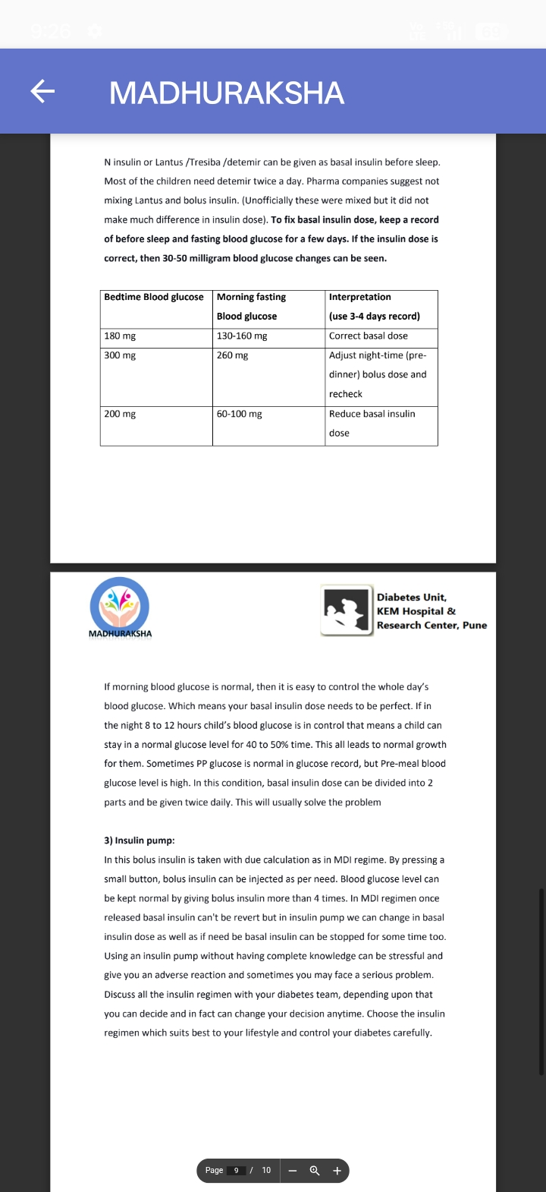
If morning blood glucose is normal, then it is easy to control the whole day's blood glucose. Which means your basal insulin dose needs to be perfect. If in the night 8 to 12 hours child's blood glucose is in control that means a child can stay in a normal glucose level for 40 to 50% time. This all leads to normal growth. for them. Sometimes PP glucose is normal in glucose record, but Pre-meal blood glucose level is high. In this condition, basal insulin dose can be divided into 2 parts and be given twice daily. This will usually solve the problem

3) Insulin pump:

In this bolus insulin is taken with due calculation as in MDI regime. By pressing a small button, bolus insulin can be injected as per need. Blood glucose level can be kept normal by giving bolus insulin more than 4 times. In MDI regimen once released basal insulin can't be revert but in insulin pump we can change in basal insulin dose as well as if need be basal insulin can be stopped for some time too. Using an insulin pump without having complete knowledge can be stressful and give you an adverse reaction and sometimes you may face a serious problem. Discuss all the insulin regimen with your diabetes team, depending upon that you can decide and in fact can change your decision anytime. Choose the insulin regimen which suits best to your lifestyle and control your diabetes carefully.

QUIZ: Match this as per above article: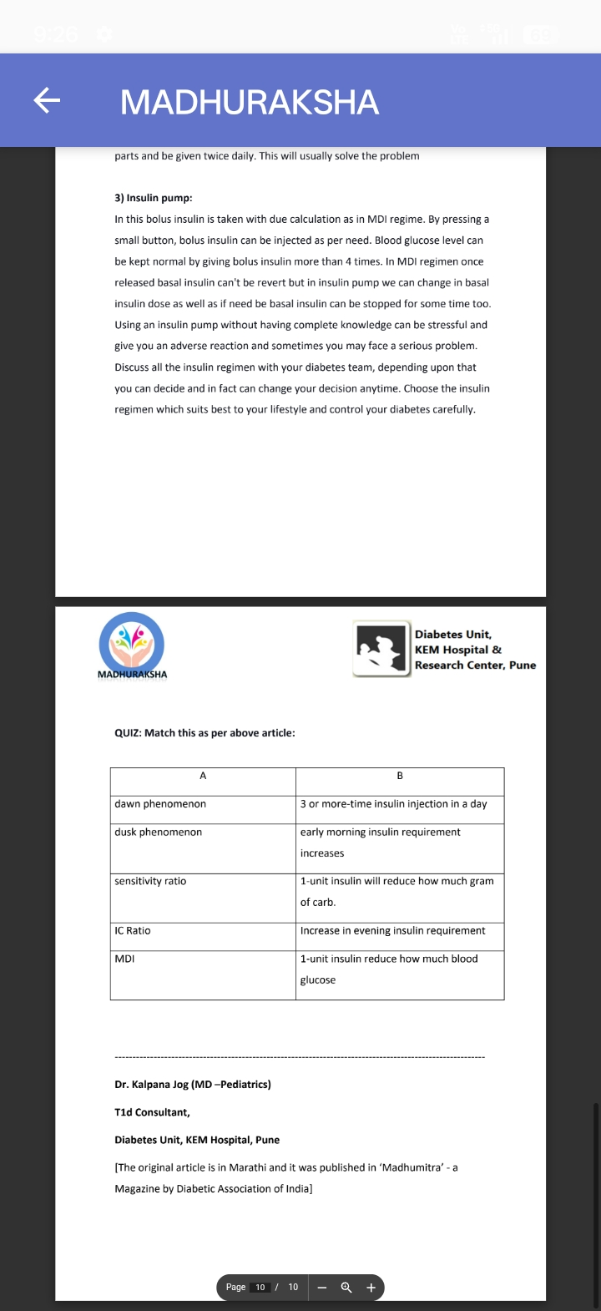

Dr. Kalpana Jog (MD-Pediatrics)

Tid Consultant,

Diabetes Unit, KEM Hospital, Pune

[The original article is in Marathi and it was published in 'Madhumitra' - a

Magazine by Diabetic Association of India]

Quiz-Insulin Types

Write down the insulin brand names from list in correct column as per their

type:-

1. Baselog

2. Actrapid

3. Insulatard

4. Wosulin-N

5.Humalog

6. Fastact

7. Glaritus

8. Apidra

9. Insugen-R

10. Insucare-N

11. Novorapid

12. Wayosulin-N

13. Lantus

14.Insuman-R

15.Levemir

16. Mixtard 30/70

17. Huminsulin 50/50
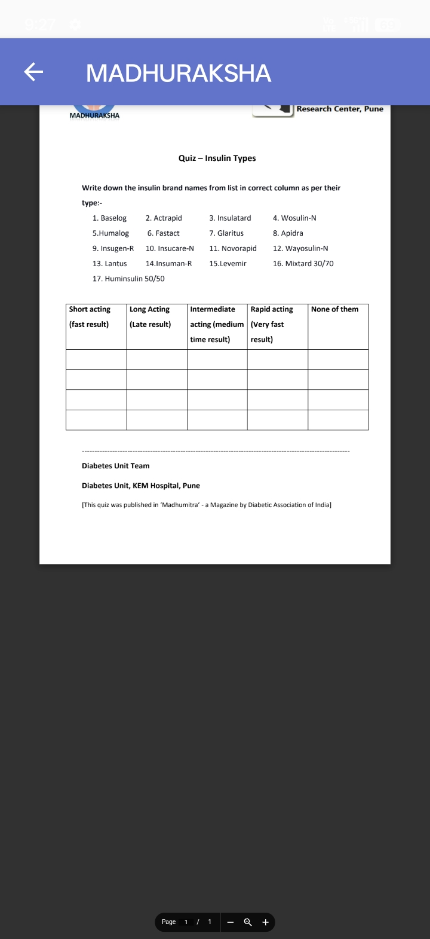

Q. As a child grows do we need to increase the dose of insulin?

Ans.

Yes. We need to monitor and increase the insulin dose as child grows and puts on weight.

Q. What is I-port?

Ans.

I port is a patch with canula inserted in sub cutaneous, through which you can give insulin by pen or syrine, without causing prick pain. Check more information: https://www .medtronicdiabetes.com/products/i -port-advance

Q. Can basal insulin (lantus / balasog) be given through i-port?

Ans.

lantus given thru sub cutaneous works better than given thru port. Give lantus on the seat (buttocks) and not arm or thigh or abdomen.

Q.

Do insulin injections cause any side effects?
Ans. If proper injection technique is

used, insulin injections do not cause any side effects. One must be vigilant about hypo and tweak doses accordingly. Incorrect injection technique, using same sites repeatedly can lead to lipohypertrophy.

Q. Does insulin make you put on weight?

Ans. It does, if taken in excess

Q. Even when after changing injection site my BSL is consistently high. What to do?

Ans. There are many factors influencing high sugars, injection site is only one of them. You need to check other factors like dose adjustment, diet etc.

