Carbohydrate counting -

Calculationg IC, ratio, IS Ratio and Insulin Dose

Next week Rama and her parents came again but this time with detail of her week's diet. They specially marked the carbohydrate sources with a red pen, which was remarkable.

"That's great. You identified them absolutely correctly. Now we will learn how to fix insulin dose depending upon the carbs. Did you get a notebook and pen? We need to do some calculations" -I asked them.

"Oh yes" They all were ready for that.

Step 1: To find out the total Daily Dose (TDD)

"What is Rama's insulin dose now?"

"Bolus (meal) insulin: before breakfast 3 units, School lunch break 5 units, before dinner 5 units and at bedtime basal insulin 12 units.

"Let's add all this 3+5+5+12-25, that means 25 is Rama's TDD. TDD=25"

Step 2: To find insulin to carb (IC) ratio

The calculation to find out IC ration is 500/TDD, In Rama case 500/25-20. Rama's IC ration is 20.

"What does that mean?" Rama.

"It means, for every 20 grams carbs in food, Rama will need 1-unit insulin." Me.

Ok. But how to calculate carbs in the diet?" asked Rama's Mother.

"To know that, check this list. In this list any given food item in given amount, contains approximately 15 grams carbs." I showed them the list -
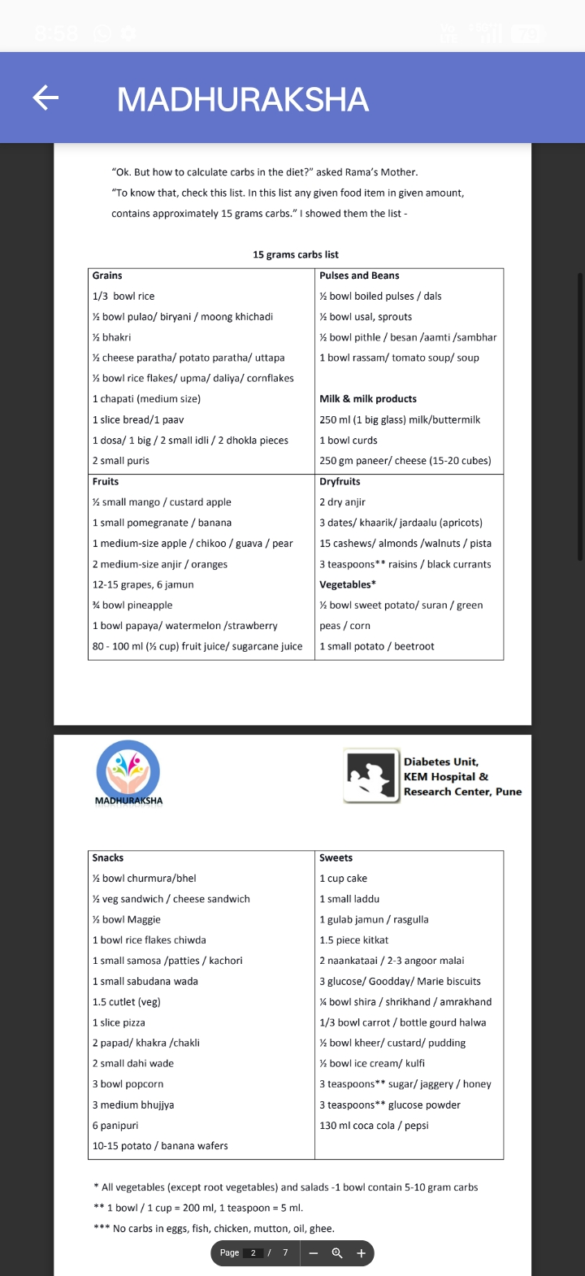

* All vegetables (except root vegetables) and salads -1 bowl contain 5-10 gram carbs

1 bowl/1 cup = 200 ml, 1 teaspoon = 5 ml.

*** No carbs in eggs, fish, chicken, mutton, oil, ghee.

Step-3 Fixing dose of insulin depending on food

"Now let's learn how to use this IC ratio. Rama, what do you generally eat at breakfast?" I asked.

"1 bowl poha or 1 bowl upma with 1 glass milk." Rama said.

"Ok. Now count the carbs from the list." Me.

"1 bowl rice flakes (poha) or upma contains 30-gram carbs and 1 glass milk contain 15 grams carb. That means total 45 grams carbs." Rama calculated.

"So, as per Rama's IC ratio, for 45-grams carbs, 45/20= 2 units would be sufficient."

"Now let's calculate her meal's insulin dose. What does she eat in her meals?" I asked her mother.

"In her school lunch box- 2 chapati, 1 bowl vegetable. In dinner- 1 chapati, 1 bowl rice, 1 bowl dal, and 1 bowl vegetable."

"As per list 1 chapati = 15, 1 bowl rice = 45, 1 bowl cooked pulse 30 and 1 bowl vegetable 10, total 100 grams carbs in dinner. For this 100/20-5 units insulin for dinner time insulin. In school for 2 chapati and vegetables (40 grams) 2 units insulin is sufficient."

"Still we give her 5 units insulin in lunch time. I think thats the reason her blood sugar goes low..." Rama's father realised.

"So...now you got it? If someday you do a slight change in your food, adjust insulin dose accordingly. For example, tonight Rama is going to have 2 homemade gulabjamun. To calculate the carbs, 2 gulabjamun means 30 carbs

(have a look in the list). For that Rama has to take 30/20-1.5 unit insulin extra (i.e. total 5 units for regular dinner +1.5 units for gulabjamun = total 6.5 units insulin). On the contrary, if someday Rama eats less, then do not force her, just reduce insulin dose after carb calculation."

"Now, I have started getting it..." said Rama's mother.

"This was all about bolus (meal) insulin. Just like this, you need to check pre-meal blood sugar level and adjust insulin dose as per that too. To calculate that there is another ratio called IS ratio." I added.

Step-4: How to find Insulin sensitivity ratio (IS ratio)

1500/TDD=1500/25=60, this is IS ratio - Insulin sensitivity ratio. This means if Rama takes 1-unit insulin, then 60 mg/dl. blood sugar will be lowered. When pre-meal blood sugar is high or low, then to control that, extra insulin dose (correction dose) needs to be taken. IS ratio is used for that. IS Ratio = 60.

Step-5: How to fix correction dose depending upon pre-meal blood sugar Let us assume that pre-meal blood sugar should be between 100-150 and calculate insulin dose considering 3 possibilities.

1. Premeal blood sugar is between 100-150.

5 units of insulin would be required as bolus insulin for her dinner. (no extra insuliln is required as sugar is in target range.)

2. Pre-meal blood sugar is high

If Rama's pre-dinner blood glucose is 330. As her target blood glucose is 150, her blood sugar is excess by 330-150-180 mg/dL. Now as per IS Ratio insulin required to lower down this extra blood glucose would be 180/60-3 unit more insulin. That means bolus insulin would be 5 (meal insulin) +3 (correction dose for excess sugar) = 8 units insulin.

3. Premeal blood sugar is low

If Rama's pre-dinner blood glucose is 60. As her target blood glucose is 150, her blood sugar is low by 150-60-90 mg/dL. Now as per the IS Ratio 90/60= 1.5 unit less insulin is required in this situation. That means bolus insulin would be 5 (meal insulin) -1.5 (correction dose for low sugar) = 3.5 units insulin.

"One important thing if you do any kind of change in a regular dose of insulin, check post-meal blood sugar after 3 hrs and find out if your correction dose was right." I said.

"Getting it?" - I asked them.

"Yes yes...with practice we will be able to do this!" Said Rama and her parents.

Now you find the insulin dose for the examples given below: -

1. Rama's premeal blood sugar is 270

Meal: 1 bhakri, 1 bowl pithla, 1 bowl rice

2. Madhav's regular bolus insulin dose- pre-breakfast 12, pre-lunch 10, pre-

dinner 8 and bedtime (basal) insulin is 20 units.

His pre-breakfast blood sugar is 120.

Breakfast: 2 dosa, 1 bowl sambar, 1 apple

3. Premeal blood sugar is low

If Rama's pre-dinner blood glucose is 60. As her target blood glucose is 150, her blood sugar is low by 150-60-90 mg/dL. Now as per the IS Ratio 90/60= 1.5 unit less insulin is required in this situation. That means bolus insulin would be 5 (meal insulin) -1.5 (correction dose for low sugar) = 3.5 units insulin.

"One important thing if you do any kind of change in a regular dose of insulin, check post-meal blood sugar after 3 hrs and find out if your correction dose was right." I said.

"Getting it?" - I asked them.

"Yes yes...with practice we will be able to do this!" Said Rama and her parents.

Now you find the insulin dose for the examples given below: -

1. Rama's premeal blood sugar is 270

Meal: 1 bhakri, 1 bowl pithla, 1 bowl rice

2. Madhav's regular bolus insulin dose- pre-breakfast 12, pre-lunch 10, pre-dinner 8 and bedtime (basal) insulin is 20 units.

His pre-breakfast blood sugar is 120.

Breakfast: 2 dosa, 1 bowl sambar, 1 apple

School tiffin for a child with T1D

For all mothers, the topic of a child's Tiffin is equally worrisome and close to heart! A mother must consider different and creative snacks/foods before packing school tiffin, according to the child's likes and dislikes. It should be tasty as well as nutritious. What shall be given so that the child will finish the tiffin happily and his/her overall growth would be adequate? Mothers are anyway worried about their child's school tiffin and on top of that if the child has type 1 diabetes then it can drive them crazy! In addition to all the above worries, comes who will give them insulin injections in school? and how will they decide the insulin dose? If they share a friend's tiffin, will their blood sugar increase? If they do not eat or finish their meal, hypo might happen?

For all uncertain situations without any confusion, let's get information about do's and don'ts.

Children with Type 1 diabetes must keep their blood sugar level between 100-200 mg/dL in school, it is crucial. In school, if the child's blood sugar increases (hyperglycemia) then they may show symptoms like frequent urination, excessive thirst, hunger, and tiredness or sleepiness. If a child's blood sugar decreases (hypoglycemia) then they may show symptoms like lack of concentration in the class, irritation, sweating, trembling, palpitations, glooming, dizziness, etc.

So it is important to provide the correct dose of prescribed insulin at the right time depending upon the child's school tiffin and his/her physical activities. Along with this, it is also important that the child must finish his/her school tiffin.

Some useful tips to prevent hyperglycemia / hypoglycaemia in school-

Make a weekly chart or timetable for food/snacks to be given each day in the school tiffin and maintain it well. Note the insulin dose as per timetable.

Keep food in a handy non-spilling box. Child will be able to eat the entire portion served and there will be no fear of hypo.

Children normally eat chapati and vegetable at home. So they might get bored with the same in their school tiffin. Maintain variety in the school tiffin. (Follow table)

Give them fresh, less processed food in the tiffin. Avoid packaged/
processed food.

Avoid excess sugar, jaggery, or salt in any food.

Common foods for school tiffin are chapatis, rice, rice flakes, idli. All these cause a spike in blood sugar. So, try to prepare these things with other grains or finely ate seasonally available ver etables and add to the recipes. There are few benefits of this, vegetables will lower glycemicindex of the dish, and an innovative look of the same food may attract the child. And they will eat happily. (Those children who do not eat vegetables, will not fuss about it as it's all grated!).

Involve your child in the making of school tiffin. Take them along to vegetable shopping. Give them small tasks like choosing their favourite vegetables, teach them washing and cutting. If you have available space on your terrace or balcony, make a small organic kitchen garden. All these activities may generate interest and they might eat these vegetables without being fussy.

Foods which increase blood sugar rapidly (all food made by grains, rarely given sweet products), give them at the time of insulin dose (big recess) or give it before playtime (follow table). Ensure that blood sugar levels are balanced before playtime in school. While on the ground, keep something in their pocket/school bag to have it in an emergency.

Food items by which blood sugar increase slowly (egg, cheese, oilseeds, salad, legume etc) give them when there is no insulin dose (short or mid recess) (follow table).

Get permission from the Principal of the school or the class teacher for your presence at the time of mid recess/before sports class when needed. It will help you to keep the track of child's blood sugar, you will be able to help in giving an insulin injection, can take care ofthe food. Submit a letter to the child's school from your Doctor.

Gradually you can teach all these to any of responsible school staff.

Children who go school walking/cycling (more than 20 mins), instruct them to keep with them and have if required something sweet while walking back. This will help prevent/treat hypoglycemia.
After taking all necessary precautions even if hypo happens, keep 15-gram glucose sachet, hypotabs, glucovita in the school bag. And share this information with classmates and schoolteacher.

Children spend most of their day time in school. Generally, school tiffin is not sufficient enough to keep them filled for longer as well as provide required nutrition. In some schools, there is a strict rule of carrying homemade chapati bhaji in school tiffin. But some schools don't follow any such rules. Children are allowed to carry packaged or processed food (like cake, biscuit, wafers, kurkure, maggie, pasta, chocolates). Seeing their classmates or friends having junk food, your child might insist the same, and as the mother of a diabetic kid it's difficult to make them understand and they get confused. These junk foods have no nutritional value. Such food increases blood sugar levels. Junk food tastes delicious, but you feel full for very short time. It puts a higher risk of obesity, depression, digestive issues, heart disease so, always choose healthy food.

Points to remember:

1. Let children enjoy school functions, friend's birthday parties and let them enjoy eating there. If you have prior information about it, adjust insulin dose accordingly, and if you do not know then check their blood sugar once they are back home. Give them the required correction dose (learn it from the Doctor).

2. Some schools provide meals (Mid meal in Govt. school). Gather complete information about what sort of meal they are going to provide to children. Depending upon that, adjust the insulin dose. If school is providing mid-day meals then no need to give school tiffin but make them carry small snack packets with, fruits, dryfruits, salad, boiled egg, etc.

3. In children it is normal to have the temptation for any specific food. If in school your child eats a friend's tiffin and his/her blood sugar increases, then do not scold him. Talk to them frankly about that, make them understand you wish well for them, and ask them to share information in the future.

4. If a child insists on anything, try not to outright deny that. Sometimes Surprise them by giving the desired food in their school tiffin. Check their blood sugar after that and make them understand the disadvantages of those cravings. Very politely convey to your child that their obstinacy will not be entertained every time. Your positive vision will help them maintain a healthy body.

A child with type 1 diabetes is still a child. Please remember that. Diabetes came later.
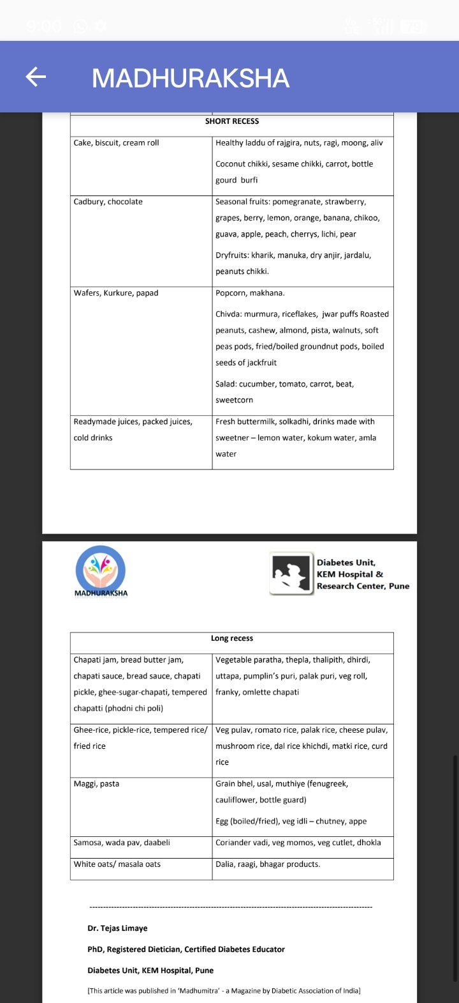



RECEPIE

1. Paneer Besan Chilla

Ingredients:

1 Cup Besan

½ tsp Salt

1 tsp Garlic paste

1 Onion, chopped

½ Cup Paneer, grated

1 Tomato

2 Green Chillies

½ tsp Ajwain

½ Cup Coriander Leaves

1 Cup Water

Oil

Preparation:

1. Take besan in a bowl, add salt, garlic paste, onion, grated paneer, tomato, green chillies, ajwain and coriander leaves.

2. Whisk all the ingredients together in the bowl along with water to make a mixture.

3. Add more water to make its consistency light.

4. Now take a pan, add some oil and put some amount of the besan mixture to pan spread it evenly over the tawa.

5. Roast till it turns solid, crispy and golden brown.

6. Pack in tiffin with chutney.

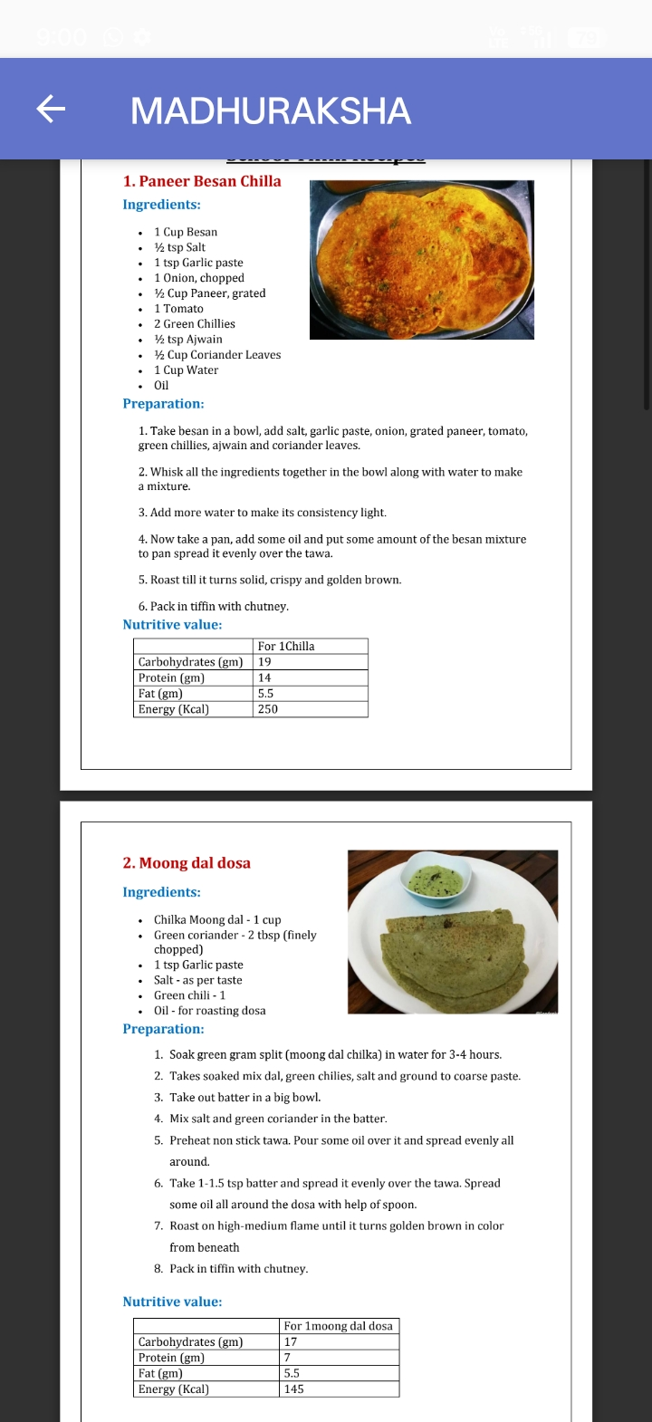2. Moong dal dosa

Ingredients:

Chilka Moong dal - 1 cup

Green coriander 2 tbsp (finely

chopped)

1 tsp Garlic paste

Salt as per taste

Green chili - 1

Oil-for roasting dosa

Preparation:

1. Soak green gram split (moong dal chilka) in water for 3-4 hours.

2. Takes soaked mix dal, green chilies, salt and ground to coarse paste.

3. Take out batter in a big bowl.

4. Mix salt and green coriander in the batter.

5. Preheat non stick tawa. Pour some oil over it and spread evenly all around.

6. Take 1-1.5 tsp batter and spread it evenly over the tawa. Spread some oil all around the dosa with help of spoon.

7. Roast on high-medium flame until it turns golden brown in color

from beneath

8. Pack in tiffin with chutney.

3. Mix Dal Appe

Ingredients:

1 cup urad dal

½ cup Chilka moong dal

¼ cup chana,

1 big onion chopped

1 grated carrot

½ cup chopped fresh coriander

2-3 green chillies

1 inch ginger

5-6 garlic pods (optional)

Salt to taste

Preparation:

1. Soak urad, chana&mug dal for 4-5 hours.

2. Takes soaked mix dal, green chillies,ginger,garlic, salt and ground to coarse paste.

3. Add chopped fresh coriander leaves, chopped onion&grated carrot and mix well.

4. Grease appe pan and pour batter with a spoon in each slot.

5. Cook it for 8-10 mins with lid covered. Reverse side upside down and drizzle drip oil and cook again for 5 mins.

6. Pack in tiffin with chutney or sauce
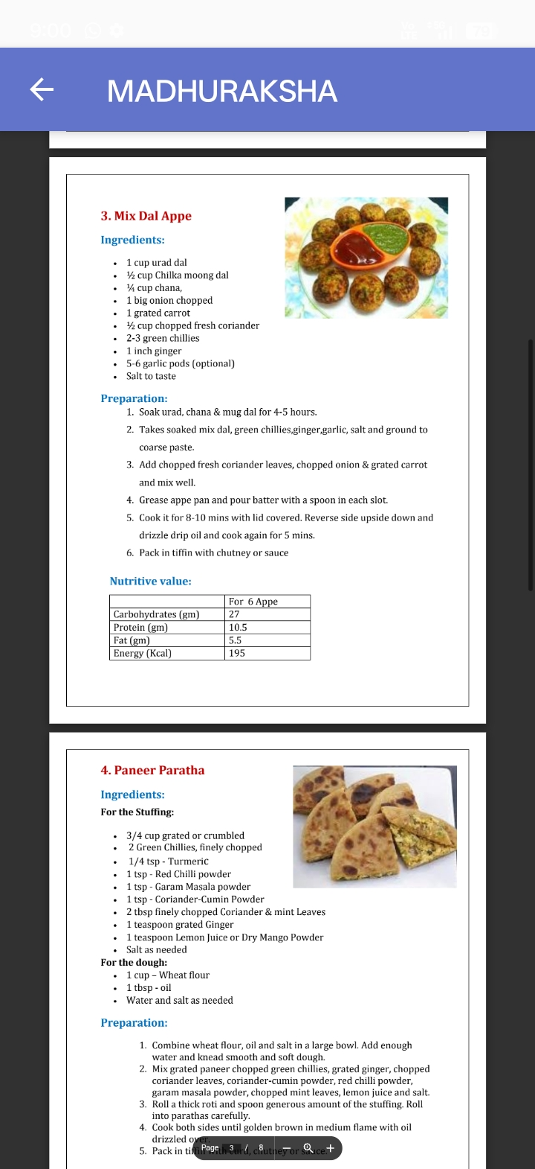
4. Paneer Paratha

Ingredients:

For the Stuffing:

3/4 cup grated or crumbled 2 Green Chillies, finely chopped

1/4 tsp Turmeric

1 tsp Red Chilli powder

1 tsp Garam Masala powder

1 tsp - Coriander-Cumin Powder

2 tbsp finely chopped Coriander&mint Leaves

1 teaspoon grated Ginger

1 teaspoon Lemon Juice or Dry Mango Powder

Salt as needed

For the dough:

1 cup Wheat flour

1 tbsp oil

Water and salt as needed

Preparation:

1. Combine wheat flour, oil and salt in a large bowl. Add enough water and knead smooth and soft dough.

2. Mix grated paneer chopped green chillies, grated ginger, chopped coriander leaves, coriander-cumin powder, red chilli powder, garam masala powder, chopped mint leaves, lemon juice and salt.

3. Roll a thick roti and spoon generous amount of the stuffing. Roll into parathas carefully.

4. Cook both sides until golden brown in medium flame with oil

drizzled ov
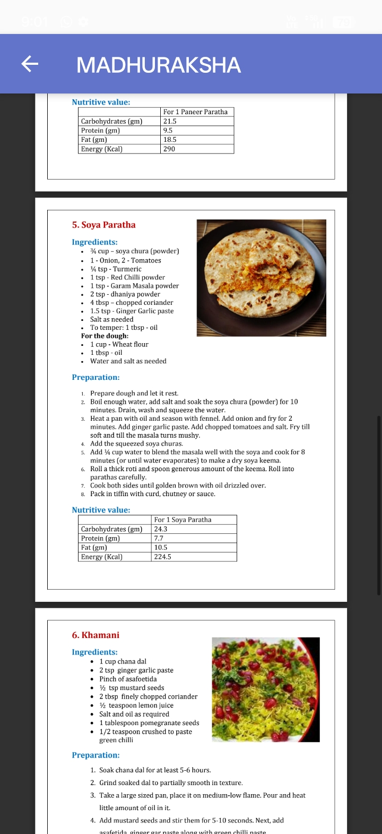
5. Soya Paratha

Ingredients:

¼ cup soya chura (powder)

1-Onion, 2-Tomatoes

¼ tsp - Turmeric

1 tsp Red Chilli powder

1 tsp Garam Masala powder

2 tsp - dhaniya powder

4 tbsp chopped coriander

1.5 tsp Ginger Garlic paste

Salt as needed

To temper: 1 tbsp - oil

For the dough:

1 cup - Wheat flour

1 tbsp - oil

Water and salt as needed

Preparation:

1. Prepare dough and let it rest.

2. Boil enough water, add salt and soak the soya chura (powder) for 10 minutes. Drain, wash and squeeze the water.

3. Heat a pan with oil and season with fennel. Add onion and fry for 2 minutes. Add ginger garlic paste. Add chopped tomatoes and salt. Fry till soft and till the masala turns mushy.

Add the squeezed soya churas.

5. Add ½ cup water to blend the masala well with the soya and cook for 8 minutes (or until water evaporates) to make a dry soya keema.

6. Roll a thick roti and spoon generous amount of the keema. Roll into parathas carefully.

8. Pack in tiffin with curd, chutney or sauce.

7. Cook both sides until golden brown with oil drizzled over.

6. Khamani

Ingredients:

1 cup chana dal

Pinch of asafoetida

2 tsp ginger garlic paste

½ tsp mustard seeds

2 tbsp finely chopped coriander

½ teaspoon lemon juice.

1 tablespoon pomegranate seeds 1/2 teaspoon crushed to paste

Salt and oil as required

green chilli

1. Soak chana dal for at least 5-6 hours.

Preparation:

2. Grind soaked dal to partially smooth in texture.

3. Take a large sized pan, place it on medium-low flame. Pour and heat little amount of oil in it.

4. Add mustard seeds and stir them for 5-10 seconds. Next, add asafetida ginger gar naste along with green chilli naste

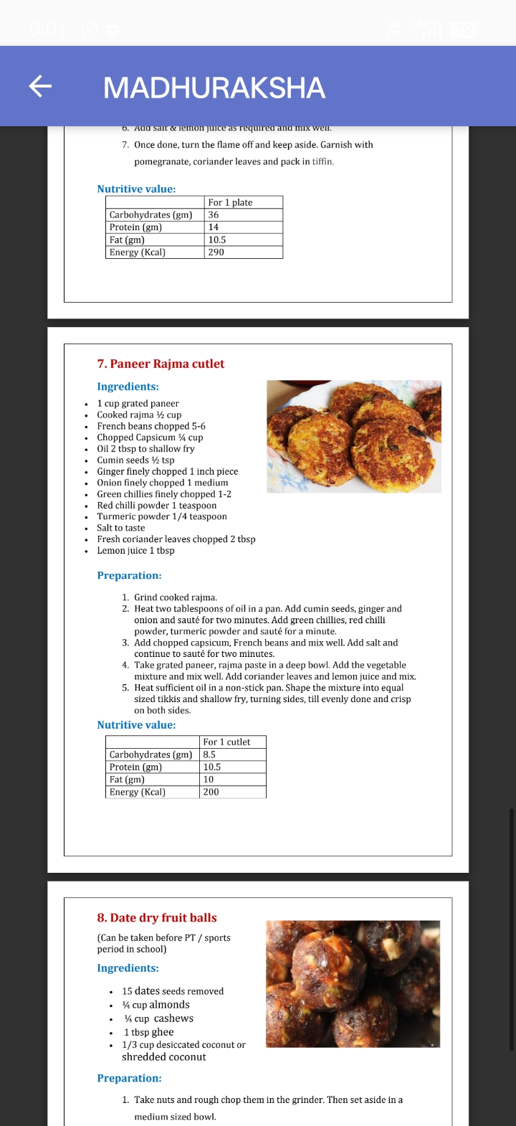

7. Paneer Rajma cutlet

Ingredients:

1 cup grated paneer

Cooked rajma ½ cup

French beans chopped 5-6

Chopped Capsicum ¼ cup

Oil 2 tbsp to shallow fry

Cumin seeds ½ tsp

Ginger finely chopped 1 inch piece

Onion finely chopped 1 medium

Green chillies finely chopped 1-2

Red chilli powder 1 teaspoon.

Turmeric powder 1/4 teaspoon

Salt to taste

Fresh coriander leaves chopped 2 tbsp

Lemon juice 1 tbsp

Preparation:

1. Grind cooked rajma.

2. Heat two tablespoons of oil in a pan. Add cumin seeds, ginger and onion and sauté for two minutes. Add green chillies, red chilli powder, turmeric powder and sauté for a minute.

3. Add chopped capsicum, French beans and mix well. Add salt and continue to sauté for two minutes.

4. Take grated paneer, rajma paste in a deep bowl. Add the vegetable mixture and mix well. Add coriander leaves and lemon juice and mix.

5. Heat sufficient oil in a non-stick pan. Shape the mixture into equal sized tikkis and shallow fry, turning sides, till evenly done and crisp on both sides.
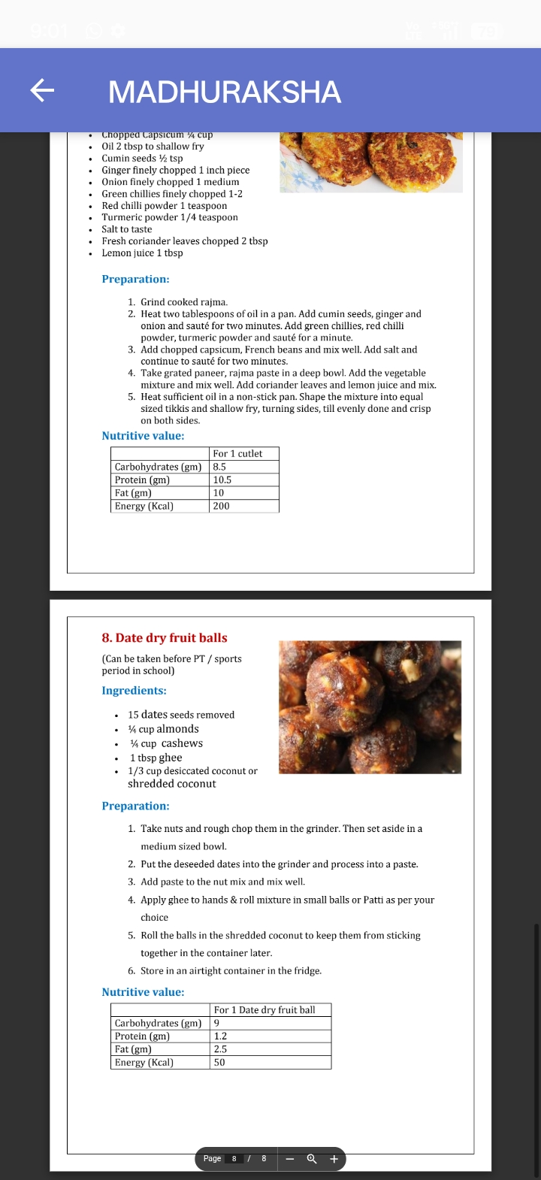
8. Date dry fruit balls

(Can be taken before PT/sports period in school)

Ingredients:

15 dates seeds removed

¼ cup almonds

¼ cup cashews

1 tbsp ghee

1/3 cup desiccated coconut or shredded coconut

Preparation:

1. Take nuts and rough chop them in the grinder. Then set aside in a medium sized bowl.

2. Put the deseeded dates into the grinder and process into a paste.

3. Add paste to the nut mix and mix well.

4. Apply ghee to hands&roll mixture in small balls or Patti as per your choice

5. Roll the balls in the shredded coconut to keep them from sticking together in the container later.

6. Store in an airtight container in the fridge.


Diabetes and Milk in the diet

There is a lot of discussion on the role of milk in the diet of diabetes patients. There are several messages about milk floating on all social networks like WhatsApp etc. Rather than solving the issue, they spread misconceptions on the topic. Let us understand in this article if there is any relation between milk and diabetes and what do recent studies have to say about it.

Milk components and their uses

Cow's milk contains 85% water, 4.6% sugar (lactose), 3.7% fats, 2.8% protein, 0.5% mineral and 3.4% other components. Many people consider milk as complete food by itself. There is some base for that. The protein of milk is of high quality. Components like vitamin D and calcium in milk are essential for health. Milk is the only source to provide vitamin B12 in vegetarians.

Milk and Blood sugar

Glycemic index of milk and milk products is medium (around 40). It means after milk consumption, the increase of sugar in the blood is moderate. Along with this, it is also seen that calcium and vitamin D from milk protect from diabetes and help in controlling blood sugar. Considering these facts, the American Diabetes Association has suggested having 2 to 3 servings of low fat milk or milk products in a day.

Harmful components of milk

Sometimes, milk is considered a cause of diabetes and heart disease because of its components like fat, cholesterol, and absence of fibers in it.

"Cow's milk should only be used by their calf. How coherent is it that humans consume cow's milk?" There are supports for these kinds of arguments.

Components like Insulin growth factor (IGF-1), Bovine serum albumin (BSA) in milk are said to be the reason behind Type 1 diabetes. This is also seen in some studies that the earlier a child starts consuming cow's milk, the higher are the chances of type 1 diabetes. Furthermore, hormones that are used to increase milk production and pesticide in fodder are seen as residues in milk which may have a dangerous impact on our health.

A1 and A2 milk:

There is a lot of discussion going on about protein, one of the main components of milk. Let us see in short.

There are 2 types of proteins available in milk-casein (80%) and whey (20%). Depending upon casein's type milk is divided into 2 types. A1 milk and A2 milk. These types are based on the heredity in the cow.
A1 milk-Foreign breed cow (No hump on back) Jersey, Holsten Frigiun, Red Danish, and those cows who bread with these cows are A1 milk producers.

A2 milk-Indian breed cows (hump on back) Jhebu, Geer, Ongol, Hallikar, Siri, Red Sindhi, Sahiwal cow's milk is A2 type. Goat, sheep, and buffalo's milk are also A2 milk.
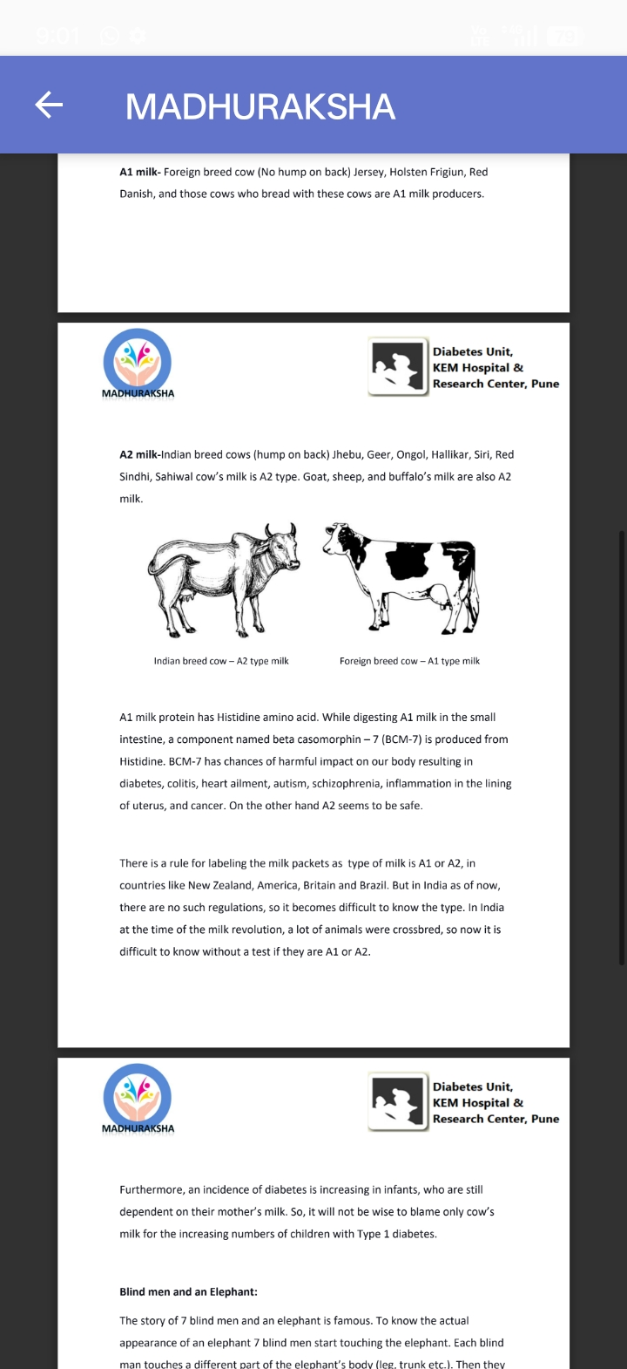

Indian breed cow-A2 type milk

Foreign breed cow-A1 type milk

A1 milk protein has Histidine amino acid. While digesting A1 milk in the small Intestine, a component named beta casomorphin-7 (BCM-7) is produced from Histidine. BCM-7 has chances of harmful impact on our body resulting in diabetes, colitis, heart ailment, autism, schizophrenia, inflammation in the lining of uterus, and cancer. On the other hand A2 seems to be safe.

There is a rule for labeling the milk packets as type of milk is A1 or A2, in countries like New Zealand, America, Britain and Brazil. But in India as of now, there are no such regulations, so it becomes difficult to know the type. In India at the time of the milk revolution, a lot of animals were crossbred, so now it is difficult to know without a test if they are A1 or A2.

Furthermore, an incidence of diabetes is increasing in infants, who are still dependent on their mother's milk. So, it will not be wise to blame only cow's milk for the increasing numbers of children with Type 1 diabetes.

Blind men and an Elephant:

The story of 7 blind men and an elephant is famous. To know the actual appearance of an elephant 7 blind men start touching the elephant. Each blind man touches a different part of the elephant's body (leg, trunk etc.). Then they The story of 7 blind men and an elephant is famous. To know the actual appearance of an elephant 7 blind men start touching the elephant. Each blind man touches a different part of the elephant's body (leg, trunk etc.). Then they described the elephant based on their limited exposure and experience (like pole or rope etc.) The same has happened to diabetes too. Some blame milk's component as the cause of diabetes, some blame climate-change while some blame germs. But as in the elephant's story, each description is partially correct but entirely different from the actual form of the elephant, same as we must be seeing in diabetes! Not enough studies have been carried out to prove who is right or wrong. We are hopeful for new and robust studies in the future.

What is the solution - Should we drink milk or not?

Presently, we do not have any conclusive results to tell you what to do.

Following points may help you to decide

1. Verify A1 and A2 animals and choose A2 animals for breeding. Check for type of milk (A1/A2) labeling on packets. This is going to take some time as effort is needed at so many levels for this.

MADHURAKSHA

Diabetes Unit, KEM Hospital&Research Center, Pune

2. If possible, cow's milk should not be included in the infant's diet for the initial six months.

3. Use an alternative to cow's milk like goat, sheep, buffalo's milk, soya's milk, coconut milk, almond milk, etc. But like cow's milk, these kinds of milk also have advantages and disadvantages. Consult your Doctor or dietician before using anything.

Before commenting anything on the advantage and disadvantage of milk one fundamental rule needs to be followed - Excess of anything is always bad!

Dr. Tejas Limaye

PhD, Registered Dietician, Certified Diabetes Educator

Diabetes Unit, KEM Hospital, Pune

[This article was published in 'Madhumitra' a Magazine by Diabetic Association of India)

Fruits and Diabetes

So many people cut down their fruit consumption, the moment they get diagnosed with diabetes. The reason behind this, they think their blood sugar will increase if they eat fruits. Some Dieticians and Doctors also suggest not to consume fruits like banana, mango, chikku, custard apple, pineapple, grapes. All fruits indeed have natural sugar in them. But is it healthy for those with diabetes not to have fruits at all? And if they wish to have fruits, then which fruit should they choose, in what quantity, at what time? Let's find some answers to such questions with scientific explanations.

Should people with diabetes eat fruits? Why?

As we need the energy for daily activities, the same goes for the body's internal mechanism. Our body needs nutrients for the smooth functioning of muscles, to destroy harmful byproducts formed during bodily functions, and to improve body's immune system. Fruits are the principal source of vitamins, antioxidants. and phytochemicals. Along with these nutrients, fruits contain fibers which help with digestion. Additionally, fibers make you feel full, so you do not overeat, and blood sugar spike can be prevented.

There is a difference between sugar available in fruits (fructose) and table sugar (sucrose). Due to fructose, blood sugar increases slowly compared to sucrose. Most of the fruits' glycemic index (speed of increase in blood sugar) falls into the low to medium category.

It has been seen that nutrients available in fruits protect us from heart attacks, diabetes, cancer, and many other diseases. Studies and research have been done on fruits and their role in diabetes. In China, a study conducted on 5 lac individuals for 7 years showed that there are fewer chances of diabetes in people who eat fruits regularly. And in patients with diabetes, it has been seen that complications of diabetes and death rates are low, if fruits are eaten regularly. According to one of the renowned research centers of America, Nurse's Health Study, it has been seen that people who eat 3 bowl fruits in a week, chances of getting diabetes are less, and for people who drink fruit juices on regular basis, chances of diabetes are high.

To summarize, it is wise to include fruits in your diet for healthy people to prevent diabetes, diabetes patients to prevent complications of diabetes, and to have the benefit of nutrients in fruits. When we crave for sweets, why not pick a natural sweet like fruits?

Which fruit to eat?

Each fruit has different sugar content. Strawberry, amla, guava, orange, sweetlime, watermelon, melon contain less sugar (per 100 grams of fruit). Whereas banana, custa comparison to fresh little high sugar. In Q + and fewer vitamins.
How much fruit to consume?

It is said that daily 5 bowls of fruits and vegetables will keep you healthy and help you in prevention from different diseases. According to this it's not a bad option to have 2 small fruits daily. To control your blood sugar level, include fewer 'high sugar fruits' and more 'low sugar fruits'.

How many fruits to be eaten at a time?

Let us see according to size and type of fruits.

Small size fresh seasonal fruit: 12-15 cherries, 10-12 grapes, 7-8 strawberries, 7-8 ber, 2 plums, 2 kiwis, 2 fresh anjeer.

Medium size fresh seasonal fruits: 1 apple/1 orange /1 pear/1 banana/2-3 slice of mango/half custard apple

Big size fresh seasonal fruits: papaya, watermelon, melon (1 slice of 5 cm width), 2 thin slices of pineapple.

Dryfruits: 1 tablespoon manuka/3-4 jardaalu/ 2-3 piece of dry anjir.

Distribute all fruits to be eaten in a day at regular intervals. Avoid eating to too much and too many fruits at a time.

In which form the fruits to be consumed?

>Prefer fresh and seasonal fruits.

>Eat fruits with skin wherever possible.

>Fruits to be eaten with skin should be cleaned and washed thoroughly.

To wash insecticides, harmful pesticides from fruits follow the instruction for washing.

1. Put 2 teaspoons (10 grams) baking soda in 1-liter water and soak fruits for 10 minutes in that. Then wash thoroughly again with tap water.

2. Put 4 teaspoons (20 grams) salt in 1 liter of water and dip fruits for 15-20 min in that. Then wash again with clean water.

3. Put 3 tablespoon (50ml) vinegar in 1-liter water and soak fruits in that for 10-15 mins. Then wash again with clean water.

Do not eat over ripped fruits, rather eat just enough ripped fruits (guava, pear, banana, anjir, custard apple, papaya)

Do not eat the pulp, jam, squash of fruits.

Do not put salt on fruits.

Protein product with fruits minimizes the speed of sugar increases in blood and you feel full for a longer time. For example-smoothie of curd and fruit, slices or cubes of fruits in curd, a cheese cube with fruit.

Mix some fruits in a salad. For example-pomegranate/orange pieces

in a salad, pineapple/apple slices in cucumber salad.

Avoid fruit juices.

Why should we avoid fruit juices?

In the form of juice, only sugar and water go into the body. The fibre portion of
fruit is discarded as a residual of the juice making process. That's why blood sugar level increases very fast after consuming juice. Fruit juice with the label of 'sugar-free/No added sugar' also has sugar (fructose) in it. In packaged juices, nutrients are less, and preservatives are more. When you drink fruit juice, you feel hungry after some time only but if you eat fruit, this can be avoided. At the time of hypoglycemia if you do not have glucose/sugar, have half a cup of fruit juice.

What is a good time to eat fruit?

Some people have a habit of eating fruit with a meal and some people have a habit of eating fruit after a meal. Some people eat fruits before bed at night. After dinner carbs already reached your body so having fruits (carbs) will increase your blood sugar more. So, by reducing any of the carbs (rice, chapati, bhakri) from your meal you can eat fruit. The ideal is to have fruit before exercise or before going to play.

Glucometer-your friend!

Best way to know the amount of blood sugar increased by a particular fruits is to check blood sugar on a glucometer after 2 hrs of having a fruit. With this, you will immediately come to know which fruit is increasing your blood glucose. You can do the same after having any other sweet products. So, by checking blood sugar on a glucometer you will find the difference of increased blood sugar between fruit and any other sugar products. With this, you, yourself will end up giving due importance to fruits!

Avoid too much of fruits

Some people eat fruits a lot, especially in the name of fasting or detox diet. Considering the more use of insecticides/pesticides, lowering of the nutrient value of fruits and with the genetic change in fruits their increased sugar value, these all may harm your body with excess use of fruits. It has been seen that excess consumption of fruits may cause pancreatic cancer (we all know about Steve Jobs). This is also Page 15 due to Extes&of trut's sugar (fructose), fat(triglyceride) of body increases which may cause an increase in insulin resistance (insulin's action decreases and blood sugar slowly increases).

Should fruit consumption be stopped?

Nowadays a lot of diabetes patients are going for a low carb diet/ keto diet for weight loss or better blood sugar control. In these types of diets either fruit consumption is entirely stopped, or a very small amount is being consumed. If one ensures that nutrients from fruits are supplemented by other vegetables, then it's reasonable to reduce intake of fruits in the diet plan. As for Vitamin C (which is not naturally produced in the human body) it is advisable to consume citrus fruits like orange, or lemon. Before embarking on any kind of diet, do consult your Doctor and Dietician!

Dr. Tejas Limaye

PhD, Registered Dietician, Certified Diabetes Educator

Diabetes Unit, KEM Hospital, Pune

[This article was published in 'Madhumitra'a Magazine by Diabetic Association of India]

Celiac Disease - Management, Gluten free diet

"Doctor tastes our biscuit please" - Shubham offered his biscuit box to doctor. "Doctor this biscuit is homemade by me. It is from ragi&Jowar." Shubham's mother informed the doctor very proudly. Shubham was diagnosed with celiac disease (CD) 6-7 months ago. In his diabetes diary there were few incidences of hypos, growth of height and weight was noted and most important there was a glow on his face. Credit to this goes to his mother!

At the time of CD diagnosis, Shubham's mother had become disturbed on learning that wheat cannot be given in any form. In a joint family in a small village, it was impossible to imagine food without wheat. Shubham's mother was anxious, thinking now he will not be able to eat simple biscuits also. After regular discussion with the diabetes team and dietician, Shubham's mother got all her question answered, and she accepted the challenge of CD and started its management.

Celiac Disease management

As of today, after diagnosis of CD, wheat-free diet is the only treatment. In our diet, Rye is not present, but barley may be there in the name of malt. In all these grains Gluten is present, so these grains should be avoided in diet. Specific characterization of this disease is that, after stopping gluten in diet, within a few months itself improvement in the intestine is seen and mostly all children return. to the normal state. But another side of this is, even if 1/8 th of a spoon of Gluten is found in diet then again inflammation in the intestine will happen and symptoms will reappear.

In daily routine diet avoiding Gluten is difficult. In India still, it is not mandatory to mention gluten quantity on packed food material or if it is gluten-free. None of the restaurants know about gluten-free food and family feels helpless once out of their home.

In developed countries, condition is not that bad but still, the absence of wheat is still felt. Available Gluten-free food in the market is costly. One more thing food meant to be of wheat does not taste as good without it! So, it is not necessary that the child will like it..

More studies and research are going on about different management of CD.

1. One research is being done on species ofwheat in which gluten or protein would be changed.

2. tTG enzyme breaks down Gluten. These broken-down components of gluten are more dangerous. So, medicine which will work against the enzymes is being researched.

3. As per one of the research, it has been seen that due to leak in the inner layer of small intestine gluten comes into the blood and form antibody. To close that leak, medicine is used on an experimental basis and to some extent, it is successful.

4. Prolyl endopeptidase is an enzyme formed from Bacteria which

completely break Verza gluten oll net challenge the immune system.

A lot of research as above and at the different levels are going on but still, a gluten-free diet is the only treatment or medicine for this disease. In addition to this, child should be given supplements to avoid nutritional deficiencies as per doctor's guideline.

Among all famous quotes of Hippocrates, one is apt for CD- "Let food be thy medicine and medicine be thy food."

Gluten free diet

CD patients should not only know what food to be avoided in their diet. They must know what food to be included, in their diet. Follow the table on the last page of the chapter..

If a proper diet is not provided, these children can face malnutrition and deficiencies of iron, calcium, magnesium, and Vitamin B. To avoid this, consult your nutritionist and plant your diet as per guideline. Timely follow up is important. In every follow-up visit check if the growth of height and weight is in adequate, there is no digestion problem and depending upon that make necessary changes in diet.

It is a big challenge to prepare gluten-free food at home and making sure that not a small amount of gluten is going into child food. If possible, the whole family should stop eating wheat and wheat products in support of the child.

It will boost their morale and they will not feel different and alone. And children will happily accept Gluten-free food.

In India, there are a lot of Gluten-free grains available. Flours of rice, sorghum (jowar), bajra, soya bean, rajgira, corn, varai (bhagar), ragi (nachani) can be used as an alternative to wheat flour. Biscuit, Cake can be made by above flours. In those children who have type 1 diabetes along with CD, blood glucose can increase with the use of jowar/rice. In that condition, multigrain flour can be prepared using the above grains. In the combination of above grains, vegetables, fruits, dry fruits, milk, milk products, eggs, meat, fish should be included. Inclusion of all these food in your diet will not only increase the nutritional value of food, but blood sugar will also remain in control.

To avoid contamination

1. Bring a separate flour machine/mill (chakki) in your home to make different grain flours. In the outside flour mill, there may be a chance of wheat flour to be mixed (contamination).

2. Use separate utensils for preparation of gluten-free foods. Do not mix them at any cost. A small amount of wheat can be problematic for you. In short, make a 'Gluten-free kitchen' in your home.

3. Outside food (hotel, party etc) is tempting for the child. In that condition eating packed food (read the label) is the only trustworthy thing.

Check the label of packed food material very carefully. Check every time.

1. If the gluten-free label is there on the pack (wheat-free labelled food will be gluten-free it is not necessary)

2. Search the ingredient list and find if any of below component is there -wheat/barley/rye/malt/Brewer's yeast/oats. Actually, oat is gluten-free but due to contamination very small amount of gluten can be found. If on the packet of oats 'gluten-free' is written, then it's okay..

In fact, different cosmetics (lipstick, moisturiser), toothpaste and some medicines may also contain Gluten. If it goes in the stomach it may cause a problem so be careful and read all the information very carefully. Consult your doctor before taking any medicine. If in any product you are not sure about the components or it is not written on their package or in any kind of doubt, just avoid it.

Nowadays in malls, on online marketing web portals like Amazon, gluten-free products are available. Gather information about them. At some places Gluten-free restaurant or gluten-free menu is available. An app like Zomato can give information about that. For gluten-free recipes visit following sites, share your experience, and participate.

Celiac Disease Foundation -https://celiac.org

Celiac Support Organization - https://celiacsupportorganisation.com

Celiac Disease Support Group- https://www.beyondceliac.org

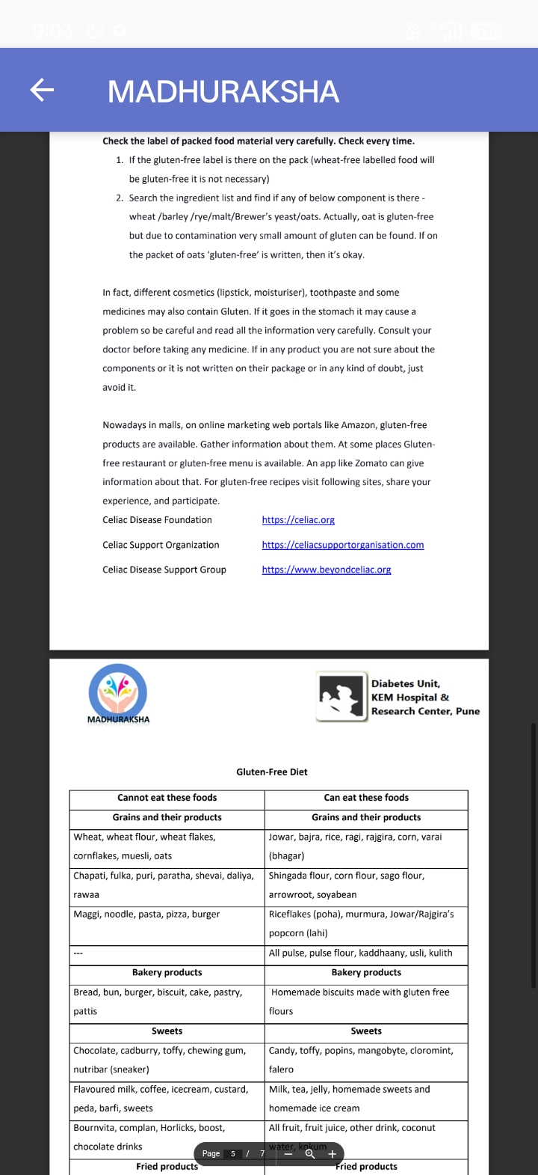
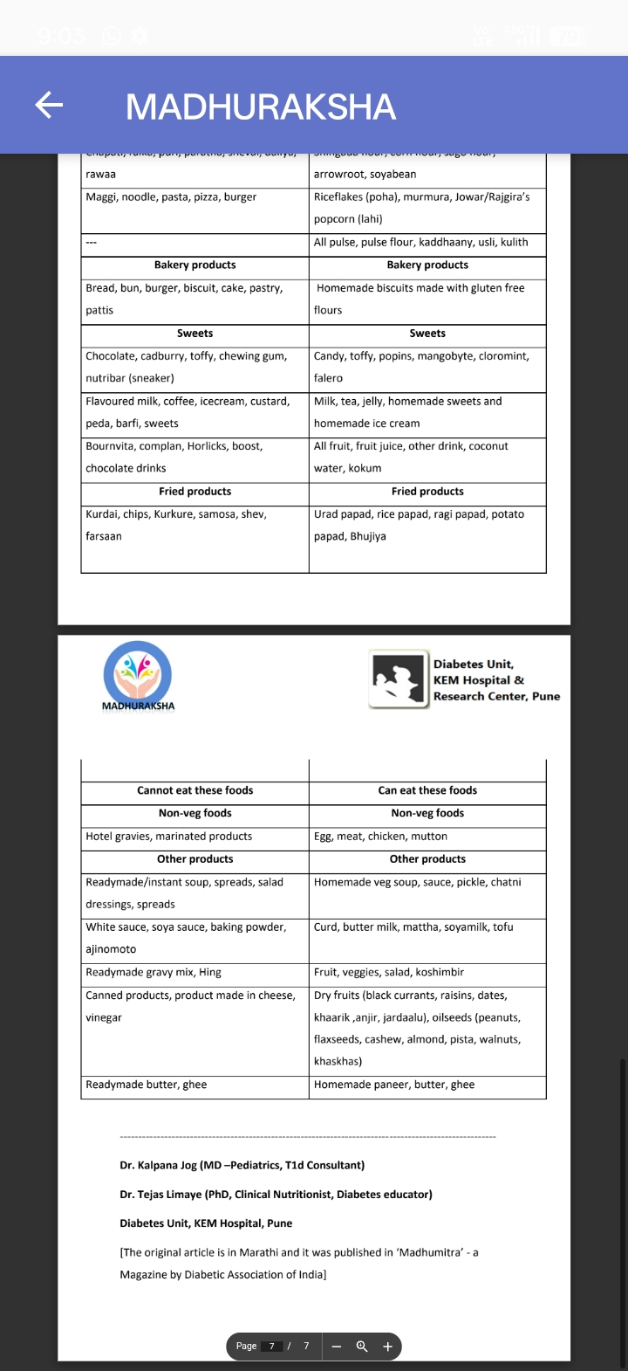



QUIZ
Q. Can a person with diabetes drink Nira?

Ans. Nira will cause tremendous sugar spikes. It can be taken in small quantities when in hypo.

Q. Can diabetics have kodo millet?

Ans. Diabetics can have anything -including millets.

Q. Can home made laddoos and chivda be eaten?

Ans.

They should be eaten in small quantities, preferably accompanied by a larger healthy meal. Carbs should be counted and dosed for accordingly if they are had.

Q. Can sugar free be used? If yes, how Often?

Ans. Sugarfree / artificial sweeteners can be used to replace sugar in the diet. Prefer sweeteners containing sucralose / stevia. The long term risks of regularly using artificial sweeteners are not known; they are being studied. It is therefore better to use them occasionally and not on daily basis especially for kids.Fruit purees or dates can be used instead of artificial sweetner.

Q. Can we have whey protein after work out?

Ans. If you do not meet your protein macros, you could. Better consult a nutritionist and not gym instructor!

Q. Does jamun lower blood glucose?

Ans. The only thing that lowers BG is insulin. Jamun may not cause a sudden spike in BG like certain other carb rich foods.

Q. Does milk cause T1D?

Ans. The association of T1d and milk protein is not all that straight forward. Milk protein mimics the body protein and can trigger autoimmunity in a genetically susceptible individual. There are various hypothesis for explaining T1 in kids but nothing has been proven.

Q. How many dates to eat in hypo?

Ans. Differs from person to person. Small kids may need just one or two. Adults may need 3-4. One date contains 5-6 grams of carbs

Q. How to curb or deal with hunger or snacking?

Ans. Protein rich snacks/foods such as nuts, cheese etc are options. Avoid refined carbs and processed junk foods

Q. Is jaggery better than sugar?

Ans.

While jaggery may be less processed than sugar, both these items are fast acting carbs and should be used sparingly and their carbs should be counted and adequate insulin taken if they are used with normal blood sugars.
Q. What can be taken as pre excercise snack?

Ans. Date Almonds laddus, Moong daal laddus with nuts, fruits, Pineapple and cheese, The key is to use protein and carbs together!

Q. What can we drink instead of cold drinks in the summer

Ans. Jaljeera, buttermilk, salted lime juice or lime soda

Q. What is IC Ratio?

Ans. IC Ratio is insulin to carbohydrate ratio. It tells you how many carbs are covered with one unit of insulin. For example, an IC ratio of 1:15 means that every 15 gms of carbs need 1 unit of insulin.

Q. Which protein powder is good and safe for kids?
Ans.

Kids do not need protein powder unless they are not able to take enough proteins through diet. The proteins for any growing child must be from the diet. Discuss with your pediatrician and dietician before consuming any protein powders.

Q. Do the ayurvedic neem jamun and karela drinks work for tid just like they work for t2d?

Ans. No. Actually there is no scientific evidence supporting the usefulness of these foods in type 2 diabetes also. Rather various studies from prestigious institutes have concluded that bitter gourd can not be recommendated as insulin replacement or as a glucose lowering
drug. In type 1 diabetes, there is absolute insulin deficiency. So here is no replacement for daily
insulin injections. Such foods won't help. These foods are healthy, have low glycemic index like any other vegetables. So there is no harm in ncluding these foods in diet (only if
the person is willing to have these foods! Not mandatory).

