Tyler Hubbell
Professor McHann
CS 255 - System Design Document
12/11/2025

UML Diagrams

UML Use Case Diagram
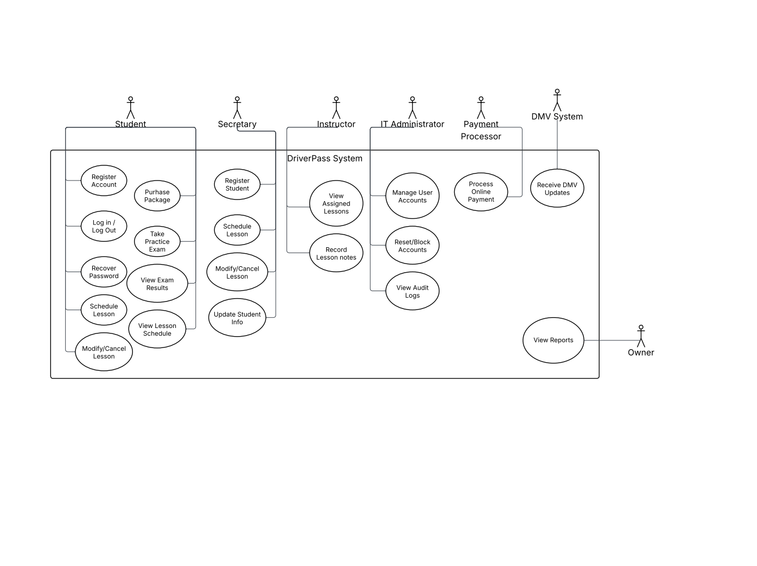

The UML use case diagram illustrates the primary interactions between users and the DriverPass system. In this, it identifies key actors, including students, instructors, administrative staff, and external systems such as the payment processor and DMV system. The diagram shows how users interact with core system functions, including registering accounts, scheduling driving lessons, taking practice exams, processing payments, and managing user information. This high-level view of system functionality ensures that all client requirements identified in the business requirements document are supported.
UML Activity Diagrams
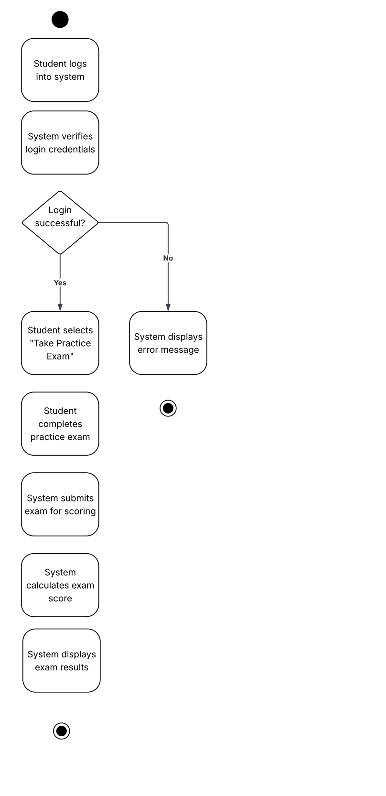
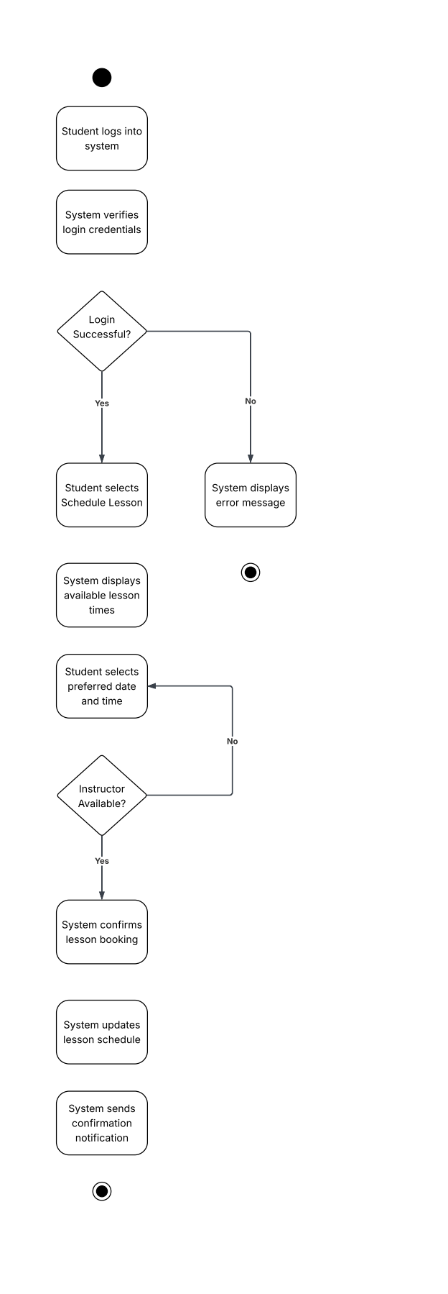
The UML activity diagrams illustrate the step-by-step workflows for two key DriverPass system functions: scheduling a driving lesson and taking a practice exam. Each diagram shows the sequence of actions performed by the student and the system, including decision points such as login validation and instructor availability. These diagrams help demonstrate how the system processes user actions, handles alternate outcomes and ensure that business requirements are met through clear and structured workflows.

UML Sequence Diagram
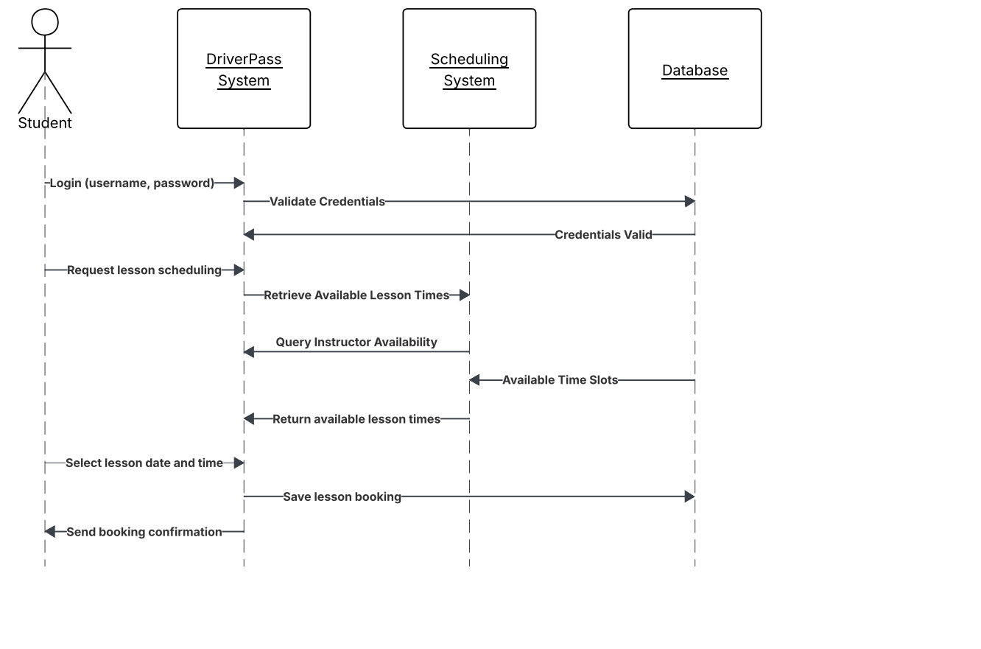

The UML sequence diagram illustrates the interactions between the student, DriverPass system, scheduling system, and database during the lesson scheduling process. It shows the order in which messages are exchanged to authenticate the user, retrieve available lesson times, confirm instructor availability, and save the lesson booking. This diagram provides a clear view of system communication and data flow for a core DriverPass operation.

UML Class Diagram
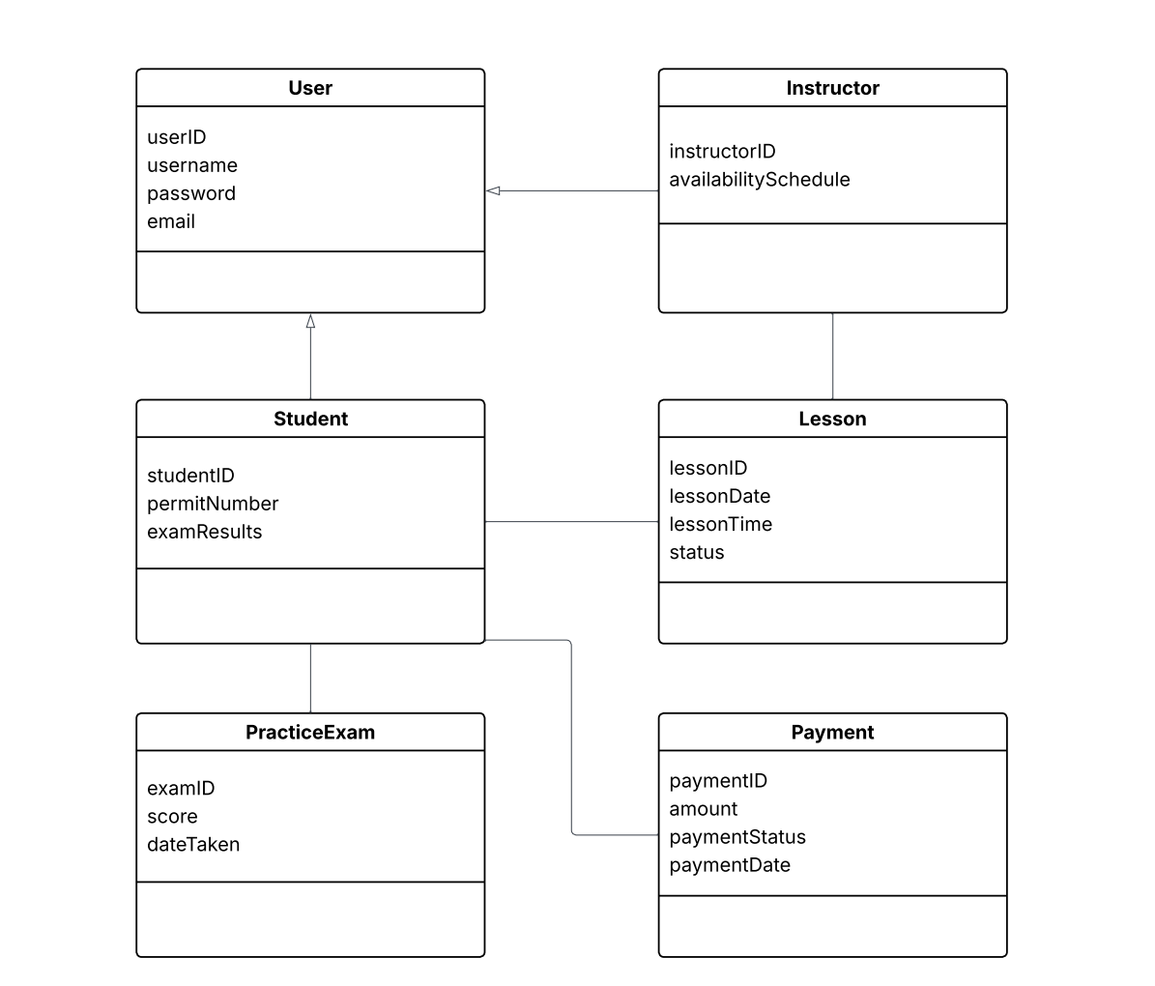
The UML class diagram represents the structural design of the DriverPass system by identifying the main classes and their attributes. It illustrates how users, students, instructors, lessons, practice exams, and payments are organized and related within the system. This diagram provides a clear view of how system data is structured and supports the functional behavior shown in the use case, activity, and sequence diagrams.

Technical Requirements
This section describes the technical requirements necessary to support the proposed DriverPass system. These requirements are based on the functional and nonfunctional needs identified in the Business Requirements Document. These are intended to guide system implementation. The technical requirements are organized into hardware, software, tools and technologies, and infrastructure considerations.

Hardware Requirements
The DriverPass system is designed to operate as a web-based application, minimizing specialized hardware requirements for end users. Students, instructors, and administrative staff will need access to a modern computing device such as a desktop, laptop, or tablet capable of running a standard web browser. Devices should support basic input peripherals, including a keyboard, mouse or touchscreen functionality to allow users to navigate the system, schedule lessons, and complete practice exams.
On the server side, the system requires reliable computing hardware capable of supporting multiple concurrent users. Server hardware should include sufficient processing power, memory, and storage to handle user authentication, lesson scheduling requests, exam data processing, and database transactions. While exact specifications may vary based on system scale, the hardware must support consistent uptime and responsive performance as the user base grows.

Software Requirements
The DriverPass system requires a modern operating system environment capable of hosting a web application and database services. Server-side software may include a commonly used operating system such as Windows Server or a Linux-based distribution. The application itself should be developed using web-compatible technologies that support secure user authentication, data validation, and session management. End users will access the system through widely supported web browsers such as Google Chrome, Mozilla Firefox, Microsoft Edge, or Safari. No additional client-side software installations are required, which improves accessibility and ease of use. Database management software is also required to securely store user accounts, lesson schedules, practice exam results, and payment records. The selected database solution must support structured data storage, query processing, and data integrity enforcement.

Tools and Technologies
Several development and modeling tools are required to support the design and implementation of the DriverPass system. UML modeling tools, such as Lucidchart, are used during the design phase to create use case, activity, sequence, and class diagrams. These diagrams provide a visual representation of system behavior and structure, ensuring alignment between business requirements and technical design. Development tools may include an integrated development environment to support coding, debugging, and testing activities. Version control systems are also recommended to manage source code changes and support collaboration among developers. Testing tools should be used to validate system functionality, including user authentication, lesson scheduling workflows, and practice exam scoring, to ensure the system operates as intended.

Infrastructure Requirements
The DriverPass system requires a reliable network infrastructure to support online access for users and secure communication between system components. Hosting the application on a cloud-based or dedicated server environment allows the system to scale based on demand and ensures high availability. Network security measures, such as firewalls and secure communication protocols, are necessary to protect sensitive user data. The infrastructure must also support regular data backups and recovery processes to prevent data loss. Secure connections using encryption should be implemented to protect user credentials, payment information, and exam results. As system usage increases, the infrastructure should allow for performance monitoring and resource expansion to maintain system responsiveness and reliability.

