

Practices for Secure Software Report

Table of Contents
Document Revision History 3
Client 3
Instructions 3
Developer 4
1. Algorithm Cipher 4
2. Certificate Generation 4
3. Deploy Cipher 4
4. Secure Communications 4
5. Secondary Testing 4
6. Functional Testing 4
7. Summary 4
8. Industry Standard Best Practices 4

Document Revision History

Version | Date | Author | Comments
1.0 | 06/19/2026 | Tyler Hubbell | Finalized documentation and security testing results

Client



Developer
Tyler Hubbell

Algorithm Cipher

For this project, I implemented the SHA-256 hashing algorithm to create a checksum verification system. SHA-256 generates a fixed 256-bit hash value regardless of the size of the original input. Unlike encryption algorithms that are designed to hide data and later decrypt it, SHA-256 is a one-way cryptographic hash function used for integrity verification. Even the smallest change to the original data produces a completely different hash value, making it useful for detecting tampering. SHA-256 is also part of the SHA-2 family of hashing algorithms and remains widely used across financial systems, digital signatures, and software verification. It’s used in secure communications because of its strong resistance to collisions and data manipulation. The main reason SHA-256 was selected for Artemis Financial is because this project required checksum verification to help ensure that transmitted data maintains its integrity and has not been altered during communication.

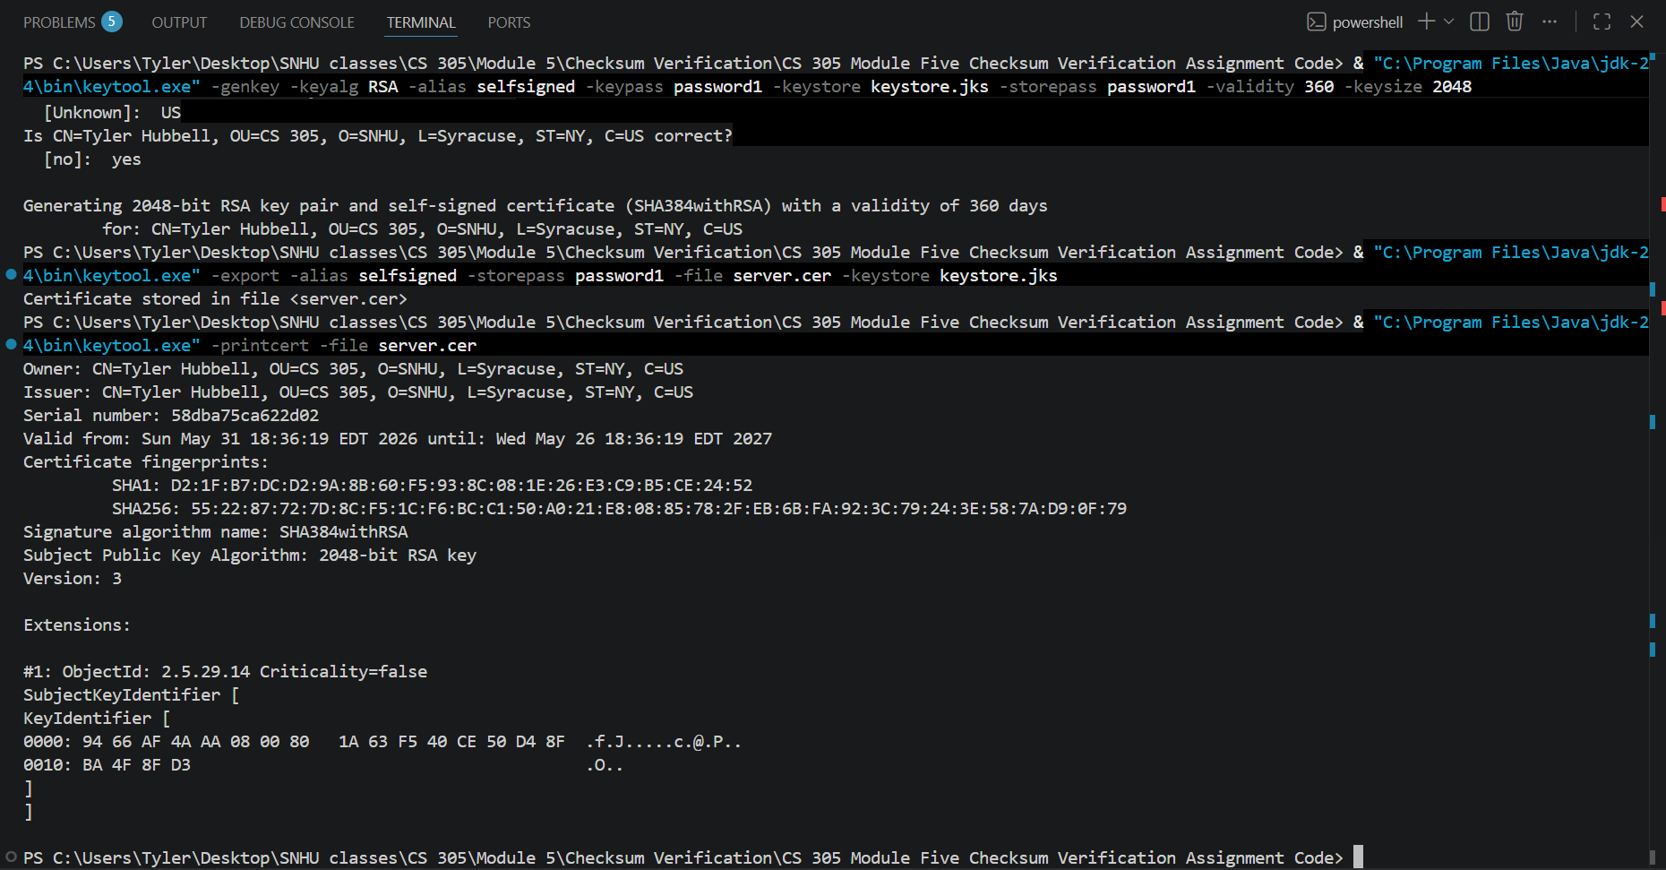
Certificate Generation

Figure 1.0: Self-Signed SSL Certificate Generated and Verified Using Keytool

The screenshot above shows the generation and validation of a self-signed SSL certificate using the Java Keytool utility. A 2048-bit RSA key pair was created and exported to a CER file, which was then verified to confirm the certificate details, validity period, fingerprint information, and public key configuration. This certificate was later used to enable HTTPS communication within the Spring Boot application. The certificate provides the foundation for SSL/TLS encryption by allowing the server to establish a secure connection and protect data transmitted between the client and server.

Deploy Cipher
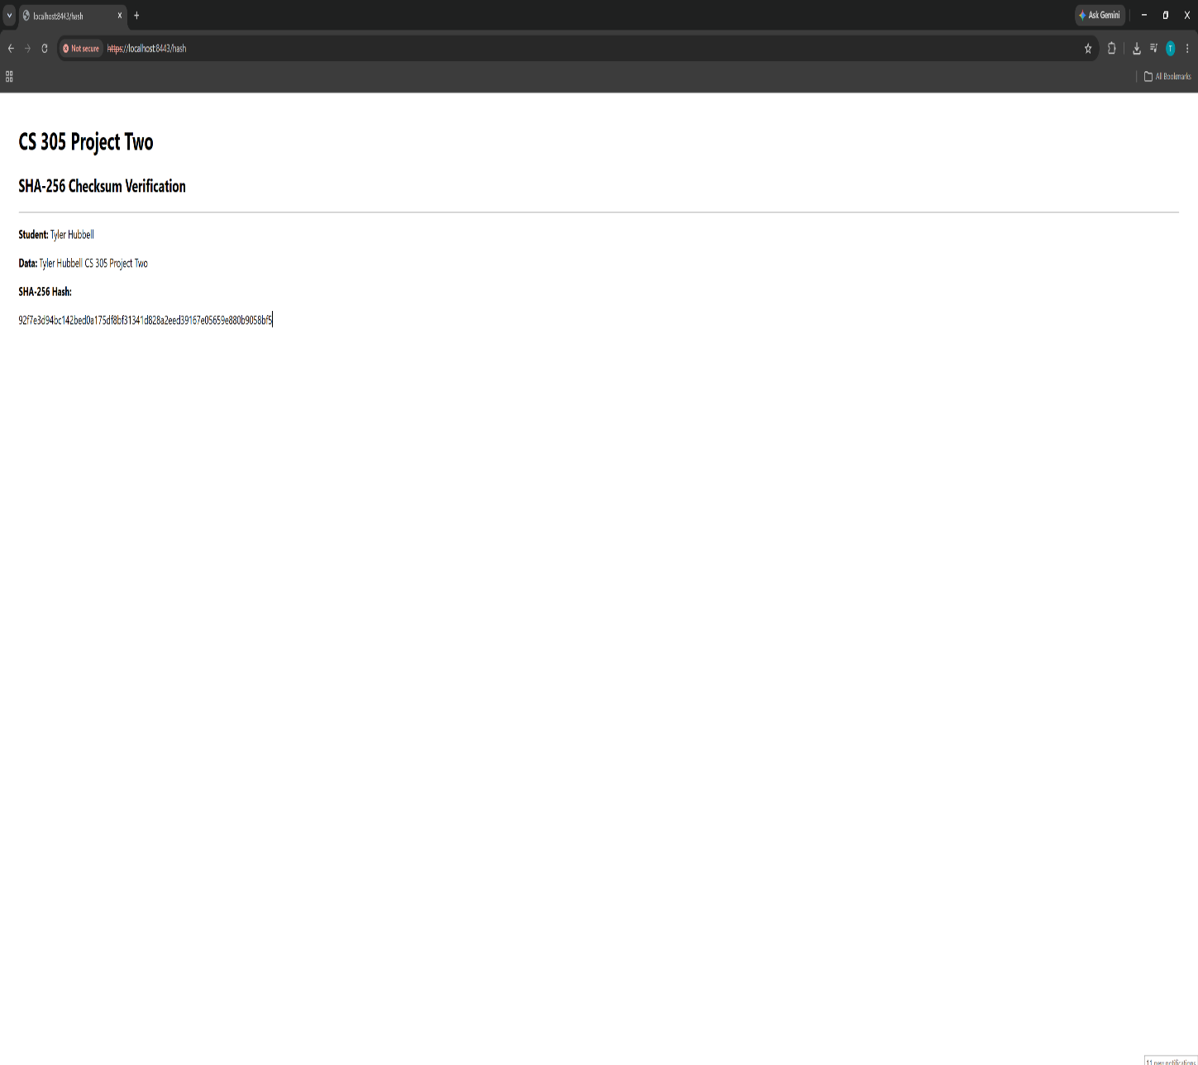

Figure 1.1: SHA-256 Checksum Verification Application

The figure above shows the deployed SHA-256 checksum verification application running successfully in the web browser. The application displays the student (Tyler Hubbell), project data, and generated SHA-256 hash value, demonstrating that the checksum functionality was implemented and deployed correctly. The checksum was generated using Java's MessageDigest class and SHA-256 hashing algorithm. By comparing generated hash values, users can verify that the original data has not been modified, providing a method for validating data integrity during communication and processing.

Secure Communications
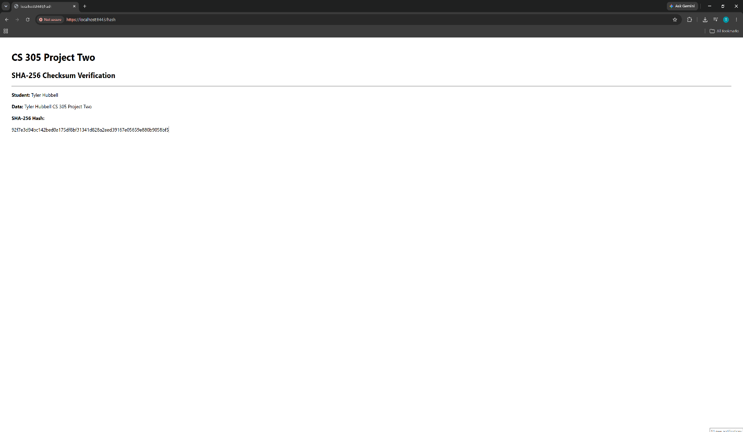

Figure 1.2: SHA-256 Checksum Verification Application

Figure 1.2 shows the application being accessed through HTTPS on port 8443 after SSL/TLS was configured in Spring Boot. The application uses the self-signed certificate that was generated earlier in the project to encrypt communication between the client and server. However, the browser does display a "Not Secure" warning because the certificate is self-signed and not issued by a trusted certificate authority. For a financial organization such as Artemis Financial, an Extended Validation (EV) certificate issued by a trusted Certificate Authority may be worth the additional cost because it can help strengthen customer confidence and demonstrate a greater level of trustworthiness. The connection is still using HTTPS and encrypted communication. This demonstrates that secure communications were successfully implemented and tested within the application. These security enhancements directly address the client/server security concerns identified during the initial vulnerability assessment by protecting sensitive financial information while it is transmitted across a network.

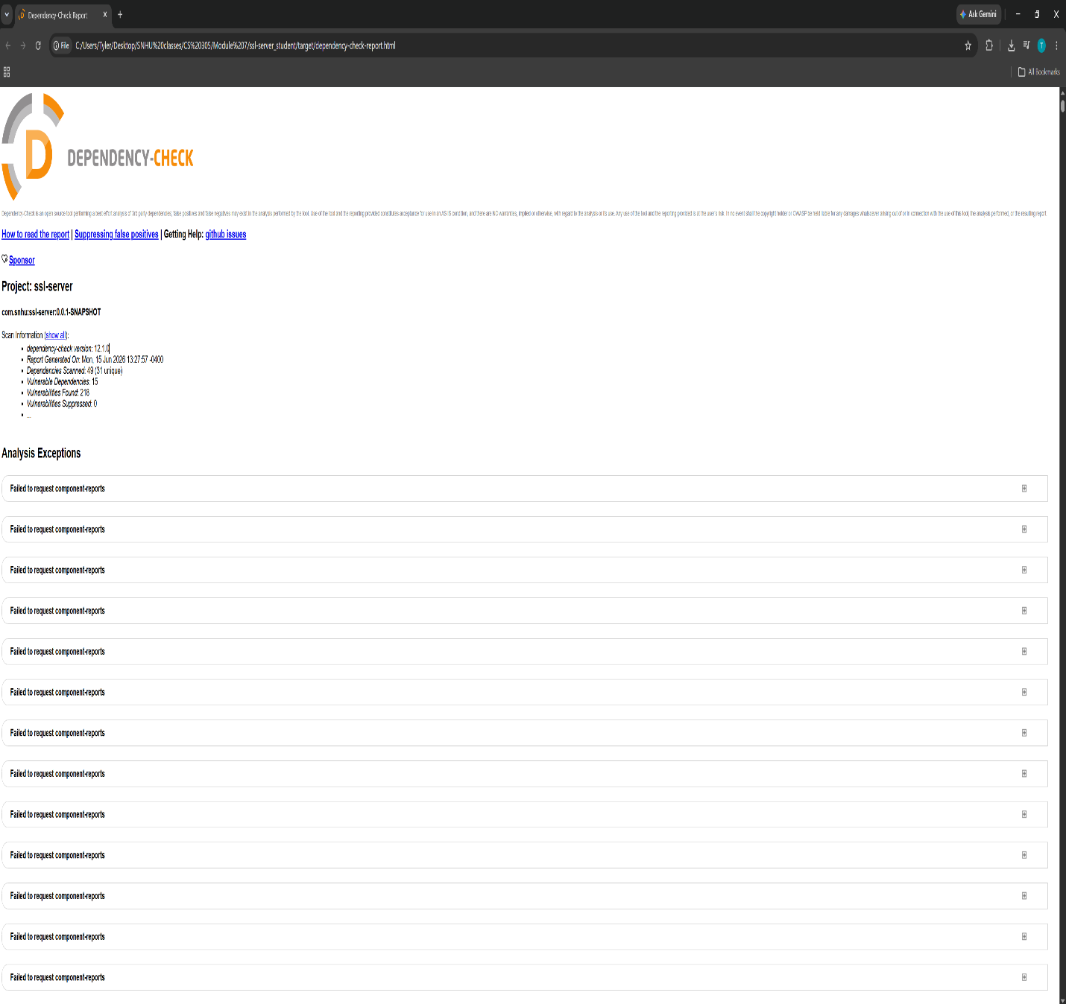
Secondary Testing

Figure 1.3: OWASP Dependency-Check report generated after security testing

Figure 1.3 above shows the OWASP Dependency-Check report that was generated after refactoring the application. I ran the scan after implementing the SHA-256 checksum functionality and HTTPS configuration to make sure the security changes did not create any new issues within the application. The report also helped identify vulnerabilities in several third-party dependencies being used by the project. Running dependency scans like this is useful because many security problems can come from external libraries rather than the code written by the developer.
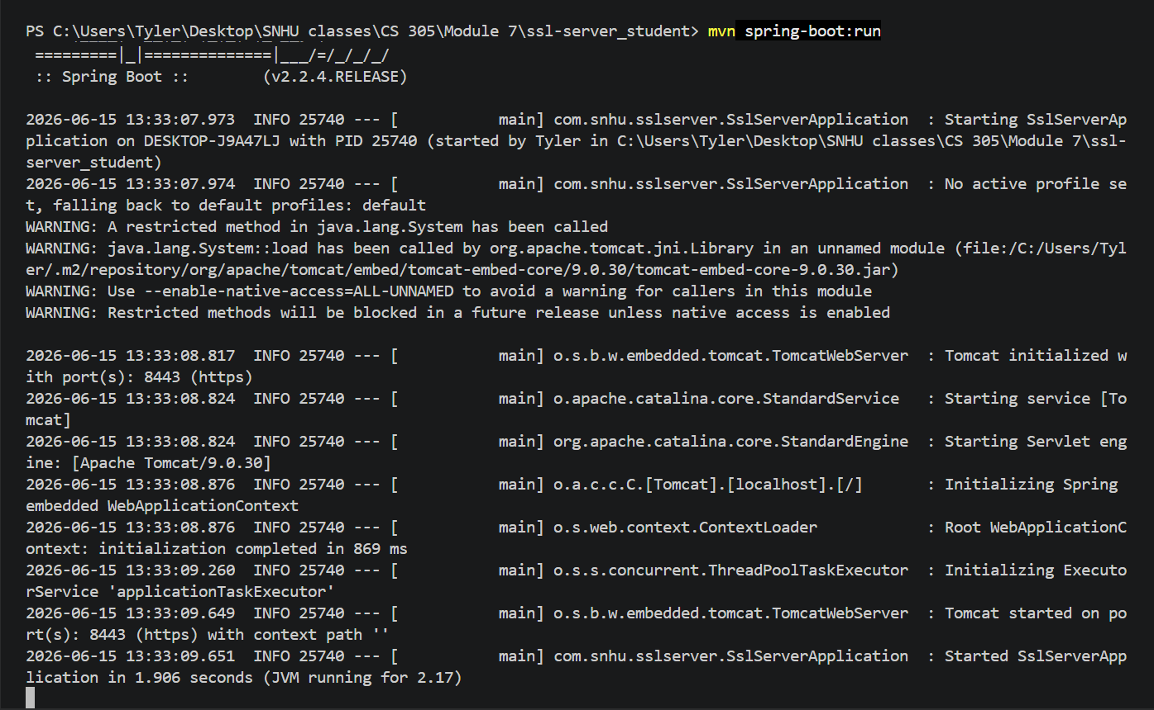
Figure 1.4: Refactored Spring Boot application executing successfully on HTTPS port 8443

Figure 1.4 shows the refactored Spring Boot application running successfully after the security enhancements were implemented. The application started without errors and initialized Tomcat on HTTPS port 8443. This verified that the SHA-256 checksum functionality and SSL/TLS configuration were implemented correctly and that the application remained fully operational after the refactored code changes.

For secondary testing, I ran the OWASP Dependency-Check against the refactored Maven project. In this, the scan reviewed the project dependencies and generated a dependency-check report. The report identified known vulnerabilities in several third-party dependencies, including Spring Boot, Tomcat, Jackson, and SnakeYAML. These findings were consistent with vulnerabilities identified during the earlier assessment of the application and confirmed that the newly implemented SHA-256 checksum functionality and HTTPS configuration did not introduce additional security concerns. I also double-checked to verify that the refactored application executed successfully without startup errors after adding the SHA-256 checksum endpoint and HTTPS configuration.

Functional Testing


Figure 1.5: Refactored Spring Boot application executing successfully on HTTPS port 8443

Figure 1.5 shows the successful execution of the refactored Spring Boot application after all security enhancements were implemented. During functional testing, the application started successfully without errors and initialized Tomcat on HTTPS port 8443. The SHA-256 checksum endpoint was tested to verify that checksum values were generated correctly, and HTTPS communication was confirmed through the browser using the configured SSL certificate. In addition to verifying application functionality, the code was reviewed to ensure that the newly implemented hashing and secure communication features operated as intended and did not introduce syntax errors, logic errors, or additional security concerns. This confirmed that the SHA-256 checksum functionality, HTTPS configuration, and overall application behavior remained operational after refactoring the code.

Summary

For this project, I refactored a Spring Boot application to incorporate several security improvements. First, I implemented the SHA-256 hashing algorithm to generate checksum values that can be used to verify data integrity. Next, I generated and configured a self-signed SSL certificate using Java Keytool and updated the application to use HTTPS communication on port 8443. This ensured that data transmitted between the client and server was encrypted using SSL/TLS. To evaluate the security of the application, I performed dependency analysis using OWASP Dependency-Check. This process helped identify known vulnerabilities within third-party libraries and reinforced the importance of regularly reviewing software dependencies. After completing the security enhancements and testing procedures, the application successfully executed without errors and maintained all intended functionality.

These improvements directly addressed several areas identified during the initial vulnerability assessment, including cryptography, client/server security, and dependency management. Through implementing checksum verification, HTTPS communication, SSL/TLS certificates, and dependency analysis, additional layers of security were added to help protect data integrity, secure information in transit, and identify known vulnerabilities within third-party components. Together, these improvements strengthened the overall security posture of the application while maintaining its intended functionality. Overall, this project provided hands-on experience with cryptographic hashing, certificate management, secure communications, dependency analysis, and secure software development practices. It reinforced the importance of incorporating security throughout the software development lifecycle rather than treating it as a separate step after development is complete.

Industry Standard Best Practices

Throughout this project, I followed several industry-standard security practices. HTTPS was used to encrypt communication between the client and server to help protect sensitive information while it is transmitted across a network. SHA-256 was implemented to verify data integrity and ensure that information was not modified unexpectedly. A digital certificate was generated and configured to support secure communications through SSL/TLS encryption. In addition to these, OWASP Dependency-Check was used to analyze project dependencies for known vulnerabilities and identify security risks within third-party libraries.

These practices help maintain the security of the application by protecting data in transit, verifying data integrity, and supporting ongoing vulnerability management. By applying these industry-standard security practices I believe it provides significant value to organizations such as Artemis Financial because it helps reduce the risk of data breaches, protects sensitive customer information, supports customer trust, and promotes the development of secure and reliable software systems.

