Nicolas Huber: 2506144

Question 1:

Task1:

Answer: We can see that the message “Nicolas” is successfully sent form the sender to the receiver:

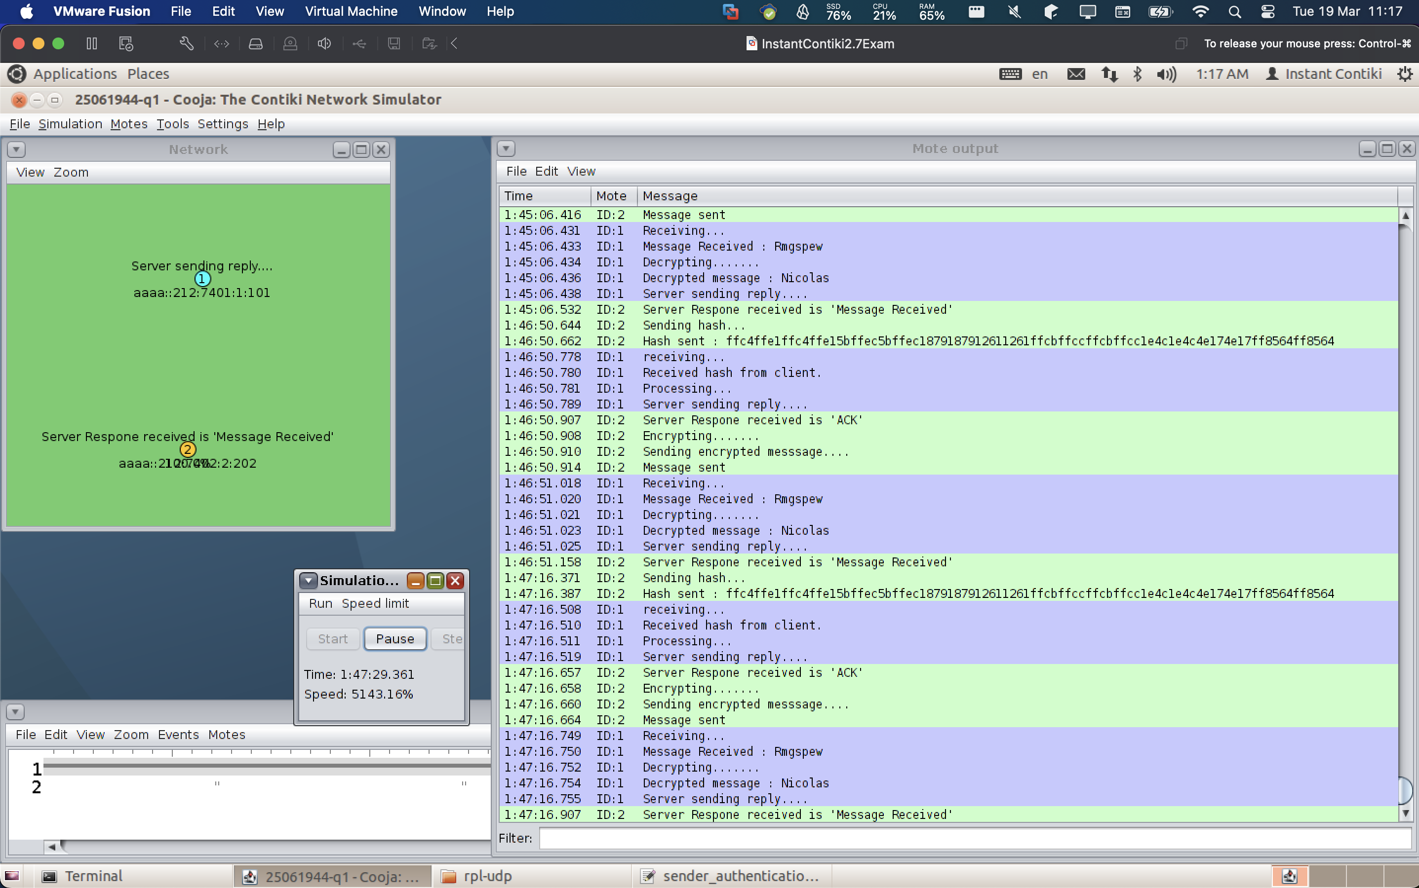

Task2:

Answer:
- Showing the hash value sent by the client 1:47:16:387
- Showing the encrypted message received by the server 1:47:16:750
- Showing the message decrypted by the server 1:47:16:752
- Showing the original message sent by the client 1:47:16:754
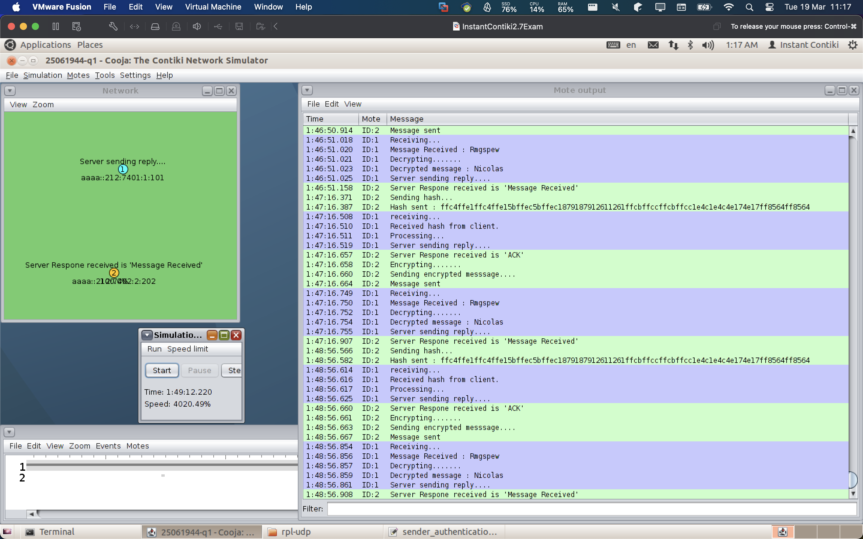

Task3:

Answer: We can see that the client identity is changed successfully and both sender and reciever have adapted the code.

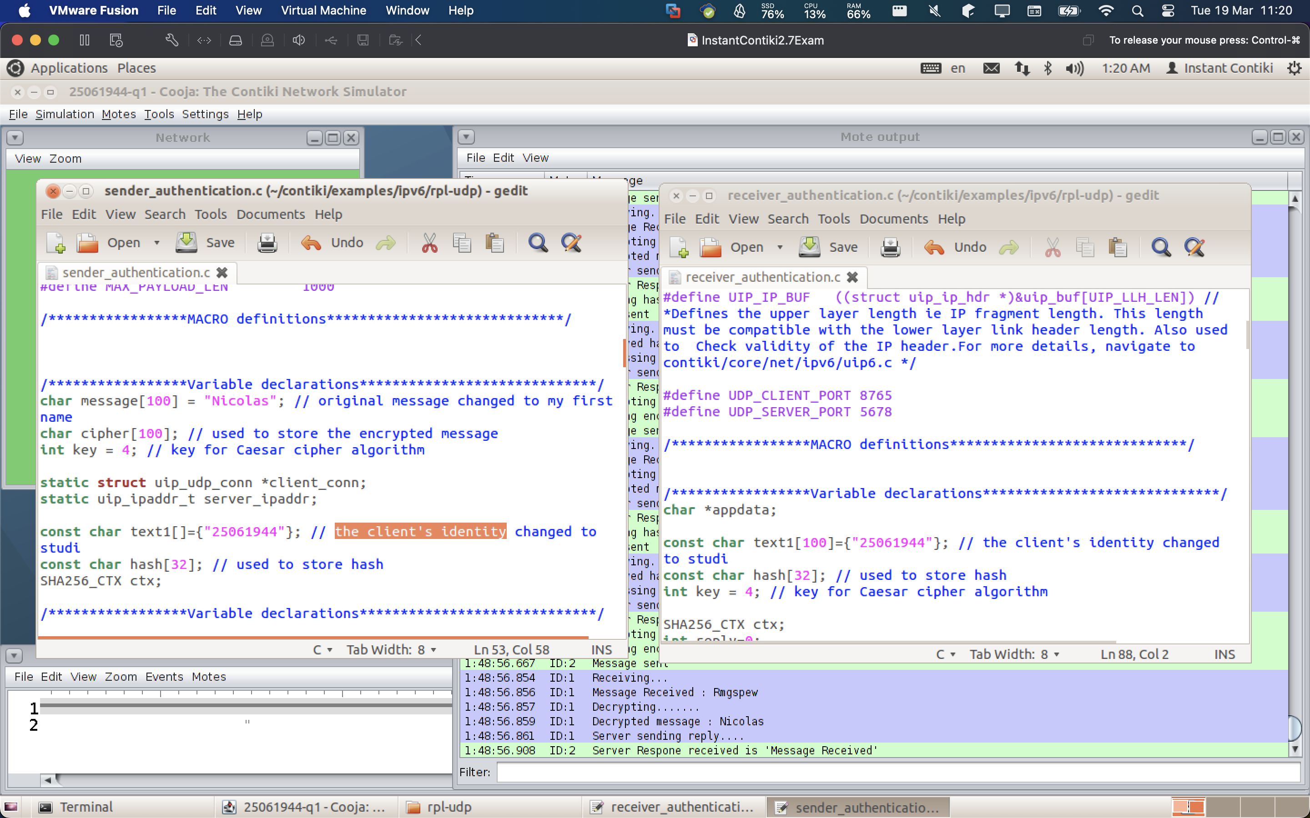

Task4:

Answer: we can see the encrypt function of the sender on the left, and we can see the decrypt function of the receiver (server) on the right.

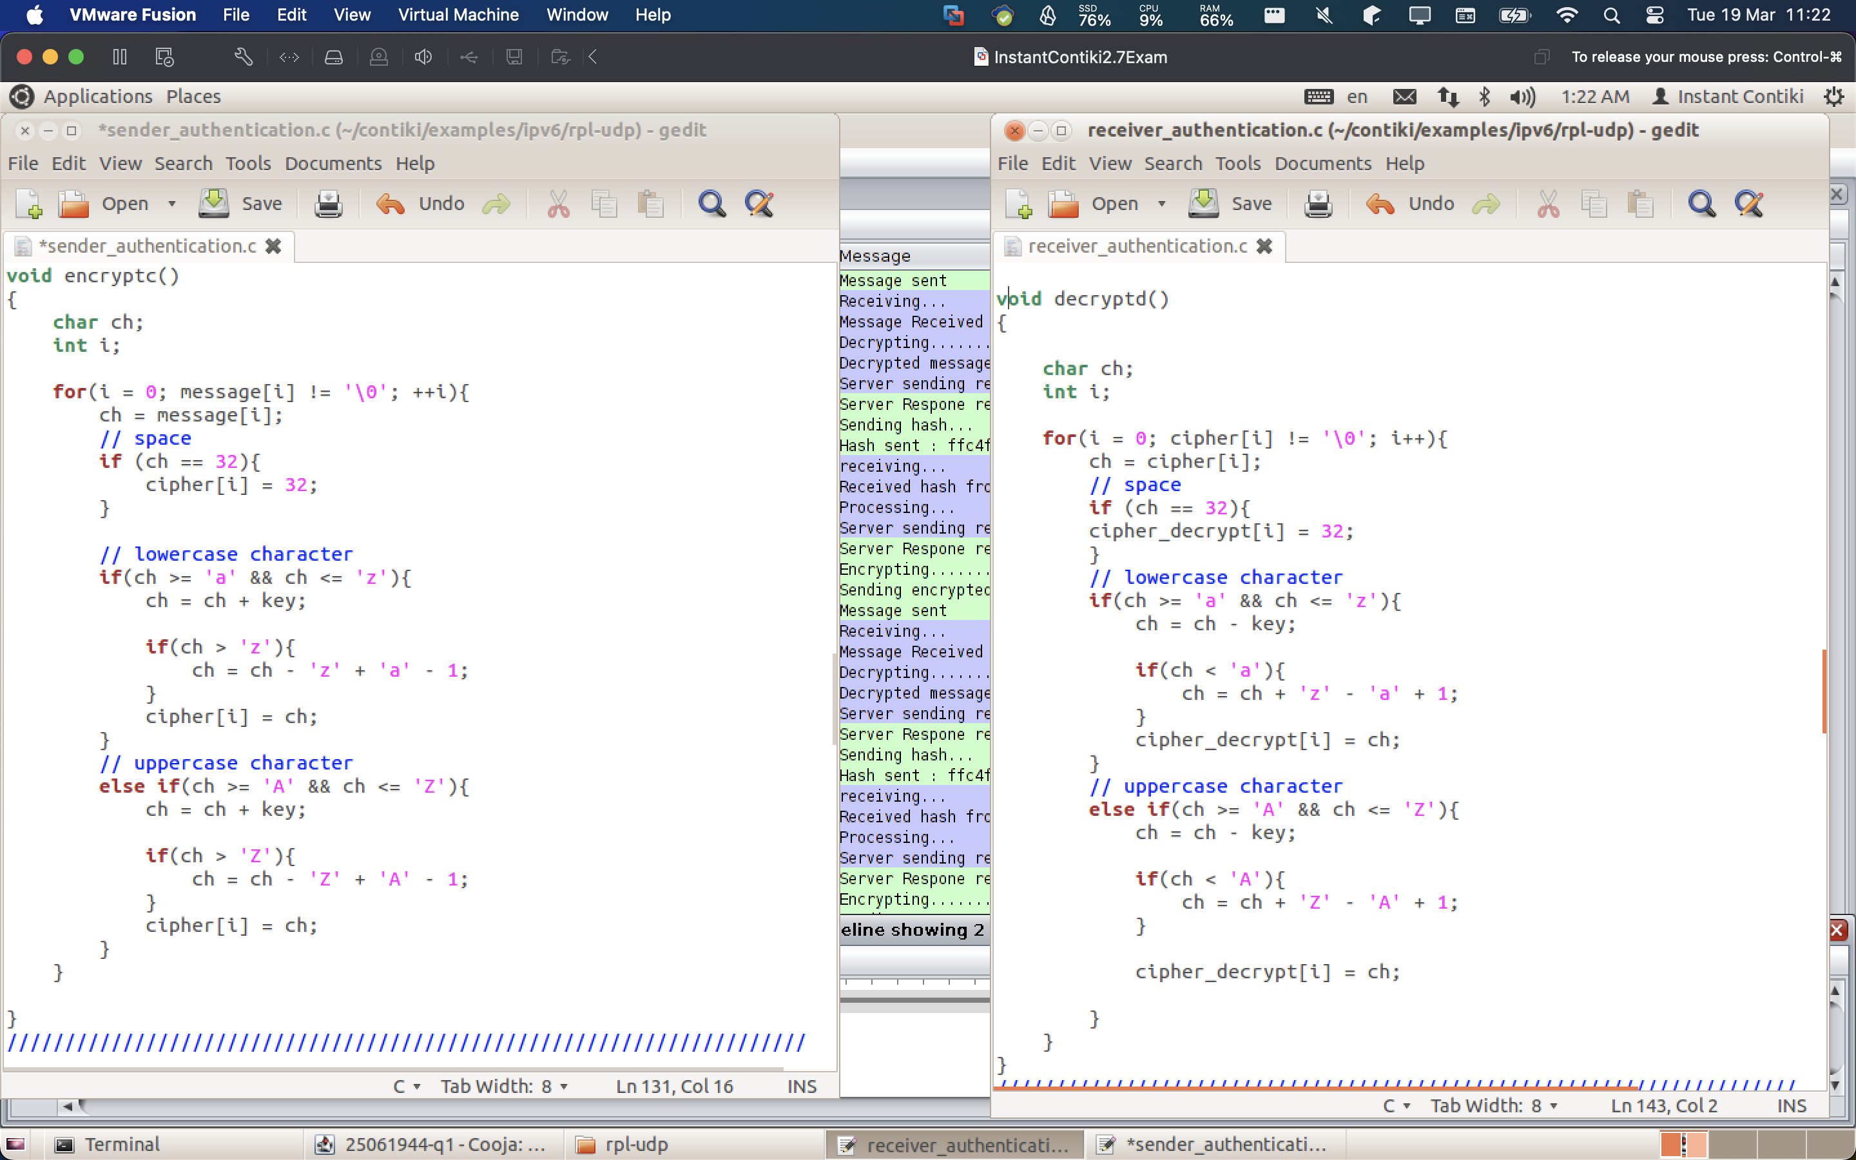

Question 2:

Task 1:
Answer: We can see that the simulation is successfully running and that we exchange messages.

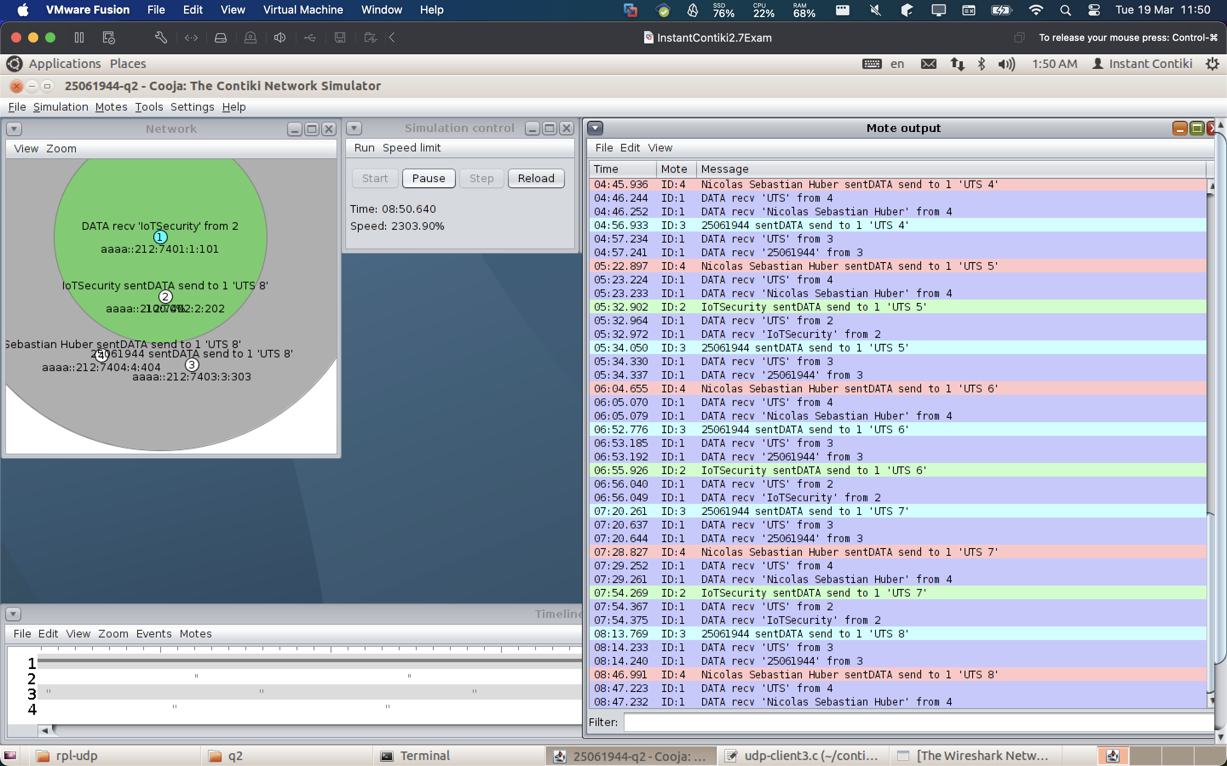

Task 2:

Make all the Clients send the message “UTS” to the server. Provide the screenshots showing the required messages that are sent by the Clients: 8%

Anser: We can see that all clients (2, 3, and 4) are sending “UTS” and that the server receives the data.

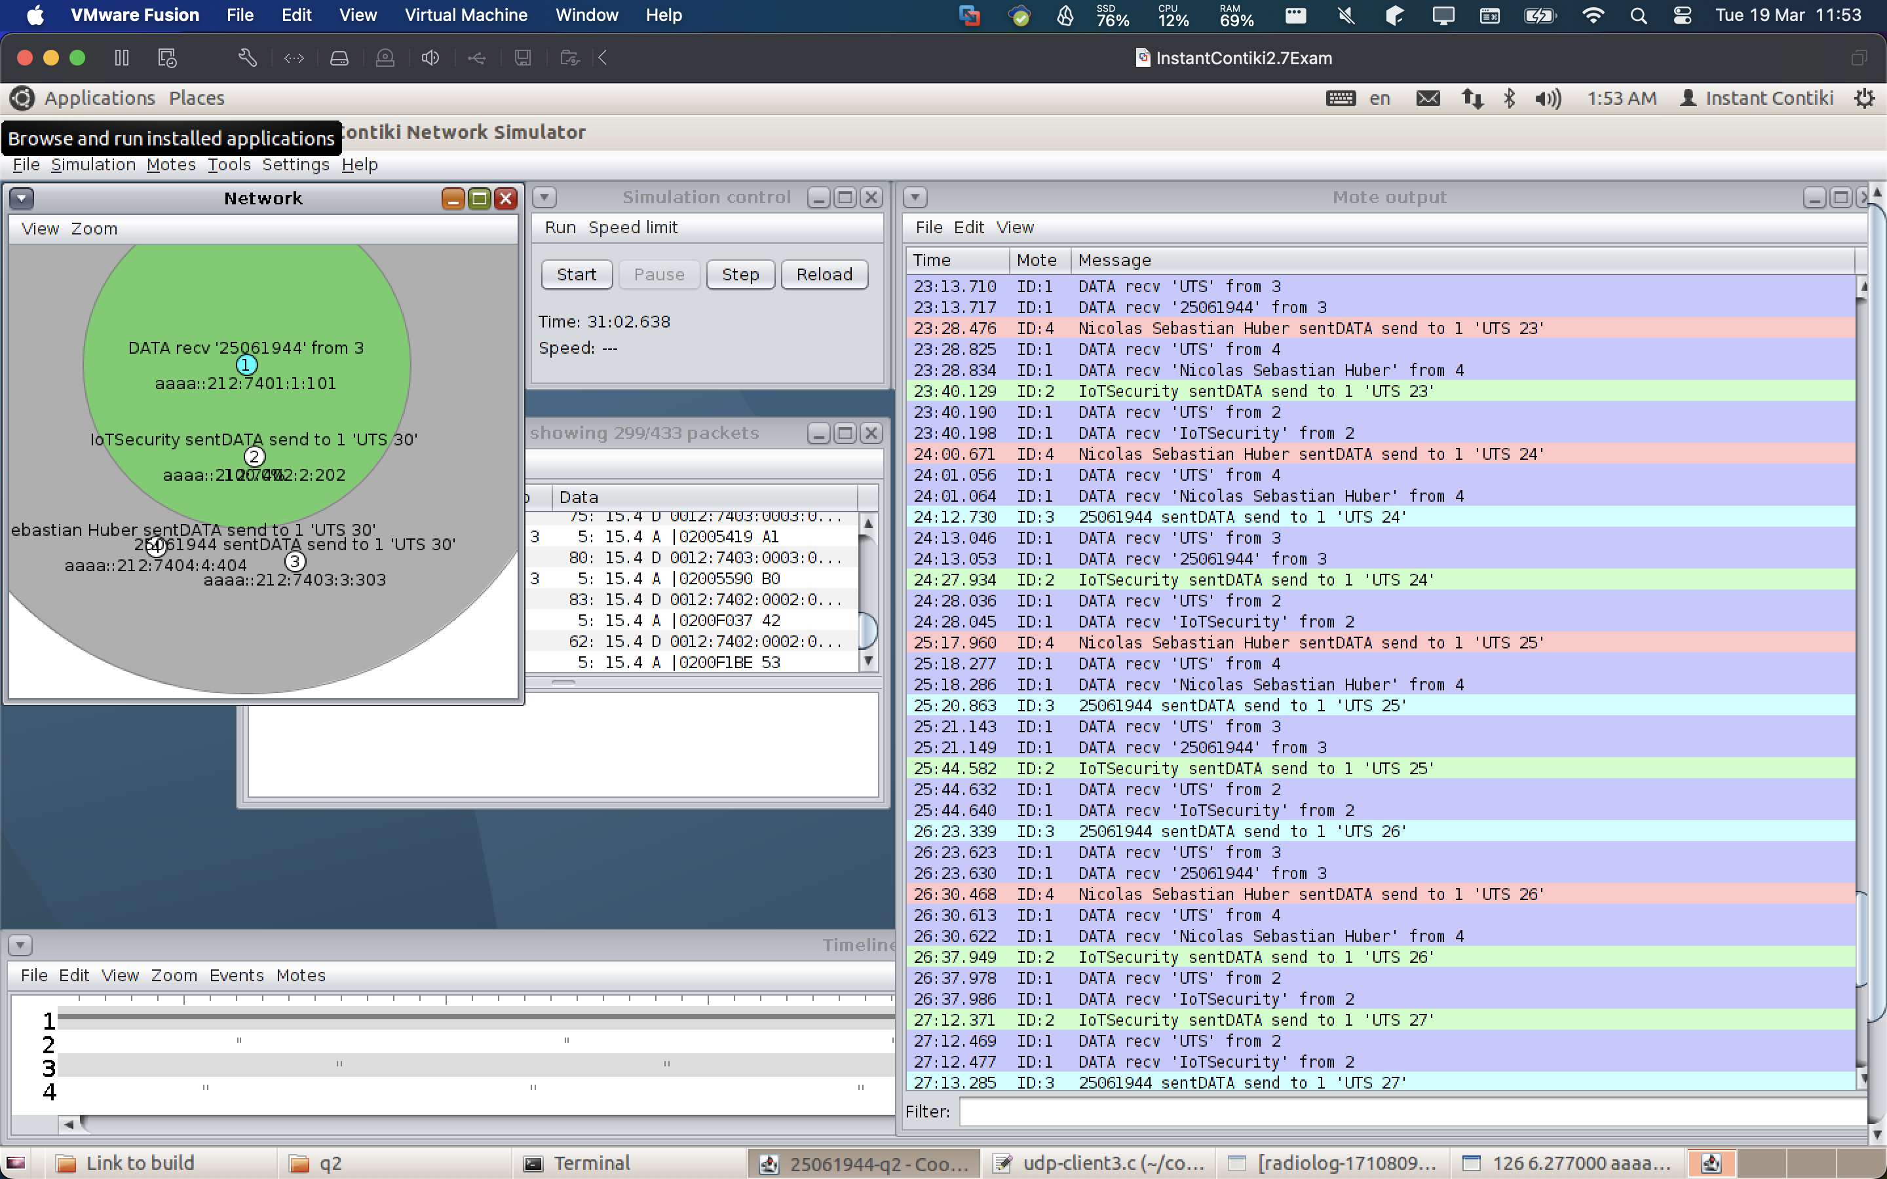

Task 3:

Make Client 1 send “IoTSecurity” message, Client 2 send your student ID message, and Client 3 send your full name to the Server. Provide screenshots showing the required messages received by the Server (the receiver): 8%.

Answer: We can see that all clients (2, 3, and 4) are sending “their corresponding messages” and that the server receives the data via the log:

Task 4:

Answer: We can export the pcap file and open it in Wireshark to inspect the network messages. We can see and inspect the “IoTSecurity” message from the corresponding client.

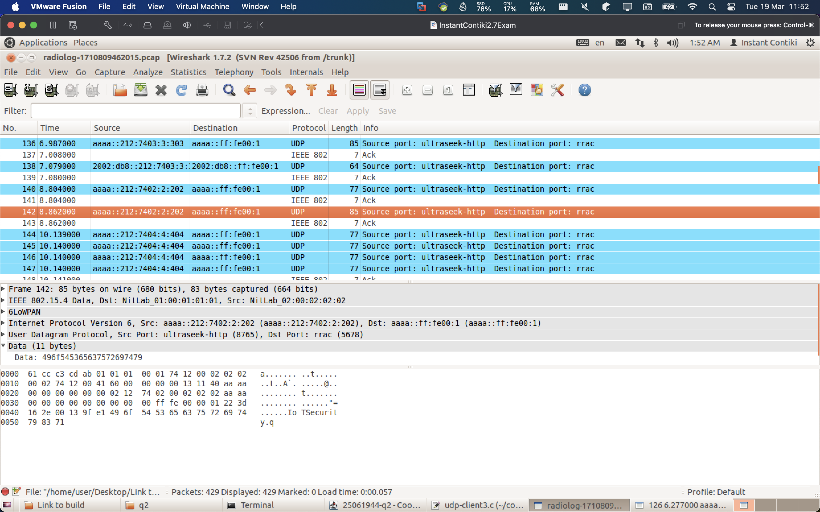
Question 3:

Task 1:
- Can successfully run the simulation (5%)
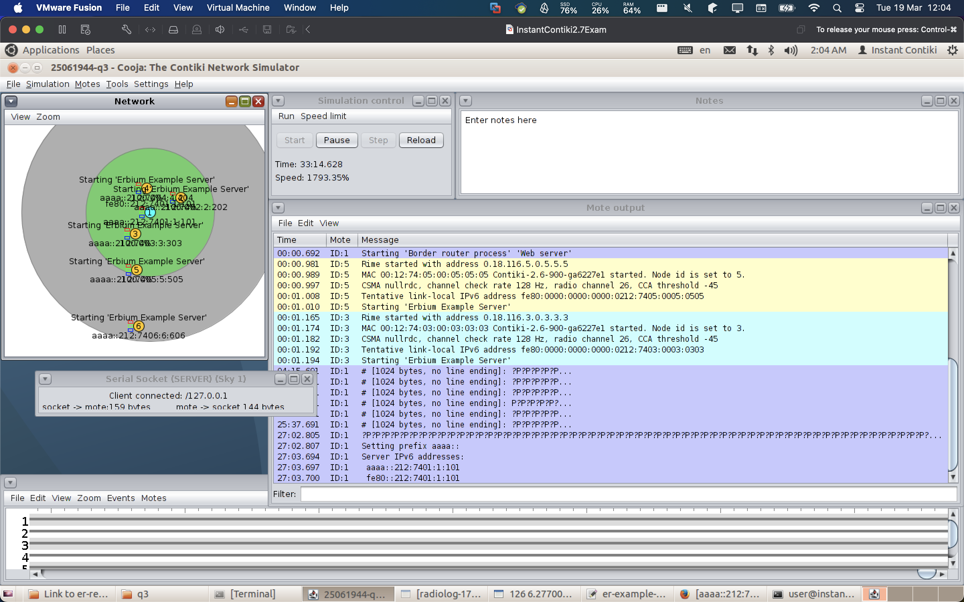

- Use Firefox to see the information of the network, i.e., network topology. Can show the network topology information via Firefox (5%)
See the following screenshots:
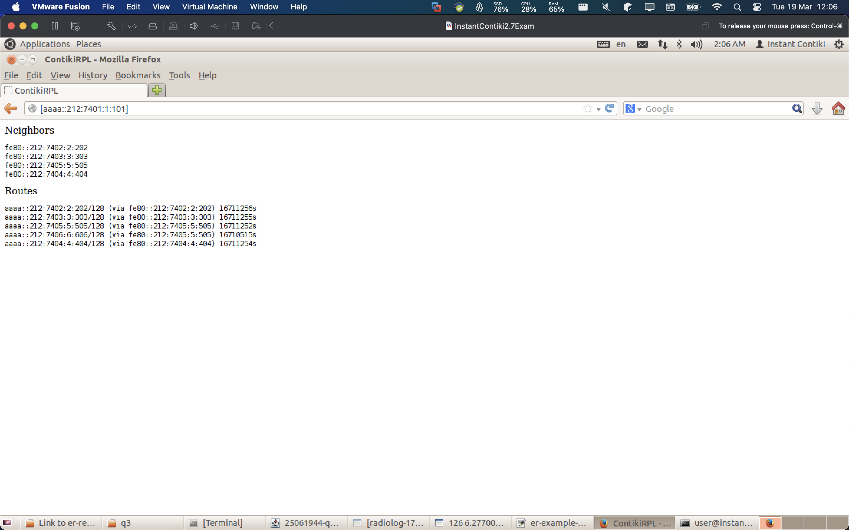

- Use Firefox to remotely control the LED RED and LED BLUE on the CoAP server 5 (mote 6). Can show the LEDs controlled by the actuator on Firefox and the LEDs of the sky mote 6 on Cooja (5%)

This is on node 2: we can control it and use post request to control the leds, since it is in range:
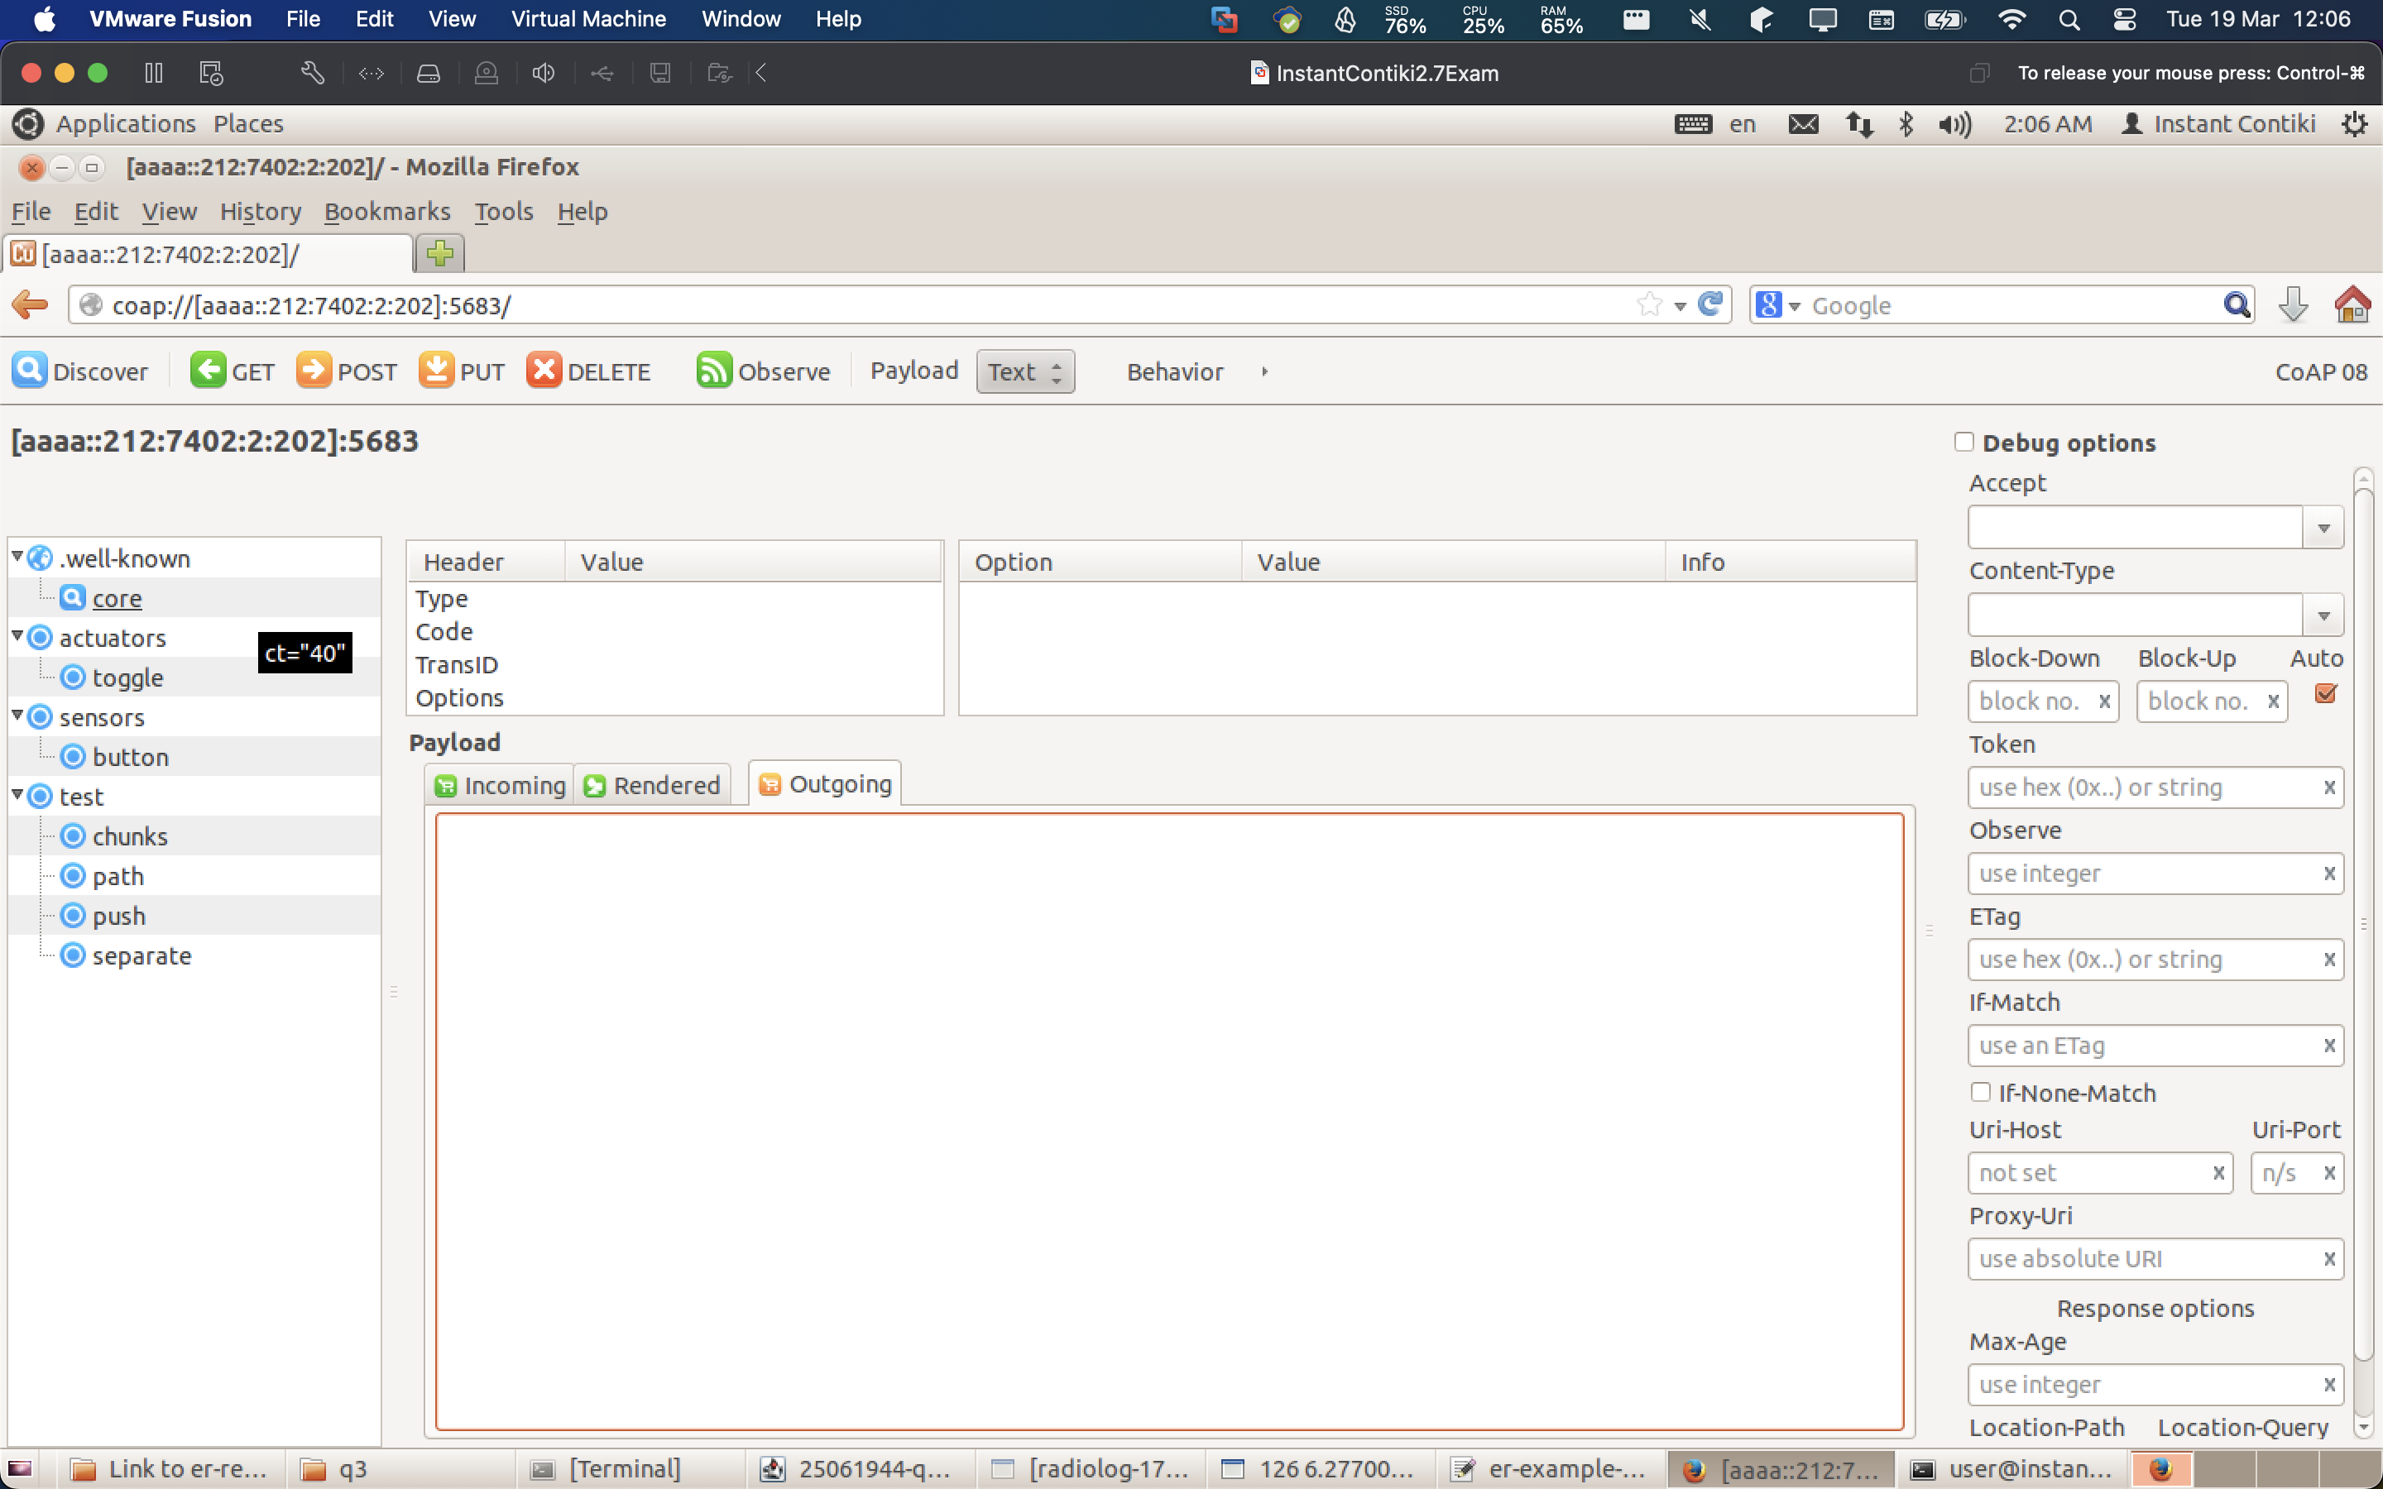

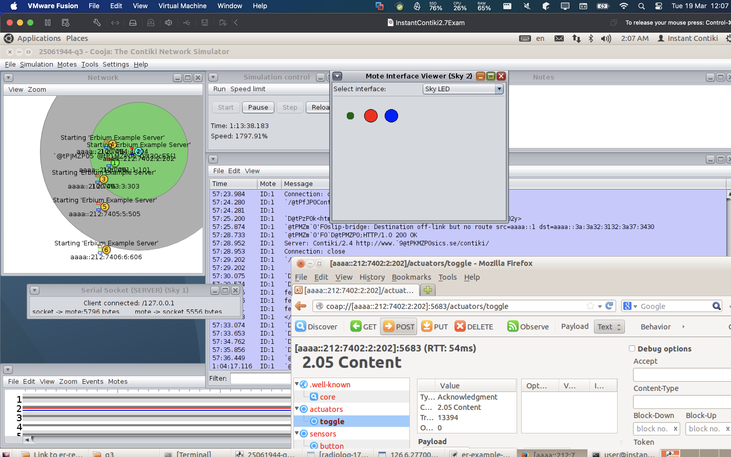
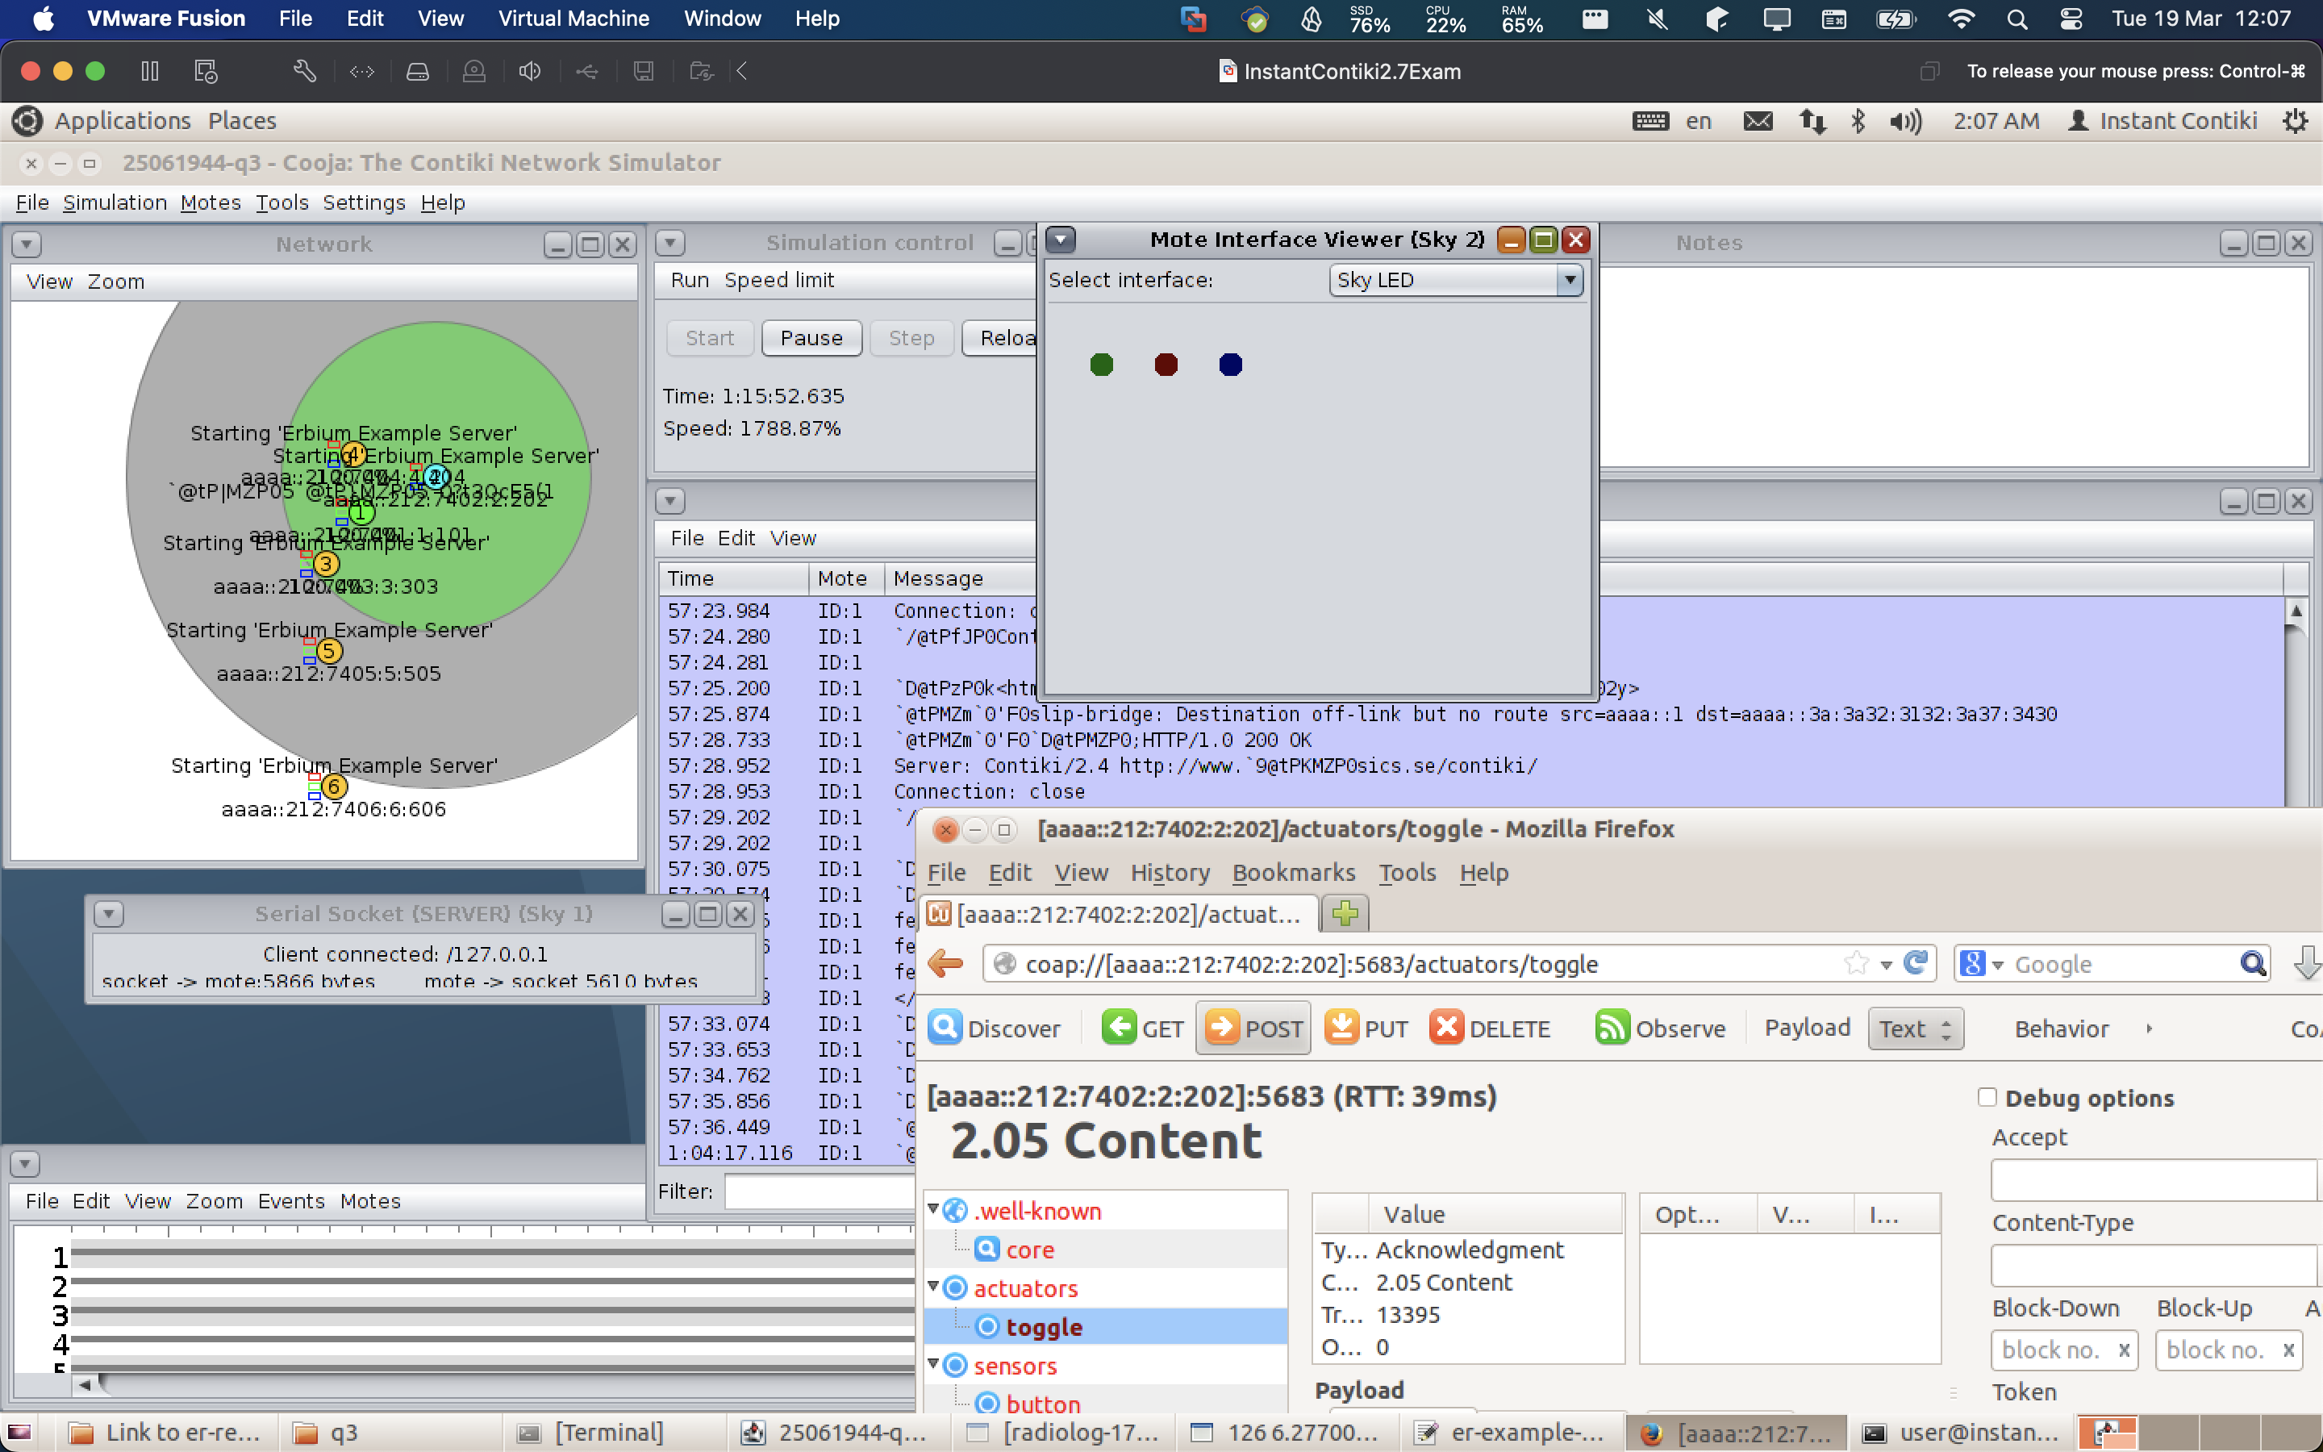

- Use Firefox to remotely control the LED RED and LED BLUE on the CoAP server 5 (mote 6). Can show the LEDs controlled by the actuator on Firefox and the LEDs of the sky mote 6 on Cooja (5%)
Not working for Server 6 because not in range!
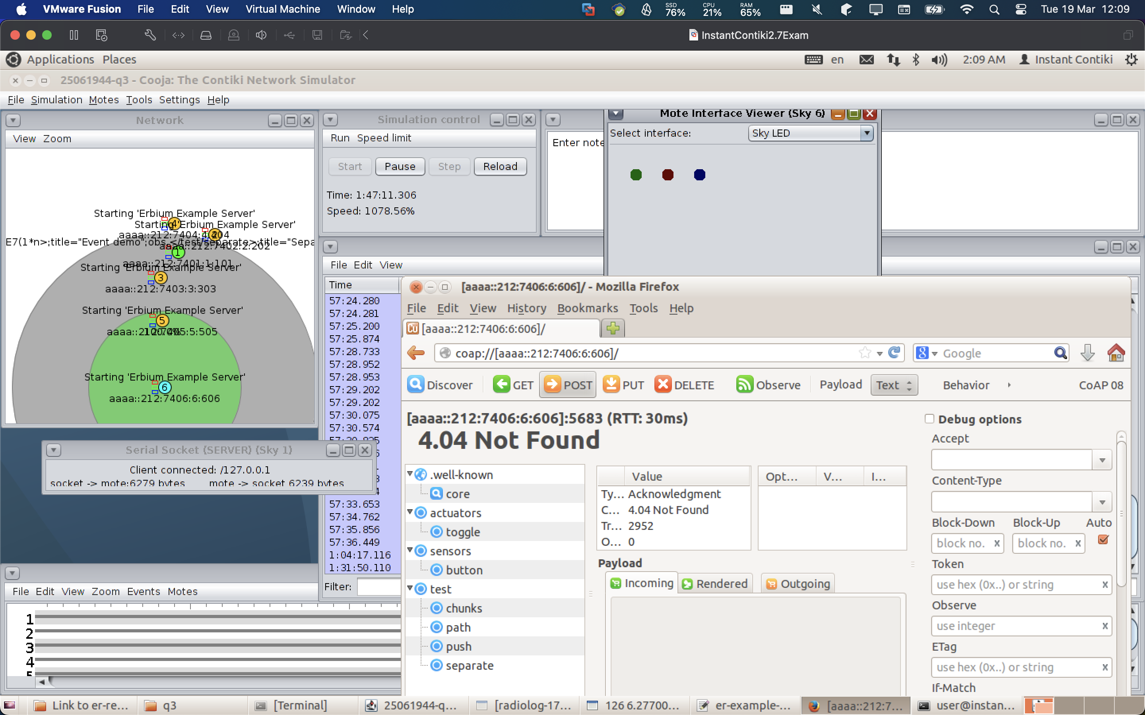

Task 2:

Answer: I added a new udp server as requested:

