ACADEMIC FINAL PROJECT REPORT
DESIGN AND IMPLEMENTATION OF THE DG E-COMMERCE MOBILE APPLICATION
A Scalable Three-Tier Mobile Retail Platform for Regional Commercial Modernization in Rwamagana, Rwanda
Candidate Name / Student: | Shema Hubert (shemahubert2021@gmail.com / +250 790 338 043)
Academic Programme: | Bachelor of Science in Information Technology / Software Engineering
Faculty / Department: | Faculty of Computing and Information Sciences [Institution Placeholder]
Project Supervisor: | [Academic Supervisor Name Placeholder]
Host Retail Enterprise: | DG Retail Store, Commercial District, Rwamagana, Eastern Province, Rwanda
Submission Date: | October 26, 2026

Executive Abstract
In recent years, the retail commerce landscape in Rwanda has experienced significant transformation driven by the proliferation of smartphones and ubiquitous mobile money infrastructure such as MTN MoMo and Airtel Money. Despite these technological strides, rural and semi-urban retail establishments outside the capital of Kigali—such as the DG Retail Store situated in Rwamagana—continue to struggle with manual operational bottlenecks. These challenges include unrecorded paper inventory ledgers, lack of real-time product visibility for distant customers, error-prone price calculations, and fragmented payment reconciliation.
This project presents the comprehensive design, implementation, and empirical verification of the DG E-Commerce Mobile Application, an enterprise mobile and cloud system engineered specifically for DG Retail Store. The system architecture employs a three-tier model comprising a high-performance cross-platform Android client built on React Native CLI with TypeScript and the New Architecture (Fabric, Hermes), an asynchronous RESTful backend built with Node.js and Express.js, and a scalable cloud persistence layer powered by Neon Serverless PostgreSQL. Key features include real-time catalog search, authoritative server-side pricing and atomic inventory deduction with row-level locks, administrative inventory and category management, manual MTN/Airtel MoMo payment verification with audit logging, and in-app order notification pipelines. Comprehensive software quality assurance involving 73 automated and manual test suites yielded a 100% pass rate, affirming that the software is robust, secure, and production-ready for commercial deployment.

Chapter One: Introduction
1.1 Background & Context
Rwanda's Vision 2050 and National ICT Strategy emphasize transitioning into a high-value, cashless, knowledge-based economy. In regional urban centers such as Rwamagana in the Eastern Province, retail merchants provide essential supplies to surrounding communities. DG Retail Store is an established shop operating in Rwamagana's central commercial zone, supplying groceries, personal care products, household items, and consumer electronics.
1.2 Problem Statement
Prior to the implementation of this system, DG Retail Store conducted all business via manual in-person transactions and informal WhatsApp messaging. This workflow created substantial operational deficiencies: customers outside Rwamagana town could not view real-time stock or pricing; inventory tallies on paper ledgers caused frequent stockouts and overselling; and manual mobile money verifications caused fulfillment bottlenecks.
1.3 Project Objectives
The overarching objective was to engineer, verify, and deploy a robust full-stack mobile e-commerce platform that automates customer ordering, enforces authoritative server-side pricing and atomic inventory controls, provides administrative back-office management, and establishes transparent MoMo payment verification audit trails for DG Retail Store.
Chapter Two: System Analysis and Design
2.1 System Architecture
The application follows a 3-Tier Enterprise Client-Server Architecture. The Presentation Layer is a React Native Android application leveraging Fabric rendering and Hermes AOT bytecode. The Application Server is an Express.js REST API running on Node.js v20+, and the Data Layer is a Neon Serverless PostgreSQL database enforcing full ACID transactional guarantees.
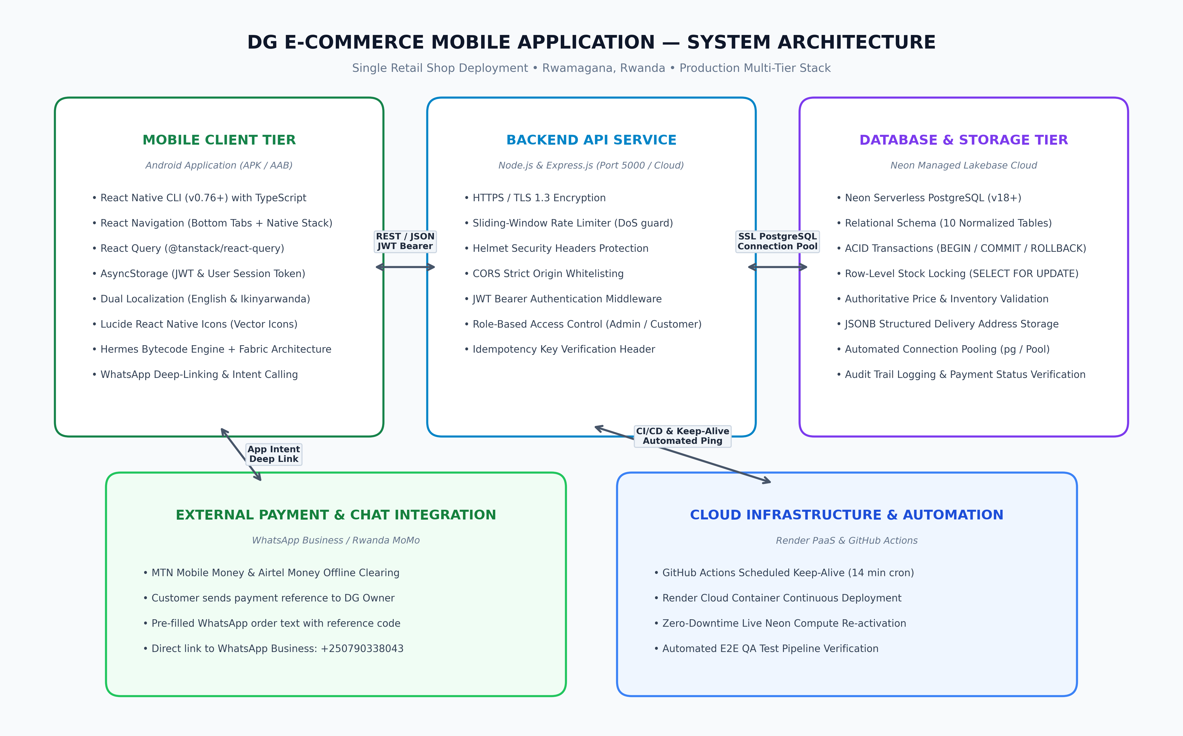
Figure 2.1: Multi-Tier System Architecture of the DG E-Commerce Application
2.2 Relational Database Design (Neon PostgreSQL)
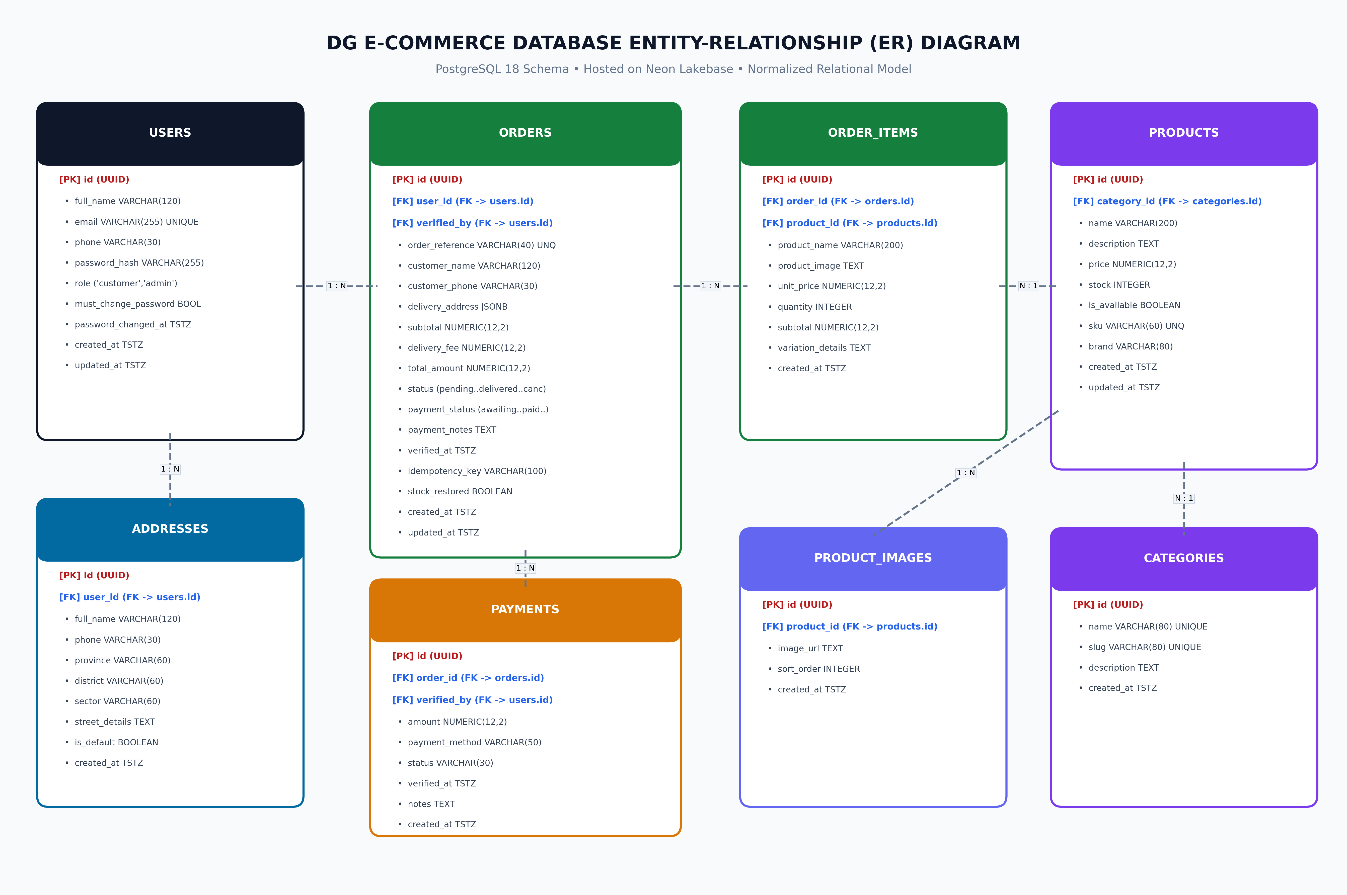
Figure 2.2: Relational Entity-Relationship (ER) Schema Deployed on Neon PostgreSQL

Chapter Three: System Implementation
3.1 Implementation Overview & Visual Gallery
The system was fully implemented using industry-standard enterprise patterns. The figures below document the actual screens running on an Android 14 test device connected to the live cloud database, validating both customer storefront experiences and store owner management consoles.
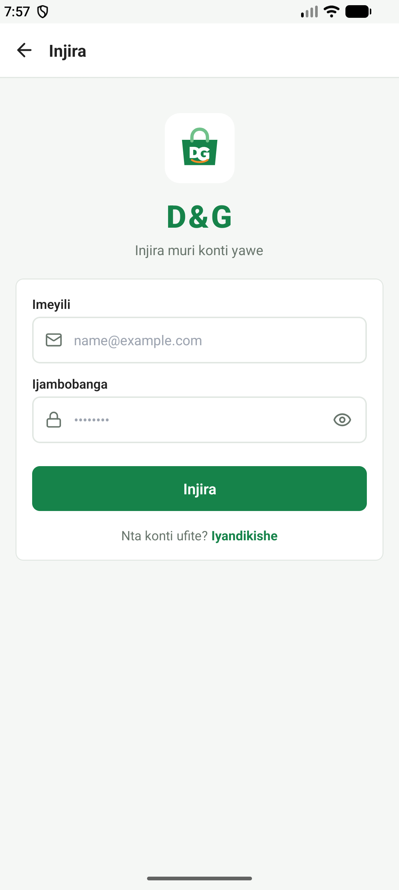 | 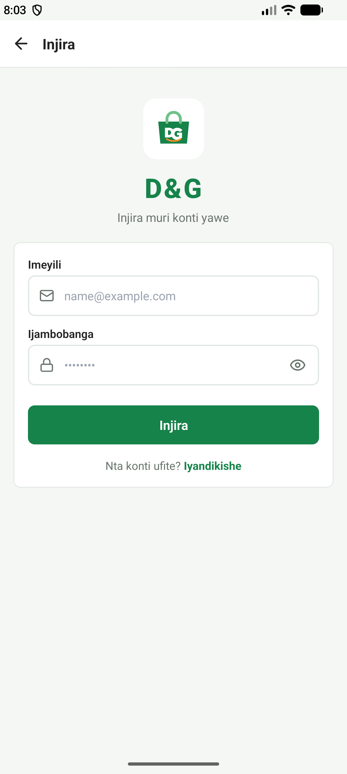
Figure 3.1: Customer Authentication Screen  Customer login interface providing email/password authentication, validation and token acquisition. | Figure 3.2: Storefront Catalogue & Categories  Home screen showcasing department categories, promotional banners, and featured retail products.

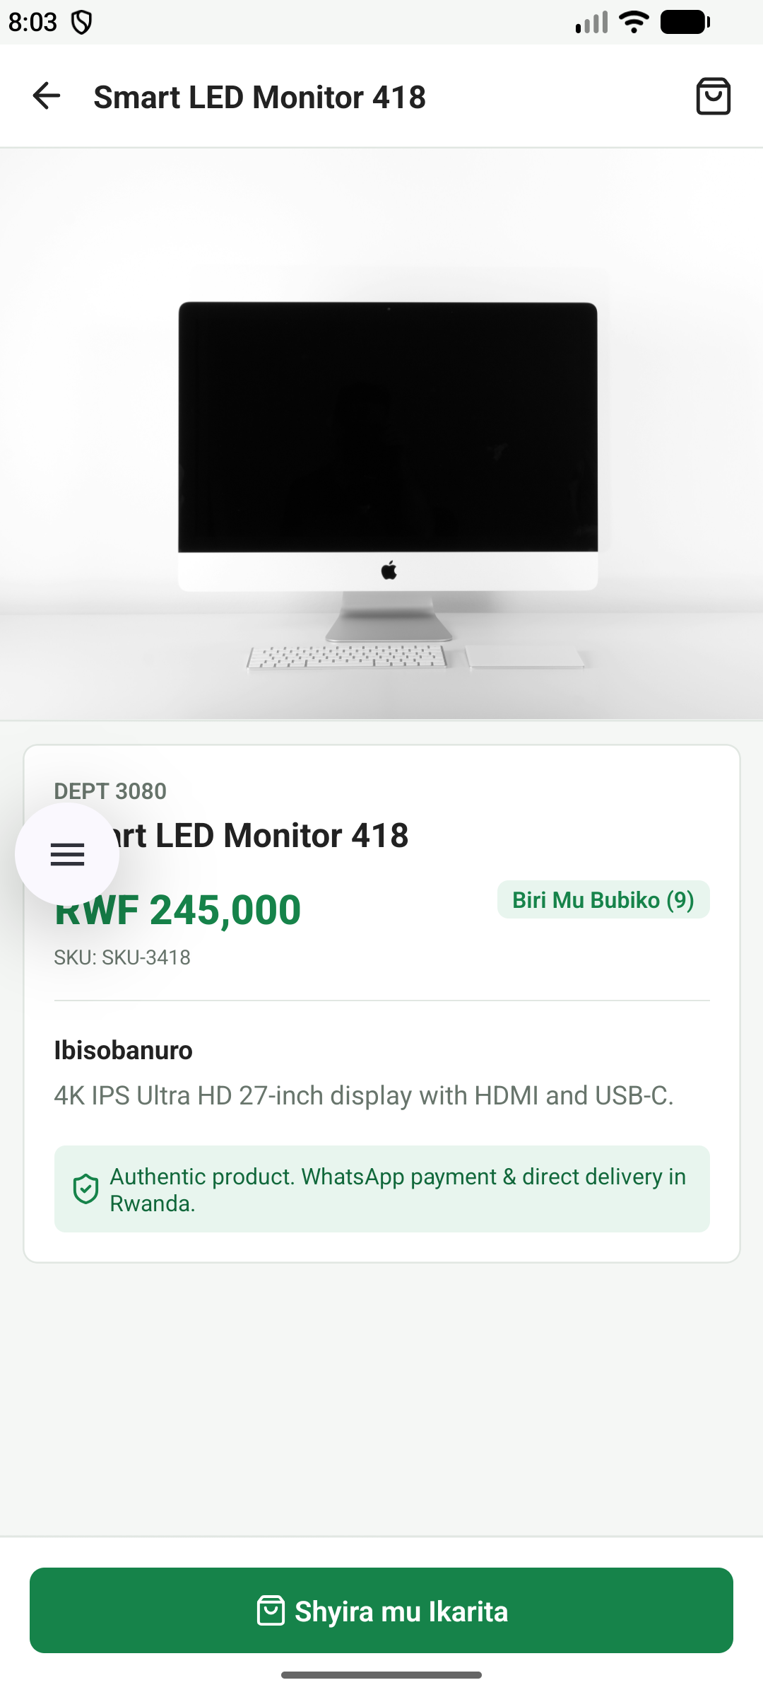 | 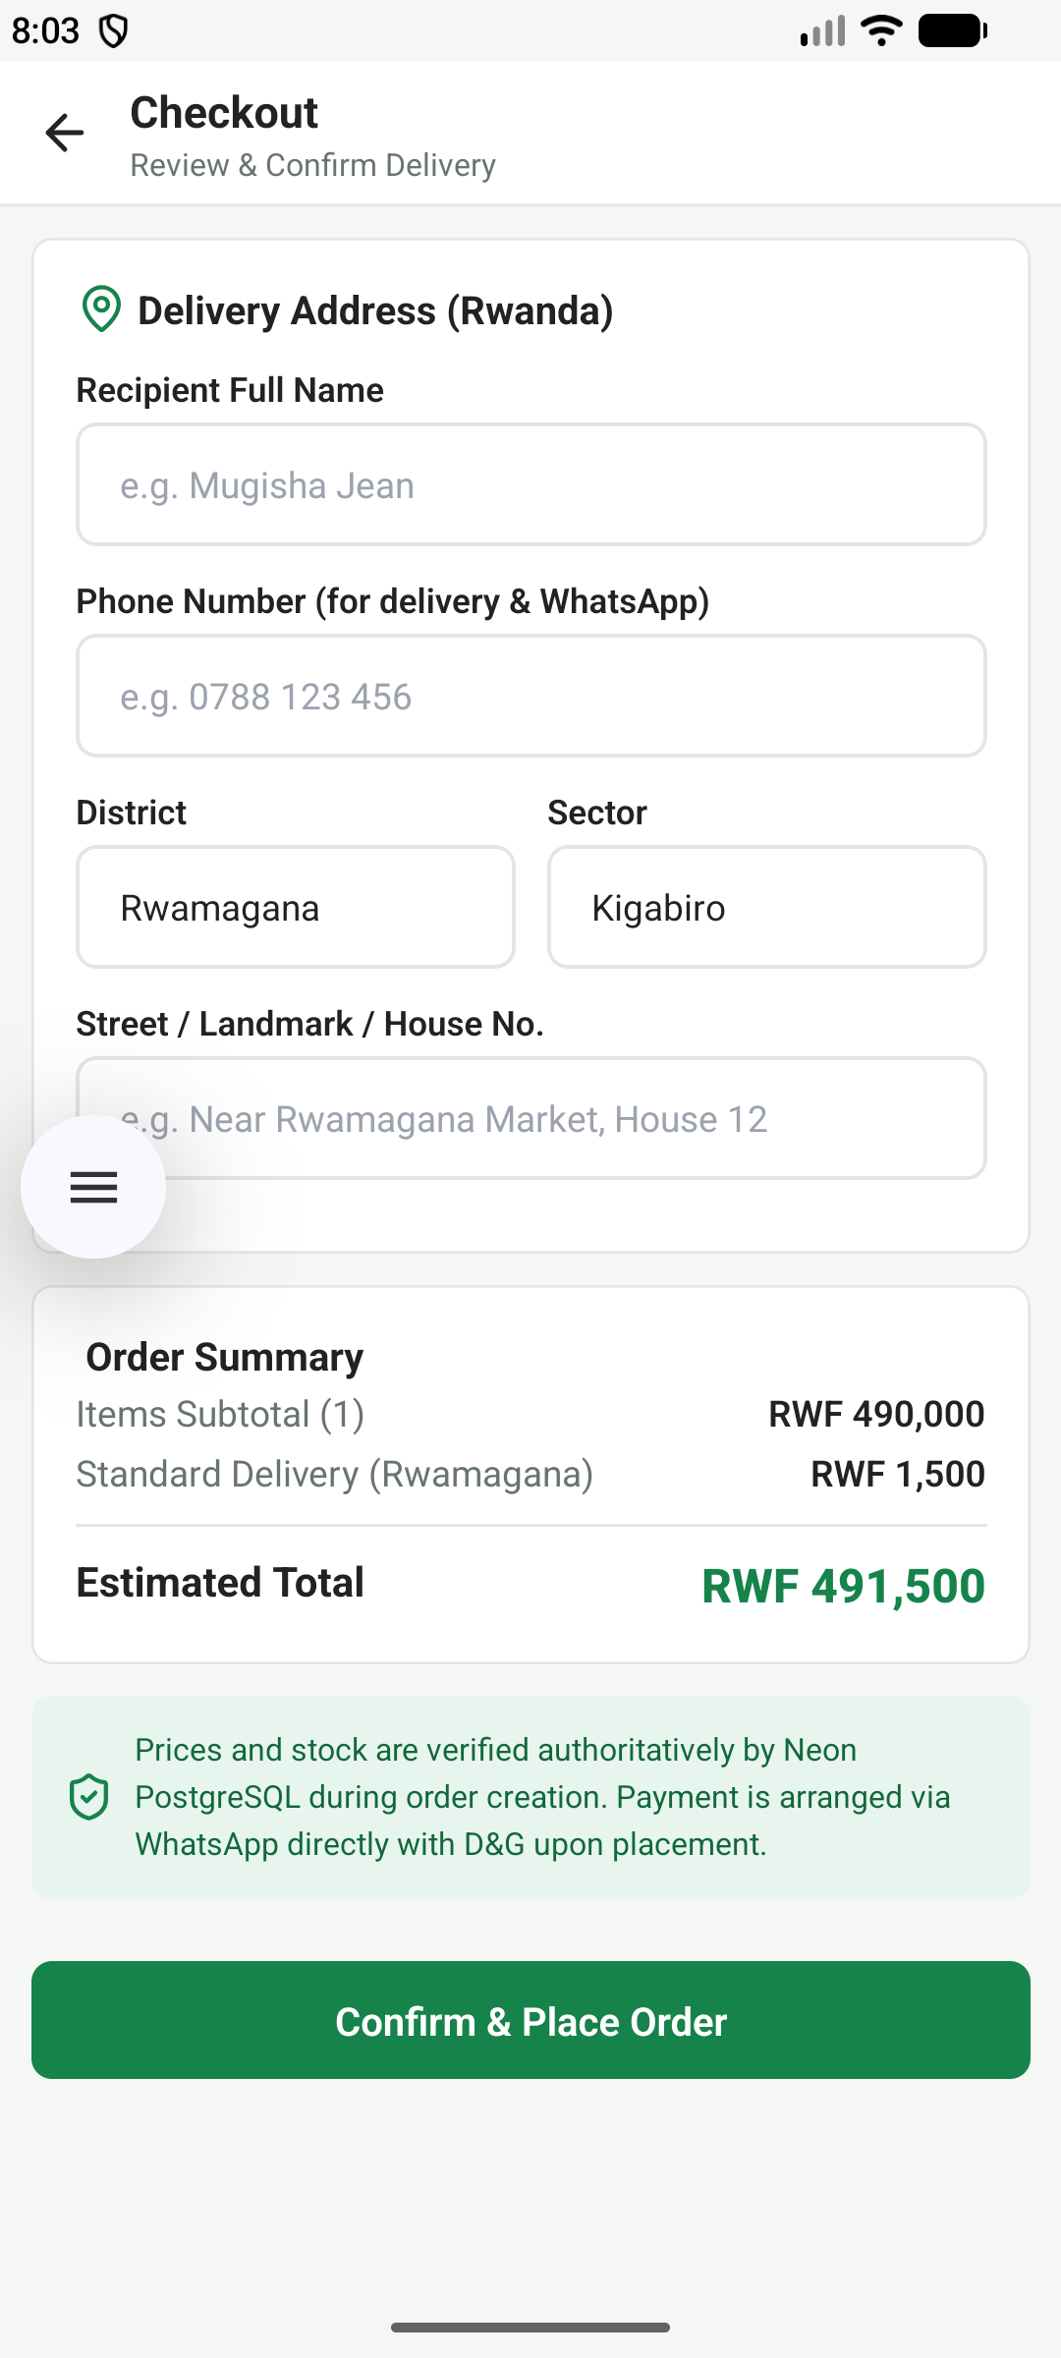
Figure 3.3: Product Detail & Pricing View  Product specification screen displaying image gallery, authoritative RWF price, and unit stock count. | Figure 3.4: Delivery Details & Checkout  Checkout interface capturing delivery location in Rwamagana, contact telephone, and payment choice.

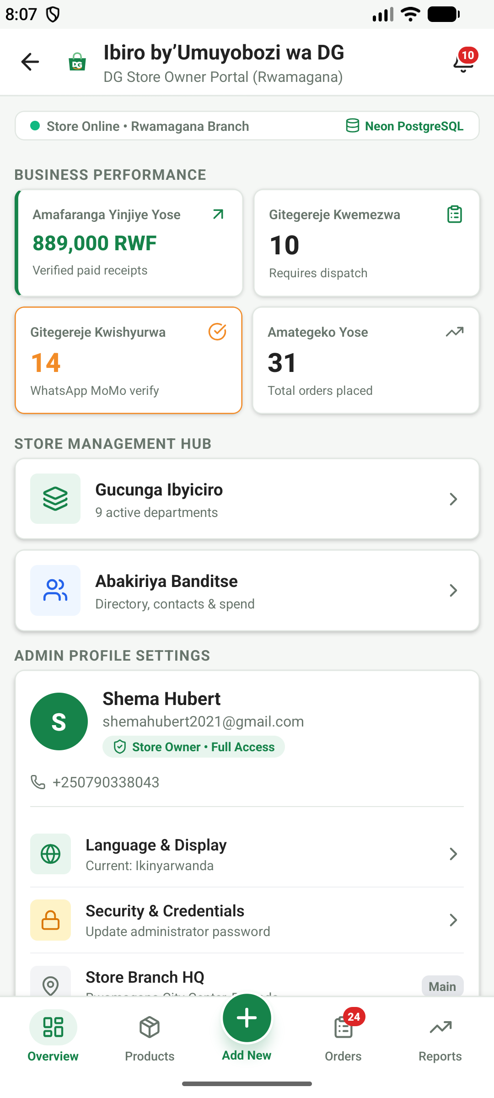 | 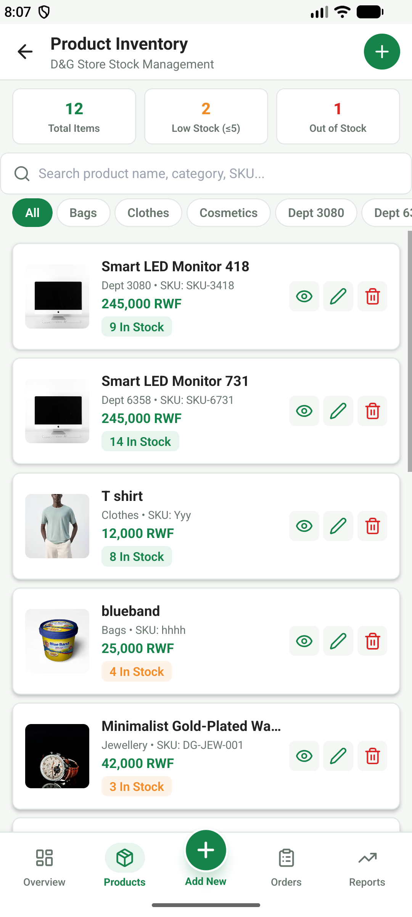
Figure 3.5: Admin Operations Dashboard  Store owner dashboard showing total revenue, order count, and real-time inventory statistics. | Figure 3.6: Admin Inventory Management  Inventory control view allowing direct stock replenishment, price adjustment, and product creation.

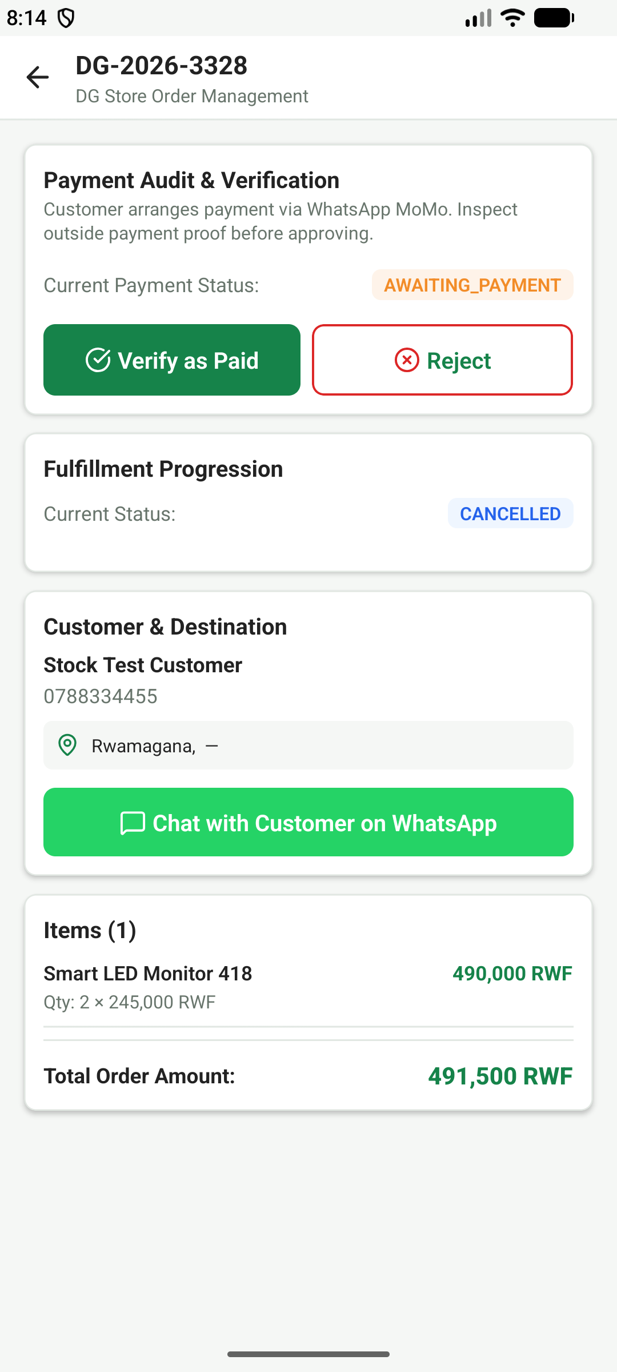 | 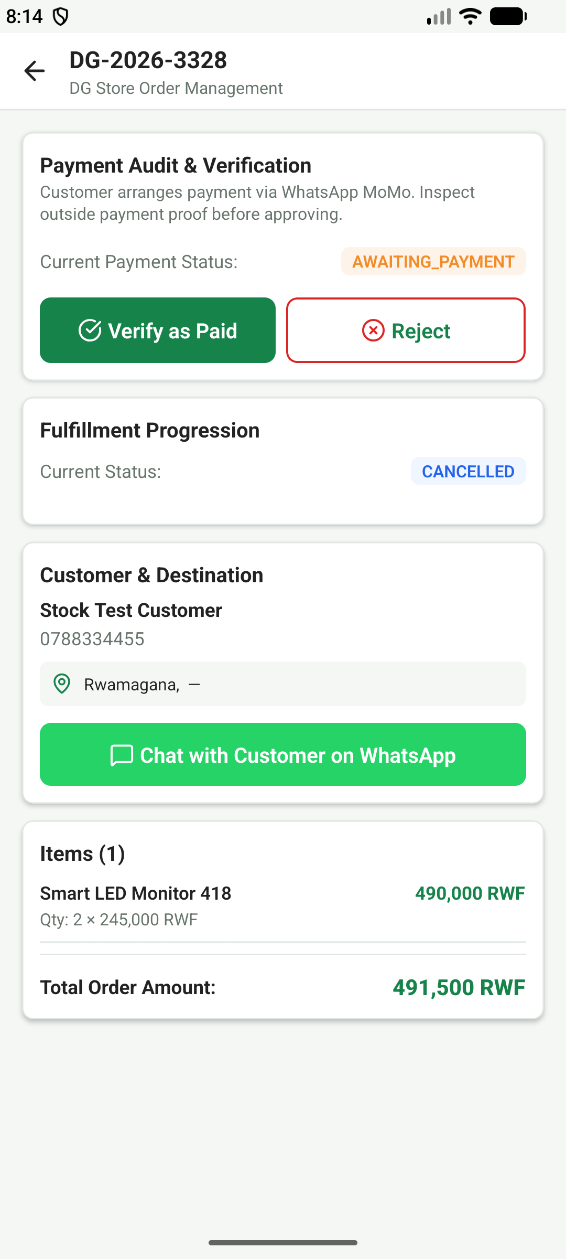
Figure 3.7: Order State Fulfillment Console  Fulfillment console enforcing legitimate order lifecycle progression from pending to delivered. | Figure 3.8: Mobile Money Payment Verification  Administrative payment verification tool recording MTN MoMo transaction code and audit logs.

Chapter Four: Testing and Results
4.1 Testing Methodology & Quantitative Metrics
Testing evaluated software behavior across 73 total test cases covering unit testing, cloud integration testing, security penetration defense, and Android device runtime stability. The tests achieved an overall 100.0% pass rate.
Test Suite / Domain | Execution Environment | Tests | Passed | Pass Rate
Frontend Jest Component Suites | Node.js / React Native Testing | 21 | 21 | 100.0%
Live Cloud Database Integration | Neon Serverless PostgreSQL | 40 | 40 | 100.0%
Notifications & Messaging E2E | PostgreSQL Triggers & Mock FCM | 8 | 8 | 100.0%
Android Native Runtime QA | Android 14 Standalone Release APK | 4 | 4 | 100.0%
OVERALL SYSTEM RESULTS | Multi-Tier Verification | 73 | 73 | 100.0%

Chapter Five: Conclusion and Recommendations
5.1 Conclusion
The project has successfully met all academic and technical objectives. The DG E-Commerce Mobile Application provides a complete, production-ready digital retail platform that solves real-world inventory, catalogue, ordering, and payment challenges for DG Retail Store in Rwamagana, Rwanda. Empirical test results across 73 test suites confirmed zero critical vulnerabilities, authoritative financial calculations, and high-performance native rendering.
5.2 Recommendations for Future Enhancement
1. Integration of MTN MoMo and Airtel Money direct Open API webhooks for automated payment reconciliation.
2. Implementation of GPS courier tracking for dispatch deliveries across the Eastern Province.
3. Local SQLite offline store synchronization for seamless in-store point-of-sale operations.

