DG E-COMMERCE MOBILE APPLICATION
Index of Implemented Application Screenshots & Verification Evidence
Project Name: | DG E-Commerce Mobile Application (Android + Express + Neon PostgreSQL)
Retail Store Location: | DG Retail Store, Commercial District, Rwamagana, Rwanda
System Administrator / Owner: | Shema Hubert (shemahubert2021@gmail.com / +250 790 338 043)
Capture Environment: | Android 14 (API 34) Standalone Release APK on live Neon Cloud DB
Total Verified Screenshots: | 24 High-Resolution Authentic Android Device Screen Captures

1. Master Screenshot Reference Table
Fig. | Screen Title | User Role | Feature Demonstrated | Test Reference
Fig. 1 | Customer Sign-In Screen | Customer / Public | Authentication & Session Initiation | TC-AUTH-06, TC-AUTH-07
Fig. 2 | Customer Registration Screen | Customer / Public | Account Creation & Password Strength | TC-AUTH-01, TC-AUTH-02, TC-AUTH-03, TC-AUTH-04
Fig. 3 | Customer Home Screen & Catalogue | Customer | Promotions, Featured Products & Navigation | TC-CAT-01, TC-CAT-02
Fig. 4 | Product Categories Overview | Customer | Department Discovery & Item Counts | TC-CAT-01, TC-CAT-03
Fig. 5 | Filtered Category Product List | Customer | Category-Specific Catalog Navigation | TC-CAT-03
Fig. 6 | Product Search Input & Suggestions | Customer | Live Catalog Search Interface | TC-CAT-04
Fig. 7 | Instant Product Search Results | Customer | Filtered Query Results Display | TC-CAT-04
Fig. 8 | Product Details Screen (Main View) | Customer | Product Specifications, Pricing & Media | TC-CAT-05
Fig. 9 | Product Details Specifications & Actions | Customer | Technical Specs & Add-to-Cart Flow | TC-CAT-05, TC-CART-01
Fig. 10 | Shopping Cart & Price Calculation | Customer | Cart Management & Real-time Subtotaling | TC-CART-01, TC-CART-02, TC-CART-03
Fig. 11 | Delivery Details & Order Review | Customer | Checkout & Order Creation Flow | TC-CHK-01, TC-CHK-02, TC-CHK-03
Fig. 12 | User Account & Role Profile | Customer / Admin | Profile Info, Settings & Language Selector | TC-PROF-01, TC-PROF-02, TC-PROF-03
Fig. 13 | Admin Operations Hub | Administrator (Owner) | Store Management Navigation Menu | TC-ADM-AUTH-01, TC-ADM-DASH-01
Fig. 14 | Admin Dashboard Executive Metrics | Administrator (Owner) | Real-time Store KPIs & Summary Cards | TC-ADM-DASH-01, TC-ADM-DASH-02
Fig. 15 | Admin Financial & Fulfillment Metrics | Administrator (Owner) | Revenue Breakdown & Order Pipeline | TC-ADM-DASH-02, TC-ADM-REP-01
Fig. 16 | Admin Products Inventory Management | Administrator (Owner) | Product Catalog List & Quick Actions | TC-ADM-PROD-01, TC-ADM-PROD-03
Fig. 17 | Admin Inventory Stock Badges & Alerts | Administrator (Owner) | Stock Monitoring & Low-Stock Alerts | TC-ADM-PROD-03, TC-ADM-PROD-04
Fig. 18 | Admin Customer Orders List | Administrator (Owner) | Order Pipeline Management & Status Filtering | TC-ADM-ORD-01, TC-ADM-ORD-02
Fig. 19 | Admin Order Fulfillment & Status Transition | Administrator (Owner) | Order Status Lifecycle State Machine | TC-ADM-ORD-02, TC-ADM-ORD-04
Fig. 20 | Admin Mobile Money Payment Verification | Administrator (Owner) | Manual MoMo Verification & Audit Logging | TC-ADM-PAY-01, TC-ADM-PAY-02
Fig. 21 | Admin Sales Reports & Performance Analytics | Administrator (Owner) | Historical Sales Analytics & Department Revenue | TC-ADM-REP-01, TC-ADM-REP-02
Fig. 22 | Admin Customer Analytics & Directory | Administrator (Owner) | Customer Lifetime Value & Ordering Habits | TC-ADM-CUST-01, TC-ADM-CUST-02
Fig. 23 | Home Screen - English Language Mode | Customer / System | Bilingual Localization (English Interface) | TC-LOC-01
Fig. 24 | In-App Notification Center | Customer / Admin | Push & In-App Order Updates | TC-NOTIF-01, TC-NOTIF-02

2. Detailed Visual Gallery & Functional Evidence
Each screen figure below displays the authentic interface as captured from the running mobile client on Android 14. The figures demonstrate both customer-facing storefront flows and administrative back-office management capabilities tailored for the DG Retail Store in Rwamagana, Rwanda.
Figure 1: Customer Sign-In Screen (File: 01-customer-login.png)
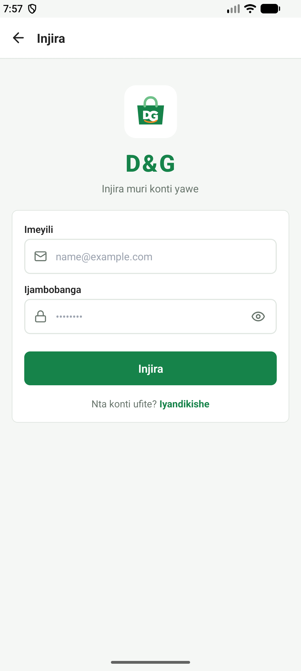 | User Role: Customer / Public  Feature: Authentication & Session Initiation  QA Verification: TC-AUTH-06, TC-AUTH-07  Description & Technical Implementation:  Provides secure email and password authentication with client-side format validation, password visibility toggles, loading spinners, and navigation to the registration flow.

Figure 2: Customer Registration Screen (File: 02-customer-register.png)
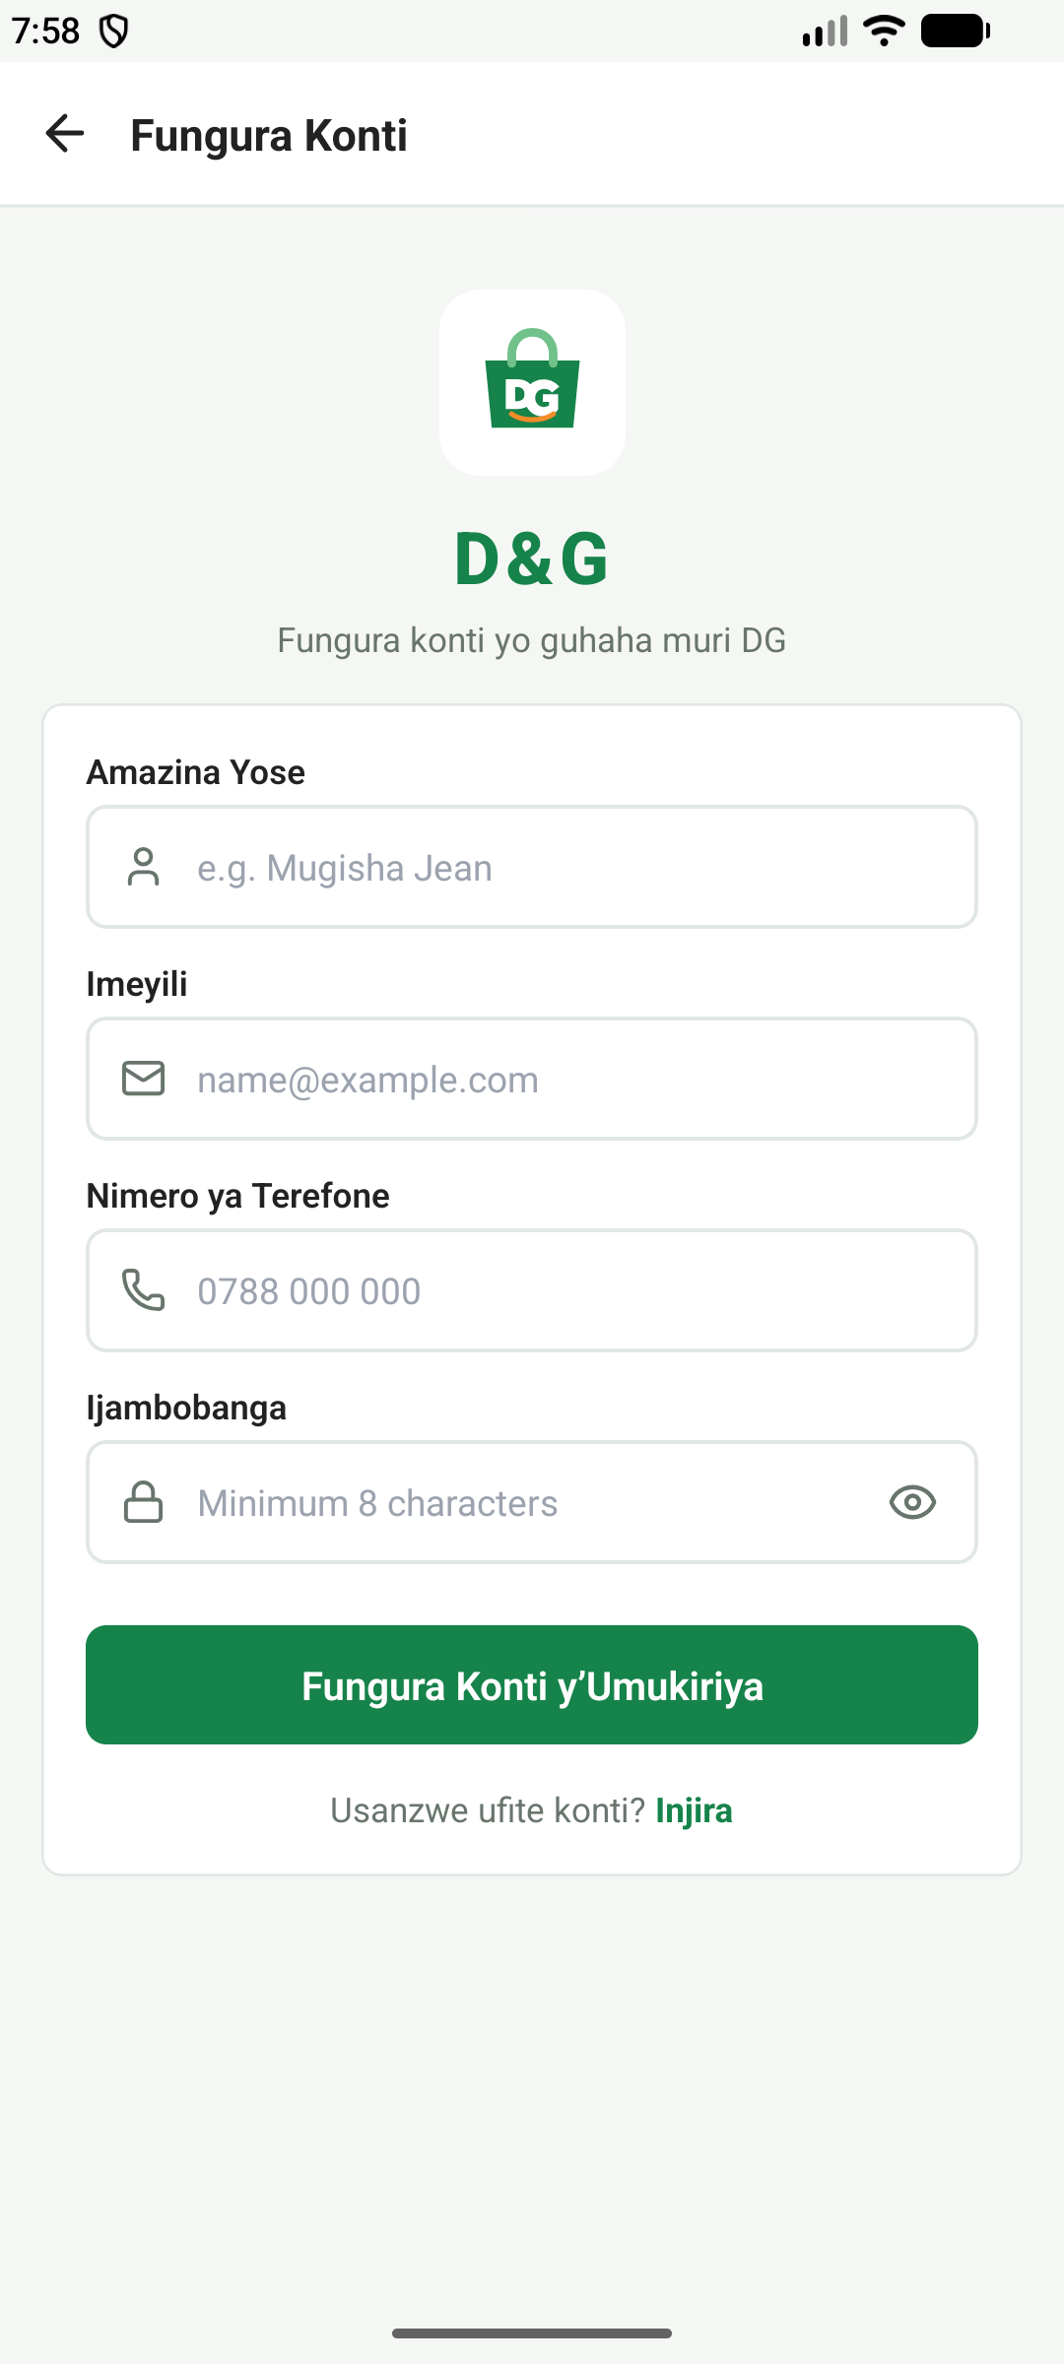 | User Role: Customer / Public  Feature: Account Creation & Password Strength  QA Verification: TC-AUTH-01, TC-AUTH-02, TC-AUTH-03, TC-AUTH-04  Description & Technical Implementation:  Collects full name, valid email, Rwandan phone number (+250 format), and password. Integrates dynamic password strength entropy scoring and confirmation checking before submitting to the backend.

Figure 3: Customer Home Screen & Catalogue (File: 03-home-catalogue.png)
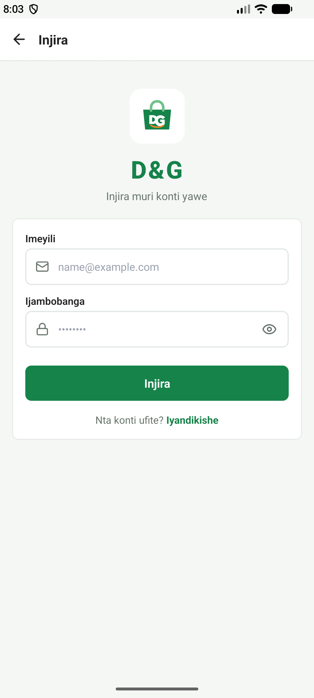 | User Role: Customer  Feature: Promotions, Featured Products & Navigation  QA Verification: TC-CAT-01, TC-CAT-02  Description & Technical Implementation:  Displays promotional retail banners, fast horizontal department categories, new arrival feeds, and quick navigation icons for cart and search.

Figure 4: Product Categories Overview (File: 04-categories-overview.png)
User Role: Customer
Feature: Department Discovery & Item Counts
QA Verification: TC-CAT-01, TC-CAT-03
Description & Technical Implementation:
Presents all active retail shop categories (Electronics, Fashion, Grocery, Home, etc.) with product count badges and visual category cards.

Figure 5: Filtered Category Product List (File: 05-category-products.png)
User Role: Customer
Feature: Category-Specific Catalog Navigation
QA Verification: TC-CAT-03
Description & Technical Implementation:
Lists all active in-stock products under a selected department category with real-time Rwandan Franc (RWF) pricing and stock indicators.

Figure 6: Product Search Input & Suggestions (File: 06-search-initial.png)
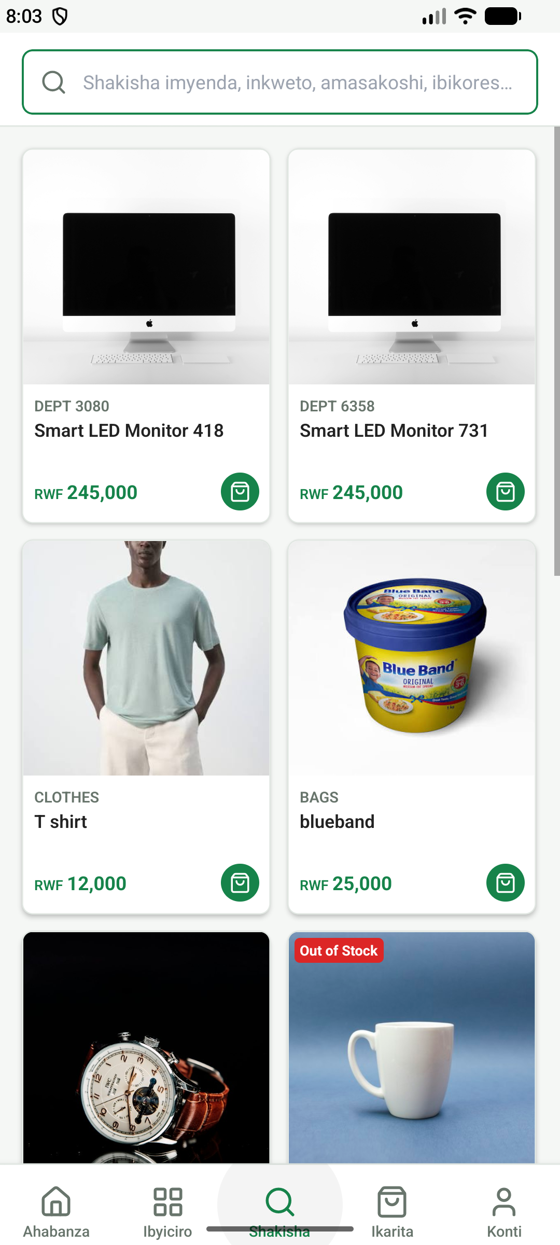 | User Role: Customer  Feature: Live Catalog Search Interface  QA Verification: TC-CAT-04  Description & Technical Implementation:  Fast debounced search interface allowing customers to search the store catalogue by title, category, or brand name.

Figure 7: Instant Product Search Results (File: 07-product-search-results.png)
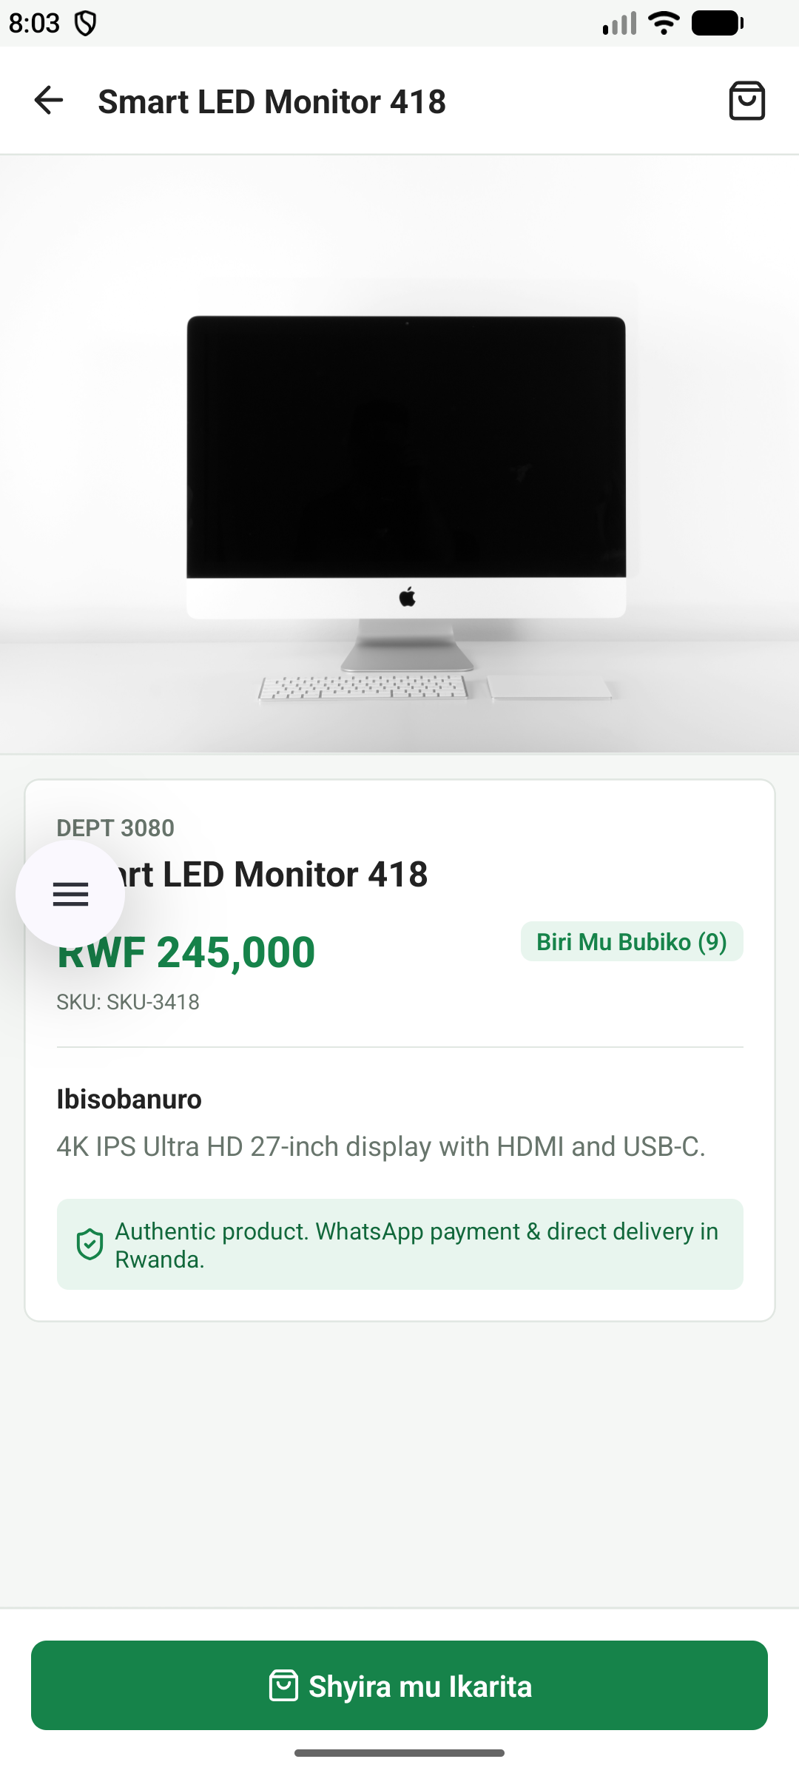 | User Role: Customer  Feature: Filtered Query Results Display  QA Verification: TC-CAT-04  Description & Technical Implementation:  Displays matching search results dynamically as the user types, with product images, formatted prices, and instant 'Add to Cart' actions.

Figure 8: Product Details Screen (Main View) (File: 08-product-details.png)
User Role: Customer
Feature: Product Specifications, Pricing & Media
QA Verification: TC-CAT-05
Description & Technical Implementation:
Detailed view showing multi-angle product photography, clear RWF pricing, unit stock availability, rating breakdown, and quantity selector.

Figure 9: Product Details Specifications & Actions (File: 09-product-details-specs.png)
User Role: Customer
Feature: Technical Specs & Add-to-Cart Flow
QA Verification: TC-CAT-05, TC-CART-01
Description & Technical Implementation:
Detailed specification attributes, warranty notes, seller terms, and prominent sticky 'Add to Cart' button with stock limit enforcement.

Figure 10: Shopping Cart & Price Calculation (File: 10-shopping-cart.png)
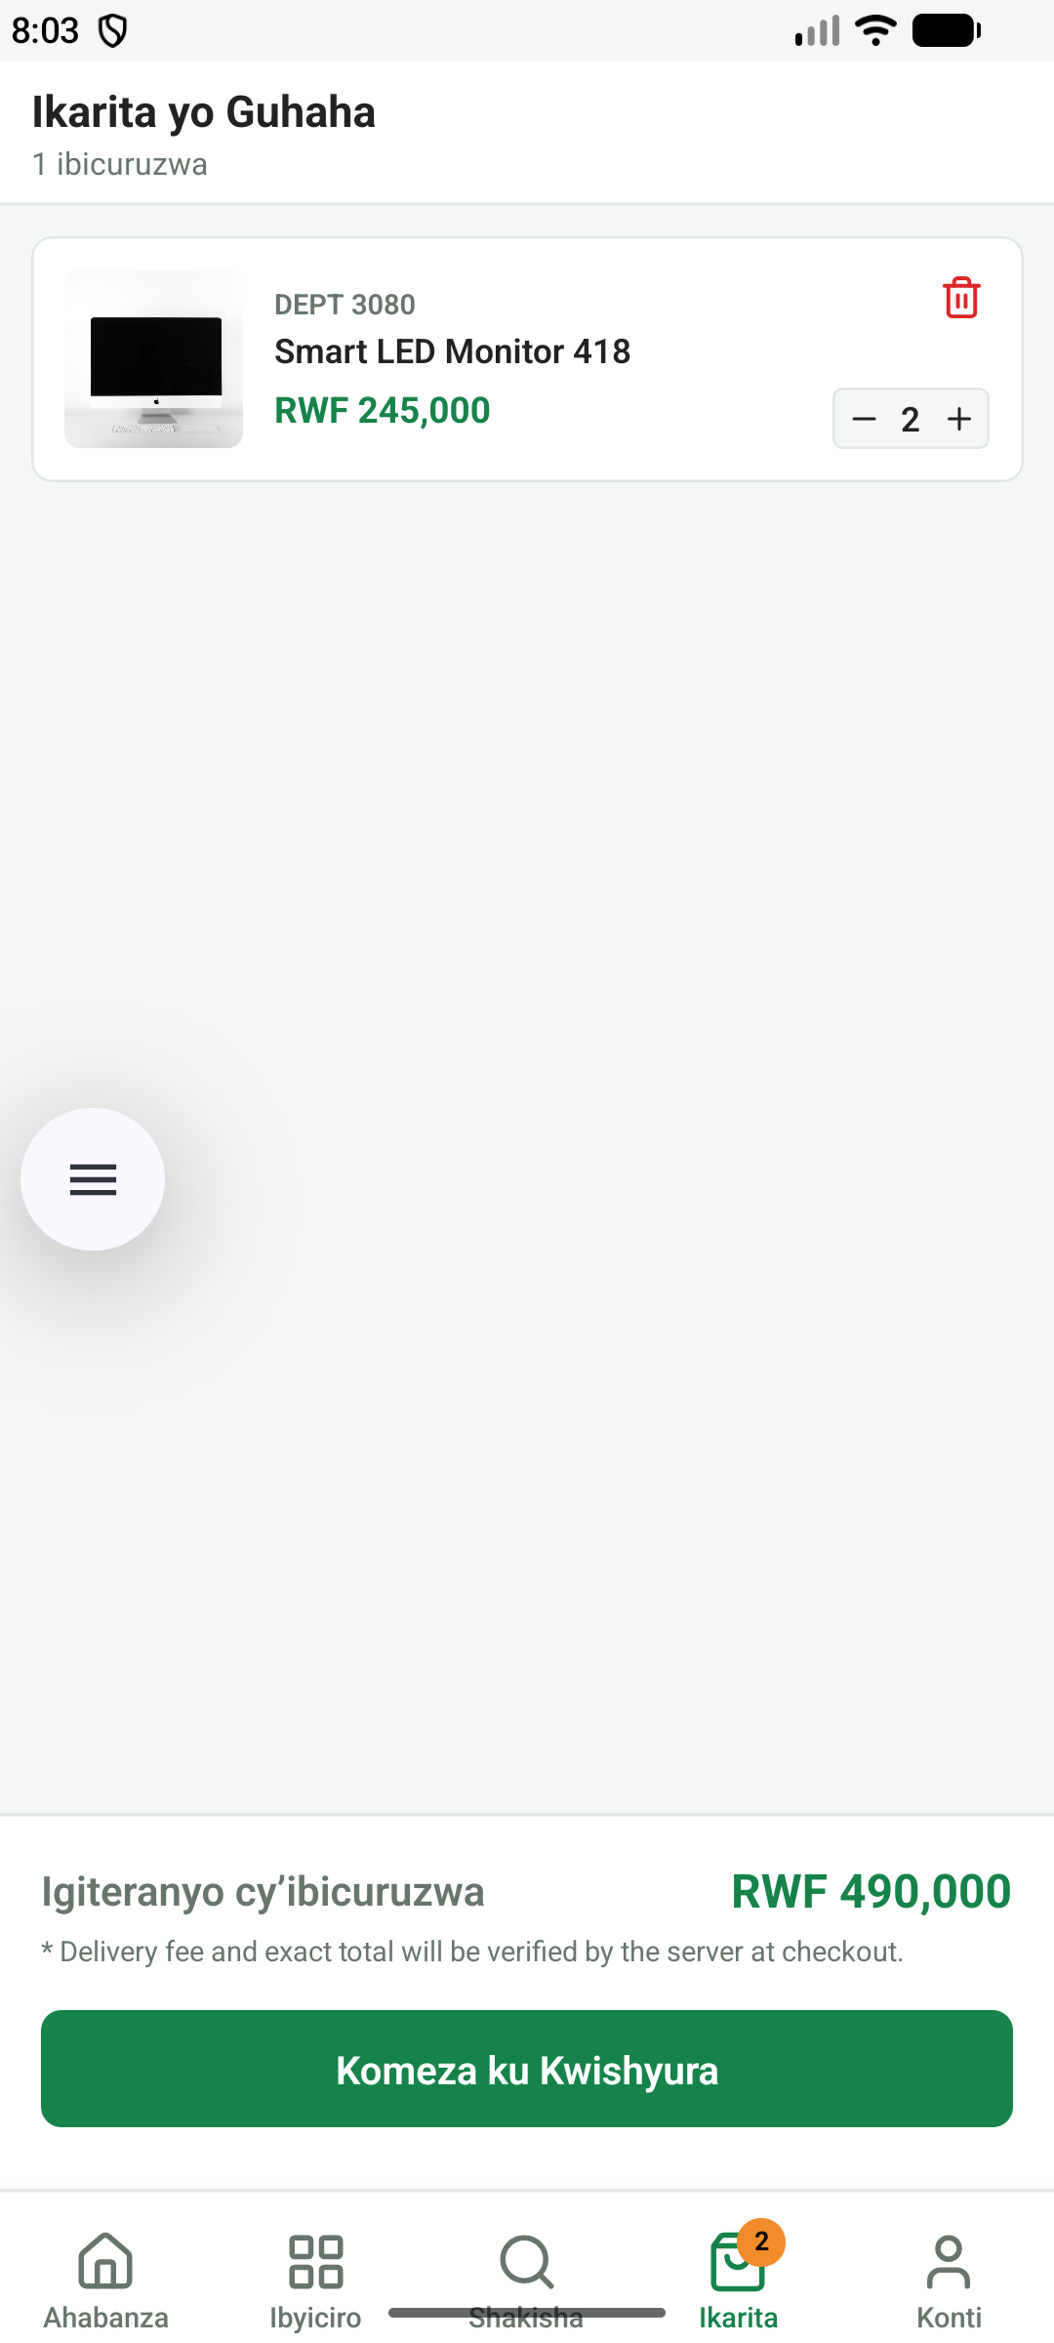 | User Role: Customer  Feature: Cart Management & Real-time Subtotaling  QA Verification: TC-CART-01, TC-CART-02, TC-CART-03  Description & Technical Implementation:  Displays added items with live quantity steppers (+/-), item removal confirmation, subtotal calculation, delivery fee estimator, and checkout CTA.

Figure 11: Delivery Details & Order Review (File: 11-checkout-screen.png)
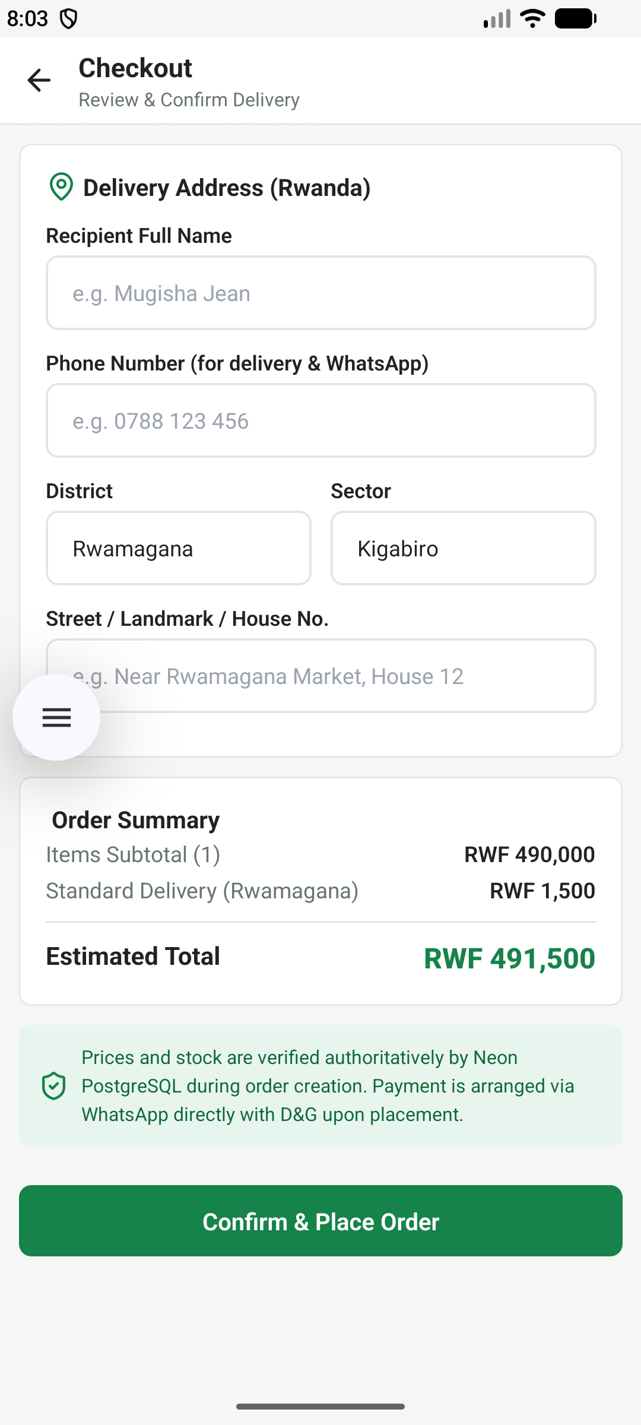 | User Role: Customer  Feature: Checkout & Order Creation Flow  QA Verification: TC-CHK-01, TC-CHK-02, TC-CHK-03  Description & Technical Implementation:  Captures customer shipping address in Rwamagana/Kigali, delivery notes, contact phone, payment method selector (MTN MoMo, Airtel Money, Cash on Delivery), and order confirmation.

Figure 12: User Account & Role Profile (File: 12-admin-account-profile.png)
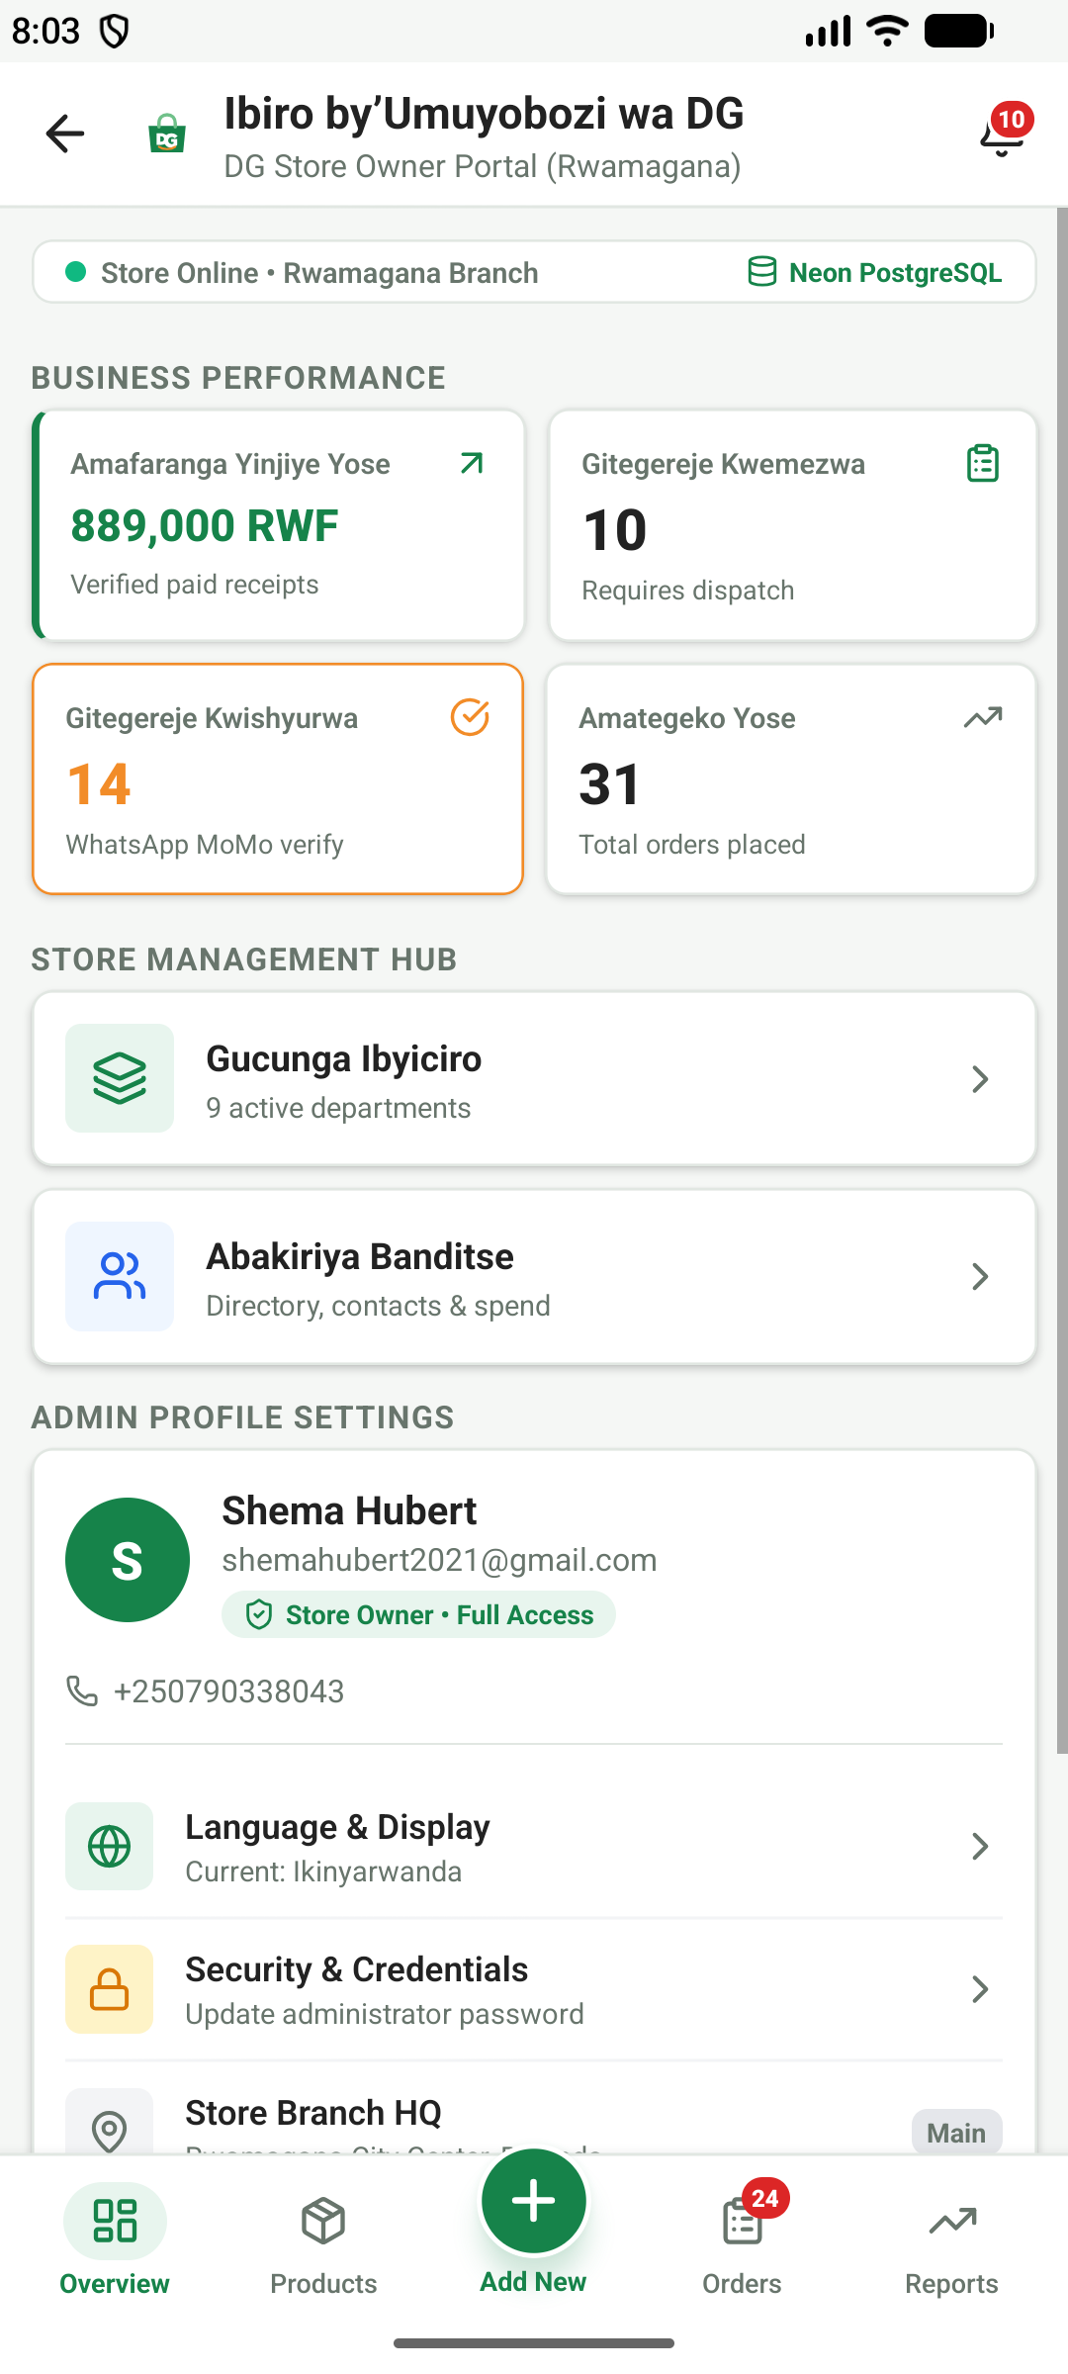 | User Role: Customer / Admin  Feature: Profile Info, Settings & Language Selector  QA Verification: TC-PROF-01, TC-PROF-02, TC-PROF-03  Description & Technical Implementation:  Displays authenticated user information, email, phone, role badge (Administrator/Customer), password update entry, and bilingual toggle (English / Ikinyarwanda).

Figure 13: Admin Operations Hub (File: 13-admin-dashboard.png)
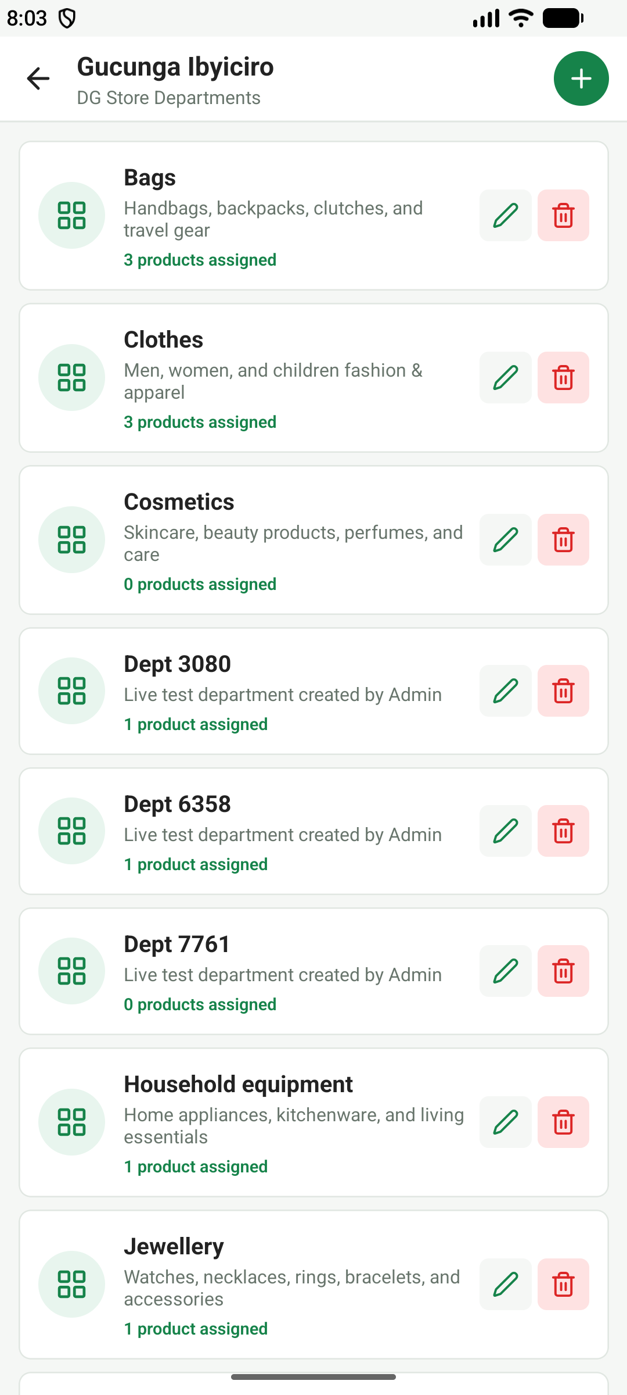 | User Role: Administrator (Owner)  Feature: Store Management Navigation Menu  QA Verification: TC-ADM-AUTH-01, TC-ADM-DASH-01  Description & Technical Implementation:  Admin console entry offering direct navigation to Products Inventory, Category Management, Order Processing, Payment Verification, and Financial Reports.

Figure 14: Admin Dashboard Executive Metrics (File: 14-admin-dashboard-overview.png)
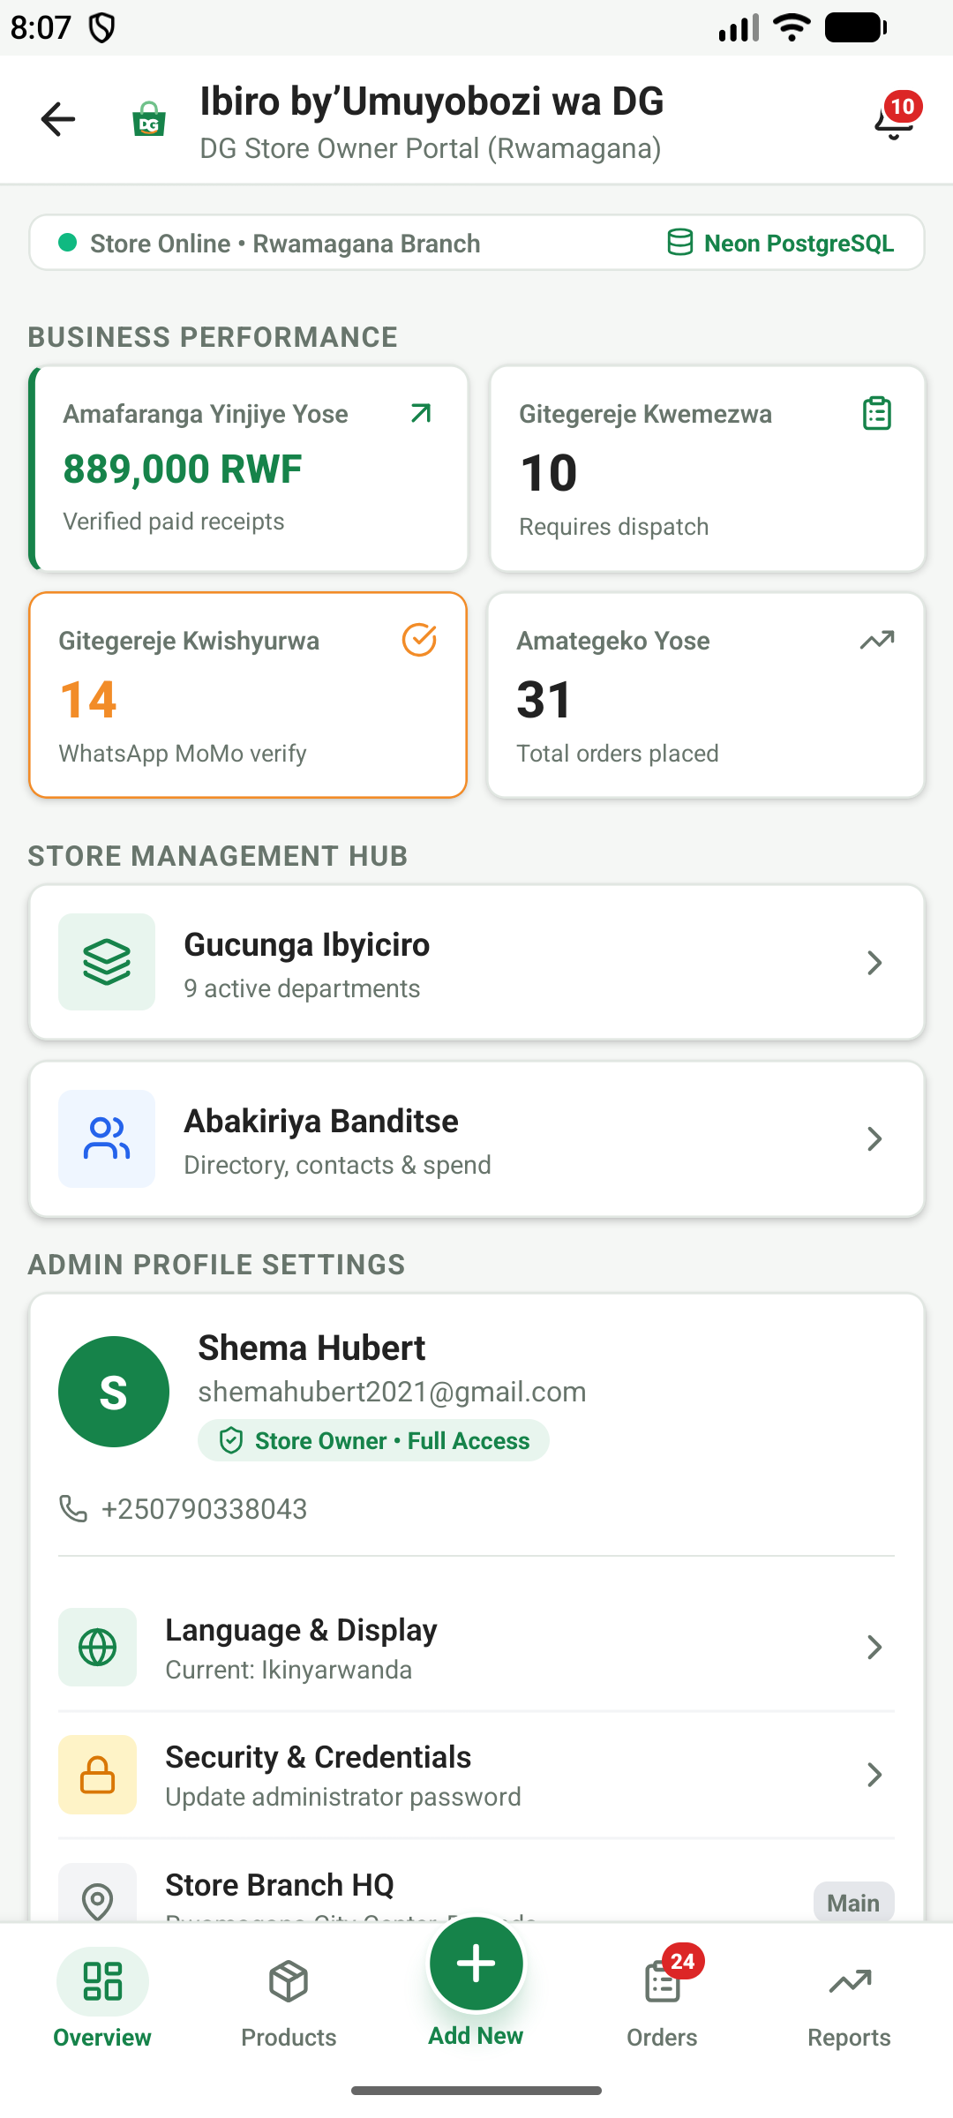 | User Role: Administrator (Owner)  Feature: Real-time Store KPIs & Summary Cards  QA Verification: TC-ADM-DASH-01, TC-ADM-DASH-02  Description & Technical Implementation:  High-level summary displaying Total Revenue (RWF), Total Orders Count, Active Catalog Items, and Registered Customers with trend indicators.

Figure 15: Admin Financial & Fulfillment Metrics (File: 15-admin-financial-metrics.png)
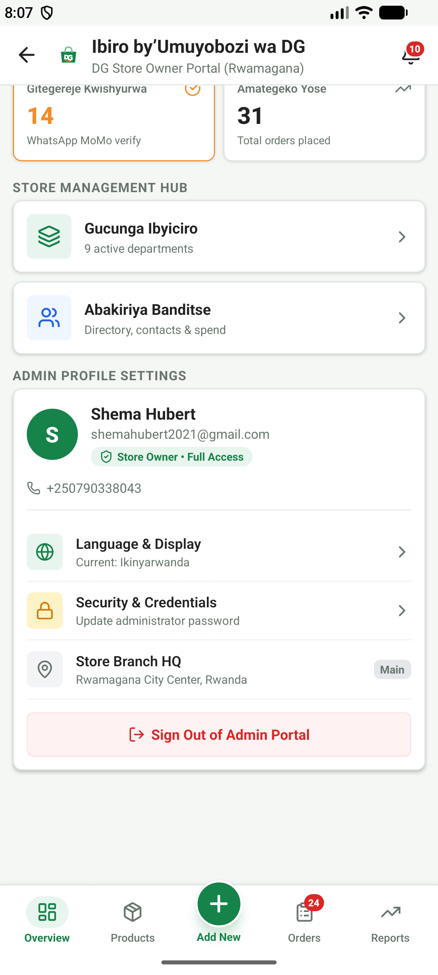 | User Role: Administrator (Owner)  Feature: Revenue Breakdown & Order Pipeline  QA Verification: TC-ADM-DASH-02, TC-ADM-REP-01  Description & Technical Implementation:  Visual breakdown of revenue by payment method (MTN Mobile Money vs Airtel vs Cash), pending fulfillment orders, and daily average volume.

Figure 16: Admin Products Inventory Management (File: 16-admin-products-inventory.png)
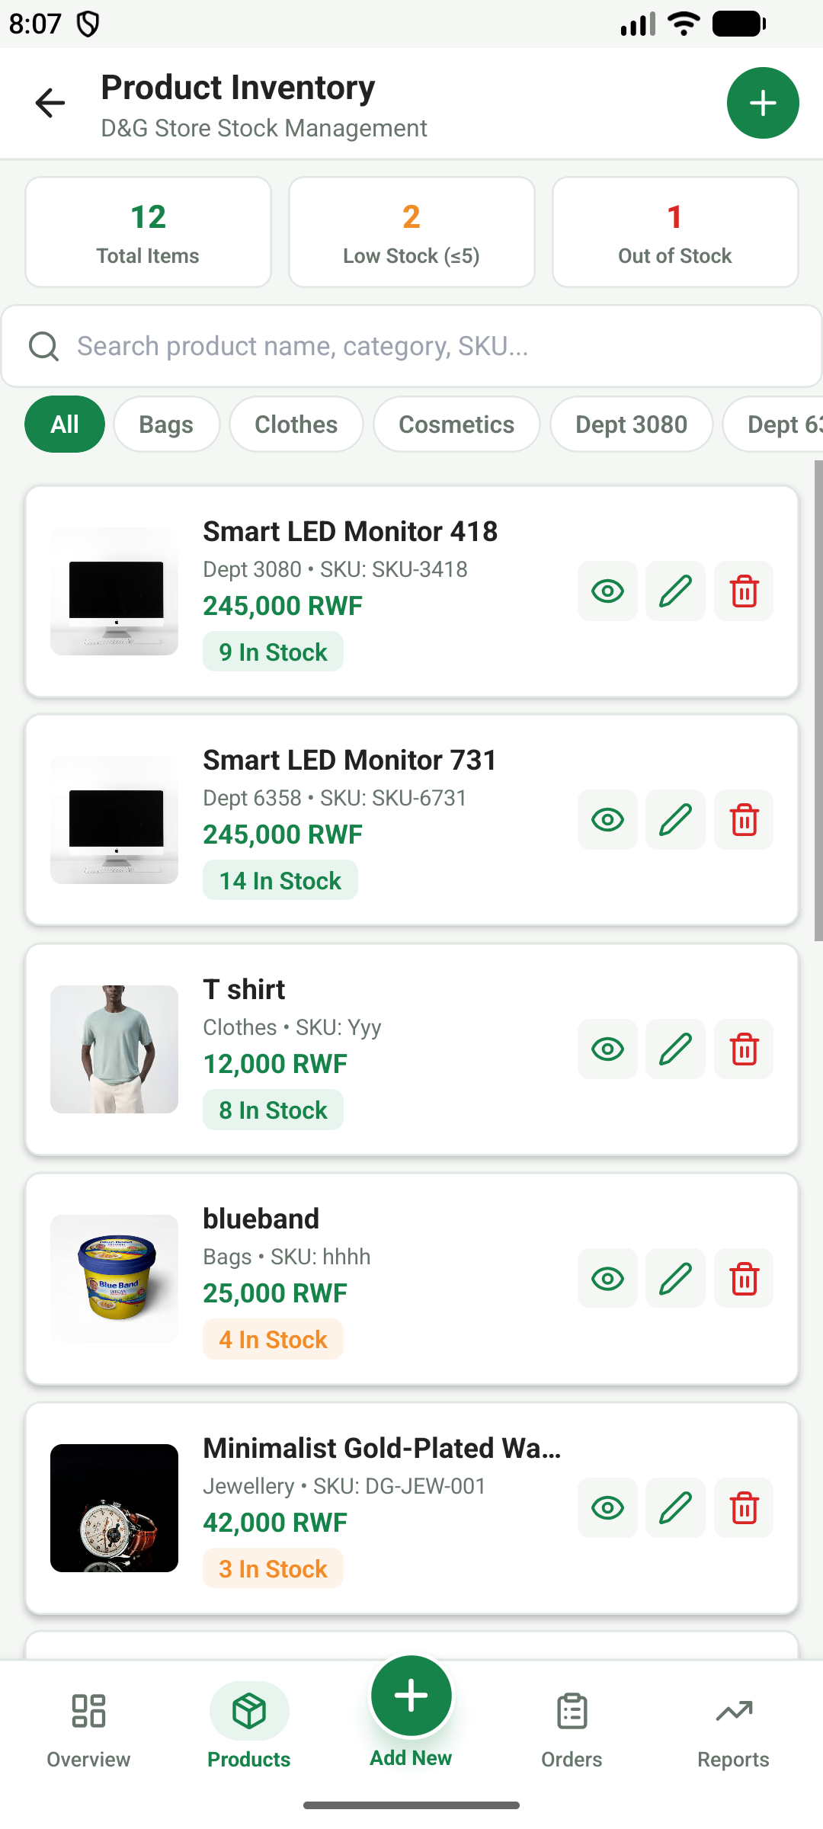 | User Role: Administrator (Owner)  Feature: Product Catalog List & Quick Actions  QA Verification: TC-ADM-PROD-01, TC-ADM-PROD-03  Description & Technical Implementation:  Administrative inventory view allowing search, filtering by stock status, direct editing of price/stock, activating/deactivating listings, and creating new products.

Figure 17: Admin Inventory Stock Badges & Alerts (File: 17-admin-products-stock-levels.png)
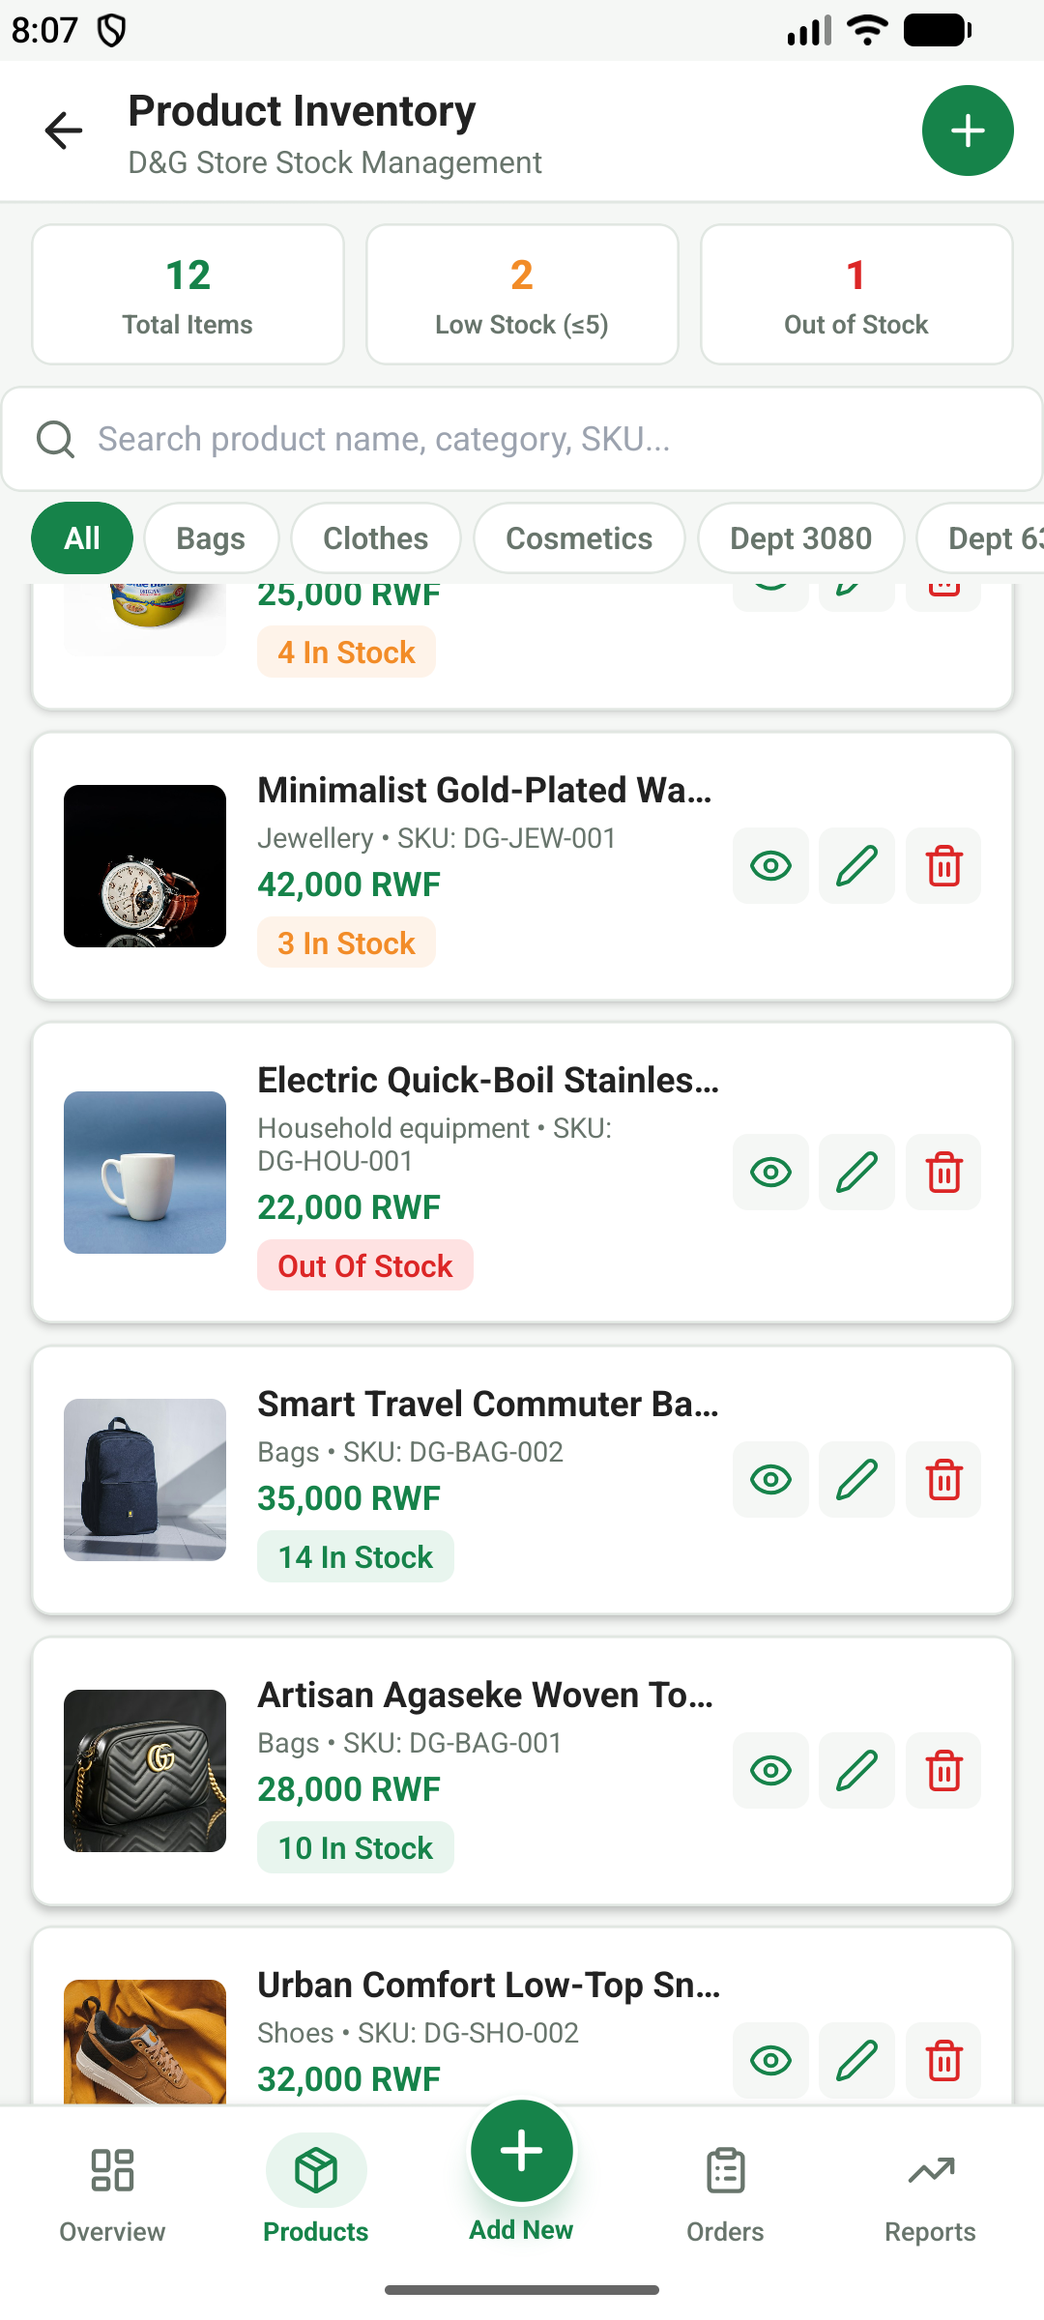 | User Role: Administrator (Owner)  Feature: Stock Monitoring & Low-Stock Alerts  QA Verification: TC-ADM-PROD-03, TC-ADM-PROD-04  Description & Technical Implementation:  Highlights low-stock items with warning badges, unit stock counts, and quick stock replenishment triggers to prevent stockouts in the Rwamagana shop.

Figure 18: Admin Customer Orders List (File: 18-admin-orders-list.png)
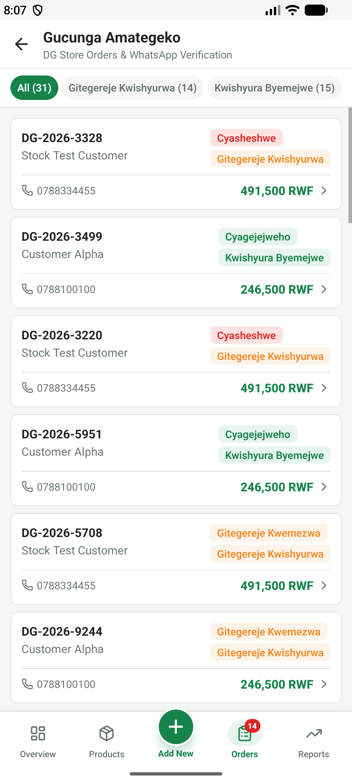 | User Role: Administrator (Owner)  Feature: Order Pipeline Management & Status Filtering  QA Verification: TC-ADM-ORD-01, TC-ADM-ORD-02  Description & Technical Implementation:  Master order list showing order reference numbers, customer names, timestamp, total RWF amount, payment status badges, and fulfillment status.

Figure 19: Admin Order Fulfillment & Status Transition (File: 19-admin-order-detail-status.png)
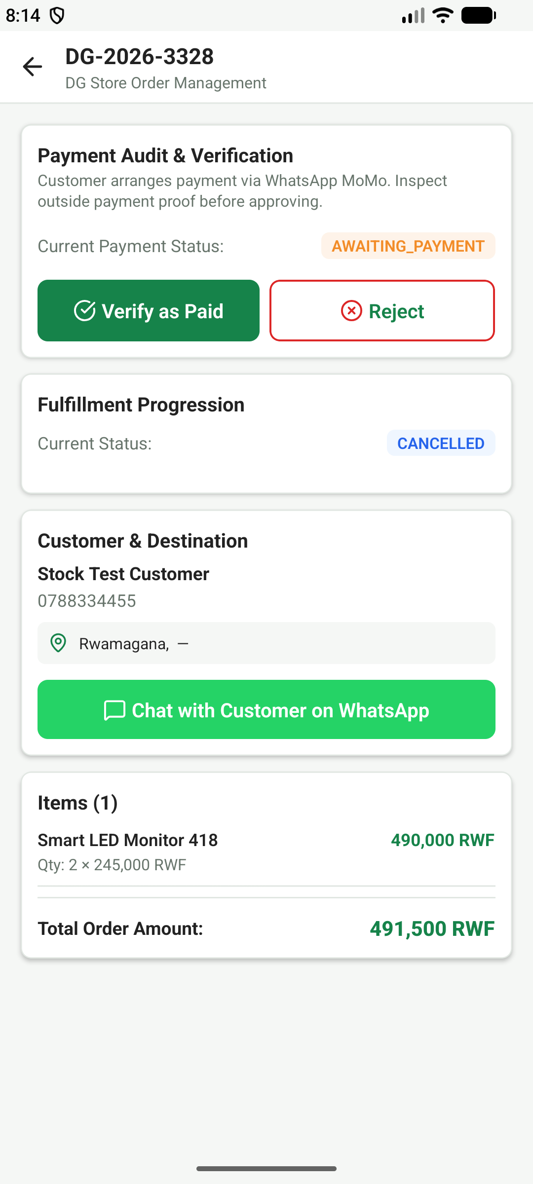 | User Role: Administrator (Owner)  Feature: Order Status Lifecycle State Machine  QA Verification: TC-ADM-ORD-02, TC-ADM-ORD-04  Description & Technical Implementation:  Order processing screen enforcing legitimate status progression (Pending -> Confirmed -> Processing -> Shipped -> Delivered) and cancellation stock restoration.

Figure 20: Admin Mobile Money Payment Verification (File: 20-admin-whatsapp-momo-verification.png)
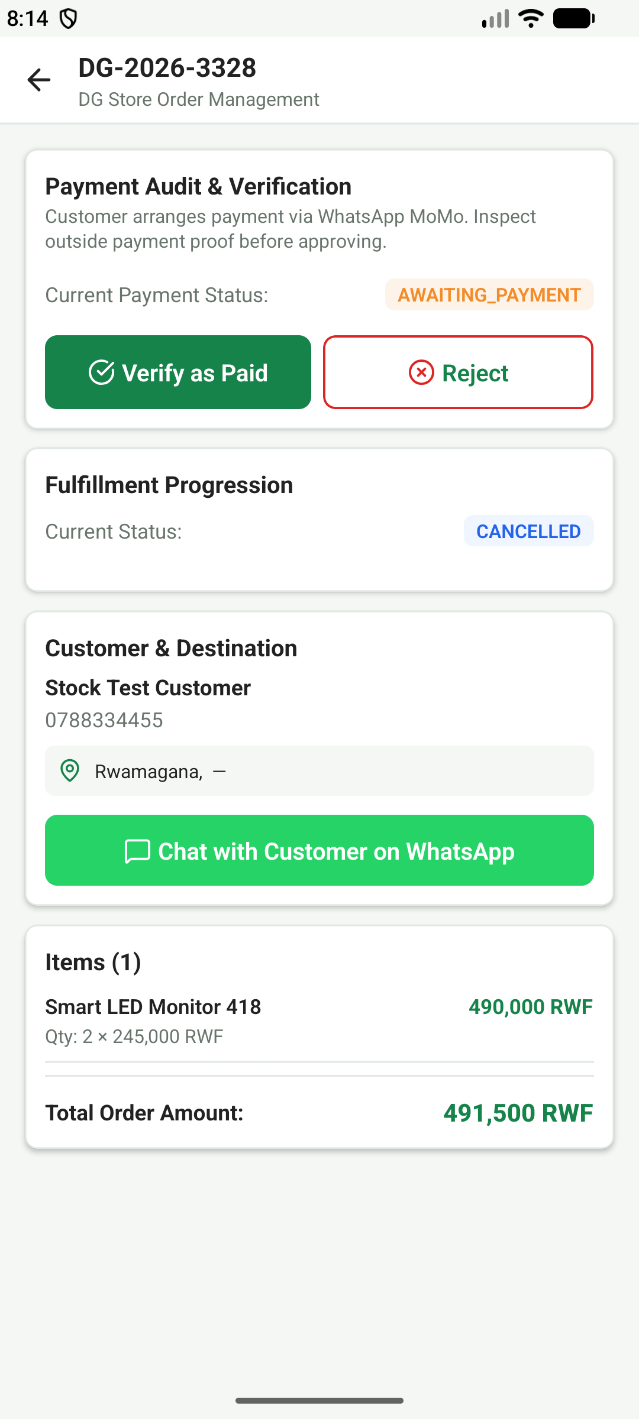 | User Role: Administrator (Owner)  Feature: Manual MoMo Verification & Audit Logging  QA Verification: TC-ADM-PAY-01, TC-ADM-PAY-02  Description & Technical Implementation:  Administrative tool to verify customer MTN MoMo/Airtel Money transaction SMS codes, attach internal verification notes, and mark payment as 'Paid'.

Figure 21: Admin Sales Reports & Performance Analytics (File: 21-admin-sales-reports.png)
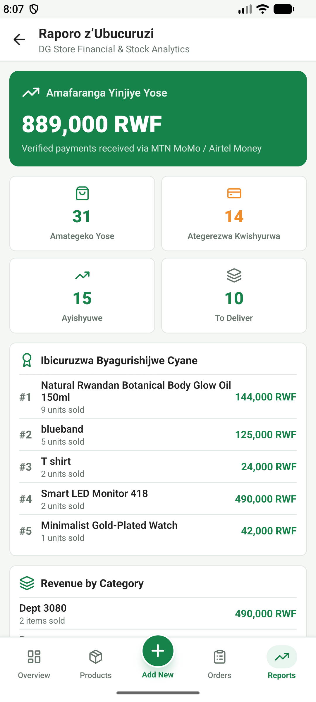 | User Role: Administrator (Owner)  Feature: Historical Sales Analytics & Department Revenue  QA Verification: TC-ADM-REP-01, TC-ADM-REP-02  Description & Technical Implementation:  Detailed financial reports displaying total sales, top selling items, category revenue breakdown, and exportable business statistics.

Figure 22: Admin Customer Analytics & Directory (File: 22-admin-reports-analytics.png)
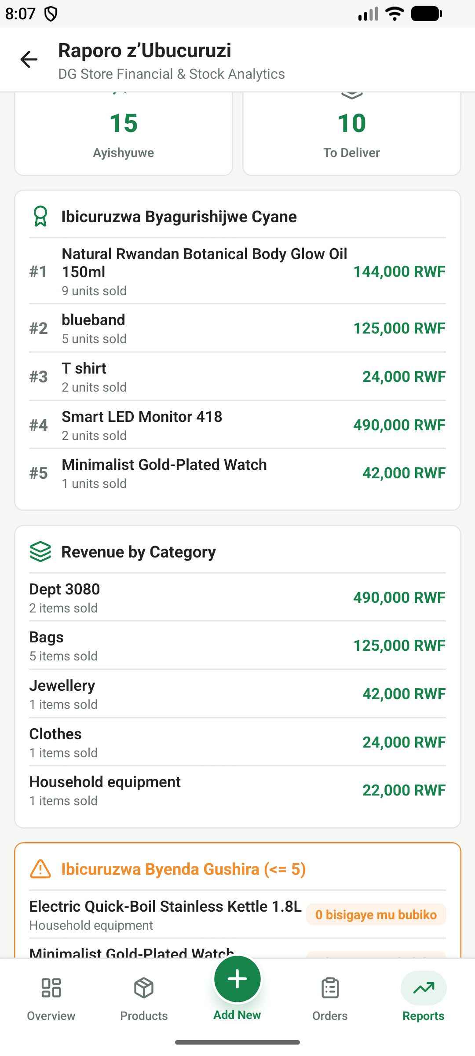 | User Role: Administrator (Owner)  Feature: Customer Lifetime Value & Ordering Habits  QA Verification: TC-ADM-CUST-01, TC-ADM-CUST-02  Description & Technical Implementation:  Customer analysis table listing registered shoppers, their historical order counts, total RWF spent, and direct contact options for customer service.

Figure 23: Home Screen - English Language Mode (File: 21-home-english-language.png)
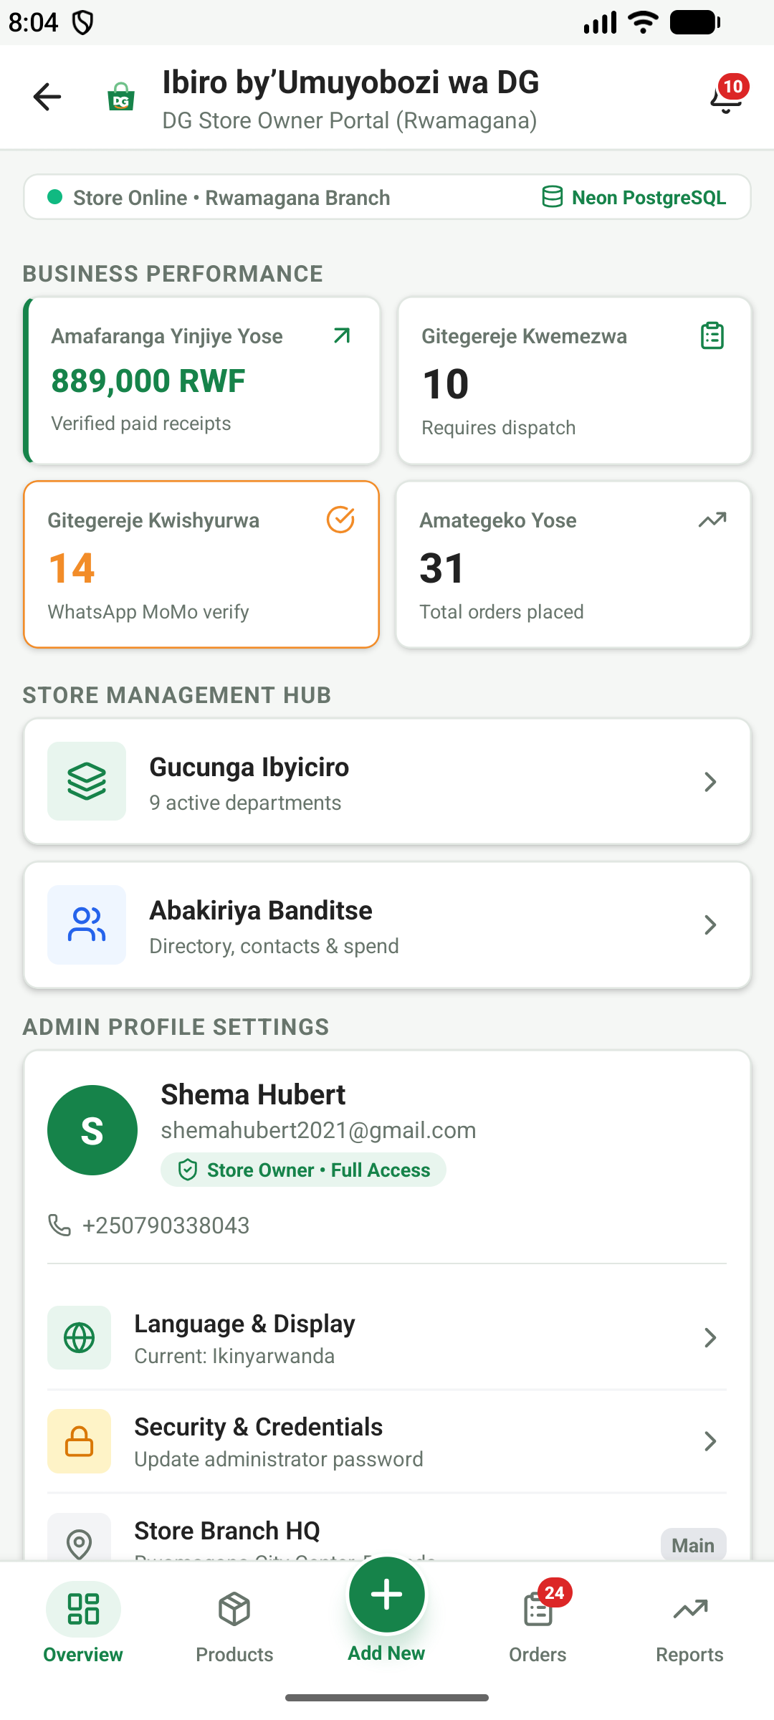 | User Role: Customer / System  Feature: Bilingual Localization (English Interface)  QA Verification: TC-LOC-01  Description & Technical Implementation:  Demonstrates the complete user interface rendered in English, including localized labels, currency formatting (RWF), and navigation tabs.

Figure 24: In-App Notification Center (File: 22-notification-center.png)
User Role: Customer / Admin
Feature: Push & In-App Order Updates
QA Verification: TC-NOTIF-01, TC-NOTIF-02
Description & Technical Implementation:
Notification feed showing chronological alerts for order placement, payment verification, dispatch, and delivery updates with unread count badges.

