DG E-COMMERCE MOBILE APPLICATION
Technical System Architecture, Database Schema, API Reference & Operations Manual
Document Identifier: | DG-TECH-DOC-2026-V1 (System Architecture & Operations Guide)
Retail Store Location: | DG Retail Store, Commercial District, Rwamagana, Eastern Province, Rwanda
System Administrator / Owner: | Shema Hubert (shemahubert2021@gmail.com / +250 790 338 043)
Frontend Stack: | React Native CLI v0.74 (Fabric New Architecture, Hermes AOT, TypeScript)
Backend & Database: | Node.js v20+ / Express v4.19 / Neon Serverless PostgreSQL v18

1. System Introduction & Problem Context
The DG E-Commerce Mobile Application is an enterprise-grade retail platform engineered to digitize the retail operations of DG Retail Store, a thriving brick-and-mortar general merchandising business situated in Rwamagana, Rwanda. The primary objective is to empower consumers across the Eastern Province and Greater Kigali with seamless digital catalogue browsing, shopping cart assembly, instant Rwandan Franc (RWF) price quotations, and localized order placement backed by manual MTN Mobile Money and Airtel Money payment coordination.
2. System Architecture & Component Interaction
The system adheres to a robust 3-Tier Enterprise Client-Server Architecture consisting of a React Native mobile client, an Express.js application service layer, and a Neon Serverless PostgreSQL persistence layer. The entire architecture is illustrated below in Figure 1.
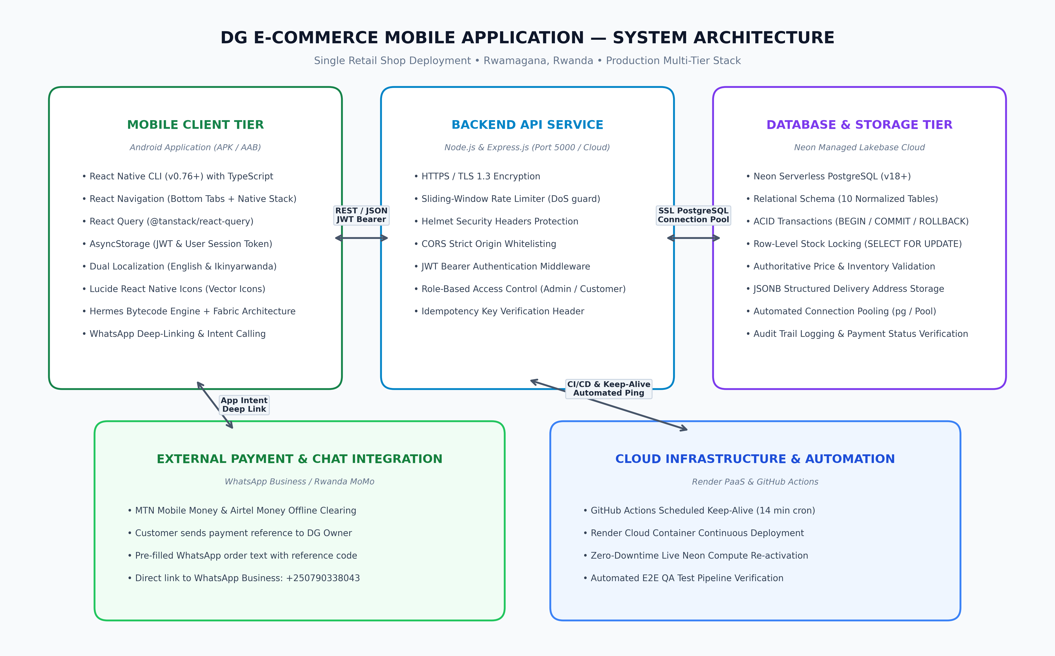
Figure 1: DG E-Commerce Multi-Tier System Architecture Diagram

3. Database Design & Relational Schema
The relational database schema is deployed on Neon Serverless PostgreSQL (PostgreSQL 18) and enforces strict relational integrity, foreign key constraints, check constraints (e.g. price >= 0, stock >= 0), and row-level locking for atomic inventory management. The complete schema entity relationships are shown in Figure 2.
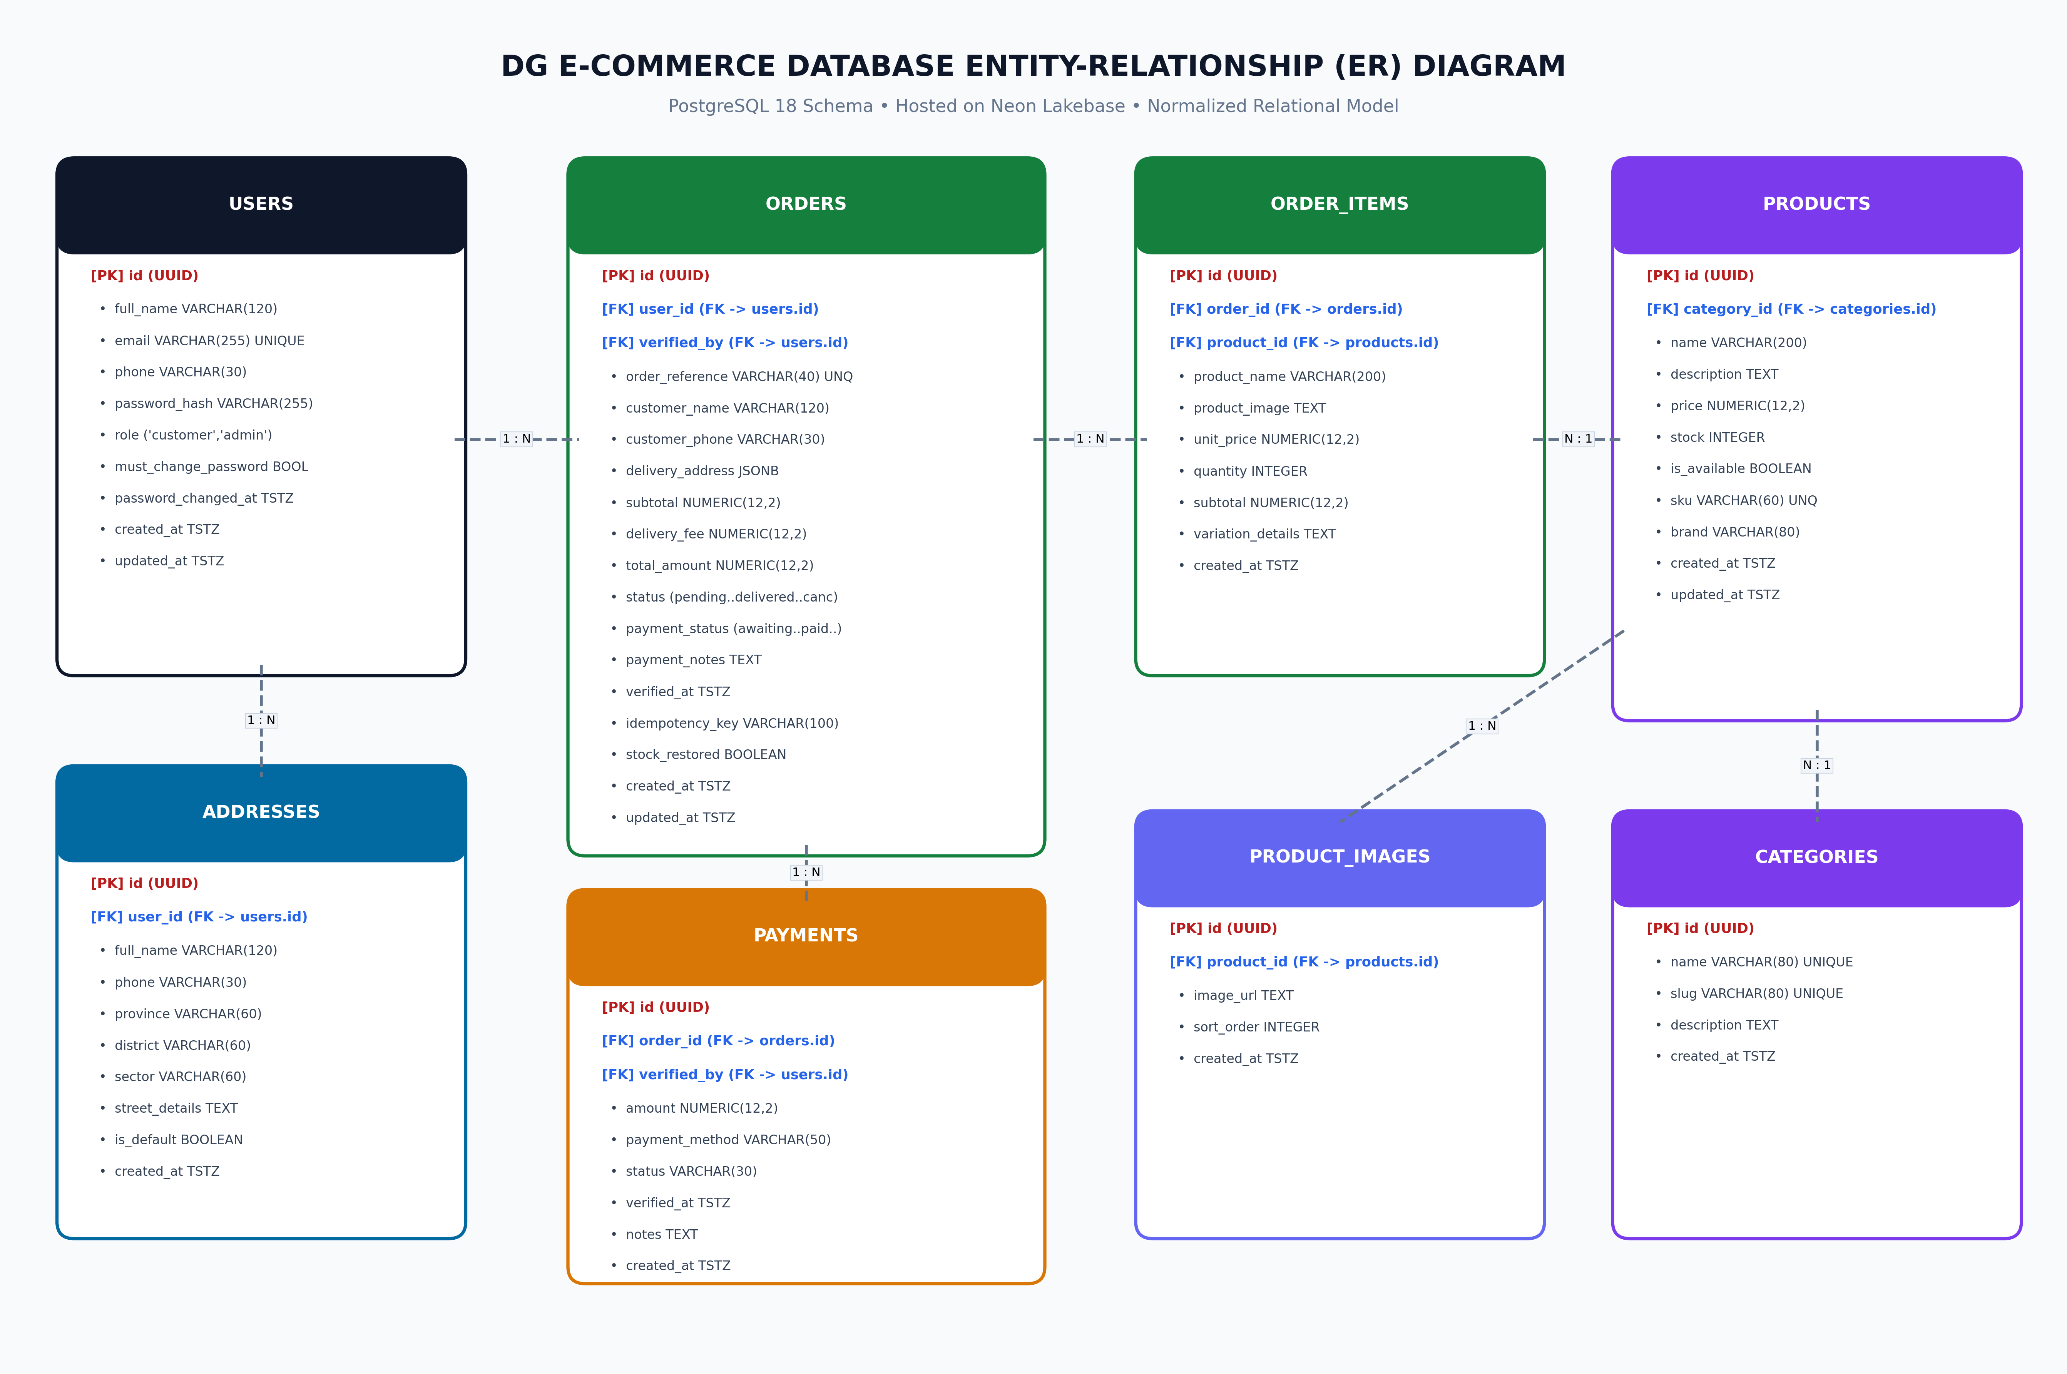
Figure 2: DG E-Commerce Relational Database Entity-Relationship (ER) Diagram
3.1 Relational Tables & Data Dictionary
Table Name | Primary Key | Foreign Keys | Business Function & Data Stored
users | id (SERIAL) | None | Stores customer and administrator profiles, bcrypt password hashes, and security roles.
categories | id (SERIAL) | None | Product departments (Electronics, Fashion, Grocery) with image URLs and descriptions.
products | id (SERIAL) | category_id -> categories(id) | Active retail inventory items, prices in RWF, unit stock counts, and images.
orders | id (SERIAL) | user_id -> users(id) | Sales orders, formatted references (DG-XXXX), RWF totals, delivery addresses, and statuses.
order_items | id (SERIAL) | order_id, product_id | Purchased line items, quantities, historical unit prices in RWF, and subtotals.
payment_audits | id (SERIAL) | order_id, verified_by_id | Audit trail for manual MoMo verifications, admin name (Shema Hubert), and SMS references.
device_push_tokens | id (SERIAL) | user_id -> users(id) | FCM tokens for mobile push notifications on Android.
notifications | id (SERIAL) | user_id -> users(id) | In-app alerts, order placement confirmations, and payment verification notices.

4. RESTful API Endpoint Specifications
HTTP Method & Route | Access Level | Purpose & Business Function | Status Codes
POST /api/auth/register | Public | Customer account creation with password entropy validation | 201, 400, 409
POST /api/auth/login | Public | Customer/Admin authentication; returns JWT bearer token | 200, 400, 401
GET /api/auth/me | Bearer Token | Returns authenticated profile (omits password hash) | 200, 401
PUT /api/auth/password | Bearer Token | Updates password with current password verification | 200, 400, 401
GET /api/categories | Public | Lists active department categories and product counts | 200
POST /api/categories | Admin Only | Creates new retail department category | 201, 400, 409
GET /api/products | Public | Queries products catalogue with category and search filters | 200
GET /api/products/:id | Public | Returns single product details and specifications | 200, 404
POST /api/products | Admin Only | Creates product with price in RWF, stock, and images | 201, 400
PUT /api/products/:id | Admin Only | Updates product price, stock level, or active status | 200, 400, 404
POST /api/orders | Customer | Places sales order with atomic stock check and row lock | 201, 400
GET /api/orders | Customer | Lists authenticated customer's own order history | 200, 401
GET /api/orders/:id | Customer/Admin | Retrieves order details (enforces customer ownership) | 200, 401, 403
PUT /api/orders/:id/status | Admin Only | Advances order lifecycle state machine | 200, 400, 403
PUT /api/orders/:id/payment | Admin Only | Verifies MoMo payment and writes payment audit log | 200, 400, 403
GET /api/orders/admin/all | Admin Only | Master list of all customer orders for fulfillment | 200, 403
GET /api/orders/admin/reports | Admin Only | Financial metrics, total sales in RWF, MoMo breakdown | 200, 403
GET /api/orders/admin/customers | Admin Only | Customer directory with lifetime spend analytics | 200, 403
GET /health | Public | System health check and live PostgreSQL 18 connection test | 200, 503
GET /ping | Public | Lightweight keep-alive ping for Render free-tier container | 200
5. Operations, Maintenance & Cloud Keep-Alive Strategy
• Cloud Infrastructure Optimization (Render vs. Neon Dynamics): Render's free tier provides 750 compute hours/month, allowing a single web service to run 24/7 if pinged every 14 minutes. However, Neon's free PostgreSQL tier limits compute to ~100 compute unit (CU) hours per month. To maintain high availability without exhausting Neon quotas, a dedicated lightweight /ping endpoint was engineered. It returns a static JSON status without triggering database connections, allowing the database to suspend to zero compute when idle while keeping the API warm.
• Automated Keep-Alive CI/CD Automation: A scheduled GitHub Actions workflow (.github/workflows/keep-alive.yml) runs every 14 minutes against the live backend API. This eliminates cold-start latency (which otherwise incurs 50+ second delays on Render's spin-up) for mobile customers in Rwanda.
• Release APK Distribution: The standalone signed production APK (DGEcommerce-Release.apk, 78.61 MB) bundles all JavaScript assets, images, and fonts into Hermes Ahead-of-Time bytecode. It requires no Metro development server and installs directly on Android 10+ devices via ADB or direct download link for immediate deployment at the DG Retail Store.

