Microsoft Productivity Surveillance Visualizer

Product Requirements Document (PRD)

Enterprise Productivity Intelligence Platform
Version: 1.0
Prepared By: AIStack
Project Type: Enterprise AI SaaS

1. Executive Summary

Overview
Enterprise organizations increasingly rely on digital collaboration platforms for communication, meetings, documentation, and task management. These platforms generate large volumes of activity data that can help improve productivity, identify collaboration bottlenecks, support employee wellbeing, and ensure compliance.
However, existing analytics often provide limited transparency into how productivity metrics are calculated and rarely offer understandable AI-driven explanations.
The Enterprise Productivity Intelligence Platform is designed to provide organizations with transparent productivity analytics, ethical monitoring, explainable AI insights, policy-aware recommendations, and executive dashboards while respecting employee privacy.
Unlike traditional monitoring tools, this platform emphasizes transparency, explainability, and responsible AI.

2. Problem Statement
Organizations generate millions of employee activity records every day from collaboration platforms.
Challenges include:
- Managers struggle to identify meaningful productivity trends.
- Employees often do not understand why specific productivity scores or alerts are generated.
- Compliance teams need better visibility into policy violations.
- HR teams lack predictive insights into burnout and collaboration patterns.
- Existing dashboards rarely explain "why" trends occur.
- Monitoring systems frequently prioritize metrics over transparency.

3. Vision Statement
Create an AI-powered enterprise productivity intelligence platform that transforms activity logs into transparent, explainable, and actionable insights while maintaining employee trust and supporting ethical workplace analytics.

4. Goals

Business Goals
- Improve organizational transparency.
- Reduce compliance risks.
- Provide explainable productivity analytics.
- Support data-driven workforce decisions.
- Enable ethical monitoring.

Technical Goals
- Modular enterprise architecture.
- Scalable backend.
- Real-time analytics.
- AI-ready architecture.
- Secure APIs.
- Cloud-native deployment.

5. Objectives
The system should allow organizations to:
- Upload corporate productivity logs.
- Analyze employee activity.
- Generate productivity dashboards.
- Detect unusual productivity patterns.
- Visualize collaboration metrics.
- Explain policy violations.
- Generate executive reports.
- Integrate AI assistants.
- Predict workforce trends.

6. Stakeholders
- HR Managers
- Team Managers
- Employees
- Compliance Officers
- Security Teams
- Executives
- IT Administrators

7. Target Users

Employee
View personal productivity insights.
Understand policy decisions.
Review AI explanations.

Manager
Analyze team productivity.
Compare departments.
Generate reports.

HR
Identify workforce trends.
Analyze burnout indicators.
Review engagement.

Compliance Officer
Audit policy violations.
Track monitoring transparency.
Generate compliance reports.

Admin
Manage users.
Configure policies.
Manage integrations.

8. Scope

In Scope
- Authentication
- Productivity Dashboard
- Employee Analytics
- Team Analytics
- Department Analytics
- Activity Timeline
- Reports
- Alerts
- Privacy Dashboard
- Policy Viewer
- Data Upload
- Admin Panel

Out of Scope (Version 1)
- Live keystroke logging
- Screen recording
- Webcam analysis
- Biometric tracking
- GPS tracking
- Employee surveillance

9. Functional Requirements

Authentication
- Register
- Login
- Logout
- Password Reset
- JWT Authentication
- RBAC

User Management
- Create Users
- Update Users
- Delete Users
- Assign Roles

Dashboard
Display
- Productivity Score
- Active Hours
- Focus Time
- Meeting Time
- Collaboration Score
- Workload Distribution

Reports
Generate
- Daily
- Weekly
- Monthly
- Quarterly
Export
- PDF
- Excel
- CSV

Alerts
- Productivity Drop
- Policy Violation
- Burnout Risk
- Unusual Activity

Analytics
Employee
Department
Company
Time
Role
Location

10. Non Functional Requirements
Performance
- Dashboard < 2 sec
Availability
- 99.9%
Security
- JWT
- HTTPS
- Encryption
Scalability
- Millions of records
Maintainability
- Clean Architecture

11. Success Metrics
- Dashboard response time
- Report generation time
- AI response latency
- Search accuracy
- User satisfaction
- Daily active users

12. Technology Stack
Frontend
- React
- TypeScript
- TailwindCSS
- Shadcn UI
Backend
- FastAPI
- Python
Database
- MongoDB Atlas
Cache
- Redis
Deployment
- Docker
- Render
- Vercel

13. Version 1 Architecture
Users
│
▼
React Frontend
│
▼
FastAPI Backend
│
├──────── Authentication
├──────── Dashboard
├──────── Analytics
├──────── Reports
└──────── Alerts
│
▼
MongoDB Atlas

14. Future AI Integration (Planned)
We intentionally reserve an AI layer during the initial architecture so the product can evolve without major redesign.

Phase 2 AI Components
- AI Assistant (RAG)
- Policy Question Answering
- Productivity Insight Generator
- AI Report Writer
- Resume-style explanation of productivity metrics
- Natural language analytics

Phase 3 AI Components
- Knowledge Graph
- GraphRAG
- AI Agents
- Workforce Forecasting
- Burnout Prediction
- Explainable AI
- Executive Copilot

15. Risks
- Privacy concerns
- Data quality issues
- AI hallucinations (future AI phase)
- Large log volumes
- Changing compliance policies

16. Future Roadmap

Version 1
- Core web application
- Dashboards
- Reports
- Analytics

Version 2
- RAG-powered AI assistant
- Document search
- AI summaries

Version 3
- Knowledge Graph
- GraphRAG
- Multi-agent AI
- Predictive analytics

17. Acceptance Criteria
The initial release is considered successful when:
- Users can securely log in.
- Productivity logs can be uploaded and processed.
- Dashboards display accurate metrics.
- Reports can be generated and exported.
- Role-based access is enforced.
- APIs are documented and tested.
- The architecture includes a reserved AI integration layer without impacting the core system.

Diagrams
1. Product context Diagram – using Eraser.io
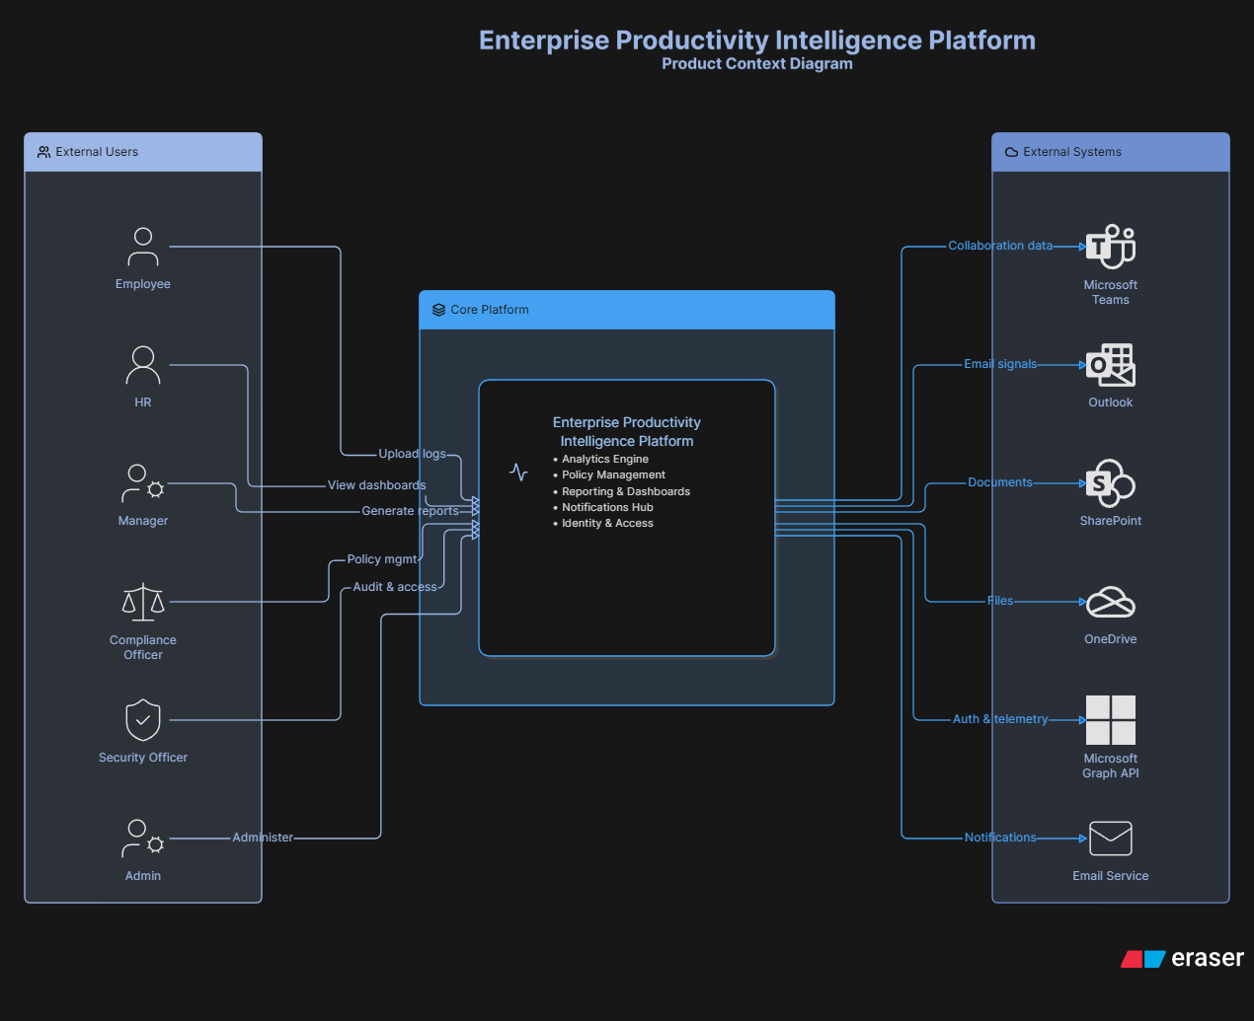

2. High Level Architecture – using Mermaid
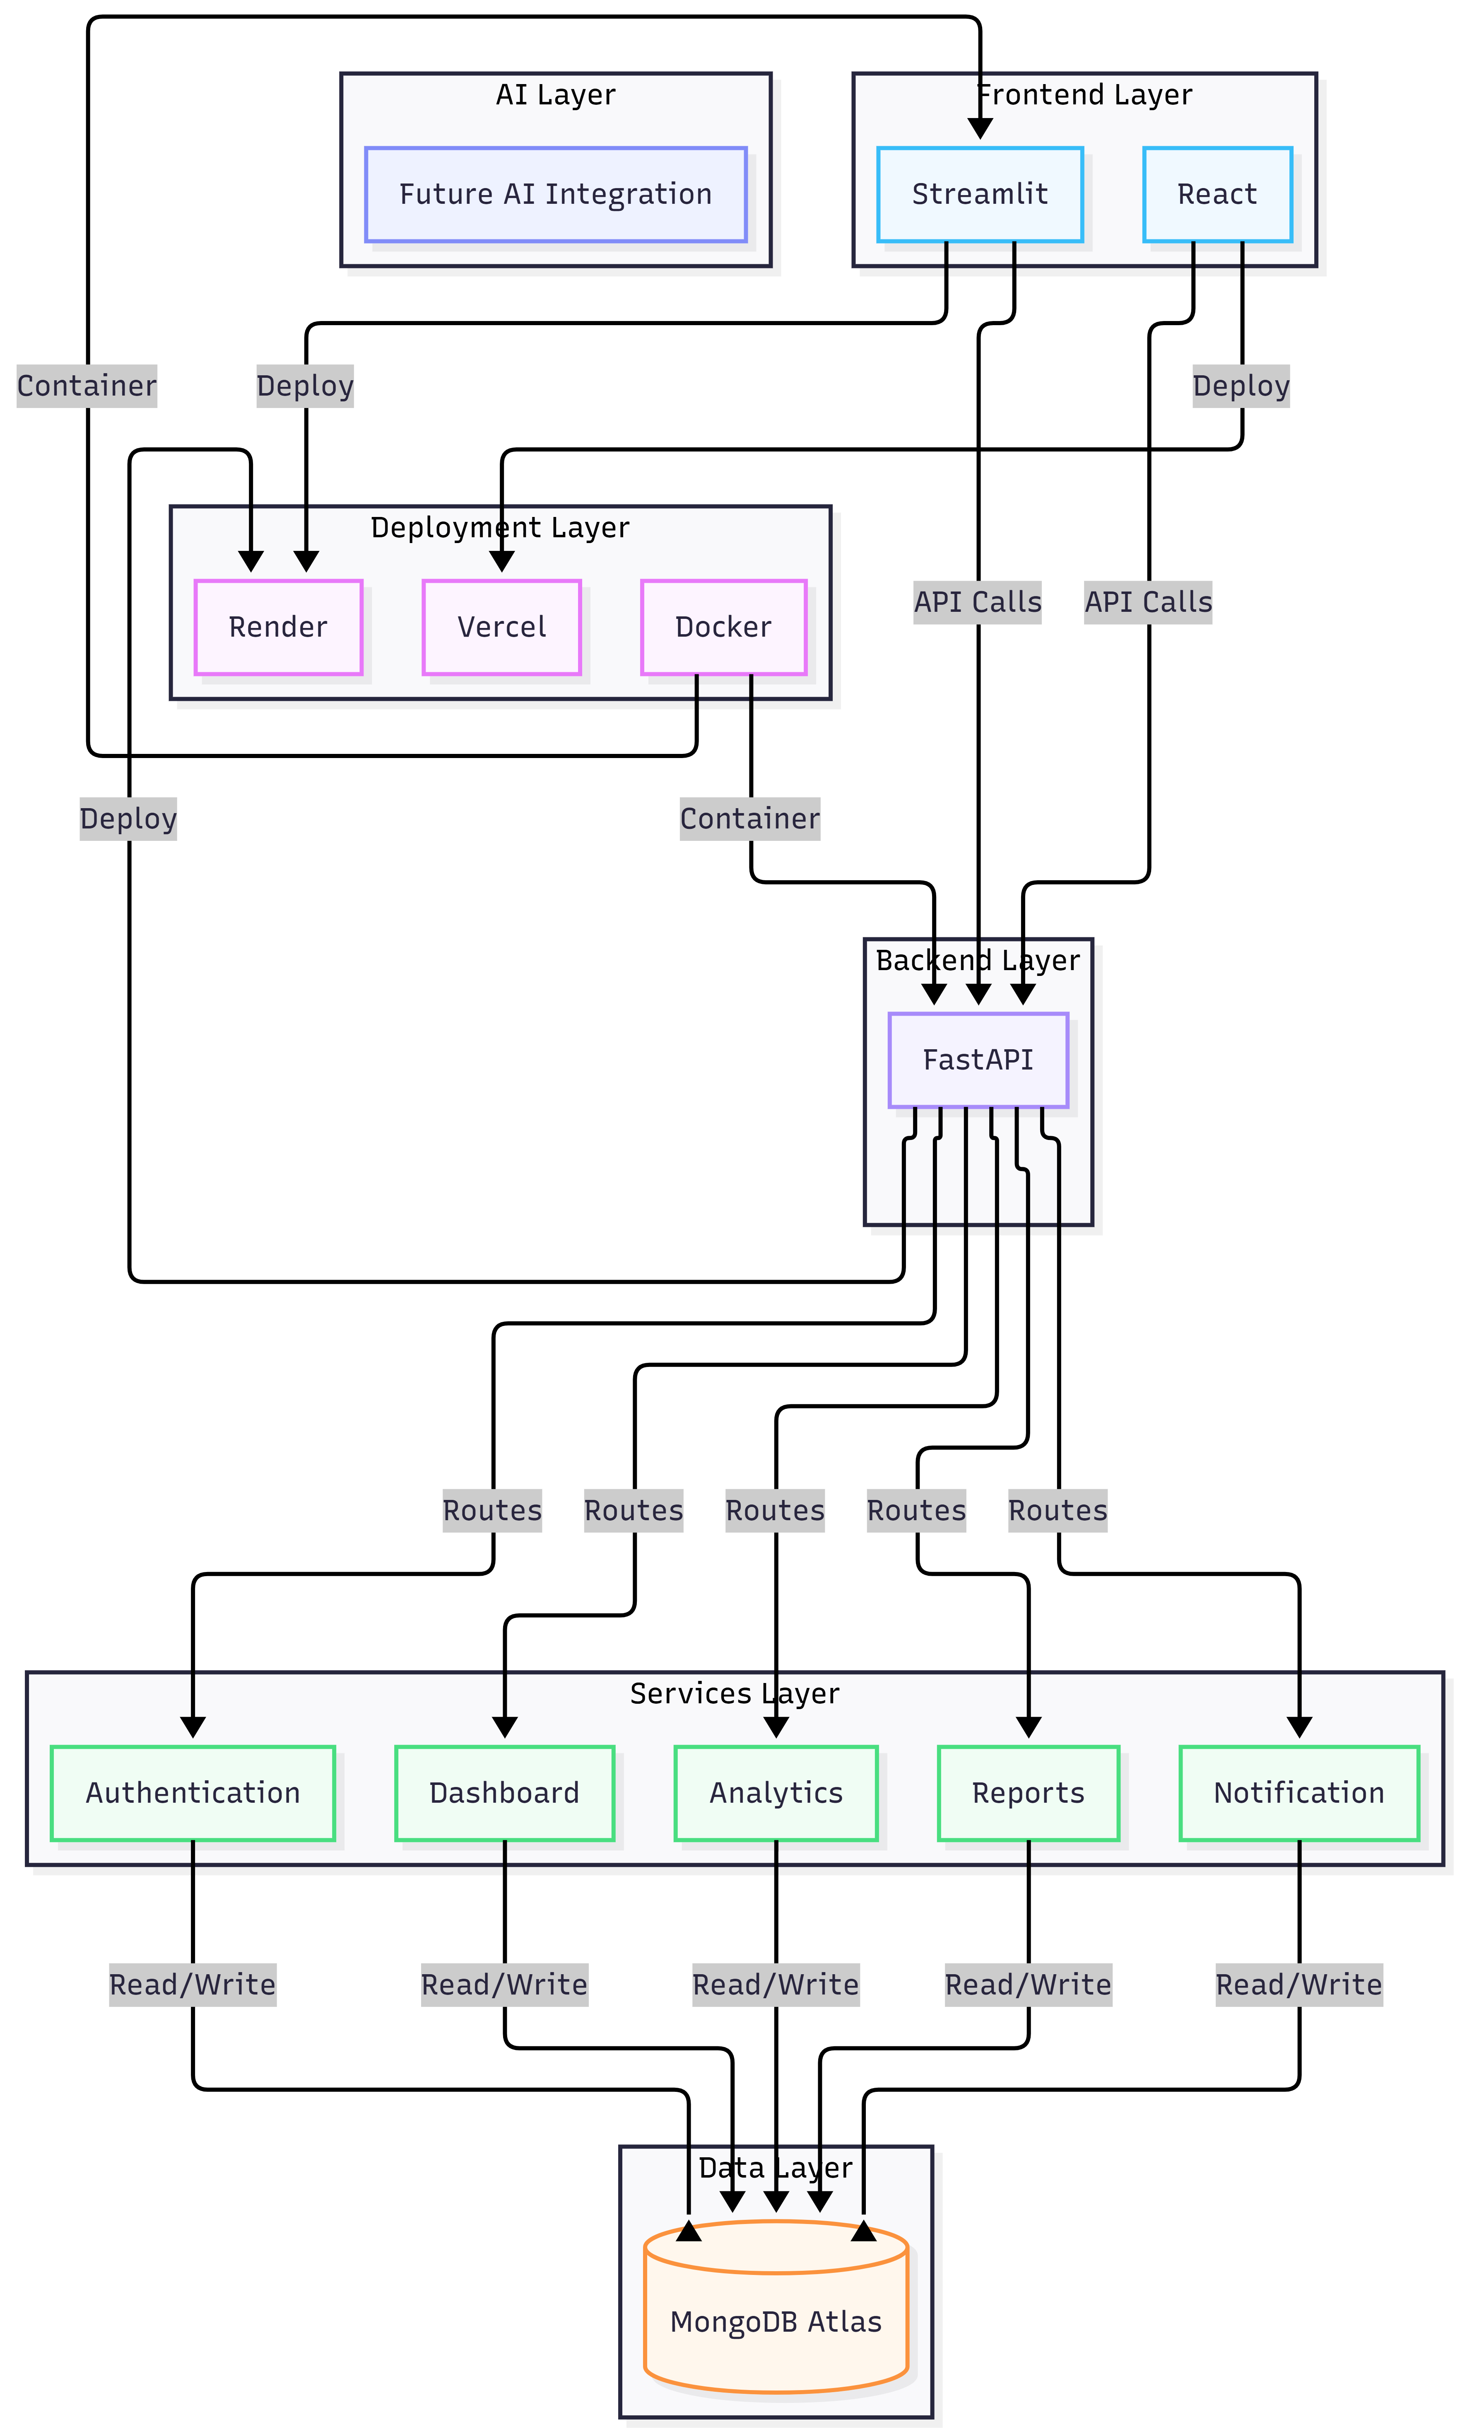
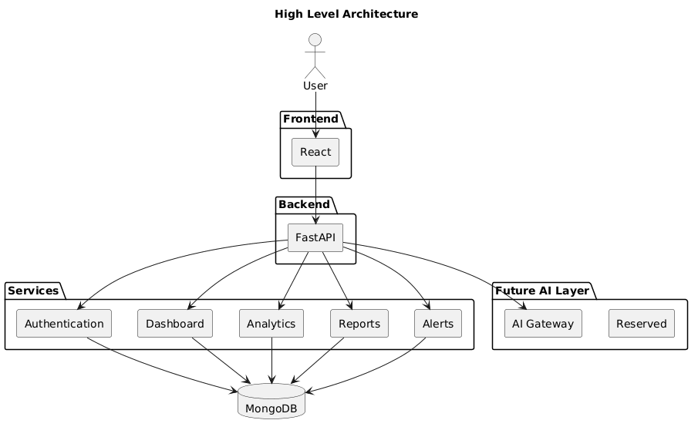

3. Low Level Architecture – using Plant UML

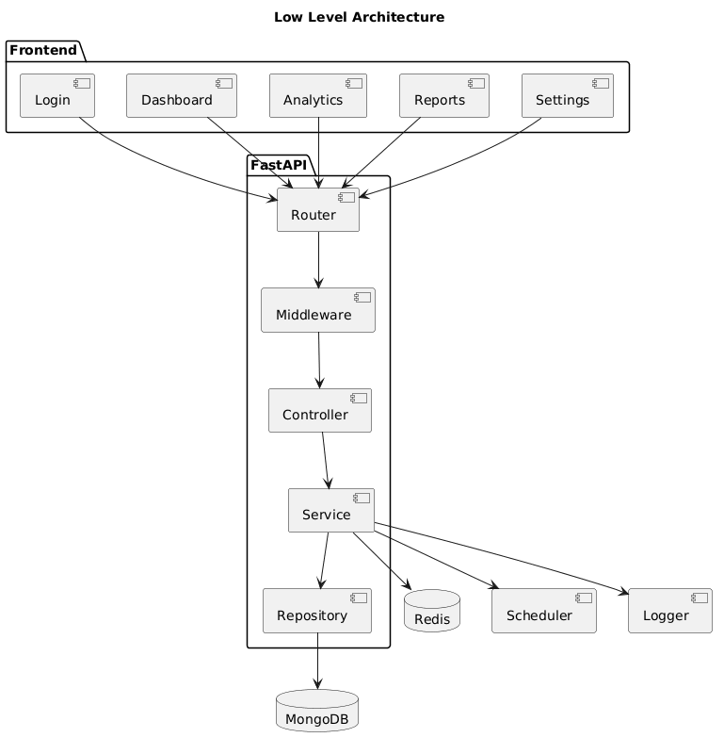

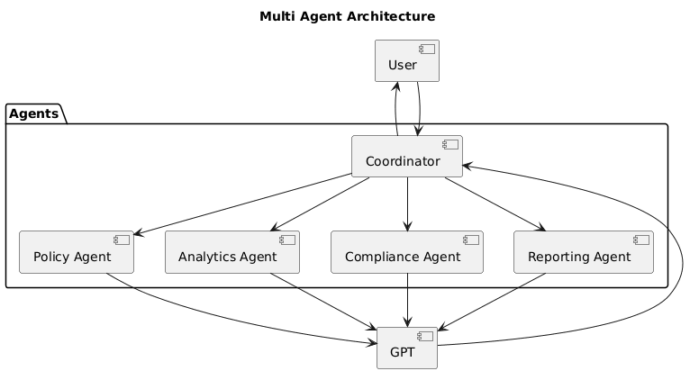



Prompt 1:
for example this is my title: 15 Microsoft Productivity Surveillance Visualizer Evaluates privacy and productivity metrics used in corporate tools Helps make employee monitoring transparent and ethical Data ethics + visualization + security policy roles Python, Streamlit, MongoDB 🔗 [Simulated Corporate Monitoring Logs] note; now take me through initial architecture diagram and then ai - integration(mention that what type ai to integrate) part with architecture and with step by step guide

---------------------------------------------------------------------------------------------------------------------------------------
Prompt 2:
okay give me complete prd for this project

---------------------------------------------------------------------------------------------------------------------------------------
Prompt 3:

now give me prompts to generate most important diagrams in eraser.io or platn uml codes

---------------------------------------------------------------------------------------------------------------------------------------
Prompt 4:

now give me prompts for codex -
1. to develop project without ai
2. prompt to add ai
3. master prompt to develop full ai integrated ai

note in all these create a guide.md file and execution-guide.md file with full breakdown of how to run this project- with end to end integrations like how to configure Databse- or any other manul configurations to be done by me
and also mention deployment-guide.md file that how to deploy this project and where to deploy

step 1: verify ollama ---> ollama –version
ollama pull qwen3:4b / ollama run qwen3:4b
ollama pull llama3.2:3b
ollama pull mistral

pip install streamlit langchain langchain-community langchain-ollama

