<https://sportacrossstaffordshire.co.uk/sports/triathlon/>



<https://www.daviepal.org/portal/triathlon>



<https://www.challengedathletes.org/events/sdtc/>

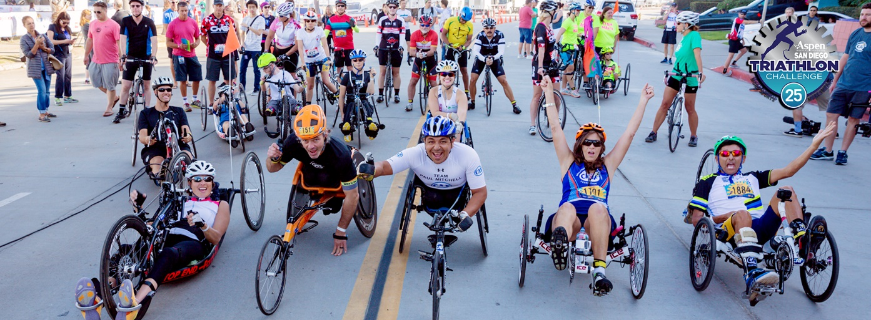

<https://www.woodsonymca.com/39th-annual-woodson-ymca-triathlon>

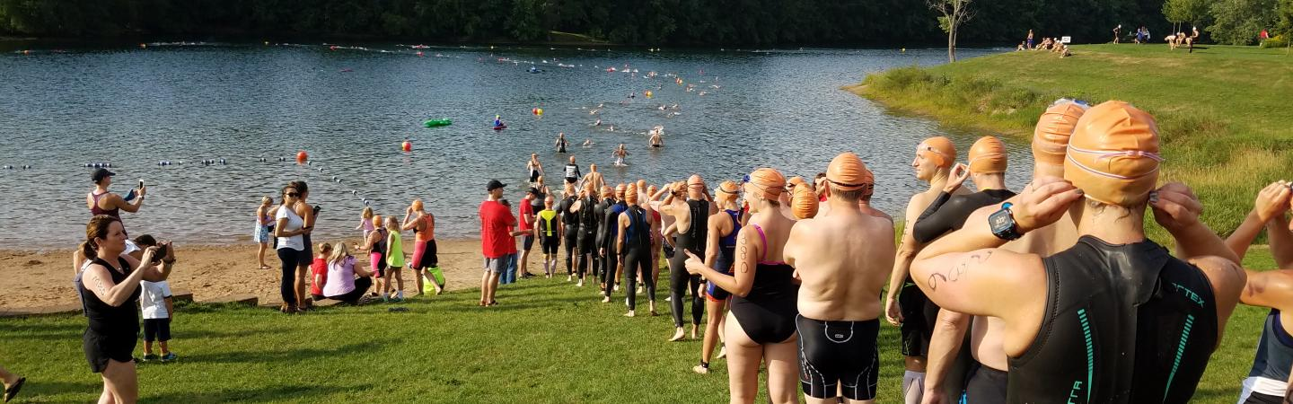

<https://edmontonjournal.com/opinion/columnists/opinion-saying-yes-to-diversity-is-a-no-brainer-in-canada-we-must-never-take-it-for-granted>

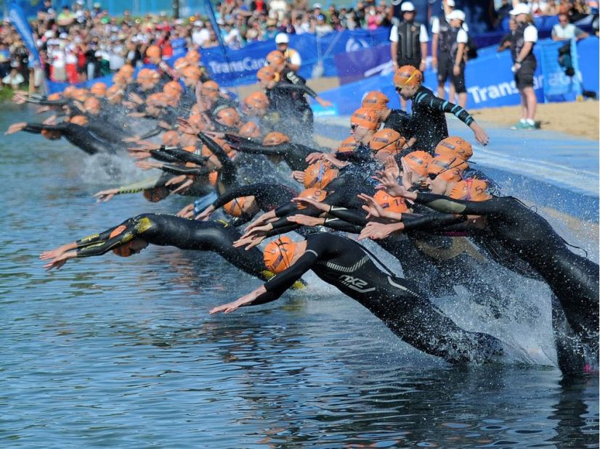

<http://lessonsinbadassery.com/20-questions-ayesha-mcgowan-bike-badass-diversity-advocate/>

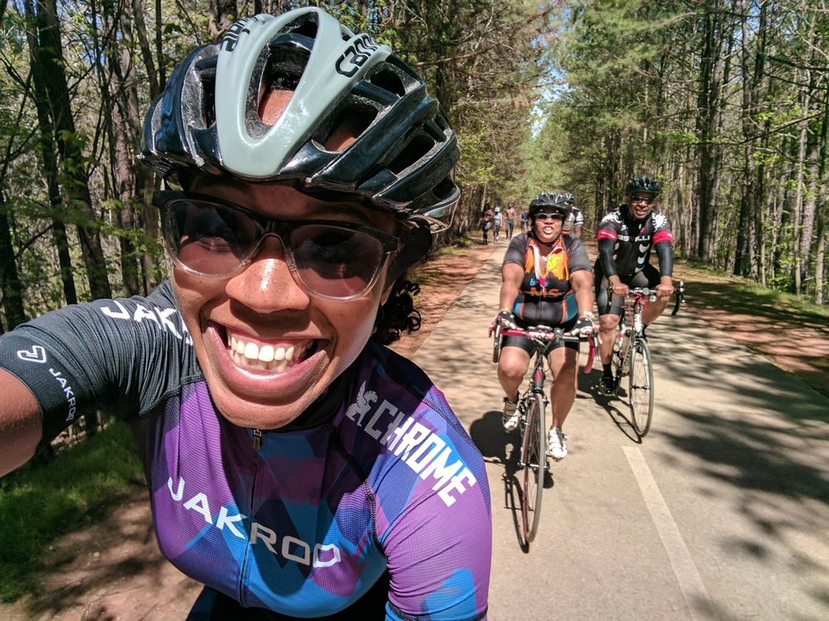

<http://lessonsinbadassery.com/20-questions-ayesha-mcgowan-bike-badass-diversity-advocate/>

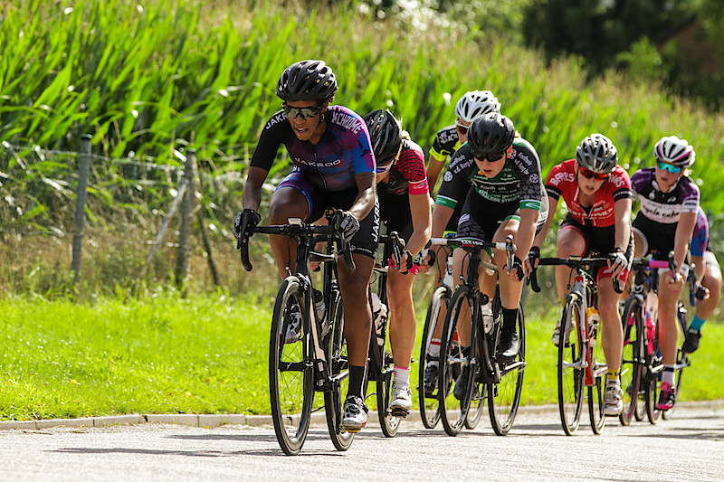

<https://www.teamusa.org/USA-Triathlon/News/Blogs/Multisport-Lab/2018/September/10/How-to-Make-the-Runner-to-Triathlete-Transition>

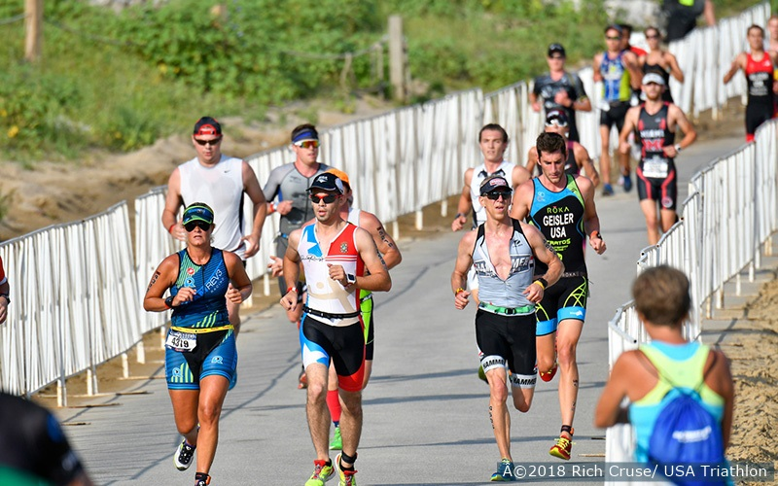

<https://www.google.com/url?sa=i&rct=j&q=&esrc=s&source=images&cd=&ved=2ahUKEwjY8sji2__gAhUrJDQIHRXBAGkQjRx6BAgBEAU&url=https%3A%2F%2Fwww.endurancebusiness.com%2F2017%2Findustry-news%2Ftrinz-targeting-olympic-podium-new-partner-wil-sport%2F&psig=AOvVaw1Ttmy2WlGtyeN_P5S-r1qy&ust=1552586956722014>

