**Improving range shift predictions: enhancing the power of traits**

**Running Title**: Improved range shift predictions via traits.

Anthony F. Cannistra+1, Lauren B. Buckley1

1. Department of Biology, University of Washington, Seattle, WA 98195-1800, USA

+. Corresponding author: Anthony F. Cannistra, Phone: (401) 793-0916, Email: [tonycan@uw.edu](mailto:tonycan@uw.edu), ORCID: 0000-0002-9852-6291

**Abstract**

Accurately predicting species’ range shifts in response to environmental change is a central ecological objective and applied imperative. Species’ functional traits are powerful predictors of responses in detailed studies and have thus been extensively incorporated in predictive frameworks such as vulnerability analyses. In synthetic analyses, traits emerge as significant but weak predictors of species’ range shifts across recent climate change. These studies assume linearity in the relationship between a trait and its function, while detailed empirical work often reveals unimodal relationships, thresholds, and other nonlinearities in many trait-function relationships. We hypothesize that the use of linear modeling approaches fails to capture these nonlinearities and therefore may be under-powering traits to predict range shifts. We evaluate the predictive performance of four different machine learning approaches that can capture nonlinear relationships (ridge-regularized linear regression, ridge-regularized kernel regression, support vector regression, and random forests). We validate our models using four multi-decadal range shift datasets in montane plants, montane small mammals, and marine fish. We show that nonlinear approaches perform substantially better than least-squares linear modeling in reproducing historical range shifts. In addition, using novel model observation and interrogation techniques, we identify trait classes (e.g. dispersal- or diet-related traits) that are primary drivers of model predictions, which is consistent with expectation. However, disagreements among models in the directionality of trait predictors suggests limits to trait-based statistical predictive frameworks. Our results highlight that non-linear approaches promise substantially improved, but potentially still limited, capacity to leverage species traits to predict climate change responses in contexts such as species vulnerability analyses.

**Keywords:** traits, range shifts, nonlinear modeling, ecological forecasting, global change responses, distribution, vulnerability

1. **INTRODUCTION**

Species have been responding to recent climate change by tracking their environment in space or time, adapting or acclimating, or facing declines (Parmesan, 2006), but we are largely unable to predict how particular species will respond (Maguire *et al.*, 2015).  Extensive documentation of shifts in distribution and seasonal timing (phenology) reveal that responses vary among species markedly in direction and extent (Rapacciuolo *et al.*, 2014). Detailed empirical studies often succeed in identifying functional traits that govern climate change responses (e.g., Adrian *et al.*, 2006) and consequently functional ecology has been rapidly gaining prominence in climate change ecology (Buckley & Kingsolver, 2012).  However, attempts to use traits to predict the relative magnitude of responses among species generally identify traits that are significant, but weak, predictors of climate change responses (Estrada *et al.*, 2016; MacLean & Beissinger, 2017).  Across studies, species traits were found to account for ~16% of the among species variation in range shifts and ~42% of the among species variation in phenological shifts using linear models (Buckley & Kingsolver, 2012). In a recent study in montane plants, for example, traits explained a very small percentage of observed variation (R2= 0.05-0.18, Angert et al. 2011), insufficient for prediction. How can we close the discrepancy between traits predicting responses well in detailed studies but poorly in broad studies? What statistical techniques will allow us to generalize the importance of traits in mediating climate change responses?

Addressing such questions is imperative for anticipating and adapting to the biological impacts of climate change. Indeed, traits are already being used to predict species’ sensitivity to climate change in vulnerability frameworks (Williams *et al.*, 2008; Foden *et al.*, 2013; Pacifici *et al.*, 2015).  However, the frameworks remain largely untested. Moreover, the traits included in vulnerability analyses differ sufficiently that different frameworks predict dramatically different rankings of vulnerability (Wheatley *et al.*, 2017).  Improving the ability of traits to predict climate change responses is necessary for robust vulnerability analyses.

Most attempts to use species’ traits to predict the magnitude of their climate change responses rely on linear regression (Buckley & Kingsolver, 2012; MacLean & Beissinger, 2017), yet detailed empirical studies often reveal non-linear relationships between traits and their function (Stenseth & Mysterud, 2002).  Unimodal relationships and thresholds are common. For example, extreme diet specialization may drive a species to track the range shift of a food item (Altermatt, 2010; Diamond *et al.*, 2011), but reducing diet specialization only slightly may alleviate the need for a species to track its food. Diet generalization could facilitate species moving to capitalize on newly climatically suitable habitat, yielding a unimodal relationship between diet specialization and the magnitude of range shifts.  Likewise, low dispersal ability may prevent a species from tracking its environmental niche (Schloss *et al.*, 2012), but the threshold of dispersal ability that allows species to track their niche may be relatively low. Trade-offs among traits and differences in the developmental dependencies of traits may also produce nonlinearities (Fitt et al., 2018). Can statistical techniques that allow for non-linear relationships between traits and species’ responses improve our predictive ability?

The universe of modeling techniques is vast and offers ecologists a wealth of tools to assess whether these nonlinear interactions between traits and range shifts can predict future responses. Standard approaches to capture variable interactions and nonlinearities in linear regressions (such as the explicit inclusion of interacting variables or polynomial expansion) rely on prior knowledge or model selection techniques to determine which variables to select. Other model types, such as machine learning approaches that optimize model parameters, are better suited than brute-force techniques to capture functional relationships among variables. These models, while offering statistical-robustness and efficiency, can be opaque and rarely afford clear coefficients to inspect when assessing the model’s learned correlations.  However, developments in the field of machine learning offer new approaches for inspecting model performance and predictions.

Limited computational background among some ecologists has restricted application of the methods despite the complex, interacting relationships inherent in many ecological studies (Olden *et al.,* 2008). Some biological domains (e.g. the identification of novel zoonotic disease reservoirs (Han *et al.,* 2015)) have showcased the potential of advanced machine learning, and methods like neural networks (Olden *et al.,* 2008), boosted regression trees (Elith *et al.,* 2008), and random forest classifiers (Cutler *et al.,* 2007) are gaining traction in applications such as species distribution modelling. Largely, however, these methods have not seen wide use in capturing non-linear biological responses such as organismal responses to climate change.

Here we assess whether machine learning-based models can better use species’ traits to predict the magnitude and direction of range shifts observed in response to recent climate change. First, we consider whether several models which are able to capture nonlinear relationships can outperform linear models in their predictive ability. Second, we use recent developments in model interpretability techniques to ask whether model predictions are consistent across modelling approaches and concur with ecological theory. Novel model inspection approaches can reveal details of model predictions, which addresses reasonable concerns about the “black box” nature of many machine learning-based models. We assess model performance and robustness using four datasets encompassing a broad taxonomic range. The number of included species ranges from 20 to 176 and range shifts were observed over time spans ranging from 30 to 100+ years. Each dataset was derived from previous evaluations of traits as range shift predictors and consists of a list of focal species, associated species-level traits, and a range shift metric. We examine (1) whether non-linear methods can improve predictive ability of traits compared to linear methods, (2) whether the novel methods identify important traits consistent with significant results from other studies, and (3) whether the directionality of the modeled effect of traits is consistent across model types.

1. **MATERIALS AND METHODS**

We describe the nonlinear modeling approaches, a framework for interpreting model predictions, and the assembly of range shift and trait data to determine whether traits can play a more powerful role in predicting ecological responses to climate change.

**2.1 Modeling Approach**

We applied three classes of learning algorithms: regularized linear regression, kernel-based regression, and tree-based regression. Regularization is a modification to traditional generalized linear regression which limits the complexity of the learned model to avoid overfitting to the data (Hastie *et al.,* 2009). Several types of regularization exist; we chose to use a “ridge”-regularized linear model, which imposes a penalty on the magnitude of each learned coefficient. The cumulative effect of this regularization procedure is a set of coefficients which both minimize prediction error on the training data and prevent overfitting. These coefficients can be interpreted explicitly as with ordinary least squares regression.

While regularization reduces overfitting when compared to a standard least-squares linear fit, regularized linear models are still not able to capture nonlinearities among or interactions between predictive variables. To remedy this, we employ two additional classes of models: kernel-based regression and tree-based regression.  A “kernel” is a function which projects a set of input data, often into a high-dimensional space, to allow for the linear “separability” of the data for the purposes of classification or regression (Hastie *et al.,* 2009). The Kernel Ridge method employed herein uses a radial basis function (or squared exponential) kernel applied to the training data and fits a ridge-regularized linear model to this transformed input. As a result of this transformation the learned coefficients, while regularized, are not immediately interpretable.

We also evaluate a kernel-based technique known as a support vector machine (SVM). This popular learning method can be formulated for regression, is robust to outliers, and can capture nonlinearities and variable interactions through a similar radial basis function kernel as in the Kernel Ridge approach. Like the Kernel Ridge method, the SVM regressor does not have interpretable coefficients. Finally, we train a random forest regression algorithm to evaluate the performance of tree-based methods. All of these models are implemented in the Python programming language using the scikit-learn software package (Pedregosa *et al*., 2011), though all analyses can be computed in the R language using available machine learning packages. All code for this project is available on GitHub in Jupyter notebooks, a “literate programming” format which combines text and executable code in a web browser. The code is located at <http://github.com/huckleylab/cc_traits>.

For comparison to the original analyses, we train an ordinary least squares regression model, which assumes linear relationships and no variable interaction. While the original analyses were mostly conducted in a single-variable framework (that is, to assess the effect size of *M* different potential predictive variables *M* models were trained, each model containing only 1 variable), we include all variables in single analyses to enable the models to capture variable interactions and to follow a common predictive modeling paradigm. This multivariate approach is a standard one in machine-learning based predictive analytics (Hastie et al., 2009).

**2.2 Evaluation**

We use data subsets for performance evaluation. To assess the predictive performance of our models we employ a *k*-fold cross-validation scheme (Hastie et al. 2009) combined with a squared error loss function. This cross-validation technique has been shown to estimate expected prediction error (Hastie et al. 2009) by randomly partitioning data points into *k =* 10 subsets, each with *N/k* members; *k - 1* subsets are used to fit the model (the “training set”), reserving one subset for testing model performance. Each of the *k* subsets is used exactly once for evaluation. A mean squared error (MSE) loss is then computed for the model prediction of range shift magnitude in the reserved test data, which is the sum of squared differences between predicted and actual range shift magnitude over all data in the testing set.  This process is repeated *k* times and a mean statistic is computed across the *k* MSE values that result (known as a “cross-validation mean”). The units of MSE estimates are those of the range shift, so MSE provides a direct assessment of model predictive ability. The same cross-validation mean approach is used to compute average variable importance values to evaluate model drivers, described below. In these experiments we choose *k =* 10 (Hastie et al. 2009).

**2.3 Model Interpretation**

The core of any basic regression analysis is typically an inspection of the significance and direction of the coefficients of a fitted model. However, the kernel methods employed herein (Kernel Ridge, SVM) do not expose any interpretable coefficients. To address this, we utilize the Shapley additive feature value method, proposed in Lundberg and Lee (2017). Shapley values are computed for each variable by treating the explanation of a given model’s prediction as a model in and of itself—values are computed by training an additive method derived from cooperative game theory to learn each variable’s contribution to a model’s prediction. Explanations are generated from each prediction in the model training set to identify the most important variables during training and are averaged for each feature across all training examples to generate a whole-model feature importance scale. We perform this procedure for each of the training sets generated by the cross-validation scheme described above to compute average feature importance values. To compare the learning techniques, we use either mean regression coefficients (for OLS and Ridge regression), mean Shapley variable importance values (Kernel Ridge and SVM), or mean Gini variable importance values (Random Forest; Brieman, 2011) to rank all variables such that each feature has an importance ranking for each of the several regression methods. We use the sign of Shapley and coefficient values to compare the directionality of predicted trait drivers for models other than random forests (Gini scores are an unsigned information-theoretic measure). All means are *k*-fold cross-validated means.

**2.4 Trait and Range Shift Data**

We evaluate our approach independently by replicating analysis across four datasets that (1) repeated historical surveys or conducted continuous surveys along latitudinal or elevational gradients to quantify shifts in northern or upper elevation range boundaries over at least three decades of change and (2) included all surveyed species (i.e. rather than including only species that shifted significantly). The first two data sets are those used by Angert et al. (2011) to assess the predictive power of traits. These datasets supplement trait data to elevational range shift data for Swiss alpine plants (Holzinger et al. (2008), *N* = 139) and for Western North American small mammals (Moritz et al (2008)). A third database from Rumpf et al. (2018) consists of elevational range shifts for European montane plants coupled with trait data derived from the TRY Plant Trait Database (Kattge et al., 2011; https://www.try-db.org) and other databases (e.g. Bjorkman et al, 2018). The fourth database was created by pairing estimates of latitudinal range shifts from coastal North American marine fish surveys (Pinsky et al., 2013) with functional trait data in Fishbase (<https://www.fishbase.org>, Froese and Pauly, 2018). Each dataset includes a directional range shift: negative values indicate shifts downward in elevation (m) for the first three datasets and equatorward in latitude (degrees) for the marine dataset. We remove samples which are missing any traits, one-hot encode categorical traits (i.e., generate one boolean column for each category), and normalize/center the numeric traits to have zero mean and unit norm. After this processing the Swiss plants dataset contains *N* = 20 species and *d* = 38 traits; the Yosemite mammal dataset contains *N* = 28 species and *d* = 19 traits; the European plants dataset contains *N =* 176 species and *d* = 18 traits; the marine fish dataset contains *N =* 76 species and *d* = 17 traits.

1. **RESULTS**

We find that the machine learning approaches improve predictive performance over an ordinary least squares (OLS) model baseline. For two datasets (Swiss alpine plants and Western NA mammals), the four machine learning approaches perform substantially better than the OLS models but similarly to each other. For the other two datasets (European montane plants and marine fish), the performance advantages of the machine learning approaches are less substantial and the four machine learning approaches differ more in their performance. Support Vector Regression (SVR) and Kernel Ridge emerge as the most performant methods across datasets **(Figure 1)**, reducing mean error in range shift estimates by an average of 62.8% and 61.6% relative to OLS, respectively. We focus on results from the Swiss alpine plants dataset (Holzinger et al. (2008) and Angert et al. (2011)) to demonstrate findings. The initial OLS analysis found that individual predictors accounted for relatively little variance in the extent of the plants’ elevational range shifts (R2= 0.05-0.18, Angert et al. 2011)

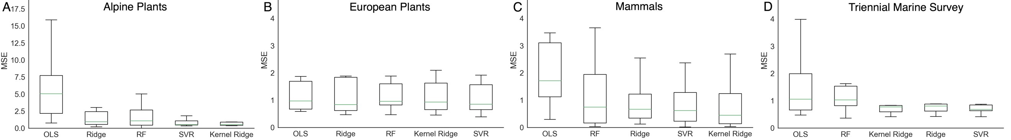

**Figure 1:** The four machine learning approaches reduce the mean squared error (MSE, 10-fold cross-validation) of range shift predictions below the MSE of the standard linear regression approach (OLS: ordinary least squares) across three of four datasets (A, C, D). Support Vector Regression (SVR) and Kernel Ridge models exhibit stronger performance than ridge regularized linear (Ridge) or Random Forest (RF) models across the datasets. The MSE units correspond to the range shift metric (A-C: m, D: degrees latitude) and thus directly indicate model performance.

In addition to reducing MSE, the traits found to be important predictors in machine learning models correspond to those identified in previous analyses and ecological theory. The most performant models for these data (SVR and Kernel Ridge, lowest MSE: **Figure 1a)** identify dispersal-related traits (e.g., the timing, height, and duration of seed shed along with seed size and dispersal mode for the Alpine and European Plants) as the most important variables in predicting range shift magnitude **(Figure 2a)**, which is consistent with our expectation and prior work (Angert et al. 2011). In the original analysis of the European Plants data (Rumpf et al., 2018) the indicator of thermal adaptation (cool to warm adaptation, “TemperatureIndicator”) was a primary predictor of range shifts; our models selected the same variable as most important (**Figure 2b**).  The previous Western NA mammal analysis (Angert et al. 2011) identified altitudinal limit as a significant predictor and longevity as a relatively strong, but non-significant, predictor. Our models select those two variables as the most important predictors (Figure 2c). Both the initial [Pinsky] and our analysis failed to identify strong trait predictors of marine range shifts and non-linear methods yielded less improvement of MSE than the other datasets. However, habitat traits such as whether species are pelagic are top predictors consistent with compilations of individual studies (Poloczanska et al. 2013).

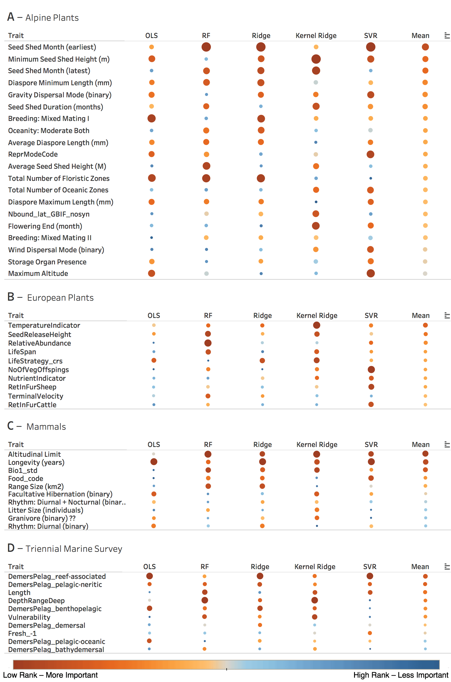

**Figure 2**: The model approaches generally select similar traits as important (larger and red = lower rank and more important) for predicting range shifts across datasets. Traits are listed in order of decreasing mean importance (increasing mean rank, right column) across all methods (except OLS) for each dataset (panels).  Model abbreviations are as in Figure 1.

The models employed in this analysis also demonstrate cross-model consistency in identifying trait drivers of range shifts (**Figure 2)**. In other words, separate models tend to agree on trait rank, especially in the top 5 traits, suggesting a common effect despite significantly different modeling methodologies (and evaluation strategies). However, there tends to be more agreement among machine learning models than between OLS and machine learning models. In particular, some traits for which thresholds seem likely are less important predictors in OLS than in machine learning models: higher seed shed heights and longer seed shed durations in alpine plants may not lead to more dispersal once thresholds are reached (Figure 2a).

Finally, models that assign directionality to a modeled effect (all models except Random Forest), tend to agree in the directionality of how traits influence range shifts **(Figure 3)**. For example, all models for European plants (except Kernel Ridge) suggest that thermophilic species that release seeds higher have shifted their altitudinal distribution higher in elevation. All models (except SVR) find that mammals with greater longevity and higher altitudinal limits exhibit smaller altitudinal range shifts. In both these examples, the exceptional model suggests the opposite relationship for both traits. Agreement is sometimes strongest within regression (OLS, Ridge) and machine learning (Kernal Ridge, SVR) type models. For example, the machine learning models suggest alpine plants with higher seed shed shift their distribution further, contrary to the findings of regression models. However, the mixed results suggest limits to the predictive capacity of species’ traits (see Discussion). It is important to note that these measures of variable contribution are computed in distinct ways depending on the modeling methodology, and it remains to be seen whether these methods of variable importance are suitable to determine effect directionality. In addition, using these heterogeneous metrics to compare effect directionality must be done with caution.

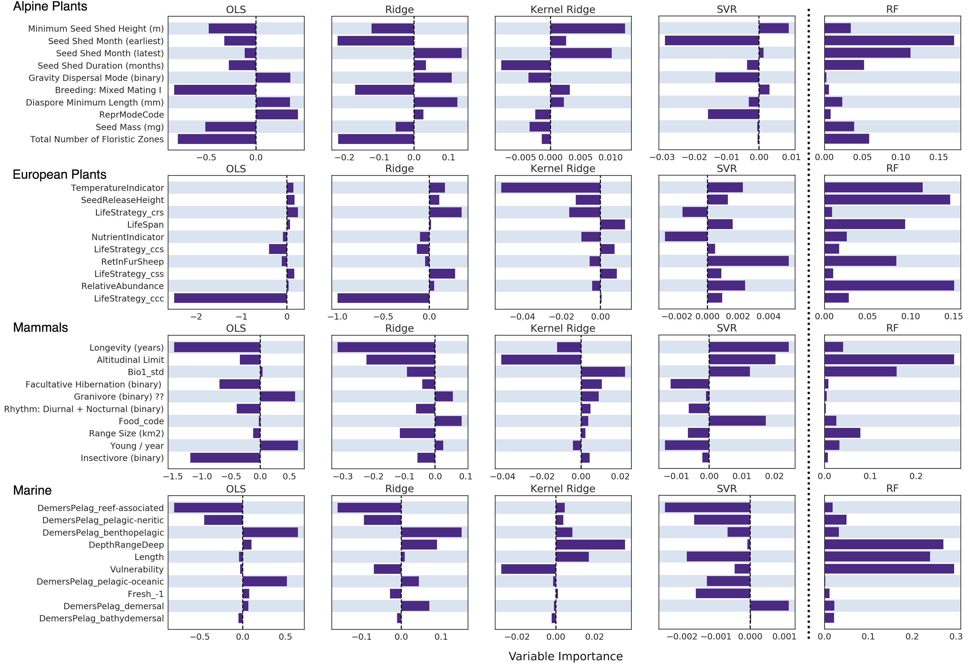

**Figure 3**: Models tend to agree on the variable importance values and directionality of top-ranking traits. We depict model coefficients (OLS, Ridge), Shapley feature importance values (Kernel Ridge, SVR), or Gini feature importance scores (which do not indicate directionality, RF) for top ten traits by rank (Figure 2) for each dataset (rows). Model abbreviations are as in Figure 1 and traits are as in Figure 2.

In summary, we find that non-linear methods increase predictive accuracy while identifying similar predictive traits and directionality of the traits.  Strong predictor traits are similar across the non-linear methods. These results are consistent across the four datasets examined in this study despite their taxonomic and geographic breadth.

**Tables**

N/A

**Figures and Figure Legends**



**Figure 1:** The machine learning approaches reduce the mean squared error (MSE, 10-fold cross-validation) of range shift predictions below the MSE of the standard linear regression approach (OLS: ordinary least squares) across all three of four datasets (A, C, D). Support Vector Regression (SVR) and Kernel Ridge models exhibit stronger performance than ridge regularized linear (Ridge) or Random Forest (RF) models across the datasets. The MSE units correspond to the range shift metric (A-C: m, D:degrees latitude) and thus directly indicate model performance.



**Figure 2**: The model approaches select similar traits as important (larger and red = more important) for predicting range shifts across datasets. Traits are listed in order of decreasing mean importance (increasing mean rank, right column) across all methods (except OLS) for each dataset (panels). Model abbreviations are as in Figure 1.



**Figure 3**: Models tend to agree on the variable importance values and directionality of top-ranking traits. We depict model coefficients (OLS, Ridge), Shapley feature importance values (Kernel Ridge, SVR), or Gini feature importance scores (RF) for top ten traits by rank (Figure [ranks]) for each dataset (rows). Model abbreviations are as in Figure 1 and traits are as in Figure 2.

1. **DISCUSSION**

Previous studies using linear modelling have found that species’ traits are significant but weak predictors of variation in observed historical range shifts (Angert *et al.*, 2011; MacLean and Beissinger, 2017). We find that non-linear modeling methods enhance the ability of traits to accurately predict observed range shifts. Our findings match biological intuition that biological processes, which respond to environmental conditions and are mediated by species’ traits, are rarely linear (Stenseth and Mysterud, 2002). Importantly, we have also shown that the novel statistical models maintain biological rigor by identifying similar predictor traits. However, some disagreements in the directionality of the relationship between trait values and range shift magnitude suggest limits to trait-based statistical prediction frameworks. Our finding that even non-linear models with strong predictive performance sometimes fail to generalize the influence of traits suggests the need to further test and perhaps reconsider the use of traits in climate change decision-making tools such as vulnerability analysis. Further, the discrepancy in predictive performance improvement across datasets highlights a need both for more and higher-quality data to underpin predictive analyses.

Models that allow for non-linearities should be employed to further reevaluate expectations for how traits govern range shifts. Consideration of the processes associated with range shifts can help select predictor traits: four sequential processes underlying range shifts have been classified as emigration, movement, establishment, and proliferation (Estrada et al. 2016). Generally, larger range shifts are expected for species with greater dispersal ability, reproductive potential, and ecological generalization (Buckley and Kingsolver 2012, MacLean and Beissinger 2017). However, a meta-analysis across range shift studies found at best moderate support for dispersal ability (body size: 22%, migratory strategy: 10%, movement ability: 50% of studies uphold predicted relationship), reproductive potential (fecundity: 36%, longevity: 60%) and ecological generalization (diet breadth: 27%, habitat breadth: 43%) as predictors of range shift magnitude (MacLean and Beissinger 2017). The large gap between expectations and observations highlights the need for novel predictive methods. Alternative expectations for traits such as ecological generalization further reinforces the need to allow for non-linear relationships between traits and climate change responses (Buckley and Kingsolver 2012). Translating spatial range shifts into metrics of the extent to which species track their environmental niche (e.g., velocity of climate change, Loarie et al. 2009) may also enhance predictive capacity.

Reevaluation with non-linear methods will provide insight into selecting appropriate predictor traits. The availability of trait data has increased substantially since some of our datasets were compiled (e.g., Angert et. al 2011), so refining traits may improve predictive capacity. Still, needs for additional trait data addressing issues such as physiology and evolutionary potential are substantial and will likely require concerted data collection efforts (Urban et al. 2016). Since species’ traits are likely to be phylogenetically conserved, phylogenetic signal in range shifts can be used to assess the potential to use traits to predict range shifts. High phylogenetic signal but weak predictive performance of traits would suggest that improving the traits used as predictors can enhance predictive capacity. The initial analyses (e.g., Angert et. al 2011) that accounted for phylogeny found limited phylogenetic signal in range shifts. We did not account for phylogeny because it is not straightforward to do so in the machine learning models. A recent synthesis of range shift studies (Diamond 2018) found variable but generally weaker phylogenetic signal in range shifts than in physiological, morphological, and life-history traits. The finding indicates limits to the predictive capacity of traits. However, local adaptation and resultant intraspecific trait variation may weaken phylogenetic signal and complicate using species-level traits. Higher phylogenetic signal in other climate change responses such as phenological and abundance shifts (reviewed in Buckley and Kingsolver 2012) suggests they may be more conducive to trait-based prediction using our methodology.

Our methodology––flexible statistical models paired with robust evaluation methods and model interrogation approaches––has been reliably employed across many predictive contexts but has yet to be fully embraced by ecologists. The emerging wealth of publicly-available ecological and environmental data, combined with the pressing need for reliable ecological forecasts that are useful in decision-making frameworks, makes this flexible and data-intensive approach a natural fit. Despite promising results, our approach presents several challenges to adoption. Of particular relevance to the ecology community is the lack of traditional statistical techniques to evaluate these methods. Following the machine learning community, we employ *k*-fold cross-validation to lend statistical robustness to the pertinent evaluative criteria for our models (here, mean squared error). In addition, the use of recent advances in model inspection methods (Shapley values from Lundberg et al., 2017) represents a necessary departure from the manual inspection and testing of linear model coefficients. As the field of model interpretation grows, ecologists can leverage these developments to verify the ecological processes underpinning the predictions of these unconventional modeling approaches. Understanding and acknowledging these shifts in method evaluation and inspection approaches are critical steps to leveraging these more performant statistical modeling approaches in the ecology community.

The general applicability of this approach should be confirmed by studies including additional taxa, a greater number of species, and using novel model interrogation techniques. In addition, the approach has the potential to improve predictive accuracy in other ecological domains relevant to policy and decisions making (species distribution modeling, forecasting of ecological carbon flux, etc.). However, as is demonstrated by the range of predictive performance improvement across datasets (e.g. between the Alpine Plants and the European Plants datasets, Figure 1), care must be taken to evaluate any novel modeling result conservatively and through a lens of data quality and available latitude for improvement.

Overall, our analysis offers a mixed outlook for using species’ traits in applied predictions, such as analyses of climate change vulnerability. The substantially better predictive performance of non-linear models relative to linear models suggests vulnerability analyses frameworks based on species’ traits (e.g., Williams *et al.*, 2008; Foden *et al.*, 2013; Pacifici *et al.*, 2015) should be adapted to account for non-linearities. However, disagreements in the directionality of trait predictors and the variability of performance improvement suggest that even non-linear methods for relating traits to climate change responses may have limited predictive accuracy. More mechanistic approaches that describe the processes by which traits mediate fitness and demographic responses to the environment may be required for predictions that require high levels of accuracy (Buckley and Kingsolver 2012, Urban et al. 2016). At a minimum, these mechanistic approaches will be useful for refining non-linear methodologies for using traits to predict climate change responses.

**ACKNOWLEDGEMENTS**

We thank the many individuals whose efforts have contributed to the datasets critical to this work, especially those who have made their trait data available on the TRY and FishBase databases. In particular we would like to thank Sabine Rumpf for her substantial efforts to coordinate the sharing of the European plants trait data. We thank Amy Angert and Malin Pinsky for sharing and aiding our interpretation of their datasets. We thank Ray Huey and members of our research group for comments. This work was supported by the National Science Foundation [IGERT DGE-1258485 fellowship to A.F.C., a Graduate Research Fellowship to A.F.C, and DBI-1349865 to L.B.B.].

**References**

Adrian, R., Wilhelm, S., & Gerten, D. (2006). Life-history traits of lake plankton species may govern their phenological response to climate warming. *Global Change Biology*, *12*(4), 652–661. http://doi.org/10.1111/j.1365-2486.2006.0112x

Altermatt, F. (2010). Tell me what you eat and I’ll tell you when you fly: diet can predict phenological changes in response to climate change. *Ecology Letters*, *13*(12), 1475–1484. http://doi.org/10.1111/j.1461-0248.2010.01534.x

Angert, A. L., Crozier, L. G., Rissler, L. J., Gilman, S. E., Tewksbury, J. J., & Chunco, A. J. (2011). Do species’ traits predict recent shifts at expanding range edges? *Ecology Letters*, *14*(7), 677–689. http://doi.org/10.1111/j.1461-0248.2011.01620.x

Baltensperger, A. P., & Huettmann, F. (2015). Predicted shifts in small mammal distributions and biodiversity in the altered future environment of Alaska: An open access data and machine learning perspective. *PLoS ONE*, *10*(7), e0132054. <http://doi.org/10.1371/journal.pone.0132054>

Bjorkman, A. D., Myers-Smith, I. H., Elmendorf, S. C., Normand, S., Thomas, H. J. D., Alatalo, J. M., … Zamin, T. (2018). Tundra Trait Team: A database of plant traits spanning the tundra biome. *Global Ecology and Biogeography*, *27*(12), 1402–1411. http://doi.org/10.1111/geb.12821

Buckley, L. B., & Kingsolver, J. G. (2012). Functional and Phylogenetic Approaches to Forecasting Species’ Responses to Climate Change. *Annual Review of Ecology, Evolution, and Systematics*, *43*(1), 205–226. http://doi.org/10.1146/annurev-ecolsys-110411-160516

Buckley, L. B., Miller, E. F., & Kingsolver, J. G. (2013). Ectotherm Thermal Stress and Specialization Across Altitude and Latitude. *Integrative and Comparative Biology*, *53*(4), 571–581. <http://doi.org/10.1093/icb/ict026>

Breiman, L. (2001). Random Forests. *Machine Learning*, *45*(1), 5–32. http://doi.org/10.1023/A:1010933404324

Cutler, D. R., Edwards, T. C., Beard, K. H., Cutler, A., Hess, K. T., Gibson, J., & Lawler, J. J. (2007). Random Forests for Classifcation in Ecology. *Ecology*, *88*(11), 2783–2792. http://doi.org/10.1890/07-0539.1

Dawson, T. P., Jackson, S. T., House, J. I., Prentice, I. C., & Mace, G. M. (2011). Beyond predictions: biodiversity conservation in a changing climate. *Science*, *332*(6025), 53–58. <http://doi.org/10.1126/science.1200303>

Diamond, S. E. (2018). Contemporary climate-driven range shifts: Putting evolution back on the table. *Functional Ecology*, *32*(7), 1652–1665. http://doi.org/10.1111/1365-2435.13095

Diamond, S. E., Frame, A. M., Martin, R. A., & Buckley, L. B. (2011). Species’ traits predict phenological responses to climate change in butterflies. *Ecology*, *92*(5), 1005–1012. http://doi.org/10.1890/10-1594.1

Elith, J., Leathwick, J. R., & Hastie, T. (2008, July 1). A working guide to boosted regression trees. *Journal of Animal Ecology*. Blackwell Publishing Ltd. http://doi.org/10.1111/j.1365-2656.2008.01390.x

Estrada, A., Morales-Castilla, I., Caplat, P., & Early, R. (2016). Usefulness of Species Traits in Predicting Range Shifts. *Trends in Ecology & Evolution*, *31*(3), 190–203. <http://doi.org/10.1016/j.tree.2015.12.014>

Fitt, R. N. L., Palmer, S., Hand, C., Travis, J. M. J., & Lancaster, L. T. (2018). Towards an interactive, process-based approach to understanding range shifts: developmental and environmental dependencies matter. *Ecography*, *0*(0). http://doi.org/10.1111/ecog.03975

Foden, W. B., Butchart, S. H. M., Stuart, S. N., Vié, J.-C., Akçakaya, H. R., Angulo, A., … Mace, G. M. (2013). Identifying the World’s Most Climate Change Vulnerable Species: A Systematic Trait-Based Assessment of all Birds, Amphibians and Corals. *PLOS ONE*, *8*(6), 1–13. <http://doi.org/10.1371/journal.pone.0065427>

Froese, R., & Pauly, D. (2010). FishBase. http://www.fishbase.org

Han, B. A., Schmidt, J. P., Bowden, S. E., & Drake, J. M. (2015). Rodent reservoirs of future zoonotic diseases. *Proceedings of the National Academy of Sciences of the United States of America*, *112*(22), 7039–44. <http://doi.org/10.1073/pnas.1501598112>

Hastie, T., Tibshirani, R., & Friedman, J. (2009). *The Elements of Statistical Learning*. *The Mathematical Intelligencer* (Vol. 27). New York, NY: Springer New York. http://doi.org/10.1007/978-0-387-84858-7

KATTGE, J., DÍAZ, S., LAVOREL, S., PRENTICE, I. C., LEADLEY, P., BÖNISCH, G., … WIRTH, C. (2011). TRY - a global database of plant traits. *Global Change Biology*, *17*(9), 2905–2935. http://doi.org/10.1111/j.1365-2486.2011.02451.x

Loarie, S. R., Duffy, P. B., Hamilton, H., Asner, G. P., Field, C. B., & Ackerly, D. D. (2009). The velocity of climate change. *Nature*, *462*(7276), 1052–1055. http://doi.org/10.1038/nature08649

Lundberg, S. M., & Lee, S.-I. (2017). A Unified Approach to Interpreting Model Predictions. In I. Guyon, U. V Luxburg, S. Bengio, H. Wallach, R. Fergus, S. Vishwanathan, & R. Garnett (Eds.), *Advances in Neural Information Processing Systems 30* (pp. 4765–4774). Curran Associates, Inc. Retrieved from http://papers.nips.cc/paper/7062-a-unified-approach-to-interpreting-model-predictions.pdf

MacLean, S. A., & Beissinger, S. R. (2017). Species’ traits as predictors of range shifts under contemporary climate change: A review and meta-analysis. *Global Change Biology*, *23*(10), 4094–4105. http://doi.org/10.1111/gcb.13736

Moritz, C., Patton, J. L., Conroy, C. J., Parra, J. L., White, G. C., & Beissinger, S. R. (2008). Impact of a Century of Climate Change on Small-Mammal Communities in Yosemite National Park, USA. *Science*, *322*(5899), 261–264. http://doi.org/10.1126/science.1163428

Olden, J. D., Lawler, J. J., & Poff, N. L. (2008). Machine Learning Methods Without Tears: A Primer for Ecologists. *The Quarterly Review of Biology*, *83*(2), 171–193. http://doi.org/10.1086/587826

Pacifici, M., Foden, W. B., Visconti, P., Watson, J. E. M., Butchart, S. H. M., Kovacs, K. M., … Rondinini, C. (2015). Assessing species vulnerability to climate change. *Nature Climate Change*, *5*, 215. Retrieved from https://doi.org/10.1038/nclimate2448

Pacifici, M., Visconti, P., Butchart, S. H. M., Watson, J. E. M., Cassola, F. M., & Rondinini, C. (2017). Species’ traits influenced their response to recent climate change. *Nature Climate Change*, *7*(3), 205–208. http://doi.org/10.1038/nclimate3223

Parmesan, C. (2006). Ecological and Evolutionary Responses to Recent Climate Change. *Annual Review of Ecology, Evolution, and Systematics*, *37*(1), 637–669. http://doi.org/10.1146/annurev.ecolsys.37.091305.110100

Pedregosa, F., Varoquaux, G., Gramfort, A., Michel, V., Thirion, B., Grisel, O., … Duchesnay, E. (2011). Scikit-learn: Machine Learning in Python. *Journal of Machine Learning Research*, *12*, 2825–2830.

Pinsky, M. L., Worm, B., Fogarty, M. J., Sarmiento, J. L., & Levin, S. A. (2013). Marine Taxa Track Local Climate Velocities. *Science*, *341*(6151), 1239–1242. <http://doi.org/10.1126/science.1239352>

Poloczanska, E. S., Brown, C. J., Sydeman, W. J., Kiessling, W., Schoeman, D. S., Moore, P. J., … Richardson, A. J. (2013). Global imprint of climate change on marine life. *Nature Climate Change*, *3*, 919. https://doi.org/10.1038/nclimate1958

Rapacciuolo, G., Maher, S. P., Schneider, A. C., Hammond, T. T., Jabis, M. D., Walsh, R. E., … Beissinger, S. R. (2014). Beyond a warming fingerprint: individualistic biogeographic responses to heterogeneous climate change in California. *Global Change Biology*, *20*(9), 2841–2855. http://doi.org/10.1111/gcb.12638

Rumpf, S. B., Hülber, K., Klonner, G., Moser, D., Schütz, M., Wessely, J., … Dullinger, S. (2018). Range dynamics of mountain plants decrease with elevation. *Proceedings of the National Academy of Sciences*, *115*(8), 1848–1853. http://doi.org/10.1073/pnas.1713936115

Santini, L., Cornulier, T., Bullock, J. M., Palmer, S. C. F., White, S. M., Hodgson, J. A., … Travis, J. M. J. (2016). A trait-based approach for predicting species responses to environmental change from sparse data: how well might terrestrial mammals track climate change? *Global Change Biology*, *22*(7), 2415–2424. http://doi.org/10.1111/gcb.13271

Schloss, C. A., Nuñez, T. A., & Lawler, J. J. (2012). Dispersal will limit ability of mammals to track climate change in the Western Hemisphere. *Proceedings of the National Academy of Sciences*, *109*(22), 8606–8611. http://doi.org/10.1073/pnas.1116791109

Stenseth, N. C., & Mysterud, A. (2002). Climate, changing phenology, and other life history traits: Nonlinearity and match–mismatch to the environment. *Proceedings of the National Academy of Sciences*, *99*(21), 13379–13381. <http://doi.org/10.1073/pnas.212519399>

Urban, M. C., Bocedi, G., Hendry, A. P., Mihoub, J.-B., Pe’er, G., Singer, A., … Travis, J. M. J. (2016). Improving the forecast for biodiversity under climate change. *Science*, *353*(6304)

Wheatley, C. J., Beale, C. M., Bradbury, R. B., Pearce-Higgins, J. W., Critchlow, R., & Thomas, C. D. (2017). Climate change vulnerability for species-Assessing the assessments. *Global Change Biology*, *23*(9), 3704–3715. http://doi.org/10.1111/gcb.13759

Williams, S. E., Shoo, L. P., Isaac, J. L., Hoffmann, A. A., & Langham, G. (2008). Towards an Integrated Framework for Assessing the Vulnerability of Species to Climate Change. *PLOS Biology*, *6*(12), 1–6. http://doi.org/10.1371/journal.pbio.0060325