Department of Computing

CS: Data Structures and Algorithms
Class: BSCS-15E
NAME:NOOR-UL-HUDA
CMS:542148

Lab 01: Introduction to Version Control (Git) and Simple Test Cases
CLO 3: Practice programs using current IDEs while testing and documenting programs according to accepted standards.
CLO 4: Demonstrate professional practice through meaningful commits, attribution, and academic integrity.

Date: 8th September 2026
Time: 2 PM – 5 PM

Instructor: Sara Tariq Sheikh
Lab Engineer: Urooj Akmal

Lab 1: Arrays, Basic OOP and Git

Lab Tasks

Task 1:
Create an array named numbers containing 2, 4, 6, 8 and 10. Change the third element to 7. Use a for loop to display all five values, separated by spaces. Predict the output before running your program.

CODE
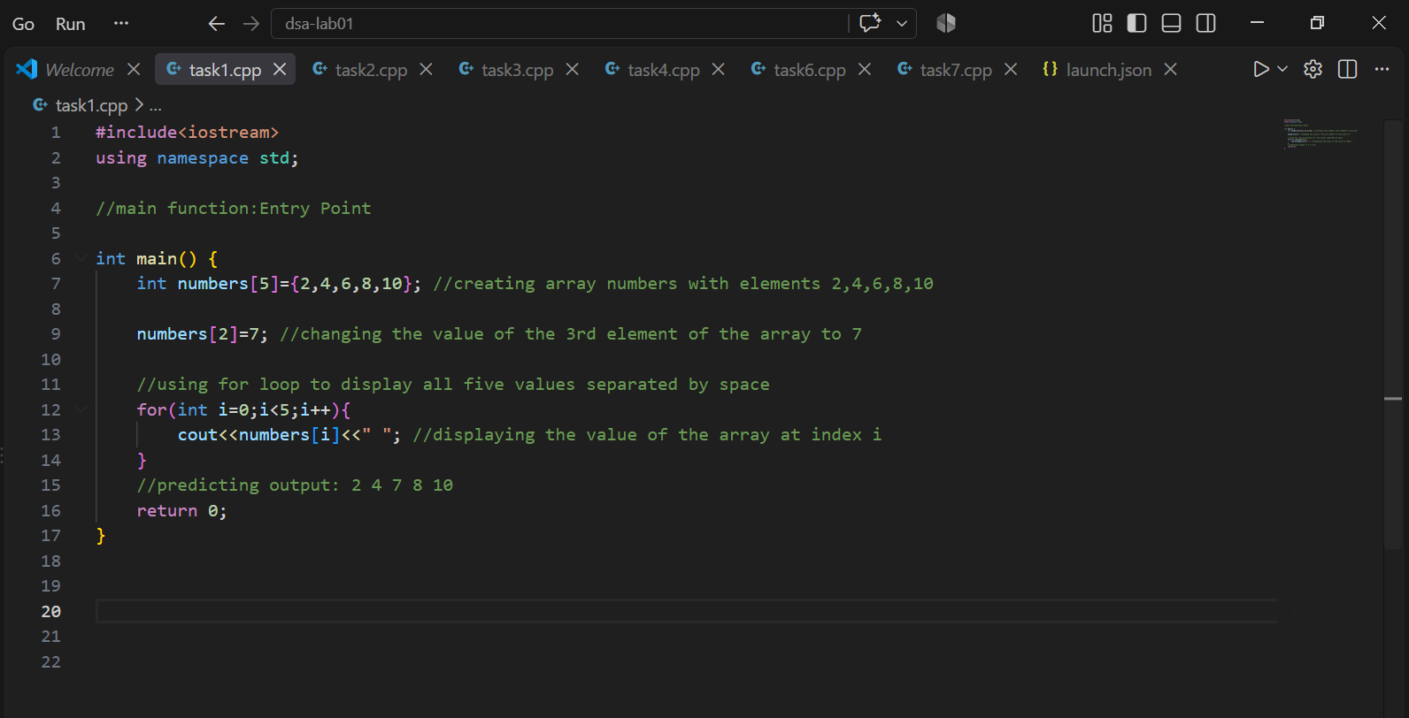
PREDICTING OUTPUT: 2 4 7 8 10

OUTPUT
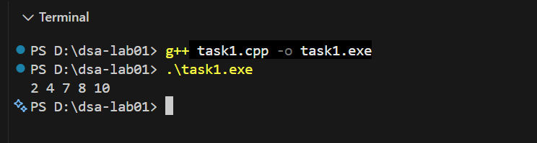

Task 2:
Declare int numbers[5]; and initialise int total = 0;. Use one loop to read five integers into the array and a second loop to add them to total. Display the total. Assume the user enters exactly five valid integers whose sum fits in int.

CODE
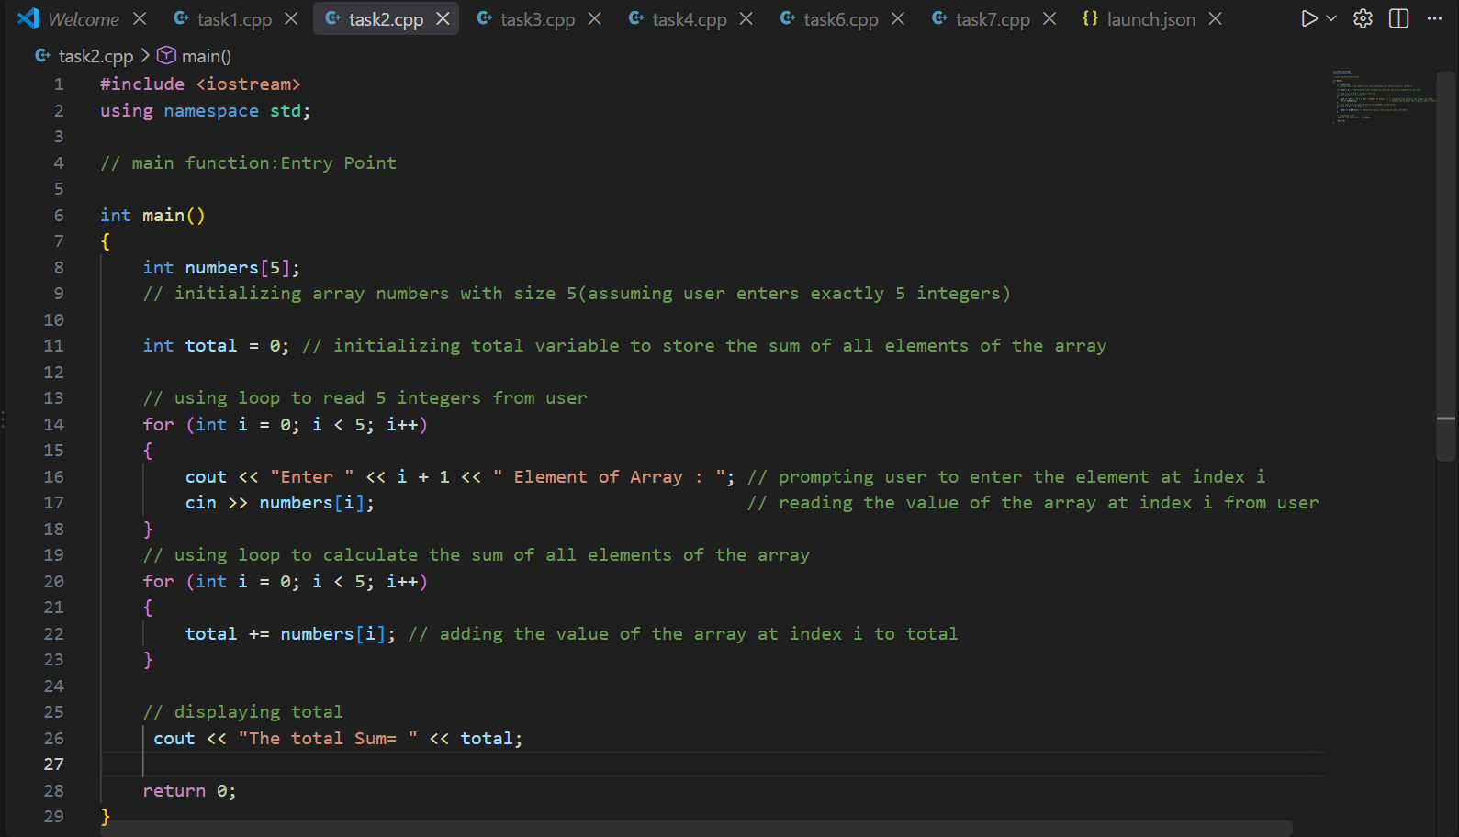

OUTPUT

Test input | Expected total | Actual total
1 2 3 4 5 | Complete before running | 15
0 0 0 0 0 | Complete before running | 0
-2 4 -1 0 3 | Complete before running | 4

For the first test, record i, numbers[i] and total after each addition. If a result differs from your prediction, check the loop bounds and the initial value of total.(PRESENTING TEST CASES FROM ABOVE TABLE)
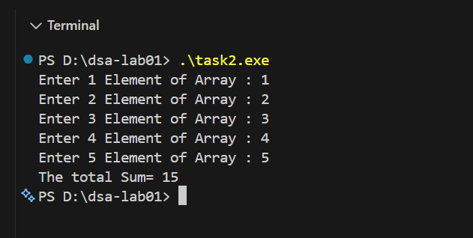
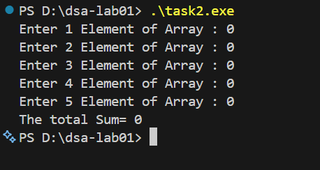
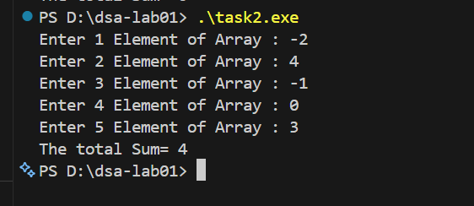

Task 3:
Define a class named Student with two public integer data members, rollNumber and marks. Add a public member function void display() that prints both values with labels on separate lines. Define the class above main().
Inside main(), create objects s1 and s2. Assign and display the following values using the dot operator and display():
Object | rollNumber | marks
s1 | 1 | 75
s2 | 2 | 90

Write the expected output before running. Then change only s1.marks to 80 and display both objects again. Predict whether s2.marks changes, and explain the result. Keep this experiment in your final program.

CODE

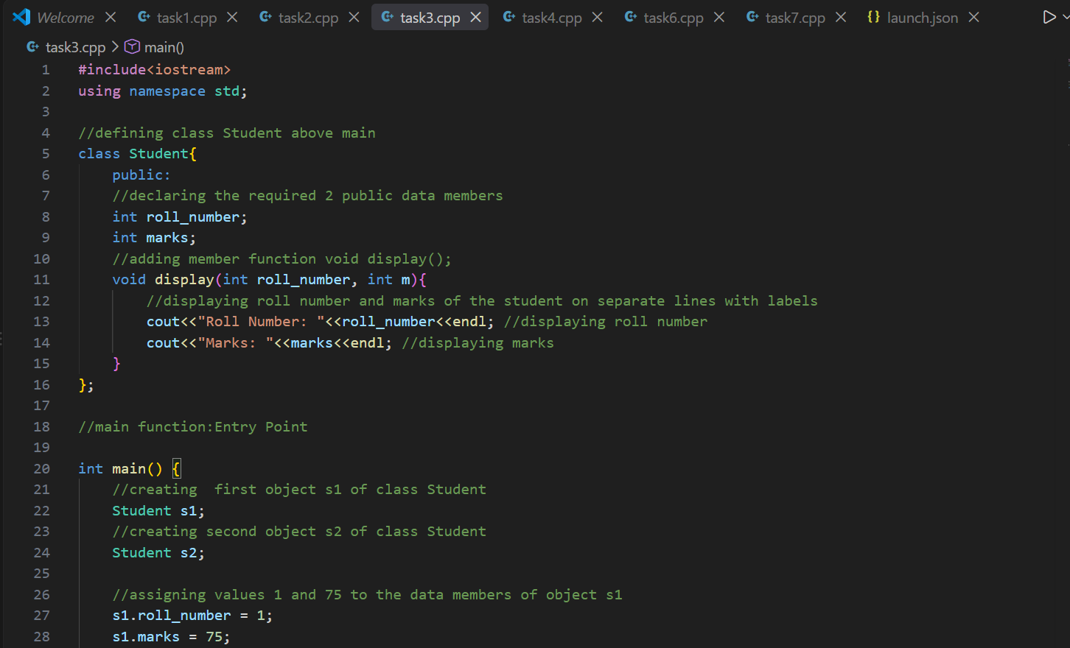
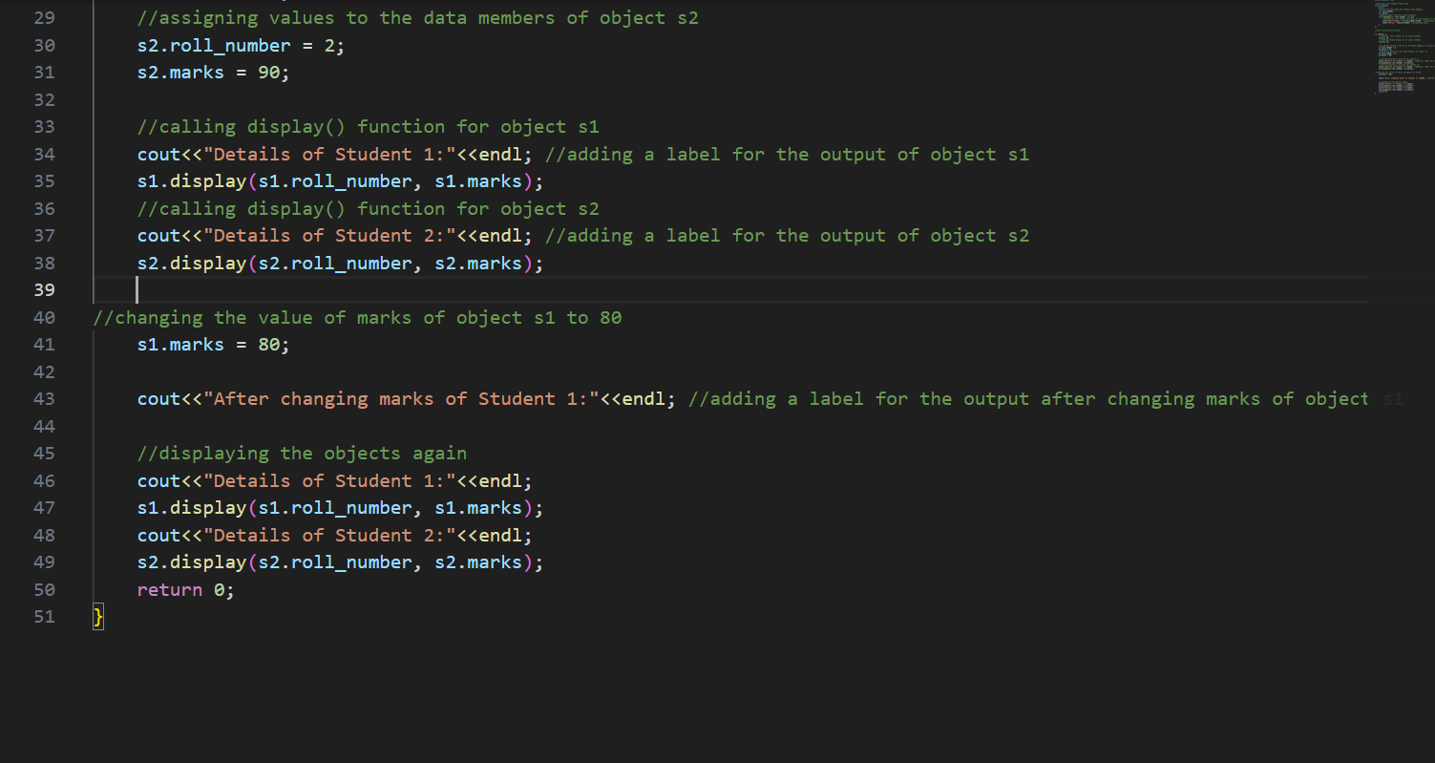
OUTPUT
EXPECTED OUTPUT:(without changing marks of Student 1)

Details of Student 1:
Roll Number: 1
Marks: 75
Details of Student 2:
Roll Number: 2
Marks: 90
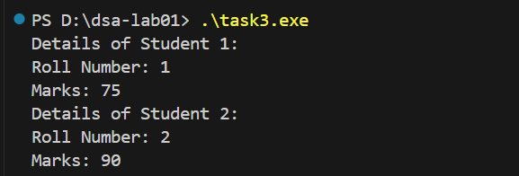
PREDICTING OUTPUT WITH CHANGING MARKS OF STUDENT 1 AND EXPLANATION
Details of Student 1:
Roll Number: 1
Marks: 75
Details of Student 2:
Roll Number: 2
Marks: 90
After changing marks of Student 1:
Details of Student 1:
Roll Number: 1
Marks: 80
Details of Student 2:
Roll Number: 2
Marks: 90
The marks of student 1 will be displayed 80 instead of 75 because the object owns its own memory space.When I edit the marks the previous marks are overwritten
OUTPUT WITHOUT CHANGING MARKS OF STUDENT 1
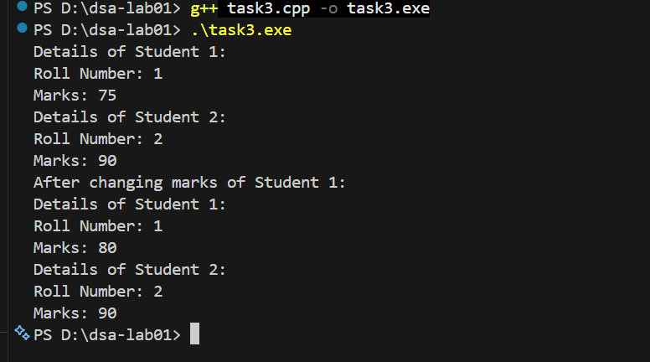
OUTPUT WITH CHANGING MARKS OF STUDENT 2

Task 4:
Read 8 integers into an array. Find and display the largest and smallest values and their indices. If a value occurs more than once, report its first occurrence.
CODE
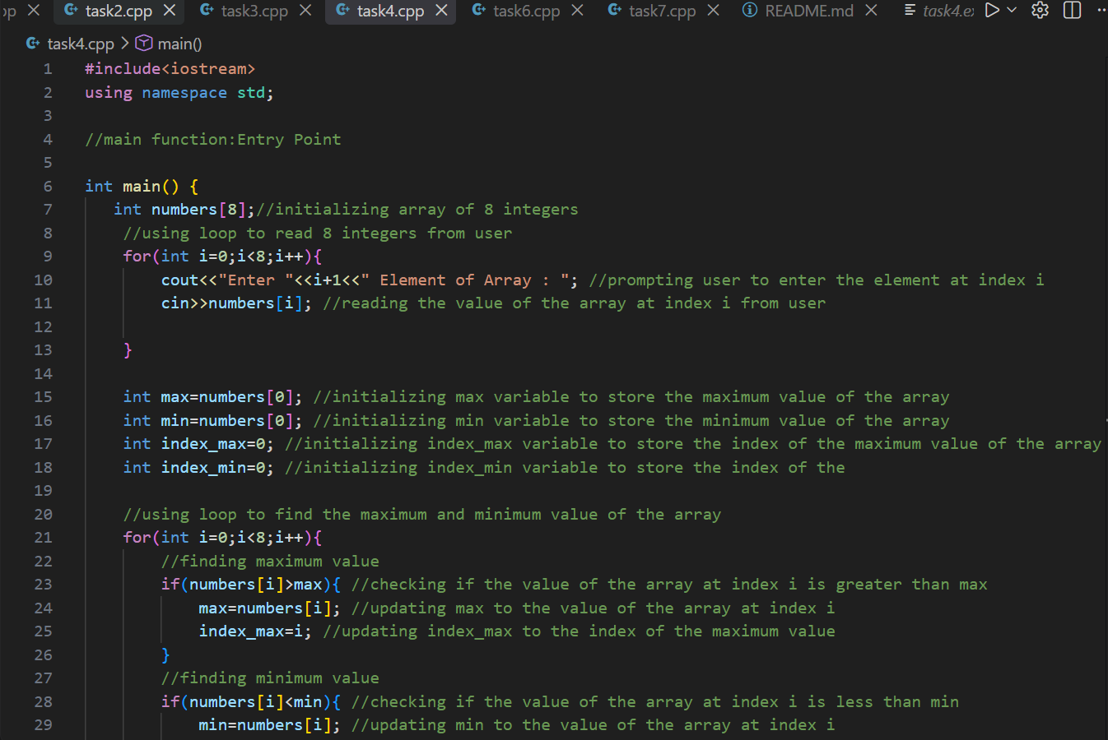
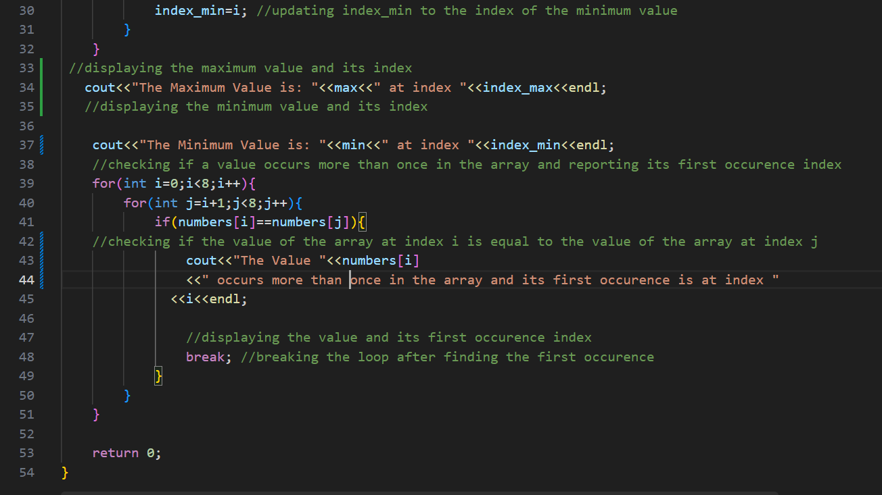

OUTPUT
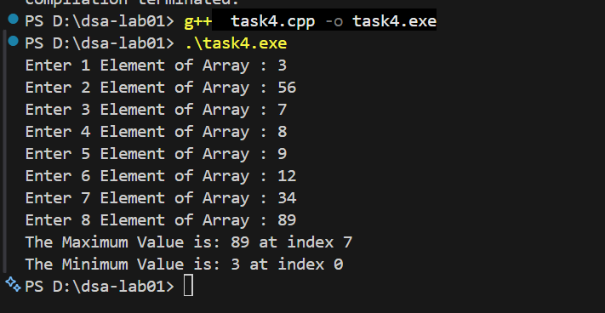

Task 5:

Read 8 integers into an array. Find and display the largest and smallest values and their indices. If a value occurs more than once, report its first occurrence.
SAME AS TASK 4

Task 6:
Read 6 integers into an array. Reverse the elements without using another array, then display the updated array.
Example: {3, 7, 2, 9, 4, 1} becomes {1, 4, 9, 2, 7, 3}.
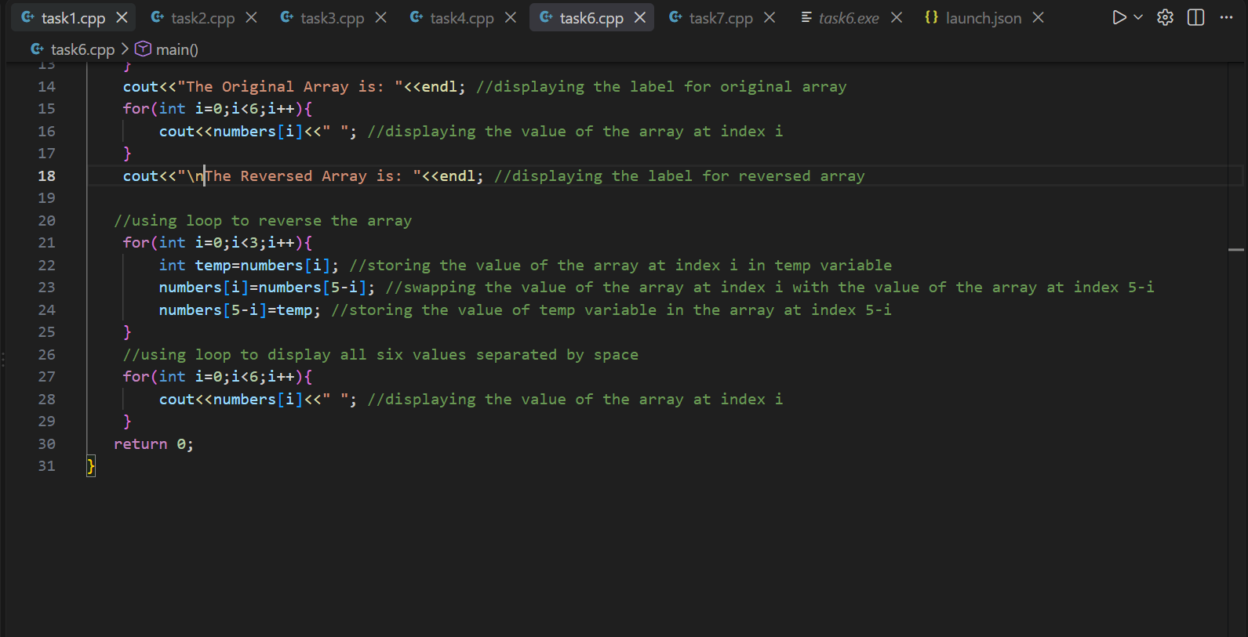

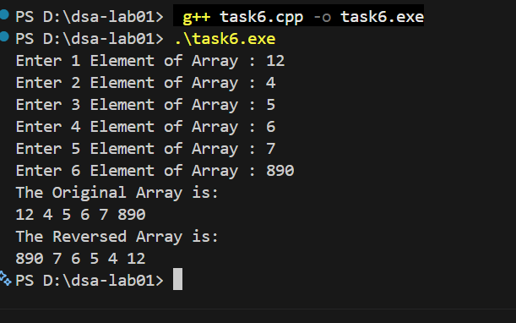

Task 7:
Read 10 integers into an array. Move the first occurrence of each distinct value into the beginning of the same array, preserving the original order. Display these unique values and their count. Do not use another array.
Example: {4, 2, 4, 7, 2, 9, 7, 1, 9, 1} produces {4, 2, 7, 9, 1}, with a count of 5.
The array’s physical capacity remains 10; only the first 5 positions represent the result.
CODE
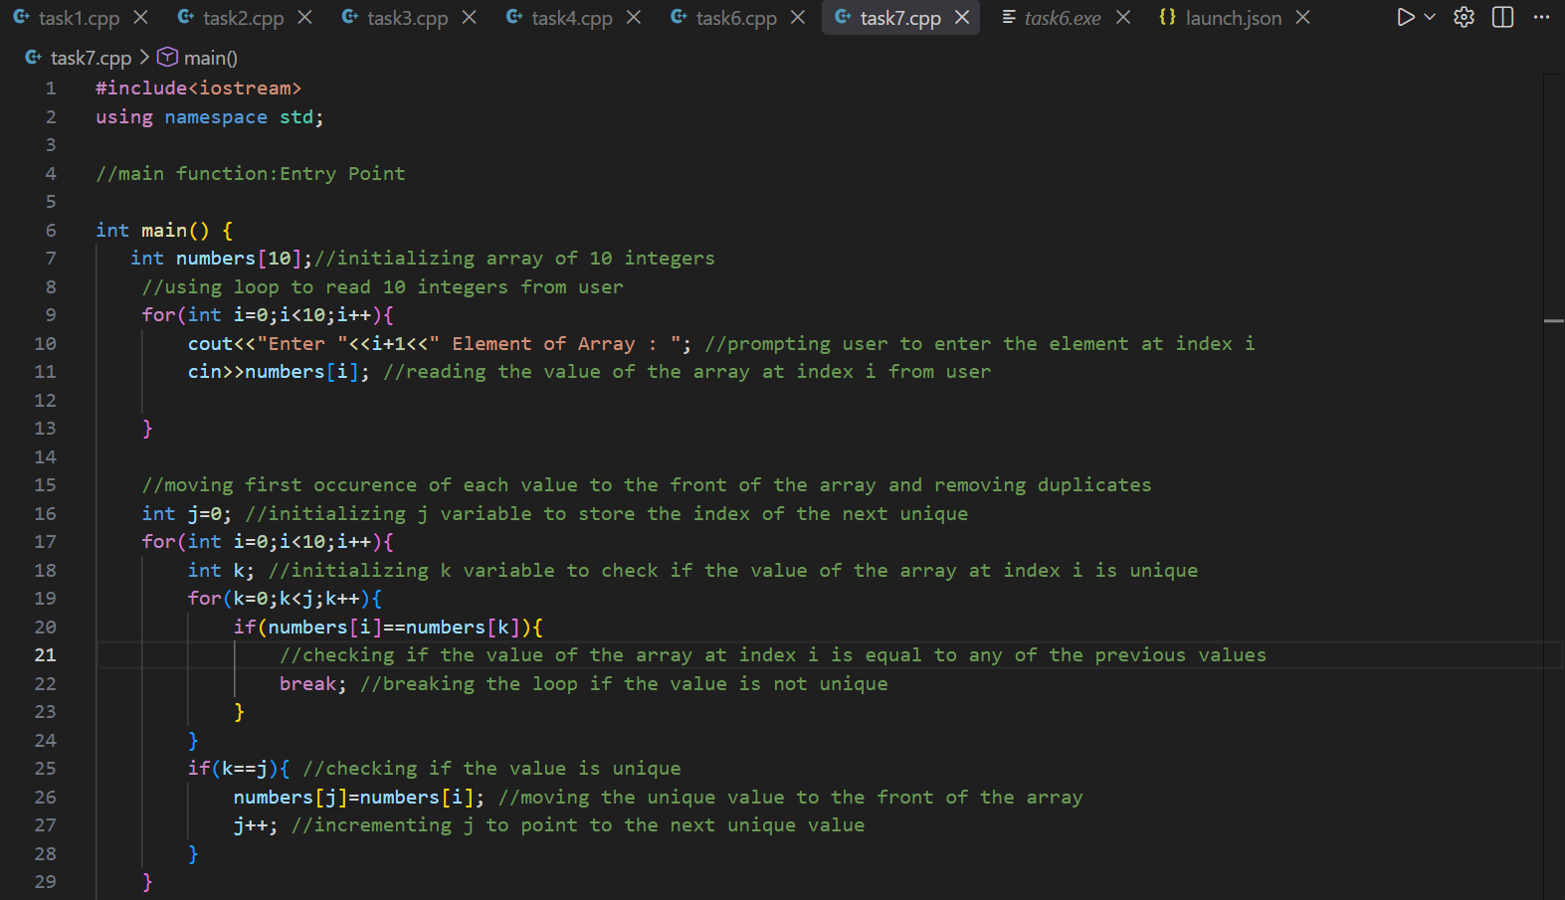
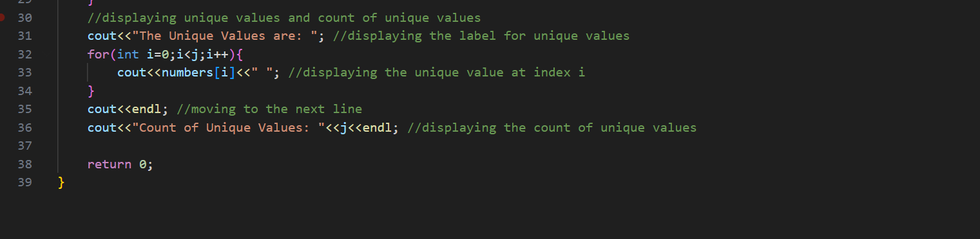

OUTPUT
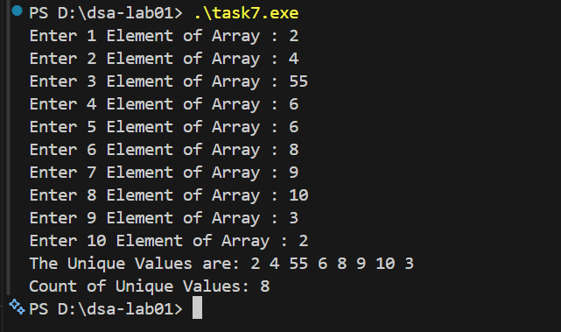

Task 8:
Create a folder named dsa-lab01 and place your tasks inside it. Open a terminal in that folder. Git setup is to be demonstrated by the lab engineer.
- git init
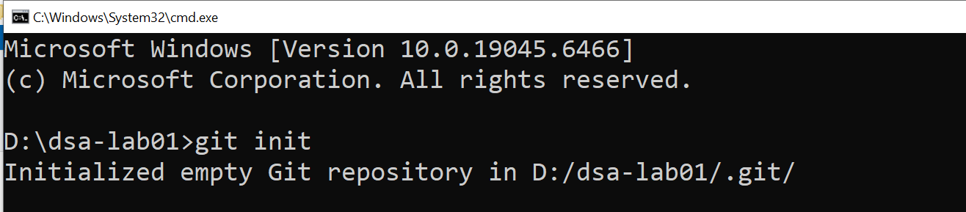
- git status
- 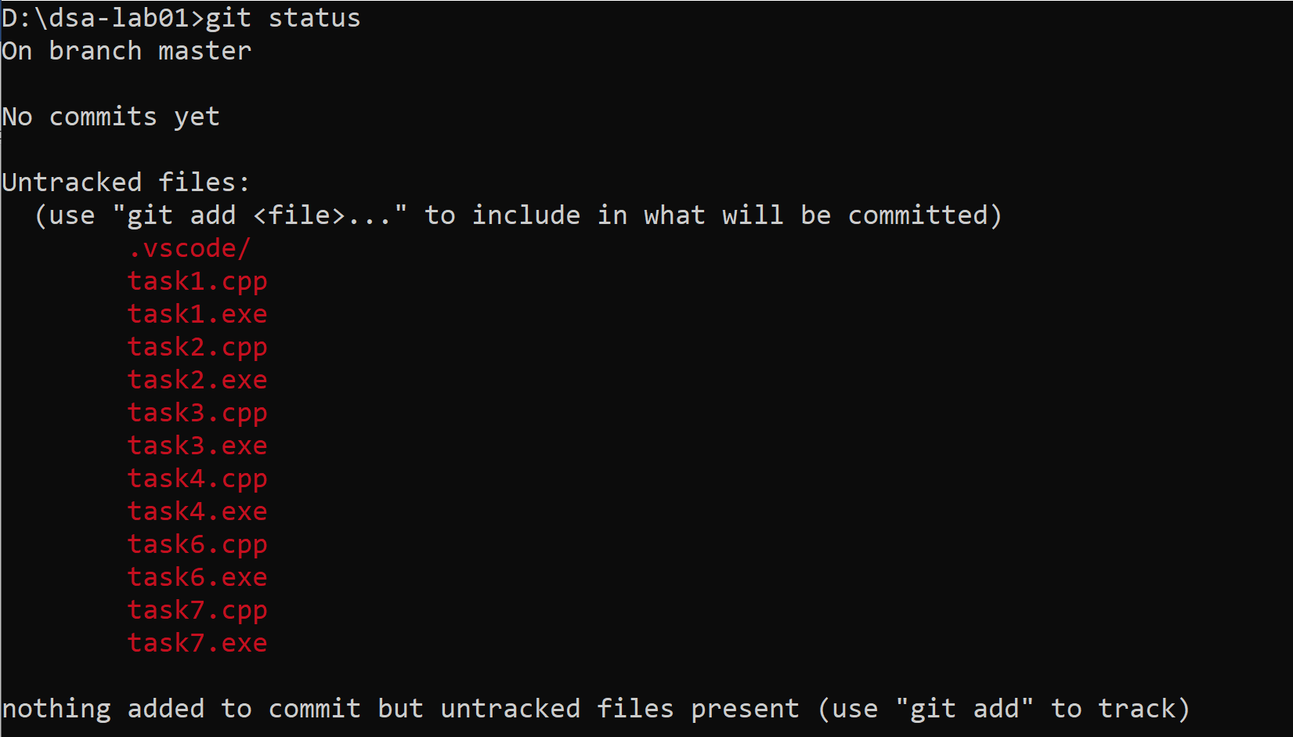
- git add task2.cpp task3.cpp task4.cpp
- git commit -m "Add array and Student class exercises"
- 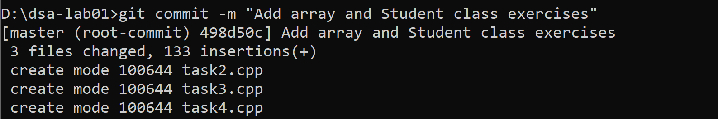
- Create README.md with your name, registration number, one sentence about each program, and the three Task 3 test results. Then run:
- 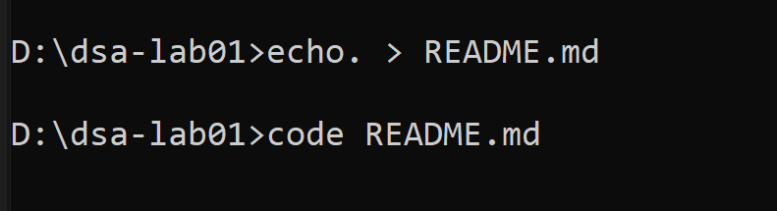
- git add README.md
- 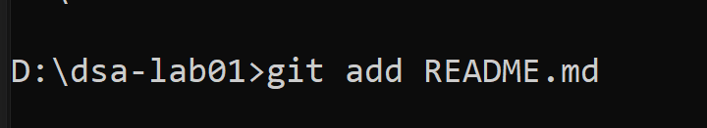
- git commit -m "Document programs and test results"
- 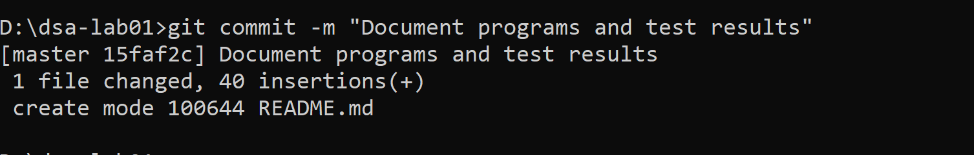
- git status
- 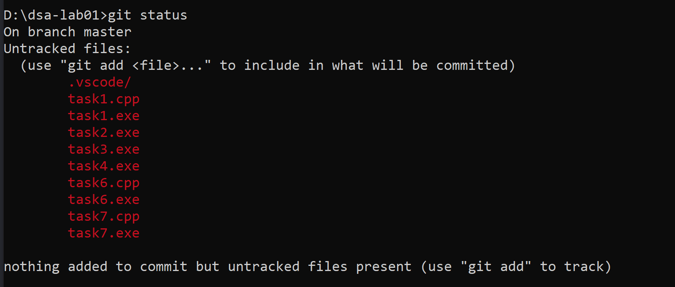
- git log –oneline
- 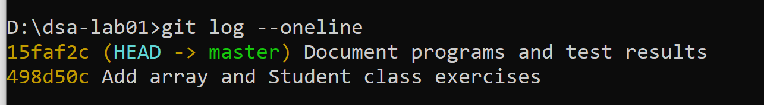
- Checking if README.md added
- 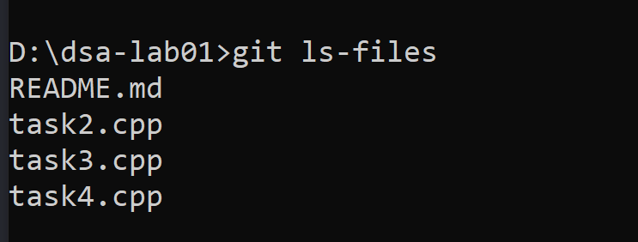
git add stages selected files. git commit records the staged version locally. git status shows file changes; git log shows commits. A commit does not upload files to GitHub. Stage only the named source and README files, not executables.

If Git asks for an identity, the instructor will help you run git config user.name "Your Name" and git config user.email "your-email@example.com" with your own details. These settings apply to this repository.

