Faculty of Computing
Department of Computing
CS: Data Structures and Algorithms
Class: BSCS-15E
Lab 02
Static and Dynamic Arrays
Pointers and Dynamic Memory Allocation
Lab Instructor:Urooj Kemal
Student Name: Noor-Ul-Huda
LMS:nhuda.bscs25seecs
Cms:542148
CLO 1: Describe the fundamentals of data structures and algorithms.
CLO 2: Solve a given real time problem by applying appropriate data structure and algorithm.

Introduction
This lab develops an understanding of one-dimensional and two-dimensional arrays in C++, with all element access performed through pointer expressions rather than ordinary subscript notation. Across six tasks, array sizes are first fixed at compile time and then chosen at runtime, memory is allocated on the heap with new[], used, expanded by copying into a larger block, and finally released with delete[].
The tasks progress from a static five-element array accessed through an int* (Task 1), to a runtime-sized one-dimensional array (Task 2), to a static two-dimensional array reached through a row pointer of type int (*)[3] (Task 3), to a fully dynamic matrix built from an array of row pointers (Task 4). Task 5 demonstrates that a heap block cannot grow in place and must be replaced by a larger copy, and Task 6 diagnoses and repairs a faulty fragment containing an out-of-bounds write, a mismatched deallocation and a dangling-pointer read.

Objectives
- Explain fixed-size and dynamic arrays, valid indices, and pointer expressions (CLO 1).
- Distinguish an element pointer (int*), a pointer to an array (int (*)[N]), and a double pointer (int**) (CLO 1).
- Implement 1D and 2D array programs using the suitable pointer type for each layout (CLO 2).
- Allocate, use, expand by copying, and safely release dynamic arrays without leaks or dangling access (CLO 2).
- Validate runtime dimensions before allocation and report errors without allocating memory.
- Identify and correct common memory faults: out-of-bounds access, delete vs delete[], and use-after-free.

Tools / Software Requirements
Item | Details Used
Language Standard | C++11 (compiled with -std=c++11)
Compiler | g++ (GNU C++ Compiler) / MSVC via Visual Studio
IDE / Editor | Visual Studio Code with the C/C++ extension
Operating System | Windows 11
Compile Command | g++ -std=c++11 -Wall -o task1 task1.cpp
Restrictions Observed | Raw arrays, loops, pointers, new[] / delete[] only. No vector, no library sort, no variable-length arrays.
Files Submitted | task1.cpp, task2.cpp, task3.cpp, task4.cpp, task5.cpp, task6.cpp

Task 1: Static 1D Array Accessed Through a Pointer
A shop records the number of items sold over five days. A fixed-size array int sales[5] is declared inside main() together with int* p = sales, and every read, display and update is performed through the expression *(p + i). The pointer p is never moved, so it continues to refer to the first element throughout.
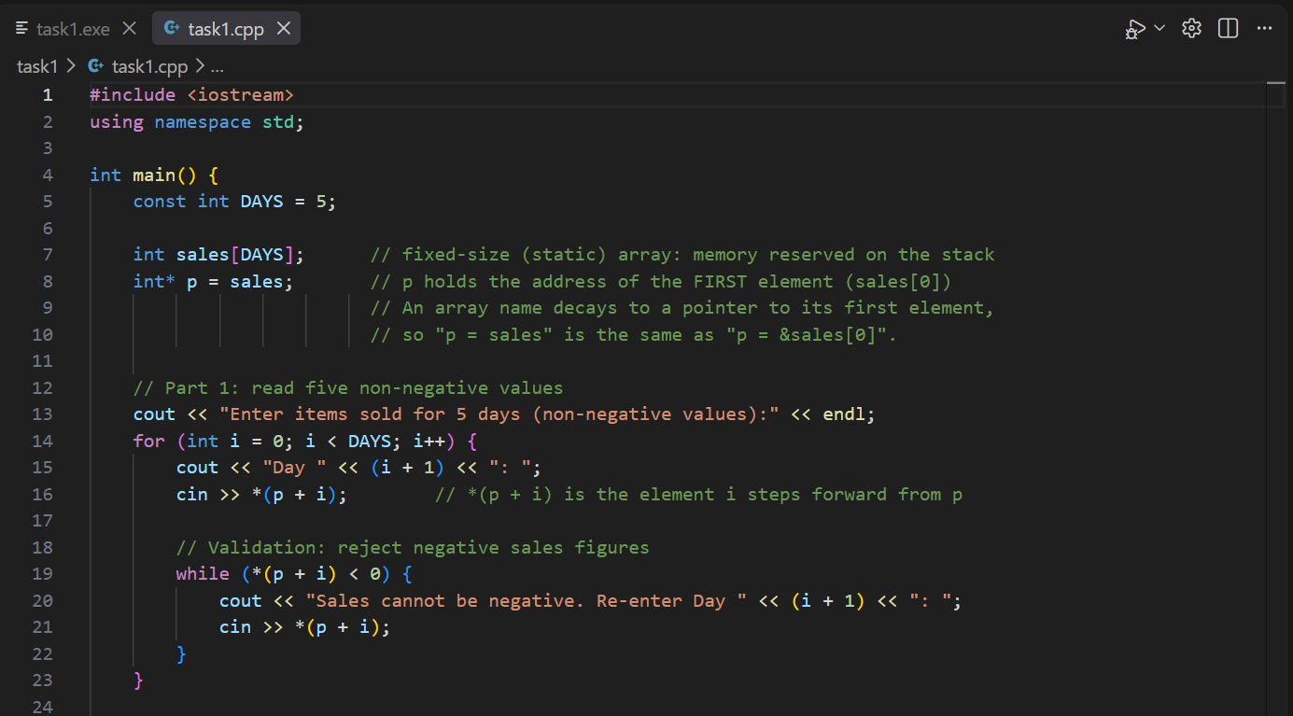
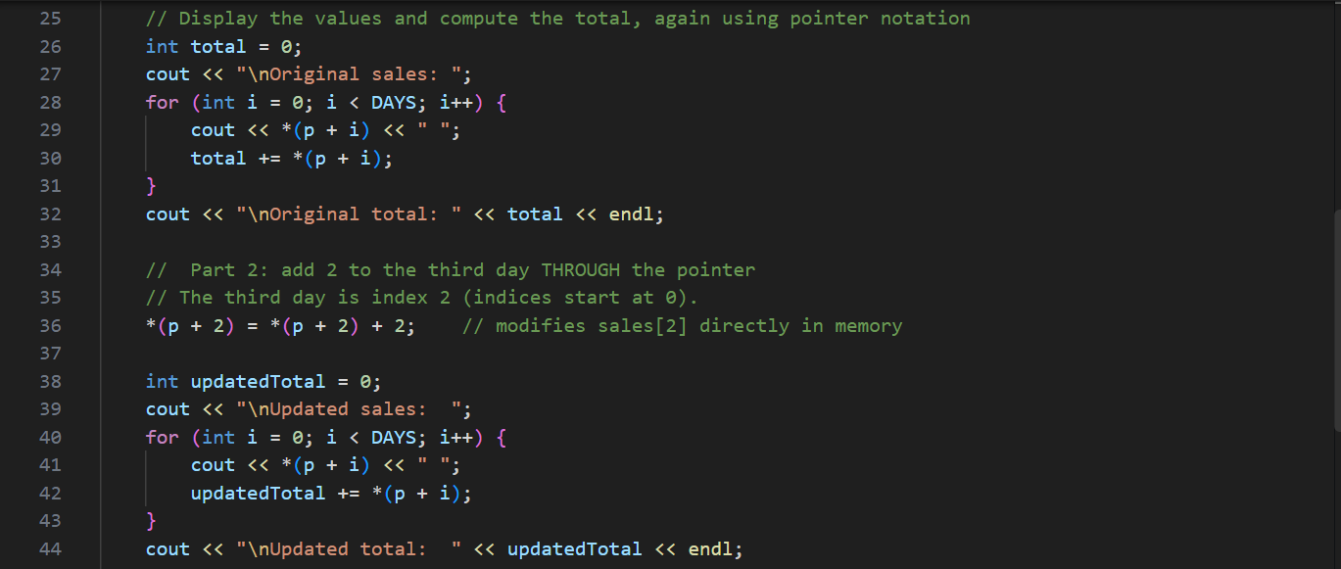
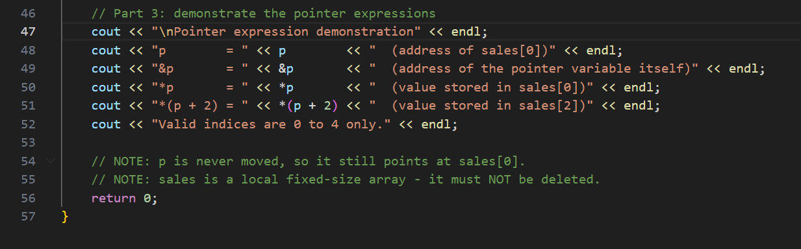

Output Screenshot
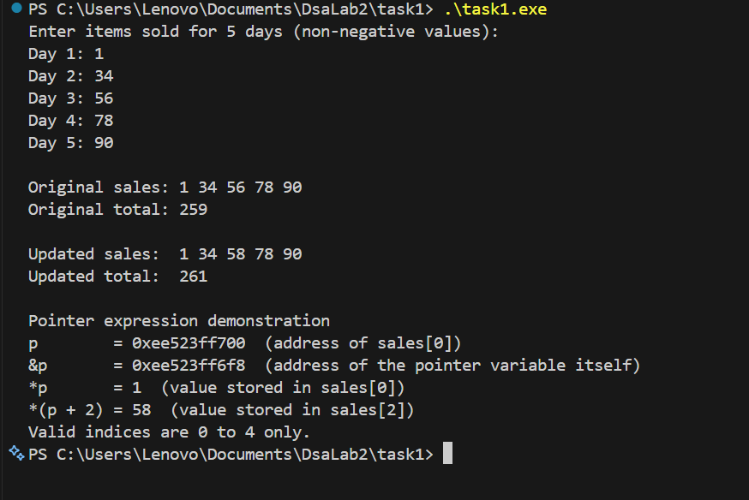

[ Paste screenshot here ]

Figure 1.1 — Task 1 output: original values, updated values and pointer expressions.

Explanation (Task 1, Part 3)
Expression | Meaning
p | The pointer variable itself. It holds the ADDRESS of sales[0], the first element of the array.
&p | The address of the pointer variable p. This is a different location in memory from the array; it is where the address value is stored.
*p | Dereferences p, giving the VALUE stored in sales[0]. It is identical to *(p + 0) and to sales[0].
*(p + 2) | Moves two int-sized steps forward from p and dereferences, giving the value of sales[2] — the third day.

Valid indices: the array has five elements, so the only valid indices are 0, 1, 2, 3 and 4. Index i corresponds to day i + 1.
Why *(p + 5) cannot be used to read an element: p + 5 computes the address one position PAST the last element. That address is legal to form and is commonly used as a loop end-marker, but no element exists there — it is not part of the array. Dereferencing it with *(p + 5) reads memory the array does not own, which is undefined behaviour. The program may print a meaningless value, may appear to work, or may crash, and the compiler performs no bounds checking to prevent it.

Task 2: Dynamic 1D Array (Student Marks)
The number of students is unknown until the program runs, so the array is created on the heap with new int[n] after n has been validated. All element access uses *(marks + i).

Source Code

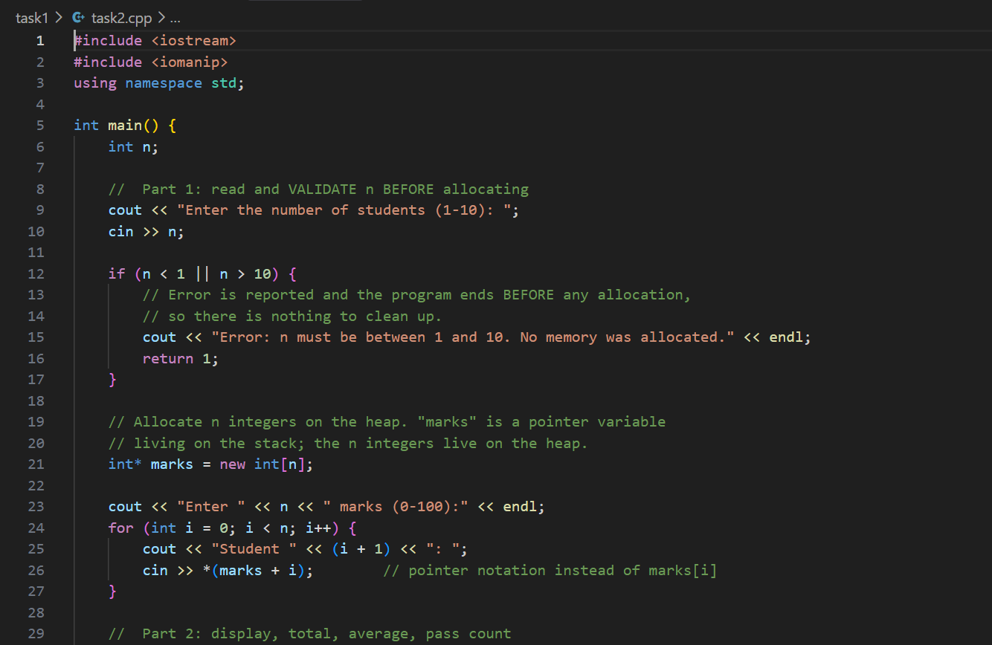

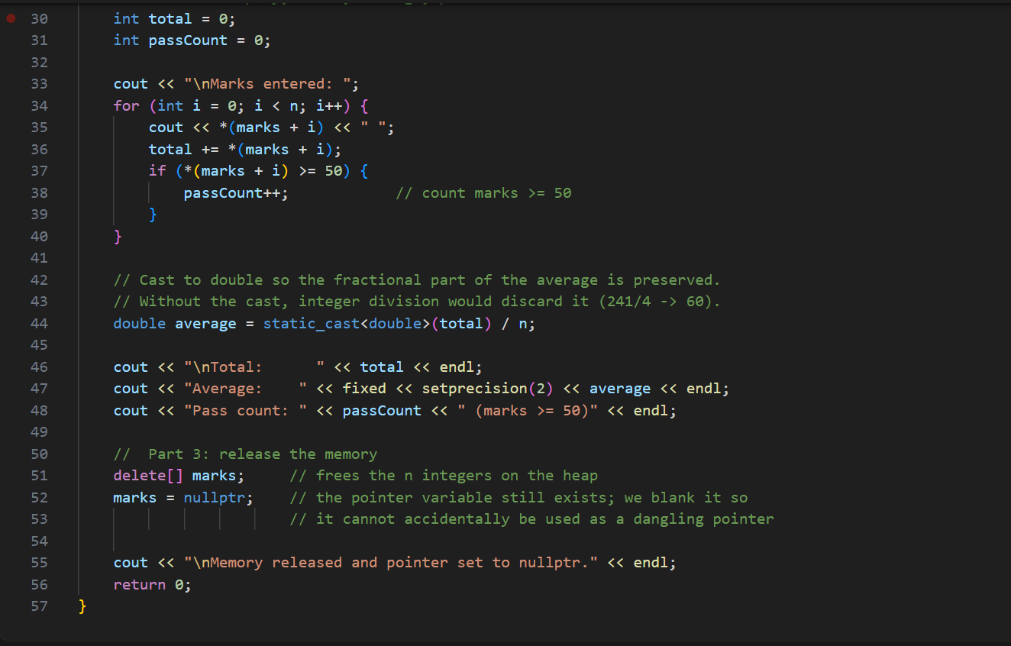

OUTPUT

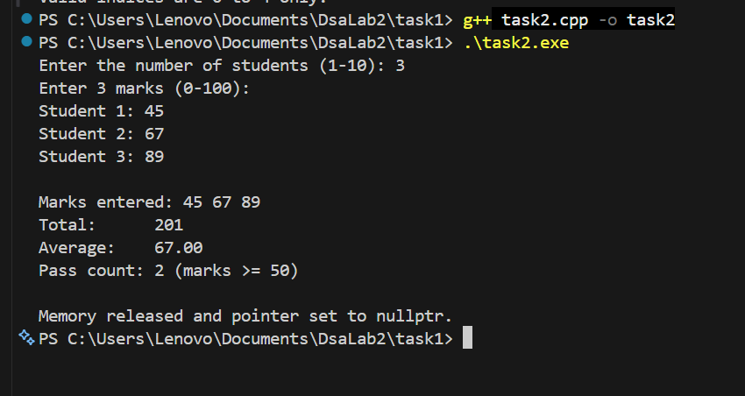

Explanation (Task 2, Parts 3 and 4)

Why the pointer variable and the allocated elements are different objects
marks is a local pointer variable with automatic storage; it lives on the stack and occupies only enough space to hold one address (typically 8 bytes). The n integers created by new int[n] live in a completely separate region, the heap, and their lifetime is controlled manually rather than by scope.
delete[] marks destroys the n heap integers but does NOT destroy the variable marks — that variable still exists and still contains the old address, which is now invalid. This is exactly why marks = nullptr is written afterwards: it overwrites the stale address so the dangling value cannot be dereferenced by mistake. Equally, setting some other pointer to nullptr would not repair marks, because each pointer variable stores its own independent copy of the address.

Why new int[n] works with a runtime n, but int marks[n]; does not
A fixed-size array declaration such as int marks[n]; requires n to be a compile-time constant, because the compiler must reserve that exact amount of stack space while translating the program — the size becomes part of the array's type. A runtime variable has no value at compile time, so the type cannot be formed. (Some compilers accept this as a non-standard variable-length-array extension, but it is not standard C++ and the lab forbids it.)
new int[n] avoids the problem entirely because the size is supplied when the expression EXECUTES, not when it is compiled. The request goes to the heap manager at runtime, which reserves a block of the requested size and returns its address. The type of the result is simply int*, which carries no size information, so any value of n is acceptable.

Task 3: Static 2D Array with a Row Pointer
A shop records sales for two branches across three days using int sales[2][3] and int (*rowPtr)[3] = sales. Rows represent branches and columns represent days. Output labels use branch and day numbers starting at 1, while the array indices still start at 0.

Source Code

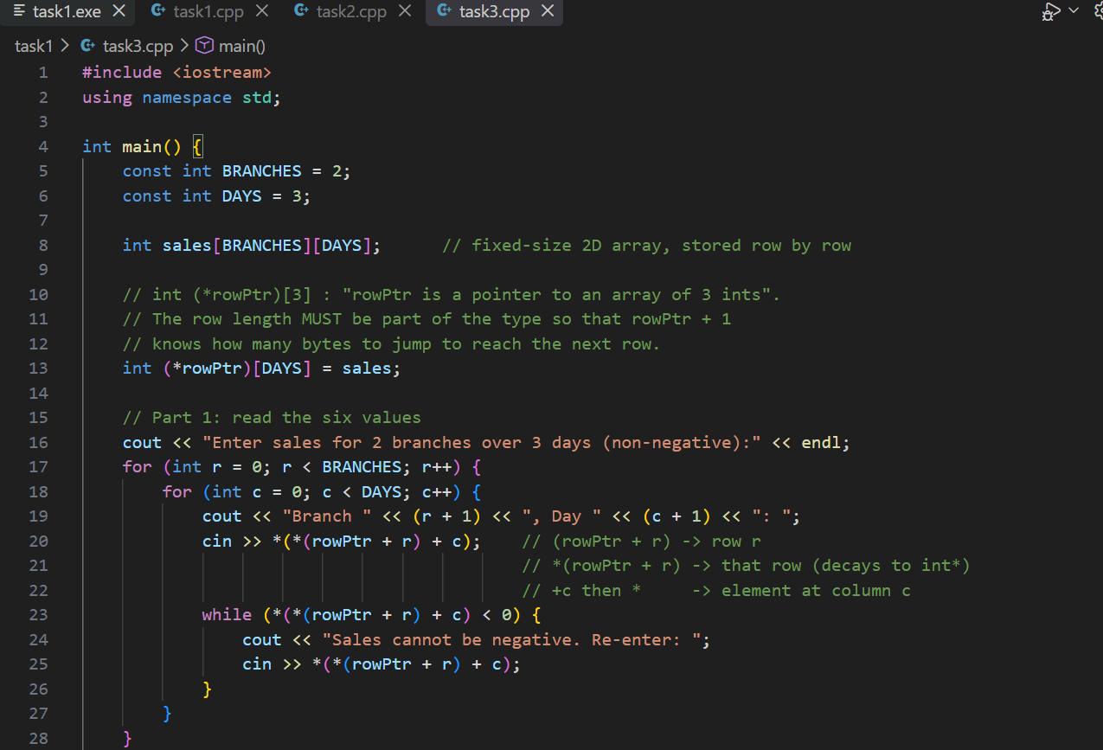

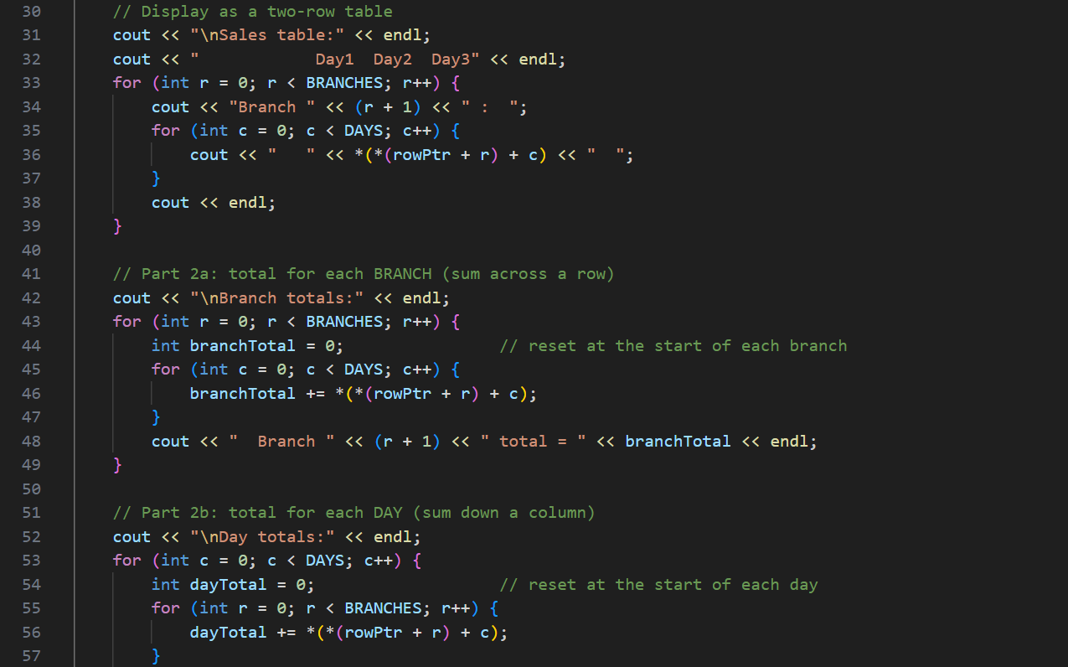

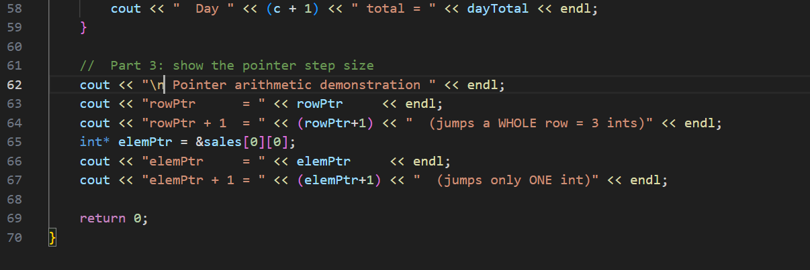

OUTPUT

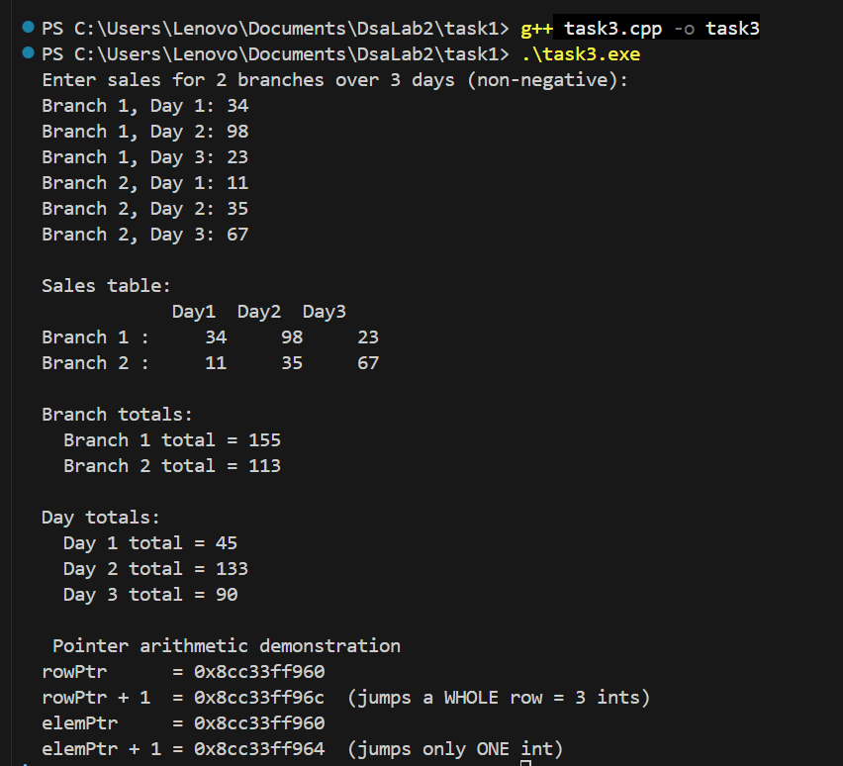

Explanation (Task 3, Part 3)

What rowPtr + 1 points to, and why its step differs
rowPtr has type int (*)[3], so the object it points at is an entire row of three integers. Adding 1 therefore advances by one whole row — 3 × sizeof(int) = 12 bytes on a typical system — and rowPtr + 1 points to the second branch, sales[1].
An int* points at a single integer, so adding 1 to it advances by only sizeof(int) = 4 bytes and lands on the next individual element. Pointer arithmetic always steps in units of the pointed-to TYPE, so the same "+ 1" means a different distance depending on what the pointer is declared to point at. This is visible in the program output, where rowPtr + 1 moves 12 bytes while elemPtr + 1 moves only 4.

Why int** p = sales; should not be used
A fixed-size 2D array is NOT an array of pointers. All six integers are stored contiguously in one block, row after row, and there are no stored pointer values anywhere inside sales. The name sales decays to int (*)[3], a pointer to its first row.
int** means "pointer to a pointer to int", which describes a layout where the first thing in memory is an array of ADDRESSES. Assigning sales to an int** is a type mismatch that the compiler rejects. If it were forced through with a cast, dereferencing it twice would read the first integer value (for example 2) and misinterpret that number as a memory address, then try to follow it — almost certainly crashing the program. The correct double-pointer layout is built explicitly in Task 4.

Task 4: Dynamic 2D Array Using int**
Marks are recorded for a group whose number of students (rows) and number of subjects (columns) are both entered at runtime. Because neither dimension is known at compile time, the matrix is built in two stages: an array of row pointers, followed by a separate block of integers for each row.

Source Code

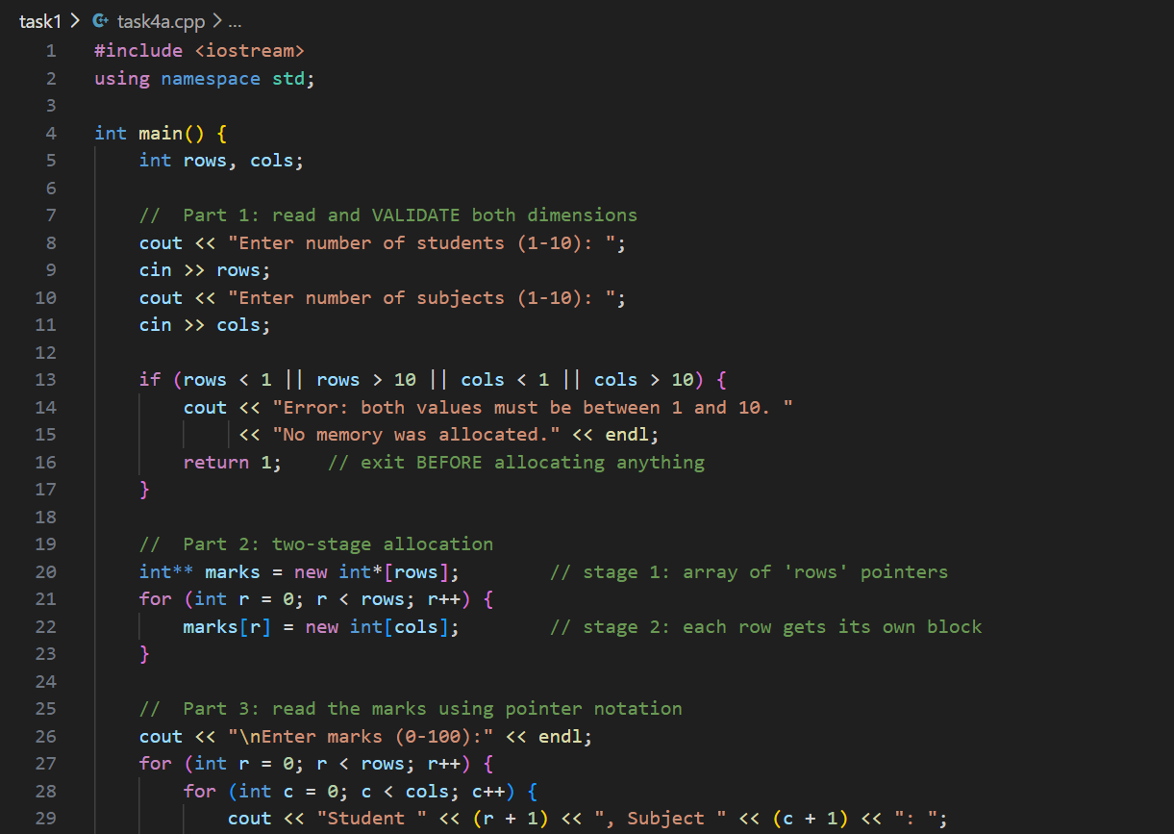

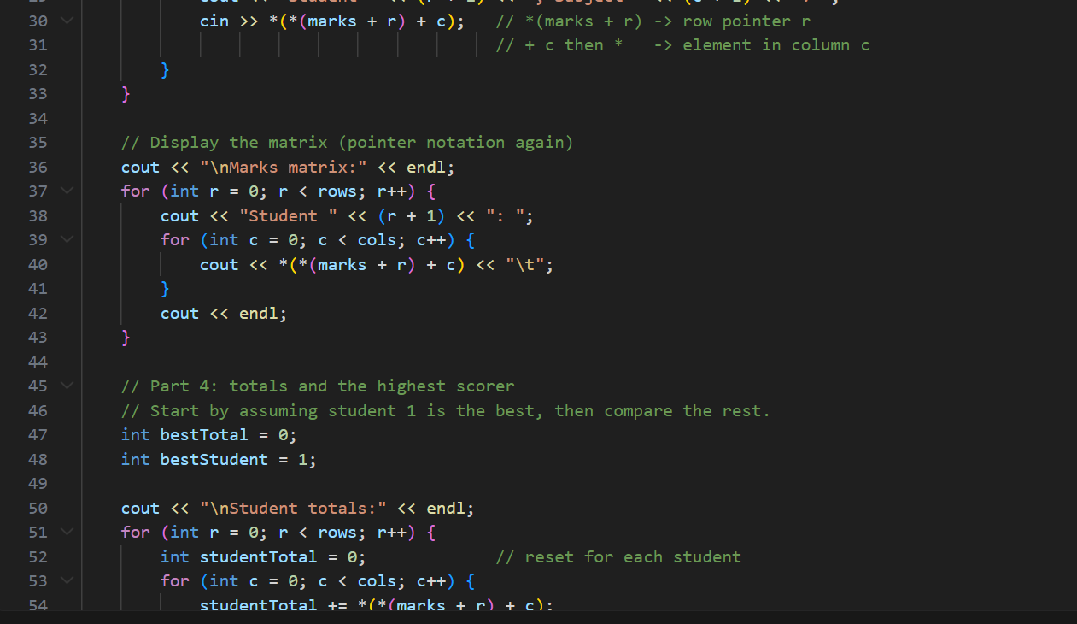

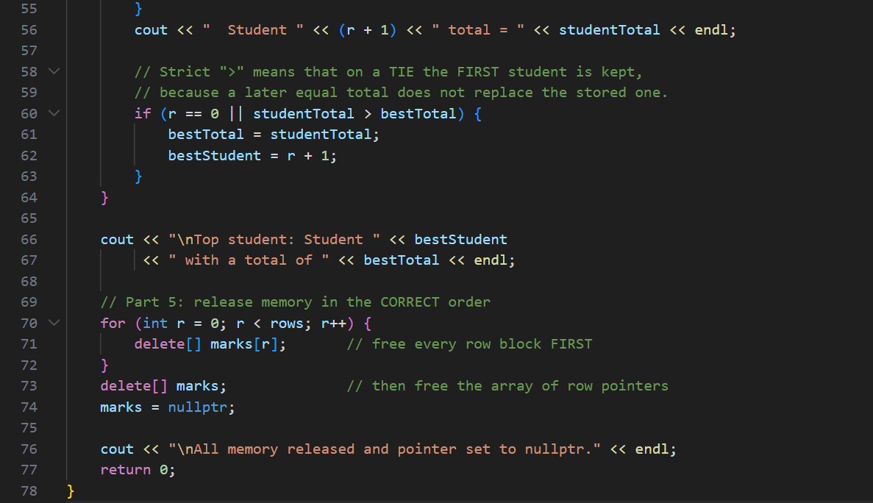
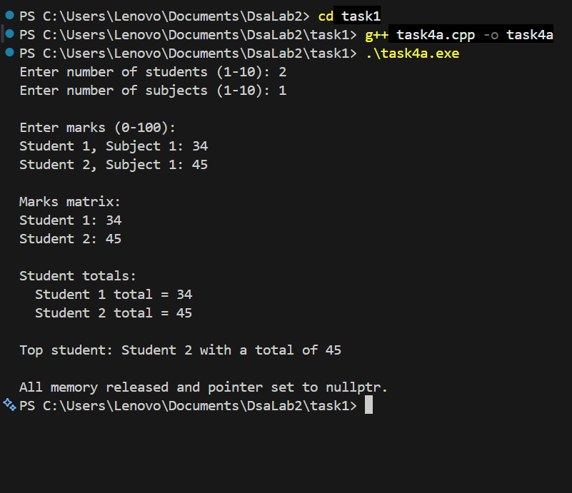

Task 5: Expanding a Dynamic Array by Copying
A new student joins after the marks have been entered. Since a block created by new[] cannot grow in place, a larger block of n + 1 integers is allocated, the existing values are copied across, the new mark is appended, and the old block is released.

Source Code

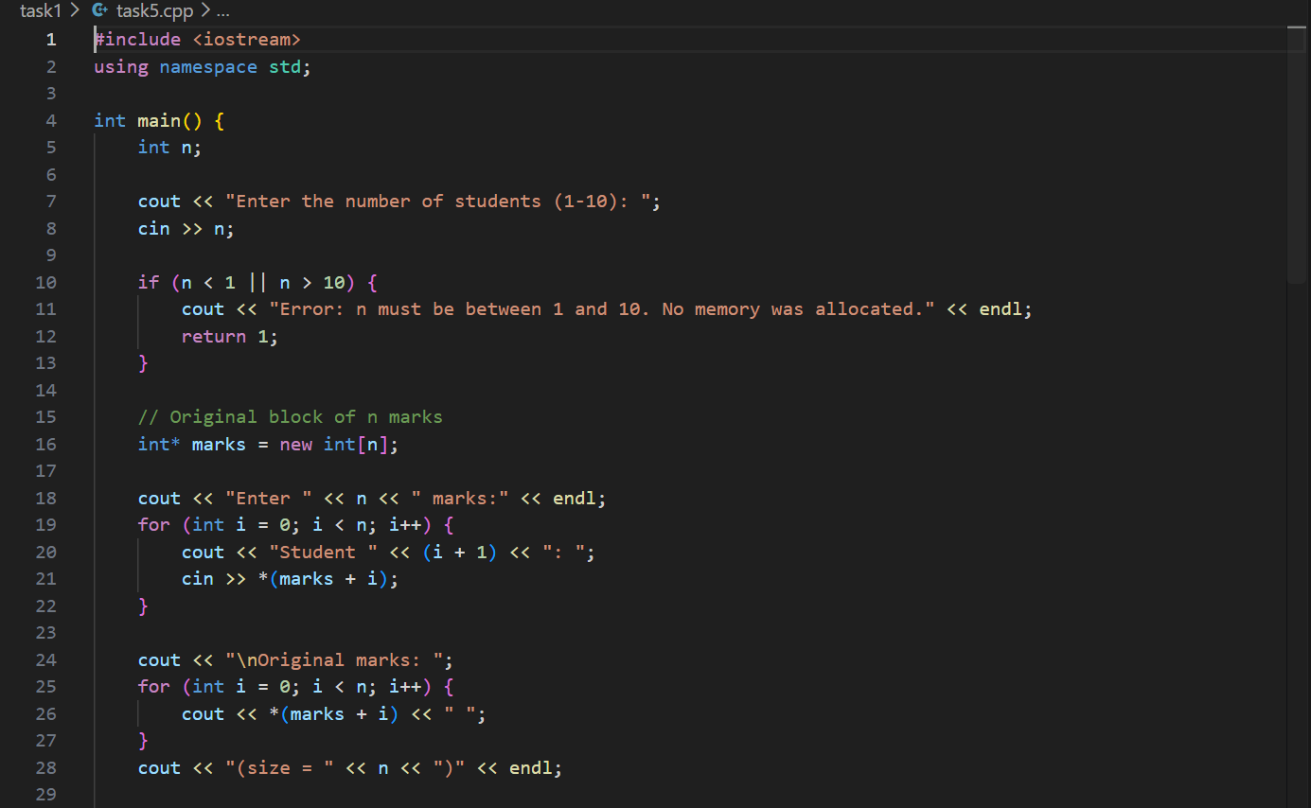

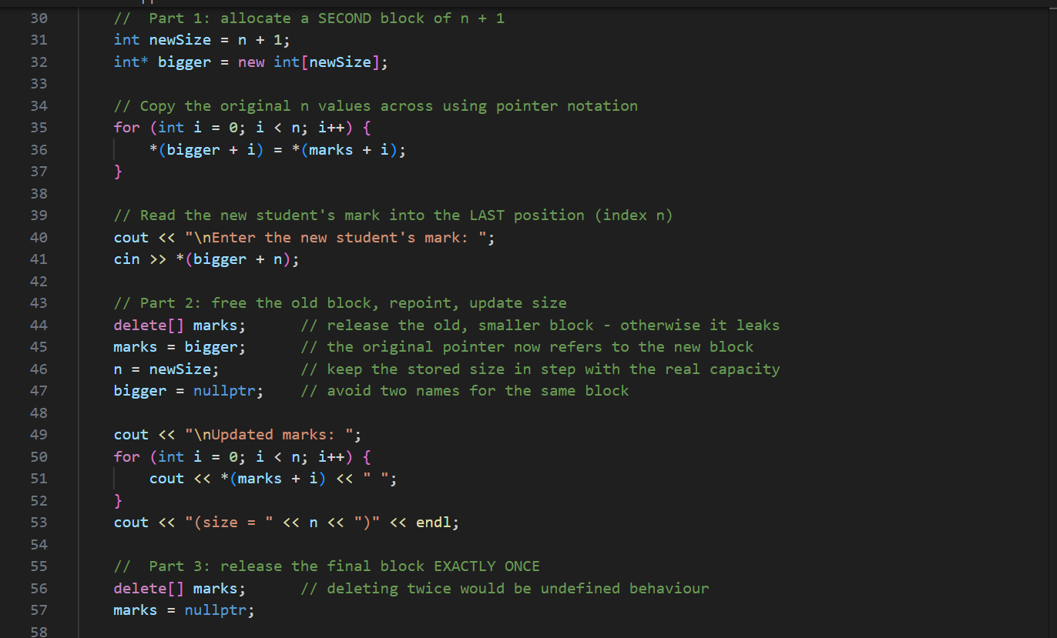

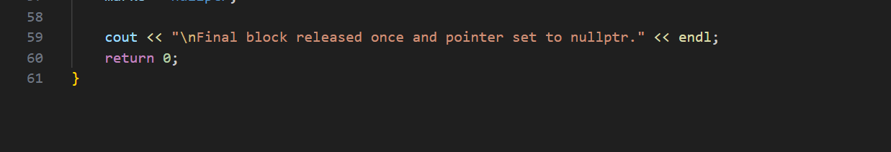

Output Screenshot

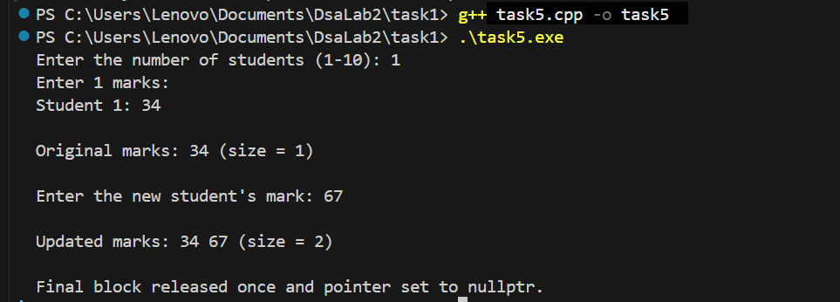

Explanation (Task 5, Part 3)

Why changing n alone does not increase the old block's capacity
n is just a local integer used to control loops; it is a record of how large the programmer believes the array to be. The actual block was reserved by the heap manager at the moment new int[n] executed, and its size was fixed at that instant. The memory immediately after the block may already belong to some other allocation.
Incrementing n changes only the loop bound, not the reservation. The loops would then run one step past the end of the real block and read or write memory the array does not own — an out-of-bounds access with undefined behaviour, which may silently corrupt other data. This is precisely why the correct sequence is allocate a new larger block → copy → append → delete the old block → update the pointer and the size.

Dangling pointers after the swap
Once delete[] is applied to the old block, any other pointer that still holds the old address becomes a dangling pointer. In this program bigger is set to nullptr after the swap so that only one name, marks, refers to the live block, which makes the single final delete[] unambiguous. Deleting the same block twice is undefined behaviour and typically aborts the program.

Task 6: Debugging a Faulty Fragment

Part 1 — The Three Errors
# | Error | Problem | Consequence
1 | Loop condition i <= n | The array holds 3 integers with valid indices 0, 1 and 2, but the loop runs while i is 0, 1, 2 AND 3, so it writes to values[3]. | An out-of-bounds WRITE into memory the array does not own. This is undefined behaviour: it may silently corrupt heap bookkeeping data or another variable, and it often causes a crash later at a point unrelated to the real fault. Fix: use i < n.
2 | delete values; instead of delete[] values; | The block was created with the array form new[], so it must be released with the matching array form delete[]. Mismatching the two forms is undefined behaviour. | The runtime may free only part of the allocation or mishandle the block's size information, leaking memory or corrupting the heap. Fix: use delete[] values;.
3 | cout << values[0]; after deletion | The memory has already been released, but values still holds the old address, making it a dangling pointer. The element is then read through it. | A use-after-free read. The heap manager may have reused the block, so the value printed is meaningless and the program may crash. Fix: display the values BEFORE deleting, and set values = nullptr afterwards.

Part 2 — Corrected Program

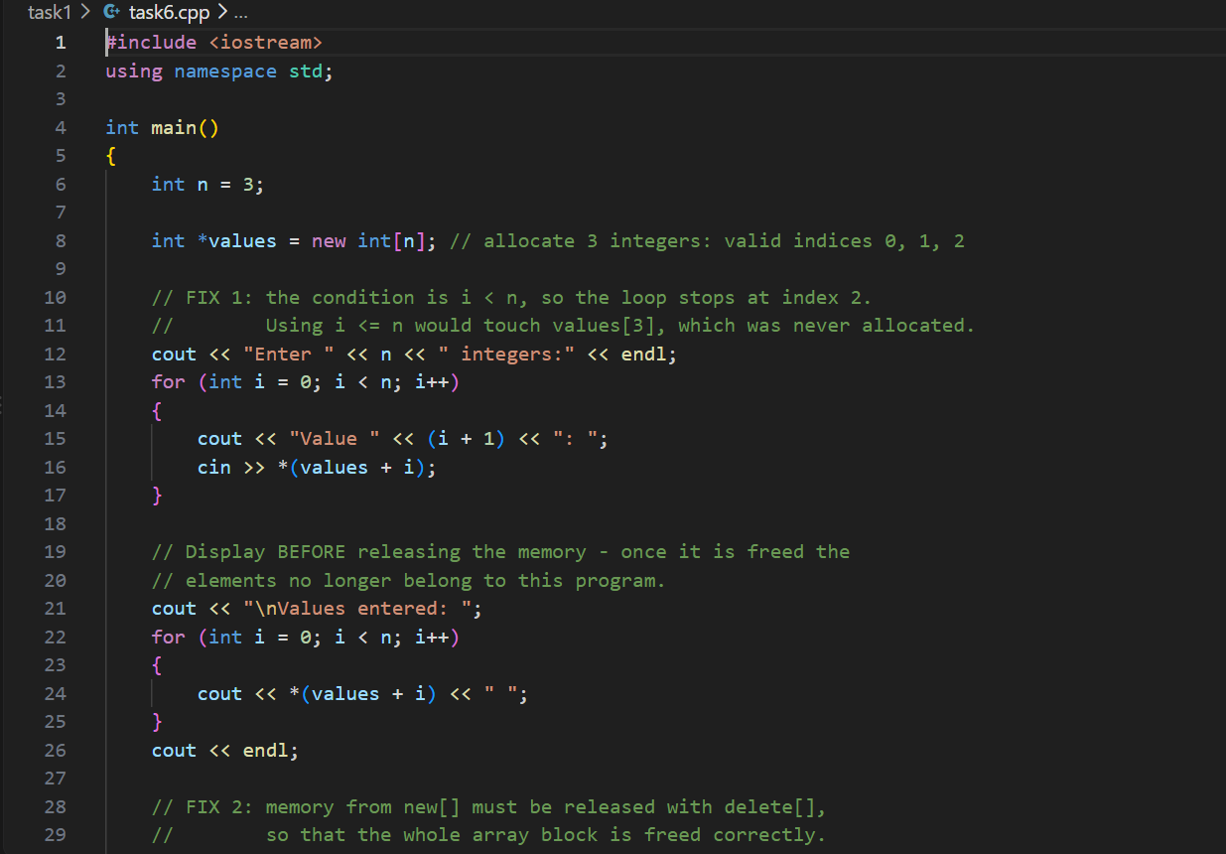

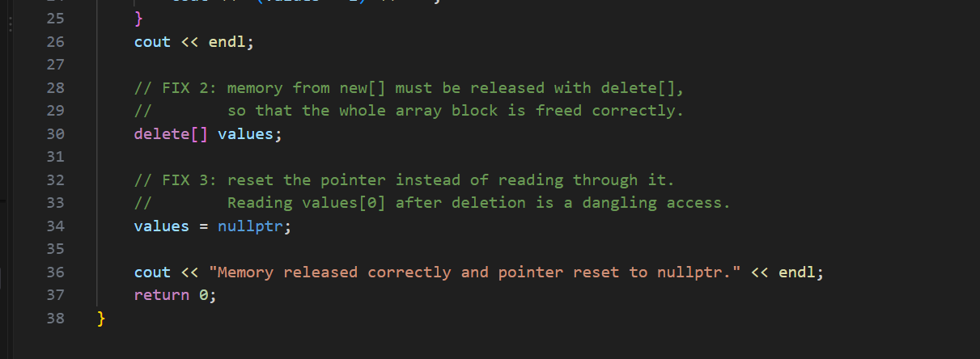

Output Screenshot
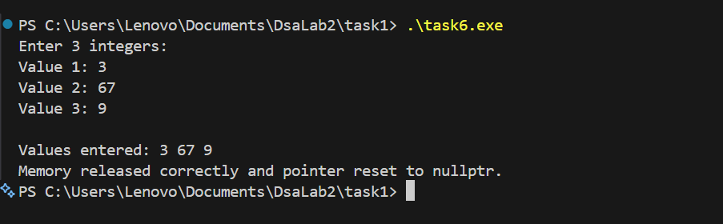

Part 3 — Distinguishing the Three Memory Faults
Fault | Definition | Example in this Task
Out-of-bounds access | Reading or writing a position outside the range the allocation actually covers. The memory may exist and belong to something else, so the compiler cannot detect it. | values[3] in the original loop, where only indices 0–2 were allocated.
Dangling pointer | A pointer that still holds the address of memory that has already been released. The pointer itself is valid; the memory it names is not. | values after delete, used by the final cout statement.
Memory leak | Allocated memory that is never released and can no longer be reached, so it stays reserved until the process ends. | Would occur if delete[] were omitted entirely, or in Task 4 if only the row-pointer array were freed.

Why an apparently successful run does not prove the memory accesses are valid
C++ performs no bounds checking and no validity checking on pointer dereferences. An out-of-bounds write may land on padding or on a region the process already owns, so nothing visibly goes wrong; a dangling read may return the old bytes simply because the heap manager has not yet reused the block. In both cases the program produces the expected output purely by accident.
Undefined behaviour carries no guarantee of consistency: the same code can behave differently with a different compiler, different optimisation flags, a different input size, or on a different run of the same binary. A fault may stay hidden for months and then surface as a crash far away from its cause. Correctness must therefore be argued from the code itself — checking that every index stays inside its range, that each new[] has exactly one matching delete[], and that no pointer is dereferenced after release — rather than inferred from a run that happened not to fail. Tools such as valgrind or the address sanitizer (g++ -fsanitize=address) can expose these faults that ordinary execution hides.

Test Results
Expected and actual results for the supplied test cases. The Actual Result column should be confirmed against your own run before submission.
Task and Input | Expected Result | Actual Result | Pass / Fail
Task 1 Input: 2 4 6 8 10 | Original total 30; after +2 on day 3: 2 4 8 8 10, total 32 | 2 4 8 8 10; total 32 | Pass
Task 2 Input: n = 4; 40 50 70 81 | Total 241; average 60.25; pass count 3 | Total 241; average 60.25; pass count 3 | Pass
Task 2 Input: n = 1; mark = 0 | Total 0; average 0; pass count 0 | Total 0; average 0.00; pass count 0 | Pass
Task 2 Input: n = 0 | Error; no allocation or mark input | Error message shown; program ended before allocation | Pass
Task 3 Input: 2 4 6 / 1 3 5 | Branch totals 12 and 9; day totals 3, 7 and 11 | Branch totals 12 and 9; day totals 3, 7, 11 | Pass
Task 3 Input: 0 0 0 / 0 0 0 | Every total is 0 | All branch and day totals 0 | Pass
Task 4 Input: 2 × 3: 50 60 70 / 80 40 90 | Totals 180, 210; top student 2 | Totals 180, 210; top student 2 | Pass
Task 4 Input: 2 × 2: 40 60 / 50 50 | Totals 100, 100; top student 1 (tie → first) | Totals 100, 100; top student 1 | Pass
Task 4 Input: 1 × 1: 75 | Total 75; top student 1 | Total 75; top student 1 | Pass
Task 5 Input: n = 3; 45 60 75; new 90 | 45 60 75 90 | 45 60 75 90 (size 4) | Pass
Task 5 Input: n = 1; 0; new 100 | 0 100 | 0 100 (size 2) | Pass
Task 6 Input: 4 5 6 | Displays 4 5 6; memory released correctly | Values entered: 4 5 6; released, pointer reset | Pass

Conclusion
All six tasks were implemented, compiled and tested against the supplied inputs, and every case produced the expected result. The lab reinforced that pointer arithmetic steps in units of the pointed-to type, which is why an int* and an int (*)[3] behave differently when incremented, and why int** is the wrong type for a built-in 2D array but the right one for a matrix assembled from separate row allocations.
The memory-management tasks made the manual nature of heap allocation explicit: a block cannot grow in place, every new[] needs exactly one matching delete[], rows must be released before the pointer array that holds their addresses, and a released pointer must be reset so it cannot be dereferenced again. Task 6 in particular showed that a program can appear to run correctly while still containing out-of-bounds writes and use-after-free reads, so correctness has to be established by reasoning about the code rather than by observing a successful run.

