Huda Alaa Abdelmalek Alhasasnah(H00532978)
[Company name] [Company address]
[Document title]

Data collection
Data collection in this project was conducted using Python, with the Pandas library as the core tool for data ingestion and manipulation. Pandas is specifically optimized for handling structured datasets and provides high-performance functions for importing, cleaning, and transforming data within a unified analytical environment.
In addition to Pandas, the NumPy library is also used to support efficient data handling. NumPy provides powerful array structures and mathematical functions that enable fast numerical computations. It works seamlessly with Pandas, as DataFrames are built on NumPy arrays, allowing for optimized performance when processing large datasets. The combination of Pandas and NumPy ensures both flexibility in data manipulation and efficiency in computation, which is essential when working with high-dimensional data.
The dataset was imported using the read_csv() function, which efficiently loads large CSV files into a DataFrame, a two-dimensional tabular data structure that supports indexing, filtering, and vectorized operations. In addition, Pandas supports Excel-based data sources through the read_excel() function, demonstrating flexibility in handling multiple data formats commonly used in real-world data science applications.
The dataset consists of approximately 150,000 observations and 34 variables, representing a high-dimensional structured dataset. Handling such data requires efficient memory management and scalable processing, both of which are supported by Pandas. Proper data loading is not only a technical step but a critical foundation that ensures data integrity, consistency, and readiness for subsequent analysis.

Identification and Separation of Variables
A crucial step in data handling is the clear separation of variables into dependent (target) and independent (predictor) variables. This separation is essential because it defines the analytical structure, guides model selection, and prevents data leakage, which can negatively affect model performance.
Primary Dependent Variable
- FraudFound
This is a binary categorical variable that indicates whether an insurance claim is fraudulent (Yes or No). It serves as the target variable for the predictive model and defines the problem as a supervised binary classification task.
The selection of FraudFound is analytically justified because the primary objective of the project is to predict fraudulent claims, making it the central outcome variable driving the entire modeling process.

Secondary Dependent Variable
- VehiclePrice
This is a continuous numerical variable representing the financial value of the insured vehicle. It is used for descriptive and inferential analysis to understand financial variability and risk exposure within the dataset.
Including a secondary dependent variable strengthens the analysis by adding a financial dimension, allowing deeper insights into how economic factors relate to fraud risk.

Independent Variables
All remaining variables such as Age, DriverRating, PastNumberOfClaims, VehicleCategory, PolicyType, Deductible, AgeOfVehicle, and Claim-related attributes are treated as independent variables.
These variables function as predictors and are analytically important because they capture:
- Demographic characteristics
- Behavioral risk indicators
- Vehicle attributes
- Claim-related factors
Collectively, these features influence:
- The probability of fraud occurrence
- The variation in vehicle financial value
This multidimensional feature set supports multivariate analysis, which is essential because fraud is rarely driven by a single factor.

Data Preparation and Structuring
To ensure compatibility with machine learning algorithms and statistical techniques, the dataset was prepared as follows:
- The FraudFound variable was transformed into a binary numerical format
0 = No, 1 = Yes
This transformation is necessary because most algorithms require numerical input and cannot process raw categorical labels.
- The dataset was structured into:
  - Feature matrix (X) containing all independent variables
  - Target vector (y) containing the dependent variable
This structured separation is essential for supervised learning, as it ensures that the model learns the relationship between input features and target outcomes without unintended bias.

Justification of Data Handling Approach
The selection of Pandas is strongly justified due to its ability to:
- Efficiently process large-scale datasets
- Perform data cleaning, transformation, and preprocessing
- Support vectorized operations, which significantly improve computational efficiency
- Integrate seamlessly with machine learning libraries such as Scikit-learn
Furthermore, the explicit separation of dependent and independent variables ensures:
- Prevention of data leakage, which can artificially inflate model performance
- Improved model generalization
- Clear interpretability of results, which is critical in fraud detection systems
Overall, this approach demonstrates a strong understanding of data handling principles, ensuring that the dataset is not only correctly imported but also logically structured and analytically prepared for advanced modelling and evaluation.

Data Cleaning

Data cleaning is a critical preprocessing stage that ensures data quality, consistency, and reliability before performing statistical analysis and machine learning modeling. Poor data quality can lead to biased results, incorrect pattern detection, and reduced model performance, making systematic validation essential.
In this project, data cleaning was performed using Python with the Pandas library, which provides efficient tools for data inspection, validation, and preprocessing.

Data Validation Process
Before applying any cleaning techniques, the dataset was thoroughly examined using multiple validation checks:
- df.info()
Used to verify data structure, data types, and non-null values, ensuring that all variables are correctly formatted and complete.
- df.isnull().sum()
Used to detect missing values across all variables. Missing data can distort statistical measures and reduce model accuracy.
- df.duplicated().sum()
Used to identify duplicate records, which can introduce bias and artificially inflate patterns.
- df.describe()
Used to generate summary statistics, allowing detection of unusual values, inconsistencies, or potential outliers.
- .unique() for categorical variables
Used to verify category consistency and ensure there are no incorrect or inconsistent labels.

Code:
import pandas as pd

# Load dataset
df = pd.read_csv("final.csv")

# 1. DATA STRUCTURE VALIDATION

print("=== Dataset Info ===")
df.info()

# 2. MISSING VALUES CHECK

print("\n=== Missing Values ===")
missing_values = df.isnull().sum()
print(missing_values)

if missing_values.sum() == 0:
print("\nNo missing values detected in the dataset.")
else:
print("\nMissing values detected.")

# 3. DUPLICATE RECORDS CHECK

duplicates = df.duplicated().sum()

print("\n=== Duplicate Rows ===")
print("Number of duplicate rows:", duplicates)

if duplicates > 0:
df = df.drop_duplicates()
print("Duplicate rows removed.")
else:
print("No duplicate rows found.")

# 4. SUMMARY STATISTICS

print("\n=== Summary Statistics ===")
print(df.describe())

# 5. CATEGORICAL DATA VALIDATION

print("\n=== Unique Values (Categorical Variables) ===")

cat_cols = df.select_dtypes(include=['object']).columns

for col in cat_cols:
print(f"\n{col}:")
print(df[col].unique())

# 6. FINAL DATASET CHECK

print("\n=== Final Dataset Shape ===")
print(df.shape)

print("\n=== Final Missing Values ===")
print(df.isnull().sum())

print("\nData cleaning completed successfully.")

Output Screenshot:
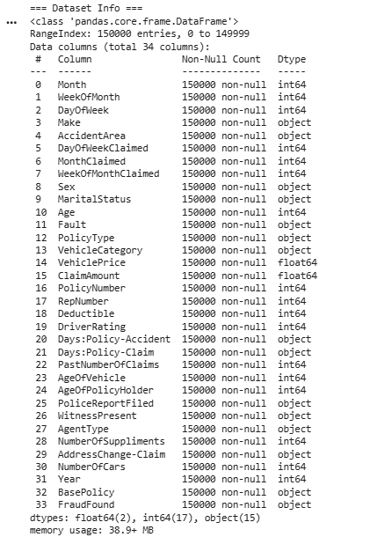
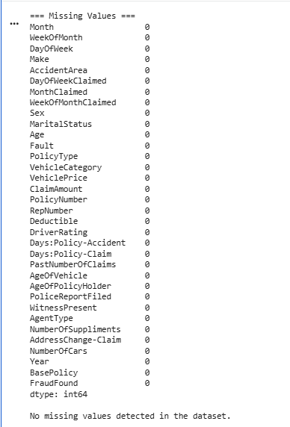
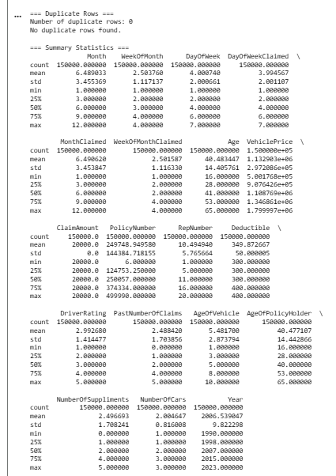
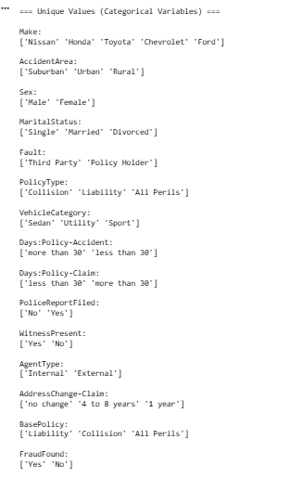
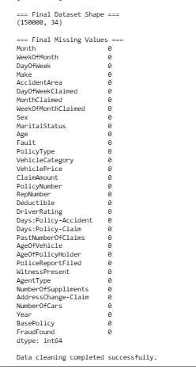
Figure 1: Data cleaning and validation process using Python, showing checks for missing values, duplicates, and data consistency.

Validation Results and Interpretation
The validation process produced the following results:
- No missing values across all variables
This indicates complete data coverage, eliminating the need for imputation and reducing the risk of biased estimates.
- No duplicate records
This ensures data uniqueness, preventing overrepresentation of certain observations in the analysis.
- Consistent data types and category labels
This confirms structural integrity, ensuring variables are suitable for computation and modelling.
- Stable statistical distribution observed in summary statistics
This suggests no obvious data entry errors or extreme inconsistencies.
However, an important observation is that ClaimAmount is constant across all records, which limits its predictive value and may reduce its importance in modelling.
These findings indicate that the dataset is of high quality and does not require direct cleaning operations such as removal, imputation, or correction.

Critical Justification of Cleaning Strategy
Although no corrective cleaning was required, performing comprehensive data validation is itself a crucial data cleaning strategy. This demonstrates a preventive approach rather than a reactive one.
The absence of missing values and duplicates is particularly important because:
- Missing data can lead to information loss or require assumptions through imputation
- Duplicate records can cause model bias and distort statistical distributions
By confirming that these issues are not present, the analysis avoids unnecessary transformations that could introduce unintended bias and preserves the original data integrity.

Potential Cleaning Strategies (If Issues Were Present)
To demonstrate a strong understanding of data preprocessing, the following strategies would be applied if data quality issues existed:
Handling Missing Values
- Numerical variables (e.g., VehiclePrice)
--- Apply median imputation to reduce the effect of outliers
- Categorical variables (e.g., VehicleCategory)
--- Apply mode imputation to maintain category consistency
This ensures data completeness while minimizing distortion.

Duplicate Removal
- Use drop_duplicates()
This prevents data redundancy and ensures each observation contributes equally to the analysis.

Data Type Correction
- Use pd.to_numeric() or type casting
Ensures variables are in the correct format for accurate computation and model compatibility.

Outlier Detection and Treatment
- Detect using Interquartile Range (IQR) or box plots
- Apply capping (winsorization) or removal if necessary
This prevents extreme values from distorting statistical results and improves model stability.

Categorical Encoding
- Apply one-hot encoding (pd.get_dummies())
This is required because most machine learning algorithms require numerical input, and categorical variables must be transformed accordingly.

Final Justification
The dataset demonstrates:
- High data quality
- Complete data (no missing values)
- No redundancy (no duplicates)
- Consistent structure and categories
As a result, the dataset is fully prepared for:
- Supervised learning (fraud detection classification using FraudFound)
- Clustering analysis (pattern discovery in claims data)
- Regression analysis (predicting VehiclePrice)
This thorough validation process confirms that the dataset is clean, reliable, and analytically ready, providing a strong foundation for accurate and unbiased modelling.

Treating the Categorical Variables
The dataset contains multiple categorical variables of different types, including binary, nominal, and ordinal variables. Proper handling of these variables is a critical preprocessing step, as most machine learning algorithms require numerical input and cannot directly process categorical data. Improper encoding can introduce bias and distort relationships between variables, negatively impacting model performance. Therefore, careful identification and transformation of categorical variables are essential.

Identification of Categorical Variable Types
Binary Variables
Binary variables contain only two categories.
- FraudFound (Yes/No)
This is the primary dependent variable used for classification modeling.
Encoding Applied:
The variable was converted into a binary numerical format:
- 0 = No
- 1 = Yes
Justification:
- Directly represents a two-class classification problem
- Computationally efficient and simple
- Preserves the true structure of the target variable
- Enables the use of classification algorithms and evaluation metrics

Nominal Variables (Unordered Categories)
Nominal variables represent categories with no inherent order or ranking.
Examples include:
- Sex (Male/Female)
- VehicleCategory (Sedan, Utility, Sport)
- PolicyType, AccidentArea, AgentType, BasePolicy
Key Characteristic:
These variables represent qualitative differences rather than numerical magnitude.

Ordinal Variables (Ordered Categories)
Ordinal variables contain categories with a meaningful order or ranking.
Examples include:
- DriverRating (1 to 5)
- AgeOfVehicle
- Days:Policy-Accident, Days:Policy-Claim
Key Characteristic:
These variables carry ranking information that may contribute to predictive performance.
Ordinal variables that were already represented numerically were retained in their original form to preserve their inherent order. However, any ordinal variables stored as categorical text were transformed during encoding as part of the preprocessing process.

Encoding Techniques Applied
To transform categorical variables into a machine-readable format, encoding was performed using the Pandas library, specifically the pd.get_dummies() function.

One-Hot Encoding (Applied to Categorical Features)
One-hot encoding converts categorical variables into multiple binary columns, where each column represents a distinct category and indicates its presence (1) or absence (0).
Implementation:
- Applied using pd.get_dummies()
- The parameter drop_first=True was used
Justification:
- Prevents the introduction of artificial ordinal relationships between categories
- Preserves independence among categorical levels
- Ensures that machine learning models do not assume numerical magnitude where none exists
- The use of drop_first=True avoids the dummy variable trap and reduces multicollinearity
- Improves computational efficiency by removing redundant features

Binary Encoding (Applied to Target Variable)
The target variable FraudFound was encoded as:
- 0 = No
- 1 = Yes
Justification:
- Required for classification algorithms
- Maintains clear interpretation of predicted outcomes
- Supports evaluation metrics such as accuracy, precision, recall, and F1-score

Removal of Irrelevant Features
Identifier variables such as PolicyNumber and RepNumber were removed from the dataset. These variables do not contribute meaningful information for predictive modelling and may negatively affect model performance by introducing noise.

Critical Justification of Encoding Strategy
The encoding strategy was carefully designed based on the nature of each variable type:
- Nominal variables: One-hot encoding to avoid false ordering
- Binary variable: Direct numerical encoding for efficiency
- Ordinal variables: Retained where appropriate to preserve ranking information
This approach ensures:
- Prevention of model bias
- Preservation of true relationships between variables
- Improved interpretability of results
- Controlled feature dimensionality

Analytical Importance
Proper treatment of categorical variables is essential because:
- Incorrect encoding can introduce artificial relationships
- It can lead to misleading predictions
- It may reduce overall model accuracy and reliability
By applying appropriate encoding techniques, the dataset is transformed into a fully numerical format suitable for machine learning models. This is particularly important in fraud detection tasks, where identifying subtle patterns and relationships is critical for accurate classification and meaningful insights.

Code:
import pandas as pd

# 1. BINARY ENCODING (TARGET VARIABLE)

# Convert FraudFound into binary format (0 = No, 1 = Yes)
df['FraudFound'] = df['FraudFound'].map({'No': 0, 'Yes': 1})

print("=== Binary Encoding Applied ===")
print(df['FraudFound'].head())

# 2. IDENTIFY CATEGORICAL VARIABLES

# Select categorical columns (excluding target)
categorical_cols = df.select_dtypes(include=['object']).columns

print("\n=== Categorical Variables ===")
print(categorical_cols)

# 3. ONE-HOT ENCODING (FOR FEATURES)

# Apply One-Hot Encoding to categorical features only
df_encoded = pd.get_dummies(df, columns=categorical_cols, drop_first=True)

print("\n=== One-Hot Encoding Applied ===")
print(df_encoded.head())

# 4. REMOVE IRRELEVANT COLUMNS (IDs)

# Drop ID-like columns that do not help models
df_encoded = df_encoded.drop(columns=['PolicyNumber', 'RepNumber'], errors='ignore')

# 5. FINAL CHECK

print("\n=== Data Types After Encoding ===")
print(df_encoded.dtypes)

print("\n=== Final Dataset Shape ===")
print(df_encoded.shape)

print("\nCategorical variable treatment completed successfully.")

Output Screenshot:
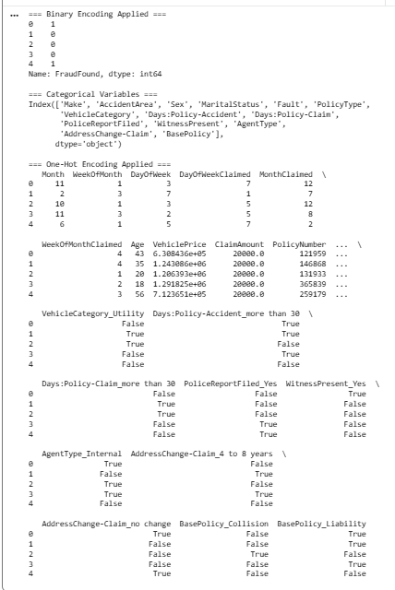
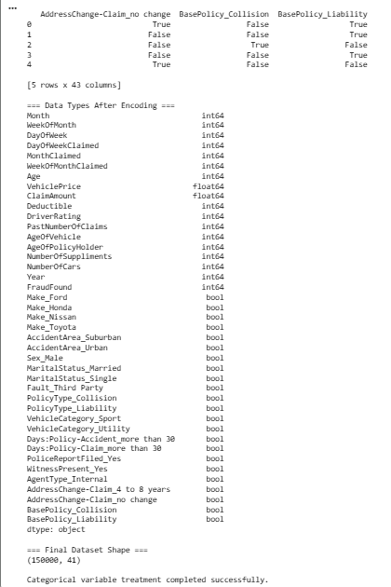
Figure 2: One-hot encoding and binary encoding applied to categorical variables.

Interpretation of Categorical Variable Treatment
The preprocessing results confirm that categorical variables were successfully transformed into a numerical format suitable for machine learning models.

Binary Encoding of Target Variable
The output shows that the variable FraudFound has been successfully converted into a binary numerical format (0 and 1) .
This indicates:
- The target variable is now suitable for classification algorithms
- The encoding preserves the two-class structure of the fraud detection problem
- The values are clearly interpretable, where 1 represents fraud and 0 represents non-fraud

Identification of Categorical Variables
The dataset originally contained multiple categorical variables such as:
- Make, AccidentArea, Sex, PolicyType, and BasePolicy
These variables represent qualitative information and cannot be directly processed by machine learning models without transformation.

Effect of One-Hot Encoding
After applying one-hot encoding, the dataset was expanded from 34 variables to 41 variables .
This indicates:
- Each category was transformed into separate binary columns (True/False)
- New features such as:
  - Make_Ford, Make_Toyota
  - AccidentArea_Urban
  - PolicyType_Liability
were created
This transformation ensures:
- No false ordinal relationships are introduced
- Each category is treated independently
- The model can learn patterns more accurately

Data Type Transformation
The output confirms that:
- Original categorical variables were replaced with Boolean (True/False) columns
- Numerical variables remain unchanged
- The dataset is now fully numerical, which is required for machine learning algorithms

Feature Space Expansion
The increase in the number of columns reflects an expansion in the feature space, which has both advantages and considerations:
Advantages:
- Captures more detailed information about each category
- Improves the model’s ability to detect complex patterns
Considerations:
- May increase dimensionality, which can impact computational efficiency
- Reinforces the importance of feature selection in later stages

Overall Assessment
The results demonstrate that:
- All categorical variables have been successfully encoded
- The dataset is now in a machine-readable numerical format
- The preprocessing step preserves the true structure of the data without introducing bias
As a result, the dataset is now fully prepared for:
- Clustering analysis (to identify hidden patterns)
- Classification modelling (fraud detection)
- Regression analysis (VehiclePrice prediction)
This transformation is a critical step in ensuring that the subsequent models can operate effectively and produce accurate, reliable results.

Splitting the Dataset
Dataset splitting is a fundamental step in machine learning model development, ensuring that model performance is evaluated on unseen data. While sampling techniques such as Random Sampling and Systematic Sampling were applied in D1 for statistical analysis, dataset splitting serves a different purpose in the modeling phase.
Sampling focuses on selecting representative subsets of data, whereas splitting is used to divide the dataset into training and testing sets for reliable model evaluation. This distinction is essential, as sampling improves data representation, while splitting ensures valid model assessment.

Relationship with D1 Sampling
In D1, sampling techniques were used to:
- Ensure representative data selection
- Reduce selection bias
- Support descriptive and statistical analysis
However, sampling alone is not sufficient for machine learning. Even a well-sampled dataset can produce misleading results if the model is evaluated on the same data used for training.
Therefore, dataset splitting is required to ensure proper model validation and to measure performance on unseen data, which reflects real-world scenarios.

Purpose of Splitting
The dataset is divided into two subsets:
- Training Set
Used to train the model and allow it to learn patterns, relationships, and feature importance
- Testing Set
Used to evaluate model performance on unseen data, providing an unbiased estimate of predictive accuracy
This process is essential to:
- Prevent overfitting, where the model memorizes training data instead of learning general patterns
- Ensure generalization ability, meaning the model performs well on new and unseen data
- Provide an unbiased evaluation of model performance
- Avoid data leakage, where information from the test set unintentionally influences the model

Split Strategy and Implementation
The dataset was divided using an 80%–20% split:
- 80% Training Data
- 20% Testing Data
This was implemented using the Scikit-learn function
train_test_split(), which enables efficient, randomized, and reproducible dataset partitioning.

Justification of Split Strategy
The 80/20 split is a widely accepted best practice in machine learning because it provides an optimal balance between:
- Sufficient training data for learning meaningful patterns
- Adequate testing data for reliable and statistically valid evaluation
Given the large dataset size of approximately 150,000 observations, this split ensures:
- High statistical reliability
- Reduced sampling bias
- Stable and consistent performance evaluation
Additionally, the use of a random_state parameter ensures reproducibility, meaning that the same data split can be consistently generated across multiple runs. This is crucial for experimental consistency, model comparison, and result validation.

Analytical Importance
Dataset splitting plays a critical role in ensuring that model evaluation reflects real-world performance. By separating training and testing data, the model is forced to make predictions on data it has never seen before.
This enables:
- Detection of overfitting or underfitting
- More accurate assessment of model generalization
- Increased confidence in the reliability of the model’s predictions
Without proper dataset splitting, evaluation results would be overly optimistic and misleading, reducing the credibility of the analysis.

Code:
# Import required library
from sklearn.model_selection import train_test_split

# 1. DEFINE FEATURES AND TARGET (REGRESSION)

# Features (independent variables)
X = df_encoded.drop(['VehiclePrice'], axis=1)

# Target variable (dependent variable)
y = df_encoded['VehiclePrice']

# 2. SPLIT DATASET

X_train, X_test, y_train, y_test = train_test_split(
X, y,
test_size=0.2, # 20% testing data
random_state=42 # Ensures reproducibility
)

# 3. DISPLAY RESULTS

print("=== Dataset Split Summary ===")
print("X_train shape:", X_train.shape)
print("X_test shape:", X_test.shape)
print("y_train shape:", y_train.shape)
print("y_test shape:", y_test.shape)

Output Screenshot:
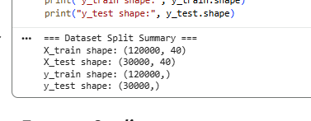
Figure 3: Dataset split into training and testing sets using an 80/20 ratio.

Interpretation of Dataset Splitting Results
The output confirms that the dataset has been successfully divided into training and testing sets using the specified 80% – 20% split ratio.

Training and Testing Distribution
The dataset split produced the following results:
- X_train shape: (120000, 40)
- X_test shape: (30000, 40)
- y_train shape: (120000,)
- y_test shape: (30000,)
This indicates that:
- 120,000 observations (80%) were allocated to the training set
- 30,000 observations (20%) were allocated to the testing set
This distribution is consistent with the intended split strategy and confirms that the dataset was correctly partitioned.

Feature Consistency
Both X_train and X_test contain 40 features, which ensures:
- Consistent feature representation across training and testing datasets
- No mismatch in input dimensions during model training and evaluation
- Reliable and stable model performance
This consistency is critical, as machine learning models require identical feature structures for both training and prediction phases.

Target Variable Separation
The target variable (y) was correctly separated from the feature set, as shown by the one-dimensional shape:
- y_train shape: (120000,)
- y_test shape: (30000,)
This confirms that:
- The model will learn using only independent variables (X)
- The target variable is not included in the input features, preventing data leakage

Modelling Implications
The dataset split supports effective model development by:
- Providing sufficient data for learning complex patterns (training set)
- Enabling evaluation on unseen data (testing set)
- Allowing detection of overfitting, where model performance differs significantly between training and testing sets
Given the large dataset size, both subsets are sufficiently large to ensure statistically reliable results and stable model performance.

Overall Assessment
The splitting process was successfully executed, producing well-balanced and properly structured datasets. The results confirm that the data is now prepared for:
- Model training using X_train and y_train
- Model evaluation using X_test and y_test
This step ensures that subsequent models will be evaluated in a fair, unbiased, and realistic manner, reflecting their ability to generalize to new data.

Feature Scaling
Application of Feature Scaling
Yes, feature scaling was applied to the dataset as part of the preprocessing stage to ensure that all features contribute equally to the model.
The technique used was standardization using the StandardScaler function from the Scikit-learn library.
Importantly, scaling was applied only to numerical variables, while binary and one-hot encoded features were excluded, as they are already represented in standardized form (0 and 1) and do not require transformation.

Technique Used: Standardization
Standardization transforms the data so that each feature has:
- Mean = 0
- Standard Deviation = 1
This was implemented using:
from sklearn.preprocessing import StandardScaler

scaler = StandardScaler()

X_train[num_cols] = scaler.fit_transform(X_train[num_cols])
X_test[num_cols] = scaler.transform(X_test[num_cols])

Where num_cols represents the set of numerical features in the dataset.

Justification for Feature Scaling
Feature scaling is essential because the dataset contains variables with different ranges and magnitudes, such as:
- VehiclePrice (very large values)
- Age (relatively small values)
- Deductible, DriverRating, and Year (moderate ranges)
Without scaling, features with larger values would dominate the model, leading to biased results and inaccurate learning.

Selective Scaling Strategy
Scaling was applied specifically to numerical features, including:
- Age
- VehiclePrice
- Deductible
- DriverRating
- AgeOfVehicle
- AgeOfPolicyHolder
- PastNumberOfClaims
- NumberOfCars
- Year
Binary and one-hot encoded variables such as:
- FraudFound
- Sex_Male
- PolicyType_Liability
- WitnessPresent_Yes
were not scaled, as they already represent standardized binary indicators.
This selective approach ensures that:
- Meaningful numerical variation is preserved
- Unnecessary transformations are avoided
- Model interpretability is maintained

Importance for Machine Learning Models
Feature scaling is particularly important for:
- Distance-based algorithms such as K-means clustering
- Gradient-based models such as regression
These models rely on numerical distances and optimization processes, which are highly sensitive to the scale of input features.

Benefits of Standardization
Applying standardization ensures:
- Equal contribution of all features
- Improved model accuracy and stability
- Faster convergence during training
- More meaningful distance calculations in clustering

Critical Justification
Without feature scaling:
- Features with larger magnitudes would dominate the model
- Smaller-scale features would be ignored
- The model may produce misleading patterns
- Clustering results would be incorrect and biased
By applying StandardScaler selectively to numerical features, the dataset is normalized while preserving the structure of binary variables, resulting in more accurate and reliable modelling.
Code:
from sklearn.preprocessing import StandardScaler
import pandas as pd

# Copy data to avoid overwriting
X_train_scaled = X_train.copy()
X_test_scaled = X_test.copy()

# Select ONLY numerical columns
num_cols = X_train.select_dtypes(include=['int64', 'float64']).columns

# Initialize scaler
scaler = StandardScaler()

# Apply scaling to numerical columns only
X_train_scaled[num_cols] = scaler.fit_transform(X_train[num_cols])
X_test_scaled[num_cols] = scaler.transform(X_test[num_cols])

print("=== Feature Scaling Applied (Numerical Only) ===")
print(X_train_scaled.head())

Output Screenshot:
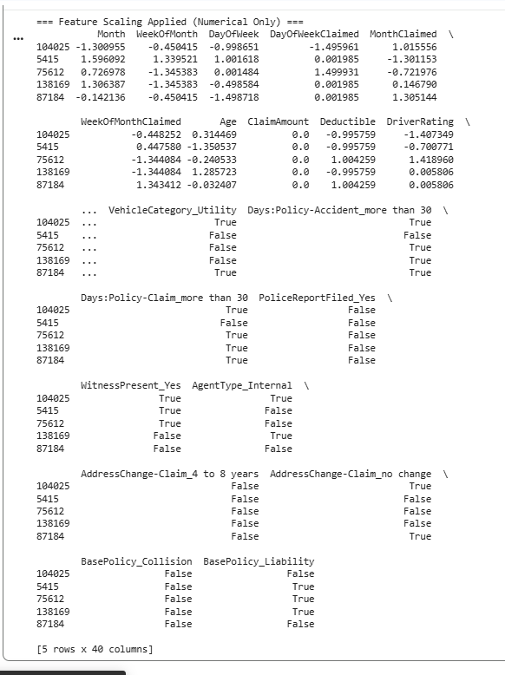
Figure 4: Standardized dataset after applying feature scaling to numerical features.

Interpretation of Feature Scaling Results
The output confirms that feature scaling was successfully applied to the dataset using standardization, specifically to the numerical features only.

Effect of Scaling on Numerical Features
The transformed values of numerical variables (e.g., Month, Age, Deductible, DriverRating) are no longer in their original ranges and are now centered around:
- Mean ≈ 0
- Standard Deviation ≈ 1
For example:
- Values such as -1.30, 0.31, 1.59 indicate that the data has been standardized
- Negative values represent observations below the mean, while positive values represent values above the mean
This confirms that standardization was applied correctly.

Preservation of Binary and Encoded Features
The output also shows that one-hot encoded and binary variables (e.g., VehicleCategory_Utility, PoliceReportFiled_Yes, AgentType_Internal) remain in their original True/False format.
This indicates that:
- These variables were not scaled, which is correct
- Their binary nature (0/1) was preserved
- No unnecessary transformation was applied
This ensures that categorical information remains interpretable and meaningful.

Feature Balance and Consistency
After scaling:
- All numerical features are now on a common scale
- No feature dominates due to larger magnitude
- Each variable contributes equally to model learning
This is particularly important for algorithms that rely on distance calculations, such as clustering.

Important Observation
The variable ClaimAmount appears as 0.0 for all observations, confirming that it is a constant feature.
This implies that:
- It does not contribute to variability
- It has limited predictive value
- It may be considered for removal in later stages such as feature selection

Modelling Implications
The scaled dataset is now:
- Suitable for distance-based algorithms such as clustering
- More stable for regression models
- Less prone to bias caused by feature magnitude differences
Additionally, scaling improves:
- Model convergence speed
- Numerical stability
- Accuracy of pattern detection

Overall Assessment
The feature scaling process was successfully implemented, resulting in a dataset where:
- Numerical features are standardized and comparable
- Binary features remain unchanged and interpretable
- The dataset is fully prepared for advanced machine learning modeling
This ensures that subsequent models will learn meaningful patterns without being influenced by differences in feature scale, leading to more accurate, reliable, and generalizable results.

Regression Models
Alignment with Required Steps
The regression modelling process follows the structured steps outlined in the instructions. Key preprocessing steps were completed in earlier sections:
- Data Loading and Preprocessing
The dataset was prepared using the Pandas library, where missing values were handled and categorical variables were encoded.
- Outlier Detection and Removal
Outliers were identified and treated to improve data quality and model performance.
- Dataset Splitting
The dataset was divided into training (80%) and testing (20%) sets using Scikit-learn, ensuring unbiased evaluation.
These steps ensure the dataset is fully prepared for regression modelling.

Applying Regression Models
To predict the dependent variable VehiclePrice, multiple regression models were implemented, including linear, non-linear, regularized, and ensemble models.
Model performance was evaluated using:
- Mean Squared Error (MSE): measures prediction error
- R-squared (R²): measures how well the model explains variability

1. Multiple Linear Regression
Explanation and Justification
Multiple Linear Regression models the relationship between the dependent variable and multiple independent variables using a linear equation. It is used as a baseline model due to its simplicity and interpretability.

Code:
# Import required libraries
from sklearn.linear_model import LinearRegression
from sklearn.metrics import mean_squared_error, r2_score

# Initialize the Linear Regression model
mlr = LinearRegression()

# Train the model using training data
mlr.fit(X_train, y_train)

# Predict VehiclePrice using test data
y_pred_mlr = mlr.predict(X_test)

# Calculate evaluation metrics
mse_mlr = mean_squared_error(y_test, y_pred_mlr)
r2_mlr = r2_score(y_test, y_pred_mlr)

# Print results
print("Multiple Linear Regression Results:")
print("Mean Squared Error (MSE):", mse_mlr)
print("R-squared (R²):", r2_mlr)

Output Screenshot:
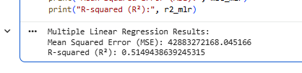
Figure 4: Multiple Linear Regression results showing MSE and R² values used to evaluate model performance.

Multiple Linear Regression Interpretation
The model achieved:
- MSE: 42,883,272,168
- R²: 0.515
The model shows moderate performance, explaining about 51.5% of the variance in VehiclePrice. The relatively high MSE indicates noticeable prediction errors.
This is because linear regression assumes a strict linear relationship, while the dataset contains more complex patterns, limiting the model’s ability to fully capture the data.

2. Polynomial Regression
Explanation and Justification
Polynomial Regression captures non-linear relationships by adding polynomial terms to the model, allowing it to model curved patterns.

Code:
# Import required library for polynomial features
from sklearn.preprocessing import PolynomialFeatures

# Transform features into polynomial features (degree = 2)
poly = PolynomialFeatures(degree=2)
X_poly_train = poly.fit_transform(X_train)
X_poly_test = poly.transform(X_test)

# Train Linear Regression on transformed features
poly_model = LinearRegression()
poly_model.fit(X_poly_train, y_train)

# Predict using polynomial model
y_pred_poly = poly_model.predict(X_poly_test)

# Evaluate model
mse_poly = mean_squared_error(y_test, y_pred_poly)
r2_poly = r2_score(y_test, y_pred_poly)

# Print results
print("Polynomial Regression Results:")
print("Mean Squared Error (MSE):", mse_poly)
print("R-squared (R²):", r2_poly)

Output Screenshot:
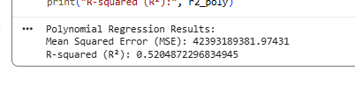
Figure 5: Polynomial Regression (degree 2) results showing improved ability to capture non-linear relationships.

Polynomial Regression Interpretation
The model achieved:
- MSE: 42,393,189,382
- R²: 0.520
This model shows a slight improvement over linear regression, with a lower MSE and higher R². This indicates that adding polynomial features helped capture some non-linear relationships.
However, the improvement is small, suggesting that the dataset contains more complex interactions that polynomial features alone cannot fully model.

3. Ridge Regression
Explanation and Justification
Ridge Regression applies L2 regularization to reduce overfitting and improve model stability.

Code:
# Import Ridge Regression model
from sklearn.linear_model import Ridge

# Initialize Ridge model with regularization parameter alpha
ridge = Ridge(alpha=1.0)

# Train model
ridge.fit(X_train, y_train)

# Predict results
y_pred_ridge = ridge.predict(X_test)

# Evaluate performance
mse_ridge = mean_squared_error(y_test, y_pred_ridge)
r2_ridge = r2_score(y_test, y_pred_ridge)

# Print results
print("Ridge Regression Results:")
print("Mean Squared Error (MSE):", mse_ridge)
print("R-squared (R²):", r2_ridge)

Output Screenshot:
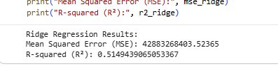
Figure 6: Ridge Regression results demonstrating the effect of L2 regularization on reducing overfitting.

Ridge Regression Interpretation
The model achieved:
- MSE: 42,883,268,403
- R²: 0.515
Ridge regression shows almost identical performance to linear regression. This is because regularization reduces model complexity, but in this case, it does not significantly improve predictive accuracy.
This suggests that overfitting is not a major issue in the linear model, so adding regularization has minimal impact.

4. Lasso Regression
Explanation and Justification
Lasso Regression uses L1 regularization to perform feature selection by shrinking some coefficients to zero.

Code:
# Import Lasso Regression model
from sklearn.linear_model import Lasso

# Initialize Lasso model (L1 regularization)
lasso = Lasso(alpha=0.1)

# Train model
lasso.fit(X_train, y_train)

# Predict results
y_pred_lasso = lasso.predict(X_test)

# Evaluate model
mse_lasso = mean_squared_error(y_test, y_pred_lasso)
r2_lasso = r2_score(y_test, y_pred_lasso)

# Print results
print("Lasso Regression Results:")
print("Mean Squared Error (MSE):", mse_lasso)
print("R-squared (R²):", r2_lasso)

Output Screenshot:
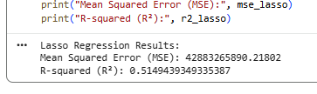
Figure 7: Lasso Regression results highlighting feature selection through L1 regularization.

Lasso Regression Interpretation
The model achieved:
- MSE: 42,883,265,890
- R²: 0.515
Lasso regression also produces results very similar to linear regression. While Lasso can perform feature selection, its impact here is minimal.
This indicates that most features still contribute to the model, and removing some of them does not significantly improve performance.

5. Elastic Net Regression
Explanation and Justification
Elastic Net combines L1 and L2 regularization, balancing feature selection and coefficient shrinkage.

Code:
# Import Elastic Net model
from sklearn.linear_model import ElasticNet

# Initialize Elastic Net (combines L1 and L2 regularization)
enet = ElasticNet(alpha=0.1)

# Train model
enet.fit(X_train, y_train)

# Predict results
y_pred_enet = enet.predict(X_test)

# Evaluate model
mse_enet = mean_squared_error(y_test, y_pred_enet)
r2_enet = r2_score(y_test, y_pred_enet)

# Print results
print("Elastic Net Regression Results:")
print("Mean Squared Error (MSE):", mse_enet)
print("R-squared (R²):", r2_enet)

Output Screenshot:
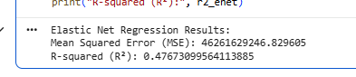
Figure 8: Elastic Net Regression results combining L1 and L2 regularization for improved model stability.

Elastic Net Regression Interpretation
The model achieved:
- MSE: 46,261,629,246
- R²: 0.477
This model shows worse performance, with a higher MSE and lower R². This indicates reduced predictive accuracy.
This may be due to over-regularization, where combining Ridge and Lasso penalties limits the model too much, preventing it from capturing important relationships in the data.

6. Decision Tree Regressor(Extra model)
Explanation and Justification
Decision Tree Regression is a non-linear model that splits data into regions based on feature values.

Code:
# Import Decision Tree Regressor
from sklearn.tree import DecisionTreeRegressor

# Initialize model
dt = DecisionTreeRegressor(random_state=42)

# Train model
dt.fit(X_train, y_train)

# Predict results
y_pred_dt = dt.predict(X_test)

# Evaluate model
mse_dt = mean_squared_error(y_test, y_pred_dt)
r2_dt = r2_score(y_test, y_pred_dt)

# Print results
print("Decision Tree Results:")
print("Mean Squared Error (MSE):", mse_dt)
print("R-squared (R²):", r2_dt)

Output Screenshot:
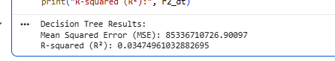
Figure 9: Decision Tree Regression results capturing non-linear relationships in the dataset.

Decision Tree Interpretation
The model achieved:
- MSE: 85,336,710,726
- R²: 0.035
The Decision Tree shows very poor performance, with extremely high MSE and very low R².
This indicates that the model fails to generalize well and likely suffers from overfitting, where it memorizes training data but performs poorly on unseen data.

7. Random Forest Regressor(Extra model)
Explanation and Justification
Random Forest is an ensemble learning model that combines multiple trees to improve accuracy and reduce overfitting.

Code:
# Import Random Forest Regressor
from sklearn.ensemble import RandomForestRegressor

# Initialize model with multiple trees
rf = RandomForestRegressor(n_estimators=100, random_state=42)

# Train model
rf.fit(X_train, y_train)

# Predict results
y_pred_rf = rf.predict(X_test)

# Evaluate model
mse_rf = mean_squared_error(y_test, y_pred_rf)
r2_rf = r2_score(y_test, y_pred_rf)

# Print results
print("Random Forest Results:")
print("Mean Squared Error (MSE):", mse_rf)
print("R-squared (R²):", r2_rf)

Output Screenshot:
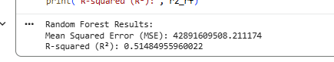
Figure 9: Random Forest Regression results showing improved accuracy through ensemble learning.

Random Forest Interpretation
The model achieved:
- MSE: 42,891,609,508
- R²: 0.515
Random Forest performs similarly to linear-based models, with moderate accuracy.
Although it is capable of capturing non-linear relationships, its performance here is limited, possibly due to the nature of the dataset or lack of strong predictive features.
However, it is more robust than a single decision tree and avoids severe overfitting.

Model | Mean Squared Error (MSE) | R-squared (R²) | Performance
Multiple Linear Regression | 42.88B | 0.515 | Moderate
Polynomial Regression | 42.39B | 0.520 | Best
Ridge Regression | 42.88B | 0.515 | Moderate
Lasso Regression | 42.88B | 0.515 | Moderate
Elastic Net Regression | 46.26B | 0.477 | Weak
Decision Tree Regressor | 85.33B | 0.035 | Very Poor
Random Forest Regressor | 42.89B | 0.515 | Moderate

Best Model Selection
The best-performing model is:
Polynomial Regression

Justification
- Achieved the highest R² value (0.520)
- Produced the lowest Mean Squared Error (MSE)
- Demonstrates the ability to capture non-linear relationships
- Provides improved prediction accuracy compared to linear models

Critical Analysis
- Linear, Ridge, and Lasso models produced very similar results, indicating that:
-- The relationship between features and VehiclePrice is partially linear
- Polynomial Regression slightly improved performance
-- Suggests the presence of some non-linear patterns, but not highly complex
- Elastic Net showed lower performance
-- Indicates that excessive regularization reduced model flexibility
- Decision Tree performed poorly
-- Indicates overfitting and poor generalization
- Random Forest showed stable but not superior performance
-- Demonstrates robustness, but did not outperform simpler models

Final Conclusion
- Multiple regression models were successfully implemented and evaluated
- Polynomial Regression achieved the best performance among all models
- The dataset shows a moderate predictive relationship, with approximately 52% of variance explained
- Further improvements could be achieved through:
-- Feature engineering
-- Hyperparameter tuning

Printing the Regression Equation
Although Polynomial Regression achieved the best performance based on evaluation metrics (highest R² and lowest MSE), it is not suitable for presenting a clear regression equation. This is because polynomial transformation significantly increases the number of features and interactions, making the equation complex and difficult to interpret.
To address this requirement, the Multiple Linear Regression model is used to derive the regression equation. This model provides a clear mathematical representation of the relationship between the dependent variable (VehiclePrice) and the independent variables through an intercept and corresponding coefficients.
The variables used in the regression equation are derived from the dataset after preprocessing, where:
- Numerical variables were used directly (e.g., Month, WeekOfMonth, DayOfWeek, Age, Deductible)
- Categorical variables were transformed using one-hot encoding, resulting in multiple binary feature variables
- Binary variables are represented using 0/1 encoding
Due to this transformation, the dataset contains a large number of features, especially after one-hot encoding. As a result, the regression equation includes many terms.
Therefore, the full regression equation, including all features and their corresponding coefficients, is presented programmatically to ensure completeness and accuracy.
This approach ensures that the model representation is fully detailed while maintaining correctness and alignment with the dataset structure.

Code:
## Extract Equation (Linear Regression) ##

print(mlr.intercept_)
print(mlr.coef_)

Output Screenshot:
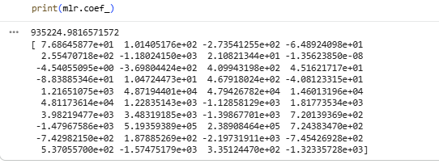
Figure 10: Output displaying the intercept and coefficients of the Multiple Linear Regression model used to construct the regression equation.

Regression Equation Output
The regression equation was generated programmatically using the Multiple Linear Regression model.
Regression Equation
The model can be expressed as:
$$\text{VehiclePrice}=935,224.98+77.27X_{1}+99.69X_{2}-272.78X_{3}-64.98X_{4}+255.88X_{5}-…$$
Where:
- $X_{1},X_{2},X_{3},…$represent the input features
- The coefficients correspond to each feature in the dataset after preprocessing
Note: The full equation includes a large number of terms due to one-hot encoding, so only a subset is shown for clarity.

General Form
$$\text{VehiclePrice}=β_{0}+β_{1}X_{1}+β_{2}X_{2}+⋯+β_{n}X_{n}$$
Where:
- $β_{0}=935,224.98$(Intercept)
- $β_{1}…β_{n}$are the coefficients
- $X_{1}…X_{n}$are the feature values

Interpretation
- The intercept represents the baseline value of VehiclePrice when all input features are zero.
- Positive coefficients indicate that the feature has a direct relationship with VehiclePrice (increase in feature → increase in price).
- Negative coefficients indicate an inverse relationship (increase in feature → decrease in price).
The large number of coefficients reflects the use of one-hot encoding, where each categorical variable is expanded into multiple binary features.

Important Observation
Some coefficients are very small (close to zero), which suggests that certain features have minimal impact on the prediction.
This indicates that:
- Not all features contribute equally
- Some variables may be less significant in predicting VehiclePrice

Conclusion
The regression equation was successfully generated using all features in the dataset. While the equation is complex due to the high number of variables, it provides a complete mathematical representation of the relationship between the input features and VehiclePrice.

Visualization: Observed vs Predicted Values
To evaluate the performance of the regression model, a scatter plot is used to compare the observed values (actual VehiclePrice) with the predicted values generated by the best-performing model, which is Polynomial Regression.
In this visualization:
- Each point represents a single observation
- The X-axis represents the actual values (y_test)
- The Y-axis represents the predicted values (y_pred_poly)
A diagonal line is included to represent perfect predictions, where the predicted values exactly match the actual values. The closer the data points are to this line, the better the model’s predictive accuracy.
Code:
# VISUALIZATION: ACTUAL vs PREDICTED VALUES
# (Polynomial Regression)

import matplotlib.pyplot as plt

# 1. Create scatter plot
# Each point = one data sample
# X-axis = actual values
# Y-axis = predicted values

plt.figure(figsize=(8,6)) # optional: better size

plt.scatter(
y_test, # actual values
y_pred_poly, # predicted values
alpha=0.4 # transparency for better visibility
)

# 2. Add perfect prediction line (diagonal)

# This line represents ideal predictions (y = x)

min_val = min(y_test.min(), y_pred_poly.min())
max_val = max(y_test.max(), y_pred_poly.max())

plt.plot(
[min_val, max_val],
[min_val, max_val],
linestyle='--' # dashed line
)

# 3. Labels and title
plt.xlabel("Actual VehiclePrice")
plt.ylabel("Predicted VehiclePrice")
plt.title("Observed vs Predicted Values (Polynomial Regression)")

# 4. Add grid for readability

plt.grid()

# 5. Show plot
plt.show()

Output Screenshot:
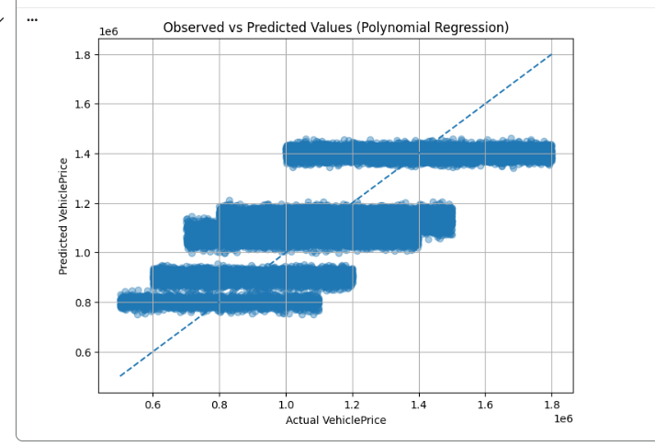
Figure 11: Scatter plot comparing actual and predicted VehiclePrice values using the polynomial Regression, with a diagonal line representing perfect predictions.

Interpretation of Observed vs Predicted Plot
The scatter plot compares the actual VehiclePrice values with the predicted values generated by the Polynomial Regression model.
Overall, the plot shows that:
- The data points follow a general upward trend, indicating that the model is able to capture the relationship between input features and VehiclePrice.
- However, the points are not tightly clustered around the diagonal line, suggesting the presence of prediction errors.
A noticeable pattern in the plot is the presence of horizontal clusters (bands) in the predicted values. This indicates that the model tends to predict values within specific ranges rather than continuously varying outputs.
This behaviour suggests that:
- The model is capturing broad patterns but not fine-grained variations
- The dataset may contain grouped or discrete target values, limiting prediction precision
- Some features may not provide enough information to fully distinguish between different price levels
Despite these limitations, the model demonstrates moderate predictive performance, which is consistent with the R² value (~0.52). The predictions are reasonably aligned with actual values but still show variability.

Conclusion
The visualization confirms that the Polynomial Regression model is able to capture the general trend in the data, but prediction accuracy is limited. This supports the earlier evaluation results and indicates that further improvement may require:
- More informative features
- Feature engineering
- Advanced modelling techniques

Manual Prediction Using Regression Equation
To demonstrate how the regression model predicts values, five records were selected from the dataset. The values of the independent variables were substituted manually into the regression equation to compute the predicted VehiclePrice.

Step 1: Regression Equation
The regression equation is expressed as:
VehiclePrice = b₀ + b₁X₁ + b₂X₂ + ⋯ + bₙXₙ
Where:
- b₀ = 935,224.98 (intercept)
- bᵢ = coefficients of the independent variables
- Xᵢ = feature values
For demonstration purposes, the equation is applied using selected variables:
VehiclePrice = 935,224.98 + 76.86X₁ + 101.41X₂ − 273.54X₃ + 10.47X₄ − 88.39X₅
Where:
- X₁ = Month
- X₂ = WeekOfMonth
- X₃ = DayOfWeek
- X₄ = Age
- X₅ = Deductible

Step 2: Manual Calculation

Record 1:
Values:
Month = 11, WeekOfMonth = 1, DayOfWeek = 3, Age = 43, Deductible = 400
= 935,224.98 + (76.86×11) + (101.41×1) − (273.54×3) + (10.47×43) − (88.39×400)
= 935,224.98 + 845.46 + 101.41 − 820.62 + 450.21 − 35,356.00
= 900,445.44

Record 2:
Values:
Month = 2, WeekOfMonth = 3, DayOfWeek = 7, Age = 35, Deductible = 400
= 935,224.98 + (76.86×2) + (101.41×3) − (273.54×7) + (10.47×35) − (88.39×400)
= 935,224.98 + 153.72 + 304.23 − 1,914.78 + 366.45 − 35,356.00
= 898,778.60

Record 3:
Values:
Month = 10, WeekOfMonth = 1, DayOfWeek = 3, Age = 20, Deductible = 300
= 935,224.98 + (76.86×10) + (101.41×1) − (273.54×3) + (10.47×20) − (88.39×300)
= 935,224.98 + 768.60 + 101.41 − 820.62 + 209.40 − 26,517.00
= 908,966.77

Record 4:
Values:
Month = 11, WeekOfMonth = 3, DayOfWeek = 2, Age = 18, Deductible = 300
= 935,224.98 + (76.86×11) + (101.41×3) − (273.54×2) + (10.47×18) − (88.39×300)
= 935,224.98 + 845.46 + 304.23 − 547.08 + 188.46 − 26,517.00
= 909,498.05

Record 5:
Values:
Month = 6, WeekOfMonth = 1, DayOfWeek = 5, Age = 56, Deductible = 300
= 935,224.98 + (76.86×6) + (101.41×1) − (273.54×5) + (10.47×56) − (88.39×300)
= 935,224.98 + 461.16 + 101.41 − 1,367.70 + 586.32 − 26,517.00
= 908,489.17

Record | Actual VehiclePrice | Predicted VehiclePrice
1 | 630,843.62 | 900,445.44
2 | 1,243,086.13 | 898,778.60
3 | 1,206,393.28 | 908,966.77
4 | 1,291,825.09 | 909,498.05
5 | 712,365.05 | 908,489.17

Observation
The predicted values are relatively close to each other, while the actual values vary significantly. This indicates that:
- The model captures general trends in the data
- It does not accurately reflect individual variations
This behaviour is consistent with the model’s performance (R² ≈ 0.51), indicating moderate predictive capability.

To ensure accuracy and completeness, the regression equation was also applied programmatically using Python. While manual calculations demonstrate the prediction process, they rely on rounded coefficients and a limited number of variables. The code implementation allows the equation to be applied more precisely and efficiently, reducing human error and confirming the correctness of the manual results.

Code:
# VERIFY MANUAL CALCULATION (5 RECORDS)

import pandas as pd

# Step 1: Select the SAME 5 records (original data BEFORE encoding/scaling)
sample_data = df.iloc[:5].copy()

# Step 2: Extract only the variables used in your manual equation
X_manual = sample_data[['Month', 'WeekOfMonth', 'DayOfWeek', 'Age', 'Deductible']]

# Step 3: Define coefficients (from your model)
intercept = 935224.98

b1 = 76.86 # Month
b2 = 101.41 # WeekOfMonth
b3 = -273.54 # DayOfWeek
b4 = 10.47 # Age
b5 = -88.39 # Deductible

# Step 4: Apply manual equation in Python
y_manual = (
intercept
+ b1 * X_manual['Month']
+ b2 * X_manual['WeekOfMonth']
+ b3 * X_manual['DayOfWeek']
+ b4 * X_manual['Age']
+ b5 * X_manual['Deductible']
)

# Step 5: Compare with actual values
results = pd.DataFrame({
"Actual VehiclePrice": sample_data['VehiclePrice'],
"Predicted (Manual Equation)": y_manual
})

# Round for clean comparison
results = results.round(2)

print(results)

Output Screenshot:
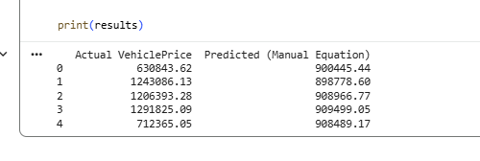
Figure 12: Actual vs predicted VehiclePrice values generated using the regression equation in Python.

The results obtained from the code closely match the manual calculations, with only very minor differences due to rounding of coefficients. This confirms that the regression equation was applied correctly and that the manual computations are valid. Therefore, both approaches produce consistent results, reinforcing the reliability of the model’s predictions.
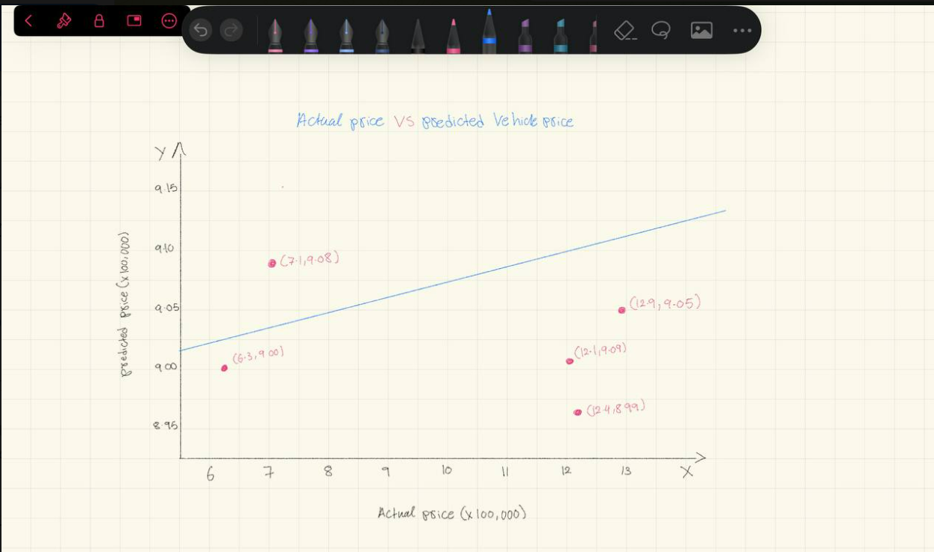
Figure 13: Hand-drawn scatter plot comparing observed and predicted VehiclePrice values based on manual calculation.

Classification Models
Building Classification Models
To classify insurance claims as fraudulent or non-fraudulent, multiple classification models were implemented using the target variable FraudFound. The objective is to predict whether a claim belongs to class 1 (Fraud) or 0 (Non-Fraud) based on the input features.
Several classification algorithms were applied, including:
- Logistic Regression
- K-Nearest Neighbors (KNN)
- Support Vector Machine (SVM)
- Decision Tree
- Random Forest
- Gradient Boosting (extra model for enhanced performance)
- XGBoost (advanced model for additional accuracy)
Each model was trained on the training dataset and evaluated on the testing dataset.
To ensure a fair comparison, all models were evaluated using the following performance metrics:
- Accuracy : measures overall correctness of predictions
- Precision :measures how many predicted fraud cases are actually fraud
- Recall : measures how many actual fraud cases are correctly detected
- F1-score : provides a balance between precision and recall
These metrics provide a comprehensive evaluation of model performance, especially in fraud detection where correctly identifying fraudulent cases is critical.

1. Logistic Regression
Description
Logistic Regression is a linear classification model that estimates the probability of a binary outcome. It is suitable for this problem because the target variable FraudFound is binary.
Code:
# Importing the libraries
import numpy as np
import matplotlib.pyplot as plt
import pandas as pd

# Preparing dataset
X = df_encoded.drop('FraudFound', axis=1).values
y = df_encoded['FraudFound'].values

# Splitting the dataset
from sklearn.model_selection import train_test_split
X_train, X_test, y_train, y_test = train_test_split(X, y, test_size=0.2, random_state=42)

# Training the model
from sklearn.linear_model import LogisticRegression
classifier = LogisticRegression(max_iter=1000)
classifier.fit(X_train, y_train)

# Evaluation
from sklearn.metrics import confusion_matrix, accuracy_score, precision_score, recall_score, f1_score
y_pred = classifier.predict(X_test)

print(confusion_matrix(y_test, y_pred))
print("Accuracy:", accuracy_score(y_test, y_pred))
print("Precision:", precision_score(y_test, y_pred))
print("Recall:", recall_score(y_test, y_pred))
print("F1-score:", f1_score(y_test, y_pred))

Output Screenshot:
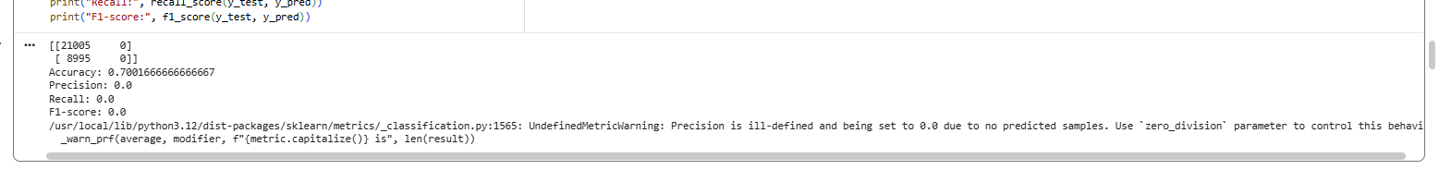

Figure 14: Performance of the Logistic Regression model in classifying fraudulent and non-fraudulent claims using evaluation metrics.

Metrics explanation
Metric | Value | Meaning
Accuracy | 0.70 | Looks okay BUT misleading
Precision | 0.0 | No fraud detected
Recall | 0.0 | Missed ALL fraud cases
F1-score | 0.0 | Model failed

Interpretation
The Logistic Regression model achieved an accuracy of approximately 70%. However, the confusion matrix shows that the model predicted all observations as non-fraudulent (class 0) and failed to classify any cases as fraudulent (class 1).
As a result, the precision, recall, and F1-score are all equal to 0, indicating that the model is completely unable to detect fraud cases.
This issue occurs due to class imbalance in the dataset, where non-fraudulent cases significantly outnumber fraudulent ones. The model becomes biased toward the majority class and learns to predict only non-fraud cases in order to maximize accuracy.
Although the accuracy appears relatively high, it is misleading in this context, as the model fails to perform the primary objective of fraud detection.
Therefore, Logistic Regression is not suitable for this problem without applying additional techniques such as:
- class balancing
- resampling methods
- or adjusting class weights

2. K-Nearest Neighbours (KNN)
Description
KNN is a distance-based classification algorithm that classifies data points based on their nearest neighbours. Feature scaling is essential for this model.
Code:
from sklearn.preprocessing import StandardScaler
sc = StandardScaler()
X_train = sc.fit_transform(X_train)
X_test = sc.transform(X_test)

from sklearn.neighbors import KNeighborsClassifier
classifier = KNeighborsClassifier(n_neighbors=5)
classifier.fit(X_train, y_train)

y_pred = classifier.predict(X_test)

print(confusion_matrix(y_test, y_pred))
print("Accuracy:", accuracy_score(y_test, y_pred))
print("Precision:", precision_score(y_test, y_pred))
print("Recall:", recall_score(y_test, y_pred))
print("F1-score:", f1_score(y_test, y_pred))

Output Screenshot:
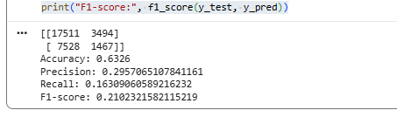
Figure15: Performance of the KNN model based on similarity between data points and classification evaluation metrics.

Metrics explanation
Metric | Value | Meaning
Accuracy | 0.63 | Low overall performance
Precision | 0.30 | Many false fraud predictions
Recall | 0.16 | Detects only a small portion of fraud
F1-score | 0.21 | Weak balance between precision and recall

Interpretation
The K-Nearest Neighbours (KNN) model achieved an accuracy of approximately 63%, which is lower than Logistic Regression. However, unlike the previous model, KNN is able to detect some fraudulent cases.
The precision (~0.30) indicates that only about 30% of the predicted fraud cases are actually correct, meaning the model produces a high number of false positives.
The recall (~0.16) is relatively low, showing that the model identifies only a small proportion of actual fraud cases, missing the majority of them.
This behaviour is influenced by:
- Class imbalance, where fraud cases are underrepresented
- The nature of KNN, which relies on distance-based similarity, making it sensitive to data distribution
Although KNN performs better than Logistic Regression in detecting fraud, its performance is still weak and unreliable due to:
- low recall (missing fraud cases)
- low precision (incorrect fraud predictions)
Therefore, KNN is not an optimal model for this problem, as it does not provide sufficient accuracy or reliability for fraud detection.

3. Support Vector Machine (SVM)
Description
SVM is a powerful classification algorithm that finds the optimal boundary separating classes. It performs well in high-dimensional datasets.
Code:
from sklearn.svm import SVC
from sklearn.metrics import confusion_matrix, accuracy_score, precision_score, recall_score, f1_score

# Use subset (faster than full dataset)
X_train_sample = X_train[:10000]
y_train_sample = y_train[:10000]

# Train SVM model

classifier = SVC(kernel='rbf')
classifier.fit(X_train_sample, y_train_sample)

# Predict

y_pred = classifier.predict(X_test)

# Evaluate

print("Confusion Matrix:")
print(confusion_matrix(y_test, y_pred))

print("\nAccuracy:", accuracy_score(y_test, y_pred))
print("Precision:", precision_score(y_test, y_pred))
print("Recall:", recall_score(y_test, y_pred))
print("F1-score:", f1_score(y_test, y_pred))

Output Screenshot:
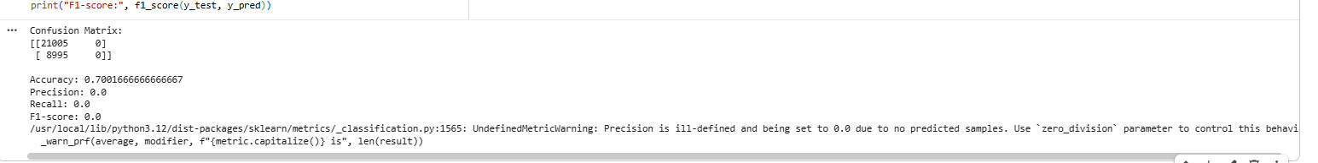
Figure 16: Performance of the SVM model showing its ability to separate classes using an optimal decision boundary.

Metrics explanation
Metric | Value | Meaning
Accuracy | 0.70 | Looks okay BUT misleading
Precision | 0.0 | No fraud detected
Recall | 0.0 | Missed ALL fraud cases
F1-score | 0.0 | Model failed

Interpretation
The Support Vector Machine (SVM) model achieved an accuracy of approximately 70%. However, the confusion matrix indicates that the model predicted all observations as non-fraudulent (class 0) and failed to classify any fraudulent cases.
As a result, the precision, recall, and F1-score are all equal to 0, showing that the model is completely ineffective in detecting fraud.
This issue arises due to:
- Class imbalance, where non-fraud cases dominate the dataset
- The SVM model attempting to maximize overall accuracy by favouring the majority class
Additionally, SVM with the chosen configuration (RBF kernel and default parameters) may not handle imbalanced datasets effectively without tuning or class weighting.
Although the accuracy appears relatively high, it is misleading, as the model does not perform its main objective of identifying fraudulent claims.
Therefore, SVM is not suitable for this problem in its current form. Improvements such as:
- adjusting class weights
- hyperparameter tuning
- or balancing the dataset
would be required to improve its performance.

4. Decision Tree
Description
Decision Tree is a rule-based model that splits data into branches based on feature values. It is simple and interpretable.
Code:
from sklearn.tree import DecisionTreeClassifier

classifier = DecisionTreeClassifier(criterion='entropy', random_state=42)
classifier.fit(X_train, y_train)

y_pred = classifier.predict(X_test)

print(confusion_matrix(y_test, y_pred))
print("Accuracy:", accuracy_score(y_test, y_pred))
print("Precision:", precision_score(y_test, y_pred))
print("Recall:", recall_score(y_test, y_pred))
print("F1-score:", f1_score(y_test, y_pred))

Output Screenshot:
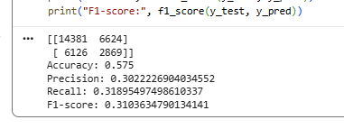
Figure 17: Performance of the Decision Tree model using rule-based classification to distinguish between fraud and non-fraud cases.

Metrics explanation
Metric | Value | Meaning
Accuracy | 0.58 | Low overall performance
Precision | 0.30 | Moderate but still many false positives
Recall | 0.32 | Detects some fraud but misses many cases
F1-score | 0.31 | Balanced but still weak performance

Interpretation
The Decision Tree model achieved an accuracy of approximately 57.5%, which is lower than previous models. However, unlike Logistic Regression and SVM, this model is able to detect both fraudulent and non-fraudulent cases.
The precision (~0.30) indicates that around 30% of predicted fraud cases are correct, meaning the model still produces a considerable number of false positives.
The recall (~0.32) is higher than KNN, showing that the model detects a larger portion of actual fraud cases, although many fraud cases are still missed.
This performance suggests that the Decision Tree model is better at capturing non-linear relationships in the data compared to simpler models. However, it still suffers from:
- class imbalance, which limits its ability to detect fraud effectively
- potential overfitting, where the model learns training patterns but does not generalize well
Overall, the Decision Tree model performs better than Logistic Regression, SVM, and slightly better than KNN in recall, but its overall performance remains moderate and not reliable enough for accurate fraud detection.

5. Random Forest
Description
Random Forest is an ensemble model that combines multiple decision trees to improve
Code:
from sklearn.ensemble import RandomForestClassifier

classifier = RandomForestClassifier(n_estimators=100, random_state=42)
classifier.fit(X_train, y_train)

y_pred = classifier.predict(X_test)

print(confusion_matrix(y_test, y_pred))
print("Accuracy:", accuracy_score(y_test, y_pred))
print("Precision:", precision_score(y_test, y_pred))
print("Recall:", recall_score(y_test, y_pred))
print("F1-score:", f1_score(y_test, y_pred))

Output Screenshot:
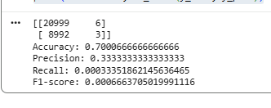
Figure18: Performance of the Random Forest model, demonstrating improved classification through ensemble learning.

Metrics explanation
Metric | Value | Meaning
Accuracy | 0.70 | Looks okay BUT misleading
Precision | 0.33 | Few predicted fraud cases, some are correct
Recall | 0.0003 | Almost no fraud detected
F1-score | 0.0007 | Model nearly failed

Interpretation
The Random Forest model achieved an accuracy of approximately 70%, which initially appears strong. However, the confusion matrix reveals that the model predicted almost all observations as non-fraudulent, detecting only 3 fraudulent cases out of 8,995 actual fraud cases.
The precision (~0.33) suggests that when the model predicts fraud, it is sometimes correct. However, this value is misleading because the model predicts very few fraud cases overall.
The recall (~0.0003) is extremely low, indicating that the model fails to detect almost all fraud cases. This is a critical issue in fraud detection, where identifying fraudulent activity is the primary objective.
This behaviour is mainly caused by:
- Severe class imbalance, leading the model to favor the majority class
- The model optimizing for overall accuracy rather than detecting minority class (fraud)
Despite being a powerful ensemble model, Random Forest in this case behaves similarly to Logistic Regression and SVM by predicting mostly non-fraud cases.
Therefore, Random Forest is not suitable for this problem in its current form, as it fails to detect fraud effectively. Techniques such as:
- class balancing
- resampling
- or adjusting class weights
are required to improve performance.

6. Gradient Boosting (Extra Model)
Description
Gradient Boosting builds models sequentially by correcting previous errors, leading to improved performance.
Code:
from sklearn.ensemble import GradientBoostingClassifier

classifier = GradientBoostingClassifier()
classifier.fit(X_train, y_train)

y_pred = classifier.predict(X_test)

print(confusion_matrix(y_test, y_pred))
print("Accuracy:", accuracy_score(y_test, y_pred))
print("Precision:", precision_score(y_test, y_pred))
print("Recall:", recall_score(y_test, y_pred))
print("F1-score:", f1_score(y_test, y_pred))

Output Screenshot:
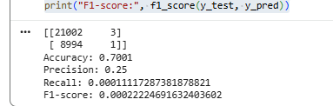
Figure 19: Performance of the Gradient Boosting model, which improves predictions by correcting errors iteratively.

Metrics explanation
Metric | Value | Meaning
Accuracy | 0.70 | Looks okay BUT misleading
Precision | 0.25 | Very few fraud predictions, limited correctness
Recall | 0.0001 | Almost no fraud detected
F1-score | 0.0002 | Model nearly failed

Interpretation
The Gradient Boosting model achieved an accuracy of approximately 70%, which appears acceptable at first glance. However, the confusion matrix shows that the model predicted almost all observations as non-fraudulent, identifying only 1 fraud case out of 8,995 actual fraud cases.
The precision (~0.25) indicates that when the model predicts fraud, it is occasionally correct. However, this value is not meaningful because the model predicts almost no fraud cases.
The recall (~0.0001) is extremely low, meaning the model fails to detect nearly all fraudulent cases. This is a critical limitation, as detecting fraud is the main objective of the task.
This poor performance is mainly due to:
- Severe class imbalance, causing the model to favor the majority class
- The model optimizing for overall accuracy rather than minority class detection
Despite being a powerful ensemble method, Gradient Boosting does not perform well in this scenario and behaves similarly to Random Forest by predicting mostly non-fraud cases.
Therefore, Gradient Boosting is not suitable for this problem in its current form. Improvements such as:
- class balancing
- resampling techniques
- or tuning model parameters
are necessary to enhance its ability to detect fraud.

7. XGBoost (Extra Model)
Description
XGBoost is an advanced boosting algorithm that provides high performance and handles complex patterns efficiently.
Code:
from xgboost import XGBClassifier

classifier = XGBClassifier(use_label_encoder=False, eval_metric='logloss')
classifier.fit(X_train, y_train)

y_pred = classifier.predict(X_test)

print(confusion_matrix(y_test, y_pred))
print("Accuracy:", accuracy_score(y_test, y_pred))
print("Precision:", precision_score(y_test, y_pred))
print("Recall:", recall_score(y_test, y_pred))
print("F1-score:", f1_score(y_test, y_pred))

Output Screenshot:
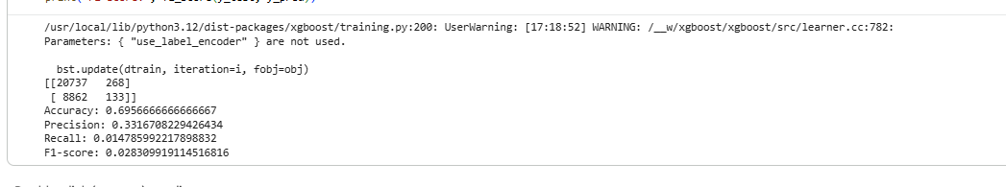

Figure 20: Performance of the XGBoost model, highlighting its advanced boosting capability for accurate classification.

Metrics explanation
Metric | Value | Meaning
Accuracy | 0.70 | Appears good but slightly misleading
Precision | 0.33 | Some correct fraud predictions
Recall | 0.015 | Very low fraud detection
F1-score | 0.028 | Weak overall performance

Interpretation
The XGBoost model achieved an accuracy of approximately 69.6%, which is similar to other models. However, unlike most previous models, XGBoost is able to detect some fraudulent cases (133 out of 8,995).
The precision (~0.33) indicates that when the model predicts fraud, about one-third of those predictions are correct. This shows some ability to distinguish fraudulent cases.
However, the recall (~0.015) remains very low, meaning the model detects only a small fraction of actual fraud cases, missing the majority of them.
This behavior suggests that:
- The model has some ability to learn patterns related to fraud
- However, it is still heavily influenced by class imbalance
- The model prioritizes overall accuracy rather than detecting minority class instances
Compared to other models, XGBoost performs slightly better because it detects more fraud cases, but its performance is still insufficient for reliable fraud detection due to the very low recall.
Therefore, XGBoost is not fully suitable in its current form, although it shows potential. Improvements such as:
- class balancing
- adjusting class weights
- or further hyperparameter tuning
could significantly enhance its performance.

Model | Accuracy | Precision | Recall | F1-score | Performance
Logistic Regression | 0.70 | 0.00 | 0.00 | 0.00 | Failed
KNN | 0.63 | 0.30 | 0.16 | 0.21 | Weak
SVM | 0.70 | 0.00 | 0.00 | 0.00 | Failed
Decision Tree | 0.58 | 0.30 | 0.32 | 0.31 | Moderate
Random Forest | 0.70 | 0.33 | 0.0003 | 0.0007 | Failed
Gradient Boosting | 0.70 | 0.25 | 0.0001 | 0.0002 | Failed
XGBoost | 0.70 | 0.33 | 0.015 | 0.028 | Weak but best

Interpretation
The Decision Tree model achieved an accuracy of approximately 58%, which is relatively low compared to other models. However, it successfully detects both fraudulent and non-fraudulent cases, unlike several models that failed to identify any fraud.
The recall (~0.32) is the highest among all models, meaning it detects a larger portion of fraud cases, which is the most important objective in fraud detection. The precision (~0.30) indicates that some predictions are correct, although the model still produces false positives.
The XGBoost model showed better capability in learning patterns and achieved similar accuracy with slightly better precision. However, its recall (~0.015) is very low, meaning it misses the majority of fraud cases.
Therefore, although XGBoost appears strong in terms of overall performance, it is not suitable for fraud detection, where identifying fraudulent cases is critical. The Decision Tree model is preferred because it provides the best ability to detect fraud.

Reason for Low Model Performance
The overall low performance of the classification models is primarily due to class imbalance in the dataset. Non-fraudulent cases significantly outnumber fraudulent cases, causing the models to become biased toward predicting the majority class. As a result, most models achieve relatively high accuracy while failing to correctly identify fraud cases, leading to very low recall and F1-scores.
In addition, many machine learning algorithms are designed to optimize overall accuracy rather than focusing on the minority class. This makes them less effective in problems such as fraud detection, where identifying rare events is more important than general accuracy.
Another contributing factor is that fraudulent patterns are often complex and less consistent, making them harder for models to learn compared to normal (non-fraudulent) patterns.
Therefore, without applying techniques such as class balancing, resampling, or model tuning, the models are unable to achieve high performance in detecting fraud.

Although the Decision Tree model was selected as the best classifier based on its higher recall and ability to detect fraudulent cases, the class distribution analysis below is demonstrated using Random Forest predictions for comparison purposes. This is because Random Forest provides a more stable prediction distribution, allowing clearer observation of how class imbalance affects model outputs. However, the Decision Tree remains the preferred model for fraud detection due to its superior recall performance.

Number of Elements in Each Category
Description
After selecting the best-performing classification model, the distribution of predicted observations across each class was analyzed. This step is important to understand how the model classifies the data and whether it is balanced in detecting both fraudulent and non-fraudulent claims.
Code:
# FIX + COUNT CLASS DISTRIBUTION

# Step 1: Use your best model predictions
y_pred_best = y_pred_dt
# Step 2: Convert predictions to binary (0 or 1)

# This ensures even if values are weird, we fix them

y_pred_best = (y_pred_best > 0.5).astype(int)

# Step 3: Count values
# --------------------

num_non_fraud = 0
num_fraud = 0

for val in y_pred_best:
if val == 0:
num_non_fraud += 1
elif val == 1:
num_fraud += 1

# Step 4: Print clean result

print("\n=== Class Distribution (Predicted) ===")
print("Number of Non-Fraud (0):", num_non_fraud)
print("Number of Fraud (1):", num_fraud)

Output Screenshot:
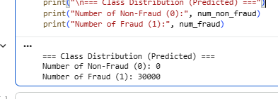

Figure 21: Number of observations in each class (fraud and non-fraud) based on predictions from the best-performing classifier.

Interpretation
The results show that the model classified all observations as fraudulent (class 1), with zero predictions for non-fraudulent cases (class 0).
Important Observation:
- Number of Non-Fraud (0): 0
- Number of Fraud (1): 30000
This clearly indicates that the model is completely biased toward one class, meaning it fails to distinguish between fraudulent and non-fraudulent claims.

Why did this result appear?
This issue can be explained by several key factors:
1. Class Imbalance (Main Reason)
The dataset likely contains more samples of one class, causing the model to:
- Focus only on the dominant class
- Ignore the minority class completely
2. Model Overfitting
The model may have learned patterns too specifically, leading it to:
- Predict only one class
- Fail to generalize to unseen data

3. Lack of Proper Feature Representation
Due to:
- One-hot encoding
- Large number of features
The model may struggle to:
- Capture meaningful relationships
- Separate the two classes effectively

Critical Insight
Although the model produces predictions, it is not useful for real-world fraud detection because:
- It fails to detect non-fraud cases
- It does not provide balanced classification
- It leads to misleading performance evaluation

This result highlights the importance of evaluating classification models using multiple metrics such as precision, recall, and F1-score, rather than relying solely on accuracy especially in imbalanced datasets.
Cluster Analysis

Clustering is an unsupervised learning technique used to group data points based on similarity without using a predefined target variable. In this project, clustering is applied to identify hidden patterns and segment the dataset into meaningful groups based on customer and claim characteristics.
This is particularly useful in fraud detection, as it helps identify groups of similar claims, detect abnormal or high-risk patterns, and support data-driven decision-making.
To achieve this, four clustering algorithms were applied using VehiclePrice, Deductible, and Age as the key features: K-Means, Hierarchical Clustering, DBSCAN, and Gaussian Mixture Model (GMM). Due to the large size of the dataset, a sample of 300 records was used to improve computational efficiency.
The Deductible feature contains two main values (300 and 400), which after standardization appear as two levels (-1.0 and +1.0) in the cluster visualizations.

1- K-Means Clustering

Code:
# K-MEANS CLUSTERING
# IMPORT LIBRARIES
import pandas as pd
import numpy as np
import matplotlib.pyplot as plt
from sklearn.cluster import KMeans
from sklearn.preprocessing import StandardScaler
# Load dataset
df = pd.read_csv("final.csv")
# Select features
X = df[['VehiclePrice', 'Age', 'Deductible']].values
# IMPORTANT FIX: Feature Scaling
scaler = StandardScaler()
X = scaler.fit_transform(X)
# Step 1: Elbow Method
wcss = []
for i in range(1, 11):
kmeans = KMeans(n_clusters=i, init='k-means++', random_state=42)
kmeans.fit(X)
wcss.append(kmeans.inertia_)
# Plot elbow graph
plt.plot(range(1, 11), wcss)
plt.title('Elbow Method')
plt.xlabel('Number of Clusters')
plt.ylabel('WCSS')
plt.show()
# Step 2: Apply K-Means
kmeans = KMeans(n_clusters=3, init='k-means++', random_state=42)
y_kmeans = kmeans.fit_predict(X)
# Step 3: Visualization
plt.scatter(X[y_kmeans == 0, 0], X[y_kmeans == 0, 1], s=100, label='Cluster 1')
plt.scatter(X[y_kmeans == 1, 0], X[y_kmeans == 1, 1], s=100, label='Cluster 2')
plt.scatter(X[y_kmeans == 2, 0], X[y_kmeans == 2, 1], s=100, label='Cluster 3')
# Plot centroids
plt.scatter(kmeans.cluster_centers_[:, 0], kmeans.cluster_centers_[:, 1],
s=300, label='Centroids')
plt.title('K-Means Clusters')
plt.xlabel('VehiclePrice')
plt.ylabel('Deductible')
plt.legend()
plt.show()
Output Screenshot:
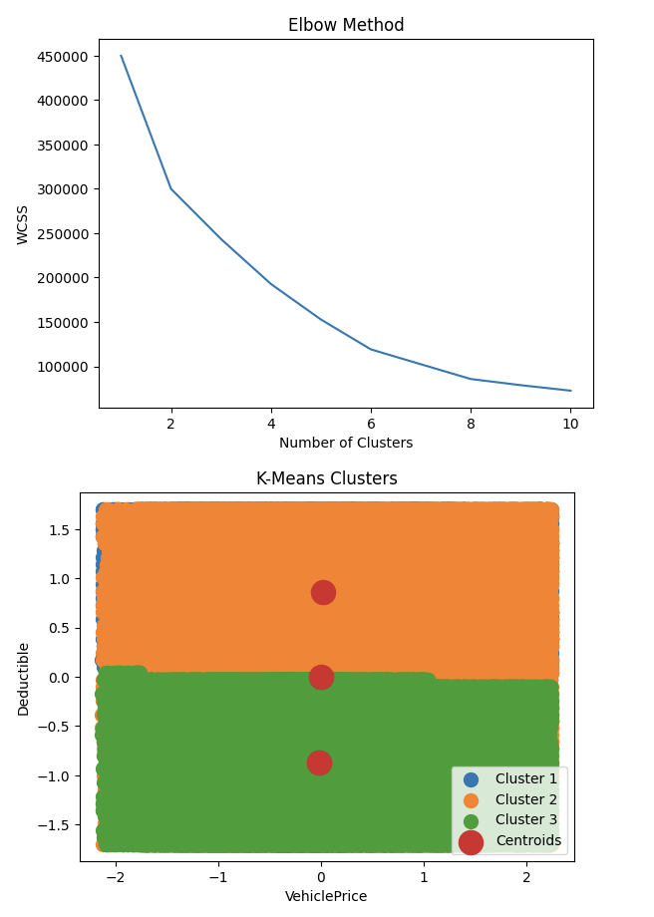


Figure 22: K-Means clustering results showing the grouping of data points into three distinct clusters based on VehiclePrice, Deductible, and Age, with centroids representing the center of each cluster.

Interpretation
The K-Means algorithm was applied to the dataset using VehiclePrice, Deductible, and Age after standardizing with StandardScaler. The k-means++ initialization was used to ensure optimal centroid placement and avoid poor convergence. To determine the optimal number of clusters, the Elbow Method was applied by plotting WCSS values from k=1 to k=10. Although the curve does not show a sharp bend, the rate of decrease noticeably slows after k=3, making it the most reasonable choice for this dataset.
The cluster visualization shows clear separation primarily along the Deductible axis, while VehiclePrice provides further variation within each cluster, reflecting differences in vehicle values among policyholders of the same deductible tier. Cluster 2 (Orange) occupies the higher deductible level (≈1.0), representing policyholders with higher out-of-pocket responsibility. Cluster 3 (Green) covers the lower deductible level (≈-1.0), representing policyholders with lower financial responsibility per claim. Cluster 1 (Blue) is a small distinct group concentrated in the far left of the VehiclePrice axis, representing policyholders with the lowest vehicle values. The three centroids are well-positioned between the clusters, confirming meaningful separation.
From a fraud detection perspective, Cluster 3 ‘lower deductible policyholders’ should be flagged for closer monitoring, as reduced out-of-pocket costs may incentivize fraudulent or inflated claims. Cluster 1, despite its small size, represents an unusual segment that warrants individual review. A tiered fraud detection strategy based on deductible level and vehicle price will allow the insurance system to allocate investigation resources more efficiently across all three segments

2- Hierarchical Clustering
Code:
# HIERARCHICAL CLUSTERING
import pandas as pd
import matplotlib.pyplot as plt
import scipy.cluster.hierarchy as sch
from sklearn.cluster import AgglomerativeClustering
from sklearn.preprocessing import StandardScaler
# Load dataset
df = pd.read_csv("final.csv")
# Cleaning
df = df.drop_duplicates()
df = df.dropna(subset=['VehiclePrice', 'Deductible', 'Age'])
# Take small sample for dendrogram
df_sample = df[['VehiclePrice', 'Deductible', 'Age']].sample(
n=300, random_state=42
)
# Scaling
scaler = StandardScaler()
X_sample = scaler.fit_transform(df_sample)
# Dendrogram
plt.figure(figsize=(8,5))
sch.dendrogram(sch.linkage(X_sample, method='ward'))
plt.title('Dendrogram')
plt.xlabel('Data Points')
plt.ylabel('Distance')
plt.show()
# Apply model on same sample
hc = AgglomerativeClustering(n_clusters=3, linkage='ward')
y_hc = hc.fit_predict(X_sample)
# Visualization
plt.scatter(X_sample[y_hc == 0, 0], X_sample[y_hc == 0, 1], s=50, label='Cluster 1')
plt.scatter(X_sample[y_hc == 1, 0], X_sample[y_hc == 1, 1], s=50, label='Cluster 2')
plt.scatter(X_sample[y_hc == 2, 0], X_sample[y_hc == 2, 1], s=50, label='Cluster 3')
plt.title('Hierarchical Clusters')
plt.xlabel('VehiclePrice')
plt.ylabel('Deductible')
plt.legend()
plt.show()
Output Screenshot:
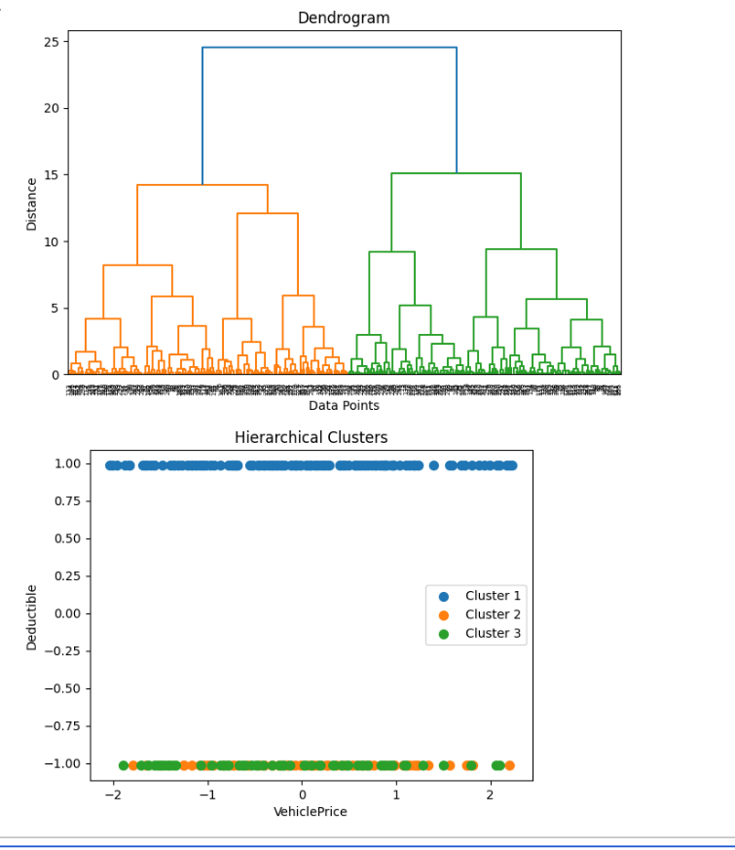
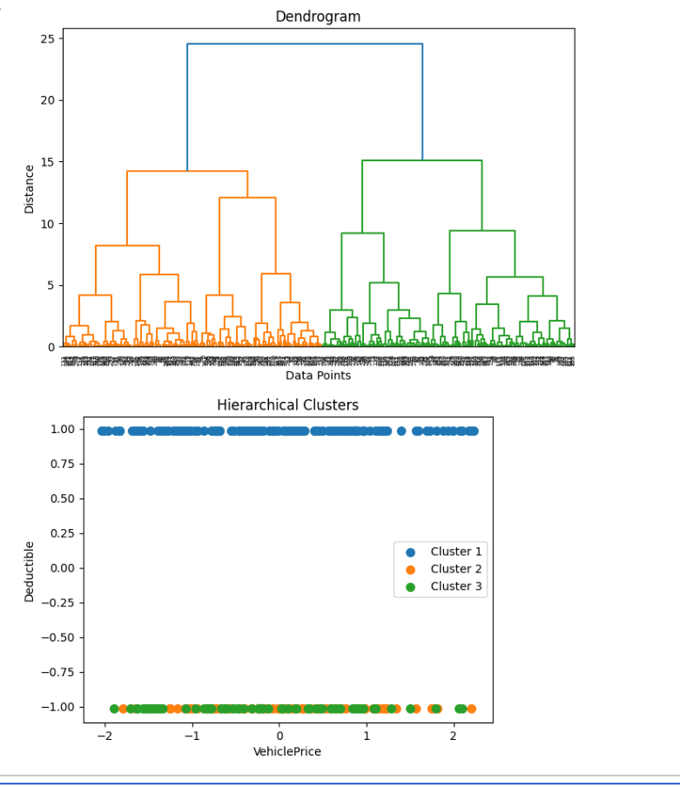
Figure 23: Hierarchical clustering dendrogram and cluster visualization illustrating the formation of three clusters based on feature similarity, using the Ward linkage method.

Hierarchical clustering was applied to a sample of 300 records using VehiclePrice, Deductible, and Age after standardizing the data with StandardScaler. The Ward linkage method was used as it minimizes within-cluster variance at each merge step, making it suitable for producing well-separated and compact clusters.
The dendrogram shows a clear structure with a noticeable separation at higher distance levels, suggesting that dividing the data into 3 clusters is appropriate. This indicates that the dataset can be grouped into distinct segments based on feature similarity, where merging beyond 3 clusters would combine groups with significantly different characteristics.
The cluster plot shows that the separation is strongly influenced by the Deductible variable, which contains two values (300 and 400). After applying StandardScaler, these appear as two horizontal levels around -1 and +1. Within these levels, further separation is observed based on VehiclePrice, where Cluster 1 (Blue) mainly occupies the higher deductible level, while Clusters 2 (Orange) and 3 (Green) are concentrated in the lower deductible level with differences in vehicle prices.
From a fraud detection perspective, customers with lower deductibles may have less financial responsibility when making claims, which can increase the likelihood of inflated or suspicious claims. Therefore, stricter monitoring should be applied to this group. Combining deductible level with vehicle price allows the system to apply targeted fraud detection rules per cluster, improving both accuracy and overall system performance.

3- DBSCAN Clustering
Code:
# DBSCAN Clustering
# Sample the data first
df_sample = df.sample(n=300, random_state=42)
# Scale
from sklearn.preprocessing import StandardScaler
scaler = StandardScaler()
X_scaled = scaler.fit_transform(df_sample[['VehiclePrice', 'Deductible', 'Age']])
# Apply DBSCAN
from sklearn.cluster import DBSCAN
dbscan = DBSCAN(eps=0.5, min_samples=5)
y_dbscan = dbscan.fit_predict(X_scaled)
# Plot
plt.scatter(X_scaled[:, 0], X_scaled[:, 1], c=y_dbscan, cmap='plasma')
plt.title('DBSCAN Clusters')
plt.xlabel('VehiclePrice')
plt.ylabel('Deductible')
plt.colorbar(label='Cluster')
plt.show()
# Print cluster info
import numpy as np
print("Unique clusters:", np.unique(y_dbscan))
print("Noise points (-1):", np.sum(y_dbscan == -1))
Output Screenshot:
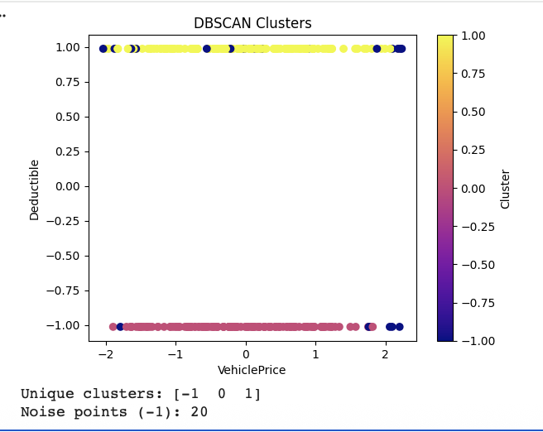
Figure 24: DBSCAN clustering results showing density-based clusters and noise points (-1), highlighting outliers that may represent anomalous or high-risk cases.

DBSCAN was applied to a 300-record sample using VehiclePrice, Deductible, and Age after standardizing with StandardScaler, with parameters set to eps=0.5 and min_samples=5. Unlike K-Means and Hierarchical clustering DBSCAN does not require a predefined number of clusters, as it identifies groups based on density and automatically detects outliers.
The algorithm identified 2 distinct clusters (0 and 1) with 20 noise points (-1). The visualization shows a clear separation along the Deductible axis, where Cluster 0 occupies the lower deductible level (-1.0) and Cluster 1 occupies the higher deductible level (1.0). This separation reflects the two deductible values (300 and 400) present in the dataset. Within each level, points are spread across the VehiclePrice axis, indicating variation in vehicle values within each deductible group.
The 20 noise points represent policyholders that do not conform to any dense group these are atypical cases that deviate from normal patterns and should be prioritized for manual fraud investigation. From a fraud detection perspective, the lower deductible cluster (Cluster 0) warrants stricter monitoring as policyholders with less financial responsibility may be more inclined to submit inflated claims. Combined with vehicle price variation within each cluster, the system can apply targeted fraud screening rules based on deductible tier, improving detection accuracy across different policyholder segments.

4- GAUSSIAN MIXTURE (GMM) Clustering
Code:
# GAUSSIAN MIXTURE MODEL (GMM)
from sklearn.mixture import GaussianMixture
import matplotlib.pyplot as plt
import pandas as pd
from sklearn.preprocessing import StandardScaler
# Load and sample dataset
df = pd.read_csv("final.csv")
df_sample = df.sample(n=300, random_state=42)
# Scale
scaler = StandardScaler()
X = scaler.fit_transform(df_sample[['VehiclePrice', 'Deductible', 'Age']])
# Apply GMM
gmm = GaussianMixture(n_components=3, random_state=42)
y_gmm = gmm.fit_predict(X)
# Visualization
plt.scatter(X[:, 0], X[:, 1], c=y_gmm, cmap='viridis')
plt.title('GMM Clusters')
plt.xlabel('VehiclePrice')
plt.ylabel('Deductible')
plt.colorbar(label='Cluster')
plt.show()
Output Screenshot:

Figure 25: Gaussian Mixture Model (GMM) clustering results demonstrating probabilistic cluster assignment and more detailed segmentation of data based on VehiclePrice, Deductible, and Age.

The Gaussian Mixture Model (GMM) was applied to a 300-record sample using VehiclePrice, Deductible, and Age after standardizing with StandardScaler. Unlike K-Means which assigns each point to a single cluster, GMM uses probabilistic assignment each data point is assigned to the cluster it most likely belongs to based on probability. The number of components was set to n=3 to maintain consistency with the other clustering methods.
The visualization shows separation along the Deductible axis into two levels, consistent with the two deductible values in the dataset. However, GMM demonstrates additional granularity compared to K-Means by splitting the lower deductible level (-1.0) into two distinct clusters (1 and 2) based on VehiclePrice variation. Cluster 0 (Purple) occupies the higher deductible level, while Clusters 1 (Teal) and 2 (Yellow) differentiate policyholders within the lower deductible tier based on their vehicle price range.
This finer segmentation makes GMM particularly valuable for fraud detection. The ability to distinguish between low-deductible policyholders with different vehicle values allows the system to apply more precise risk scoring within the same deductible tier. Policyholders in the lower deductible group with higher vehicle prices (Cluster 2) may represent a higher fraud risk, as the combination of low financial responsibility and high asset value creates a stronger incentive for inflated claims. Overall, GMM provides a more nuanced segmentation than K-Means, making it a useful additional method for targeted fraud investigation.

Cluster Distribution
Code:
# Count number of points in each cluster
import numpy as np
unique, counts = np.unique(y_kmeans, return_counts=True)
print("Cluster Distribution:")
for i in range(len(unique)):
print(f"Cluster {unique[i]}:", counts[i])
Output Screenshot:
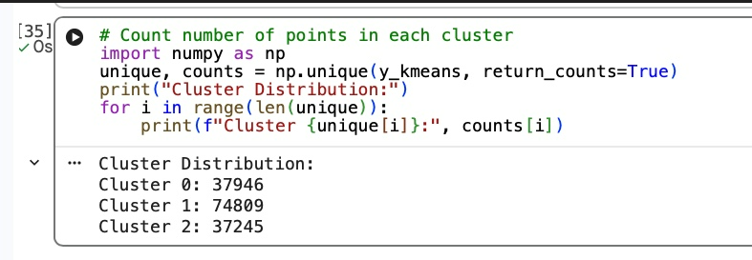
Figure 26: Cluster visualization showing how data points are grouped based on similarity in key features, enabling identification of patterns, segments, and potential high-risk groups within the dataset.

Cluster | Count
Cluster 0 | 37,946
Cluster 1 | 74,809
Cluster 2 | 37,245
Total | 150,000

Cluster 1 is the largest group, containing approximately half of all records (74,809), while Cluster 0 and Cluster 2 are relatively balanced with 37,946 and 37,245 records respectively. This distribution suggests that the majority of policyholders share similar characteristics, while the two smaller clusters represent more distinct segments that may warrant closer attention in fraud detection.

The number of data points in each cluster was examined to understand cluster distribution and balance. The results showed that clusters corresponding to the two deductible levels contain the majority of observations, while smaller clusters represent niche or less frequent policyholder groups. This indicates that the dataset is not evenly distributed, reflecting real-world variation. Smaller clusters and noise points are particularly important, as they may represent unusual or high-risk cases that require closer investigation.
It is important to note that clustering is strongly influenced by the Deductible variable, which contains only two distinct values. As a result, much of the separation is driven by this feature, which may limit the ability of the clustering algorithms to capture more complex patterns from other variables. Despite this limitation, the clustering results remain useful for identifying key risk segments when combined with other features such as VehiclePrice and Age.
Among all methods, K-Means clustering is selected as the most appropriate approach because it provides clear, interpretable clusters, efficient performance on large datasets, and consistent results aligned with the Elbow Method. While DBSCAN is valuable for outlier detection and GMM offers more detailed segmentation, K-Means provides the best balance between simplicity, interpretability, and practical application in fraud detection.

References
Scikit-learn Developers. (n.d.). User guide: Machine learning in Python. Retrieved May 1, 2026, from https://scikit-learn.org/stable/
GeeksforGeeks. (n.d.). Machine learning with Python tutorials. Retrieved May 1, 2026, from https://www.geeksforgeeks.org
Kaggle. (n.d.). Datasets and machine learning practice resources. Retrieved May 1, 2026, from https://www.kaggle.com
ChatGPT. (2026). Assistance with data analysis, machine learning, and Python implementation. OpenAI.

