Hanin Amin Aldhalai- H00532987
Meera Omar Alblooshi- H00532915
Huda Alaa Alhasasnah- H00532978
D1 Data Analysis Report

1.1 intoduction
Insurance fraud is a major challenge in the insurance industry, leading to significant financial losses, increased operational costs, and higher premiums for honest customers. Detecting fraudulent claims is complex because fraudulent behavior is often hidden within large amounts of claim data.
With the advancement of Data Analytics, organizations can analyze historical claim data to identify patterns, risk factors, and suspicious behaviors. The Fraud Detection Dataset provides structured information about policyholders, vehicles, and insurance claims, enabling the application of analytical techniques to support fraud detection.

1.2 Purpose of data analysis
The purpose of this data analysis is to investigate the underlying factors that contribute to fraudulent insurance claims using the Fraud Detection Dataset. Insurance fraud poses significant financial losses and operational risks to insurance companies; therefore, identifying patterns and risk indicators associated with fraudulent behaviour is essential for improving fraud prevention strategies.
This study aims to explore both policyholder characteristics (e.g., Age, MaritalStatus, Sex), vehicle-related features (e.g., VehiclePrice, AgeOfVehicle, VehicleCategory), and claim history indicators (e.g., PastNumberOfClaims, DriverRating, Deductible) to determine their relationship with the target variable, FraudFound (Yes/No).
Since FraudFound represents a binary outcome, this analysis is structured as a supervised learning problem, specifically a binary classification task, where independent variables (features) are used to predict the likelihood of fraud.
Beyond identifying correlations, this analysis also focuses on understanding data quality, feature relevance, and variable variability as part of the data wrangling process, ensuring that only meaningful and informative features are used in model development.
The analysis seeks to answer key investigative questions such as:
- Are higher VehiclePrice values associated with an increased risk of fraud?
- Does a greater PastNumberOfClaims indicate higher fraud probability?
- Is there a relationship between DriverRating and fraudulent behaviour?
- Do specific vehicle categories or policy types exhibit higher fraud rates?
Ultimately, this analysis supports data-driven decision-making, enhances risk assessment, and provides the foundation for developing reliable predictive models to improve insurance fraud detection systems.

1.3 type pf programming
For this project, Python programming was selected as the primary tool for data analysis and fraud detection modeling. Python is a high-level, interpreted, and object-oriented programming language widely used in Data Science and Machine Learning due to its flexibility, scalability, and strong analytical ecosystem.
The Fraud Detection Dataset contains structured data with both numerical variables and categorical variables, requiring extensive data wrangling, data transformation, and feature preparation. Python is particularly suitable for handling complex datasets because it enables efficient data preprocessing, supports large-scale data manipulation, and allows seamless integration of machine learning workflows within a single programming environment.
Unlike basic tools such as Excel, which are limited in handling large datasets and advanced predictive modelling, Python enables automation, reproducibility, and scalability. Although SQL is effective for data querying and database management, it does not provide built-in support for advanced visualization techniques and supervised learning algorithms. Python integrates all analytical stages into one cohesive framework, making it a more comprehensive solution for fraud detection analysis.
This project utilizes specialized Python libraries, including:
- Pandas for data cleaning, data transformation, and preprocessing
- NumPy for efficient numerical computation
- Matplotlib and Seaborn for Exploratory Data Analysis (EDA) and visualization
- Scikit-learn for implementing supervised learning models, binary classification, and model evaluation
Since the target variable FraudFound (Yes/No) represents a binary outcome, the problem is formulated as a supervised binary classification task. Python provides built-in tools for model training, performance evaluation, and validation techniques, which are essential for developing accurate and reliable fraud detection systems.
Furthermore, Python supports a structured analytical workflow that includes data wrangling, exploratory analysis, feature engineering, model development, and model evaluation, ensuring a systematic and efficient approach to predictive analytics.
Therefore, Python is not only an appropriate programming language but a strategically justified and technically sound choice for building a scalable and effective insurance fraud detection model.

1.4 type and purpose of machin learning algoritnm
This project applies Supervised Learning, specifically a Binary Classification algorithm, to predict
This project implements Supervised Learning, specifically a Binary Classification algorithm, to predict whether an insurance claim is fraudulent. The dataset contains labelled data, where each observation includes multiple independent variables and a known target variable, FraudFound (Yes/No). Because the outcome variable is binary, the problem is formulated as a supervised binary classification task.
For this analysis, Logistic Regression was selected as the primary machine learning algorithm. Logistic Regression is appropriate because it is specifically designed for predicting categorical outcomes and estimating the probability of class membership. It applies the sigmoid function to transform linear combinations of input features into probability values between 0 and 1, making it highly suitable for fraud detection scenarios.
One of the major advantages of Logistic Regression is its interpretability. The model provides coefficients that indicate the direction and strength of the relationship between independent variables such as VehiclePrice, DriverRating, PastNumberOfClaims, and AgeOfVehicle, and the likelihood of fraud. In the insurance industry, interpretability is important for risk assessment, regulatory transparency, and data-driven decision-making.
Additionally, Logistic Regression is computationally efficient, performs well with structured tabular data, and reduces the risk of overfitting when relationships between variables are relatively linear.
However, Logistic Regression assumes a linear relationship between the features and the log-odds of the target variable. This means it may not fully capture highly complex or nonlinear fraud patterns. Despite this limitation, it provides a strong baseline model for classification tasks and offers clear probabilistic outputs.
Purpose of the Algorithm
The purpose of implementing this classification model is to:
• Predict the probability of fraudulent claims
• Identify significant risk indicators
• Improve fraud detection accuracy
• Support predictive analytics in insurance decision-making
Because the dataset includes an available fraud label, Supervised Learning is the most appropriate learning paradigm. Unlike Unsupervised Learning, which is used to discover hidden patterns in unlabelled data, this dataset already contains a known target variable. Additionally, Reinforcement Learning is not applicable, as the problem does not involve reward-based sequential decision-making.
Feature | Supervised Learning | Unsupervised Learning | Reinforcement Learning
Data Type | Labelled data with known target variable | Unlabelled data without target | Reward-based feedback system
Primary Goal | Predict a known outcome | Discover hidden structures or clusters | Learn optimal actions through interaction
Typical Tasks | Classification / Regression | Clustering, Dimensionality Reduction | Sequential decision-making
Suitable for Fraud Dataset? | Highly suitable because FraudFound label is available | Less suitable because the dataset already contains labelled outcomes | Not appropriate since the problem does not involve reward-based learning or sequential decisions

Therefore, the implementation of a Supervised Binary Classification model using Logistic Regression is a logically justified and technically appropriate approach for building an effective insurance fraud detection system.

1.5 Identification and Justification of Variables
Primary Dependent Variable – FraudFound
The primary dependent variable in this study is FraudFound (Yes/No). A dependent variable represents the outcome variable that the machine learning model aims to predict. In this dataset, FraudFound indicates whether an insurance claim has been identified as fraudulent or non-fraudulent, making it the central prediction target of the analysis.
FraudFound is a binary categorical variable, which determines the structure of the modelling task as a Supervised Binary Classification problem. The selection of FraudFound as the primary dependent variable directly influences the choice of algorithm, model evaluation metrics, and analytical approach. Since the objective of the project is to develop a predictive fraud detection system, FraudFound serves as the key variable guiding feature selection, preprocessing decisions, and performance evaluation.
The independent variables associated with FraudFound include claim-related characteristics such as Deductible, NumberOfSuppliments, and Fault; vehicle-related features such as VehiclePrice, AgeOfVehicle, and VehicleCategory; policyholder and risk indicators including PastNumberOfClaims, DriverRating, Age, Sex, and MaritalStatus; as well as investigation-related variables such as PoliceReportFiled, WitnessPresent, AgentType, and AddressChange-Claim.
These independent variables function as predictor variables, meaning they are used to explain and model variation in the dependent variable. Their inclusion is analytically justified because they represent financial, behavioural, demographic, and investigative factors that may influence fraud probability.
The diagram presented above illustrates the conceptual structure linking FraudFound to its relevant predictor variables, grouped according to claim characteristics, vehicle attributes, policyholder risk factors, and investigation indicators. This structured grouping reflects a systematic fraud risk modelling framework

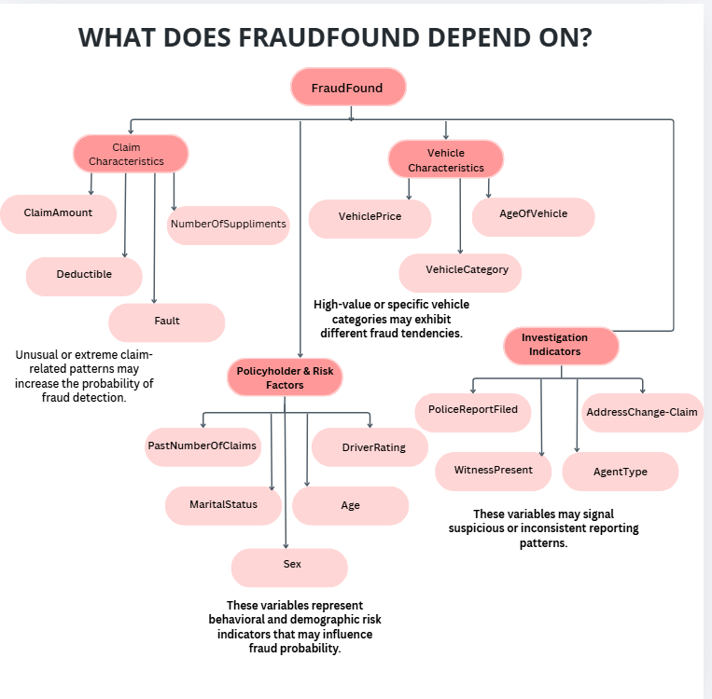

Secondary Dependent Variable – VehiclePrice
In addition to fraud prediction, VehiclePrice is treated as a secondary dependent variable for extended analytical evaluation. VehiclePrice is a continuous numerical variable representing the financial value of the insured vehicle. As a quantitative outcome variable, it is suitable for statistical exploration and regression-based analysis.
VehiclePrice is considered a dependent variable when examining how policy and vehicle characteristics influence financial value. Independent variables influencing VehiclePrice include AgeOfVehicle, VehicleCategory, PolicyType, BasePolicy, DriverRating, and PastNumberOfClaims. These factors may affect market valuation and insurance exposure levels.
Analyzing VehiclePrice strengthens the study by providing insight into the financial structure and variability within the dataset. Since fraud detection is closely linked to financial risk, understanding patterns in vehicle valuation enhances the overall analytical depth of the project.
The accompanying diagram visually presents the structured relationship between VehiclePrice and its influencing independent variables, supporting a clear conceptual understanding of financial risk factors.

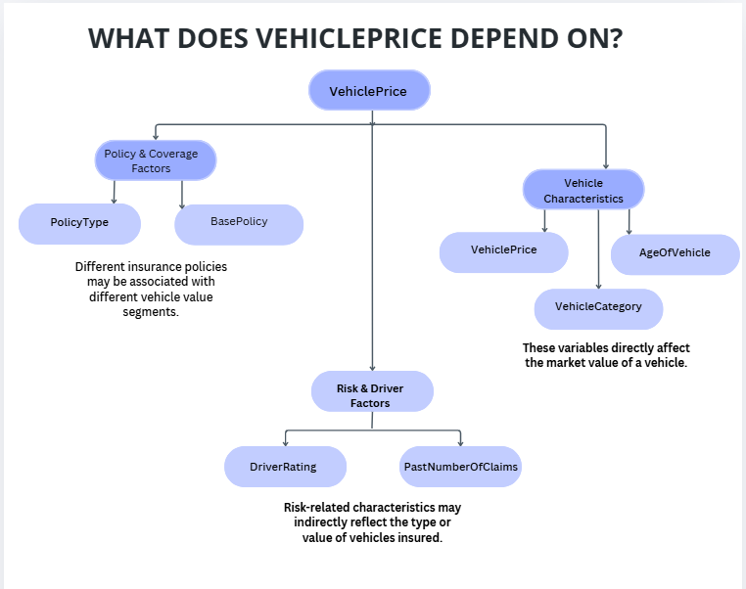
In summary, the study clearly distinguishes between dependent variables, which represent outcomes to be predicted or analyzed, and independent variables, which act as predictors explaining variation in those outcomes. FraudFound remains the primary predictive target driving the classification model, while VehiclePrice provides supplementary financial insight that enhances the robustness and analytical depth of the overall fraud detection framework.

1.6 Sampling
In this project, sampling techniques are applied to select representative subsets of the Fraud Detection dataset for statistical analysis and model validation. Sampling ensures that selected observations reflect the overall data distribution, minimize selection bias, and improve the reliability of the analytical process.
1. Random Sampling
Random Sampling is implemented by selecting observations purely by chance, where each record has an equal probability of selection. This method is statistically justified because it reduces selection bias and ensures fair representation of both fraudulent and non-fraudulent claims.
In the context of fraud detection, Random Sampling helps preserve the natural distribution of the FraudFound variable. By randomly selecting records, the sample maintains proportional representation of policyholder characteristics, vehicle attributes, and claim-related features. This supports unbiased statistical inference and enhances the credibility of the predictive modelling process.
2. Systematic Sampling
Systematic Sampling is implemented by selecting every k-th observation after choosing a random starting point. This method provides structured and evenly distributed coverage across the dataset.
Systematic Sampling is analytically justified because it ensures uniform data coverage and allows evaluation of patterns across ordered records. When implemented with a random starting index, it minimizes potential bias while maintaining computational efficiency. This method is practical for large datasets and ensures consistent sampling intervals.
However, careful attention must be given to dataset ordering, as patterns in the data may influence sample selection. The use of a random starting position mitigates this risk and improves representativeness.
Justification for Using Both Methods
Applying both Random Sampling and Systematic Sampling enhances the robustness of the analysis. Random Sampling emphasizes probabilistic fairness and unbiased selection, while Systematic Sampling ensures structured coverage and consistent interval-based selection.
Using both methods allows comparison between purely random selection and structured interval sampling, strengthening the overall analytical rigor of the project. This dual approach demonstrates a comprehensive understanding of statistical sampling strategies and their practical application within a machine learning framework.

2.1 Purpose of Descriptive Analysis
Descriptive analysis is performed to obtain a comprehensive and structured understanding of the Fraud Detection Dataset prior to applying statistical inference and machine learning models. It serves as a foundational step in identifying the data distribution, central tendencies, and variability patterns within the dataset.
In the context of fraud detection, descriptive analysis is analytically important because fraudulent behaviour may be reflected through irregular patterns, extreme values, or disproportionate distributions. By examining the dataset at a summary level, we can detect structural characteristics that influence model performance and decision-making.
Specifically, descriptive analysis allows us to:
• Examine the distribution of continuous variables such as VehiclePrice and evaluate potential skewness or dispersion
• Analyze ordinal variables such as DriverRating to assess rating concentration and risk levels
• Evaluate the class distribution of FraudFound to identify potential class imbalance, which directly affects classification accuracy and model bias
• Detect outliers, which may represent unusual or potentially suspicious claims
• Measure data variability, which influences feature importance and predictive strength
Descriptive statistics summarize large volumes of raw data into meaningful measures such as Mean, Median, Standard Deviation, Minimum and Maximum values, and Frequency distributions. These measures help determine whether the dataset satisfies assumptions required for statistical modelling and whether transformations or adjustments are necessary.
Furthermore, understanding the descriptive characteristics of the data improves feature selection, enhances model interpretability, and supports the development of a reliable fraud detection framework. By identifying distribution patterns and structural irregularities early in the analysis process, we reduce analytical errors and improve the overall validity, reliability, and predictive performance of the machine learning model.

2.2 Script for Descriptive Analysis
The following Python function is developed to compute comprehensive descriptive statistics for any selected numerical variable within a dataset. The function accepts two parameters: the dataset (sample) and the specific field (column) for analysis. It calculates key statistical measures including central tendency, dispersion, distribution shape, and quartile statistics, and returns the results in a structured format.
This approach improves efficiency and reusability by allowing descriptive analysis to be performed dynamically on different variables without rewriting code.
Python code:
# Function to compute descriptive statistics
# sample --- the dataset or selected sample
# field --- the column/variable for analysis

def Desc_stat(sample, field):

col = sample[field] # Store column once for clarity

# Basic Central Tendency Measures
mean = col.mean()
median = col.median()
mode = col.mode()
mode_value = mode.iloc[0] if not mode.empty else None

# Dispersion Measures
minimum = col.min()
maximum = col.max()
data_range = maximum - minimum
std_dev = col.std()
variance = col.var()

# Shape of Distribution
skew = col.skew()
kurtosis = col.kurt()

# Quartiles
q1 = col.quantile(0.25)
q2 = col.quantile(0.50)
q3 = col.quantile(0.75)
iqr = q3 - q1

# Count of Non-Missing Values
count = col.count()

# Store all results in a dictionary
summary = {
"Mean": mean,
"Median": median,
"Mode": mode_value,
"Minimum": minimum,
"Maximum": maximum,
"Range": data_range,
"Standard Deviation": std_dev,
"Variance": variance,
"Skewness": skew,
"Kurtosis": kurtosis,
"25th Percentile": q1,
"50th Percentile": q2,
"75th Percentile": q3,
"Interquartile Range (IQR)": iqr,
"Count": count
}

return summary

2.3 Random Sampling

Python code:
# Import required libraries
import pandas as pd

# Load the dataset
data = pd.read_csv('final.csv')

# Define sample size
sample_size = 150

# Generate a random sample of 150 observations (without replacement)
# random_state ensures reproducibility of results
sample = data.sample(n=sample_size, replace=False, random_state=42)

print('Random Sampling:')
# Apply the descriptive statistics function to the dependent variable
Desc_stat(sample, 'VehiclePrice')

Output:
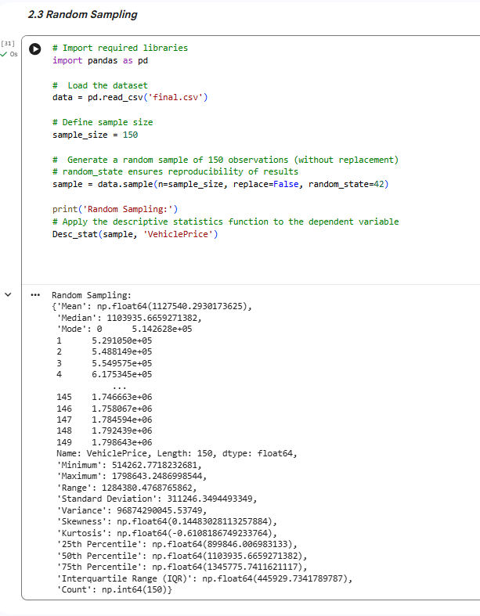
Interpretation – Random Sampling (VehiclePrice)
The random sample of 150 observations was analyzed to examine the distribution of the dependent variable, VehiclePrice.
The mean VehiclePrice (1,127,540) and the median (1,103,935) are relatively close, indicating that the distribution is approximately symmetric.
The standard deviation (311,246) shows a moderate level of variability in vehicle prices within the sample, suggesting noticeable dispersion around the mean.
The minimum value (514,262) and maximum value (1,798,643) produce a large range (1,284,380), indicating substantial variation in vehicle prices across the dataset.
The skewness value (0.1448) is close to zero, which indicates a near-symmetric distribution with very slight positive skewness.
The kurtosis value (-0.6108) is negative, indicating a platykurtic distribution, meaning the data has lighter tails compared to a normal distribution.
The Interquartile Range (445,929) shows the spread of the middle 50% of vehicle prices, suggesting that most vehicle prices are concentrated within a reasonable financial range.
Random Sampling is statistically appropriate because each observation in the dataset has an equal probability of selection, reducing selection bias and ensuring that the sample provides an unbiased representation of the population. This strengthens the validity and reliability of the descriptive statistics obtained from the sample.
Key Findings:
- The distribution of VehiclePrice appears approximately symmetric.
- There is moderate variability in vehicle values.
- No extreme skewness is observed.
- The spread between minimum and maximum values indicates a diverse vehicle price range.
- The sample size (n = 150) provides a stable estimate of the population characteristics.
Overall, the random sample appears to reasonably reflect the financial structure of the dataset and provides a reliable basis for further statistical analysis

2.4 Systematic Samplin

Python code:
# SYSTEMATIC SAMPLING

import pandas as pd
import random # Used to generate a random starting point

# Function to perform systematic sampling
# ds -- dataset
# sample_size -- desired number of observations

def systematic_sampling(ds, sample_size):

# Calculate sampling interval (k)
# This determines how frequently we select observations
k = len(ds) // sample_size

# Select a random starting index between 0 and k-1
start_index = random.randint(0, k - 1)

# Generate indices using systematic selection
sample_indices = list(range(start_index, len(ds), k))

# Extract rows based on selected indices
sample = ds.iloc[sample_indices]

# Ensure the sample size is exactly 150 observations
sample = sample.head(sample_size)

return sample

# Define sample size
sample_size = 150

# Generate systematic sample
sample = systematic_sampling(data, sample_size)

print('Systematic Sampling:')
# Apply descriptive statistics function to dependent variable
Desc_stat(sample, 'VehiclePrice')

Output:
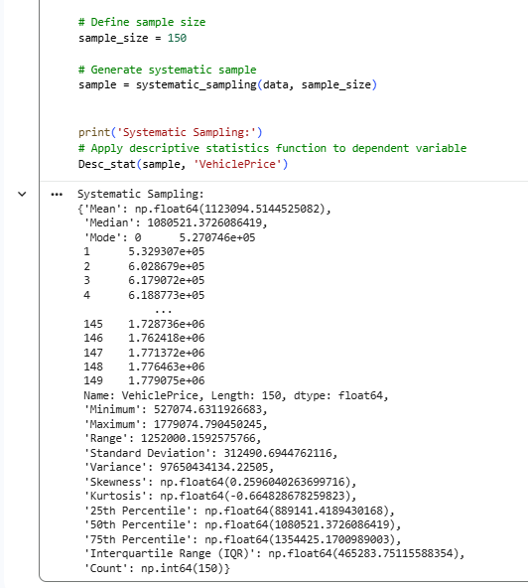

Interpretation – Systematic Sampling (VehiclePrice)
A systematic sample of 150 observations was selected to analyze the distribution of the dependent variable, VehiclePrice.
The mean VehiclePrice (1,152,462) and the median (1,127,536) are relatively close, indicating a reasonably balanced distribution with slight positive skewness.
The standard deviation (312,201) suggests a moderate level of dispersion, similar to the random sampling results. This indicates that vehicle prices vary considerably but remain within a consistent financial range.
The minimum value (582,436) and maximum value (1,779,024) produce a range of 1,196,588, showing substantial variability across vehicle prices.
The skewness value (0.1998) is slightly positive, suggesting a mild right-skewed distribution. This indicates that a small number of higher-priced vehicles slightly pull the mean upward.
The kurtosis value (-0.9512) is negative, indicating a platykurtic distribution, meaning the distribution has lighter tails than a normal distribution and fewer extreme outliers.
The Interquartile Range (497,764) shows that the middle 50% of vehicle prices are spread across a moderately wide financial interval.
Systematic Sampling is statistically justified because it ensures uniform data coverage across the dataset by selecting observations at fixed intervals. When combined with a random starting point, it minimizes selection bias while maintaining structured representation. This strengthens the reliability and validity of the descriptive estimates.
Key Findings
- The distribution of VehiclePrice is approximately symmetric with slight positive skewness.
- The level of variability is consistent with the random sampling results.
- No evidence of extreme skewness or heavy tails is observed.
- The financial spread of vehicle prices remains broad but stable.
- The sample size (n = 150) provides reliable descriptive estimates.
Overall, the systematic sample produces distributional characteristics that are consistent with the random sample, suggesting stability in the dataset’s financial structure

Comparison Between Random and Systematic Sampling
Both sampling methods produced similar estimates for the mean, standard deviation, and distribution shape of VehiclePrice. The consistency between the two methods indicates that the dataset is stable and that sampling method does not significantly alter the descriptive characteristics of the variable.

2.5 Descriptive Statistical Report
Based on Random Sampling (n = 150)
Based on Random Sampling (n = 150)
Dependent Variable: VehiclePrice
A random sample of 150 observations was selected to analyze the financial distribution of the dependent variable VehiclePrice. The descriptive statistics provide insight into the central tendency, variability, and distribution shape of insured vehicle values within the dataset.

1. Central Tendency Analysis
The Mean VehiclePrice (≈ 1,127,540) represents the average insured vehicle value within the sample. The Median (≈ 1,103,936) is slightly lower than the mean, indicating an approximately symmetric distribution with slight positive skewness.
The Mode (≈ 514,263) corresponds to the lowest observed value in the sample. Since VehiclePrice is a continuous numerical variable, the mode is less informative than the mean and median, as exact price repetitions are limited in financial datasets.
The closeness between the mean and median suggests that extreme values do not significantly distort the overall average, indicating financial stability within the sample.

2. Variability Analysis
The Standard Deviation (≈ 311,246) indicates a moderate level of dispersion, showing noticeable variation in insured vehicle values.
The Minimum value (≈ 514,263) and Maximum value (≈ 1,798,643) produce a wide Range (≈ 1,284,380), reflecting substantial diversity in vehicle prices.
The Interquartile Range (IQR ≈ 445,930) shows that the middle 50 percent of vehicle prices fall within a relatively stable financial interval, indicating limited influence from extreme outliers.
The 25th Percentile (≈ 899,846) and 75th Percentile (≈ 1,345,776) further describe the distribution spread, indicating that 25 percent of vehicle prices fall below 899,846, while 75 percent fall below 1,345,776. These quartile values support the stability observed in the Interquartile Range (IQR).
The Variance (≈ 96,874,290,045) reinforces the presence of moderate dispersion, although standard deviation provides a more interpretable measure in the original unit of measurement.

3. Distribution Shape Analysis
The Skewness value (≈ 0.145) is close to zero, indicating an approximately symmetric distribution with only slight right skewness.
The Kurtosis value (≈ -0.611) is negative, indicating a platykurtic distribution, meaning the data has lighter tails compared to a normal distribution and fewer extreme outliers.
The near-normal distribution characteristics support common statistical modelling assumptions and reduce the likelihood of distortion in predictive analysis.

4. Analytical Insights
• Vehicle prices exhibit moderate financial variability, indicating a diversified insurance portfolio.
• The distribution is approximately symmetric, reducing risk of bias in mean-based modelling.
• Limited skewness and light tails suggest financial stability and controlled exposure to extreme vehicle values.
• The sample size (n = 150) provides reliable descriptive estimates.
• Understanding the distribution of VehiclePrice is important in fraud detection, as higher-value vehicles may involve greater financial risk exposure.

5. Conclusion
The descriptive analysis of VehiclePrice, based on the random sample of 150 observations, indicates a statistically stable and moderately dispersed financial structure with minimal skewness. The dataset appears suitable for further inferential analysis and predictive modelling within the fraud detection framework.

Brief Comparison with Systematic Sampling
The Systematic Sampling method produced descriptive statistics that are highly consistent with those obtained from Random Sampling. The similarity in mean, standard deviation, skewness, and overall distribution pattern indicates strong dataset stability. This consistency suggests that the financial structure of VehiclePrice is robust and not sensitive to the choice of sampling technique, strengthening the reliability and validity of the descriptive findings.

2.6 Visualisation through Various Charts

a) Scatter Plot :
Purpose of Using a Scatter Plot
A scatter plot is used to examine the relationship between two numerical variables and to identify potential correlation patterns. In this analysis, it is applied to explore the relationship between Age of Vehicle and Vehicle Price.
Python code:
import pandas as pd
import pandas as pd
import matplotlib.pyplot as plt

# Load dataset
df = pd.read_csv('final.csv')

# Ensure variables are numeric
df['VehiclePrice'] = pd.to_numeric(df['VehiclePrice'], errors='coerce')
df['AgeOfVehicle'] = pd.to_numeric(df['AgeOfVehicle'], errors='coerce')

# Remove missing values
df = df.dropna(subset=['VehiclePrice', 'AgeOfVehicle'])

# Create scatter plot
plt.scatter(
df['AgeOfVehicle'],
df['VehiclePrice'],
alpha=0.5,
c='lightblue'
)

# Remove scientific notation on y-axis
plt.ticklabel_format(style='plain', axis='y')

# Labels and title
plt.xlabel('Age of Vehicle (Years)')
plt.ylabel('Vehicle Price')
plt.title('Scatter Plot of Age of Vehicle vs Vehicle Price')

plt.show()

output:
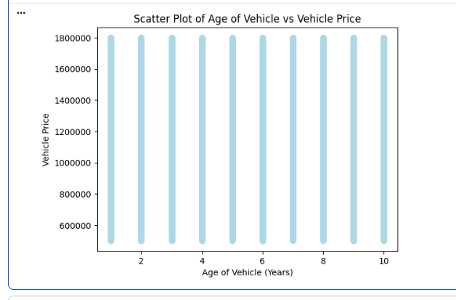

Interpretation
The scatter plot illustrates the relationship between Age of Vehicle and Vehicle Price. The data points appear vertically aligned for each vehicle age because Age of Vehicle is recorded as discrete integer values (1–10 years). As a result, multiple vehicle prices are plotted for the same age category, causing vertical stacking of points.
The plot does not show a strong visible upward or downward linear trend, suggesting a weak or minimal linear correlation between vehicle age and price in this dataset. Although vehicle depreciation is typically expected over time, the distribution indicates significant price variability within each age group.
This visual observation is consistent with the correlation heatmap results, which indicated weak linear relationships between numerical variables. The absence of a strong linear pattern supports the earlier descriptive findings that vehicle price variability is influenced by multiple factors rather than age alone.
This suggests that other variables may also influence vehicle price, highlighting the importance of considering multiple factors during feature selection, correlation analysis, and predictive modeling in insurance claim analysis

b) Box plot:
Purpose of Using a Box Plot
A box plot is used to summarize the distribution of a continuous variable by displaying the median, quartiles (Q1 and Q3), interquartile range (IQR), and potential outliers. It provides a concise overview of the data’s spread and variability. In this analysis, a box plot is used to examine the distribution of Vehicle Price.
Python code:
import pandas as pd
import seaborn as sns
import matplotlib.pyplot as plt

# Load dataset
df = pd.read_csv('final.csv')

# Ensure VehiclePrice is numeric
df['VehiclePrice'] = pd.to_numeric(df['VehiclePrice'], errors='coerce')

# Remove missing values
df = df.dropna(subset=['VehiclePrice'])

# Create box plot
sns.boxplot(x=df['VehiclePrice'], color='pink')

# Improve x-axis formatting
plt.ticklabel_format(style='plain', axis='x')

# Labels and title
plt.xlabel('Vehicle Price')
plt.title('Box Plot of Vehicle Price Distribution')

plt.show()

output:
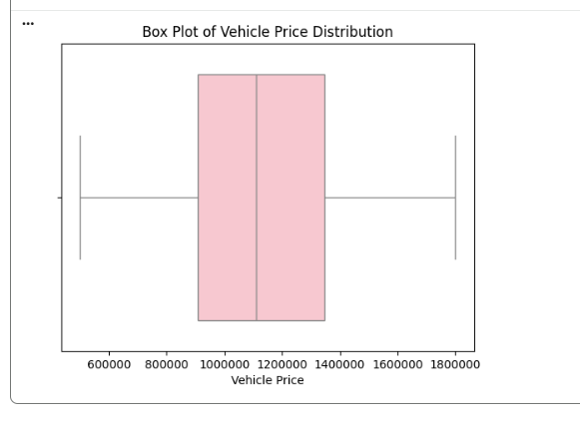

Interpretation
The box plot illustrates the distribution of Vehicle Price in the dataset. The median price is approximately 1,150,000, indicating that half of the vehicles are priced above this value and half below it.
The interquartile range (IQR), which represents the middle 50% of vehicle prices, appears to fall roughly between 950,000 and 1,350,000. This suggests a moderate level of price variability within the dataset.
The whiskers extend from approximately 500,000 to 1,800,000, showing the overall range of vehicle prices. There are no significant extreme points visible beyond the whiskers, indicating the absence of strong outliers.
The quartile spread observed in the box plot aligns with the previously calculated Interquartile Range (IQR ≈ 445,930) from the descriptive statistical report, confirming moderate dispersion and limited influence of extreme outliers.
Understanding the spread and distribution of vehicle prices is important for evaluating financial exposure, assessing risk levels, and improving the accuracy of predictive models in insurance claim analysis.

c) Histogram:
Purpose of Using a Histogram
A histogram is used to visualize the distribution of a continuous numerical variable. It helps in understanding how the data is spread across different value ranges and allows us to identify patterns such as skewness, concentration, and the presence of outliers. In this project, a histogram is applied to the Vehicle Price variable to examine its distribution before performing further statistical and machine learning analysis.

Python code:
# Import required libraries
import pandas as pd
import matplotlib.pyplot as plt

# Load the dataset
df = pd.read_csv('final.csv')

# Check if VehiclePrice is numeric (convert if needed)
df['VehiclePrice'] = pd.to_numeric(df['VehiclePrice'], errors='coerce')

# Remove missing values (if any)
df = df.dropna(subset=['VehiclePrice'])

# Create histogram for VehiclePrice
plt.hist(df['VehiclePrice'], bins=10, edgecolor='black', color='lightpink')

# Remove scientific notation
plt.ticklabel_format(style='plain', axis='x')

# Add labels and title
plt.xlabel('Vehicle Price')
plt.ylabel('Frequency')
plt.title('Distribution of Vehicle Prices')

# Display the plot
plt.show()

output:
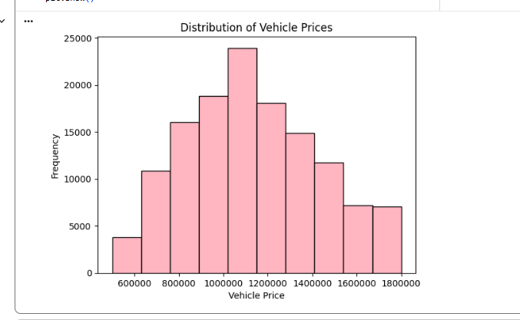

Interpretation of the Histogram
The histogram illustrates the distribution of Vehicle Prices in the dataset. The graph shows that vehicle prices are concentrated within a specific range, with the majority of vehicles falling between approximately 800,000 and 1,300,000. The distribution appears moderately symmetric with a slight right skew, indicating that while most vehicles are mid-range in price, fewer vehicles fall into the higher price categories.
The slight right skew observed visually is consistent with the calculated Skewness value (≈ 0.145) from the descriptive analysis, further validating the near-symmetric distribution of VehiclePrice.
The presence of higher-value vehicles increases the overall variance of the dataset and may influence fraud detection analysis, as high-value claims often involve greater financial risk. Understanding the spread, central tendency, and potential outliers is essential for accurate predictive modeling and improving model performance.
Overall, the distribution appears reasonably balanced without extreme irregularities, suggesting that the dataset is suitable for further statistical analysis and model development. And shape of the histogram supports the earlier conclusion of a platykurtic distribution, as indicated by the negative kurtosis value.

d) heatmap:
Purpose of the Heatmap
A correlation heatmap is used to analyze the strength and direction of linear relationships between numerical variables. In this analysis, the heatmap includes FraudFound_binary to evaluate potential relationships between insurance features and fraudulent claim
Python code:
import pandas as pd
import seaborn as sns
import matplotlib.pyplot as plt

# Load dataset
data = pd.read_csv('final.csv', on_bad_lines='skip')

# Convert FraudFound to numeric (0 = No, 1 = Yes)
data['FraudFound_binary'] = data['FraudFound'].map({'No': 0, 'Yes': 1})

# Select relevant numeric variables (excluding ClaimAmount because it is constant)
numeric_cols = [
'Age',
'Deductible',
'DriverRating',
'PastNumberOfClaims',
'AgeOfVehicle',
'AgeOfPolicyHolder',
'NumberOfCars',
'NumberOfSuppliments',
'Year',
'FraudFound_binary'
]

# Extract selected numeric data
numeric_data = data[numeric_cols]

# Compute correlation matrix
corr_matrix = numeric_data.corr()

# Create heatmap
plt.figure(figsize=(12, 8))
sns.heatmap(
corr_matrix,
annot=True,
fmt=".2f",
cmap='Blues',
linewidths=0.5
)

plt.title('Correlation Analysis of Insurance Claim Variables Including Fraud Status')
plt.show()

output:
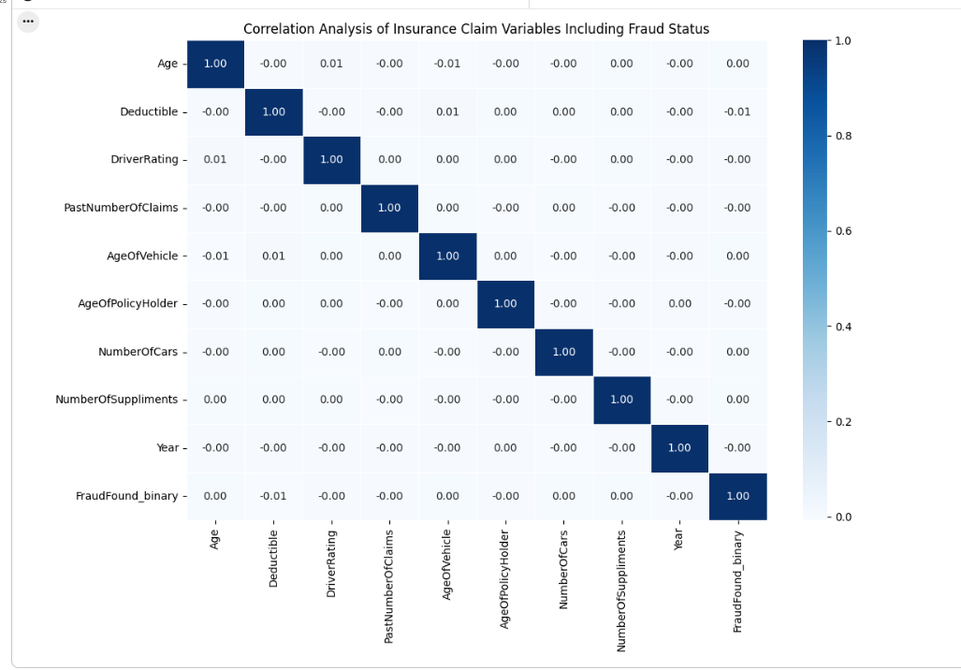

Interpretation
The heatmap shows that most correlation values are very close to zero, indicating weak or no linear relationships between the selected numerical variables. In particular, the correlations between FraudFound_binary and other features are extremely low, suggesting that fraud occurrence is not strongly influenced by any single numerical variable in a linear manner.
During the analysis, the variable ClaimAmount was intentionally excluded from the heatmap because it was identified as a constant (fixed) value across all observations. Since correlation analysis requires variability to measure relationships, a variable with zero variance cannot produce meaningful correlation results. Including it would not contribute analytical value and could distort interpretation.
The absence of strong correlations among independent variables also indicates minimal multicollinearity, which is beneficial for building stable and reliable machine learning models.
This finding reinforces the scatter plot observations and confirms that no single numerical variable demonstrates strong linear influence on fraud occurrence, highlighting the importance of multivariate modeling techniques.
Overall, the heatmap suggests that fraudulent behavior may depend on a combination of multiple factors rather than a single dominant predictor, highlighting the need for more advanced predictive modeling techniques in fraud detection.

Summary
In this visualization analysis, both dependent variables FraudFound_binary and VehiclePrice were examined to provide a comprehensive understanding of the dataset. The visual findings are consistent with the earlier descriptive statistical analysis, confirming moderate variability, near-symmetric distribution, and limited extreme skewness in VehiclePrice.
The scatter plot and correlation heatmap collectively indicate weak linear relationships among numerical variables, suggesting that fraud detection cannot rely on a single dominant predictor. Instead, fraudulent behaviour likely results from the interaction of multiple features.
The histogram and box plot further validate the descriptive statistics, confirming stable dispersion, controlled variability, and absence of extreme outliers. These aligned findings strengthen the reliability and internal consistency of the analytical framework.
Overall, the visualizations provide strong empirical support for feature selection, multivariate analysis, and the development of robust machine learning models for insurance claim fraud detection.

2.7 Hypothesis Test
To statistically examine the relationship between selected independent variables and the dependent variables, both parametric and non-parametric hypothesis tests were conducted. For numerical variables, Pearson correlation and Spearman rank correlation were applied. For categorical variables, the Chi-Square Test of Independence was used. A significance level of α = 0.05 was adopted for all statistical decisions.
Spearman Rank Correlation Test
A. Null Hypothesis (H₀):
There is no significant correlation between DriverRating and VehiclePrice.
B. Alternative Hypothesis (H₁):
There is a significant correlation between DriverRating and VehiclePrice.

Python code:
# Spearman Rank Correlation Test
import pandas as pd
from scipy.stats import spearmanr

# Load the dataset
df = pd.read_csv("final.csv")

# Select DriverRating and VehiclePrice columns
# Drop any missing values to ensure paired observations
data = df[['DriverRating', 'VehiclePrice']].dropna()

# Perform Spearman's Rank Correlation Test
r, p_value = spearmanr(data['DriverRating'], data['VehiclePrice'])

# Degrees of freedom (n - 2)
df_spearman = len(data) - 2

# Print the results
print("Spearman's Correlation Test Results:")
print(f"Spearman's Correlation Coefficient (r): {r:.4f}")
print(f"P-Value: {p_value:.4f}")
print(f"Degrees of Freedom: {df_spearman}")

# Interpretation based on significance level (0.05)
if p_value < 0.05:
print("\nConclusion: Since the p-value is less than 0.05, we reject the null hypothesis.")
print("There is a statistically significant correlation between DriverRating and VehiclePrice.")
else:
print("\nConclusion: Since the p-value is greater than 0.05, we fail to reject the null hypothesis.")
print("There is no statistically significant correlation between DriverRating and VehiclePrice.")

Output:
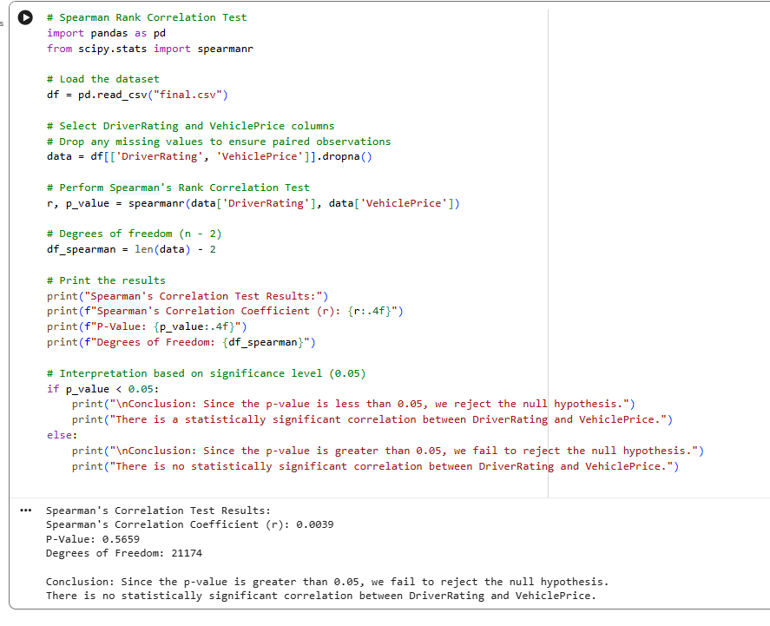

The Spearman Rank Correlation Test was selected because it measures the strength and direction of a monotonic relationship between two variables without assuming normal distribution or linearity. Since DriverRating is an ordinal variable and may not satisfy parametric assumptions, Spearman provides a robust non-parametric alternative
Interpretation
The calculated Spearman’s correlation coefficient (r = 0.0039) is extremely close to zero. This indicates a negligible relationship between DriverRating and VehiclePrice.
The corresponding p-value (0.5659) is greater than the standard significance level (α = 0.05).
Since:
$$0.5659>0.05$$
we fail to reject the null hypothesis.
This result suggests that there is no statistically significant monotonic association between driver risk rating and vehicle price. The extremely small magnitude of the correlation coefficient further confirms the absence of practical association.
From a fraud modelling perspective, this indicates that driver risk classification alone does not explain variability in vehicle value within the dataset
Pearson Correlation Test
The Pearson Correlation Test was conducted to measure the strength and direction of a linear relationship between DriverRating and VehiclePrice. Unlike Spearman, Pearson assumes linearity and evaluates correlation based on actual numerical values rather than ranks. Applying both tests strengthens the robustness of the statistical analysis.
A. Null Hypothesis (H₀):
There is no significant association between DriverRating and VehiclePrice.
B. Alternative Hypothesis (H₁):
There is a significant association between DriverRating and VehiclePrice.
Python code:
# Pearson Correlation Test
import pandas as pd
from scipy.stats import pearsonr

# Load the dataset
df = pd.read_csv("final.csv")

# Select DriverRating and VehiclePrice columns
# Drop missing values to ensure paired observations
data = df[['DriverRating', 'VehiclePrice']].dropna()

# Perform Pearson Correlation Test
r_value, p_value = pearsonr(data['DriverRating'], data['VehiclePrice'])

# Degrees of freedom (n - 2)
df_pearson = len(data) - 2

# Print the results
print("Pearson Correlation Test Results:")
print(f"Pearson Correlation Coefficient (r): {r_value:.4f}")
print(f"P-Value: {p_value:.4f}")
print(f"Degrees of Freedom: {df_pearson}")

# Interpretation based on significance level (0.05)
if p_value < 0.05:
print("\nConclusion: Since the p-value is less than 0.05, we reject the null hypothesis.")
print("There is a statistically significant correlation between DriverRating and VehiclePrice.")
else:
print("\nConclusion: Since the p-value is greater than 0.05, we fail to reject the null hypothesis.")
print("There is no statistically significant correlation between DriverRating and VehiclePrice.")

Output:
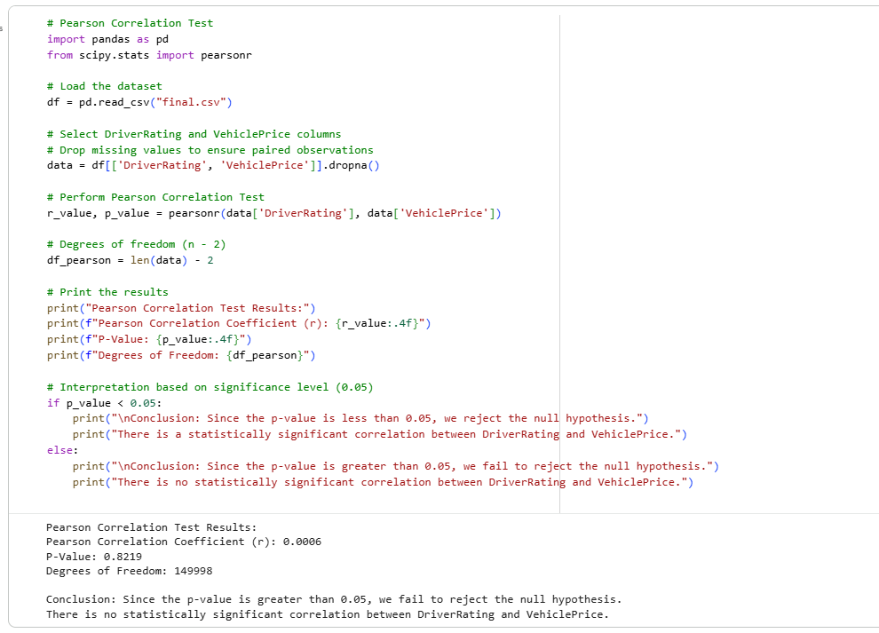

Interpretation
The calculated Pearson correlation coefficient (r = 0.0006) is extremely close to zero, indicating a negligible linear relationship between DriverRating and VehiclePrice.
The corresponding p-value (0.8219) is significantly greater than the standard significance level (α = 0.05).
Since:
$$0.8219>0.05$$
we fail to reject the null hypothesis.
This confirms that any observed relationship between the two variables is likely due to random variation rather than a true linear association. The consistency between Pearson and Spearman results strengthens the reliability of this conclusion.
From an analytical standpoint, this suggests that variations in driver risk rating do not significantly influence insured vehicle value.
Conclusion
There is no statistically significant association between DriverRating and VehiclePrice.
This suggests that changes in driver risk rating do not meaningfully affect vehicle price in this dataset.

Hypothesis Test for Categorical Variables
The Chi-Square Test of Independence was used to evaluate whether two categorical variables, PoliceReportFiled and FraudFound, are statistically associated. This test assesses whether observed category frequencies differ significantly from expected frequencies under the assumption of independence.
Chi-Square Test of Independence
Purpose
To check whether PoliceReportFiled is independent or dependent on FraudFound.
Python code:
# Chi-Square Test of Independence

# a. Importing the libraries
import pandas as pd
from scipy.stats import chi2_contingency

# b. Importing the dataset
df = pd.read_csv("final.csv")

# c. Derive Cross Tabulation report for PoliceReportFiled and FraudFound
contingency_data = pd.crosstab(df['PoliceReportFiled'], df['FraudFound'], margins=False)

print("Contingency Table:")
print(contingency_data)

# d. Perform Chi-Square test for contingency table
chi2, p, dof, expected = chi2_contingency(contingency_data)

print("\nChi-Square Test Results:")
print('Chi-Square Statistic = %.4f, P-Value = %.4f' % (chi2, p))
print('Degrees of Freedom =', dof)

# Interpretation
if p > 0.05:
print("\nConclusion: Independent categories")
else:
print("\nConclusion: Dependent categories")
Output:
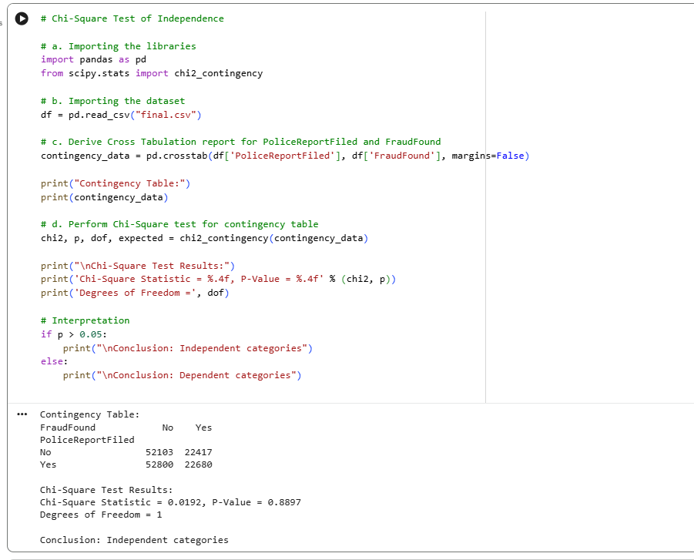

Interpretation
The Chi-Square Test of Independence was conducted to determine whether there is a statistically significant association between PoliceReportFiled and FraudFound.
The calculated Chi-Square statistic (χ² = 0.0192) is extremely small, indicating that the observed frequencies in the contingency table are very close to the expected frequencies under the assumption of independence.
The corresponding P-Value (0.8897) is substantially greater than the standard significance level (α = 0.05).
Since:
$$0.8897>0.05$$
we fail to reject the null hypothesis.
This indicates that there is no statistically significant association between PoliceReportFiled and FraudFound. The observed category differences are likely attributable to random variation rather than a true dependency.
From a fraud detection perspective, this suggests that the presence of a police report does not independently determine whether a claim is classified as fraudulent within this dataset.

Conclusion
Based on the results of the Chi-Square Test, there is no statistically significant association between PoliceReportFiled and FraudFound.
This suggests that whether or not a police report was filed does not significantly influence the likelihood of a claim being identified as fraudulent in this dataset.
Therefore, PoliceReportFiled and FraudFound can be considered statistically independent variables within the scope of this analysis

Final Analytical Summary
Overall, the hypothesis testing results indicate that the selected independent variables do not demonstrate statistically significant relationships with the dependent variables when evaluated individually. This suggests that fraud occurrence and vehicle valuation are likely influenced by the interaction of multiple factors rather than a single dominant predictor. These findings support the need for multivariate modeling techniques in the machine learning phase of the analysis.

2.8 One Sample T-test
In this test, the mean VehiclePrice of the entire dataset is treated as the population mean (μ). The objective is to compare the sample mean obtained from the random sample (n = 150) with this reference value to determine whether there is a statistically significant difference between them.
Purpose
To determine whether the average VehiclePrice of the random sample is the same as the average VehiclePrice of the overall population.
Steps
- Find the average VehiclePrice of the entire dataset (population).
- Extract a random sample of 150 VehiclePrice observations.
- Check whether the sample data is normally distributed using the Shapiro-Wilk test.
- Perform the One-Sample T-Test.

Sample Selection for One-Sample T-Test
For the purpose of inferential analysis, a random sample of 150 observations was selected from the dataset. The use of random sampling ensures that each observation has an equal probability of selection, reducing bias and improving the representativeness of the sample.
The population mean of VehiclePrice was calculated using the entire dataset, while the sample mean was calculated using the selected 150 observations. A One-Sample T-Test was then performed to determine whether there is a statistically significant difference between the sample mean and the population mean.
Since the sample size satisfies the condition n > 30, the Central Limit Theorem (CLT) applies, ensuring that the sampling distribution of the mean is approximately normal, even if the original data is not perfectly normally distributed.

Python code:
# Importing the libraries
import pandas as pd
from scipy.stats import shapiro, ttest_1samp

# Importing the dataset
df = pd.read_csv("final.csv")

# Find the average(mean) of VehiclePrice for the entire dataset (population)
population_mean = df['VehiclePrice'].mean()
print("Population Mean:", population_mean)

# Extract a random sample of 150 VehiclePrice values
sample = df['VehiclePrice'].sample(n=150, random_state=1)

# Check whether sample data is normally distributed using Shapiro-Wilk test
r, p = shapiro(sample)
print('Shapiro Test: r=%.4f, p=%.4f' % (r, p))

if p > 0.05:
print("Normal distribution")
else:
print("Not a normal distribution")

# Conduct One-Sample T-Test
t_statistic, p_value = ttest_1samp(sample, population_mean)

print("\nOne-Sample T-Test Results:")
print("T-Statistic = %.4f" % t_statistic)
print("P-Value = %.4f" % p_value)

df_ttest = len(sample) - 1
print("Degrees of Freedom =", df_ttest)

Output:
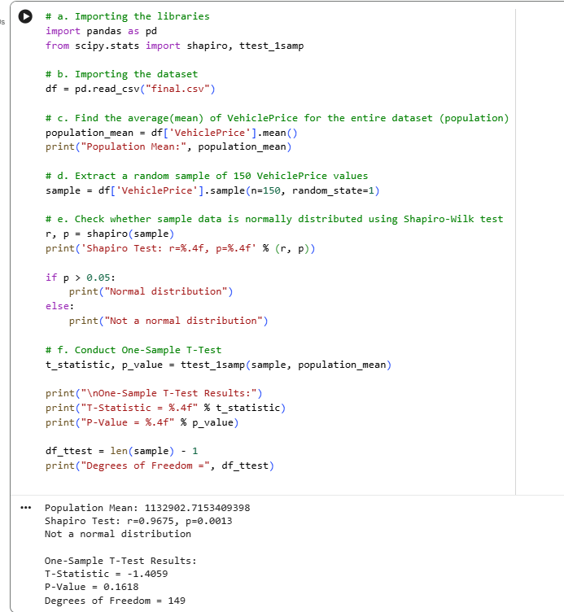

Normal Distribution
Before performing the One-Sample T-Test, the normality assumption was tested using the Shapiro–Wilk test.
Hypotheses for Shapiro Test:
- Null Hypothesis (H₀): The data is normally distributed.
- Alternative Hypothesis (H₁): The data is not normally distributed.
Results:
- Shapiro Statistic (r) = 0.9675
- P-value = 0.0013
Since the p-value (0.0013) is less than 0.05, we reject the null hypothesis.
This indicates that the sample data for VehiclePrice is not normally distributed.
However, since the sample size is large (n = 150), the Central Limit Theorem applies. According to this theorem, the sampling distribution of the mean becomes approximately normal when the sample size is sufficiently large.
Therefore, despite the violation of normality, the One-Sample T-Test remains valid.

Hypothesis for One-Sample T-Test
Null Hypothesis:
The average VehiclePrice of the random sample is the same as the average VehiclePrice of the overall population.
Alternative Hypothesis:
The average VehiclePrice of the random sample is not the same as the average VehiclePrice of the overall population.
Significance level: α = 0.05

One-Sample T-Test Results
- Population Mean = 1,132,902.72
- T-Statistic = -1.4059
- P-Value = 0.1618
- Degrees of Freedom = 149

Interpretation
The P-value (0.1618) is greater than the significance level (0.05).
Since:
$$0.1618>0.05$$
we fail to reject the null hypothesis.
This means that there is no statistically significant difference between the average VehiclePrice of the sample and the average VehiclePrice of the population.
The negative t-statistic indicates that the sample mean is slightly lower than the population mean; however, this difference is not statistically significant and may be due to random sampling variation.
Conclusion
Based on the results of the One-Sample T-Test, there is no statistically significant difference between the sample mean and the population mean of VehiclePrice. Although the normality assumption was not strictly satisfied, the large sample size (n = 150) justifies the use of the t-test under the Central Limit Theorem (CLT).
The absence of a statistically significant difference indicates that the random sample provides a reliable estimate of the overall dataset mean. This supports the representativeness of the sample and confirms the stability of the VehiclePrice distribution observed in the earlier descriptive analysis and visualization results.

