C19738789

Huda ALRubayawi

7990-0-=lkjhrec 0987653

Ip addresss

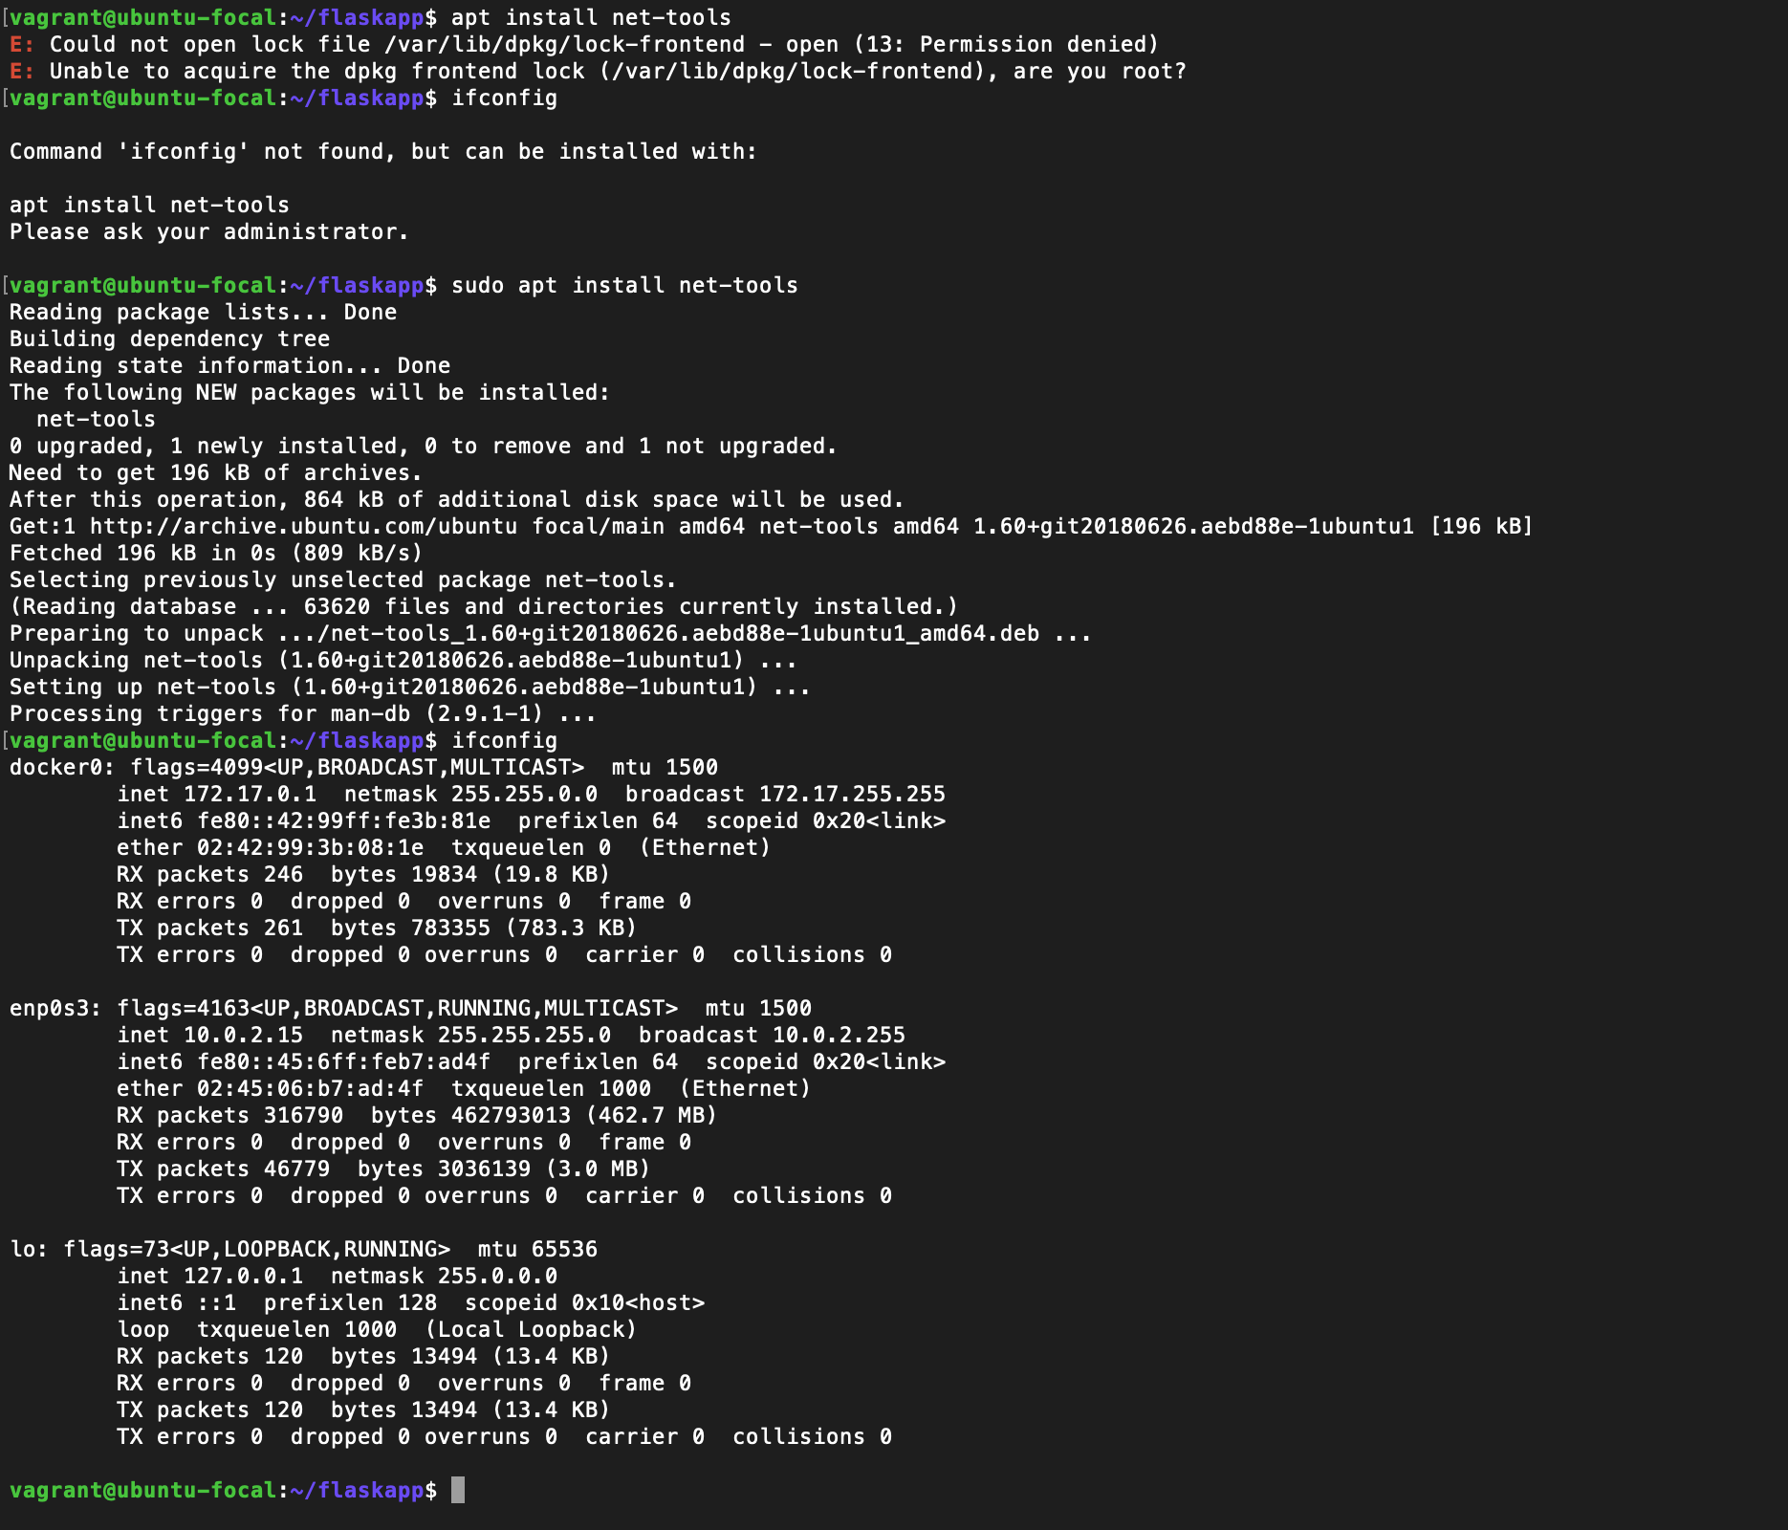

Nano file name to open file

Controle s to exit command to

