With Determination and strength, we achieve the impossible

1

**CREATING SIMPLE OPERATING SYSTEM**

Team Work:

Eng. Huda Abdallah Aljazzar

Eng. Nour Abo Anza

Under the supervision of:

Dr. Hazem Albaz

**Analysis last Steps (Creating calculation age application):**

1-In this step we need to add keyboard files

^Creating keyboard .h file

^Creating char .c file

^Creating char .h file

^Creating utils .h file

^Creating utils .c file

^Creating types .h file

2-We need to update kernel .c file to include codes to calculate age

**Sources used:**

<https://github.com/pritamzope/OS/tree/master/x86%20Calculator/kernel_c/src>

**The FINAL result:**

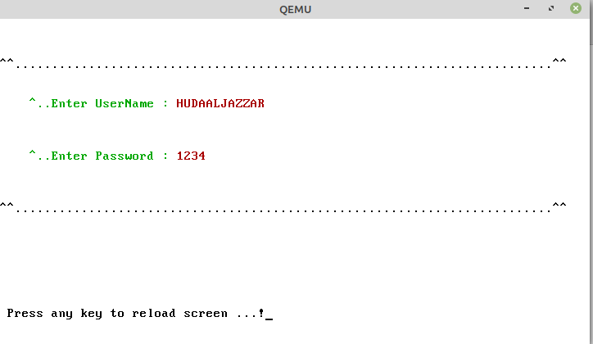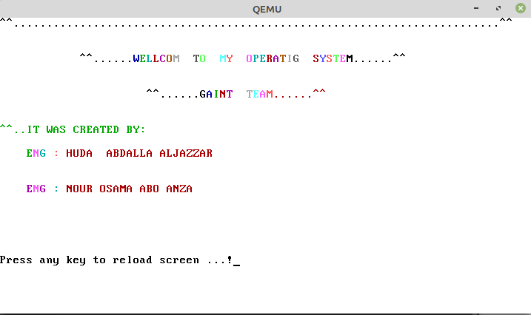

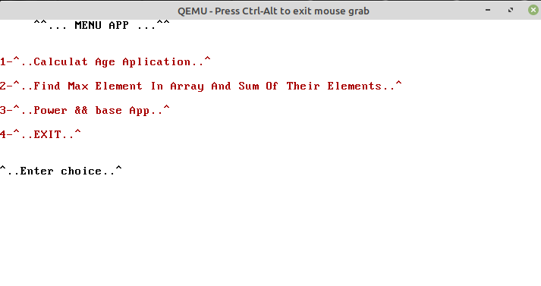

**Achievements of the team:**

1. **Building bootloader**
2. **Building kernel**
3. **Link the boot with kernel**
4. **Building User Interface include application to calculate age-array_max_sum-power**

**Challenges that faced by the team:**

**1- Lack of experience in research**

**2- Lack of proficiency in the English language**

**3- Working under pressure**

**4- Self-reliance**

**5 - Difficulty understanding the assembly language**

**6- Lack of proficiency in the C language**

**7- Many problems in the virtual environment**

**Acquired skills:**

**1- Search skill in google and websites**

**2 - The skill of understanding and analysis codes**

**3- Skill tracking code and error detection**

**4- Working under pressure and getting up after despair**

**5- The skill of maintaining the safety of our devices**

**6-progress in C language and the ability to understand assembly language**

**Used equipment's:**

**Giants Team: Huda && Nour**