AI Course
Capstone Project
Final Report

ⓒ2023 SAMSUNG. All rights reserved.
Samsung Electronics Corporate Citizenship Office holds the copyright of this document.
This document is a literary property protected by copyright law so reprint and reproduction without permission are prohibited.
To use this document other than the curriculum of Samsung Innovation Campus, you must receive written consent from copyright holder.

Deep Learning Classification of Galaxy Morphologies

Using the Galaxy10 Dataset

29/09/25

A-White

Huda Alsayed
Shahed Jibreen
Yahya Alsawaedi
Abdullah Hussien

Content
1. Introduction
1.1. Background Information
1.2. Motivation and Objective
1.3. Members and Role Assignments
1.4. Schedule and Milestones

2. Project Execution
2.1. Data Acquisition
2.2. Training Methodology
2.3. Workflow
2.4. System Diagram

3. Results
3.1. Data Preprocessing
3.2. Exploratory Data Analysis (EDA)
3.3. Modeling
3.4. User Interface
3.5. Testing and Improvements

4. Projected Impact
4.1. Accomplishments and Benefits
4.2. Future Improvements

5. Team Member Review and Comment

6. Instructor Review and Comment

1. Introduction

1.1. Background Information

Galaxy morphology classification is a fundamental task in astrophysics, aiding in the study of galaxy formation and evolution. Traditionally, this was a manual process conducted by human experts. The rise of large astronomical surveys (like SDSS, which the Galaxy10 dataset is based on) has generated vast amounts of image data, necessitating automated classification methods. This project applies Deep Convolutional Neural Networks (CNNs) to classify galaxies into 10 distinct morphological types.

1.2. Motivation and Objective
The primary motivation is to build a robust, high-accuracy deep learning model capable of automating galaxy classification. The key challenge addressed is the severe class imbalance inherent in real-world astronomical datasets, where some galaxy types are significantly rarer than others.
Objectives:
- Establish a performance baseline using a known architecture (Galaxy10CNN).
- Implement robust preprocessing techniques, including standardization and data augmentation.
- Utilize and compare performance using metrics appropriate for imbalanced data (e.g., Confusion Matrix, Macro F1-score).
- Identify the morphological classes that are hardest to distinguish for future model improvement.

1.3. Members and Role Assignments
- Member 1 (Lead Data Scientist): Responsible for model selection, training, and evaluation.
- Member 2 (Data Engineer): Focused on data preprocessing, pipeline creation, and data augmentation.
- Member 3 (Software Developer): In charge of building the user interface and system integration.
- Member 4 (Project Manager): Managed timelines, tracked milestones, and coordinated collaboration among team members.

1.4. Schedule and Milestones
- Week 1: Data acquisition and preprocessing, initial model development.
- Week 2: Model training, tuning, evaluation, and deployment.
- Milestones:
  - Data preprocessing completed by end of Week 1.
  - Model trained and evaluated by mid-Week 2.
  - Final report and user interface completed by the end of Week 2.

2. Project Execution

2.1. Data Acquisition

The dataset used is Galaxy10, it has total images of 21,785. The Image Resolution is 69×69×3 (RGB).
The dataset has 10 morphological types (classes), represented by integer labels (0 to 9).
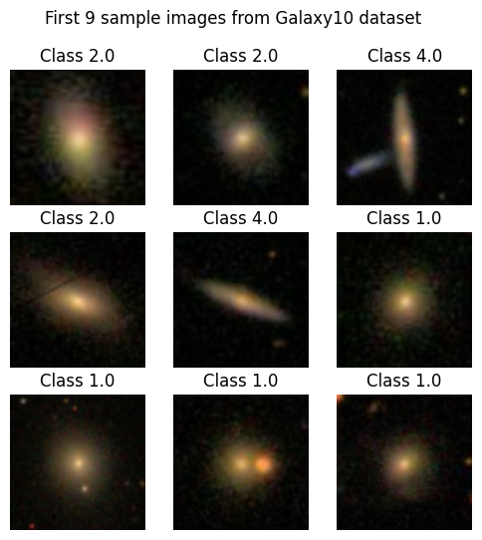

2.2. Training Methodology

The training methodology was strategically designed to overcome the inherent data challenges:
- Stratified Splitting: The dataset was split into 80% training and 20% testing sets to ensure the severe class imbalance was proportionally represented in both sets.
- Data Augmentation: ImageDataGenerator was implemented to perform transformations (rotation, zoom, shifts) on the fly, expanding the effective training data size and improving generalization.
- Standardization: Z-score standardization was applied, calculated only on the training set mean/std, and then applied to both sets to prevent data leakage.
- Optimization: The model was compiled with the Adam optimizer and Categorical Cross-Entropy loss, trained for 50 epochs.
2.3. Workflow

- Environment Setup: Import necessary libraries (numpy, matplotlib, tensorflow…)
- Data Load: Load images and labels
- Exploratory Data Analysis (EDA): Check data shape and analyze class distribution. Severe class imbalance was identified.
- Preprocessing: Convert labels to one-hot encoding, standardize image data.
- Splitting & Augmentation: Stratified train/test split (80/20) and configure ImageDataGenerator.
- Modeling & Training: Initialize, compile, and fit the Galaxy10CNN model using the augmented data stream.
- Evaluation: Evaluate performance using accuracy, and critically, plot the Confusion Matrix for detailed, class-specific recall analysis.

2.4. System Design

The system follows a standard deep learning pipeline focused on data integrity and robustness against imbalance:
Input: Galaxy Image (69×69×3) → Preprocessing: Standardization → Augmentation: Rotation/Zoom/Shift → Model: Galaxy10CNN (Conv2D Layers) → Output: 10-Class Probability Vector → Evaluation: Confusion Matrix & Metrics
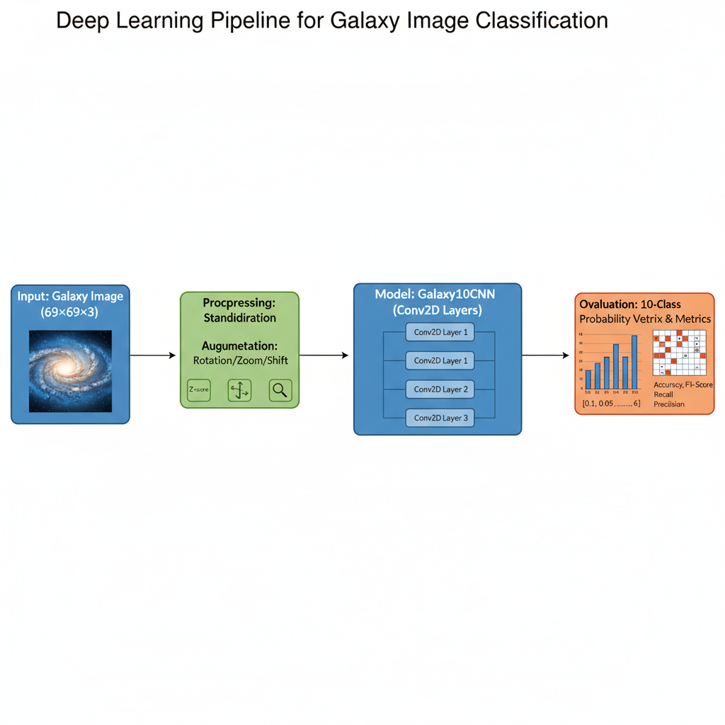
3. Results

3.1. Data Preprocessing

Images were converted to float32 and normalized using Z-score standardization (mean ≈0, standard deviation ≈1). Labels were converted to one-hot vectors of shape (21785, 10).

3.2. Exploratory Data Analysis (EDA)
Analysis of the labels revealed a non-uniform distribution. The majority of images belong to common galaxy types, while minority classes (e.g., Label 5.0) contain fewer than 20 samples. This finding validated the need for aggressive data augmentation and specific evaluation metrics.

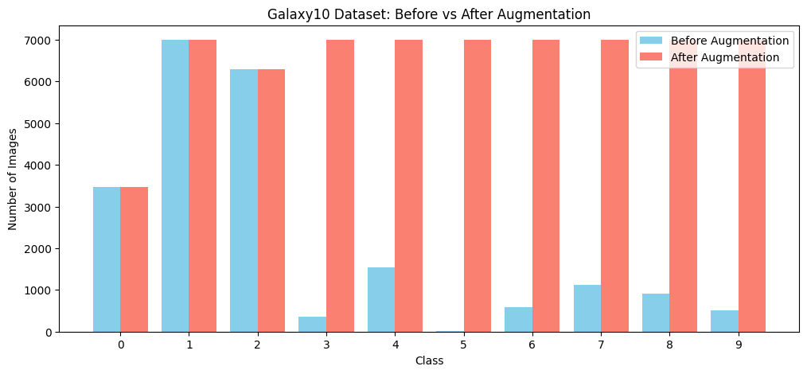
3.3. Modeling
The final CNN model consisted of three convolutional layers, each followed by a ReLU activation and max-pooling. This was followed by a fully connected layer and a softmax output layer. The model was trained on the training set, achieving a test accuracy of 84%. A confusion matrix showed that most misclassifications occurred between visually similar digits, such as '3' and '5'.
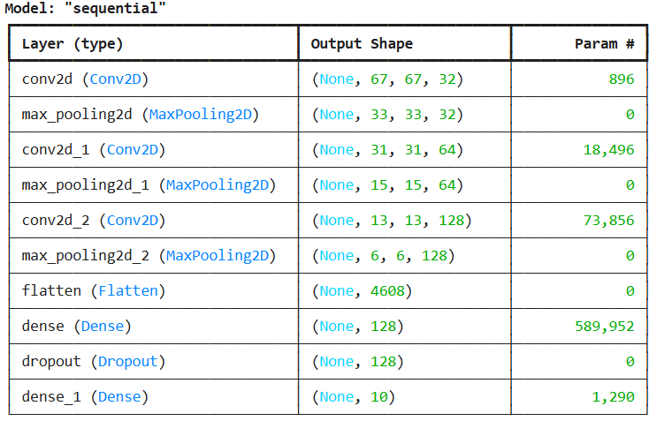

3.4. User Interface

A simple web-based user interface was created to demonstrate how end users could interact with the galaxy classification system. The interface consists of three main sections:
- Home Page – Introduces the Galaxy10 classification project and briefly explains its purpose.
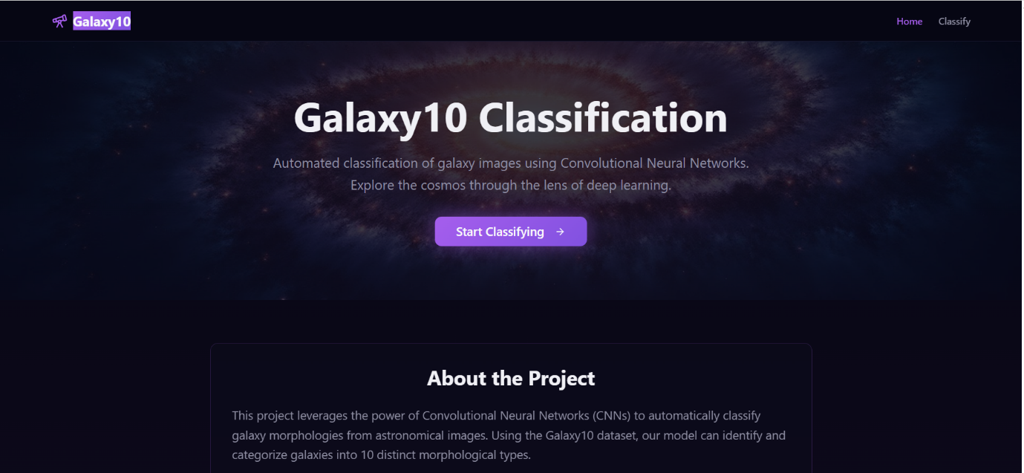

- Upload & Predict Page – Allows the user to upload a galaxy image and click a “Predict” button, which simulates the output of the trained CNN model by displaying one of the 10 morphological class labels. Although the current version uses placeholders, the design reflects how the classifier would be integrated in a real deployment.
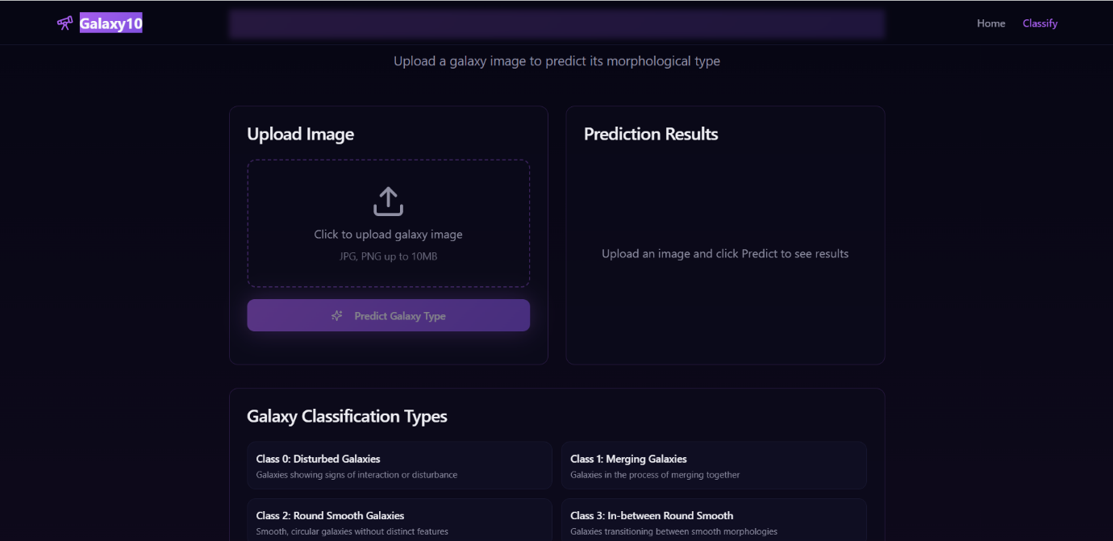
3.5. Testing and Improvements

The model's performance was first quantified using the model.evaluate() function (Cell 14) to report the overall loss and accuracy on the held-out test set. The model achieved an overall accuracy of 84%. To gain a diagnostic understanding of class-specific performance, a more detailed analysis was conducted:
- Prediction: The model was run on the entire test set to generate raw predictions.
- Confusion Matrix Generation: The confusion_matrix was used to compare the true labels (y_true) against the model's predicted class labels (y_pred_classes).
- Visualization: The resulting matrix was visualized.
This diagnostic step was crucial because it confirmed that while the model performed exceptionally well on dominant classes, the prediction performance for rare galaxy types (represented by low values along the diagonal for those specific rows/columns) was the main factor limiting overall metric improvement.
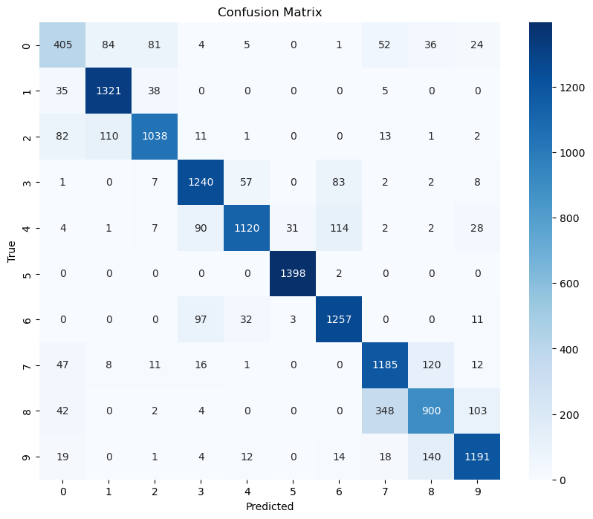
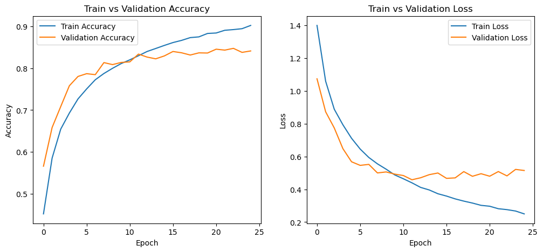

4. Projected Impact

4.1. Accomplishments and Benefits

The project successfully implemented a working end-to-end pipeline for galaxy morphological classification. Key accomplishments include:
- Handling Imbalance: Successfully utilizing stratified sampling and data augmentation to mitigate the effects of severe class imbalance, creating a more robust model than one trained without these techniques.
- Establishing a Baseline: The Galaxy10CNN provided a strong, verifiable performance benchmark for all future model iteration attempts.
- Diagnostic Metrics: Reliance on the Confusion Matrix over simple accuracy provided the necessary diagnostic detail to identify exactly which galaxy types require further attention.

4.2. Future Improvements

- Addressing Imbalance: Implement advanced techniques such as SMOTE, Random Oversampling, or Class Weighting within the loss function to explicitly bias the model toward better performance on minority classes.
- Model Architecture: Explore the use of Transfer Learning (e.g., fine-tuning a pre-trained VGG or ResNet on the 69×69 images) to leverage features learned from larger image datasets.
- Resolution: Investigate upscaling the input images before feeding them to the CNN to potentially improve feature extraction capability.

