
MSc in Computing - Team Project
Final Report
Group 2 – SafePath
More than Navigation, Smarter, Safer journeys
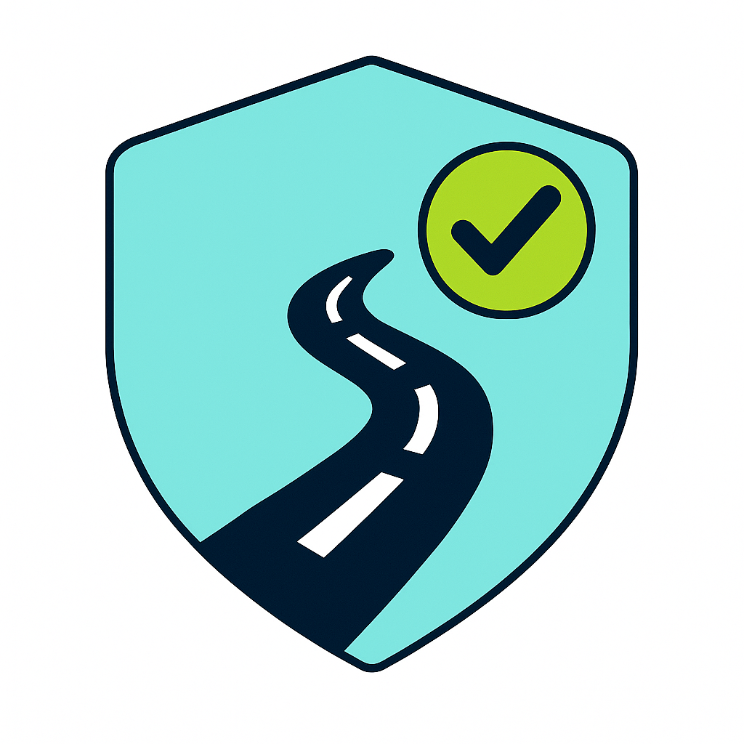
Team Members
D24126048 – Shalini Kuruguntla
D24126339 – Huda Ibrahim
D24127853 – Hina Kausar
D24125575 – Sai Priyanka Basa Shanker
D24125555 – Karan Joseph

17/12/2025

Table of Contents
User Scenario: The Characters (500 words approx.) 3
Who is your target user? 3
What problem are you solving for them? 3
Technical Problem: The Setting (1,000 words approx.) 3
Why does your system exist? 3
Can you review other existing systems or products that address this problem? (how do they meet or fail to meet the needs of your target users) 3
Technical Solution: The Plot (2,500 words approx.) 3
What does your system do? Shalini 3
Front-end: Technologies, User interface components including interface mock-ups Shalini 5
Back-end: Technical components Shalini 5
Data: What data resources are you using and how do you access, collect, and store them? What bottlenecks do you face related to data, what choices have you made to address them? Shalini 6
What are the key technical contributions of your solution? Shalini 7
User Evaluation: The Results (2,000 words approx.) 8
What components of your system are you evaluating and why? 8
What have you learned from the evaluation? 8
Conclusion: Review of the Project (1,000 words approx.) 8
What was your project management strategy? 8
What is the key contribution of your project and what future extensions do you envision for improving your system? 8
What lessons have you learned by developing this system? (what problems are hard/easy, has your perspective changed since the start?) 8
References and Key Resources 8

User Scenario: The Characters (500 words approx.)

Who is your target user?
Start writing paragraphs here

Why are they important?
Start writing paragraphs here

What problem are you solving for them?
Start writing paragraphs here

Technical Problem: The Setting (1,000 words approx.)

Why does your system exist?
Start writing paragraphs here
What is the core technical problem? (provide an example, an image or a diagram that describes the technical components)
Start writing paragraphs here

Can you review other existing systems or products that address this problem? (how do they meet or fail to meet the needs of your target users)
Start writing paragraphs here

Technical Solution: The Plot (2,500 words approx.) Shalini

What does your system do? Shalini
SafePath is a navigation platform created specifically for people who walk or cycle in urban environments. Rather than focusing solely on the quickest journey from point A to B, SafePath prioritises safety. It takes into account local crime patterns, reported hazards, lighting conditions, collision history and crowd-uploaded alerts, then generates safer alternative routes for the user to choose from. The intention is simple. A journey may take two extra minutes, but if that alternative stays on well-lit streets, avoids areas with frequent incidents and has fewer hazard alerts, it becomes far more reassuring for someone travelling alone or late at night. When a user opens the app, they are met with a clean map interface where they can select their start and end location. SafePath responds by displaying several routing options on the map. One will be the fastest route, another will be the safest. Each route appears in a different colour, normally with the safest one in green and the fastest in grey, making visual comparison clear and intuitive. Instead of presenting safety as a mysterious number, the route card explains why it is safer. For example, it might say that it avoids recent incidents or that the street lighting quality along the path is higher. This approach encourages trust, as users can see the reasoning behind each suggestion rather than relying blindly on the system.

SafePath also enables users to submit live hazard reports directly on the map. Someone who encounters a pothole, broken street light or threatening area can open the hazard form and describe what they see. An optional photo can be attached, and the report becomes visible to other users instantly. This material is integrated with official crime statistics so the map continues to grow more accurate through community participation. A further feature known as Find Buddy allows travellers heading in the same direction to request walking or cycling together. This was introduced after research participants expressed that they would often feel safer with another person present. SafePath combines routing, live hazard awareness and social reassurance into one cohesive tool.

How does it work? (System diagram) Shalini
Although the user experience appears simple, the system processes a significant amount of data each time a route is requested. The architecture consists of a Next.js client application deployed on Vercel, a Node.js and Express backend hosted on Render.com and a PostgreSQL database enhanced with PostGIS for spatial analysis. The front-end communicates with the backend using HTTPS for regular requests, while WebSockets through Socket.IO manage real-time updates such as hazard alerts. When a user asks for directions, the front-end sends the selected coordinates and travel mode to the backend. The server requests a preliminary route from the OSRM routing engine, which provides baseline geometry optimised for time efficiency. SafePath then evaluates each route step by step. Every one hundred metres approximately, a coordinate sample is generated, and the system checks the corresponding geographical cell inside our spatial grid. Each grid cell holds pre-processed information including crime density, lighting quality, road characteristics, verified hazards and historical collision statistics. These values combine into a weighted Safety Score. The weighting can differ depending on whether users are cycling or walking and whether they prefer higher caution or faster movement. After calculating the overall safety value for all route options, SafePath ranks them and returns them to the interface. The safest and the fastest route become visible as coloured polylines. A user can tap one to view estimated travel time, distance and explanation for why the score is high or low. The interface updates without reloading thanks to client-side React state management. Hazard reporting flows in the opposite direction. A report sent from the app sends the image to Cloudinary and the data to the backend. Once validated, the record is stored in the database. Immediately after storing, a real-time event is triggered through Socket.IO which displays the new hazard to users nearby. This creates an environment where information spreads rapidly rather than relying on periodic refreshes. The entire hazard cycle is captured in the system diagram which outlines how user submissions propagate through the backend and return as new alerts. In early design plans, SafePath was structured as a microservices system with Redis caching and separate routing modules. Later, after feedback during interim stages, the architecture was simplified into a modular backend that maintained internal separation but ran within a single deployable service. This proved easier to maintain, debug and scale within the time frame of the MSc project while preserving the future possibility to expand into microservices later if required.

Front-end: Technologies, User interface components including interface mock-ups Shalini
The front-end was developed using Next.js version fifteen combined with React nineteen and Tailwind CSS for styling. Maps and route visualisation are handled using React Leaflet, giving us a responsive map component capable of drawing routes, hazard markers and user overlays. Because Next.js performs server-side rendering, page loads remain fast and mobile usage feels smooth even on slower connections. The interface follows a map-first design. On both desktop and mobile screens, the map takes centre focus rather than text or menus. The user enters origin and destination using a search input or by allowing the app to detect their location. After submitting these points, a suggestions screen appears where the user can scroll between route cards. Selecting a card highlights the route directly on the map. The interface explains safety factors in simple language so users feel informed about why the safer option may be better. This design decision arose directly from user testing where participants mentioned they wanted clarity, not just numbers. Reporting a hazard uses a compact form designed to be completed in seconds. Users choose a hazard type, severity and optionally attach an image. The purpose is to encourage quick reporting rather than discouraging it with large forms. Once submitted, the acknowledgement is instant and the icon appears on the map, creating a feeling that user contributions matter. Colour choices, layout spacing and control placement were tested during the evaluation phase. Earlier interface iterations used lighter tones which failed to stand out against detailed map backgrounds. After adjustments, we adopted a darker navy and green palette where icons and route colours became sharper and more legible outdoors. Mobile ergonomics were also refined. Buttons were enlarged and placed within thumb-reachable areas to improve accessibility for one-handed use. The interface design now feels confident, visually clean and intuitive for first-time users. The Find Buddy portion uses a similar interaction model. It highlights nearby journeys with overlapping paths and allows users to opt in to sharing. Privacy controls let users disconnect at any moment. The design approach prioritises consent, comfort and user autonomy, since safety becomes meaningful only when individuals feel in control.

Back-end: Technical components Shalini
The backend of SafePath forms the core engine that connects all moving parts of the system. It acts as the bridge between raw spatial data, routing logic, user requests and the live hazard stream. The entire backend is built using Node.js twenty. Express is used to structure RESTful endpoints in a clean and modular manner, while Socket.IO supports real time communication. Everything runs on Render.com which manages HTTPS, deployment pipelines and scaling, allowing us to focus on logic rather than server maintenance. All sensitive configuration such as JWT secrets, Cloudinary keys and database URLs are stored as environment variables rather than being hard coded which keeps the system secure and portable. Routing logic represents one of the most intensive parts of the server. When a route is requested, the backend communicates with OSRM to generate candidate paths. At this point, the response only knows the shortest time path. SafePath then enhances this by sampling each route segment, passing coordinates to PostGIS and retrieving information about the surrounding environment including crime scores, hazards, lighting conditions and collision patterns. For every segment the system produces a numerical safety score, and then aggregates that score to classify the entire route. This process must happen quickly to feel interactive. Spatial indexing in PostGIS and route caching mechanisms prevent bottlenecks. We also integrated over one hundred thousand grid records pre computed from crime and environmental data to avoid heavy calculations during live route requests. The server returns all scoring information back to the front end which then visualises the safest and fastest choices side by side. The hazard engine is a second crucial backend module. When a hazard is submitted, image uploads are first sent to Cloudinary where the file is compressed and stored. The backend receives metadata like coordinates, category, severity and the link to the Cloudinary image. Before inserting a hazard into Postgres, the input is validated to avoid malicious content. JWT authentication confirms that the user is legitimate. After storing the hazard, the backend broadcasts a hazard event through Socket.IO. Any user currently active in that region receives the update instantly instead of waiting for map refresh. This makes the app feel alive and reactive. We also record upvotes, downvotes and verification ratings for hazards. Over time verified hazards gain higher weight in safety scores while false reports decay and disappear. Authentication and account security depend on bcrypt for hashing passwords and JWT tokens for verifying future requests without session storage. This stateless approach reduces server complexity and allows the API to scale horizontally. If usage increases, multiple backend instances can be created while keeping authentication consistent since token verification does not rely on an in memory session store. The database structure was designed carefully to support spatial analysis. PostGIS stores geometries for hazards and grid cells and performs geospatial queries like identifying hazards within a bounding box or finding the closest grid cell to a coordinate. Data models cover users, user preferences, hazards, hazard votes, crime grid, routes, and ETL snapshots. The decision to use a modular monolith instead of a fully fragmented microservice structure proved beneficial. It reduced maintenance overhead, simplified integration testing and allowed rapid development. However, the architecture has been intentionally separated logically so that routing, hazards and authentication can later be extracted into microservices if the system expands to global city coverage. In summary the backend acts as the heart of SafePath. It receives requests, processes safety scoring, manages real time communication and maintains all spatial datasets. It transforms raw data into meaningful route recommendations and does so in a way that remains secure, scalable and straightforward to deploy.

Data: What data resources are you using and how do you access, collect, and store them? What bottlenecks do you face related to data, what choices have you made to address them? Shalini
SafePath integrates official crime data, public transport and road network maps, lighting and collision statistics and user-submitted hazard information. Crime data was downloaded from the UK Police API in bulk CSV format, cleaned using Python and GeoPandas, and processed into a form suited for routing. Duplicate entries were removed, coordinates were converted into standard geographic projection and crime categories were reduced into broader groups for more efficient modelling. Each record was weighted by severity and decayed over time so that recent events affected route calculation more strongly than older ones.

Mapping data originates from OpenStreetMap and Overpass, which provide street geometry and sometimes lighting details. Collision information from STATS19 was integrated where available. Lighting data remains incomplete in some locations, which is one of the current limitations. Crowdsourced hazard reports fill this gap by providing an updated picture of road conditions. Reports include a type, severity rating, optional image, timestamp and verification score. Community votes can increase or decrease the influence of a report in safety calculations. The volume of initial data presented a challenge. Millions of individual crime points are too heavy to process during live routing queries. The solution was to aggregate them into grid cells and pre-compute risk values. Routing then queries the grid rather than raw points which is significantly faster. PostGIS indexes further improve speed. An automated ETL pipeline is used to refresh crime data monthly, ensuring the safety model does not grow stale over time. Bottlenecks still exist, especially concerning lighting accuracy and the requirement for continuous storage optimisation. Despite this, the data system functions efficiently for real-time routing and hazard updates.

What are the key technical contributions of your solution? Shalini
SafePath delivers several meaningful contributions from a technical standpoint. First, it demonstrates how safety can be quantified and integrated directly into routing instead of being visualised merely as points on a map. Most navigation systems treat safety as an afterthought. SafePath proves that risk indicators can be processed, harmonised and transformed into a Safety Score that influences route generation itself. This alone is a shift in the way routing algorithms can work. A significant technical contribution lies in unifying heterogeneous datasets into one scoring framework. Crime incidents, OpenStreetMap roads, collision statistics and real time user hazards originate in entirely different formats. Some come as CSV files, others as API responses or geometric network edges. SafePath transforms them into a common grid model that boosts routing performance. The grid based approach dramatically reduces computational cost compared to evaluating individual incidents. It balances accuracy with real time responsiveness which is essential for real world use. Real time hazard broadcasting is another impactful contribution. Instead of expecting users to refresh the interface repeatedly, SafePath pushes hazard updates instantly through Socket.IO. This means that as soon as one person reports a broken street light, a cyclist approaching that segment could be warned before arriving. This infrastructure also enables future possibilities like live crowd movement, emergency alerts or time based safety adjustments. Transparency and user trust form another core innovation. Often applications compute internal scores silently without allowing users to question the reasoning. SafePath takes the opposite approach by showing safety breakdowns and explaining the decision making behind route generation. During evaluation users expressed higher trust when understanding why a route was suggested. This demonstrates how data explainability can change behaviour in safety focused design. The platform is also built with forward scalability in mind. Although currently operating for London, the entire system can adapt to a different city by rerunning the ETL process and recreating grid layers. New safety attributes such as air quality risk, flood zones or school areas could be added without rewriting fundamental architecture. A future version might incorporate machine learning to generate predictive scores for routes where live data is unavailable. The existing rule based engine provides a foundation for training such models. SafePath therefore stands not only as a working product but as a framework for city aware routing. It shows how open datasets can be converted into safety knowledge and how user interaction can strengthen that knowledge over time. It moves routing beyond the fastest path paradigm into a space where navigation feels protective, contextual and human centered.

User Evaluation: The Results (2,000 words approx.)

What components of your system are you evaluating and why?
Start writing paragraphs here

How are you evaluating them (data collected, users involved, evaluation metrics)?
Start writing paragraphs here

What have you learned from the evaluation?
Start writing paragraphs here

Conclusion: Review of the Project (1,000 words approx.)

What was your project management strategy?
Start writing paragraphs here

What were the biggest challenges you faced as a team during the project and how did you address them?
Start writing paragraphs here

What is the key contribution of your project and what future extensions do you envision for improving your system?
Start writing paragraphs here

What lessons have you learned by developing this system? (what problems are hard/easy, has your perspective changed since the start?)
Start writing paragraphs here

References and Key Resources
[1]

