CS-506
Big Data Analytics
Mini Project : Employee Data Analysis
Class: BS(CS)6th Semester
Section: M3
Submitted to: Ms. Nimra Razzaq
Group Members:
Huda Tariq (2023-ag-9551)
Syeda Khushbakht Arshed (2023-ag-9683)
Zainab Abdullah (2023-ag-9696)

EXPLANATION
Employee Data Analysis Project

Objective:
The objective of this project is to analyze an employee performance dataset using PySpark. The project focuses on calculating average salary per department, filtering high salary employees, and sorting employees by experience.

Dataset:
The dataset used is an Employee Performance dataset. It contains employee details such as ID, name, age, gender, department, salary, joining date, performance score, experience, status, location, and session.

Tools Used:
Python
PySpark
Jupyter Notebook

Steps Performed:

- Import Libraries

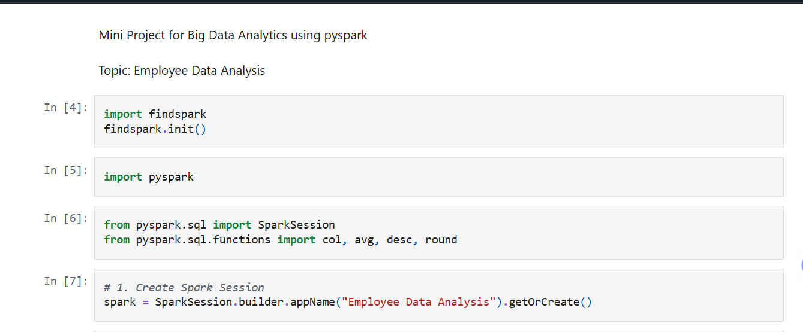

- Loaded the employee dataset using PySpark and showing schema.
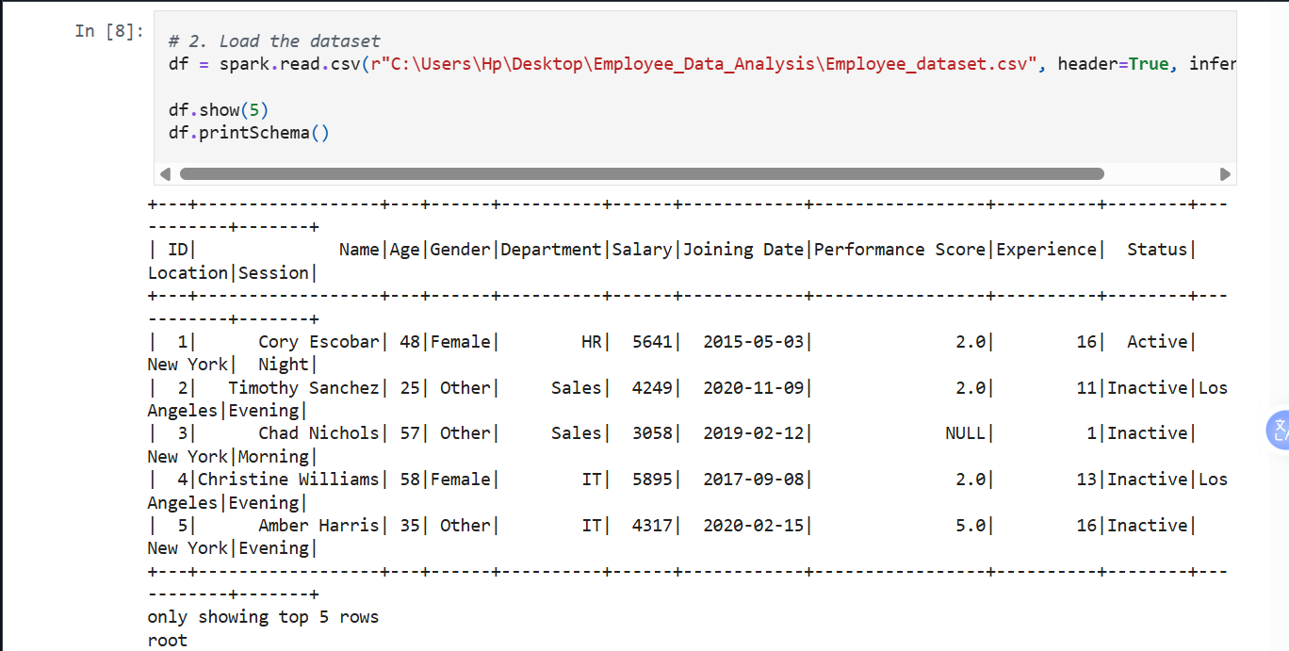

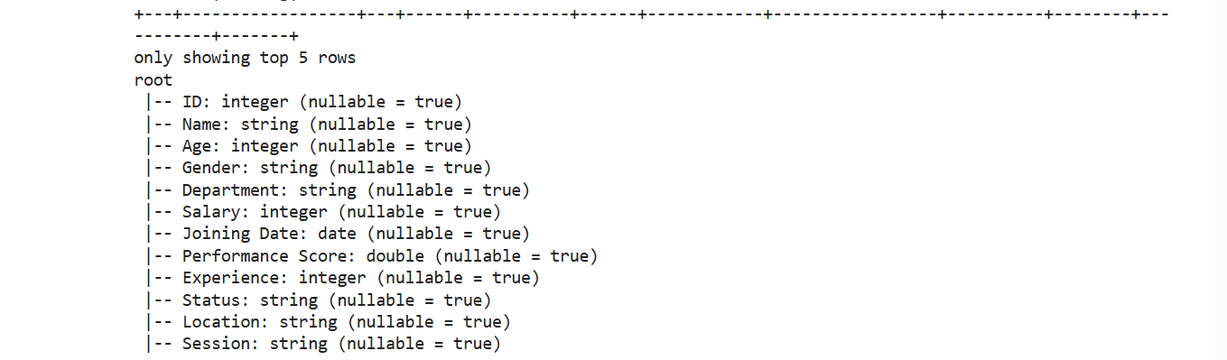

- Cleaned the dataset by removing missing values from important columns. Converted Salary and Experience columns into numeric format.
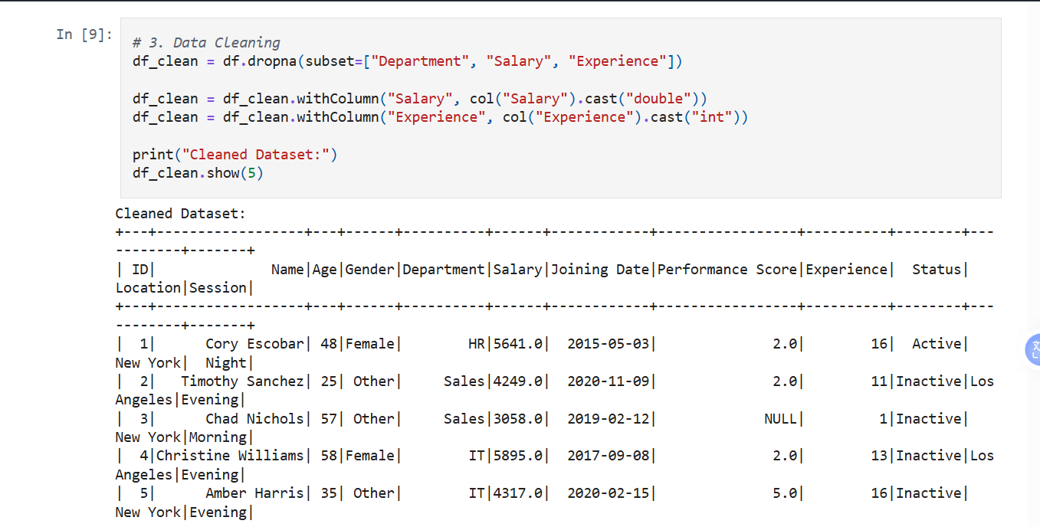

Table 1: Average Salary per Department
This table shows the average salary of employees in each department. The HR department has the highest average salary with 5982.40, followed by IT with 5968.37, and Sales with 5804.09. This helps compare salary distribution among different departments.
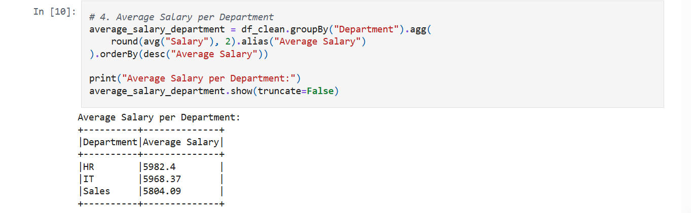

Table 2: High Salary Employees
Threshold used: Salary greater than 8000.This table shows employees whose salary is greater than 8000. In this project, these employees are considered high salary employees. The highest salary in the dataset is 9993, earned by Jesse Miller from the HR department. This analysis helps identify employees with higher salary packages.

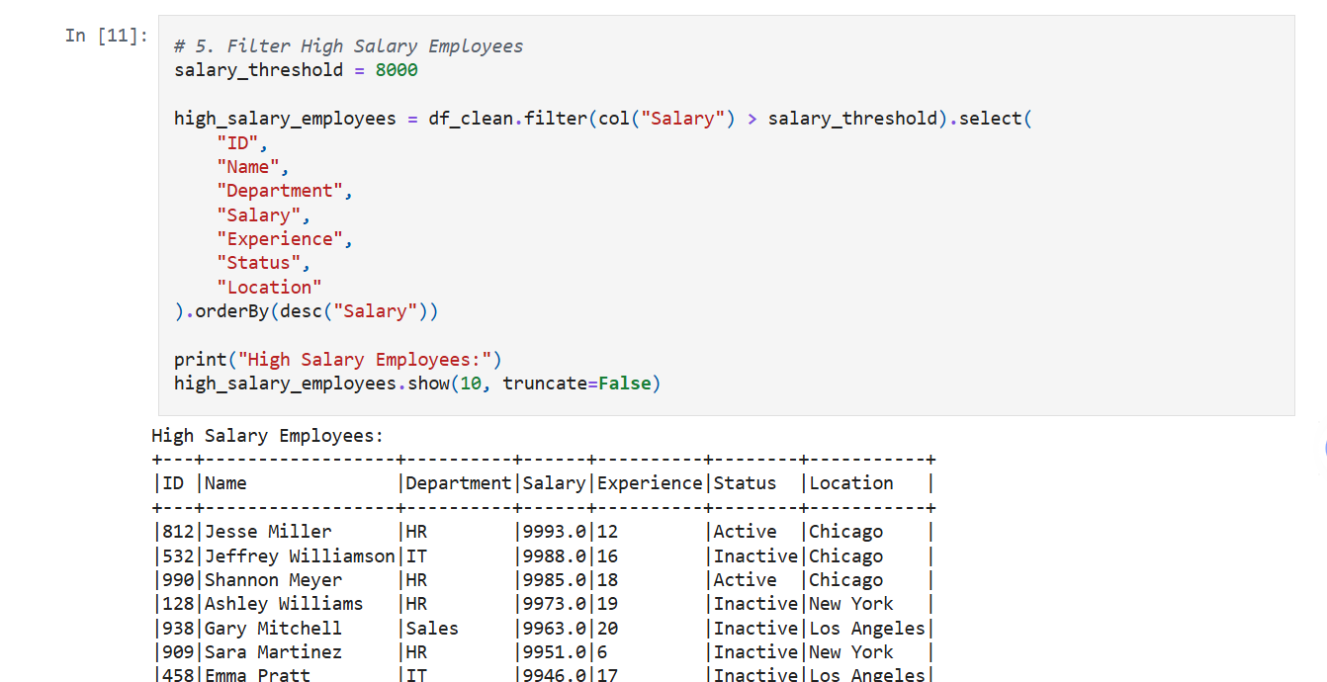

Table 3: Employees Sorted by Experience
This table shows employees sorted by experience in descending order. Employees with the highest experience appear at the top. In this dataset, the maximum experience is 20 years. This analysis helps identify the most experienced employees in the organization.

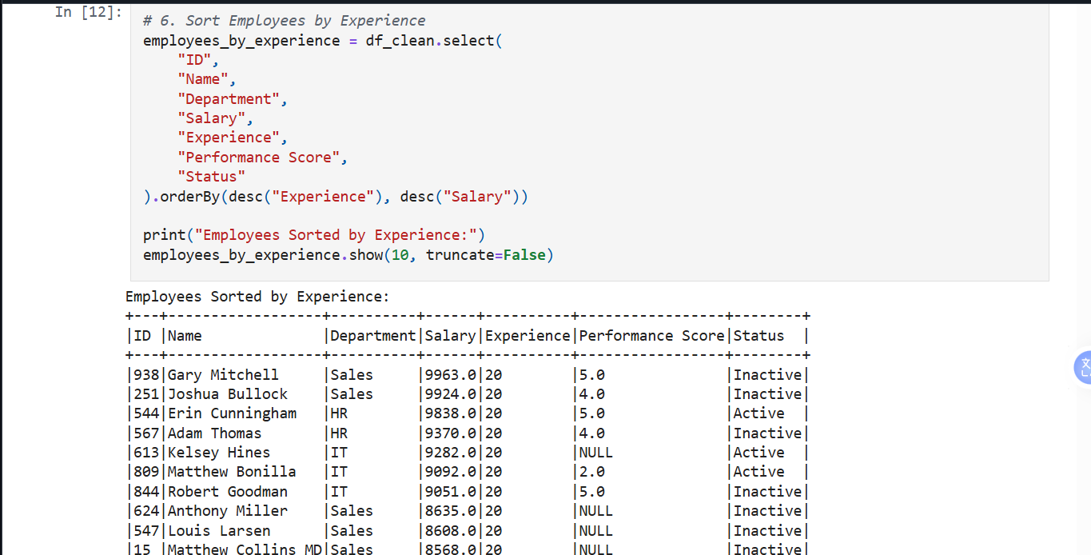

Visualization:

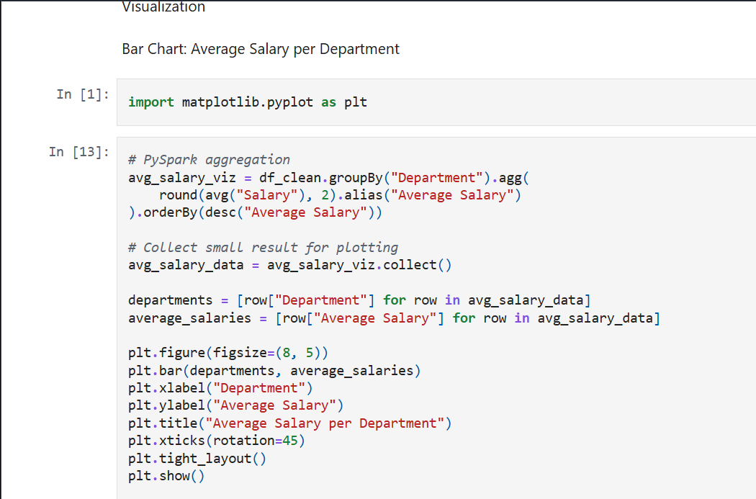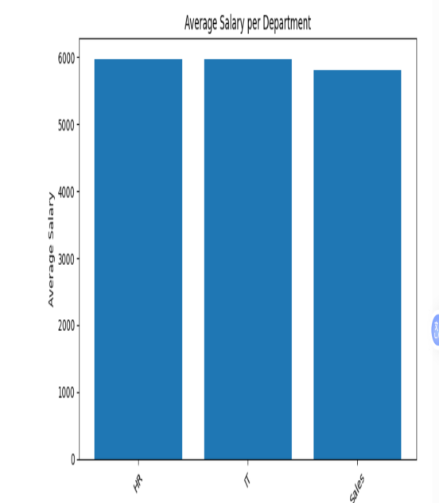

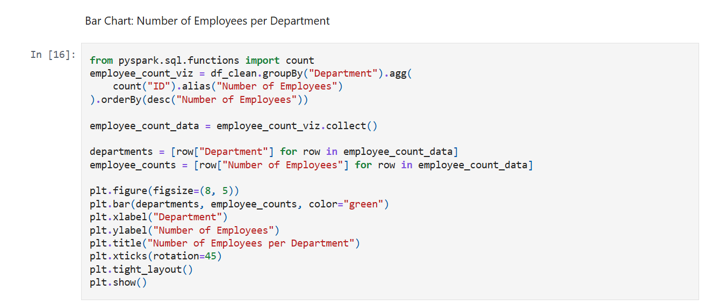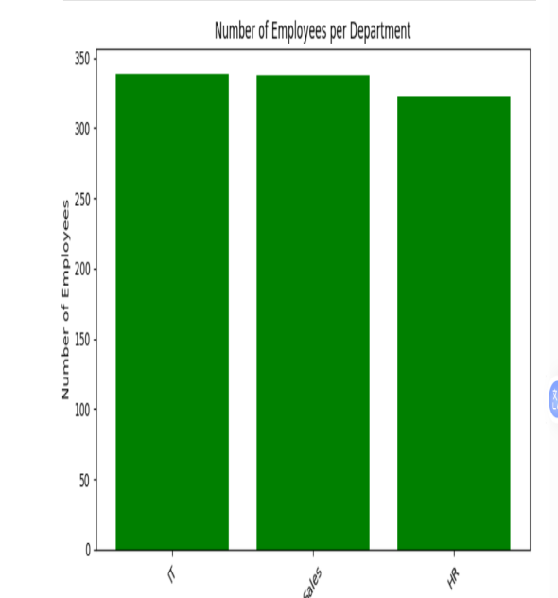

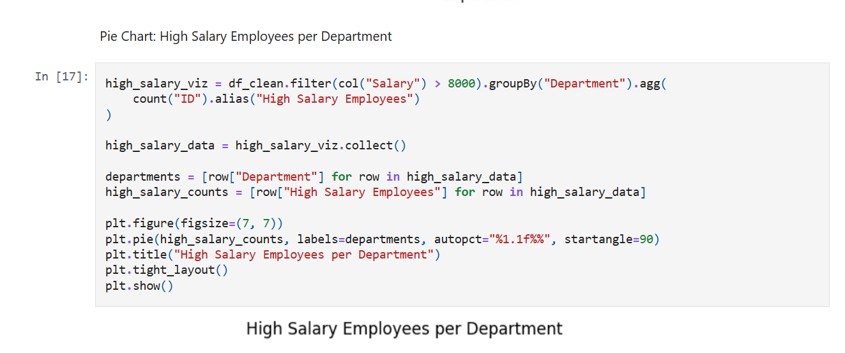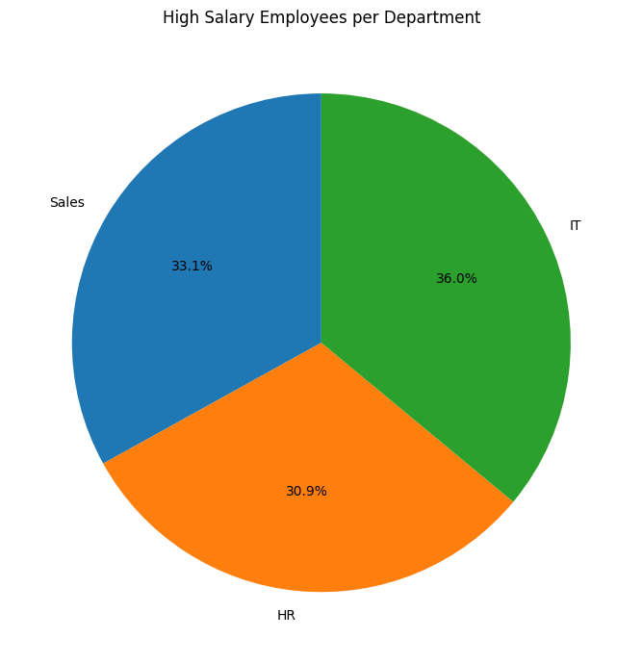

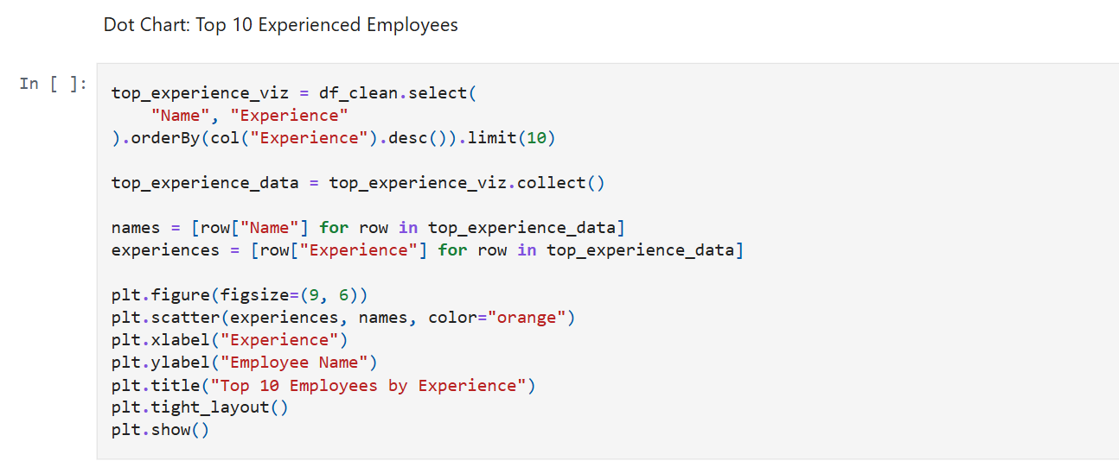

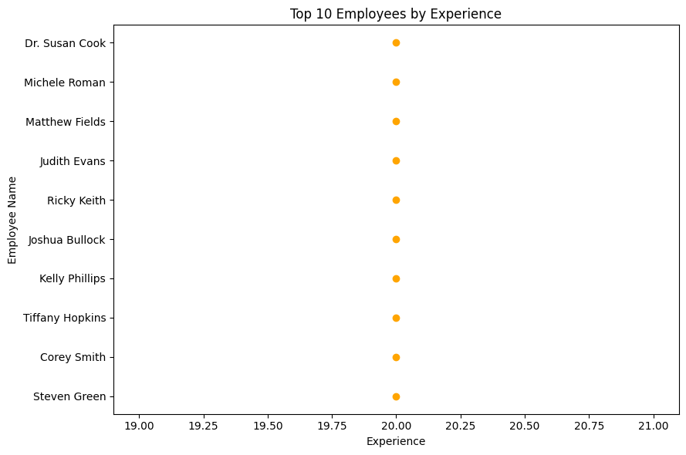

Conclusion:
This project demonstrates how PySpark can be used for basic employee data analysis. It helps in understanding salary distribution across departments, identifying high salary employees, and ranking employees according to experience.

