**Algorithm Lab. Class Assignment-1**

Name-Ritam Hudait

Roll-1905797

1.WAP in C to input n integers in to an array. Let us assume that there can be duplicates elements. Write a program to search an element in the array in such a way that we get the highest frequency if there are duplicate elements.

Code::

#include<stdio.h>

void main() {

int n;

printf("enter size of array:");

scanf("%d",&n);

int arr[n];

printf("enter element in array : ");

for (int i=0;i<n;i++){

scanf("%d",&arr[i]);

}

printf("\n");

int mx=0,mx_num=-1;

for(int i=0;i<n-1;i++){

int c=0;

for(int j=0;j<n;j++){

if(arr[i]==arr[j]){

c++;

}

if(c>mx){

mx=c;

mx_num=arr[i];

}

}

}

printf("the num is %d with highest freq %d",mx_num,mx);

}

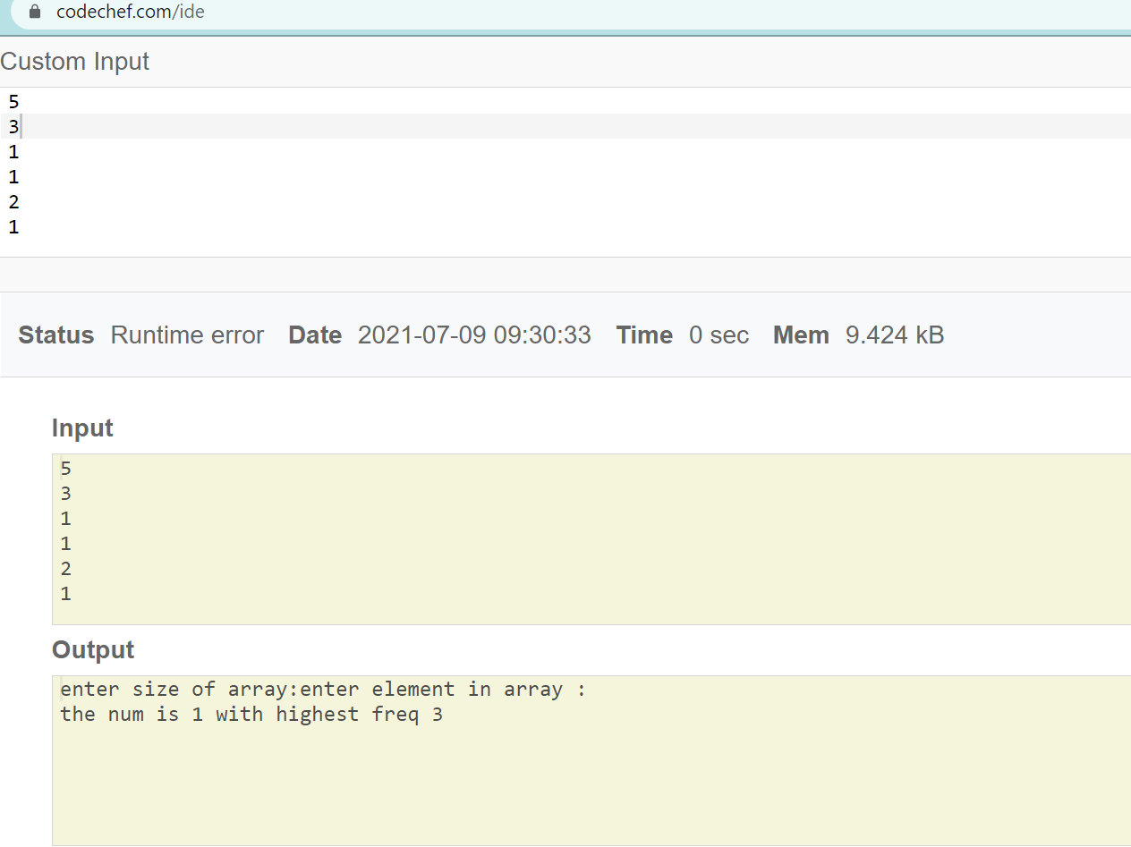

2.WAP for finding i and j in an array A for any key such that A[j]2 + A[i]2 == key

#include <stdio.h>

void main(){

int n,i,j,key;

printf("enter size of array : ");

scanf("%d",&n);

int arr[n];

printf("enter element in array : ");

for (int i=0;i<n;i++){

scanf("%d",&arr[i]);

}

printf("enter key :");

scanf("%d",&key);

printf("\n");

int f=0;

for(i=0;i<n-1;i++){

for(j=i+1;j<n;j++){

if(((arr[i]*arr[i])+(arr[j]*arr[j]))==key)

{

f=1;

break;

}

}

if(f==1)

break;

}

printf("i: %d j : %d",i,j);

}

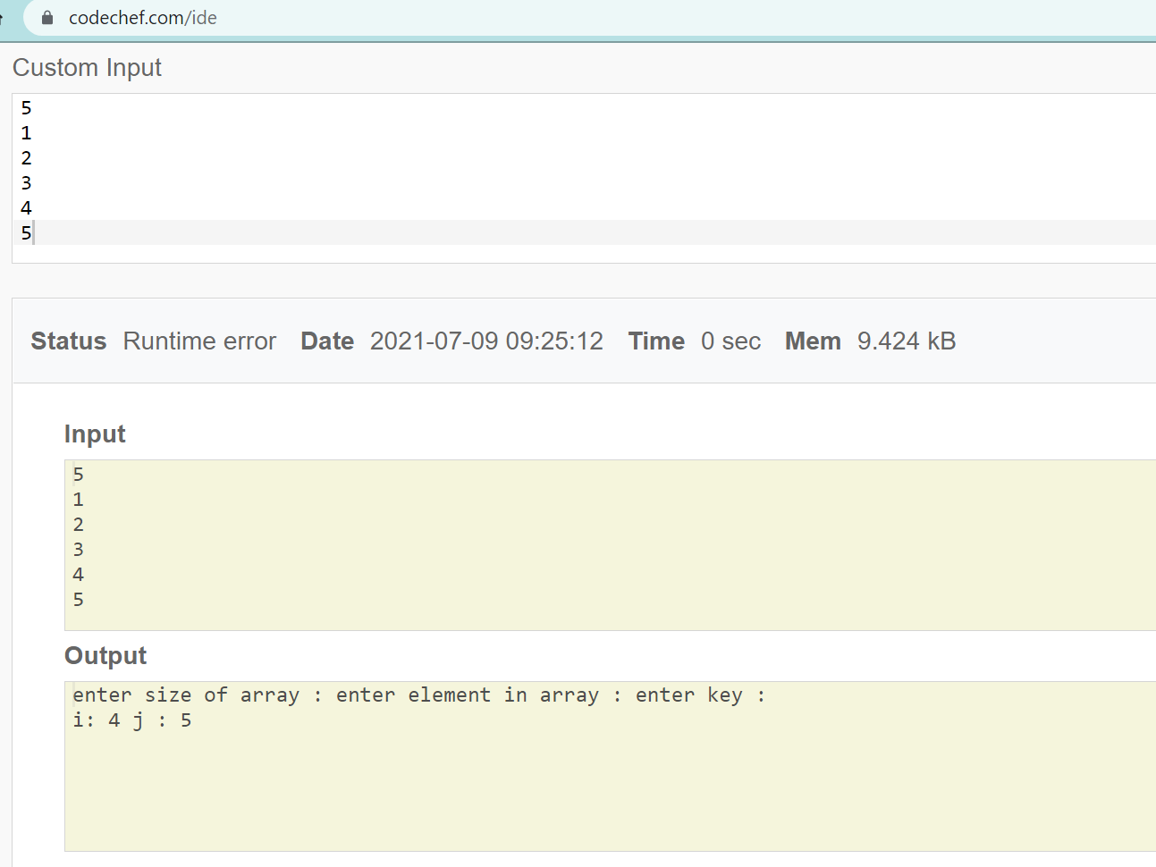

3.Suppose an array A has n distinct integers. Increasing sequence is given as A[0].........A[k] and decreasing sequence is given as A[k+1]........A[n-1]. Write a program for finding k.

#include <stdio.h>

void main(){

int n;

printf("enter size of array :");

scanf("%d",&n);

int arr[n];

printf("enter element in array : ");

for (int i=0;i<n;i++){

scanf("%d",&arr[i]);

}

int i;

for(i=0;i<n-1;i++){

if(arr[i+1]<arr[i])

break;

}

printf("the value of k is %d",i);

}

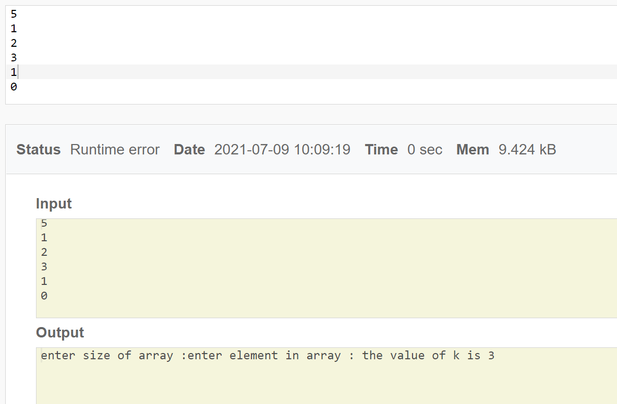

4.WAP to display an array of n integers (n>1) in O(n) time, where at every index of the array should contain the product of all elements in the array except the element at the given index. No additional array declaration is allowed.

*Example:* Input : 10, 4, 1, 6, 2

Output : 48,120,480,80,240

#include <stdio.h>

void main(){

int n;

printf("enter the size of array :");

scanf("%d",&n);

int arr[n];

printf("enter element in array : ");

for (int i=0;i<n;i++){

scanf("%d",&arr[i]);

}

int i,j;

for(i=0;i<n;i++){

int mul=1;

for(j=0;j<n;j++){

if(i!=j)

mul*=arr[j];

}

printf(",%d",mul);

}

}

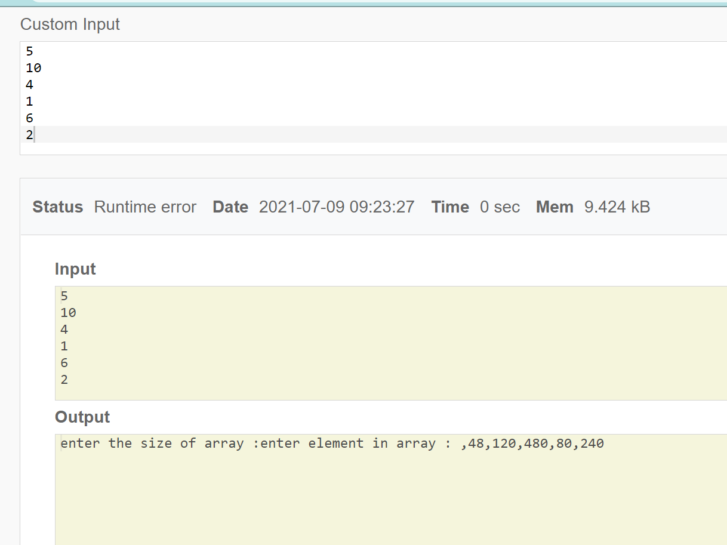

Pograme

