**Student Name:-Ritam Hudait**

**Student Roll No.:- 1905797**

**Algorithm Lab. Class Assignment-5**

**CSE Group 1**

**Date: - 6th August 2021**

1. **Write a C program to find the sum of contiguous subarray within a one dimensional (1-D) array of numbers which has the largest sum. Find the time complexty of your program.**

**Example**

|  |  |  |  |  |  |  |  |
| --- | --- | --- | --- | --- | --- | --- | --- |
| -2 | -3 | 4 | -1 | -2 | 1 | 5 | -3 |

**0 1 2 3 4 5 6 7**

**4 + (-1) + (-2) + 1 + 5 = 7**

**So the maximum contiguous subarray sum is 7**

**Program**

**#include <stdio.h>**

**#include <time.h>**

**#include <limits.h>**

**#include <stdlib.h>**

**int maxSum(int a[], int n)**

**{**

**int prev = INT_MIN, curr = 0;**

**for (int i = 0; i < n; i++)**

**{**

**curr = curr + a[i];**

**if (prev < curr)**

**prev = curr;**

**if (curr < 0)**

**curr = 0;**

**}**

**return prev;**

**}**

**int main() {**

**int n;**

**scanf("%d", &n);**

**int arr[n];**

**for(int i=0;i<n;i++) {**

**scanf("%d",&arr[i]);**

**}**

**time_t start, end;**

**double time;**

**start = clock();**

**printf("Max Subarray sum : %d\n", maxSum(arr, n));**

**end = clock();**

**time = (end - start) * 1.0 / CLOCKS_PER_SEC;**

**printf("Time taken: %f seconds", time);**

**return 0;**

**}**

**Output**

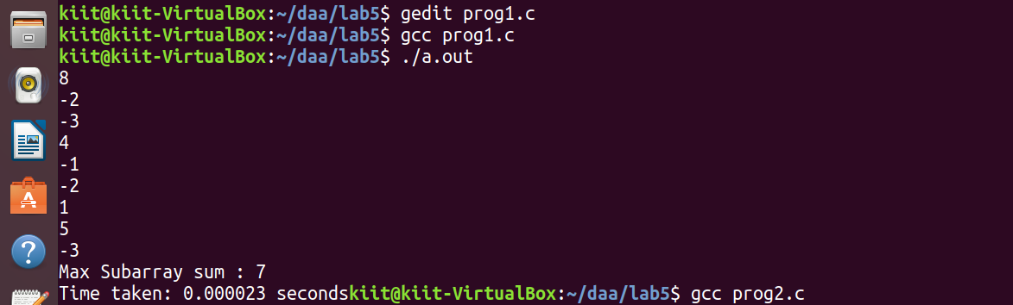

1. **Write a program to find out the largest difference between two elements A[i] and A[j] ( A[j]-A[i]) of the array of integers A in O(n) time such that j > i. For example: Let A is an array of integers:**

**int[] a = { 10, 3, 6, 8, 9, 4, 3 };**

**if i=1, j=3, then diff = a[j] – a[i] = 8 – 3 = 5**

**if i=4, j=6, then diff = a[j] – a[i] = 3 – 9 = -6**

**………**

**………**

**if i=1, j=4, then diff = a[j] – a[i] = 9 – 3 = 6**

**………**

**………**

1. **is the largest number between all the differences, that is the answer.**

**Find the time complexty of your program.**

**Program**

**#include <stdio.h>**

**#include <time.h>**

**#include <limits.h>**

**#include <stdlib.h>**

**int maxDiff(int a[], int n)**

**{**

**int max = INT_MIN, c;**

**for(int i=0;i<n;i++) {**

**for(int j=i + 1;j<n;j++) {**

**c = a[j] - a[i];**

**max = (c > max) ? c : max;**

**}**

**}**

**return max;**

**}**

**int main() {**

**int n;**

**scanf("%d",&n);**

**int arr[n];**

**for(int i=0;i<n;i++) {**

**scanf("%d",&arr[i]);**

**}**

**time_t start, end;**

**double time;**

**start = clock();**

**printf("Max Difference : %d\n", maxDiff(arr, n));**

**end = clock();**

**time = (end - start) * 1.0 / CLOCKS_PER_SEC;**

**printf("Time taken: %f seconds", time);**

**return 0;**

**}**

**Output**

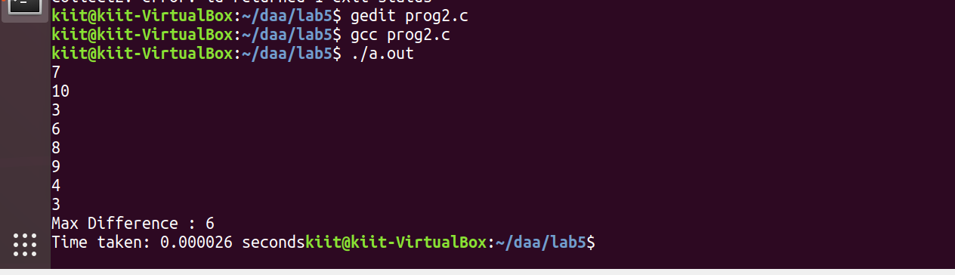

1. **Find the GCD and LCM of n numbers where (n>=2).**

**Program**

**#include <stdio.h>**

**#include <time.h>**

**#include <limits.h>**

**#include <stdlib.h>**

**int gcd(int a, int b)**

**{**

**if (b == 0)**

**return a;**

**return gcd(b, a % b);**

**}**

**int lcm(int a, int b) {**

**return (a * b / gcd(a, b));**

**}**

**int GCDN(int a[], int n) {**

**int gcd_ = a[0];**

**for(int i=1;i<n;i++) {**

**gcd_ = gcd(gcd_, a[i]);**

**}**

**return gcd_;**

**}**

**int LCMN(int a[], int n) {**

**int lcm_ = a[0];**

**for(int i=1;i<n;i++) {**

**lcm_ = lcm(lcm_, a[i]);**

**}**

**return lcm_;**

**}**

**int main() {**

**int n;**

**scanf("%d",&n);**

**int arr[n];**

**for(int i=0;i<n;i++) {**

**scanf("%d",&arr[i]);**

**}**

**time_t start, end;**

**double time;**

**start = clock();**

**printf("GCD of numbers: %d\n", GCDN(arr, n));**

**end = clock();**

**time = (end - start) * 1.0 / CLOCKS_PER_SEC;**

**printf("Time taken: %f seconds\n", time);**

**start = clock();**

**printf("LCM of numbers: %d\n", LCMN(arr, n));**

**end = clock();**

**time = (end - start) * 1.0 / CLOCKS_PER_SEC;**

**printf("Time taken: %f seconds\n", time);**

**return 0;**

**}**

**Output**

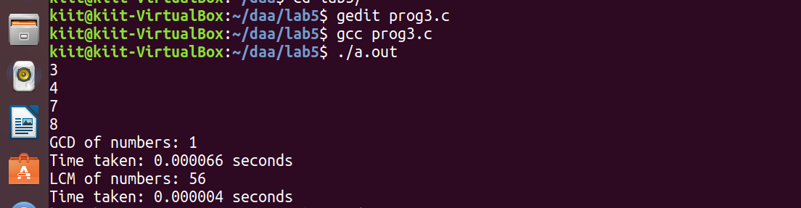

1. **Consider an n × n matrix A = (aij), each of whose elements aij is a nonnegative real number, and suppose that each row and column of A sums to an integer value. We wish to replace each element aij with either ˥ aij ˥ or ˩ aij ˩ without disturbing the row and column sums. Here is an example:**



**Write a program by defining an user defined function that is used to produce the rounded matrix as described in the above example. Find out the time complexity of your algorithm/function.**

**Program**

**#include <stdio.h>**

**#include <time.h>**

**#include <limits.h>**

**#include <stdlib.h>**

**int main() {**

**int n;**

**scanf("%d",&n);**

**float arr[10][10];**

**float a[10][10];**

**for(int i=0;i<n;i++) {**

**for(int j=0;j<n;j++) {**

**scanf("%f", &arr[i][j]);**

**a[i][j] = arr[i][j] - (int)(arr[i][j]);**

**}**

**}**

**float row[n], col[n];**

**for(int i=0;i<n;i++) {**

**float s = 0.0;**

**for(int j=0;j<n;j++) {**

**s += a[i][j];**

**}**

**row[i] = s;**

**}**

**for(int j=0;j<n;j++) {**

**float s = 0.0;**

**for(int i=0;i<n;i++) {**

**s += (arr[i][j] - (int)(arr[i][j]));**

**}**

**col[j] = s;**

**}**

**for (int i = 0; i < n; i++) {**

**for (int j = 0; j < row[i]; j++) {**

**if (col[j] == 0) {**

**a[i][j] = 0;**

**continue;**

**}**

**a[i][j] = 1;**

**col[j]--;**

**}**

**}**

**for (int i = 0; i < n; i++) {**

**for (int j = 0; j < col[i]; j++) {**

**if (row[j] == 0) {**

**a[j][i] = 1;**

**continue;**

**}**

**a[j][i] = 0;**

**row[j]--;**

**}**

**}**

**printf("Rounded up matrix :\n");**

**for(int i=0;i<n;i++) {**

**for(int j=0;j<n;j++) {**

**printf("%d ", (int)(arr[i][j]) + (int)(a[i][j]));**

**}**

**printf("\n");**

**}**

**return 0;**

**}**

**Output**

