DBMS ASSIGNMENT

NAME-RITAM HUDAIT

ROLL-1905797

1. Write a PL/SQL block to print all odd numbers between 1 and 10 using BASIC LOOP.

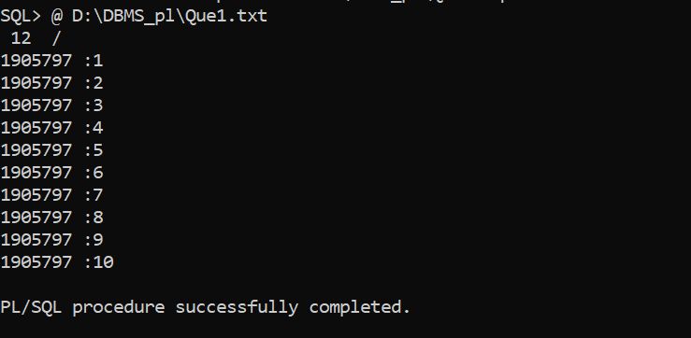

1. Using FOR LOOP, print the values 10 to 1 in reverse order.

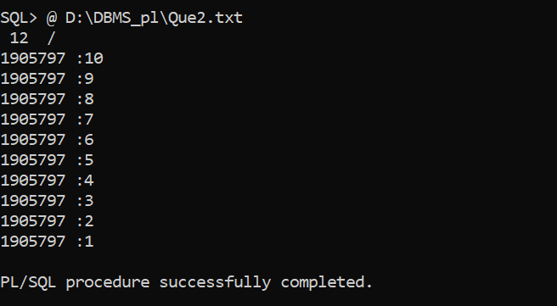

3.Using WHILE LOOP, print the average of sum of number from 10 to 20.

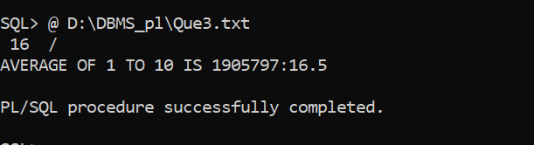

4.Read PHYSICS, CHEMISTY and MATHEMATICS marks (out of 100) from the key board and print the average marks as follow: \* If the average mark is greater than 90 then print “Average mark is >90”; \*If the average mark is greater than 80 then print “Average mark is >80”; \* If the average mark is greater than 70 then print “Average mark is> 70”; \* ELSE print “Average mark is <70”;

