**Date : 09-11-2020**

**QUESTION NUMBER-1(ARRAYS)**

# **Program to find repeating element in an array (duplicate elements)**

#include<stdio.h>

#include<stdlib.h>

void printRepeating(int arr[], int size)

{

int i, j;

printf(" Repeating elements are ");

for(i = 0; i < size; i++)

for(j = i+1; j < size; j++)

if(arr[i] == arr[j])

printf(" %d ", arr[i]);

}

int main()

{

int arr[] = {4, 2, 4, 5, 2, 3, 1};

int arr_size = sizeof(arr)/sizeof(arr[0]);

printRepeating(arr, arr_size);

return 0;

}

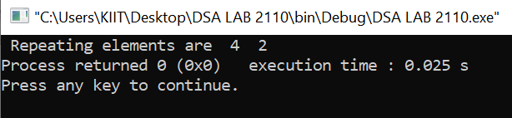

# **Program to remove duplicate elements in an array**

**Program to remove duplicate elements in an array (sorted and unsorted array cases) is discussed here. Given an array, all the duplicate elements of the array are removed.**

**For example, consider the array.**

## ****case 1:** **Remove duplicates from sorted array****

****Input:** arr = {1, 2, 3, 4, 4}**

****Output:** arr = {1, 2, 3, 4}**

## ****case 2:** **Remove duplicates from unsorted array****

****Input:** arr = {9, 2, 7, 4, 7}**

****Output:** arr = {9, 2, 7, 4}**

#include<stdio.h>

#include<conio.h>

int main()

{

int a[20], i, j, k, n;

printf("\nEnter array size: ");

scanf("%d", &n);

printf("\nEnter %d array element: ", n);

for(i = 0; i < n; i++)

{

scanf("%d", &a[i]);

}

printf("\nOriginal array is: ");

for(i = 0; i < n; i++)

{

printf(" %d", a[i]);

}

printf("\nNew array is: ");

for(i = 0; i < n; i++)

{

for(j = i+1; j < n; )

{

if(a[j] == a[i])

{

for(k = j; k < n; k++)

{

a[k] = a[k+1];

}

n--;

}

else

{

j++;

}

}

}

for(i = 0; i < n; i++)

{

printf("%d ", a[i]);

}

}

Output :

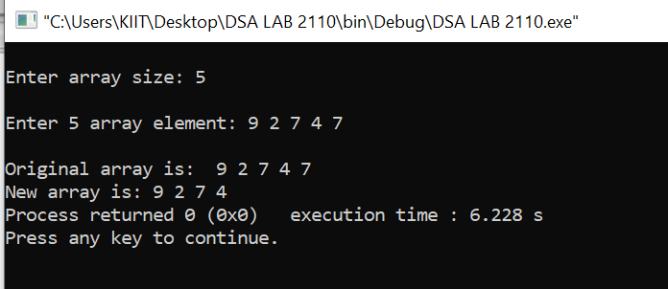

**QUESTION NUMBER-2 (2-D ARRAYS)**

# **Program to add two matrices**

Program :

#include <stdio.h>

int main() {

int r, c, a[100][100], b[100][100], sum[100][100], i, j;

printf("Enter the number of rows (between 1 and 100): ");

scanf("%d", &r);

printf("Enter the number of columns (between 1 and 100): ");

scanf("%d", &c);

printf("\nEnter elements of 1st matrix:\n");

for (i = 0; i < r; ++i)

for (j = 0; j < c; ++j) {

printf("Enter element a%d%d: ", i + 1, j + 1);

scanf("%d", &a[i][j]);

}

printf("Enter elements of 2nd matrix:\n");

for (i = 0; i < r; ++i)

for (j = 0; j < c; ++j) {

printf("Enter element a%d%d: ", i + 1, j + 1);

scanf("%d", &b[i][j]);

}

for (i = 0; i < r; ++i)

for (j = 0; j < c; ++j) {

sum[i][j] = a[i][j] + b[i][j];

}

printf("\nSum of two matrices: \n");

for (i = 0; i < r; ++i)

for (j = 0; j < c; ++j) {

printf("%d ", sum[i][j]);

if (j == c - 1) {

printf("\n\n");

}

}

return 0;

}

Output :

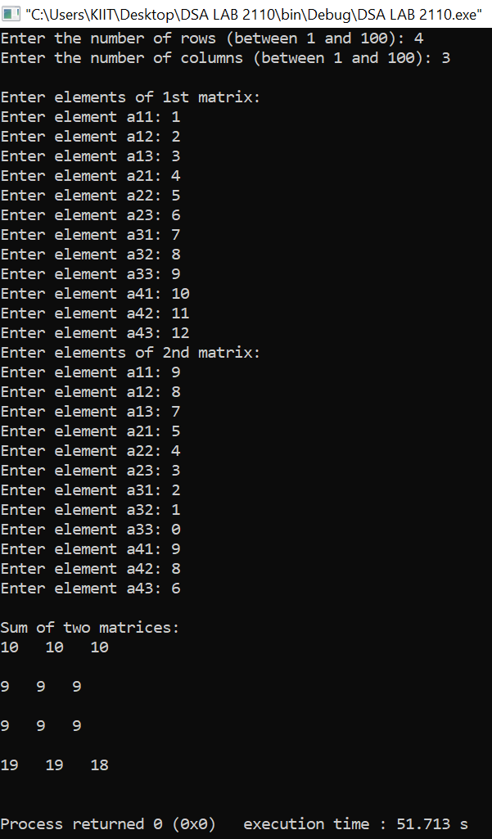

* **(RECURSION)- TOWERS OF HANOI.**

#include <stdio.h>

void towers(int, char, char, char);

int main()

{

int num;

printf("Enter the number of disks : ");

scanf("%d", &num);

printf("The sequence of moves involved in the Tower of Hanoi are :\n");

towers(num, 'A', 'C', 'B');

return 0;

}

void towers(int num, char from, char to, char temp)

{

if (num == 1)

{

printf("\n Move disk 1 from peg %c to peg %c", from, to);

return;

}

towers(num - 1, from, temp, to);

printf("\n Move disk %d from peg %c to peg %c", num, from, to);

towers(num - 1, temp, to, from);

}

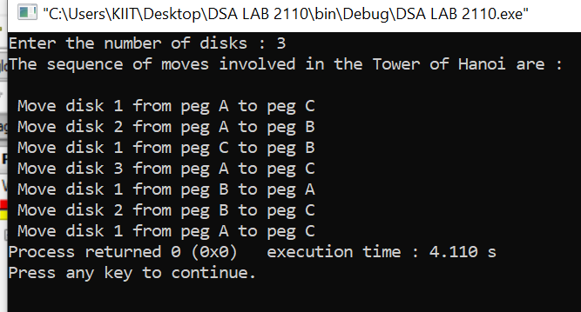

**QUESTION NUMBER -3(STACKS)**

* **[Sorting a stack using a temporary stack](https://www.faceprep.in/sort-a-stack-using-temporary-stack-and-recursion/" \t "https://www.faceprep.in/data-structures/data-structures-programs/_blank)**

#include <stdio.h>

#include <stdlib.h>

struct Stack

{

int data;

struct Stack *next;

}*input=NULL , *tmpStack=NULL;

void push(struct Stack **st,int x)

{

struct Stack *t;

t = (struct Stack *)malloc(sizeof(struct Stack));

if (st == NULL)

{

printf("Stack is full \n");

}

else

{

t->data =x;

t->next = *st;

*st = t;

}

}

int pop(struct Stack **st)

{

struct Stack *t;

t=(struct Stack *)malloc(sizeof(struct Stack));;

int x;

if (st == NULL)

{

printf("stack is empty");

}

else

{

t = *st;

*st=(*st)->next;

x = t->data;

free(t);

}

return x;

}

void display(struct Stack *st)

{

struct Stack *p;

p = st;

while (p)

{

printf("%d ", p->data);

p = p->next;

}

printf("\n");

}

void sort(){

while(input){

int temp=pop(&input);

while(tmpStack && tmpStack->data < temp ){

push(&input,pop(&tmpStack));

}

push(&tmpStack,temp);

}

}

void recursuion()

{

while(input){

int temp=pop(&input);

push(&tmpStack,temp);

}

}

void clone()

{

while(tmpStack)

{

int temp=pop(&tmpStack);

push(&input,temp);

}

}

int main(){

int n;

printf("Enter the value of n ");

scanf("%d",&n);

for (int i = 0; i < n; i++)

{

printf("Enter element for stack ");

int a;

scanf("%d",&a);

push(&input,a);

}

display(input);

sort();

display(tmpStack);

return 0;

}

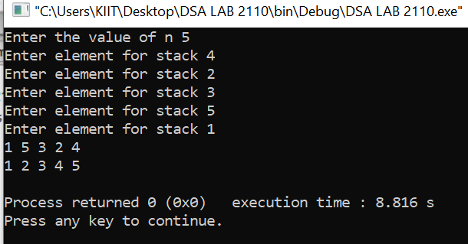

* **[Infix to postfix using a stack](https://www.faceprep.in/procoder/knowledgebase/infix-to-postfix-conversion-using stack/" \t "https://www.faceprep.in/data-structures/data-structures-programs/_blank)**

#include<stdio.h>

#include<stdlib.h>

struct Node

{

int data;

struct Node *next;

};

typedef struct

{

struct Node *top;

}Stack;

int IsEmpty(Stack s);

int push(Stack *s,int v);

int pop(Stack *s,struct Node **v);

void display(Stack s,int a,int n);

int IsOperand(int c);

int getVal(char a);

int IsLtoH(char a,char b);

int Infix_Postfix(char *inp , char *out);

struct Node *m;

int main()

{

char inp[100];

int l=0,i=0;

printf("Enter infix expression:");

gets(inp);

while(inp[l] != '\0')

{

l++;

}

char out[l];

printf("The postfix Expression is:");

int c=Infix_Postfix(inp,out);

while(out[i]!='\0')

{

printf("%c",out[i]);

i++;

}

return 0;

}

int Infix_Postfix(char *inp , char *out)

{

Stack s;

s.top=NULL;

int i=0,k=0,p,q;

while(inp[i] != '\0')

{

if(IsOperand(inp[i]))

{

out[k++]=inp[i];

}

else if(inp[i]==32)

{

i++;

continue;

}

else if(inp[i]=='(')

{

q=push(&s,inp[i]);

}

else if(inp[i]==')')

{

while(1>0)

{

p=pop(&s,&m);

if(p==1)

{

printf("Improper bracket pairs\n");

return 1;

}

if(m->data=='(')

break;

out[k++]=m->data;

}

}

else

{

if(IsEmpty(s))

{

q=push(&s,inp[i]);

}

else

{

p=pop(&s,&m);

if(p==1)

{

printf("Improper bracket pairs\n");

return 1;

}

if((m->data=='(')||(IsLtoH(m->data,inp[i])))

{

push(&s,m->data);

push(&s,inp[i]);

}

else

{

out[k++]=m->data;

i--;

}

}

}

i++;

}

while(!(IsEmpty(s)))

{

p=pop(&s,&m);

if(p==1)

{

printf("Improper bracket pairs\n");

return 1;

}

out[k++]=m->data;

}

out[k]='\0';

}

int IsLtoH(char a,char b)

{

if(getVal(a)<getVal(b))

return 1;

else

return 0;

}

int getVal(char a)

{

int t;

switch(a)

{

case '+':

case '-': t=1;

break;

case '*':

case '/':t=2;

break;

case '^':t=3;

break;

}

return t;

}

int IsOperand(int c)

{

if( ((c>=65)&&(c<=90)) || ((c>=97)&&(c<=122)) )

{

return 1;

}

return 0;

}

int IsEmpty(Stack s)

{

if(s.top==NULL)

return 1;

return 0;

}

int push(Stack *s,int v)

{

struct Node *cur;

cur= (struct Node *)malloc(sizeof(struct Node));

if(cur==NULL)

{

printf("Overflow");

return 1;

}

cur->data=v;

cur->next = s->top;

s->top=cur;

return 0;

}

int pop(Stack *s,struct Node **v)

{

if(IsEmpty(*s))

{

printf("Underflow");

return 1;

}

*v = s->top;

s->top=s->top->next;

return 0;

}

void display(Stack s,int a,int n)

{

Stack s1;

s1.top=NULL;

int k,l;

while(!(IsEmpty(s)))

{

k=pop(&s,&m);

if(a==1)

printf("%d\t",m->data);

l=push(&s1,m->data);

}

while(!(IsEmpty(s1)))

{

k=pop(&s1,&m);

if(a==0)

printf("%d\t",m->data);

l=push(&s,m->data);

}

}

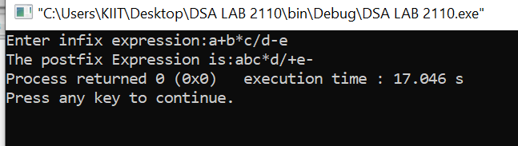

* **[Infix to prefix using a stack](https://www.faceprep.in/procoder/knowledgebase/infix-to-prefix-conversion-using-stack/" \t "https://www.faceprep.in/data-structures/data-structures-programs/_blank)**

#include<stdio.h>

#include<math.h>

#include<string.h>

#include <stdlib.h>

#define MAX 20

void push(int);

char pop();

void infix_to_prefix();

int precedence (char);

char stack[20],infix[20],prefix[20];

int top = -1;

int main()

{

printf("\nINPUT THE INFIX EXPRESSION : ");

scanf("%s",infix);

infix_to_prefix();

return 0;

}

void push(int pos)

{

if(top == MAX-1)

{

printf("\nSTACK OVERFLOW\n");

}

else {

top++;

stack[top] = infix[pos];

}}

char pop()

{

char ch;

if(top < 0)

{

printf("\nSTACK UNDERFLOW\n");

exit(0);

}

else

{

ch = stack[top];

stack[top] = '\0';

top--;

return(ch);

}

return 0;

}

void infix_to_prefix()

{

int i = 0,j = 0;

strrev(infix);

while(infix[i] != '\0')

{

if(infix[i] >= 'a' && infix[i] <= 'z')

{

prefix[j] = infix[i];

j++;

i++;

}

else if(infix[i] == ')' || infix[i] == '}' || infix[i] == ']')

{

push(i);

i++;

}

else if(infix[i] == '(' || infix[i] == '{' || infix[i] == '[')

{

if(infix[i] == '(')

{

while(stack[top] != ')')

{

prefix[j] = pop();

j++;

}

pop();

i++;

}

else if(infix[i] == '[')

{

while(stack[top] != ']')

{

prefix[j] = pop();

j++;

}

pop();

i++;

}

else if(infix[i] == '{')

{

while(stack[top] != '}')

{

prefix[j] = pop();

j++;

}

pop();

i++;

}}

else

{

if(top == -1)

{

push(i);

i++;

}

else if( precedence(infix[i]) < precedence(stack[top]))

{

prefix[j] = pop();

j++;

while(precedence(stack[top]) > precedence(infix[i])){

prefix[j] = pop();

j++;

if(top < 0) {

break;

}}

push(i);

i++;

}

else if(precedence(infix[i]) >= precedence(stack[top]))

{

push(i);

i++;

}}}

while(top != -1)

{

prefix[j] = pop();

j++;

}

strrev(prefix);

prefix[j] = '\0';

printf("EQUIVALENT PREFIX NOTATION : %s ",prefix);

}

int precedence(char alpha)

{

if(alpha == '+' || alpha =='-')

{

return(1);

}

if(alpha == '*' || alpha =='/')

{

return(2);

}

return 0;

}

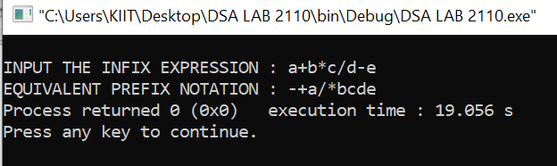

**QUESTION NUMBER-4( QUEUES)**

* **[Queue using a linked list](https://www.faceprep.in/procoder/knowledgebase/queue-data-structure-insertions-and-deletion/" \t "https://www.faceprep.in/data-structures/data-structures-programs/_blank)**

#include<stdio.h>

#include<stdlib.h>

#define m 5

struct node

{

int data;

struct node *nxt;

};

typedef struct

{

struct node *r,*f;

}queue;

int insert(queue *q,int n)

{

struct node *ptr=(struct node*)malloc(sizeof(struct node));

if(ptr==NULL)

{

printf("Full Queue.\n");

return 1;

}

ptr->data=n;

ptr->nxt=NULL;

if(q->r==NULL)

{

q->r=q->f=ptr;

}

else

{

q->r->nxt=ptr;

q->r=ptr;

}

return 0;

}

int delete(queue *q,int *n)

{

if(q->f==NULL)

{

printf("Empty Queue.\n");

return 1;

}

if(q->f==q->r)

{

*n=q->f->data;

free(q->f);

q->r=q->f=NULL;

}

else

{

struct node *ptr=q->f;

*n=q->f->data;

q->f=q->f->nxt;

free(ptr);

}

return 0;

}

int main()

{

queue q;

q.r=q.f=NULL;

int n,x,y;

for(int i=0; i<m; i++)

{

x=insert(&q,rand()%21);

}

for(int i=0; i<m; i++)

{

y=delete(&q,&n);

printf("%d ",n);

}

printf("\n");

return 0;

}

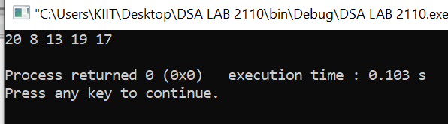

* **[Circular queue using arrays](https://www.faceprep.in/procoder/knowledgebase/circular-queue-using-arrays-and-linked-lists/" \t "https://www.faceprep.in/data-structures/data-structures-programs/_blank)**

#include<stdio.h>

#include<stdlib.h>

#define m 5

typedef struct

{

int data[m];

int r,f;

}queue;

int insert(queue *q,int n)

{

if((q->r==m-1 && q->f==0) || q->f==q->r+1)

{

printf("Insertion Not Possible.\n");

return 1;

}

if(q->r==-1)

{

q->f=q->r=0;

q->data[q->r]=n;

}

else

{

q->r=(q->r+1)%m;

q->data[q->r]=n;

}

return 0;

}

int delete(queue *q, int *n)

{

if(q->f==-1)

{

printf("Deletion Note Possible.\n");

return 1;

}

if(q->r==q->f)

{

*n=q->data[q->f];

q->f=q->r=-1;

}

else

{

*n=q->data[q->f];

q->f=(q->f+1)%m;

}

return 0;

}

int main()

{

queue q;

q.f=q.r=-1;

int n,x,y;

for(int i=0; i<m-2;i++)

{

scanf("%d",&n);

x=insert(&q,n);

}

y=delete(&q,&n);

y=delete(&q,&n);

for(int i=0; i<m-1; i++)

{

scanf("%d",&n);

x=insert(&q,n);

}

for(int i=0; i<m; i++)

{

y=delete(&q,&n);

printf("%d ",n);

}

printf("\n");

}

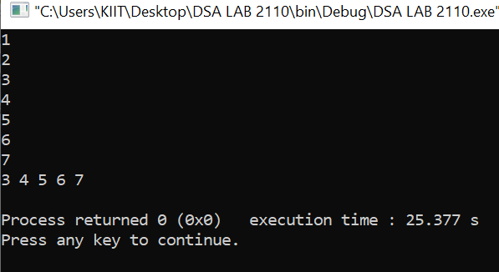

* **[Circular queue using Linked list](https://www.faceprep.in/procoder/knowledgebase/circular-queue-using-arrays-and-linked-lists/" \t "https://www.faceprep.in/data-structures/data-structures-programs/_blank)**

#include<stdio.h>

#include<stdlib.h>

#define m 5

struct node

{

int data;

struct node *nxt;

};

typedef struct

{

struct node *r;

}queue;

int insert(queue *q, int n)

{

struct node *ptr=(struct node*)malloc(sizeof(struct node));

if(ptr==NULL)

{

printf("Insetion Not Possible.\n");

return 1;

}

ptr->data=n;

ptr->nxt=NULL;

if(q->r==NULL)

{

q->r=ptr;

q->r->nxt=q->r;

}

else

{

ptr->nxt=q->r->nxt;

q->r->nxt=ptr;

q->r=ptr;

}

return 0;

}

int delete(queue *q, int *n)

{

if(q->r==NULL)

{

printf("Deletion Not Possible.\n");

return 1;

}

if(q->r==q->r->nxt)

{

*n=q->r->data;

free(q->r);

q->r=NULL;

}

else

{

struct node *ptr=q->r->nxt;

q->r->nxt=ptr->nxt;

*n=ptr->data;

free(ptr);

}

return 0;

}

int main()

{

queue q;

q.r=NULL;

int n,x,y;

for(int i=0; i<m;i++)

{

scanf("%d",&n);

x=insert(&q,n);

}

y=delete(&q,&n);

printf("%d ",n);

y=delete(&q,&n);

printf("%d ",n);

printf("\n");

}

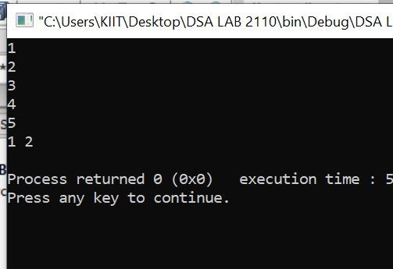

* **[Implement stack using a queue](https://www.faceprep.in/procoder/knowledgebase/implementing-stacks-using-queues/" \t "https://www.faceprep.in/data-structures/data-structures-programs/_blank)**

#include<stdio.h>

#include<stdlib.h>

#define MAX 20

typedef struct{

int data[MAX];

int front;

int rear;

}Queue;

Queue q1;

int insert(Queue *q, int v){

if(q->rear == MAX-1){ //full Q

printf("Queue is full\n");

return 1;

}

if(q->rear == -1){ //Empty Q

q->front = q->rear = 0;

q->data[q->rear] = v;

}else{ //Partially full Q

q->rear++;

q->data[q->rear] = v;

}

return 0;

}

int delete(Queue *q, int *m){

if(q->front == -1){ //Empty Q

printf("Q is empty\n");

return 1;

}

if(q->front == q->rear){

*m = q->data[q->front];

q->front = q->rear = -1;

}else{

*m = q->data[q->front];

q->front++;

}

return 0;

}

int delete2(Queue *q, int *m){

if(q->front == -1){

printf("Q is empty\n");

return 1;

}

if(q->front == q->rear){

*m = q->data[q->front];

q->front = q->rear = -1;

}else{

*m = q->data[q->front];

for(int i=1; i<q->rear; i++){

q->data[i-1] = q->data[i];

}

q->rear--;

}

return 0;

}

void display(Queue q){

int i;

if (q.front == - 1)

printf("Queue is empty \n");

else{

for (i = q.front; i <= q.rear; i++)

printf("%d ", q.data[i]);

printf("\n");

}

}

int isEmpty(Queue q){

return (q.front == -1) ? 1 : 0;

}

int push(int v){

return insert(&q1, v);

}

int pop(int *m){

int p = isEmpty(q1);

if(p) return p;

int i = q1.front;

int j = q1.rear;

while(i!=j){

int n;

delete(&q1, &n);

insert(&q1, n);

i++;

}

int n;

delete(&q1, &n);

*m = n;

return 0;

}

int main(){

q1.front = q1.rear = -1;

int t = push(10);

display(q1);

t = push(20);

display(q1);

t = push(30);

display(q1);

int m;

int r = pop(&m);

display(q1);

return 0;

}

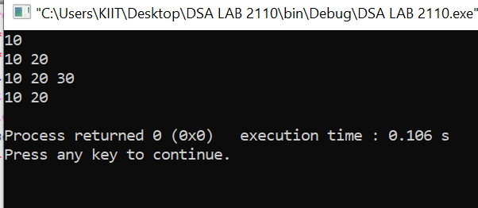

* **[Implement queue using a stack](https://www.faceprep.in/procoder/knowledgebase/implementing-queues-using-stacks/" \t "https://www.faceprep.in/data-structures/data-structures-programs/_blank)**

#include <stdio.h>

#include <stdlib.h>

struct node {

int data;

struct node* next;

};

void push(struct node** top_ref, int new_data);

int pop(struct node** top_ref);

struct queue {

struct node* stack1;

struct node* stack2;

};

void enQueue(struct queue* q, int x)

{

push(&q->stack1, x);

}

int deQueue(struct queue* q)

{

int x;

if (q->stack1 == NULL && q->stack2 == NULL)

{

printf("Q is empty");

getchar();

exit(0);

}

if (q->stack2 == NULL)

{

while (q->stack1 != NULL)

{

x = pop(&q->stack1);

push(&q->stack2, x);

}

}

x = pop(&q->stack2);

return x;

}

void push(struct node** top_ref, int new_data)

{

struct node* new_node = (struct node*)malloc(sizeof(struct node));

if (new_node == NULL) {

printf("Stack overflow \n");

getchar();

exit(0);

}

new_node->data = new_data;

new_node->next = (*top_ref);

(*top_ref) = new_node;

}

int pop(struct node** top_ref)

{

int res;

struct node* top;

if (*top_ref == NULL) {

printf("Stack underflow \n");

getchar();

exit(0);

}

else {

top = *top_ref;

res = top->data;

*top_ref = top->next;

free(top);

return res;

}

}

int main()

{

struct queue* q = (struct queue*)malloc(sizeof(struct queue));

q->stack1 = NULL;

q->stack2 = NULL;

printf("Enter any 4 No.\n");

int n;

scanf("%d",&n);

enQueue(q, n);

scanf("%d",&n);

enQueue(q, n);

scanf("%d",&n);

enQueue(q, n);

scanf("%d",&n);

enQueue(q, n);

printf("By Queue using Stack Deletion is: ");

printf("%d ", deQueue(q));

printf("%d ", deQueue(q));

printf("%d ", deQueue(q));

printf("\n");

return 0;

}

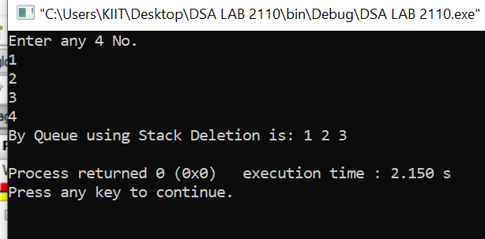

**QUESTION NUMBER-5 (LINKED LIST)**

* **[Remove duplicates from a linked list](https://www.faceprep.in/remove-duplicates-from-a-linked-list/" \t "https://www.faceprep.in/data-structures/data-structures-programs/_blank)**

#include <stdio.h>

#include <stdlib.h>

struct node

{

int num;

struct node *next;

};

void create(struct node **);

void dup_delete(struct node **);

void release(struct node **);

void display(struct node *);

int main()

{

struct node *p = NULL;

struct node_occur *head = NULL;

int n;

printf("Enter data into the list\n");

create(&p);

printf("Displaying the nodes in the list:\n");

display(p);

printf("Deleting duplicate elements in the list...\n");

dup_delete(&p);

printf("Displaying non-deleted nodes in the list:\n");

display(p);

release(&p);

return 0;

}

void dup_delete(struct node **head)

{

struct node *p, *q, *prev, *temp;

p = q = prev = *head;

q = q->next;

while (p != NULL)

{

while (q != NULL && q->num != p->num)

{

prev = q;

q = q->next;

}

if (q == NULL)

{

p = p->next;

if (p != NULL)

{

q = p->next;

}

}

else if (q->num == p->num)

{

prev->next = q->next;

temp = q;

q = q->next;

free(temp);

}

}

}

void create(struct node **head)

{

int c, ch;

struct node *temp, *rear;

do

{

printf("Enter number: ");

scanf("%d", &c);

temp = (struct node *)malloc(sizeof(struct node));

temp->num = c;

temp->next = NULL;

if (*head == NULL)

{

*head = temp;

}

else

{

rear->next = temp;

}

rear = temp;

printf("Do you wish to continue [1/0]: ");

scanf("%d", &ch);

} while (ch != 0);

printf("\n");

}

void display(struct node *p)

{

while (p != NULL)

{

printf("%d\t", p->num);

p = p->next;

}

printf("\n");

}

void release(struct node **head)

{

struct node *temp = *head;

*head = (*head)->next;

while ((*head) != NULL)

{

free(temp);

temp = *head;

(*head) = (*head)->next;

}

}

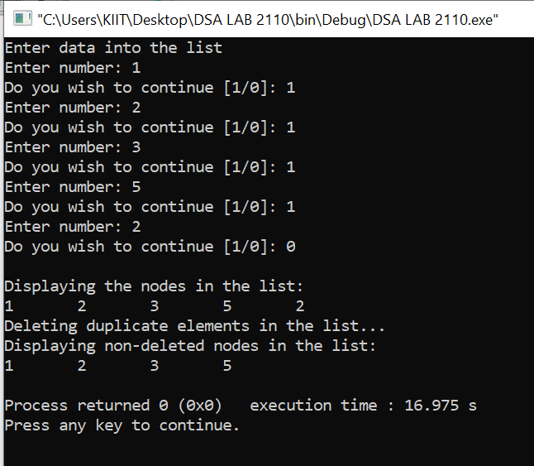

* **[Reverse a linked list](https://www.faceprep.in/procoder/knowledgebase/reversing-a-linked-list/" \t "https://www.faceprep.in/data-structures/data-structures-programs/_blank)**

#include<stdio.h>

#include<stdlib.h>

struct node{

int data;

struct node *next;

};

struct node *start = NULL;

struct node *create(struct node *start){

int n;

struct node * new_node = (struct node *)malloc(sizeof(struct node));

printf("enter value : ");

scanf("%d",&n);

new_node->data =n;

new_node->next =start;

start=new_node;

return start;

}

struct node *ins_end(struct node* start){

int n;

struct node *new_node = (struct node *)malloc(sizeof(struct node));

struct node *ptr;

printf("enter value: ");

scanf("%d",&n);

new_node->data =n;

new_node->next =NULL;

ptr = start;

while(ptr->next !=NULL){

ptr =ptr->next;

}

ptr->next= new_node;

return start;

}

struct node *rev(struct node*start){

struct node *ptr,*preptr=NULL,*temp;

ptr=start;

while(ptr!=NULL){

temp=ptr->next;

ptr->next=preptr;

preptr =ptr;

ptr=temp;

}

start= preptr;

return start;

}

void display(struct node *start){

struct node *temp;

if(start == NULL)

printf("the linked list doesn't exists. ");

else{

temp = start;

while(temp != NULL){

printf(" %d",temp->data);

temp = temp->next;

}

printf("\n");

}

}

int main(){

int ch;

while(1){

printf("1. Create .\n");

printf("2. Insert at end.\n");

printf("3. reverse the entered link list.\n");

printf("4. Display .\n");

printf("5. Exit .\n");

printf(" Enter your choice : ");

scanf("%d",&ch);

switch(ch){

case 1:

start = create(start);

break;

case 2:

start = ins_end(start);

break;

case 3:

start = rev(start);

break;

case 4:

display(start);

break;

case 5:

exit(0);

break;

default:

printf(" wrong choice . \n");

}

}

return 0;

}

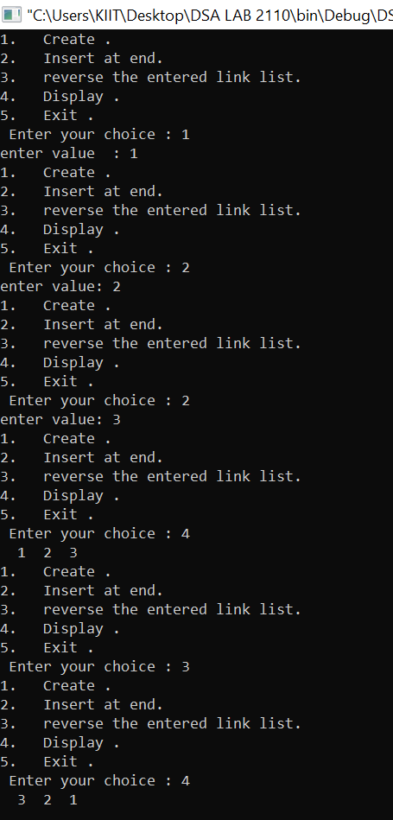

* **[Circular queue using arrays](https://www.faceprep.in/procoder/knowledgebase/circular-queue-using-arrays-and-linked-lists/" \t "https://www.faceprep.in/data-structures/data-structures-programs/_blank)**

#include<stdio.h>

#include<stdlib.h>

#define m 5

typedef struct

{

int data[m];

int r,f;

}queue;

int insert(queue *q,int n)

{

if((q->r==m-1 && q->f==0) || q->f==q->r+1)

{

printf("Insertion Not Possible.\n");

return 1;

}

if(q->r==-1)

{

q->f=q->r=0;

q->data[q->r]=n;

}

else

{

q->r=(q->r+1)%m;

q->data[q->r]=n;

}

return 0;

}

int delete(queue *q, int *n)

{

if(q->f==-1)

{

printf("Deletion Note Possible.\n");

return 1;

}

if(q->r==q->f)

{

*n=q->data[q->f];

q->f=q->r=-1;

}

else

{

*n=q->data[q->f];

q->f=(q->f+1)%m;

}

return 0;

}

int main()

{

queue q;

q.f=q.r=-1;

int n,x,y;

for(int i=0; i<m-2;i++)

{

scanf("%d",&n);

x=insert(&q,n);

}

y=delete(&q,&n);

y=delete(&q,&n);

for(int i=0; i<m-1; i++)

{

scanf("%d",&n);

x=insert(&q,n);

}

for(int i=0; i<m; i++)

{

y=delete(&q,&n);

printf("%d ",n);

}

printf("\n");

}



* **[Circular queue using Linked list](https://www.faceprep.in/procoder/knowledgebase/circular-queue-using-arrays-and-linked-lists/" \t "https://www.faceprep.in/data-structures/data-structures-programs/_blank)**

#include<stdio.h>

#include<stdlib.h>

#define m 5

struct node

{

int data;

struct node *nxt;

};

typedef struct

{

struct node *r;

}queue;

int insert(queue *q, int n)

{

struct node *ptr=(struct node*)malloc(sizeof(struct node));

if(ptr==NULL)

{

printf("Insetion Not Possible.\n");

return 1;

}

ptr->data=n;

ptr->nxt=NULL;

if(q->r==NULL)

{

q->r=ptr;

q->r->nxt=q->r;

}

else

{

ptr->nxt=q->r->nxt;

q->r->nxt=ptr;

q->r=ptr;

}

return 0;

}

int delete(queue *q, int *n)

{

if(q->r==NULL)

{

printf("Deletion Not Possible.\n");

return 1;

}

if(q->r==q->r->nxt)

{

*n=q->r->data;

free(q->r);

q->r=NULL;

}

else

{

struct node *ptr=q->r->nxt;

q->r->nxt=ptr->nxt;

*n=ptr->data;

free(ptr);

}

return 0;

}

int main()

{

queue q;

q.r=NULL;

int n,x,y;

for(int i=0; i<m;i++)

{

scanf("%d",&n);

x=insert(&q,n);

}

y=delete(&q,&n);

printf("%d ",n);

y=delete(&q,&n);

printf("%d ",n);

printf("\n");

}



**QUESTION NUMBER - 6( TREES)**

* **[Height of a binary tree](https://www.faceprep.in/find-the-height-of-a-binary-tree/" \t "https://www.faceprep.in/data-structures/data-structures-programs/_blank)**

#include<stdio.h>

#include<stdlib.h>

struct node

{

int data;

struct node* left;

struct node* right;

};

int maxDepth(struct node* node)

{

if (node==NULL)

return 0;

else

{

int lDepth = maxDepth(node->left);

int rDepth = maxDepth(node->right);

if (lDepth > rDepth)

return(lDepth+1);

else return(rDepth+1);

}

}

struct node* newNode(int data)

{

struct node* node = (struct node*)

malloc(sizeof(struct node));

node->data = data;

node->left = NULL;

node->right = NULL;

return(node);

}

int main()

{

struct node *root = newNode(1);

root->left = newNode(2);

root->right = newNode(3);

root->left->left = newNode(4);

root->left->right = newNode(5);

printf("Height of tree is %d\n", maxDepth(root));

return 0;

}

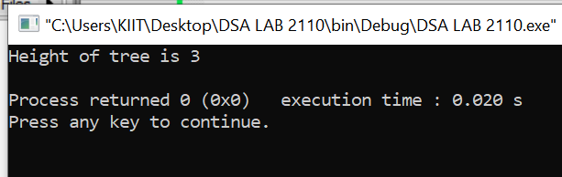

* **[Find kth maximum value in a binary search tree](https://www.faceprep.in/program-to-find-the-kth-maximum-element-in-a-binary-search-tree/" \t "https://www.faceprep.in/data-structures/data-structures-programs/_blank)**

#include <stdio.h>

struct Node {

int data;

struct Node *left, *right;

};

struct Node* newNode(int data)

{

struct Node* temp = malloc(sizeof(struct Node));

temp->data = data;

temp->right = temp->left = NULL;

return temp;

}

struct Node* KthLargestUsingMorrisTraversal(struct Node* root, int k)

{

struct Node* curr = root;

struct Node* Klargest = NULL;

int count = 0;

while (curr != NULL) {

if (curr->right == NULL) {

if (++count == k)

Klargest = curr;

curr = curr->left;

}

else {

struct Node* succ = curr->right;

while (succ->left != NULL && succ->left != curr)

succ = succ->left;

if (succ->left == NULL) {

succ->left = curr;

curr = curr->right;

}

else {

succ->left = NULL;

if (++count == k)

Klargest = curr;

curr = curr->left;

}

}

}

return Klargest;

}

int main()

{

/* Constructed binary tree is

4

/ \

2 7

/ \ / \

1 3 6 10 */

struct Node* root = newNode(4);

root->left = newNode(2);

root->right = newNode(7);

root->left->left = newNode(1);

root->left->right = newNode(3);

root->right->left = newNode(6);

root->right->right = newNode(10);

printf("Finding K-th largest Node in BST : %d\n", KthLargestUsingMorrisTraversal(root, 3)->data);

return 0;

}

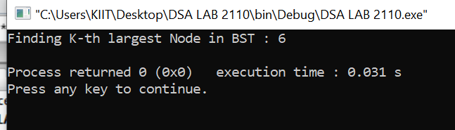

**QUESTION NUMBER -7 (SEARCHING AND SORTING)**

* **[Bubble Sort](https://www.faceprep.in/bubble-sort-in-c/" \t "https://www.faceprep.in/data-structures/data-structures-programs/_blank)**

#include <stdio.h>

int main()

{

int size;

printf("\nEnter the size of array: ");

scanf("%d", &size);

int array[size];

printf("\nEnter %d elements:\n", size);

for (int i = 0; i < size; i++)

scanf("%d", &array[i]);

printf("\nThe array is:\n");

for (int i = 0; i < size; i++)

printf("Element %d: %d\n", i + 1, array[i]);

for (int i = 0; i < size; i++)

for (int j = 0; j < size - 1; j++)

if (array[j] > array[j + 1])

{

int temp = array[j];

array[j] = array[j + 1];

array[j + 1] = temp;

}

printf("\nThe Bubble Sorted array is:\n");

for (int i = 0; i < size; i++)

printf("Element %d: %d\n", i + 1, array[i]);

return 0;

}

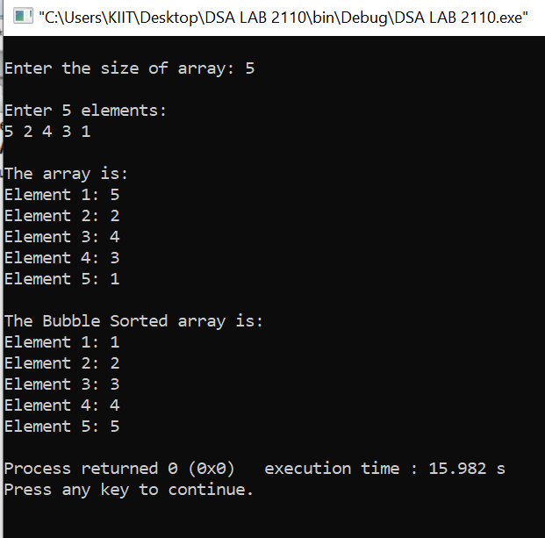

* **[Selection Sort](https://www.faceprep.in/selection-sort-in-c/" \t "https://www.faceprep.in/data-structures/data-structures-programs/_blank)**

#include <stdio.h>

int main()

{

int array[100], n, c, d, position, t;

printf("Enter number of elements\n");

scanf("%d", &n);

printf("Enter %d integers\n", n);

for (c = 0; c < n; c++)

scanf("%d", &array[c]);

for (c = 0; c < (n - 1); c++)

{position = c;

for (d = c + 1; d < n; d++)

{

if (array[position] > array[d])

position = d;

}

if (position != c)

{

t = array[c];

array[c] = array[position];

array[position] = t;

}}

printf("Sorted list in ascending order:\n");

for (c = 0; c < n; c++)

printf("%d\n", array[c]);

return 0;

}

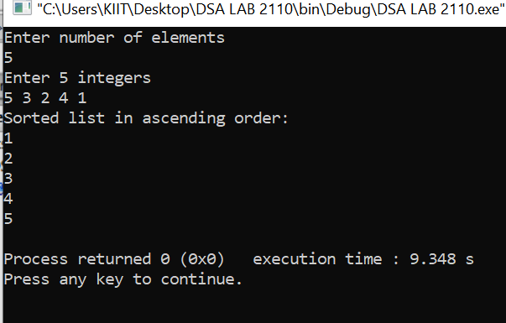

* **[Insertion Sort](https://www.faceprep.in/insertion-sort-in-c/" \t "https://www.faceprep.in/data-structures/data-structures-programs/_blank)**

#include <stdio.h>

int main()

{

int size;

printf("\nEnter the size of array: ");

scanf("%d", &size);

int array[size];

printf("\nEnter %d elements:\n", size);

for (int i = 0; i < size; i++)

scanf("%d", &array[i]);

printf("\nThe array is:\n");

for (int i = 0; i < size; i++)

printf("Element %d: %d\n", i + 1, array[i]);

for (int i = 1; i <= size - 1; i++)

{

int j = i;

while (j > 0 && array[j - 1] > array[j])

{

int temp = array[j];

array[j] = array[j - 1];

array[j - 1] = temp;

j--;

}

}

printf("\nThe Insertion Sorted array is:\n");

for (int i = 0; i < size; i++)

printf("Element %d: %d\n", i + 1, array[i]);

return 0;

}

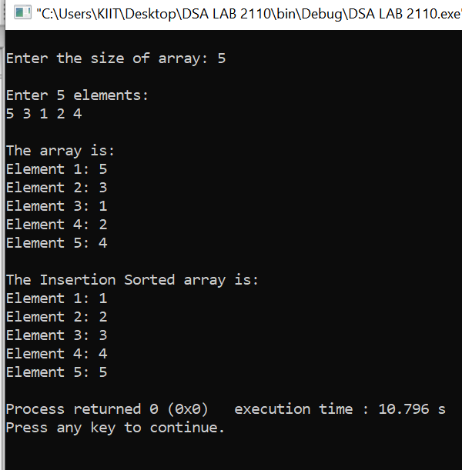

* **[Merge Sort](https://www.faceprep.in/merge-sort-in-c/" \t "https://www.faceprep.in/data-structures/data-structures-programs/_blank)**

#include <stdio.h>

#include <stdlib.h>

void merge(int arr[], int l, int m, int r)

{

int i, j, k;

int n1 = m - l + 1;

int n2 = r - m;

int L[n1], R[n2];

for (i = 0; i < n1; i++)

L[i] = arr[l + i];

for (j = 0; j < n2; j++)

R[j] = arr[m + 1 + j];

i = 0;

j = 0;

k = l;

while (i < n1 && j < n2) {

if (L[i] <= R[j]) {

arr[k] = L[i];

i++;

}

else {

arr[k] = R[j];

j++;

}

k++;

}

while (i < n1) {

arr[k] = L[i];

i++;

k++;

}

while (j < n2) {

arr[k] = R[j];

j++;

k++;

}

}

void mergeSort(int arr[], int l, int r)

{

if (l < r) {

int m = l + (r - l) / 2;

mergeSort(arr, l, m);

mergeSort(arr, m + 1, r);

merge(arr, l, m, r);

}

}

void printArray(int A[], int size)

{

int i;

for (i = 0; i < size; i++)

printf("%d ", A[i]);

printf("\n");

}

int main()

{

int arr_size;

printf("Enter the size of array");

scanf("%d",&arr_size);

printf("Enter elements:");

int i;

int arr[arr_size];

for(i=0;i<arr_size;i++)

scanf("%d",&arr[i]);

printf("Given array is \n");

printArray(arr, arr_size);

mergeSort(arr, 0, arr_size - 1);

printf("\nSorted array is \n");

printArray(arr, arr_size);

return 0;

}

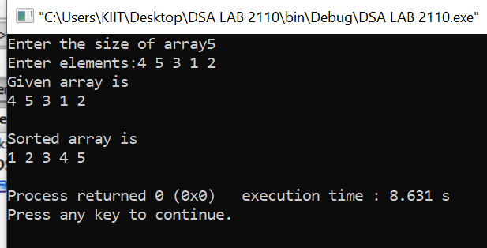

* **[Quick Sort](https://www.faceprep.in/quick-sort-algorithm-in-c/" \t "https://www.faceprep.in/data-structures/data-structures-programs/_blank)**

#include<stdio.h>

void swap(int* a, int* b)

{

int t = *a;

*a = *b;

*b = t;

}

int partition (int arr[], int low, int high)

{

int pivot = arr[high];

int i = (low - 1);

for (int j = low; j <= high- 1; j++)

{

if (arr[j] < pivot)

{

i++;

swap(&arr[i], &arr[j]);

}

}

swap(&arr[i + 1], &arr[high]);

return (i + 1);

}

void quickSort(int arr[], int low, int high)

{

if (low < high)

{

int pi = partition(arr, low, high);

quickSort(arr, low, pi - 1);

quickSort(arr, pi + 1, high);

}

}

void printArray(int arr[], int size)

{

int i;

for (i=0; i < size; i++)

printf("%d ", arr[i]);

printf("\n");

}

int main()

{

int n,i;

printf("Enter size of array");

scanf("%d",&n);

int arr[n];

printf("Enter array elements:\n");

for(i=0;i<n;i++)

scanf("%d",&arr[i]);

quickSort(arr, 0, n-1);

printf("Sorted array: \n");

printArray(arr, n);

return 0;

}

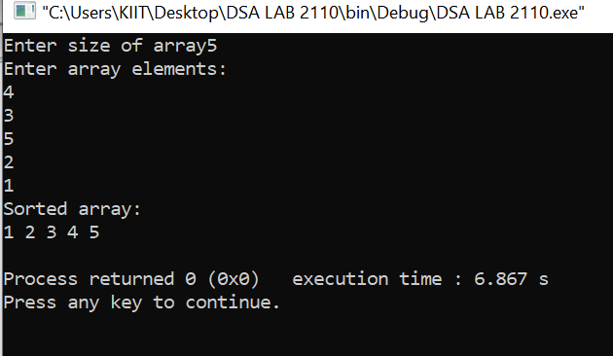

## **CHAUDHARY HAMDAN**

**1905387**

**DSA LAB**

**Date : 09-11-2020**

**Faculty in charge : Meghna Ma’am**