|  |
| --- |
| **Experiment No.2** |
| Mapping ER/EER to Relational schema model. |
| Date of Performance: |
| Date of Submission: |

**Aim :-** Prepare the schema for Relational Model with the ER/ERR diagram, drawn for the identified case study in experiment no.1.

**Objective :-** To map the Entity Relationship (ER) / Extended Entity-Relationship (EER) Diagram to Relational Model schema and learn to incorporate various schema-based constraints.

# Theory:

Mapping an Entity-Relationship (ER) model to a relational database schema involves translating the conceptual model represented in the ER diagram into tables and relationships in a relational database management system (DBMS). Here are the general rules for mapping ER to a schema in a DBMS:

1. Entities to Tables:
   1. Each entity in the ER diagram corresponds to a table in the relational schema.
   2. The attributes of the entity become the columns of the table.
   3. The primary key of the entity becomes the primary key of the table.
2. Relationships to Tables:
   1. Many-to-Many Relationships:
      1. Convert each many-to-many relationship into a new table.
      2. Include foreign key columns in this table to reference the participating entities.
      3. The primary key of this table may consist of a combination of the foreign keys from the participating entities.
   2. One-to-Many and One-to-One Relationships:
      1. Represented by foreign key columns in one of the participating tables.
      2. The table on the "many" side of the relationship includes the foreign key column referencing the table on the "one" side.
      3. The foreign key column typically references the primary key of the related table.
3. Attributes to Columns:
   1. Each attribute of an entity becomes a column in the corresponding table.
   2. Choose appropriate data types for each attribute based on its domain and constraints.
   3. Ensure that attributes participating in relationships are represented as foreign keys when needed.
4. Primary and Foreign Keys:
   1. Identify the primary key(s) of each table based on the primary key(s) of the corresponding entity.
   2. Ensure referential integrity by defining foreign keys in tables to establish relationships between them.
   3. Foreign keys should reference the primary key(s) of related tables.
   4. Ensure that foreign keys have appropriate constraints, such as ON DELETE CASCADE or ON UPDATE CASCADE, to maintain data integrity.
5. Cardinality Constraints:
   1. Use the cardinality constraints from the ER diagram to determine the multiplicity of relationships in the relational schema.
   2. Ensure that the constraints are enforced through the appropriate use of primary and foreign keys.
6. Normalization:
   1. Normalize the schema to minimize redundancy and dependency.
   2. Follow normalization rules such as First Normal Form (1NF), Second Normal Form (2NF), Third Normal Form (3NF), etc., to ensure data integrity and minimize anomalies.
7. Indexing and Optimization:
   1. Consider indexing frequently queried columns to improve query performance.
   2. Evaluate the schema design for optimization opportunities based on query patterns and performance requirements.

**Implementation:**

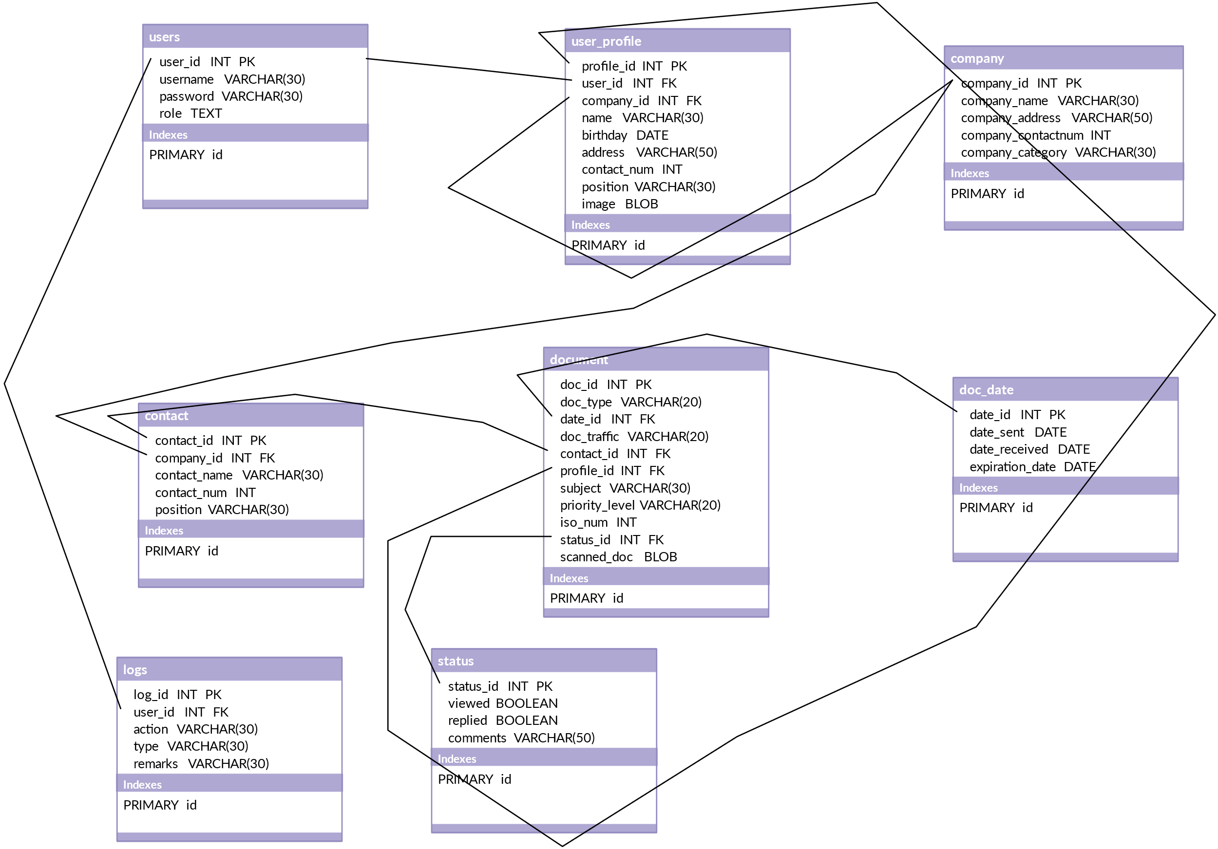

**Conclusion:**

1. write definition of relational schema and notations
2. write various schema-based constraints

In conclusion, relational schema and schema-based constraints play crucial roles in database design and management:

1. Relational Schema:

- Definition: A relational schema defines the structure of a relational database, including tables, columns, and relationships between tables.

- Notations:

- Table: Represented as a rectangle with the table name at the top.

- Attributes: Represented as ovals inside the table rectangle, specifying the attribute name and data type.

- Primary Key: Underlined attribute(s) indicate the primary key(s) of the table.

- Foreign Key: Attributes representing foreign keys establish relationships between tables.

- Example:

```

Student

-------

student_id (PK): int

name: varchar

age: int

```

2. Schema-Based Constraints:

- Primary Key Constraint:

- Ensures uniqueness and non-nullity of a column or combination of columns.

- Example: `PRIMARY KEY (student_id)`

- Foreign Key Constraint:

- Enforces referential integrity by ensuring that values in a column match values in a related table's primary key.

- Example: `FOREIGN KEY (dept_id) REFERENCES Department(dept_id)`

- Unique Constraint:

- Ensures that values in a column or combination of columns are unique.

- Example: `UNIQUE (email)`

- Check Constraint:

- Validates data integrity by specifying a condition that must be satisfied for each row.

- Example: `CHECK (age >= 18)`

- Not Null Constraint:

- Ensures that a column does not accept NULL values.

- Example: `age INT NOT NULL`

These schema-based constraints ensure data integrity, consistency, and accuracy within the database, enforcing rules and restrictions on the data stored in the tables. By defining a clear relational schema and applying appropriate constraints, database administrators can maintain the quality and reliability of the database system, facilitating efficient data management and retrieval operations.