boreDom:   
Szegedi Bence Csaba  
Ruszó Richárd  
Forgó Balázs

boredBets

Used Softwares:

* Visual studio
* Visual studio code
* XAMPP
* Octopus.do (This gave us the starting stroke for the basics of the website arhitecture)
* Dbdiagram.io (Was easy to use and exportable to sql file)

Programming languages:

* HTML, JAVASCRIPT, CSS
* BOOTSTRAP
* React
* ASP.NET

After careful consideration, we found the idea of creating a betting site to be exciting.

In HTML, we will structure the body of this page, and with CSS and Bootstrap, we will style it to achieve the desired appearance

Main Page:

The main page will feature a straightforward design with a Bootstrap-created navigation bar. On the right side of this bar, a logo will be prominently displayed. The navigation bar will include tabs labeled News, Upcoming Races, and Links, allowing users to seamlessly navigálté to the respective sections by clicking on them. Additionally, a login panel, crafted in HTML and programmed in JavaScript, will be positioned on the right side of the bar. The last element on the navigation bar is a register button that, upon clicking, will redirect users to another site.

Community Page:

Within the Community tab, users will encounter a valuable "Find People" section equipped with a sophisticated search engine. This functionality, seamlessly integrated with our database through ASP.NET, empowers users to conduct precise queries. Leveraging the power of ASP.NET, this search engine ensures efficient interaction with the database, enabling the retrieval of pertinent information. Users can expect a seamless and tailored experience in discovering and connecting with others in the community.There will also be an overall money flow counter, which will be retrieved from our database using ASP.NET. The values will be summed up server-side, and then, through the use of AJAX or Fetch, the dynamically updated counter will be displayed on the frontend.

Somewhere on the website, there will be a counter showcasing the total number of our registered users.  
Horse stats will be sequentially displayed, with all the relevant information retrieved from our database through ASP.NET

Jockey stats will also work in the same way as those for the horses.

Weekly Races Page:

On the Weekly Races page, you'll encounter a search engine that seamlessly interacts with the database. Powered by ASP.NET, this search engine allows users to query the database based on specific parameters such as date, location, horse, and jockey. If a match is found, the relevant information will be dynamically displayed on another dedicated site. This functionality provides users with a convenient and efficient way to retrieve detailed race information tailored to their preferences. Whether you're looking for specific dates, locations, preferred horses, or jockeys, our search engine ensures a user-friendly experience, connecting you with the precise race details you seek.

Race Results Page:

This is the dedicated page where the results of your searches will be presented.

User Management Page:

On this page, you'll find two options for navigation: "Personal Info" and "Privacy Settings." These choices empower users to seamlessly access and manage their personal information or customize their privacy preferences according to their individual needs and preferences.

Personal Area Page:

On this page, users have the ability to customize their name and avatar. In addition, users can view their bookmarked races and betting history. All user preferences, including bookmarked races and betting history, will be securely stored in the database. The custom name and avatar, however, are optional and won't be stored in the database, ensuring flexibility for users who choose not to customize these details while maintaining data integrity and security.

Admin Page:

Reserved exclusively for administrators, the 'Manage User Data/Details' panel, powered by ASP.NET, grants administrative users the ability to directly modify and update user information within the database. This feature ensures that administrators have the necessary tools to efficiently manage and maintain accurate user details as needed.

Introducing the "Regenerate Database" tab, exclusively available to administrators, this functionality provides a realistic and efficient way to refresh horse and track data. Powered by ASP.NET, administrators can seamlessly regenerate and reupload data to ensure accuracy and realism within the database. This feature empowers administrators to maintain a dynamic and up-to-date platform, enhancing the overall user experience with the most current information on horses and tracks.

Welcome to the "Create/Delete Users" tab, a robust tool exclusively designed for administrators. This functionality, fueled by ASP.NET, empowers administrators with the capability to selectively create or remove users based on specific properties within the database. With a focus on precision and control, this feature facilitates the management of user accounts, enabling administrators to fine-tune the user database to adapt to evolving needs while upholding data integrity and security.

Html structure

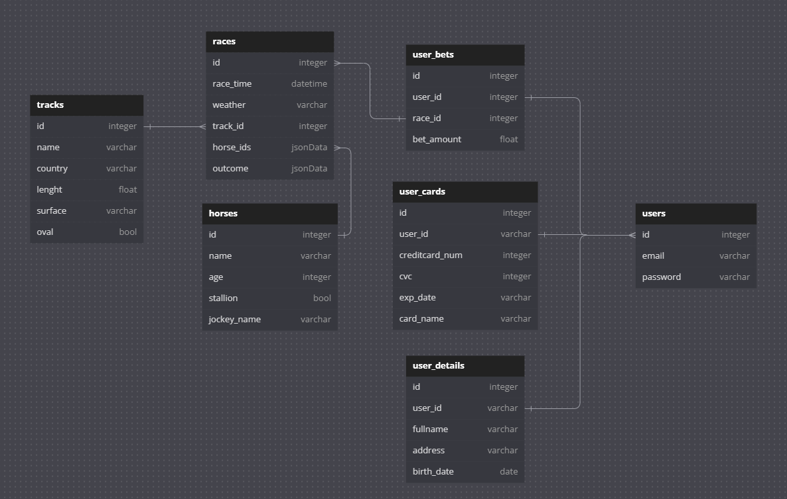

Database plan

Choice of theme and motivation:

In this project, we aim to showcase the culmination of our learnings throughout the year by implementing advanced database management and pushing the limits of Object-Relational Mapping (ORM) through ASP.NET. We will leverage our proficiency in HTML, JavaScript, and CSS, demonstrating the culmination of our skills. While our Bootstrap skills may have been lacking, we are committed to refining them for a successful outcome. It won't be easy, but we are determined to see this project through to completion by the end of the year.

Our motivation stems from the diversity within the betting world, offering a plethora of options beyond traditional horse betting. We embrace a wide array of games, such as blackjack and various casino-related activities. This broad spectrum allows us to cater to diverse preferences, ensuring an engaging and dynamic betting experience for our users.

The abundance of betting sites provides us with inspiration from numerous sources. With a vast array of platforms, each offering unique features and approaches, we draw insights and ideas from this diverse landscape. This wealth of options allows us to stay innovative and responsive to the evolving needs and preferences of our users, ensuring a dynamic and engaging betting experience.