

boredDom

Table of contents:

1. Used assets
2. Description
3. API
4. Database
5. Frontend
6. Backend
7. Used assets

|  |  |  |
| --- | --- | --- |
| Microsoft Visual Studio  Microsoft Visual Studio Code | React  Node  Bootstrap  Axios | phpMyAdmin  ASP.NET  XAMPP |

1. Description  
   We created a website „Y.com”, where you can upload pictures with a selected category, title and content/description.
2. API  
   We tried to create a comprehensive set of endpoints.

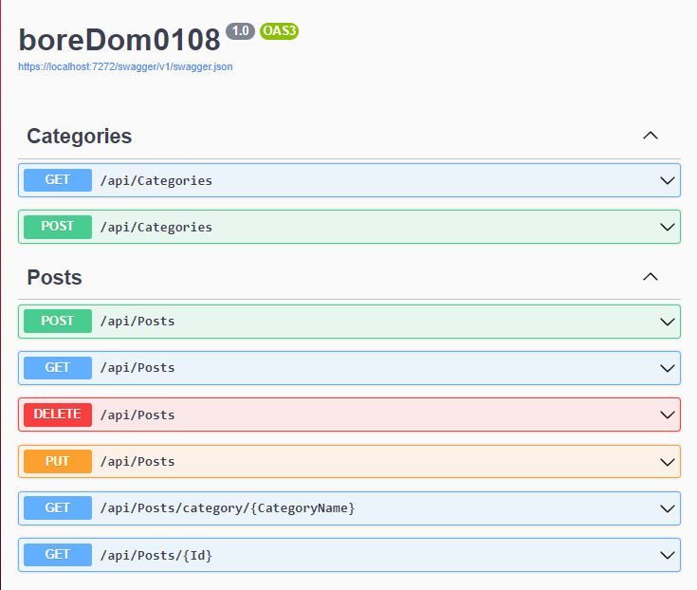

1. Database  
   The database optimization proved to be a challenge, especially the question of how to store the pictures that users upload.

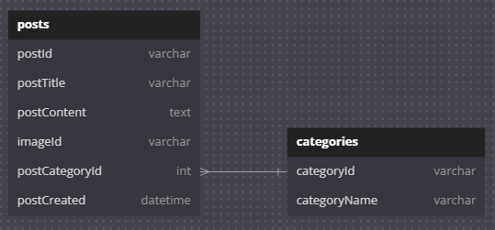

1. Frontend  
   We thought of a **very unique and one of a kind** desing and style for the website.

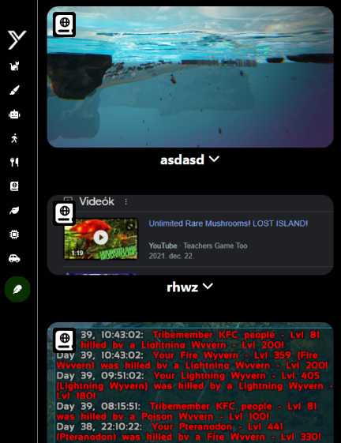

1. Backend  
   The site was created using React and is a Single-page-application.

