

boredDom

Table of contents:

1. Used assets
2. Description
3. API
4. Database
5. Frontend
6. Backend
7. **Used assets**

|  |  |  |
| --- | --- | --- |
| Microsoft Visual Studio  Microsoft Visual Studio Code | React  Node  Bootstrap  Axios | phpMyAdmin  ASP.NET  XAMPP |

1. **Description**  
   We developed „Y.com”, a website that enables photo sharing with a twist. On Y, you can upload pictures with various categories, such as nature, art, travel, or food. You can also add a title and a description to your pictures, to give them more context and meaning. You can discover amazing images from other users also. We will show you how Y works, what features it offers, and why it is different from other photo sharing websites.
2. **API**  
   We tried to create a comprehensive set of endpoints. Also, other than the Main Api, that controls data about the Posts and Categories, we created another endpoint, which handles image uploads.

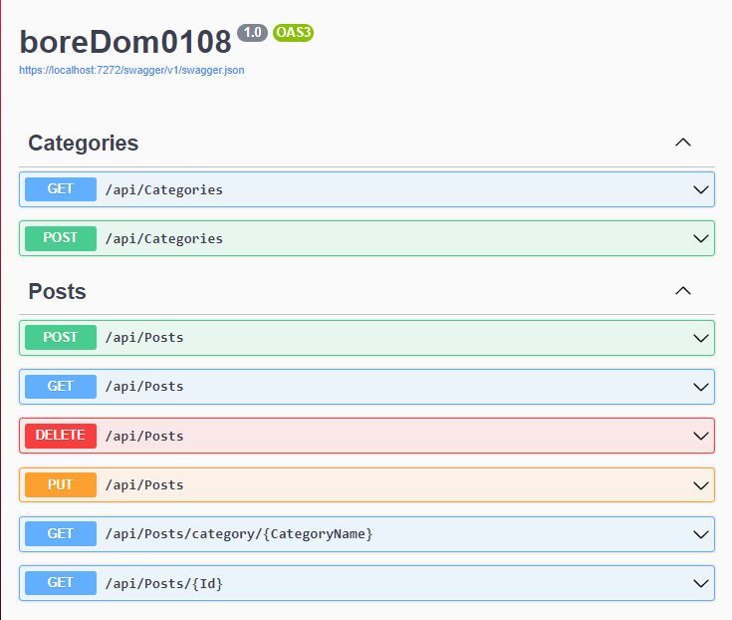

1. **Database**  
   The database optimization proved to be a challenge, especially the question of how to store the pictures that users upload.

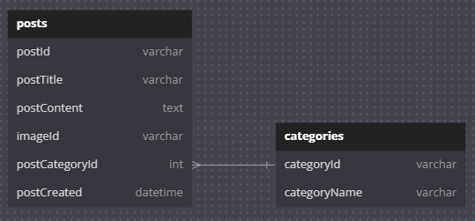

1. **Frontend**  
   We thought of a **very unique and one of a kind** desing and style for the website.

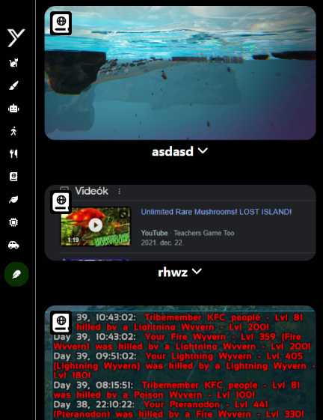

By default, the website will bring you to the main page, where all the posts are available, ordered in such a way that you see the freshest content at all times.

After some scrolling, the user can also pick a certain category to check out all the related posts to their taste.

If the user is done checking out their favorite category, they can easily navigate back to the main page by clicking on the website’s logo (Y).

On the occasion that the user is interested in posting new content themselves, the post button is easily accessible.

Upon pressing the ‘Post’ button, a pop-up menu will appear, letting the user fill in their new post to their own desire.

Here, after selecting their own image, filling out the necessary text fields, and selecting the post’s category, they will be able to instantly post it.

If any error occurs, the page will notify the user, and they will be able to retry, if they made any mistake, or forgot to fill in all the necessary fields.

If all fields are correct, and the website accepts, the data, the post will be sent to the API, and upon positive response the webpage will show a notification, telling the user that their post have been succesfully posted, when this notification is dismissed, the page will reload, showing the user their newly created post.

1. **Backend**  
   Y is a web application built with React, NodeJS, and CSS. It is a single page application (SPA) that allows users to view and interact with posts on various topics. The app has a modular and organized structure, which makes it easy to navigate and maintain.

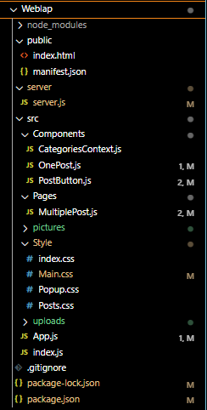**server**: This directory contains the server.js file, which is a server-side script that handles picture uploads from the app. It uses Express, a web framework for NodeJS, to create routes and endpoints for the app’s functionality.

**src**: This directory contains all the source code for the app’s front-end. It is divided into subdirectories for different components, pages, pictures, and styles. The main files in this directory are:

**Components**: This subdirectory contains all the reusable components that are used in different pages of the app.

**Pages**: This subdirectory contains all the pages that are rendered by the App component based on the URL path.

**pictures**: This subdirectory contains all the media assets that are used in the app, such as images and icons.

**Style**: This subdirectory contains all the CSS files that style the app’s components and pages. Some of the stylesheets are:

**uploads**: This directory contains the pictures that are uploaded by the users.