**The Plans**

By the end of class (and for homework), you will have a file submission to Blackbaud.

You will make and submit

* 1 ideation session,
* 3 block diagrams
* 2 other methods for organizing information.

The overall goal of *The Arcade Exhibit* is to program a short & sweet, but rich & entertaining, game in a 3D world, using Processing.

Before you begin diagramming, complete an ideation session. In a document, generate (or ideate) as many “Arcade Game” as you can imagine. There’s no right or wrong, if you have an idea, write it down! Your game can be an official game like Pac-Mac but it can also be silly, like lawn-mower racing!

**Ideation Session**

Please up with at least 50 ideas and use 15-25 minutes to accomplish this. You can work alone or with a partner. Your ideas should be quick and don’t settle on any one idea until you’ve generated the entire list.

**Choosing Some Ideas**

Great! Now you have a list of potential game ideas!

Which ones are your favorites? What is the goal of each game? Is it one-player, multiplayer, or does someone play against an AI? How does someone win? How does someone score a point? Do you even score points at all?

Choose three of your Arcade Exhibit game ideas to turn into block diagrams. Your block diagrams should thoroughly describe the gameplay.

There is no “your block diagram should be this many blocks” but by this point in the year, you should be grasping the intuitive feeling of “Information is missing here; I should fill in this detail” …balanced with “this is a lot of detail; I don’t need to go in-depth here just yet. I can do that later after I get the overarching picture more developed.”

You should use about 15 minutes for each block diagram

SO, FINALLY, What’s next?

**2 methods of Information Collection**

What’s that?

It can be a list, it can be a mood board, it can be a bunch of images pasted onto a word page… It can be all of those.

For this, I want you to look at 2 of your block diagrams and list out every little piece that you might need in your game. These are called assets.

What assets do you need in your game?

What 3D models do you need?

If you have typography in your game, what font do you need?

Do you have a backdrop?

What does the player look like?

How does the player interact with the game (mouse, keyboard, game controller, camera, microphone, touchscreen, something else?)

List out every possible detail in your game. Envision what the game looks like when you close your eyes. Act out playing the game! There’s tons of arcade games that dont use a mouse and keyboard…

The rest of the time should be used to develop these asset groups/lists/categorizations … and maybe you update your block diagrams, as you’re making your lists.

So, why did I have you come into class with 5 examples analyzed? Because, as you write your collections of assets, I want you to think of the question “Should I find this somewhere -or should I program it in?” For example: if you have a sphere that is a beachball you could program it in, but if you need a lawnmower 3D model…maybe it’s best to find that 3D model somewhere else. I wanted you to explore the capabilities of Processing. What about a sprinkler? In Processing, you can make “Particle Systems” and you can use those to simulate water spraying from a sprinkler. So you could make the sprinkler interactive!

Alright, enough details! Get to it! Have fun, and lets start the Arcade Exhibit!

**Ideation Session (Transcribed from Computer Science Notebook):**

1. Basketball – similar to 2k – or basketball stars
2. Choose your own adventure
3. Puzzle game
4. PVP
5. Multiplayer game
6. Card/boardgame modeled after existing game like Sorry or Monopoly
7. Racing Game – Asphault
8. Soccer – simulation of PK or mini 3v3 game
9. Building/creating something (ex. Structure) game
10. First-person game (maybe PacMan but now scarier because you don’t know where the ghosts are until you turn the corner)
    1. “Ghosts” floating around the maze
    2. Try to get out without being eaten by the ghost
11. Simulation of real life (school, driving to school)
12. Learning games (math, English vocabulary)
13. Home Economics (Learn practical home skills while playing a game)
14. Typing game (complete the paragraph before…)
15. Level game (achievement based – like Mario)
16. Virtual Reality type game (is that even possible with our computers??)
17. Hardware control – using different components of our computer
18. 2d game with 3d graphics
19. Mortal Combat PVP game w/ unique characters (or maybe the same)
20. 3d version of 2d games like PacMan
21. Escape the guard while trying to rob something (building escape simulation)
22. Radial Pac-Man – minotaur maze-ish
23. Hit the clown arcade game (knock all the clowns down before they come back up) (some sort of throwing mechanic)
24. Drawing Game (draw your own solutions to problems)
25. Endless Running game (Subway Surfers or Temple Run)
    1. Snowboarder/skier escaping avalanche
26. Open SIM – multiplayer – interact with other players on a server
27. Draw your way to freedom (devise artistic solutions to complex problems)
28. Escape Room game
29. Don’t sink the boat – carefully manage resources to board the most penguins but don’t sink the boat!
30. Small-sided games (tic/tac/toe, rock paper scissors, archery)
31. Mission Impossible: Steal the item in a precarious situation
32. Floor is Lava – last one standing wins
33. Space Game – survive the cosmos as an astronaut – complete tasks before oxygen runs out
34. Rocket Race – rocket obstacle course race
35. Sorting or stacking game ~ tetris
36. Parkour
37. Physics Game – testing the laws of physics while having fun
38. Don’t let the structure collapse (build the most unstable yet still standing structure)
39. World-building game – create your own universe
40. Card-building game – deck-building games like Magic the Gathering
41. Journey League-focused game (merging my website/app idea with this game project)
42. Wii-type game – but geared towards helping those improve at basketball
43. Multi-player game with friendly basketball competitions – both active and mental challenges (playing the game but it requires you (at times) to get up and actually move (like Just Dance))
44. Pokémon Go type GPS tracking game
45. Trivia Game
46. Another Journey League-focused game: progress through a personalized basketball career as a character player – the only way to progress is by completing drills and challenges in the app.
    * Motivation game as well as a resource to get better
47. Erase the screen before pictures/drawings overwhelm it (level-up erasers throughout the game as drawings quicken)
48. Screen-agers – avoid the cars and catastrophes as you cross the street (~Crossy Roads)
49. Steal the prize: navigate through the museum without being spotted by the security guard to steal the prized diamond
50. Build bridges for a character before they fall off the cliff
51. Strategy game – war game
52. Tile Run
    1. Ball rolls down an endless path
    2. On the page, tiles randomly spawn with directional arrows
    3. If you fail to press the directional arrow in time – you lose

**HoopDreams Block Diagram:**

**Endless Runner Block Diagram:**

**Tile Run Block Diagram:**

**Tile Run MoodBoard:**

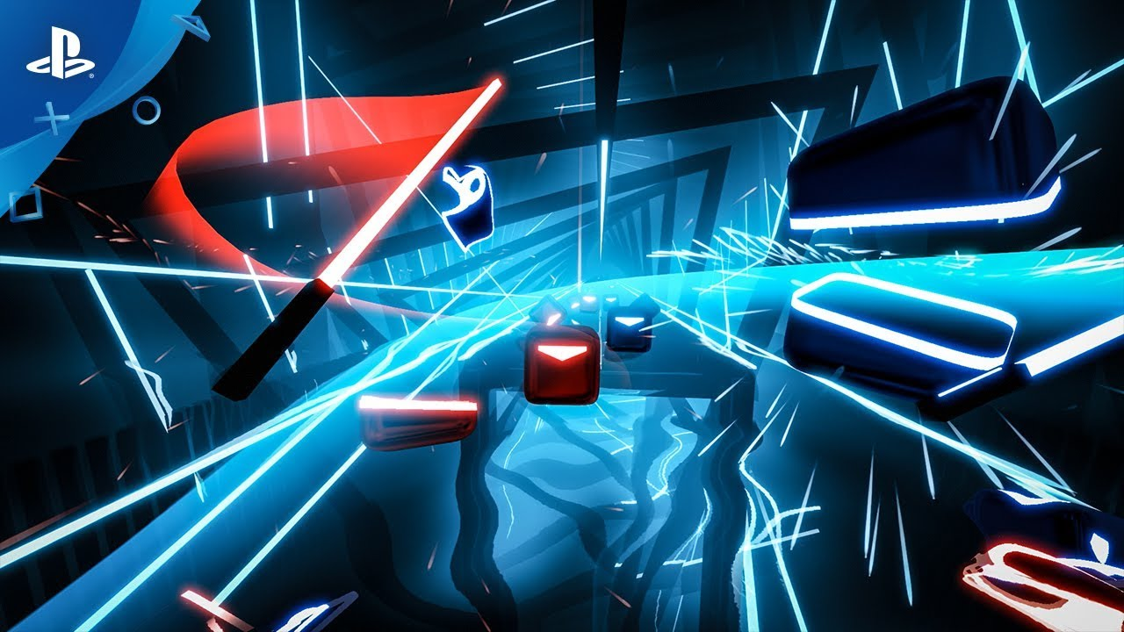

**Beat Sabers**

“Swiping tiles away” concept (but use the tiles as the path)

Also want to use this color and theme

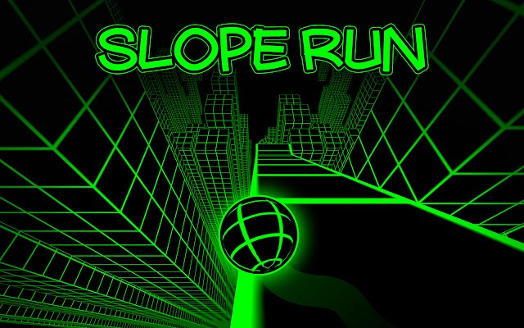



“Ball on Ramp” games

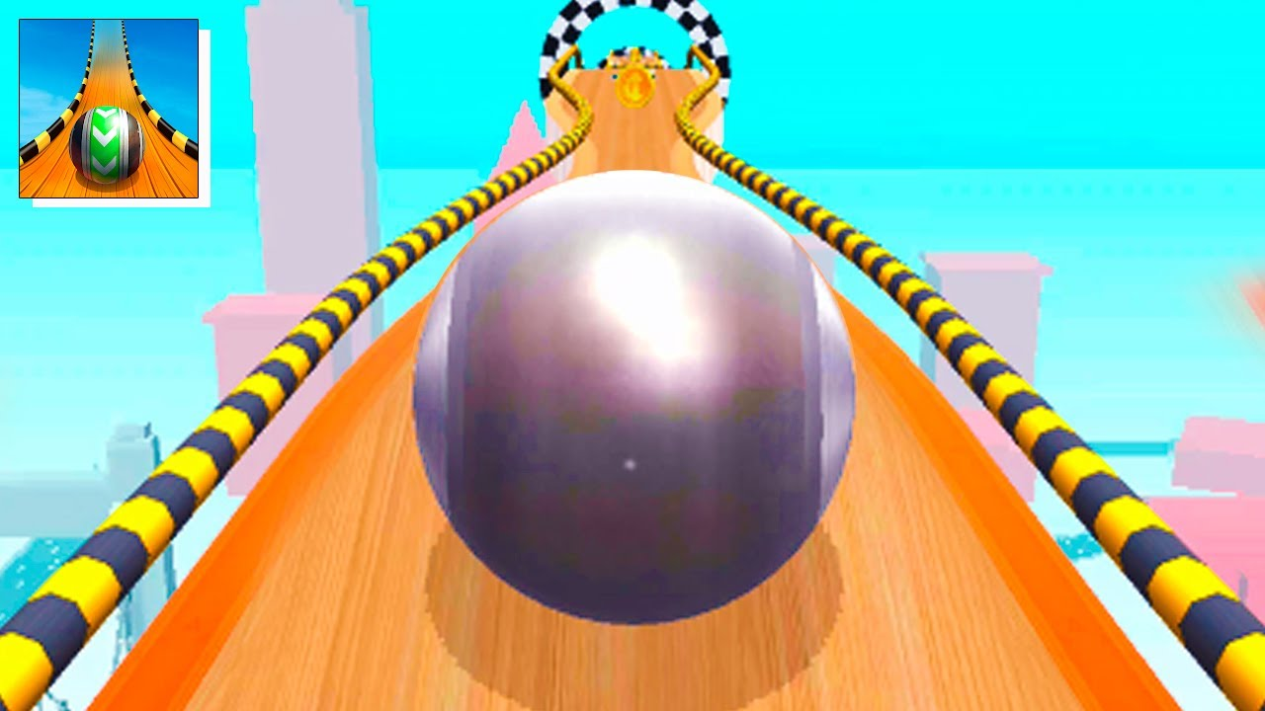

Sample Tile

**HoopDream Planning Page:**

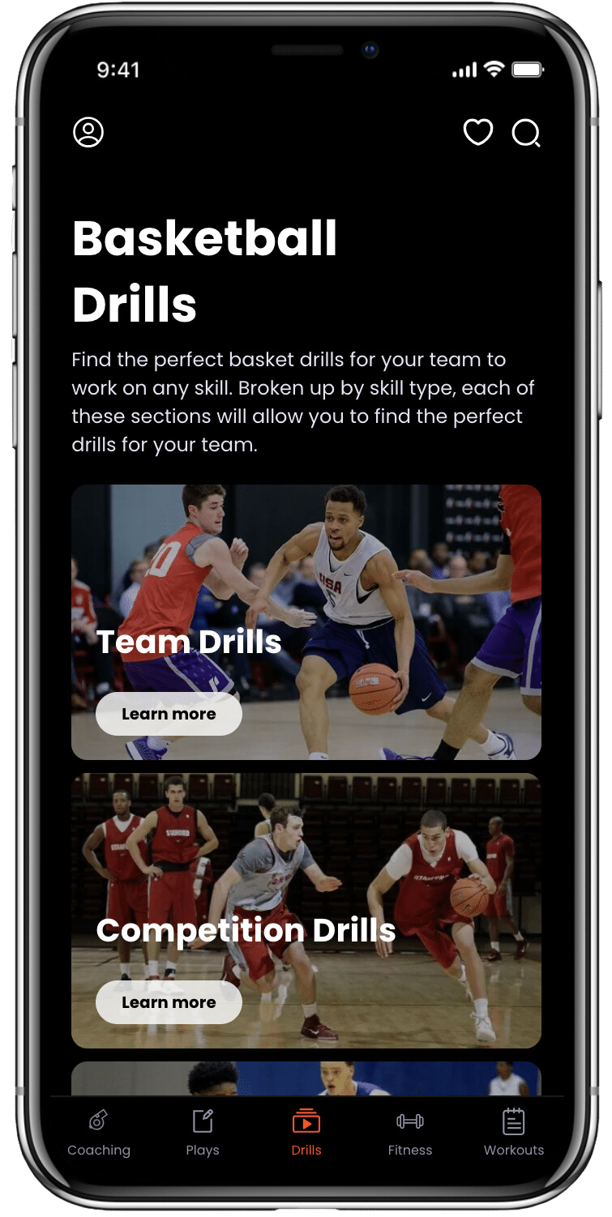

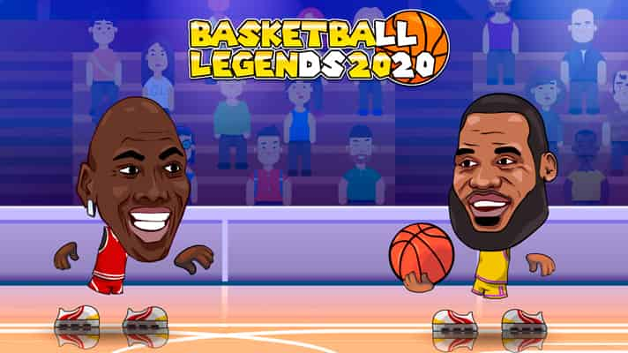

Character Design Idea ^

Drill Catalog Idea 🡪

Drill Catalog:

1. Passing
   * Semicircle Pass Rotation and Shooting Drill
2. Shooting
   * Shoot Through the Foul Drill
   * 2 line Catch and Shoot Competition Drill
3. Ball-Handling
   * Ghost Tag
   * Sharks and Minnows
   * Stationary Pounds (different levels)
   * Crossovers
   * Between the legs
   * Behind the back
4. Games
   * Read and React Drill (Shoot/Pass)
   * Touchdown (Ultimate)
   * Simon Says
5. Strength and Power
   * Burpees
   * Pushups
   * Jumping Jacks
6. Mobility/Stretching/Conditioning
   * Sprints
   * Dynamic Warmup
   * Stretch Routine (Best with video)
7. Mental Game
8. Nutrition
   * Healthy Snacks
9. Ball Knowledge (IQ)
10. Defense (or would it go in another category or would other categories fall into this one)

*Images come from Journey League clips and pictures?

Additional Thoughts:

* Avatar needs to be upgradable (visual improvements)
* Animation for drills?
* Varying levels of difficulty for each drill (parent toggled)
* Drill Recommendations rather than mandating drills
* Daily Mission Bar (recommended drills)
* Bosses to beat by accumulating xp – go from stage to stage (court to court) 🡪 gamify skill-building