Design for team page and login styling

Field | Value
Author | Aziz Ahmadi — UX Designer
Date | 12 August 2026
Task | [BOOTSTRAP RESTYLING] Design Login Style & Team Page Layout

1. Purpose of this document
This document explains not only what the design looks like, but why each decision was made. Every colour, size and layout choice below is followed by the reasoning behind it, so the choices can be reviewed on their merits rather than taken on trust — and so that anyone changing this design later understands what they would be trading away.
Four screens were produced: the login page in its default and error states, the team page showing all five members, and a set of team card edge cases.

2. Design principles
Three principles drove every decision that follows.
Reuse, do not invent.
No new colours or fonts were introduced. Everything comes from the existing theme.
Why: The requirement is a restyle, not a rebrand. Introducing new values would create a second visual language in the same product, and every future page would have to pick a side.
One set of tokens, two pages.
Both pages draw from the same table of colours, sizes and spacing values in section 3.
Why: The requirements ask for the two pages to be visually consistent. Consistency achieved by eye drifts as soon as either page is edited. Consistency achieved by shared values holds automatically.
Design the failure cases, not just the happy path.
Missing photos, long names, long blurbs and error messages were designed deliberately rather than left to the implementation.
Why: Undesigned states get decided by whoever writes the code, under time pressure, without the requirements in front of them. Deciding them here costs minutes; discovering them in testing costs a round trip between three people.

Design decisions
ID | Decision | Applies to | Detail and reason
1 | Name shown at 18 px semi bold, directly under the photo | Name | Largest text on the card so it is read first. Wraps to two lines, then truncates.
2 | Photo shown as a 120 px circle, supplied at 400 x 400 px | Photo | Circle crop makes every photo uniform regardless of how it was framed. Supplying larger keeps it sharp on high-resolution screens.
3 | Role at 14 px in muted grey, directly under the name | Role | Muted colour rather than a smaller size, so it reads as secondary without becoming hard to read.
4 | Blurb at 14 px muted, maximum four lines | Blurb | Four lines is enough for a short description and stops one long blurb stretching its card.
5 | One card design, repeated five times, with fixed space reserved for each field | Layout | Reserving space for the longest case is what keeps all five cards the same height.
6 | Colours, spacing and type changed only | Login | No fields added, removed or reordered. No social sign-in, no remember-me. Authentication untouched.
Style values
Both pages use this one set, which is what makes them visually consistent.
Item | Value | Used for
Page background | #0F172A | Behind everything
Card background | #1E293B | Login card and member cards
Border | #334155 | Card and input outlines
Primary blue | #3B82F6 | Buttons, links, focus
Text | #F1F5F9 | Names, headings
Muted text | #94A3B8 | Roles, blurbs, helper text
Error red | #EF4444 / #FCA5A5 | Invalid field border / message text
Corner radius | 12 px / 6 px | Cards / inputs and buttons
Login card | 360 px wide | Centred on the page
Member card | 280 px wide, 24 px gap | Five across

Login scope
- Styling only. No change to authentication logic or session behaviour.
- No fields added, removed or reordered. Email and password only.
- Incorrect credentials behave exactly as before; only the appearance of the message changed.
- Desktop only. Mobile is out of scope for this sprint.
Edge cases
Case | How the design handles it
No profile picture | A 120 px circle showing the member's initials in blue. Same size and position as a photo, so nothing below it moves.
Long name | Wraps to two lines, then truncates with an ellipsis. Does not overlap the role.
Long role | Stays on one line and truncates with an ellipsis.
Long blurb | Wraps to four lines, then truncates with an ellipsis. Stays inside its space.
Missing name, role or blurb | Card still renders, with an em dash in place of the missing value. Page never fails.
Photos of different sizes | All supplied at 400 x 400 px and displayed at 120 px circular, so no image can distort the layout.
Login error message showing | Field order and button position stay the same. Form remains usable.
Wrong credentials vs field validation | Wrong credentials show a red banner above the form. Field validation shows a message under that specific field, so the user knows which one to fix.

Screens
Login page — default
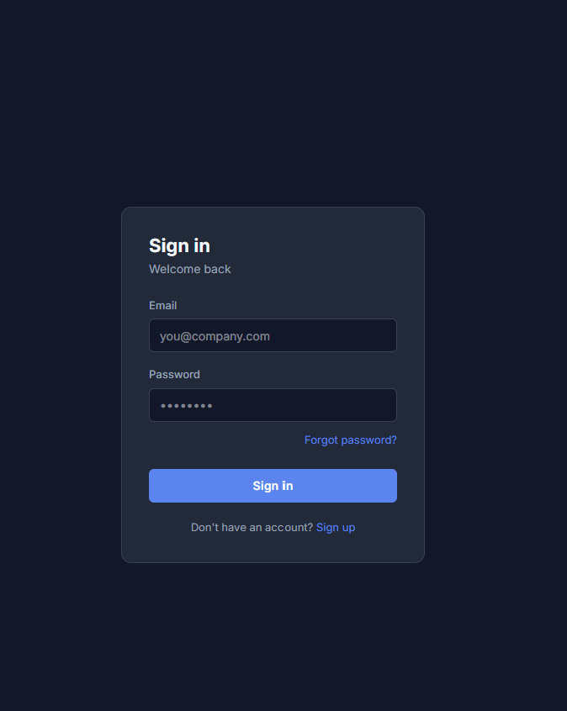
Login page — error state
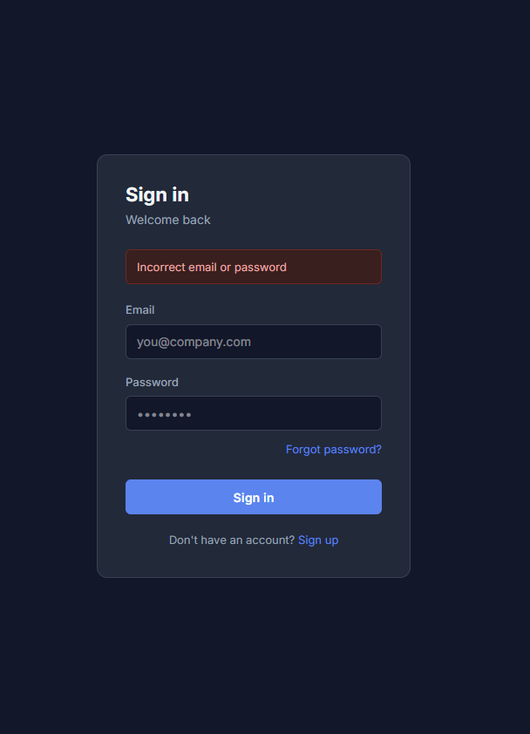
Team page — all five members
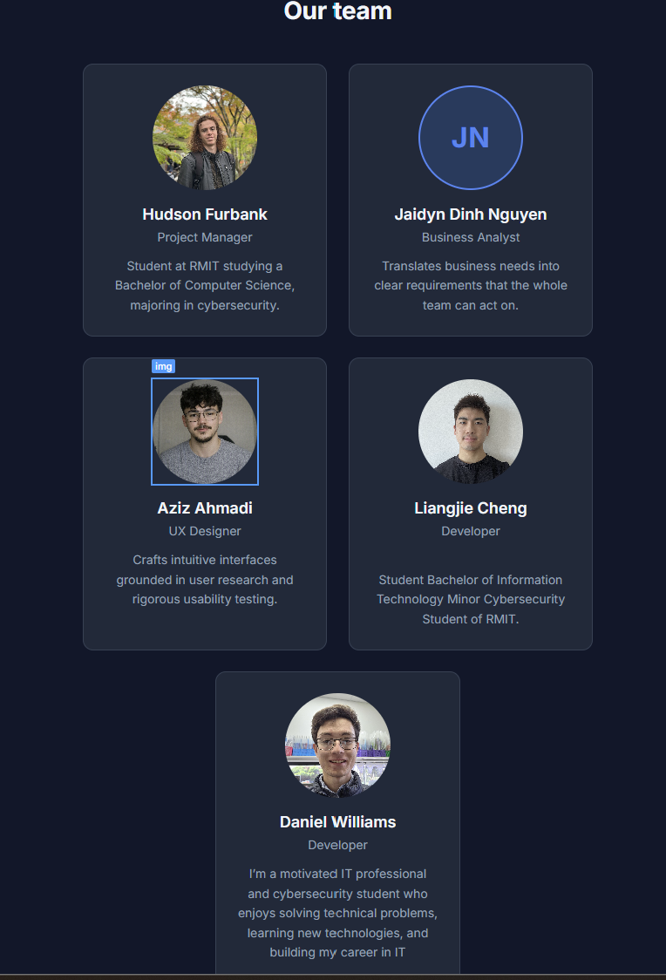
Team card — edge cases
Alr 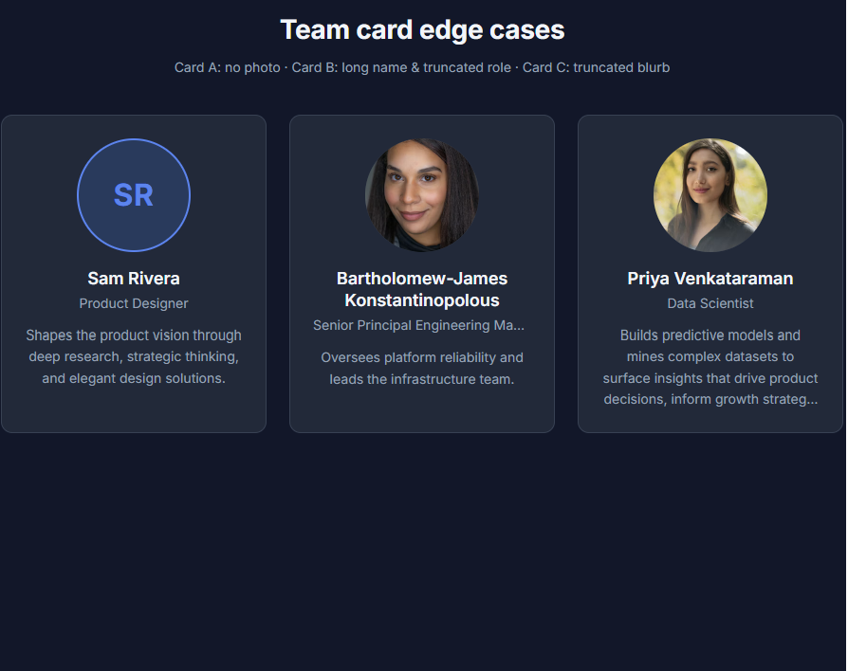
BA sign-off
Field | Value
Reviewed by | BA – Jaidyn Dinh Nguyen
Date | 12/08/26
Outcome | Approved / Changes requested
Comments | Looks good and aligns with my requirements, however a few things to clarify are how long roles are handled, what happens when names or blurbs exceed their maximum lines, and how missing name/role/blurb information is handled.

