

Robo Advisor
AQ098-3-3-RBA
Individual Assignment

STUDENT NAME: NGUYEN VAN KHOA
STUDENT NO: TP078366
INTAKE CODE: APD3F2601IT(FT)
LECTURER: DR. AHMAD DANIAL BIN ZAINUDIN
SUBMISSION DATE: 21/08/2026

TABLE OF CONTENTS
1.0 Introduction 3
2.0 Stock Selection and Data Preparation 3
2.1 Stock and Raw-Data Authentication 3
2.2 Data Preparation and Positive Average Daily Return Verification 3
3.0 Descriptive Statistics and Data Characterization 4
3.1 Return Distribution and Price Behavior 4
3.2 Missing Observations and Liquidity 4
4.0 Signal, threshold and holding-period design 5
5.0 Back-Testing Assumptions and FinBERT Configuration Defense 5
5.1 Realistic Backtesting Assumptions 5
5.2 FinBERT Configuration and Batch-Size Test 6
6.0 Performance Evaluation and Multi-Horizon Comparison 7
6.1 Cross-Horizon Performance 7
6.2 Best Horizon and Configuration 7
7.0 Critical Reflection and Financial Interpretation 8
7.1 Genuine Result Anomaly 8
7.2 Market Efficiency and Information Spillover 8
7.3 Transaction-Cost Drag and General Implications 9
8.0 Conclusion 10
9.0 References 10
10.0 Appendices 11

1.0 Introduction

This report develops and evaluates a FinBERT news-sentiment trading strategy for MI Technovation Berhad (5286) using one-minute price data from 13 April to 8 July 2026. Financial headlines are converted into trading signals and tested across multiple holding periods under defined risk and cost assumptions. Performance is assessed using return, risk and trading-efficiency metrics.

2.0 Stock Selection and Data Preparation

2.1 Stock and Raw-Data Authentication
MI Technovation Berhad (5286; MITE.KL) was selected for analysis. Figure A1 in Appendix A authenticates the LSEG Workspace export in MYR, containing one-minute exchange timestamps, closing prices and volumes from 13 April to 8 July 2026.

2.2 Data Preparation and Positive Average Daily Return Verification
As shown in Figure A2, the raw dataset contained 19,928 timestamped observations. Removing 5,338 rows with missing closing prices left 14,590 valid records, while no duplicate timestamps were found. Prices were not interpolated or forward-filled because artificial observations could overstate liquidity and bias the backtest’s entry prices, exit prices and returns.
The cleaned dataset covered 58 trading days and generated 57 daily returns. Figure A3 reports a positive arithmetic mean of 0.8849%, satisfying the assignment’s stock-selection requirement. The LSEG whole-period change was excluded because it is an endpoint return rather than the required mean of daily returns.

3.0 Descriptive Statistics and Data Characterization

3.1 Return Distribution and Price Behavior
Figure B1 in Appendix B shows an average daily return of 0.8849%, compared with a median of 0.6452% and a range from −6.2241% to 9.9476%. The standard deviation of 3.1641% substantially exceeded the mean, indicating that the positive return was accompanied by considerable volatility. Skewness of 0.2946 indicates a mildly positive but relatively balanced distribution, while Pearson kurtosis of 3.4146 suggests slightly heavier tails than a normal distribution and some exposure to unusually large movements.
The dataset covered 58 trading days and generated 57 daily returns. One-minute prices ranged from RM2.86 to RM5.06. Figure B2 shows that the daily closing price rose from RM2.88 on 13 April to RM5.06 on 3 June before ending at RM4.63 on 8 July. Although this upward movement supports the positive mean return, the wide price range and volatility justify clear risk controls and testing across multiple holding periods.

3.2 Missing Observations and Liquidity
Figure B3 shows that missing closing prices represented 26.79% of the raw observations, leaving valid-price coverage of 73.21% and an average of 251.55 valid one-minute bars per day. No missing volume fields remained. Total volume was 244.56 million shares, while average daily volume of 4.22 million exceeded the median of 3.13 million, indicating uneven trading activity. Furthermore, 55.00% of consecutive valid intraday prices were unchanged, while the longest observed gap was 22 minutes, from 10:43 a.m. to 11:05 a.m. on 5 May.
These findings indicate meaningful overall trading activity but intermittent intraday liquidity. Missing prices were therefore not artificially filled, and the strategy uses the next available observed price while recognizing possible execution delays, slippage and transaction-cost effects.

4.0 Signal, threshold and holding-period design
Figures C1 and C2 in Appendix C compare minimum daily sentiment thresholds of 0.00 and 0.30. Raising the threshold removed three weak signals, reducing entries from 20 to 17 (15%). At the one-day horizon, win rate increased from 10.00% to 11.76%, Sharpe improved from −0.28 to 1.24, and maximum drawdown fell from 6.58% to 4.31%.
The results demonstrate a frequency–conviction trade-off: 0.00 captures more signals but admits more noise, whereas 0.30 produces fewer, stronger trades. Greater selectivity is appropriate because the headlines mainly reflect broad US market sentiment rather than company-specific MI Technovation news. Therefore, 0.30 was selected, although the small sample of 17 trades requires cautious interpretation.
Holding periods of 1, 2, 3, 4, 5, 10 and 20 calendar days were tested. The shorter horizons examine immediate and gradual information absorption, while 10 and 20 days test persistence or reversal. This range is justified by MI Technovation’s 3.1641% daily volatility, mildly heavy-tailed returns and intermittent intraday liquidity.

5.0 Back-Testing Assumptions and FinBERT Configuration Defense

The final strategy and FinBERT settings are summarized in Figure C3 in Appendix C.

5.1 Realistic Backtesting Assumptions
The RM10,000 initial capital represents a plausible Malaysian retail account. Position size was reduced from 100% to 50% because committing all capital to each signal was excessive given MI Technovation’s 3.1641% daily volatility, mildly heavy-tailed returns and intermittent liquidity. The revised position is approximately RM5,000, leaving half the account as a risk buffer.
At prices of RM2.86–RM5.06, RM5,000 purchases approximately 1,000–1,700 shares, below 0.06% of the stock’s 3.13 million-share median daily volume. The assumed order should therefore have limited market impact. Round-trip transaction cost was set at 0.38% instead of the generic 0.50%. For a RM5,000 position, estimated brokerage, stamp duty and clearing fees total RM18.76 for entry and exit, equal to 0.3752% and rounded to 0.38% (Bursa Malaysia, n.d.; Rakuten Trade, n.d.).
The annual risk-free rate was adjusted from 3.00% to 2.75%, using Bank Negara Malaysia’s Q3 2026 Overnight Policy Rate as a current Malaysian benchmark proxy (Bank Negara Malaysia, 2026). The breakeven stop was retained because, once price rises sufficiently to cover transaction costs, it protects the position if price subsequently reverses. It does not prevent losses when the breakeven level is never reached.

5.2 FinBERT Configuration and Batch-Size Test
ProsusAI/finbert was retained because it is trained on financial language and classifies headlines as positive, negative or neutral (Araci, 2019). Net sentiment was calculated as positive probability minus negative probability, producing the daily signal used by the strategy.
Batch sizes 16 and 8 were tested on the same 74 eligible headlines. Batch size 16 required approximately five processing passes, whereas size 8 required approximately ten. Both completed without errors and produced identical signals and backtesting results, confirming that batch size affected computational efficiency rather than investment conclusions. Batch size 8 was selected because its lower memory demand was more suitable for a standard laptop, while the additional processing time was negligible for this small dataset.
The minimum headline length of 12 characters removed incomplete fragments, while the 0.55 alphabetic-ratio requirement excluded symbol-dominated or corrupted records. These filters reduced input noise without rejecting legitimate financial headlines containing prices, percentages or ticker symbols.

6.0 Performance Evaluation and Multi-Horizon Comparison

6.1 Cross-Horizon Performance
Figure C4 in Appendix C presents the complete multi-horizon results. The one- and two-day horizons generated 17 completed trades, while the others generated 16 because one late signal lacked sufficient future price data. Win rate increased from 70.59% at one day to 82.35% at two days and 87.50% from three days onward.
Returns strengthened through day five. Average return per trade rose across days one to five from 0.15%, 0.24%, 0.66% and 0.82% to 1.00%. Cumulative return similarly increased from 1.26% to 8.16%, raising ending equity from RM10,126.48 to RM10,815.87. Performance then weakened: at ten days, average return was 0.47%, cumulative return was 3.80% and equity was RM10,380.50. At 20 days, returns were approximately zero and equity remained RM10,000; therefore, its 87.50% win rate lacked economic significance.
Maximum drawdown was −2.05% at one day and −2.83% at two days, while the backtest reported 0.00% thereafter. Sharpe moved from 1.63 and 1.39 at days one and two to a peak of 3.90 at day three, before moderating to 3.30, 3.01 and 1.47 at days four, five and ten. It was undefined at day 20 because returns had virtually no variation. Profit factors of 1.46 and 1.74 at days one and two show that gains exceeded losses. From day three onward, profit factor was undefined because the breakeven-stop results contained no meaningful negative-return denominator; this does not mean unlimited profitability.

6.2 Best Horizon and Configuration

The three-day horizon delivered the strongest risk-adjusted performance through its 3.90 Sharpe ratio. However, five days was the best overall horizon because it achieved the highest average return per trade, cumulative return and ending equity, while retaining a strong 3.01 Sharpe ratio. The weaker ten- and twenty-day results suggest that the useful sentiment effect was concentrated within three to five days.
The selected configuration therefore combines ProsusAI/finbert, batch size 8, a 0.30 minimum daily score and a five-day holding period with the assumptions defended in Section 5. This remains an in-sample finding based on only 16–17 trades and does not guarantee future performance.

7.0 Critical Reflection and Financial Interpretation

7.1 Genuine Result Anomaly
A genuine anomaly is the 20-day horizon, which reported an 87.50% win rate despite an average return of 0.00%, cumulative return of 0.00% and unchanged ending equity of RM10,000. Its Sharpe ratio and profit factor were also undefined. This occurred because the breakeven stop exited trades at a price intended to recover the 0.38% round-trip cost, producing net returns extremely close to zero. Very small positive numerical values could still be counted as wins before being rounded to 0.00% in the report. Since these returns had virtually no variation or meaningful negative denominator, neither Sharpe ratio nor profit factor could be calculated. Therefore, the apparently high win rate at 20 days does not represent economic profitability and demonstrates why win rate should not be interpreted without return magnitude, risk and cost measures.

7.2 Market Efficiency and Information Spillover
Semi-strong market efficiency proposes that publicly available information should be rapidly incorporated into share prices (Fama, 1970). However, MI Technovation’s results strengthened gradually: cumulative return increased from 1.26% at one day to 8.16% at five days, while the highest Sharpe ratio occurred at three days. This pattern suggests that the market did not fully absorb the sentiment information immediately. It is consistent with gradual information diffusion, whereby less-followed or less-liquid securities may adjust more slowly to relevant information (Hou, 2007). Media sentiment can also create temporary price pressure before prices subsequently adjust or reverse (Tetlock, 2007).
MI Technovation’s intermittent liquidity provides a possible explanation. Approximately 55% of consecutive valid prices were unchanged, 26.79% of raw observations had empty closing-price fields, and the longest interval between observed prices was 22 minutes. These conditions may delay recorded price adjustment and allow information spillover across several trading days. Nevertheless, performance fell to 3.80% at ten days and approximately zero at 20 days, indicating that the information advantage eventually disappeared. This does not disprove market efficiency because the test used only 16–17 trades, covered 58 trading days and occurred during a strong upward price trend that may have contributed to the returns.

7.3 Transaction-Cost Drag and General Implications
Transaction costs materially affect the viability of the strategy. After applying a 0.38% round-trip cost, the one-day horizon earned an average of only 0.15% per trade. This narrow margin could be eliminated by bid–ask spreads, slippage or delayed execution, which were not fully captured by the fixed-cost assumption. Prior research similarly shows that frequent trading costs can substantially reduce or eliminate apparently profitable strategies (Lesmond et al., 2004). The stronger five-day average return of 1.00% provided a larger buffer against these costs, while the breakeven stop prevented some profitable trades from reversing into losses. However, the stop does not limit losses when the price never reaches breakeven and may partly explain the zero returns and undefined profit factors at longer horizons.
More generally, one-minute data and rapid sentiment scoring do not guarantee that intraday trading will be profitable. News-based strategies should filter weak signals, avoid excessive turnover, use realistic execution prices and costs, and match the holding period to the signal’s information life. For this sample, the useful response was concentrated within three to five days, with five days producing the best overall in-sample result. However, this conclusion requires confirmation using longer datasets, additional stocks, realistic slippage, non-overlapping or independently evaluated trades, and out-of-sample comparison against buy-and-hold and no-news benchmarks.

8.0 Conclusion
The FinBERT strategy showed that strong positive news sentiment contained short-lived predictive value for MI Technovation. The five-day horizon achieved the best overall result, generating an 8.16% cumulative return and ending equity of RM10,815.87, while the three-day horizon recorded the highest Sharpe ratio of 3.90. Performance weakened after five days, indicating that the signal’s information value gradually disappeared. However, the small sample, intermittent liquidity and execution costs mean these findings remain preliminary and require longer out-of-sample testing before practical implementation.

9.0 References

Araci, D. (2019). FinBERT: Financial sentiment analysis with pre-trained language models [Preprint]. arXiv. https://doi.org/10.48550/arXiv.1908.10063
Bank Negara Malaysia. (2026, July 9). Monetary policy statement. https://www.bnm.gov.my/-/monetary-policy-statement-09072026
Bursa Malaysia. (n.d.). Transaction costs. Retrieved August 18, 2026, from https://www.bursamalaysia.com/trade/trading_resources/equities/transaction_costs
Fama, E. F. (1970). Efficient capital markets: A review of theory and empirical work. The Journal of Finance, 25(2), 383–417. https://doi.org/10.2307/2325486
Hou, K. (2007). Industry information diffusion and the lead-lag effect in stock returns. The Review of Financial Studies, 20(4), 1113–1138. https://doi.org/10.1093/revfin/hhm003
Lesmond, D. A., Schill, M. J., & Zhou, C. (2004). The illusory nature of momentum profits. Journal of Financial Economics, 71(2), 349–380. https://doi.org/10.1016/S0304-405X(03)00206-X
Rakuten Trade. (n.d.). FAQs: Charges and fees. Retrieved August 18, 2026, from https://www.rakutentrade.my/faqs/charges-and-fees
Tetlock, P. C. (2007). Giving content to investor sentiment: The role of media in the stock market. The Journal of Finance, 62(3), 1139–1168. https://doi.org/10.1111/j.1540-6261.2007.01232.x

10.0 Appendices

Appendix A: Data Source and Preparation Evidence

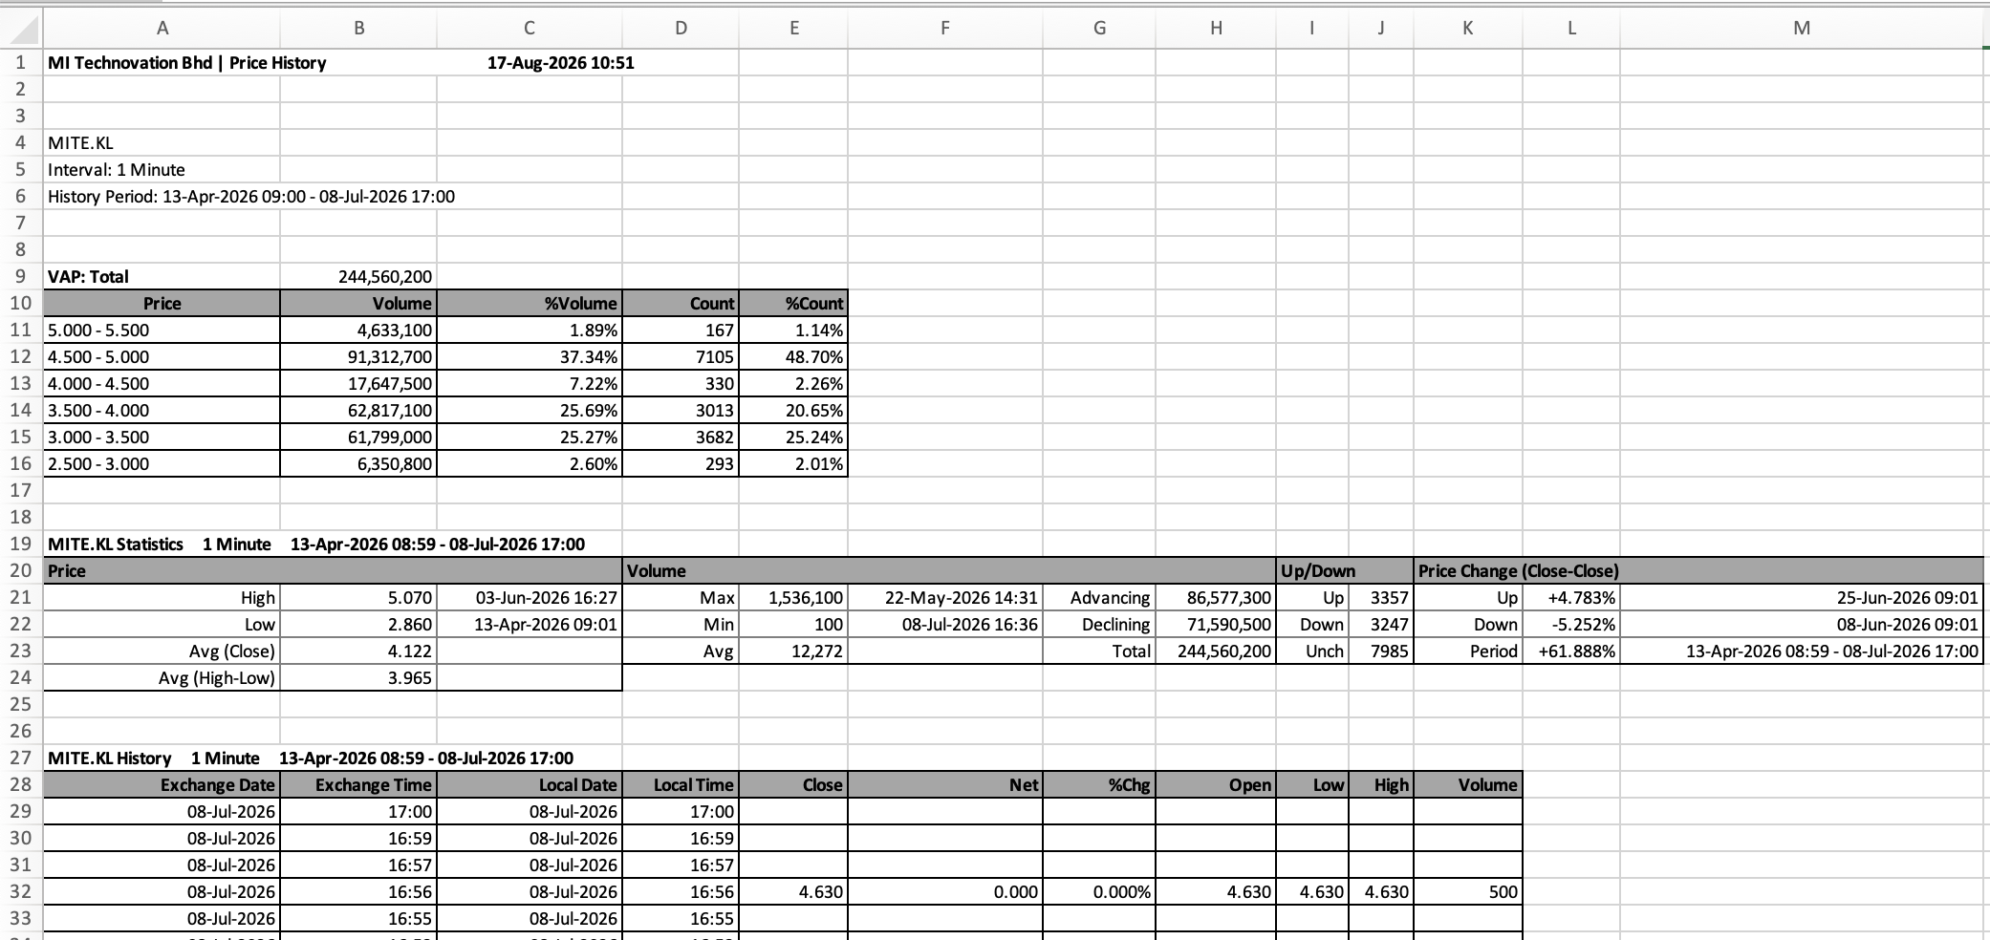
Figure A1. Timestamped one-minute raw price export for MI Technovation Berhad.
Source: LSEG Workspace (2026).

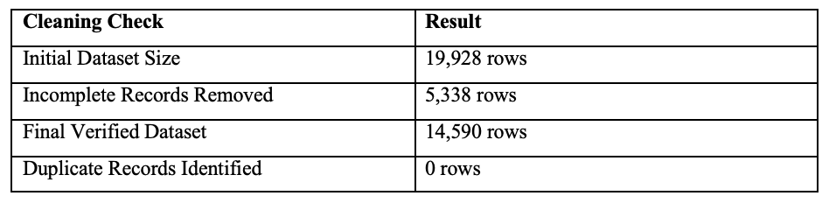
Figure A2. Price-data cleaning verification for MI Technovation Berhad.
Source: Author’s calculation using LSEG Workspace data (2026).

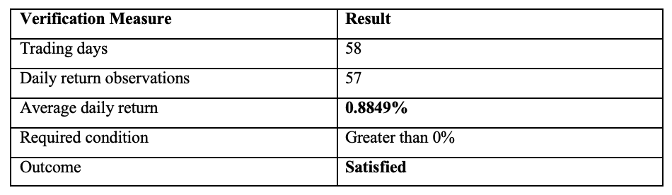
Figure A3. Positive average daily-return verification for MI Technovation Berhad.
Source: Author’s calculation using LSEG Workspace data (2026).

Appendix B: Descriptive Statistics and Price Behaviour

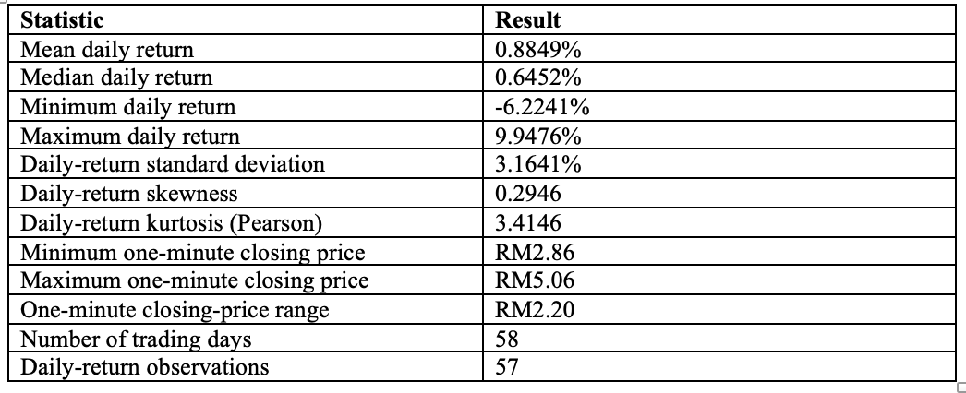Figure B1. Descriptive statistics of MI Technovation Berhad.
Source: Author’s calculation using LSEG Workspace data (2026).
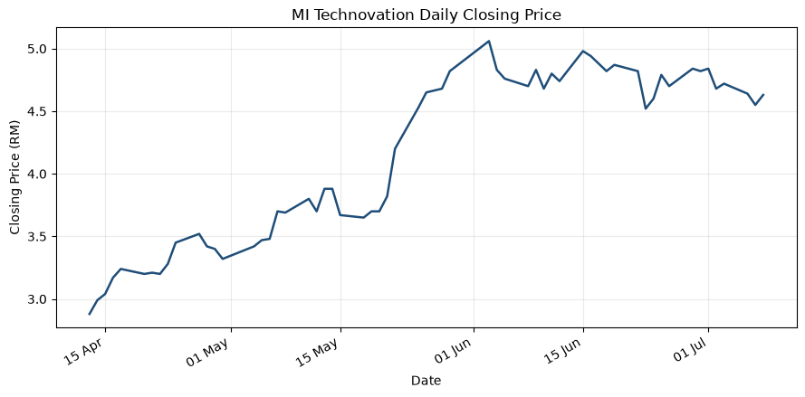Figure B2. Daily closing price of MI Technovation Berhad.
Source: Author’s calculation using LSEG Workspace data (2026).

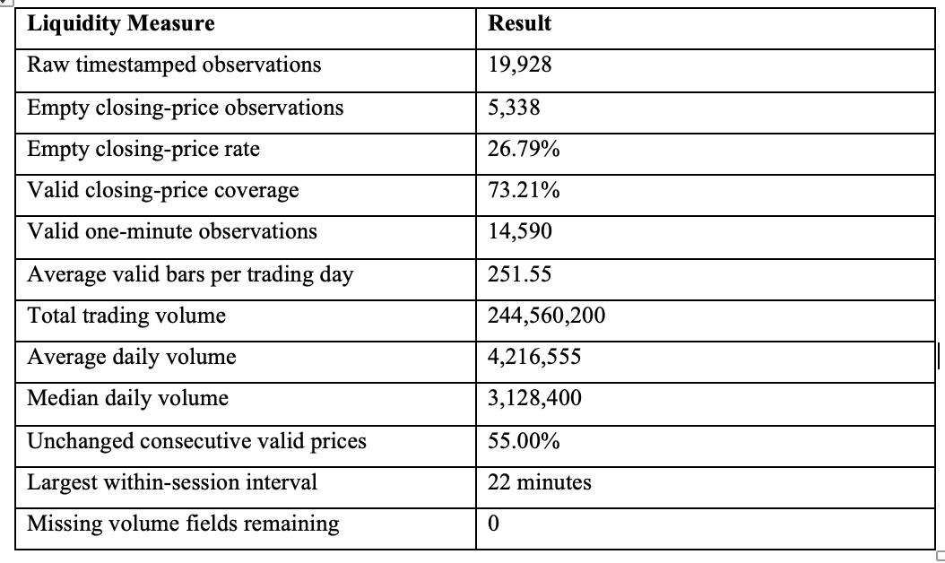Figure B3. Missing observations and liquidity measures.
Source: Author’s calculation using LSEG Workspace data (2026).

Appendix C: Strategy Configuration and Supporting Outputs

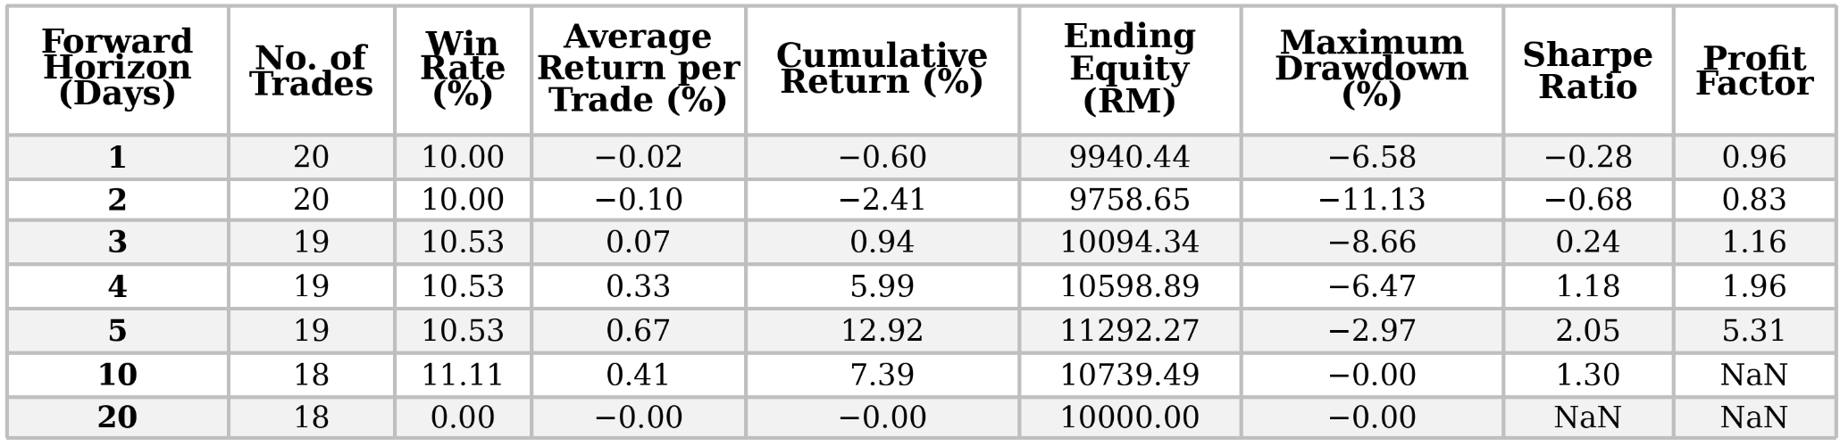Figure C1. Backtesting results using threshold 0.0 for MI Technovation Berhad.
Source: Author’s backtesting results (2026).

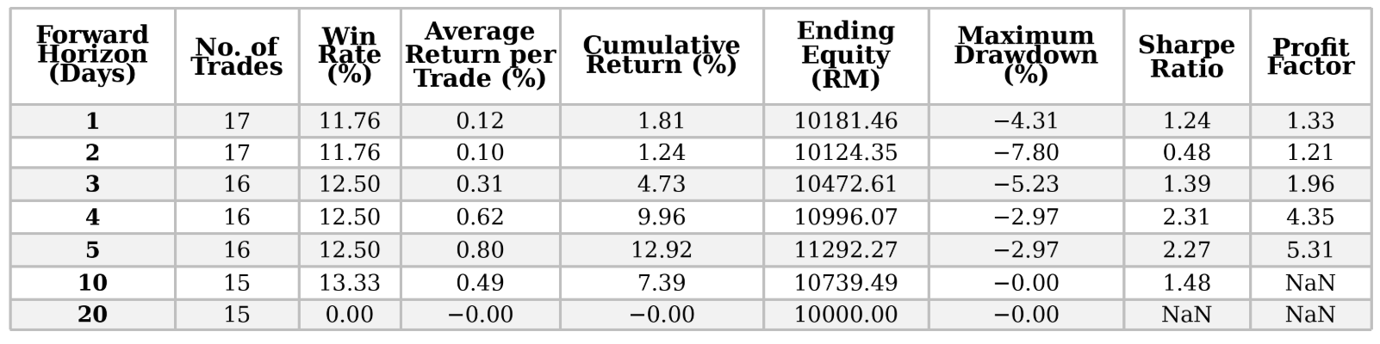Figure C2. Backtesting results using threshold 0.3 for MI Technovation Berhad.
Source: Author’s backtesting results (2026).
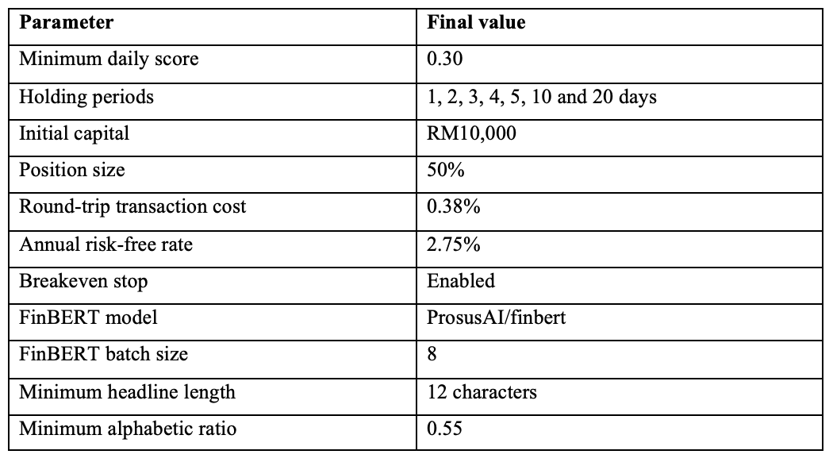
Figure C3. Final backtesting assumptions and FinBERT configuration.
Source: Author’s strategy configuration (2026).

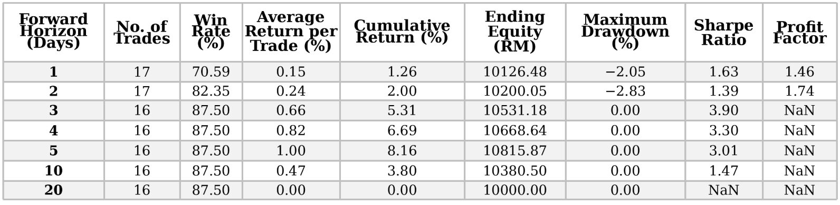
Figure C4. Multi-horizon performance of the final FinBERT strategy.
Source: Author’s backtesting results (2026).

