|  |  |
| --- | --- |
| compareTo(Integer anotherInteger) | 與另一個 Integer 物件比較大小,傳回 0 表示相等,傳回 -1 表示小於anotherInteger,傳回 1 表示大於 anotherInteger |

程式範例：

public class WrapperDemo{

    public static void main(String[] args){

        Integer ageOfStudent = new Integer(20);

        Integer ageOfOther = new Integer(10);

        int result = ageOfStudent.compareTo(ageOfOther);

}

結果：

result=1

|  |  |
| --- | --- |
| 1  2  3  4  5  6  7  8  9  10  11  12  13 | public class AutoBoxDemo3{      public static void main(String[] args) {          Integer iRef1 = 200;          Integer iRef2 = 200;            if (iRef1.equals(iRef2)) {              System.out.println("iRef1 == iRef2");          }          else {              System.out.println("iRef1 != iRef2");          }      }  } |

*程式碼 8-4 AutoBoxDemo3.java*

執行結果如下:

[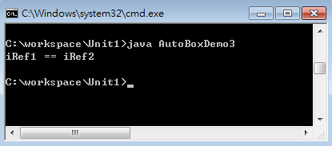](http://www.codedata.com.tw/book/java-basic/images/8-13.png)

**重點提示**

**關係運算子==用於比較物件時,是用來比較兩個物件是否為同一物件,如果您要比較兩個物件的相等性,請用equals()方法**

**String類別：**

[**http://www.kaiching.org/2011/01/java-string.html**](http://www.kaiching.org/2011/01/java-string.html)

[**https://caterpillar.gitbooks.io/javase6tutorial/content/c6_1.html**](https://caterpillar.gitbooks.io/javase6tutorial/content/c6_1.html)

[**http://www.codedata.com.tw/book/java-basic/index.php?p=ch9-2**](http://www.codedata.com.tw/book/java-basic/index.php?p=ch9-2)