KinderSort — Teacher's Guide
*How to sort your students' event photos automatically*

What KinderSort Does
KinderSort looks at each photo from a school event and finds your students' faces.
It then automatically puts each photo into the right student's folder — so you don't
have to sort hundreds of photos by hand!
**One photo can appear in multiple folders** — for example, a group shot with three
students will be copied to all three students' folders.

Before You Start
You need three folders ready on your computer:

1. Reference Photos Folder
One clear, front-facing photo of each student.
- Name each photo with the student's full name
- Examples: `Ali.jpg`, `Siti.png`, `Kumar.jpeg`
- Make sure the face is clearly visible and well-lit

2. Events Folder
A folder containing **subfolders** — one subfolder per event.
- Example structure:
```
Events/
Sports_Day/
IMG_001.jpg
IMG_002.jpg
Field_Trip/
IMG_003.jpg
```
- ⚠️ **Important:** Photos must be inside a subfolder (the event name), not directly in the Events folder.

3. Output Folder
An empty folder where KinderSort will save the sorted results.
You can create a new empty folder anywhere on your computer.

Step-by-Step Guide

Step 1 — Open KinderSort
Double-click the **KinderSort.exe** file to launch the app.
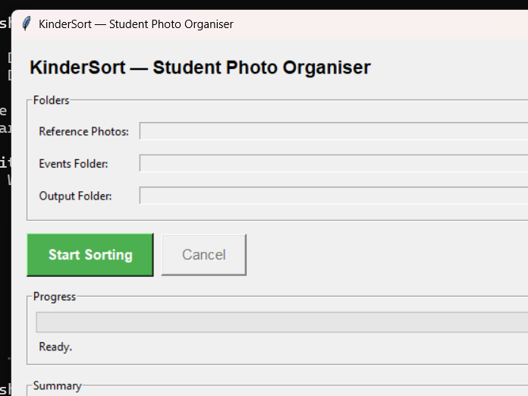
You will see three folder selector rows at the top.

Step 2 — Select Your Reference Photos Folder
Click the **Browse…** button next to "Reference Photos".
Navigate to your folder of student reference photos and click **Select Folder**.
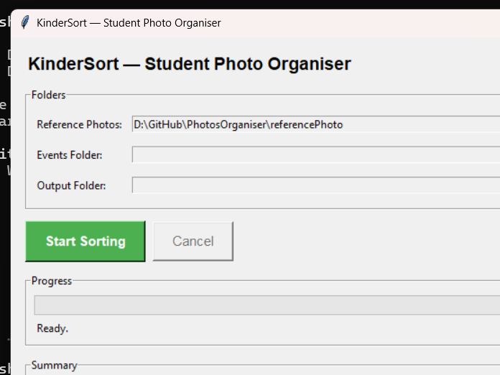
The path to your folder will appear in the box.

Step 3 — Select Your Events Folder
Click the **Browse…** button next to "Events Folder".
Navigate to your Events folder (the one containing event subfolders) and click **Select Folder**.
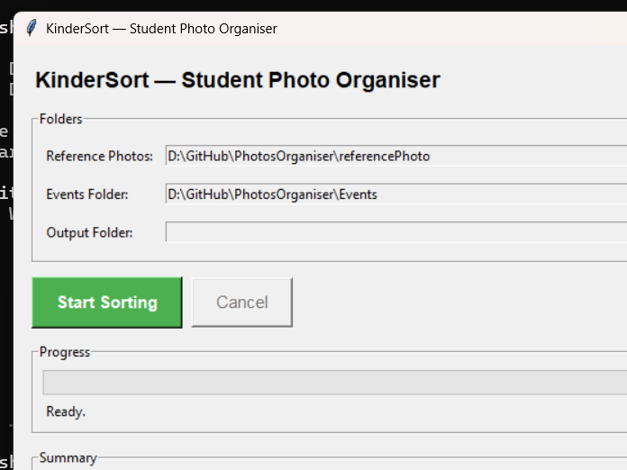

Step 4 — Select Your Output Folder
Click the **Browse…** button next to "Output Folder".
Navigate to your empty output folder and click **Select Folder**.
When all three folders are selected, the app is ready.
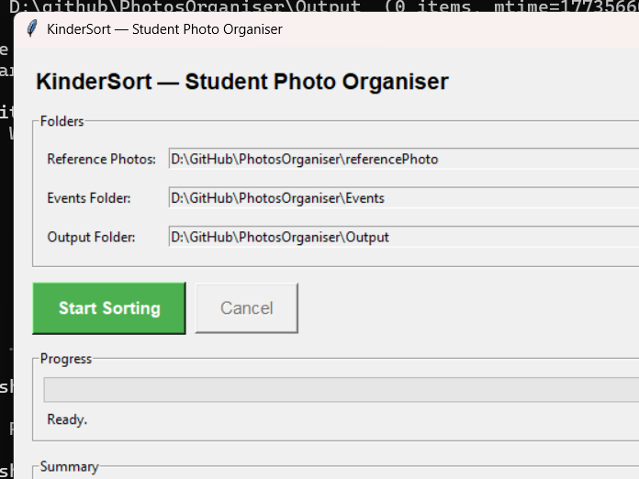

Step 5 — Start Sorting
Click the large green **Start Sorting** button.
KinderSort will begin processing your photos. You will see:
- A **progress bar** filling up as photos are processed
- A **status line** showing the current photo filename
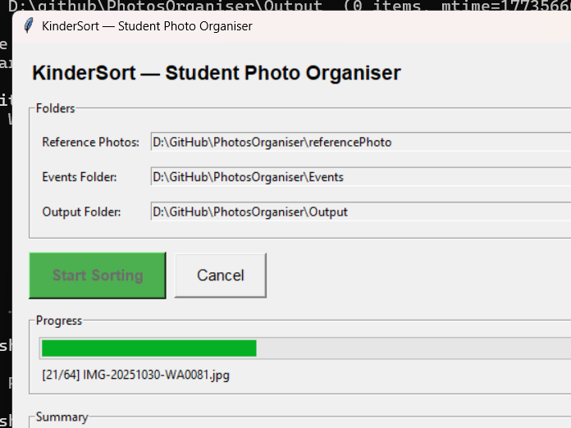
⏱️ Processing time depends on the number of photos. Expect about 1–2 minutes per 10 photos on a normal computer.
You can click **Cancel** at any time to stop — photos processed so far will be saved.

Step 6 — Review the Results
When sorting is complete, you will see a summary:
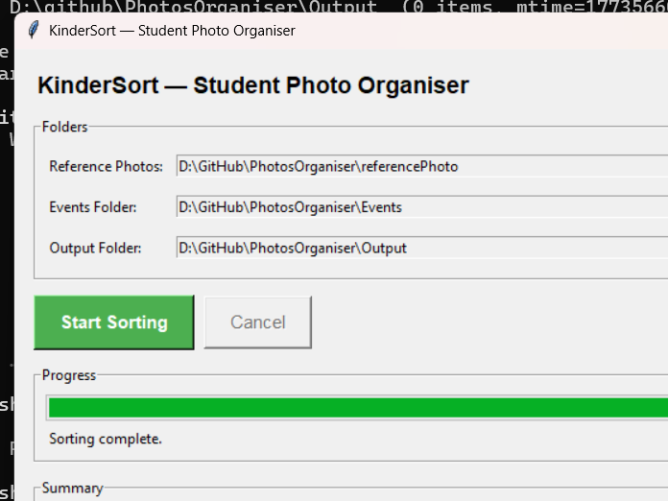
The summary shows:
- **Total images found** — how many photos were scanned
- **Matched (sorted)** — how many photos were placed into student folders
- **Unmatched** — photos where no student face was recognised
- **Skipped (errors)** — photos that could not be opened

Understanding Your Output Folder
After sorting, your Output folder will look like this:
Output/
Ali/
Sports_Day__IMG_001.jpg
Concert__IMG_045.jpg
Siti/
Sports_Day__IMG_001.jpg ← same group photo, copied here too
Field_Trip__IMG_023.jpg
_unmatched/
blurry_photo.jpg
background_only.jpg
kindersort_log.txt
**Each student has their own folder** containing all photos where their face was detected.
The **`_unmatched` folder** contains:
- Photos where no faces were detected (e.g. landscape shots, blurry images)
- Photos where faces were detected but didn't match any student (e.g. teachers, parents)
The **`kindersort_log.txt` file** is a detailed record of everything KinderSort did.
You don't need to read it normally, but it's useful if something seems wrong.

Common Problems & Solutions

"No face was detected" warning on startup
**Cause:** One of your reference photos doesn't show the student's face clearly enough.
**Fix:** Replace that student's reference photo with a clearer, front-facing photo.
Good lighting and a plain background work best.

Many photos end up in `_unmatched`
**Possible causes:**
- Reference photo quality is poor — use a clearer photo
- Event photos are very blurry or taken from far away
- Students are wearing face masks or hats in the event photos
**Fix:** Try better reference photos first. KinderSort cannot recognise faces that
are partially covered or turned away.

"Missing folders" error when clicking Start
**Fix:** Make sure all three folder fields are filled in before clicking Start Sorting.

The app seems stuck / progress bar not moving
**Cause:** Face recognition is CPU-intensive — it is still working.
**Fix:** Wait patiently. A batch of 100 photos may take 10–15 minutes on an older computer.
Watch the status line — if it shows a new filename, it is still running.

Output folder photos have long names like `Sports_Day__IMG_001.jpg`
This is normal! The event folder name is added as a prefix so you always know
which event a photo came from.

Tips for Better Results
- **Use a clear, recent reference photo** — front-facing, good lighting, no sunglasses
- **One face per reference photo** — if a reference photo has multiple faces, KinderSort uses the first face detected
- **Consistent lighting** helps — very dark or backlit event photos may not match well
- **Re-run with a higher tolerance** if you're missing matches — ask your IT support to adjust the `DISTANCE_THRESHOLD` in `sorter.py` from `0.5` to `0.6`
- **Keep events in subfolders** — KinderSort only reads photos inside named subfolders of the Events folder

*KinderSort — Student Photo Organiser | Runs fully offline, no internet required*

