Anotaciones bibliografía

Histonas
transcription start site (TSS) and transcript end sites (TES)

Estas histonas se encuentran correlacionadas de forma negativa con la hipermetilación del DNA, es decir, NO SE ENCUENTRAN EN REGIONES HIPERMETILADAS.
SE ENCUENTRAN EN REGIONES HIPO-METILADAS?????
Nuestras histonas no deben estar en estados relacionados con CpG
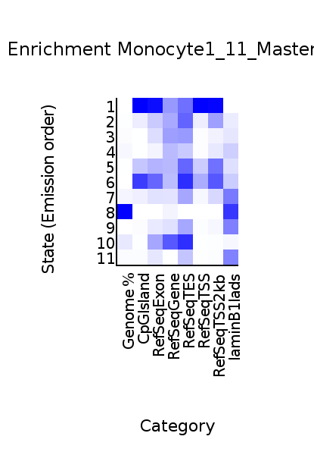
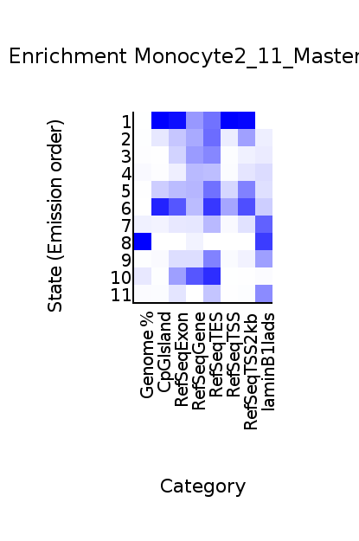

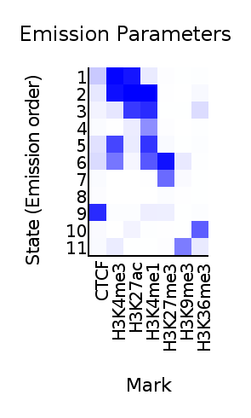

El estado 1 tiene mucha relación con regiones hipermetiladas, pero también con regiones TSS y en menor medida regiones TES. Las modificaciones de histonas H3K4me3 y H3K27ac se encuentran enriquecidas en el estado 1 → podría ser por las regiones TSS. La CpG porque H
El estado 5 está enriquecido algo en TES. En el estado 5 solo está enriquecida la H3K4me3, podría ser un artefacto porque también está en ese estado la H3K4me1 y se colocan en posiciones diferentes. ¿El estado 5 es una combinación de H3K4me3 y H3K4me1, pero no hay gran presencia en TSS? Estaría mal???
H3K4me3 → histona 3 tri-metilada en lisina 4
- Se une a promotores activos
- Su presencia indica que es un promotor activo
H3K27Ac → histona 3 mono-acetilada en lisina 27
- Marcador de enhancer
- Se encuentra en enhancer proximales y distales de genes
- Se encuentra enriquecido en regiones TSS

Frases bibliografía
https://www.ncbi.nlm.nih.gov/pmc/articles/PMC4793332/ (2016)
“expanded regions of DNA sequences that are marked by enhancer-specific histone modifications, such as acetylation of histone H3 lysine 27 (H3K27ac) domains coincide with cell-specific enhancers, known as super or stretch enhancers.”

https://www.ncbi.nlm.nih.gov/pubmed/29233090 (2017)
“DNA methylation at promoters is largely correlated with inhibition of gene expression.”
“found anti-correlation between H3K4me1 and H3K4me3 enrichment at low and intermediate DNA methylation loci. We hypothesized "seesaw" (balancín) dynamics between H3K4me1 and H3K4me3 in the low and intermediate DNA methylation range, in which DNA methylation discriminates between enhancers and promoters, marked by H3K4me1 and H3K4me3, respectively.”
Importante: “We summarize these observations into a rule of thumb of one-out-of-three methylation marks: "In each genomic region only one out of these three methylation marks {DNA methylation, H3K4me1, H3K4me3} is high. If it is the DNA methylation, the region is inactive. If it is H3K4me1, the region is an enhancer, and if it is H3K4me3, the region is a promoter". ”

No confundir H3K4me3 con H3K4me1 → “H3K4me1, in contrast to all other active chromatin marks, is positively correlated with DNA methylation within hypomethylated regions at enhancers and promoters”

Importante → “The active chromatin marks (H3K4me1, H3K9ac, H3K4me3, H3K27ac) show negative correlations with DNA hypermethylated classes, while some repressive marks, including H3K9me3 and H3K20me3, are positively correlated”
“the negative correlation with DNA hypermethylated is especially strong in Promoter-TSSs. ”

“According to their distance to the TSSs, the enhancers are usually classified into proximal and distal enhancers. The flanking regions of promoters are usually enriched with H3K4me1 defining proximal enhancers; however, the study of DNA methylation regulating histone methylation is more relevant in distal regions.”
“We studied the correlation of the signal of the three methylation states of H3K4 {me1, me2, me3} with the DNA methylation level, and found that while H3K4me2 and H3K4me3 signals anticorrelate with DNA methylation level across the whole DNA methylation range,”
“H3K4me3 enrichment occurs at low DNA methylation level (Med = 24%)” median DNA methylation (Med)

https://www.ncbi.nlm.nih.gov/pubmed/29484447
“Enhancers are cis-regulatory elements which promote transcription activation and are characterized by histone marks including H3K27ac and H3K4me1/2”
“A subset of constituent enhancers arbitrarily defined as super enhancers (SEs) are typically marked by dense H3K27ac and H3K4me,”

Importante → “DNA methylation is essential for the deposition of specific histone modifications and specifically acts upstream (primero metilación de DNA y luego estas histonas) of H3K27me3, H3K27ac, and H3K4me, histone marks with regulatory consequences at both gene promoters and enhancers, while H3K4me3 is deposited independently of DNA methylation.”

https://en.wikipedia.org/wiki/H3K27ac
“Acetylation is usually linked to the up regulation of genes. This is the case in H3K27ac which is an active enhancer mark. It is found in distal and proximal regions of genes. It is enriched in Transcriptional start sites (TSS).”

Estado 1 | N.º segmentos (200 bp) | Proporción
intersección sin filtrar completo | 48602 | Total
intersección filtrado 0.7 completo | 44008 | 90% (perdemos 10%)
intersección filtrado 0.9 completo | 39207 | 80% (perdemos 20%)

Estado 2 | N.º segmentos (200 bp) | Proporción
intersección sin filtrar completo | 92408 | Total
intersección filtrado 0.7 completo | 81418 | 88% (perdemos 12%)
intersección filtrado 0.9 completo | 63315 | 69% (perdemos 31%)

