HOW TO START SAVING

This is a quick guide on how to start saving and investing. It shows good practices and habits to keep a healthy financial life, as well as sustainable and prepared for mishaps. It will show you how to use your available time and money while having a normal job, in order to be able to quit it one day to live from what you generate. It will help you grow diversified sources of income aside from your job, and will help you achieve financial freedom in the long term.

The contents of this guide are meant as a compilation of good practices, just to get you started on saving and investing, and under no circumstance represent financial advise.

WHERE DO I START?

This guide assumes you have a job and a salary. At this stage it's not important how much you get paid, what's important is that you have a reliable periodic income of money. At the same time you also have liabilities, or expenses: your rent or mortgage, bills, groceries expenses, children's education, your ex's monthly payment... Most people are careless with money and don't prepare for eventualities, spending the whole or most of their salary every month. Besides, they usually spend the most on the first days after getting it, which means the rest of the month they will be in a worse scarcity situation, not realising how much wealth they are letting slip through their fingers.

I will also imagine you have little to no savings. This guide helps you on how to get started from zero savings. You may or may not have a mortgage. This is always a right financial decision, but we need to choose the right moment to do so, both in our lives and the real state market.

A NOTE ABOUT TAXES

Before we start, it's worth making some mentions about taxes.

Most people have an allowance of £1000 earned in interest every year. That means the first £1000 you make every tax year are tax-free. Read more here https://www.gov.uk/apply-tax-free-interest-on-savings. The rest of the money will be taxed according to your tax band. Learn more about tax bands here https://www.gov.uk/income-tax-rates

ISAs are a very powerful instrument for increasing your wealth. They allow you to put money away while getting your interest tax-free. You can find more information on https://www.gov.uk/individual-savings-accounts

A NOTE ABOUT CREDIT SCORE

Your credit score measures how attractive you are for banks to lend you money. It represents how reliable you are to return that money in time. In this guide we will need to create some current/savings/ISA accounts, so we will need to keep an eye on the credit score to do this successfully. This is because most current accounts have some overdraft associated, which counts as credit, so you won't be granted one unless you have a worthy score.

There are three Credit Score Agencies in the UK: Equifax, Experian and TransUnion. All three of them offer services for you to track and improve your score, but those are paid services. However, for each provider there is a free alternative provider you can use, so you can stay on top of our credit score.

PROVIDER | FREE ALTERNATIVE
Equifax | ClearScore  https://app.clearscore.com/login
Experian | MSE's Credit Club  https://clubs.moneysavingexpert.com/creditclub/register
TransUnion (formerly CallCredit) | Credit Karma (formerly Noddle)  https://www.creditkarma.co.uk/account/sign-in

If you need to open a new current account, you should check your credit score to know whether you are likely to be approved, before applying. In case your score is not high enough, you can build it with Credit Score Building Credit Cards. Here are some recommended ones:
- Vanquis Card – High chances of being approved. The available amount and the rate will depend on your personal circumstances. Referral: you can get £25 after your first transaction using the link https://www.vanquis.co.uk/raf-app?code=D790CE2ACDF42A38C273

Now that we know the basics, it's time to start the plan. These are, in order, the first steps to follow for someone on this situation.
- Track your expenditure
- Minimize your expenditure to maximise your savings
- Where to put your savings
- Learn about investing
- Other ideas to diversify your income streams

- TRACK YOUR EXPENDITURE

It all boils down to how much goes in, and how much goes out. If you are a regular employer you would know exactly how much comes in every month, but if you work on commission or similar your wages may vary. In this case, you probably want to be more conservative with your savings, allowing you to have some money for a rainy day, or month.

But it's in what comes out where we have the biggest power, at least at this stage. By spending less we are retaining more wealth, that could become an asset in the future to acquire even more wealth. The first thing is to make a budget. In an excel sheet, start by breaking down your expenditure and set an amount that you will spend on each concept during the following month. Don't be too precise when creating the categories. For example, rather than specifying shampoo, or train for Tuesday, you can create categories for groceries and transportation.

Then you only need to update your table with your actual expenditure. Whenever you spend money, the table needs to be updated in order to do the tracking. Once you notice one of the concepts is getting closer to the limit, you could try to be more conscious about spending more on it. This is actually something very easy to do, but where the most people struggle because they can't see the huge benefit. If you manage to track your expenditure, to the penny, you will get to know your spending habits well, and now you can start acting on them. They will impose some discipline on spending and tracking habits that will be paramount in future steps of this plan.

If you don't need to start saving immediately, you can trial the first month by trying to guess how much you will spend on each category, then spending normally and comparing the results against your predictions.

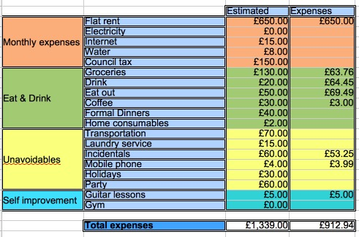Illustration 1: Example of expenditure table

- MINIMISE YOUR EXPENDITURE TO MAXIMISE YOUR SAVINGS

Now that you know your expenditure habits, it's time to act on them. Realise how much money you spend on things you don't need, and things that you eat or drink that are bad for your health. Cut toxic habits out. Restrict expensive habits. Try to be more smart about making the most out of your resources, try to get deals in the supermarket that you can easily stock. We are looking for all those pennies that we can spare – and we didn't even know we could! This will be the beginning of our savings, and where we will start building up our wealth.

Saving is always a great thing but sometimes hard for people with some habits. Some of you may have expensive tastes, like clothes, restaurants or trips. This doesn't mean you should ditch them immediately. Your life is your most precious resource and you should enjoy it to the fullest. But being smart about money, or financially savvy, will allow you to live more carefree, and probably to enjoy it further.

Remember saving is always the cheapest money! You will see further down the line, but once you start having money and investing it, even when you get good rates you will be risking a lot of money for the promise of a reward, that you could have easily saved instead. To give you an example, in order to generate £100 from investments, at an annual rate of 5%, you will need to invest £2000. That means that you need to take £2000 from your pocket and risk losing it, only for the promise of a reward of £100 after a year, which you probably could have saved easily by cutting one food delivery every couple of months. Besides, your benefit is subject to taxing regulations, whereas your savings are always tax-free. See? Saving is cheaper! It's easier! And it's the foundation of our financial plan, so you better be committed if you want to make it there!

Adjust your original budget, and try to stick to it. Don't spend on concepts that you planned to not spend, and don't go beyond the threshold on the rest. Now you have actual power over how much money you can save (generate) per month. You should keep reviewing your budget in the long term, as your needs will change with time.

- WHERE TO PUT YOUR SAVINGS

We now have a stream of money that we don't spend every month. Great! The first part of our plan is now complete. Now we want this stream of money to generate more money, so we can increase the stream month after month.

It's usually a good idea to have a month worth of expenses. Other authors say three. I personally think one can be short at times, and three may be too much to keep always available. This is not exact maths, so find a solution according to your needs. If you don't have a clue you can start with a month. So, our first financial goal will be to save up the amount of money we need to continue living the same way for a month, multiplied by the number of months we have chosen.

And here is when it becomes interesting. While you get there, you may as well get some interest on your savings. There are several ways to do this but under no circumstance have your savings at 0%. Why would you? Nowadays there are current bank accounts that pay you interest on your balance.

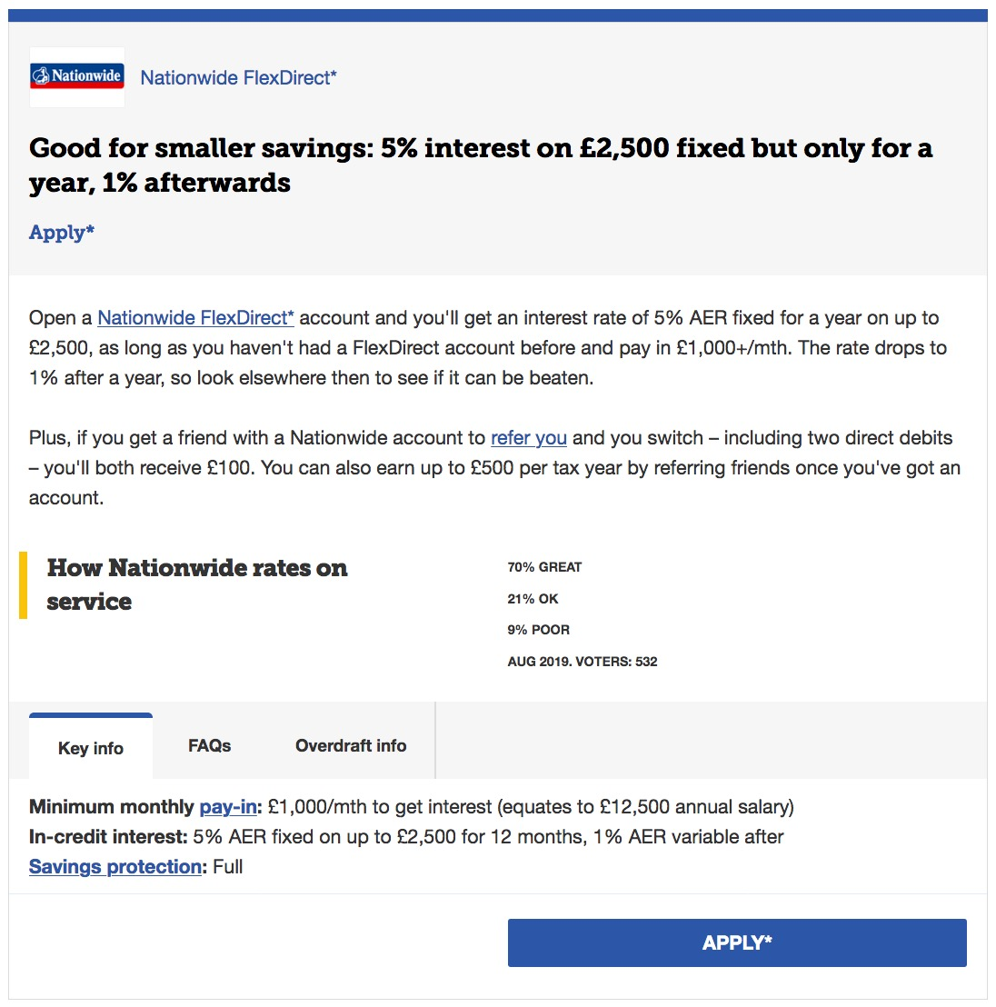
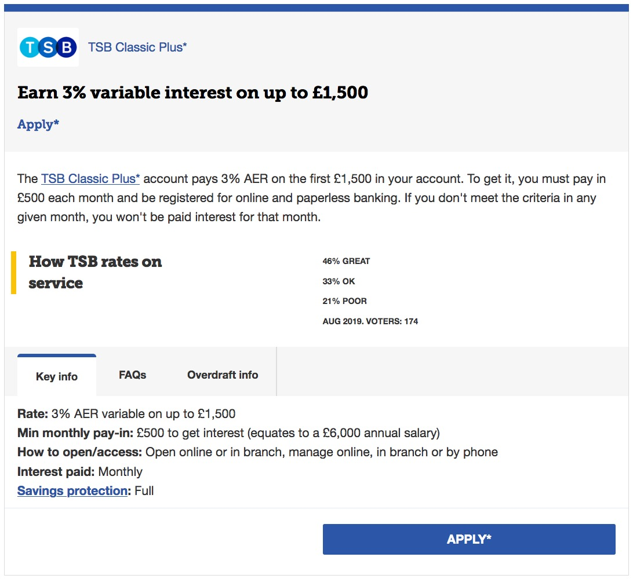
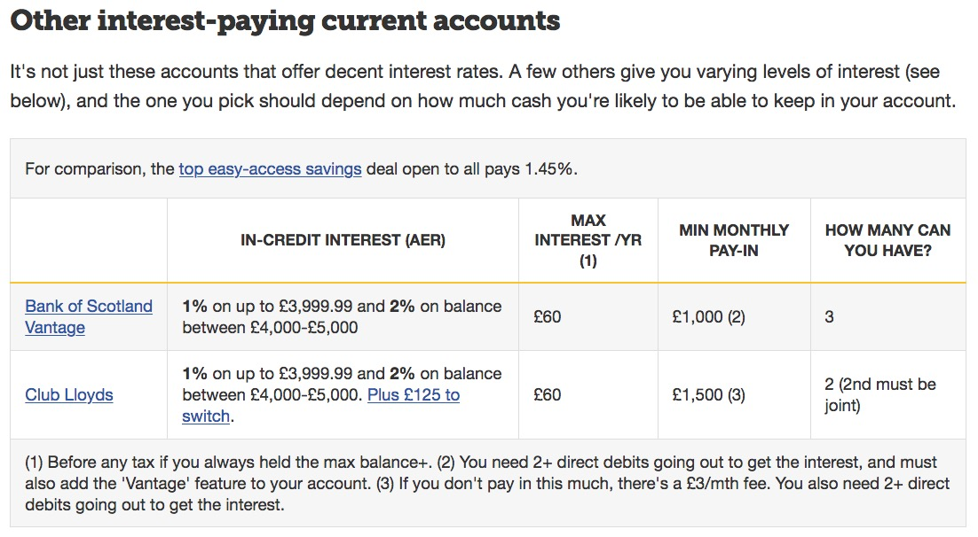Illustration 2: Current bank accounts with interest. Source: moneysavingexpert.com
Alternatively, you could choose a savings account or even a cash ISA.

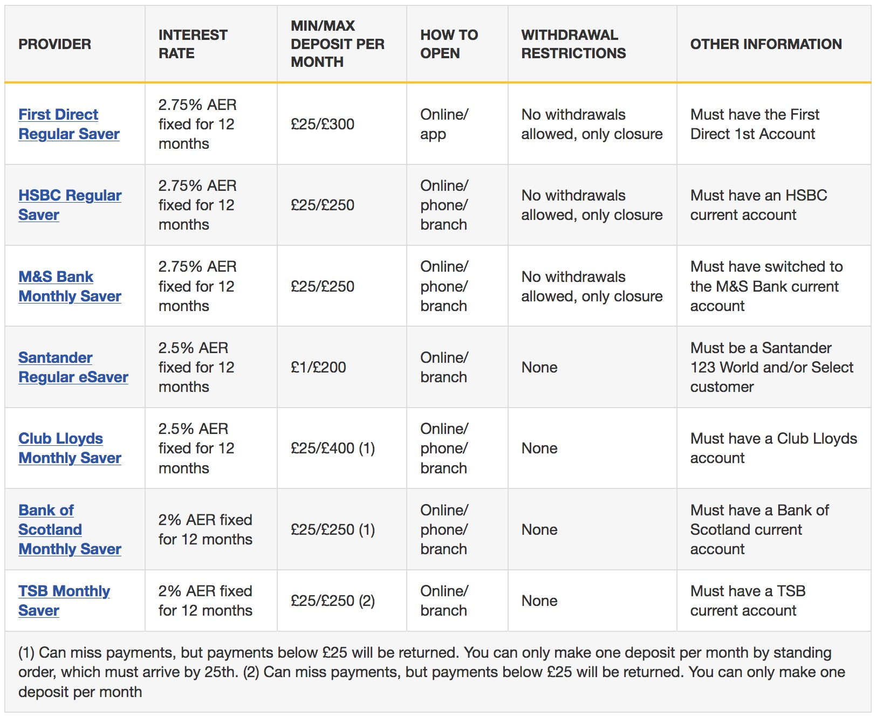Illustration 3: Regular savings accounts. Source: moneysavingexpert.com
The important thing about your rainy day fund is that it is liquid, or immediately available to spend. If you have your rainy day fund invested in gold, you will need to sell that gold first in case of financial adversities, and a buyer may not be readily available.

A very important rule to remember is, once each penny reaches your savings, it won't leave them. This means once you put a penny into for example a savings account, even when the account matures and gets closed that doesn't become expendable cash. It comes from your savings and they shall be repurposed to start generating their own money in the product of our choice. Your savings always grow (or stay the same) but never decrease. You can be more lenient about this rule once you have many streams of income, and can intelligently repurpose some of them to fit your needs.

Once you have the bare minimum, that is you rainy day fund full, then you can think about taking more risky steps.

- LEARN ABOUT INVESTING

When you invest you money is at risk. This means you could potentially get better results than with your savings, but you could also end up with less money that you started, so do it at your own risk, and invest only what you can afford to lose. If you are prepared, there are lots of ways to do so nowadays, especially online.

Some investing financial products come in an ISA wrapper, allowing you to earn your interest tax-free. Some of them are detailed below, with promotions an referral bonuses included:
- Moneyfarm: It's a robo-trading application: you create an account according yo your needs and invest your money into it. Once there, it gets split across different investment products, according to your investment profile. Referral: Get £5000 managed free of charge for one year, by using the code MF177409 at www.moneyfarm.com
- Zopa: The leader of P2P lending. Once you invest your money it gets split and lent to different borrowers, and you will get the interest on that loan, that will be paid monthly. Referral: Get £50 when you invest £2000 or more when using the following link https://www.zopa.com/lending/mgm/d57e571566e2
- Wealthify: It's a Stocks & Shares ISA, and it works similar to Moneyfarm. Referral: Get £50 by investing £500 or more for at least three months, by following this link https://invest.wealthify.com/refer/57116418

- OTHER IDEAS TO DIVERSIFY YOUR INCOME STREAMS

You are encouraged to research and experiment with the following: stocks, shares, bonds, funds, real estate, crowdfunding, dropshipping, peer to peer loans, crypto trading...

********************************************************************************

IN FUTURE CHAPTERS...
- Debt
- How to use credit to your benefit
- Mortgages

MAIN MANTRAS
- Pay yourself first
- Saving is the cheapest money
- Invest only what you can afford to lose
- Once a penny enters the savings, it doesn't leave them
- Compounding multiplies our investment

RECOMMENDED RESOURCES:

Books
- Rich Dad, Poor Dad – Robert Kiyosaki
- The Intelligent Investor – Benjamin Graham
- The Naked Trader – Robbie Burns
- The Art Of War – Sun Tzu

Links
- www.gov.uk
- https://www.moneysavingexpert.com/banking/compare-best-bank-accounts/
- https://www.moneysavingexpert.com/savings/best-regular-savings-accounts/

