Software Requirements Specification (SRS)
Project: Basic ZIP Compression Tool Using Huffman Coding for File Size Reduction
Version: 1.0
Authors:

P Ritesh – PES2UG24CS340
Pavithra N – PES2UG24CS347
Pranav Balebail - PES2UG24CS362
Nikshep V A- PES2UG24CS320

Date: 06-09-2026
Status: Draft

Revision history
Version | Date | Author | Change summary | Approval
1.0 | 04-09-2026 | Student | Initial SRS for Huffman-based file compression tool

Approvals
Role | Name | Signature / Email | Date
Course Coordinator

Table of Contents
1. Introduction
2. Overall description
3. External interface requirements
4. System features (detailed)
5. Non-functional requirements (detailed)
6. Quality attributes & Acceptance tests
7. UML Use-Case Diagrams
8. Requirements Traceability Matrix (RTM)

1. Introduction

1.1 Purpose
This SRS defines a standalone command-line file compression utility implemented entirely in C. The tool uses Huffman coding to reduce file size and provides lossless decompression to reconstruct the original data.

1.2 Scope
The system covers command-line input, byte-frequency analysis, Huffman tree construction, prefix-code generation, bit-level encoding, compressed-file creation, header validation, decompression, integrity checking, and error reporting. The implementation is restricted to C and standard file-I/O facilities.
The project is an educational, basic ZIP-like compression utility. It does not claim to implement the complete ZIP/DEFLATE standard; Huffman coding is the primary compression algorithm.

1.3 Audience
Developers, QA engineers, lab instructors, students, and assessment evaluators.

1.4 Definitions
• Huffman Coding – lossless coding that assigns shorter prefix-free codes to more frequent symbols.
• Huffman Tree – binary tree used to derive Huffman codes.
• Frequency Table – occurrence count of each byte value.
• Bitstream – encoded sequence represented at bit level.
• Compression Ratio – compressed size divided by original size.
• Header – metadata required for decoding.
• Lossless Compression – decompression reproduces the original bytes exactly.

2. Overall description

2.1 Product perspective
The product is a standalone command-line utility. It reads a local file, calculates byte frequencies, builds a Huffman tree, encodes the file into a binary stream, and stores enough metadata to decode that stream later.

2.2 Major product functions
• Accept compression/decompression commands and file paths.
• Read arbitrary binary files.
• Calculate byte frequencies and build a Huffman tree.
• Generate prefix-free Huffman codes.
• Encode and decode data at bit level.
• Create and parse a documented binary header.
• Report file sizes and compression ratio.
• Handle empty, single-symbol, invalid, truncated, and corrupted inputs.
• Manage C memory and file resources safely.

2.3 User roles and characteristics
• User: basic command-line knowledge and supplies file paths.
• Developer: implements the algorithm, file format, memory management, and tests.
• Evaluator: checks requirements, source code, test results, and correctness.

2.4 Operating environment
Command-line environment on a desktop/laptop operating system with a C compiler such as GCC or Clang. The program uses local storage and standard C/POSIX-compatible file operations.

2.5 Constraints
• Only C may be used for the implementation.
• No external compression libraries may be used.
• Compression must be lossless.
• The program must support binary files, not only text.
• Dynamic memory and file handles must be explicitly managed in C.

3. External interface requirements

3.1 User interfaces
The primary interface is command-line based. Example syntax: hzip -c input_file output_file for compression and hzip -d compressed_file output_file for decompression.

3.2 File interfaces
• Input: any readable text or binary file.
• Compressed output: custom binary container containing a format identifier, decoding metadata, and encoded bits.
• Decompressed output: byte-for-byte reconstruction of the original input.

3.3 Software interfaces
The implementation shall use standard C facilities such as fopen(), fread(), fwrite(), fseek(), ftell(), and fclose(), as supported by the target environment. Python, Java, C++, and third-party compression APIs are not permitted.

3.4 Communications
No network communication is required. All compression and decompression occur locally.

4. System features (detailed)
Each requirement includes acceptance criteria and a reference test case. IDs follow HZIP-F-###.
Req ID | Requirement | Type | Priority | Source/Stakeholder | Acceptance criteria | Test case
HZIP-F-001 | The system shall accept a file path as the input for compression. | Functional | High | User | Valid file is opened. | TC-CMP-01
HZIP-F-002 | The system shall support a command-line compression option. | Functional | High | User | Compression mode is selected. | TC-CLI-01
HZIP-F-003 | The system shall support a command-line decompression option. | Functional | High | User | Decompression mode is selected. | TC-CLI-02
HZIP-F-004 | The system shall read input as binary data and support byte values 0–255. | Functional | High | Developer | Binary test file is read without corruption. | TC-FILE-01
HZIP-F-005 | The system shall calculate the frequency of every byte occurring in the input. | Functional | High | Developer | Counts match a reference calculation. | TC-HUF-01
HZIP-F-006 | The system shall construct a Huffman tree from the calculated frequencies. | Functional | High | Developer | Tree is generated for valid inputs. | TC-HUF-02
HZIP-F-007 | The system shall generate a prefix-free Huffman code for every symbol present. | Functional | High | Developer | No valid code is a prefix of another. | TC-HUF-03
HZIP-F-008 | The system shall encode input data using Huffman codes at bit level. | Functional | High | Developer | Encoded data can be decoded exactly. | TC-CMP-02
HZIP-F-009 | The system shall write a header containing sufficient metadata for decompression. | Functional | High | Developer | Decoder reads and uses the metadata. | TC-FMT-01
HZIP-F-010 | The system shall create the requested compressed output without modifying the original. | Functional | High | User | Original file remains unchanged. | TC-CMP-03
HZIP-F-011 | The system shall display original and compressed file sizes after compression. | Functional | Medium | User | Correct sizes are printed. | TC-STAT-01
HZIP-F-012 | The system shall display compression ratio for non-empty input. | Functional | Medium | User | Ratio matches size calculation. | TC-STAT-02
HZIP-F-013 | The system shall validate the compressed-file header before decompression. | Functional | High | Developer | Invalid format is rejected. | TC-DEC-01
HZIP-F-014 | The system shall reconstruct the Huffman decoding structure from stored metadata. | Functional | High | Developer | Decoder reconstructs the required tree. | TC-DEC-02
HZIP-F-015 | The system shall decode the bitstream and write the original byte sequence. | Functional | High | User | Output is byte-for-byte identical. | TC-DEC-03
HZIP-F-016 | The system shall correctly handle an empty input file. | Functional | Medium | Developer | No crash; round trip succeeds. | TC-EDGE-01
HZIP-F-017 | The system shall correctly handle a file containing one unique byte value. | Functional | Medium | Developer | Round trip succeeds. | TC-EDGE-02
HZIP-F-018 | The system shall report file, memory, format, and command-line errors clearly. | Functional | High | User | Error message and failure status occur. | TC-ERR-01
HZIP-F-019 | The system shall close opened files and release allocated memory before normal termination. | Functional | High | Developer | No resource leaks in normal tests. | TC-MEM-01
HZIP-F-020 | The system shall reject unsafe attempts to overwrite the compressed input file during decompression. | Functional | Medium | User | Same-path operation is rejected. | TC-ERR-02

4.1 Compression
Frequency counting, Huffman tree construction, code generation, bit packing, header creation, and binary output form the compression workflow.

4.2 Decompression
The decoder validates the header, reconstructs the Huffman structure, reads encoded bits, and writes the recovered bytes to the output file.

4.3 Error handling and edge cases
The tool shall safely handle missing/unreadable files, invalid arguments, malformed headers, truncated streams, allocation failures, output-file failures, empty files, and single-symbol files.

5. Non-functional requirements (detailed)
Req ID | Requirement | Category | Priority | Acceptance criteria / Measurement | Test case
HZIP-NF-001 | Every valid file shall be recovered byte-for-byte after compression followed by decompression. | Correctness | High | Binary comparison of input and recovered file is identical. | TC-NF-01
HZIP-NF-002 | The system shall process files without loading the entire file into memory. | Memory | High | Peak memory does not grow with full file size. | TC-NF-02
HZIP-NF-003 | The system shall support arbitrary binary byte values. | Portability | High | 0x00–0xFF test data round-trips exactly. | TC-NF-03
HZIP-NF-004 | Invalid input shall result in controlled errors rather than avoidable crashes. | Reliability | High | Invalid-input tests return an error status. | TC-NF-04
HZIP-NF-005 | The implementation shall compile as portable C without external compression libraries. | Portability/Maintainability | High | Build succeeds using documented C compiler flags. | TC-NF-05
HZIP-NF-006 | Normal execution shall not leave detectable memory leaks. | Maintainability | High | Allocation checks show owned memory is released. | TC-NF-06

5.1 Security

5.1.1 Security Objectives
• SO-001: Preserve file confidentiality during processing by performing compression locally and avoiding unnecessary logging of file contents.
• SO-002: Preserve data integrity by validating compressed data and reporting corruption instead of silently producing incorrect output.

5.1.2 Security Requirements
Req ID |  | Requirement |  | Type |  | Priority |  | Acceptance criteria / Test case ref
HZIP-SR-001 |  | The system shall validate the compressed-file magic value and format/version before processing it. |  | Security |  | High |  | Malformed header is rejected.
Req ID | Requirement |  | Type |  | Priority |  | Acceptance criteria |  | Test case
HZIP-SR-001 | The system shall validate the compressed-file magic value and format/version before processing it. |  | Security |  | High |  | Malformed header is rejected. |  | TC-SEC-01
HZIP-SR-002 | The system shall validate header fields and decoding metadata before using them. |  | Security |  | High |  | Invalid metadata is rejected safely. |  | TC-SEC-02
HZIP-SR-003 | The system shall detect premature end-of-file and invalid bitstreams during decompression. |  | Security |  | High |  | Truncated/corrupt files produce an error. |  | TC-SEC-03
HZIP-SR-004 | The system shall not print or store original file contents in normal diagnostic output. |  | Security/Privacy |  | Medium |  | Normal output contains metadata/statistics only. |  | TC-SEC-04
HZIP-SR-005 | The system shall safely handle memory and file-I/O failures without invalid pointer/file-handle use. |  | Security/Reliability |  | High |  | Fault tests terminate safely. |  | TC-SEC-05

6. Quality attributes & Acceptance tests
• Correctness: compression followed by decompression must reproduce every input byte.
• Performance: processing time should scale reasonably with input size.
• Memory efficiency: file contents should be streamed rather than duplicated in memory.
• Portability: the documented C build must compile and execute in the target environment.
• Maintainability: Huffman tree, bit I/O, file format, compression, decompression, and CLI logic should be separated into clear C functions/modules.
• Reliability: invalid input must result in controlled errors.

6.1 Acceptance test suites
• CLI tests
• Frequency and Huffman-tree tests
• Bit encoding/decoding tests
• Compression tests using text, binary, repetitive, random, empty, and single-symbol files
• Corrupt/truncated compressed-file tests
• End-to-end round-trip tests
• Memory/file-resource tests
Exit criteria: all high-priority functional and security requirements pass their associated tests, all critical correctness tests pass, and no known crash occurs for defined invalid-input cases.

7. UML Use-Case Diagrams
The diagrams below show the primary user interactions with the standalone C-based compression utility.
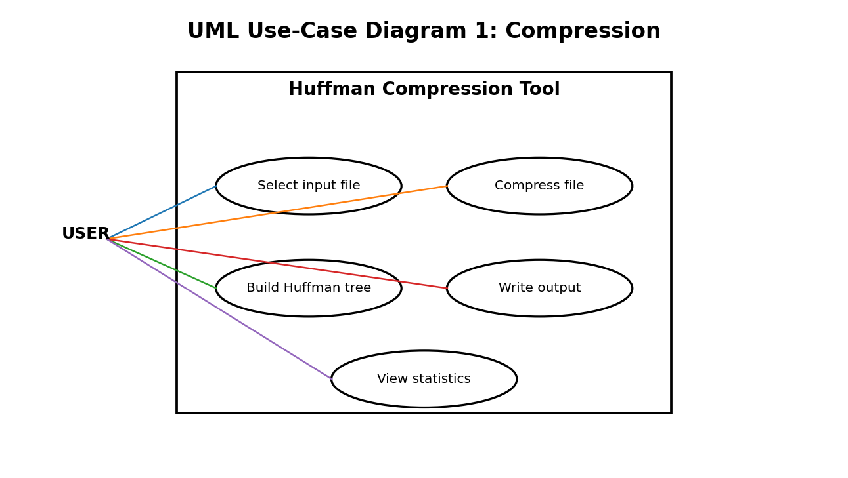
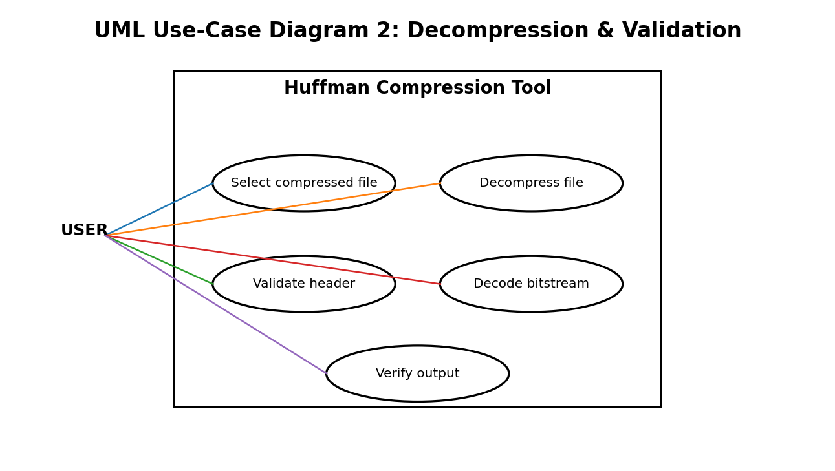

8. Requirements Traceability Matrix (RTM)
Req ID | Requirement short | Section ref / Design Spec | Module | Test case(s) | Status (N/P/A) | Comments
HZIP-F-001 | Accept input file | 4 / DS-CLI-01 | CLI Module | TC-CMP-01 | N
HZIP-F-005 | Calculate byte frequencies | 4 / DS-FREQ-01 | Frequency Module | TC-HUF-01 | N
HZIP-F-006 | Build Huffman tree | 4 / DS-HUF-01 | Huffman Module | TC-HUF-02 | N
HZIP-F-007 | Generate Huffman codes | 4 / DS-HUF-02 | Huffman Module | TC-HUF-03 | N
HZIP-F-008 | Encode bitstream | 4 / DS-BIT-01 | Bit I/O + Encoder | TC-CMP-02 | N
HZIP-F-009 | Write compressed header | 4 / DS-FMT-01 | File Format Module | TC-FMT-01 | N
HZIP-F-013 | Validate compressed header | 4 / DS-FMT-02 | Decoder Module | TC-DEC-01 | N
HZIP-F-015 | Decode original bytes | 4 / DS-DEC-01 | Decoder Module | TC-DEC-03 | N
HZIP-F-016 | Handle empty file | 4.3 / DS-EDGE-01 | Compression Module | TC-EDGE-01 | N
HZIP-F-017 | Handle one-symbol file | 4.3 / DS-EDGE-02 | Huffman Module | TC-EDGE-02 | N
HZIP-NF-001 | Lossless correctness | 5 / DS-TEST-01 | Test Harness | TC-NF-01 | N
HZIP-NF-002 | Bounded memory | 5 / DS-MEM-01 | File I/O Module | TC-NF-02 | N
HZIP-NF-005 | Portable C | 5 / DS-C-01 | All Modules | TC-NF-05 | N
HZIP-SR-001 | Validate magic/version | 5.1 / DS-SEC-01 | File Format Module | TC-SEC-01 | N
HZIP-SR-003 | Reject corrupt stream | 5.1 / DS-SEC-03 | Decoder Module | TC-SEC-03 | N

Appendix A — Implementation Constraint
The implementation shall use only the C programming language. The expected design uses C structures for Huffman nodes, arrays for byte frequencies/codes, explicit dynamic memory management, and standard binary file I/O. No external compression library or other programming language is permitted.

