Software Test Plan (STP) - Basic ZIP Compression Tool Using Huffman Coding for File Size Reduction

Project: Basic ZIP Compression Tool
Version: 1.0
Authors:
P Ritesh (PES2UG24CS340),
Pavithra N (PES2UG24CS347) ,
Nikshep V A (PES2UG24CS320)
Pranav Balebail (PES2UG24CS362)

Date: 16/09/2026
Status: Draft

Introduction
1. Introduction
- Purpose: Defines the test plan for the Basic ZIP Compression Tool v1.0. It outlines objectives, scope, strategy, and verification criteria for testing.

- Scope: Covers testing of command-line interface execution, byte frequency calculation, Huffman tree building, bit-level encoding/decoding, header writing/validation, file integrity, and error handling. Third-party algorithms, GUI interfaces, and multi-threading are excluded.
- References: SRS v1.0 (Basic ZIP Compression Tool Using Huffman Coding).
- Definitions: Huffman Coding, Bitstream, Compression Ratio, Header, Lossless Compression

Test Items
- CLI Argument Parsing Module
- Frequency Analysis & Huffman Tree Construction Module
- Bit-level Encoder & File Output Module
- Binary Header Creation & Parsing Module
- Bitstream Decoder & Recovery Module
- Resource Management (Memory & File Handling) Module

Features to be Tested
Features mapped to SRS requirement IDs:
FUNCTIONAL FEATURES AS MENTIONED IN THE SRS ARE:

- HZIP-F-001 / HZIP-F-002 / HZIP-F-003: CLI option parsing for compression and decompression modes.
- HZIP-F-004 / HZIP-F-005: Binary file reading and byte frequency calculation (0–255 range).
- HZIP-F-006 / HZIP-F-007: Huffman tree construction and prefix-free code generation.
- HZIP-F-008 / HZIP-F-009 / HZIP-F-010: Bit-level encoding, header generation, and compressed output creation.
- HZIP-F-011 / HZIP-F-012: Reporting file sizes and compression ratio.
- HZIP-F-013 / HZIP-F-014 / HZIP-F-015: Header validation, tree reconstruction, and byte-for-byte decompression.
- HZIP-F-016 / HZIP-F-017: Edge-case handling (empty files and single-symbol files).
- HZIP-F-018 / HZIP-F-019 / HZIP-F-020: Error reporting, proper memory/file cleanup, and overwrite protection.

NON FUNCTIONAL FEATURES AS MENTIONED IN THE SRS ARE:
- HZIP-NF-001: Lossless byte-for-byte correctness.
- HZIP-NF-002: Stream-based processing to maintain dynamic memory bounds.
- HZIP-NF-003 / HZIP-NF-005: C-compiler portable execution across arbitrary binary inputs.
- HZIP-NF-004 / HZIP-NF-006: Controlled crash-free error handling and leak-free memory cleanup.
- HZIP-SR-001 / HZIP-SR-002: Validation of magic bytes, version numbers, and stored header metadata.
- HZIP-SR-003: Detection of corrupted bitstreams and premature end-of-file conditions.
- HZIP-SR-004 / HZIP-SR-005: Prevention of raw data leakage in diagnostic output and safe handling of memory/file-I/O failures.

Features Not to be Tested
- GUI Interface Elements: The application is purely command-line driven, so graphical user interfaces or desktop windowing integrations are excluded.
- Multi-threading and Parallel Processing: Concurrent execution or multi-threaded file compression/decompression logic is not part of the system design.
- Third-Party Compression Algorithms: Standard DEFLATE, LZ77, LZW, or ZIP archive format standards are excluded, as implementation is strictly limited to basic Huffman coding.
- Network & Remote Storage Transfers: Network file transfers, cloud storage integration, or socket-level stream processing are out of scope.
- Operating System Kernel & File System Internals: Low-level OS file system driver behaviors, disk sector operations, and underlying C compiler runtime libraries are assumed to be pre-validated by the vendor/platform

Test Approach / Strategy

Non-Functional Test Approach
- Correctness & Integrity: Compress and decompress files, then compare them byte-for-byte.
- Memory Efficiency: Monitor memory usage across different file sizes.
- Binary Data: Test arbitrary byte values (0–255) to ensure data integrity.
- Reliability: Test corrupted, truncated, empty, and malformed inputs for graceful handling.
- Portability: Compile and execute using the supported standard C environment.
- Memory Safety: Use Valgrind or an equivalent tool to detect leaks and invalid memory access.
- Security & Robustness: Test malformed headers, unsupported versions, corrupted data, and resource failures.

Security Validation
The following conditions shall be tested:
- HZIP-SR-001 – Invalid/malformed file header: Input is rejected with an appropriate error.
- HZIP-SR-002 – Unsupported file format/version: Input is rejected safely.
- HZIP-SR-003 – Corrupted compressed data: Corruption is detected and the application terminates gracefully.
- HZIP-SR-004 – Truncated compressed file: Incomplete data is detected without uncontrolled termination.
- HZIP-SR-005 – File allocation/open failure: Failure is handled with an appropriate error.
- HZIP-SR-006 – Memory allocation failure: Failure is handled safely without undefined behaviour.

Test Environment
NFR testing environment:
- Standard C compiler such as GCC or Clang.
- Supported operating-system environment.
- Valgrind or equivalent memory-analysis tool for memory safety testing.
- Binary comparison utility for verifying byte-for-byte reconstruction.
- Test files containing text, binary data, empty files, and corrupted/truncated compressed files.

Test Schedule
Milestones:
- Test case design: 05-Sep-2026
- Environment setup: 07-Sep-2026
- Test execution start: 08-Sep-2026
- Test execution end: 20-Sep-2026
- UAT: 22-Sep-2026 to 25-Sep-2026

Test Deliverables
- Test Plan
- Functional and non-functional test cases
- Acceptance test cases
- Test scripts
- Test data
- Test execution logs
- NFR test results
- Quality attribute test results
- Memory-analysis/Valgrind reports
- Binary integrity comparison results
- Defect reports
- Requirements traceability matrix
- Final Test Summary Report

Roles and Responsibilities

Role | Name | Responsibility
QA Lead | <Name> | Prepare plan, coordinate execution
Test Engineer | <Name> | Design & execute test cases, log defects
Developer | <Name> | Support defect fixes and triage
Product Owner | <Name> | Approve test results, sign-off readiness

Risks and Mitigation

Risk | Mitigation
Delay in stable build delivery | Request early smoke builds from dev team
Test environment downtime | Maintain backup environment on cloud VM
Dependency on third-party ATM hardware vendor | Engage vendor early and maintain test stubs

NFR Risks and Mitigations

Risk | Impact | Mitigation
Excessive memory consumption | Large files may cause failures | Monitor memory usage and test progressively larger files.
Memory leaks | Long-running use may degrade system performance | Use Valgrind or an equivalent memory-analysis tool.
Corrupted input causes unexpected behaviour | Reliability/security issue | Test malformed, corrupted, and truncated files.
Binary data is not preserved | Data loss | Test files containing all possible byte values.
Environment-specific behaviour | Portability issues | Test compilation and execution in the supported environments.

Assumptions & Dependencies
- Valgrind or an equivalent memory-analysis tool is available for memory testing.
- A supported standard C compiler is available.
- Representative text and binary test files are available.
- The operating environment provides sufficient resources for performance and memory testing.

Suspension & Resumption Criteria

Suspend testing if any of the following conditions occur:

• The test environment, C compiler, executable, input files, or output directory is unavailable for more than 4 hours.

• The Huffman compression-tool build is unstable and blocks more than 30% of the planned compression/decompression test cases.

• the application cannot be compiled or launched, or a critical defect prevents meaningful execution of the NFR test cases.

Resume testing when all of the following conditions are satisfied:

• Blocking defects affecting compression, decompression, Huffman tree construction, header parsing, or file I/O are resolved and a corrected build is available.

• The compiler, executable, test files, output folder, and test environment are restored and verified using a basic compression/decompression smoke test.
• Testing remains suspended if repeated runs produce corrupted compressed files, uncontrolled crashes, or unrecoverable file-I/O errors.

Test Case Management & Traceability
RTM ensures mapping of SRS requirements to test cases. The following test cases cover the functional, non-functional, and security requirements of the Basic ZIP Compression Tool.

Test Cases
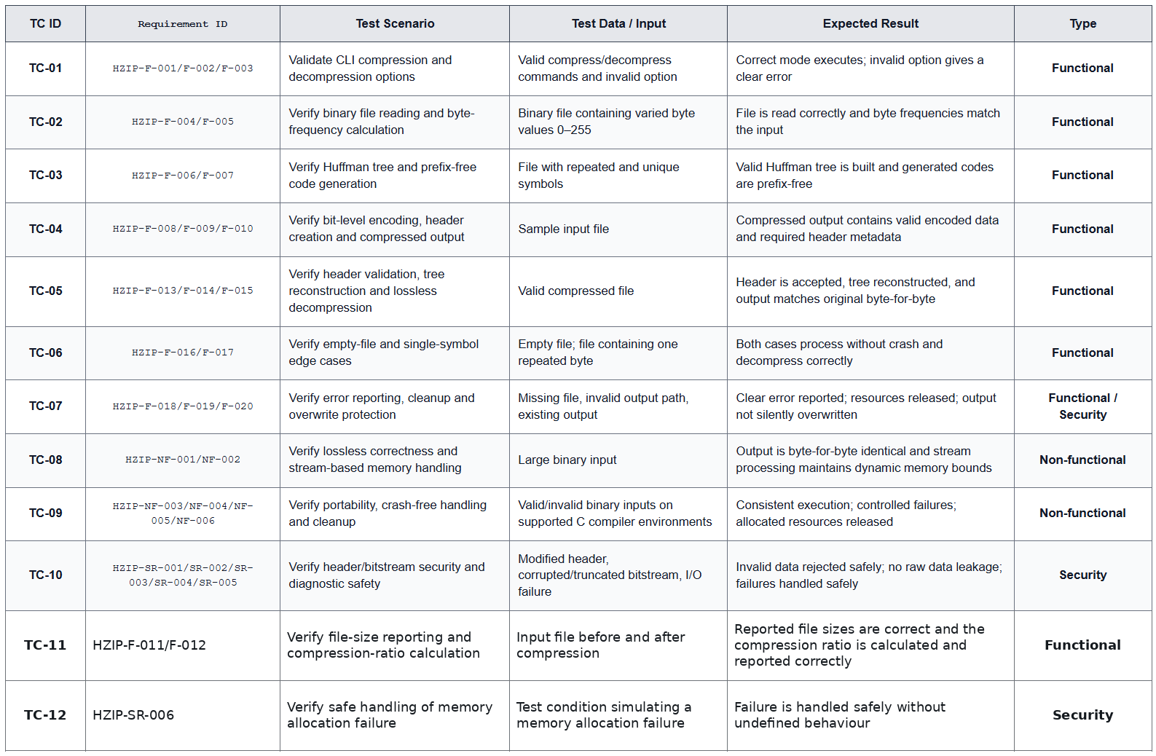

Requirement-to-Test Case Traceability (RTM)

• HZIP-F-001 to HZIP-F-003 → TC-01
• HZIP-F-004 to HZIP-F-005 → TC-02
• HZIP-F-006 to HZIP-F-007 → TC-03
• HZIP-F-008 to HZIP-F-010 → TC-04
• HZIP-F-013 to HZIP-F-015 → TC-05
• HZIP-F-016 to HZIP-F-017 → TC-06
• HZIP-F-018 to HZIP-F-020 → TC-07
• HZIP-NF-001 to HZIP-NF-002 → TC-08
• HZIP-NF-003 to HZIP-NF-006 → TC-09
• HZIP-SR-001 to HZIP-SR-005 → TC-10
• HZIP-F-011 to HZIP-F-012 → TC-11
• HZIP-SR-006 → TC-12

Test Metrics & Reporting

• % Test Cases Executed = (executed test cases / planned test cases) × 100
• % Passed/Failed = passed or failed test cases / total executed test cases × 100
• Requirement Coverage = SRS requirements covered by test cases / total applicable SRS requirements × 100
• Defect Density = defects identified / size of tested software, using the team's selected size metric
• Defect Aging = time a defect remains open until closure
• Security Test Coverage = security scenarios executed / total planned security scenarios × 100

Reports:
• Daily execution status
• Test execution summary with pass/fail counts
• Defect status and aging report
• Requirement traceability and coverage report
• Final Test Summary Report

Approvals
Role | Name | Signature / Date
QA Lead
Dev Lead
Product Owner

