Question 1
Processor Information
- Describe the architecture of the underlying system that you're using to explore performance of the matrix multiply application.
- List all key attributes that will affect performance, and discuss briefly why they're relevant in the context of the matrix multiply application.
My experiments were run on a 13th Generation Intel Core i7-1355U using Intel's hybrid architecture: 2 high-performance P-cores (each with Hyper-Threading, boosting to 5.0 GHz) and 8 power-efficient E-cores (no Hyper-Threading), giving 12 logical CPUs across a single socket. The hardware features most relevant to matrix multiplication are listed below.
Cache hierarchy. The L1 data cache totals 352 KiB, with 48 KiB per P-core and 32 KiB per E-core. L2 totals 6.5 MiB across 4 instances, where each P-core has a private 1.25 MiB partition and pairs of E-cores share 2 MiB. L3 is a single 12 MiB shared cache. Each cache line is 64 bytes, holding 8 doubles. Matrix multiplication must traverse both rows of A and columns of B; because C is stored row-major, accesses to B[k][j] as k increments jump a full row of N doubles in memory. For N=64 that already exceeds a single cache line, meaning each B access fetches 64 bytes to use only 8, wasting roughly 87.5% of every cache line loaded for B.
The three NxN double matrices occupy 24N^2 bytes in total; they fit within L1 only for N≲37, within L2 for N≲209, and within the 12 MiB L3 for N≲707, at which point N = sqrt(12 × 1024² / 24). Beyond N=707 every cache miss goes to main memory and the application becomes fully memory-bandwidth-bound.
Multicore. Ten physical cores (12 logical) enable thread-level parallelism via OpenMP. The P/E-core asymmetry means per-thread throughput differs across cores, so speedup will not scale uniformly with thread count.
SIMD / AVX2. The avx2 flag in lscpu shows 256-bit vector register support, letting four 64-bit doubles be processed per instruction and directly increasing arithmetic throughput in the inner multiply-accumulate loop.
FMA. Fused Multiply-Add merges a multiplication and addition into one instruction with a single rounding step, halving the instruction count of the inner loop's core operation and improving numerical accuracy.

Question 2
Baseline Performance: Graph
- Plot FLOPS vs matrix size for square matrices, exploring a range of matrix sizes which demonstrate key operational scenarios for the underlying system.
- Upload your plot as an image/PDF.
- Marks for plot are included in discussion response in next question.

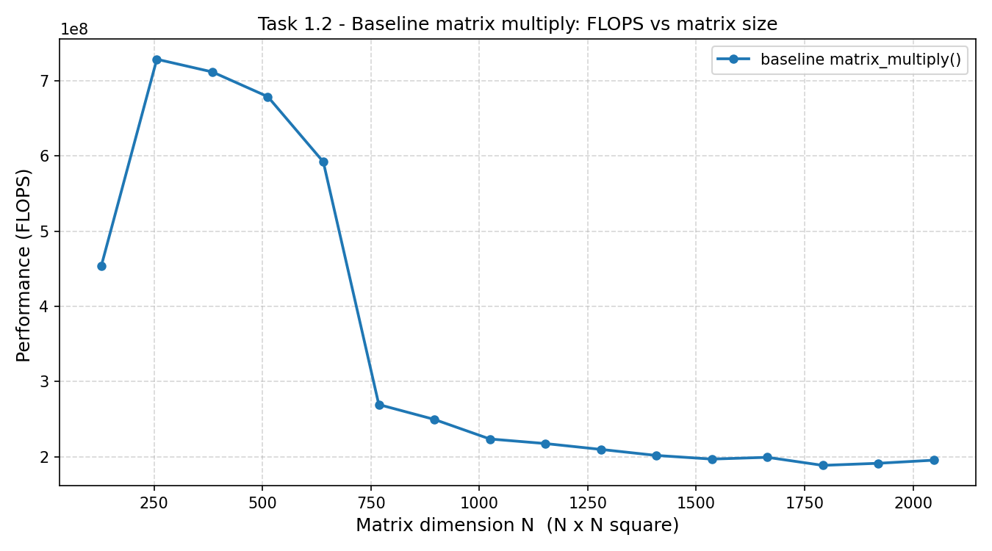

Question 3
Baseline Performance: Discussion
- Evaluate the baseline performance using the matrix_multiply() function, measuring FLOPS for a range of matrix sizes.
- Analyse and discuss how matrix dimensions affect performance (FLOPS), referencing the data presented in the plot from the previous question.
I measured the baseline matrix_multiply() function across square matrices from N=128 to N=2048 with no compiler optimisation. The FLOP count is FLOP = LN(2M-1), which for square matrices simplifies to N^2(2N-1), and dividing by execution time gives the FLOPS rate shown in Figure 1.
Performance starts at around 4.5x10^8 FLOPS at N=128, rises to a peak of approximately 7.3x10^8 FLOPS at N=256, then holds relatively stable through N=512. From N=640 to N=768 there is a sharp decrease, with FLOPS dropping from roughly 5.9x10^8 to 2.7x10^8 in a single step. Beyond N=768 the curve flattens to a floor of approximately 2x10^8 FLOPS for all remaining sizes up to N=2048. This corresponds to the three matrices overflowing the 12 MiB L3 cache.
The three N×N double matrices together occupy 24N² bytes. They fit within L1 only for N = sqrt(32,768 / 24) ≈ 37, within L2 for N = sqrt(1,048,576 / 24) ≈ 209, and within the 12 MiB L3 for N = sqrt(12,582,912 / 24) ≈ 707. Beyond N=707 every cache miss goes to main memory and execution time grows much faster than the O(N³) FLOP count.
The fall is steeper than simple cache overflow would predict because of the column-stride access to B. The innermost loop computes C[i][j] += A[i][k] * B[k][j] over k, and each increment of k moves B[k][j] by a full row of N x 8 bytes in memory. Even at N=128 that is 1,024 bytes per step, meaning every B access fetches a fresh 64-byte cache line to use one double from it. This wastes 87.5% of every cache line loaded for B and generates a miss rate far higher than the row-major accesses to A. This with L3 overflow it explains why the FLOPS floor at large N is only about 27% of the peak.
By varying the dimensions independently shows that growth in N is most damaging: it worsens the B access stride and adds more output columns. Growth in M lengthens the innermost loop without changing the stride. Growth in L adds rows to A and C without affecting the B pattern at all, making it the least harmful dimension to scale.

Question 4
Compiler Optimisation: Graph
- Plot application performance (FLOPS) vs matrix dimensions, to show the effect of compiler optimisations on application performance.
- Explore the effect of compiler flags -O, -O1, -O2, and -O3, for the same range of square matrix dimensions as the previous question to enable comparison with baseline performance.
- Upload your plot as an image/PDF.
- Marks for plot are included in discussion response in next question.
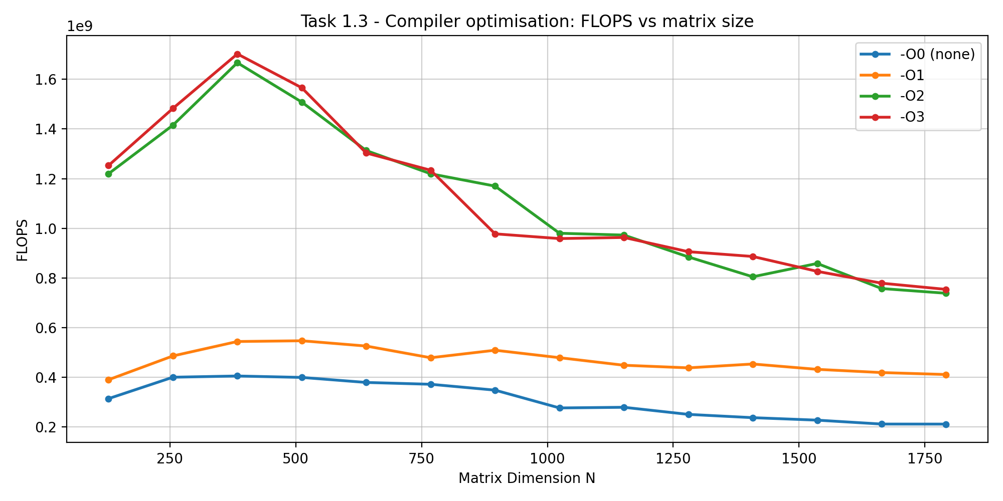
Question 5
Compiler Optimisation: Discussion
- Analyse and discuss the effect of compiler flags on application performance, referencing data from the plot in the previous question. You should explore the effect of compiler flags -O, -O1, -O2, and -O3, passing them to the compiler through the makefile variable $(OPT).
- Investigate performance for the same range of square matrix dimensions as the previous question to enable comparison with baseline performance.
- Discuss any observed changes in performance, and how the compiler is likely to have achieved these differences.
I recompiled the baseline function at -O0, -O1, -O2 and -O3 by adjusting $(OPT) in the makefile and ran the same matrix range. The results are shown in Figure 2.
At -O0 no transformations are applied. Looking at main.s shows scalar vmulsd and vaddsd instructions operating on xmm registers, one double at a time, alongside explicit jmp and jl branch instructions on every loop iteration and variables reloaded from the stack via rbp-relative addresses. Performance sits in a flat band around 3 x 10^8 FLOPS, declining slightly to around 0.2x10^9 at large N.
-O1 improves register allocation, dead code elimination and basic constant propagation, keeping loop counters and accumulators in registers rather than memory. This gives an improvement to roughly 0.4-0.55x10^9 FLOPS, though the loop structure itself is unchanged so the gain is limited.
The most significant jump in the plot is from -O1 to -O2. At N=384, -O2 reaches approximately 1.65x10^9 FLOPS, roughly a 3x improvement over -O1 at the same size. The change in main.s is direct: vbroadcastsd loads a scalar from A[i][k] into all four lanes of a ymm register, followed by vmulpd and vaddpd operating on 256-bit ymm registers rather than individual xmm registers. This confirms GCC enables auto-vectorisation at -O2 on this target, transforming scalar mulsd/addsd pairs into four-wide AVX2 operations. -O2 also adds loop-invariant code motion and strength reduction, but the vectorisation is what drives the performance gain.
-O3 adds more aggressive loop unrolling and peaks at approximately 1.7x10^9 FLOPS at N=384, only marginally higher than -O2. The two curves are very similar across the entire dimension range, which shows that on this system vectorisation is already fully exploited at -O2 and the additional unrolling at -O3 offers little further benefit for this loop structure. All remaining tasks compile at -O3, though the practical advantage over -O2 is minimal here.

Question 6
Loop Unrolling: Analysis and Discussion
- Explore how loop unrolling affects the matrix multiply application and its impact on performance. (Use unrolled_matrix_multply(), and explore the effect of different values of UNROLL).
- Discuss the resulting performance (FLOPS), and the reasoning behind any changes that are observed - are the results as expected for the given application?
unrolled_matrix_multiply() manually unrolls the j loop by a factor of UNROLL, accumulating partial results into a local C_temp[UNROLL] array before writing back to C. I tested UNROLL values of 1, 2, 4, 8 and 16 at -O3.
Loop unrolling reduces the number of branch checks and counter increments by processing UNROLL elements per iteration instead of one. More importantly, it increases instruction-level parallelism by making the loop body longer: the accumulators C_temp[0] through C_temp[UNROLL-1] are fully independent across j iterations, so a larger UNROLL window gives the out-of-order scheduler more independent multiply-accumulate operations to dispatch simultaneously.
Figure 3 shows a clear and consistent benefit from unrolling. UNROLL=1 performs noticeably worse than all other values across the full N range, peaking at around 1.9x10^9 FLOPS at N=384 and falling to under 1.0x10^9 at N=1800. UNROLL=2, 4, 8 and 16 all substantially outperform it, with UNROLL=16 consistently the best or joint-best, peaking at approximately 3.75x10^9 FLOPS at N=256. UNROLL=8 is very close behind.
The manual unrolling is beneficial at -O3 here. The compiler vectorises the inner k loop but does not fully unroll the j dimension to the same degree, leaving instruction-level parallelism unexploited across j iterations. The UNROLL=1 result makes this gap clear: even with the compiler's own optimisations applied, a single-element j loop is substantially slower, and the assembly confirms this with a single vmulsd/vaddsd pair per iteration operating on scalar xmm registers.

At higher UNROLL values the assembly shows multiple vmulpd instructions back to back on ymm registers, which confirms the compiler is now vectorising across the wider accumulator array. At UNROLL=16 there is no sign of register spilling, suggesting all 16 independent accumulators fit comfortably within the AVX2 register file.

Question 7
Multicore: Graph
- Plot the observed performance when changing the number of cores used to execute the application. Plot FLOPS vs matrix dimensions for different values of OMP_THREADS, for the same range of matrix dimensions explored previously.
- Upload your plot as an image/PDF.
- (Marks for plot are included in discussion response in next question.)
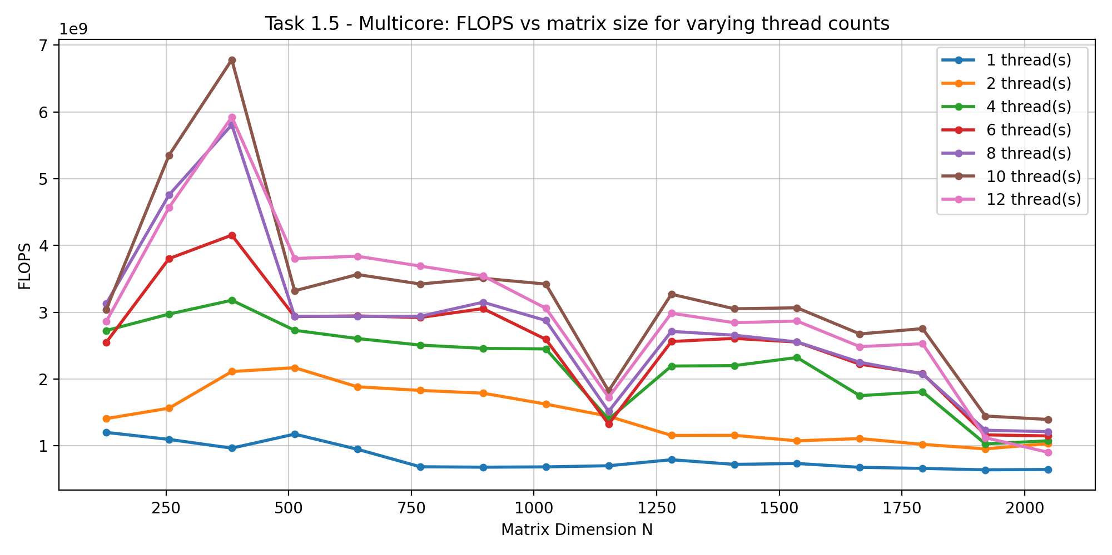

Question 8
Multicore: Discussion
- Analyse and describe how performance changes when using multicore_matrix_multiply(), and how this varies for differenct matrix dimensions (referencing from the plot in the previous question).
- Discuss how many cores/threads your system supports, and whether better performance is always achieved by increasing the number of OMP_THREADS - is this as expected?
I tested multicore_matrix_multiply() with OMP_THREADS set to 1, 2, 4, 6, 8, 10 and 12, compiled at -O3. The results are shown in Figure 4.
Matrix multiplication is parallel in the row dimension: each row of C depends only on one row of A and the entirety of B, so rows are completely independent and OpenMP can distribute them across threads with no synchronisation overhead.
The plot shows clear scaling from 1 to 4 threads, with 1 thread peaking at ~1.2x10^9 FLOPS and 4 threads reaching ~3.2x10^9, roughly a 2.7x improvement. Beyond 4 threads gains slow, and from 8 threads the curves begin to cluster. 10 threads achieves the highest single peak of approximately 6.8x10^9 FLOPS at N=384, which is higher than 12 threads at the same point (~5.9x10^9). This makes 10 threads equal to the number of physical cores the optimal choice rather than the full 12 logical CPUs.
12 threads underperforms 10 threads at the peak because the two extra logical threads come from Hyper-Threading on the P-cores. Hyper-Threading shares all execution units between two logical threads on the same physical core. Since the inner multiply-accumulate loop is compute-bound and already saturates the floating-point units, the second hyperthread has no idle resources to use and introduces scheduling noise instead.
Hyper-Threading benefits latency-hiding in memory-bound workloads rather than compute-bound loops like this one. The non-linear scaling between 4 and 10 threads also reflects the hybrid architecture: each core has separate L1 instruction and data caches, and the E-cores have a smaller L1d (32 KiB) than the P-cores (48 KiB) as well as lower per-thread floating-point throughput, so the speedup curve bends as the faster P-core threads saturate first.

Question 9
Blocking: Graph
- Plot application performance (FLOPS) for the same range of matrix dimensions used previously, exploring the effect of different values of BLOCK_SIZE on performance.
- Upload your plot as an image/PDF.
- Marks for plot are included in discussion response in next question.
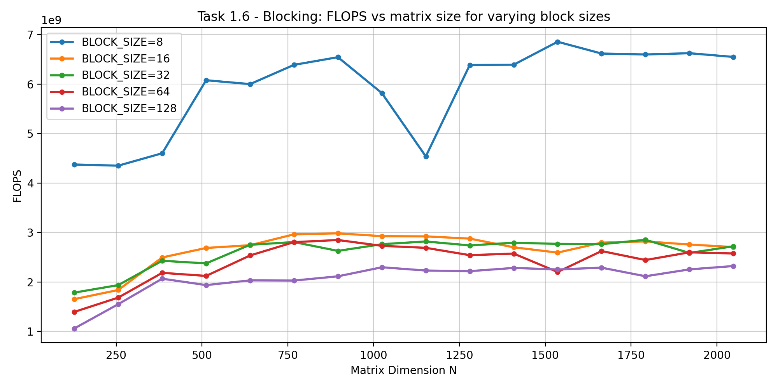

Question 10
Blocking: Analysis and Discussion
- Discuss how blocking impacts application performance, and the underlying theory behind how it works.
- Discuss the results obtained when using blocked_matrix_multiply(), with a range of values assigned to BLOCK_SIZE (plotted in the previous question). Is the observed difference in performance as expected?
- Discuss how different block sizes interact with the underlying hardware, and reason why the best block size offers optimal performance for the given system.
The problem with the unoptimised loop is the 87.5% cache-line waste on B accesses described earlier. As N grows the working set overflows each cache level in turn, and by the time L3 is exceeded the application spends most of its time waiting on main memory.
Blocking addresses this by partitioning the matrices into blocks of BLOCK_SIZE x BLOCK_SIZE and completing the full k-accumulation for each block before moving on. While one block is being processed, all three block submatrices stay resident in L1, so accesses within the block hit L1 rather than requiring a cache refill.
I tested BLOCK_SIZE values of 8, 16, 32, 64 and 128 at -O3 across N=128 to N=2048, with results shown in Figure 5. BLOCK_SIZE=8 is by far the best. It starts at approximately 4.4x10^9 FLOPS at N=128 and actually increases with matrix size, reaching around 6.8x10^9 FLOPS at N=1500 and sustaining this well beyond the L3 boundary where all other sizes plateau. BLOCK_SIZE=16 is second at roughly 2.5-3.0x10^9, with BLOCK_SIZE=32 and 64 close behind, and BLOCK_SIZE=128 the worst.
For the E-cores with 32 KiB L1d, three blocks must fit simultaneously:
BLOCK_SIZE = sqrt(L1d / (3 x sizeof(double))) = sqrt(32768 / 24) ~= 36, so 32 as the largest fitting power of two
3 x BLOCK_SIZE^2 x 8 bytes <= 32,768 bytes => BLOCK_SIZE^2 <= 1,365 => BLOCK_SIZE <= 36
By this analysis BLOCK_SIZE=32 should be optimal, yet BLOCK_SIZE=8 outperforms it substantially.
The reason is compiler code generation. The do_block() function has three nested loops each bounded by the compile-time constant BLOCK_SIZE. At BLOCK_SIZE=8 those loops cover only 8x8x8 = 512 iterations total, which the compiler can fully unroll and vectorise into a tight sequence of AVX2 instructions, effectively treating the entire block as a fixed-size kernel. This is visible in main.s: the assembly shows 8 consecutive vmulpd instructions at 32-byte offsets (0, 32B, 64B, 96B, 128B, 160B, 192B, 224B) with no loop branches between them, confirming the entire block was unrolled into a branchless sequence of four-wide vector operations. At BLOCK_SIZE=32 the inner triple loop covers 32,768 iterations, which the compiler cannot fully unroll. BLOCK_SIZE=8 therefore benefits from both block-induced cache reuse and aggressive compiler loop optimisation at the same time, while BLOCK_SIZE=32 only gets the cache benefit. The optimal block size is determined by cache capacity and how the compiler can optimise small fixed-size loops.

Question 11
SIMD: Analysis and Discussion
- Discuss how the SIMD instructions impact performance when using subword_parallelism_matrix_multiply()?
- Describe how performance varies with matrix dimensions, and any factors which may be limiting the effectiveness of the SIMD operations.
subword_parallelism_matrix_multiply() uses AVX2 intrinsics to process four doubles per instruction. _mm256_broadcast_sd loads a scalar A[i][k] into all four lanes of a 256-bit register; _mm256_load_pd loads four consecutive B[k][j] elements; _mm256_mul_pd and _mm256_add_pd perform the four-wide multiply-accumulate; and _mm256_store_pd writes the result back. This replaces four sequential scalar operations with one vector instruction. The pattern is visible in main.s: vbroadcastsd loads A[i][k] into ymm1, followed by vmulpd and vaddpd operating on 256-bit ymm registers.
Figure 6 shows the SIMD implementation at approximately 3.9x10^9 FLOPS at N=128, declining to around 1.65x10^9 FLOPS at N=2048. The -O3 baseline peaks at roughly 1.5x10^9 at N=384 and falls to about 0.7x10^9 at large N. The speedup at small N is around 3.5x and narrows to approximately 2.4x at large N, falling short of the theoretical 4x because the -O3 baseline already uses some auto-vectorisation and both implementations begin waiting on memory as N grows past the L3 boundary. The gap does not collapse entirely at large N though: SIMD maintains roughly a 2x advantage at N=2048 because the wider vector loads reduce the number of individual memory transactions required. The 32-byte alignment from aligned_alloc() is essential throughout since _mm256_load_pd requires 32-byte aligned addresses and will segfault otherwise.

Question 12
Part II - Optimisation: Analysis and Discussion
- Develop your own matrix multiplication function, combining the techniques explored in earlier questions, along with any other techniques that may help exploit the underlying hardware to improve performance. (8 marks)
  - Discuss how each technique is tailored to the underyling hardware, and configured to ensure synergy with other techniques employed, using data to back-up your design choices. Report the performance in a similar way as in Part I, exploring FLOPS vs matrix dimensions for a range of matrix sizes, and compare your results with the baseline configurations from Part I to evaluate speed-up.
  - Marks will be awarded for the quality of the overall solution, the data used to back-up any design decisions, and discussion demonstrating how the method is configured optimally to extract maximum performance from the underlying systems
- Reflect on the process of optimising an application for a given architecture and the observered speed-up; and comment on the challenge of producing generic applications/compilers capable of reliably benchmarking different systems. (2 marks)
Design rationale and hardware tailoring
My combined kernel, combined_matrix_multiply(), applies all three Part I techniques simultaneously: blocking for cache locality, AVX2 SIMD for arithmetic throughput, and OpenMP for multicore utilisation. Each technique is configured specifically for the i7-1355U rather than using default values.
Blocking uses BLOCK_SIZE=32. The Task 1.6 data showed that BLOCK_SIZE=8 is best when the compiler can fully unroll the inner block, but within the combined kernel the inner loops contain additional branching for the SIMD tail and OMP synchronisation points that prevent the same degree of unrolling. BLOCK_SIZE=32 is the best choice in this context since three 32×32 double tiles occupy 3 × 32² × 8 = 24,576 bytes, which fits within the 32 KiB E-core L1d and well within the larger 48 KiB P-core L1d, ensuring the active block stays resident in L1 across all core types on this chip.
OMP_THREADS=10 is used rather than 12. Figure 4 showed 10 threads achieving a higher peak than 12 threads (6.8 vs 5.9x10^9 FLOPS at N=384). The two extra logical threads from Hyper-Threading share execution ports with the first thread on each P-core, and with a compute-bound inner loop they add contention rather than throughput.
schedule(dynamic) is used for the OpenMP distribution. The i7-1355U P-cores and E-cores have different throughput, so a static schedule giving equal tile counts to all threads leaves the faster P-core threads idle while E-cores finish. Dynamic scheduling lets faster threads claim additional tiles at runtime.
AVX2 intrinsics are used directly rather than relying on auto-vectorisation inside the block loops. Within a tiled loop the compiler cannot always prove inner loop bounds are multiples of four, so it may emit scalar code at tile boundaries.
Using AVX2 directly with an explicit scalar tail guarantees that the main body always processes four doubles at a time using 32-byte aligned memory loads, while the scalar tail handles any remaining columns that do not divide evenly into groups of four.
Performance and speedup
Figure 7 shows the combined method rising from approximately 5.8x10^9 FLOPS at N=128 to a peak of around 1.56x10^10 FLOPS near N=768, after which it stays flat between 1.4 and 1.56x10^10 FLOPS through N=2048. Every individual method sits in the 0.09-0.44x10^10 range and all decline at large N, while the combined method does not. This sustained high performance is the direct result of blocking: the working set stays in L1 cache even as the total matrix far exceeds L3, eliminating the cliff that dominates every other method.
Figure 8 shows the speedup over the -O3 baseline starting at approximately 6x at N=128, rising through 20x at N=896 to a peak of 25x at N=1024, then settling in the 18-22x range through N=2048. The growing speedup with N is particularly significant since it shows the combined approach scales best in the regime where the baseline degrades most. Blocking ensures SIMD instructions operate on cache-resident data rather than stalling on memory latency, while OpenMP distributes the cache-local block computations across all physical cores simultaneously.
Reflection on architecture-specific optimisation and generic compilation
This exercise shows that achieving large speedups requires reasoning from specific hardware parameters rather than applying generic improvements. My decisions here based on the properties of the i7-1355U: the 32 KiB E-core L1d derivation for block size, the thread count data showing 10 outperforms 12, the 4-wide AVX2 stride. The 25x speedup achieved here also highlights how misleading single-number performance claims can be: the same binary running on this machine under different matrix sizes ranges from 6x to 25x faster than baseline, so the values without context is meaningless in my opinion.
A compiler cannot determine the optimal block size at compile time since it depends on both the target hardware's cache capacity and how aggressively the compiler itself will unroll the specific loop body, creating a circular dependency that prevents it from performing blocking automatically. Benchmarking faces the same problem in reverse: a result on this hybrid i7-1355U tells you almost nothing about performance on a homogeneous server CPU with different cache sizes, core counts and SIMD widths. Portable performance ultimately requires either accepting a suboptimal baseline or shipping architecture-specific program for each target, which is the approach taken by libraries like OpenBLAS and Intel MKL.

