Question 1

1. 1. Unity3D Game Engine

* Unity is easy to use and compatible with almost every game platform.
* Performance scales extremely well from simple games for low end pc’s and mobile to complex games for high end pc’s, consoles and mobile
* Workflows support 2D 3D and hybrid games effortlessly.
* Active development sees bugs regularly fixed and new features regularly released.



2. Unreal Engine 4 (UE4)

1. 1. C#

* It is easy and fun to learn.
* C# is the best choice for learning game development. It has everything you need to start from frameworks to books.
* Learning C# will help you later on if you decide to learn harder programming languages (e.g. C or C++).  The programming style of C# is very similar to other C languages.
* C# has the advantage of being better integrated into Windows, so it should be much better for GUI.

2. C++

Question 2

a)

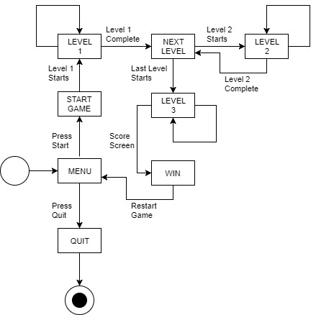

b)

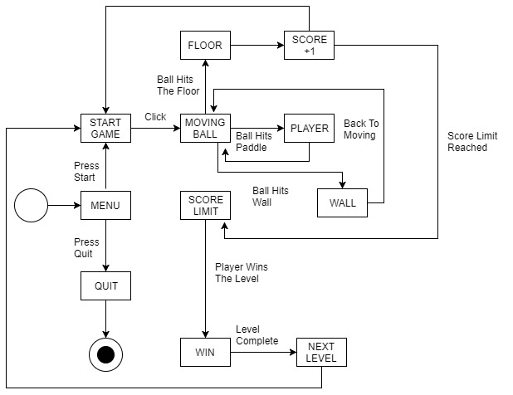

Question 3

Compression is referred to reducing the original file size to a smaller one. Since video and audio files consume a lot of disk space compared to document files it is important to compress them. For our project using Unity Engine it is important to compress our files. Compressing files will increase the game’s performance and load times drastically. Compressed files also help in reducing time to attach, upload and download files.

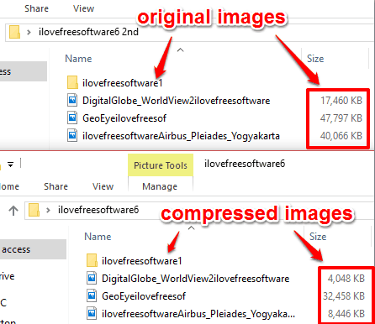

Links:

<http://www.careerride.com/view/what-is-compression-why-is-it-necessary-to-compress-files-multimedia-compression-3536.aspx>

<https://forums.anandtech.com/threads/pros-and-cons-of-c.735466/>

<https://www.quora.com/What-are-the-main-pros-and-cons-of-Unity-3D-and-Unreal-Engine>