OTF Agentic Orchestrator - Project Summary
2026-06-24

1. Executive Summary
OTF Agentic Orchestrator is a two-container application that automates Jira-driven software delivery workflows. It combines a FastAPI backend with a React + Vite frontend to trigger, monitor, and persist end-to-end orchestration runs. A run fetches Jira context, clones a target repository, invokes Copilot CLI for agentic implementation guidance, creates commits/branches, and opens GitHub pull requests. The system persists run history and progress events in SQLite so users can inspect active and completed jobs. It is designed for on-prem Jira compatibility and headless operation using token-based authentication.

2. Architecture Overview
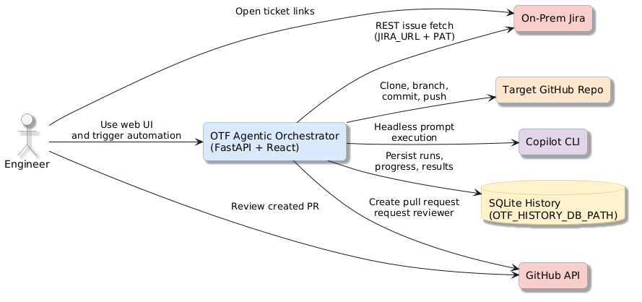
High-Level Architecture
The system has one primary runtime boundary: the orchestrator stack (frontend + backend) running under Docker Compose.
- Frontend (Vite dev server) provides trigger and run-history UX.
- Backend (FastAPI) executes orchestration jobs asynchronously and exposes REST endpoints.
- Jira integration is implemented through the Python jira client and filter projection rules.
- GitHub integration uses both git operations and REST API calls for PR creation and reviewer assignment.
- Copilot CLI is used for autonomous, headless prompt execution inside cloned repositories.
- SQLite stores job metadata and progress timelines for observability and post-run analysis.

3. Processing Pipeline
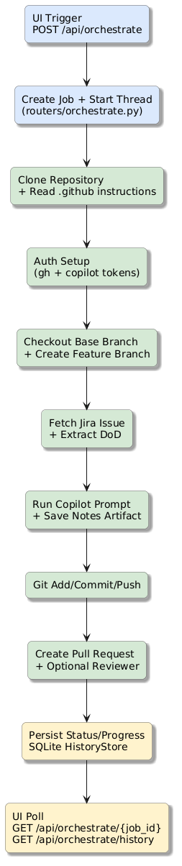
Processing Pipeline

Pipeline Walkthrough
- UI submits POST /api/orchestrate with Jira ticket, target repository, branch, reviewer, commit message, and change plan.
- Backend allocates a job_id, persists a queued job in HistoryStore, and starts a background thread.
- Worker clones the repository to OTF_REPO_BASE_DIR, then scans .github instructions.
- Worker validates runtime/auth tooling (gh, copilot) and resolves Copilot token source.
- Worker checks out the requested base branch, fast-forwards, and creates feature branch.
- Worker fetches Jira issue details and extracts DoD bullet points from description text.
- Worker submits a single rich Copilot prompt with Jira context, implementation plan, and repository instructions.
- Worker writes an implementation artifact under .otf_agentic/ and computes change statistics.
- Worker stages/commits changes (excluding .otf_agentic/**), pushes branch, and creates PR via GitHub API.
- Worker stores final result payload (PR URL, steps, usage metrics), while UI polls status and history.

4. Core Components
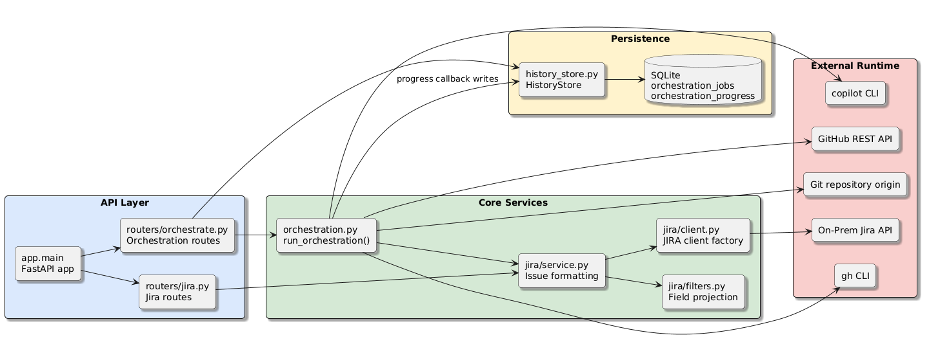
Component Relationships

Backend Components
Component | Responsibility | Key Entry Points
app.main | FastAPI bootstrapping, .env loading, CORS setup, router registration | app, _load_environment()
app.routers.orchestrate | Job API, background thread lifecycle, status/history endpoints | orchestrate(), orchestrate_status(), orchestrate_history()
app.orchestration | Full agentic workflow execution and external integration | run_orchestration()
app.history_store | SQLite schema, job/progress persistence, retention cleanup | HistoryStore, get_history_store()
app.routers.jira | Jira endpoint wrappers and HTTP error mapping | list_issues(), get_issue()
app.jira.service | Jira retrieval + response shaping with filter config | get_issues(), get_issue()
app.jira.client | Jira client factory and auth/config validation | get_client()
app.jira.filters | YAML field filter loading and projection logic | load_filters(), apply_filter()

Frontend Components
Component | Responsibility | Key Behaviors
src/App.jsx | Main orchestration console, run trigger, polling, history rendering | Trigger form, result panels, artifact modal
src/FlowDiagram.jsx | Stage visualization for runtime progress | Step-state resolution, status legends, custom icons
vite.config.js | Dev server proxy to backend service | /api, /health forwarding

Cross-Cutting Behaviors
- Error handling: orchestration failures are captured and returned with per-job status.
- Progress telemetry: progress_callback emits named step events persisted in SQLite.
- Security boundary: tokens are sourced from environment variables and not persisted in history payloads.

5. API Contracts / Message Schemas

Health
- Method: GET /health
- Response:
Field | Type | Description
status | string | Always ok when service is available

Jira Issues
- Method: GET /api/jira/issues?jql=<optional>&max_results=<1..100>
- Response:
Field | Type | Description
issues | array | Filtered Jira issues based on backend/config/filters.yaml
Each issue includes:
Field | Type | Notes
key | string | Jira issue key (for example OTF-123)
url | string | Direct Jira browse URL
summary | string | If available via filter projection
description | string | If included by filter projection
status | string | Derived from status.name mapping

Trigger Orchestration
- Method: POST /api/orchestrate
- Request body:
Field | Type | Required | Description
jira_ticket_id | string | Yes | Jira issue key
repository | string | Yes | owner/repo or clone URL
base_branch | string | Yes | Base branch to branch from
reviewer | string/null | No | GitHub reviewer username
commit_message | string | Yes | Commit message for automated commit
change_plan | array | No | Planner bullets passed to Copilot prompt
- Response body:
Field | Type | Description
job_id | string | Job identifier (UUID)
status | string | Initial status (queued)

Poll Orchestration Status
- Method: GET /api/orchestrate/{job_id}
- Response body:
Field | Type | Description
id | string | Job identifier
status | string | queued
request | object | Original request payload (plus jira_url)
result | object/null | Final result after completion
progress | array | Ordered progress events
error | string/null | Failure reason if status is failed

Progress Event Schema
Field | Type | Description
timestamp | string | ISO-8601 UTC timestamp
name | string | Stage identifier (clone_repository, create_pr, etc.)
status | string | Stage state (running, success, failed, skipped)
details | string/null | Optional contextual detail

6. Infrastructure & Deployment
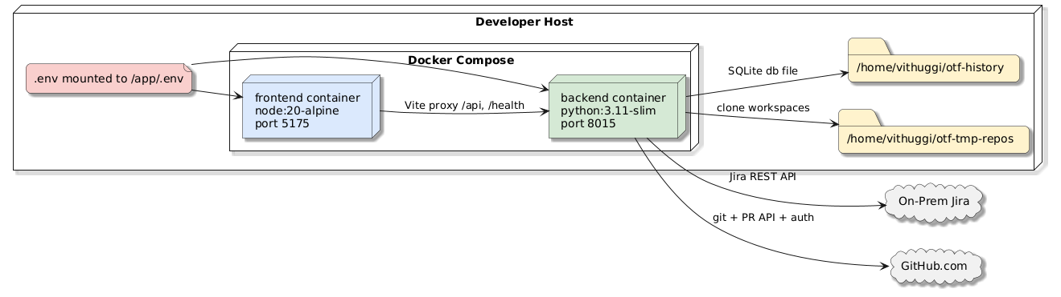
Deployment and Infrastructure

Container Topology
- backend service:
  - Base image: python:3.11-slim
  - Exposed port: 8015
  - Installs git, gh, nodejs, npm, and global @github/copilot
- frontend service:
  - Base image: node:20-alpine
  - Exposed port: 5175
  - Runs Vite dev server

Compose Runtime Configuration
- Root .env is mounted into both containers at /app/.env.
- Backend persistent mounts:
  - /home/vithuggi/otf-tmp-repos -> /tmp/otf-tmp-repos (repo clones)
  - /home/vithuggi/otf-history -> /tmp/otf-history (SQLite db)
- Frontend proxy target is configured using VITE_PROXY_TARGET=http://backend:8015.

CI/CD and Automation
No CI workflow files were detected under .github/workflows/ in the current repository snapshot. Build and runtime automation currently relies on local Docker Compose and manual command execution.

7. Extension Patterns

Add a New Orchestration Stage
- Add stage emission in app/orchestration.py using _emit_progress(...).
- Append StepResult(...) entries for final result reporting.
- Ensure failures raise OrchestrationError for coherent status propagation.
- Add frontend display mapping in src/App.jsx and src/FlowDiagram.jsx if it should appear visually.
- Add/adjust tests in backend/tests/test_orchestration.py and router tests for payload changes.

Add Jira Field Projections
- Update backend/config/filters.yaml with additional dotted field paths.
- Optionally map renamed output keys using rename.
- Validate output through GET /api/jira/issues.
- If project-specific, add under projects.<KEY> section.

Add Additional Result Artifacts
- Generate artifact files during run in run_orchestration().
- Include metadata in returned artifacts list (path, content).
- Frontend history panel auto-renders artifact buttons and markdown modal content.

8. Rules & Anti-Patterns

Operational Rules
- Do not run orchestration without GITHUB_TOKEN; backend fails fast if missing.
- Prefer dedicated COPILOT_GITHUB_TOKEN with Copilot Requests permission for headless runs.
- Keep .otf_agentic/** out of commits (_COMMIT_EXCLUDE_PATHS) to avoid committing generated notes.
- Use normalized repo inputs (owner/repo or full GitHub clone URL only).

Anti-Patterns
- Hardcoding Jira credentials in source files.
- Expanding filters to include large, unnecessary Jira payloads for list views.
- Treating progress events as unordered; UI and history semantics rely on sequence.
- Running against non-fast-forward base branches without reconciling upstream state.

9. Dependencies

Backend (Python)
Package | Version Spec | Purpose
fastapi | >=0.110 | API framework
uvicorn[standard] | >=0.29 | ASGI server
python-dotenv | >=1.0 | Environment loading
jira | >=3.8 | Jira API client
pyyaml | >=6.0 | Filter config parsing
requests | >=2.31 | GitHub REST API calls
pytest | >=8.2 | Test framework
httpx | >=0.27 | HTTP testing/runtime support

Frontend (Node)
Package | Version Spec | Purpose
react | ^19.2.0 | UI runtime
react-dom | ^19.2.0 | DOM renderer
react-markdown | ^10.1.0 | Markdown artifact rendering
remark-gfm | ^4.0.1 | GFM support in markdown
vite | ^7.2.0 | Dev/build tooling
@vitejs/plugin-react | ^5.1.0 | React transform plugin

10. Code Structure
agentic-orchestrator/
├── backend/
│ ├── app/
│ │ ├── jira/
│ │ │ ├── client.py
│ │ │ ├── filters.py
│ │ │ └── service.py
│ │ ├── routers/
│ │ │ ├── jira.py
│ │ │ └── orchestrate.py
│ │ ├── history_store.py
│ │ ├── main.py
│ │ └── orchestration.py
│ ├── config/
│ │ └── filters.yaml
│ ├── tests/
│ │ ├── conftest.py
│ │ ├── test_history_store.py
│ │ ├── test_orchestrate_router.py
│ │ └── test_orchestration.py
│ ├── Dockerfile
│ └── requirements.txt
├── frontend/
│ ├── src/
│ │ ├── App.jsx
│ │ ├── FlowDiagram.jsx
│ │ ├── main.jsx
│ │ └── styles.css
│ ├── Dockerfile
│ ├── index.html
│ ├── package.json
│ └── vite.config.js
├── docker-compose.yml
└── README.md

Accuracy Spot-Checks
The following implementation artifacts were directly reviewed while generating this document:
- backend/app/main.py
- backend/app/orchestration.py
- backend/app/history_store.py
- backend/app/routers/orchestrate.py
- backend/app/jira/service.py
- frontend/src/App.jsx
- frontend/src/FlowDiagram.jsx
- docker-compose.yml

