Document
Project Summary
Date: 2026-06-05 | Version: 1.0

Table of Contents
Copilot Usage — Project Summary
1. Executive Summary
2. Architecture Overview
High-level runtime responsibilities
3. Processing Pipeline
End-to-end flow
Key control points
4. Core Components
Interfaces and implementations
Important components
5. API Contracts / Message Schemas
Session summary contract
Language-model tools
VS Code commands and views
6. Infrastructure & Deployment
Runtime model
Operational behaviors
7. Extension Patterns
Add support for a new persisted log field
Add a new analysis question to `@usage`
Add a new UI section to the tree view
8. Rules & Anti-Patterns
Rules
Anti-patterns
9. Dependencies
Declared development dependencies
Runtime libraries observed in source
10. Code Structure
Annotated structure notes
Verification Notes

Copilot Usage — Project Summary

1. Executive Summary
Copilot Usage is a lightweight VS Code extension that inspects locally stored Copilot Chat logs and turns them into per-session cost, token, timing, and tool-call insights. The extension scans VS Code workspace storage for debug-logs and chatSessions JSONL files, normalizes them into a common SessionSummary model, and presents the result in an activity-bar tree plus an @usage chat participant. The tree view is optimized for quick operational analysis, while the chat participant and language-model tools expose the same parsed session graph for ad hoc questions about cost patterns, commands, and risky operations. The implementation is intentionally local-first: it reads files from the developer machine and does not upload data on its own.

2. Architecture Overview
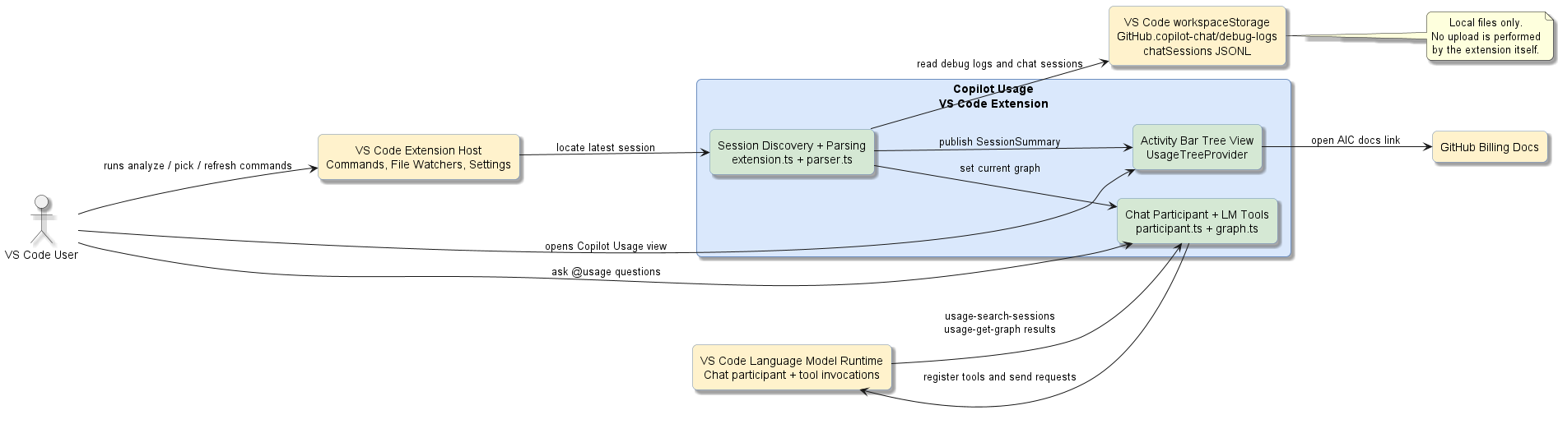
High-Level Architecture
The repository contains a single TypeScript extension package with four source files under src/. The extension host entry point in src/extension.ts owns activation, session discovery, title resolution, spend-summary refresh, tree view population, and command registration. Parsing logic in src/parser.ts is the core data-processing layer: it detects the best available source file, tolerates multiple Copilot log shapes, merges system continuations, rolls subagent usage into parent messages, and enriches summaries with prompt-composition metadata. The chat-facing layer uses src/participant.ts and src/graph.ts to wrap the parsed session in a queryable SessionGraph that can be serialized for language-model analysis.

High-level runtime responsibilities
Area | Primary file | Responsibility
Extension shell | src/extension.ts | Activation events, command registration, file watching, quick-pick session selection, tree rendering
Parsing core | src/parser.ts | JSONL normalization, session parsing, billing extraction, prompt/tool metadata analysis
Chat analysis | src/participant.ts | @usage participant, LM tool registration, request orchestration
Query layer | src/graph.ts | Session graph projection, tool/command aggregation, risk detection, LLM-friendly serialization
Tests | test/parser.test.js | Parser behavior and regression coverage

3. Processing Pipeline
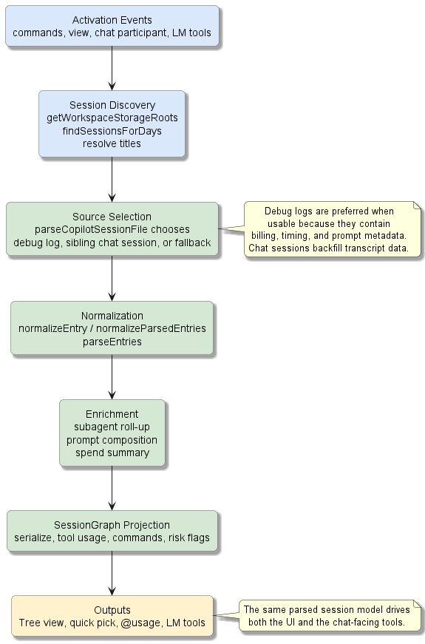
Processing Pipeline
The processing path starts when VS Code activates the extension from a command, view, chat participant, or language-model tool contribution defined in package.json. activate() creates the tree view, wires settings listeners, auto-loads the newest session, starts a file watcher on the chosen session file, and registers the @usage participant plus three user commands.

End-to-end flow
1. Session discovery locates candidate Copilot storage directories from standard VS Code paths and optional configured search roots.
2. The extension selects the newest likely session, preferring recent files with billing data when available.
3. parseCopilotSessionFile() chooses between a debug log, a sibling chatSessions transcript, or a fallback path depending on file quality and availability.
4. parseDebugLog() and parseChatSessionLog() normalize different persisted formats into a shared LogEntry list.
5. parseEntries() groups messages, model turns, and tool calls into a SessionSummary, merging system-generated continuation messages such as terminal notifications.
6. The parser enriches the summary with subagent roll-up totals and prompt-composition metadata extracted from referenced system-prompt and tools files.
7. UsageTreeProvider renders tree nodes for spend history, session totals, per-message metrics, prompt-size details, tool usage, and command groups.
8. setCurrentGraph() wraps the current summary in a SessionGraph, which powers usage-search-sessions, usage-get-graph, and the @usage participant.

Key control points
Control point | Behavior | Why it matters
safeQuickPeekHasBillingData() in src/extension.ts | Biases auto-load toward sessions with billing totals | Improves the chance that the first loaded session has cost data
parseCopilotSessionFile() in src/parser.ts | Resolves whether to trust debug logs, transcript files, or both | Keeps the extension useful when one storage format is incomplete
isSystemContinuation() in src/parser.ts | Collapses terminal notifications and similar system chatter into the preceding message | Prevents inflated message counts and misleading cost attribution
SessionGraph.serialize() in src/graph.ts | Produces compact text for LLM analysis | Keeps the chat participant efficient and deterministic

4. Core Components
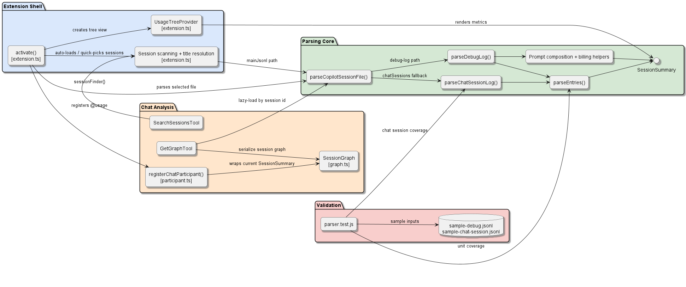
Component Relationships
The design is small but layered. src/extension.ts is the orchestrator. src/parser.ts owns the canonical domain model. src/participant.ts exposes that model to Copilot Chat, and src/graph.ts provides the analysis surface needed by both tools and the participant.

Interfaces and implementations
Contract or type | Implemented or used by | Notes
SessionSummary | Produced in src/parser.ts, consumed in src/extension.ts, src/graph.ts, src/participant.ts | The central parsed-session contract
vscode.TreeDataProvider<TreeItemData> | UsageTreeProvider in src/extension.ts | Drives the activity-bar visualization
vscode.LanguageModelTool<SearchInput> | SearchSessionsTool in src/participant.ts | Searches sessions by title or ID across a date window
vscode.LanguageModelTool<GetGraphInput> | GetGraphTool in src/participant.ts | Loads or resolves a session graph for analysis
SessionFinder / TitleResolver function types | Bound in registerChatParticipant() | Decouple participant logic from storage-scanning details

Important components
Component | File | Role
activate() | src/extension.ts | Application bootstrap for the extension host
UsageTreeProvider | src/extension.ts | Converts session and spend summaries into a hierarchical UI
parseEntries() | src/parser.ts | Core reducer from normalized log entries to message-turn summaries
parseDebugLog() | src/parser.ts | Reads debug JSONL, removes title-generation noise, rolls up subagents
parseChatSessionLog() | src/parser.ts | Reconstructs session state from incremental transcript updates
SessionGraph | src/graph.ts | Lazy, immutable analysis view over a parsed session
registerChatParticipant() | src/participant.ts | Registers tools and the @usage assistant surface

5. API Contracts / Message Schemas
This project does not expose an HTTP API. Its public contracts are internal TypeScript structures, VS Code contribution points, and language-model tool schemas declared in package.json and implemented in src/participant.ts.

Session summary contract
Property | Type | Meaning
sessionId | string | Stable Copilot session identifier
title | string? | Best resolved session title from metadata, title files, or content
userMessages | UserMessageSummary[] | Parsed user-facing messages after continuation merging
totalInputTokens | number | Aggregate input tokens across all model turns
totalOutputTokens | number | Aggregate output tokens across all model turns
totalCachedTokens | number | Aggregate cached prompt tokens
totalNanoAiu | number | Billing total in nano AIU units
modelTurnCount | number | Total number of LLM turns in the session
toolCallCount | number | Total number of tool calls associated with those turns
promptComposition | PromptComposition? | Optional metadata about prompt and tool-definition size

Language-model tools
Tool | Input fields | Output shape
usage-search-sessions | query?: string, daysBack?: number, limit?: number | Text list of matching and recent session IDs with titles and timestamps
usage-get-graph | sessionId?: string, includeMessages?: boolean, maxMessages?: number | Serialized SessionGraph text with stats, tool usage, risks, commands, and optional messages

VS Code commands and views
Contribution | Identifier | Purpose
Command | copilotUsageTracker.analyzeSession | Load the most recent session
Command | copilotUsageTracker.pickSession | Open the interactive session picker
Command | copilotUsageTracker.refresh | Re-scan and refresh summaries
View container | copilot-usage | Activity-bar container for the dashboard
Tree view | copilotUsageTree | Main token-usage tree
Chat participant | copilot-usage-tracker.usage | User-facing @usage Copilot participant

6. Infrastructure & Deployment
This repository packages a client-side VS Code extension rather than a network service. There is no Dockerfile, container orchestration manifest, or CI workflow in the repository. The primary runtime is the VS Code extension host, and the primary deployment artifact is a .vsix package.

Runtime model
Aspect | Observed implementation
Packaging | vsce package via npm run package
Build | TypeScript compile to out/ via tsc -p ./
Test execution | npm test runs npm run compile and node test/parser.test.js
Node/TypeScript target | CommonJS, ES2022 target, output to out/
Storage dependencies | Local VS Code workspaceStorage, debug-logs, and chatSessions files
External integration | VS Code API, Copilot Chat language-model tools, GitHub billing documentation link

Operational behaviors
• The extension watches the currently loaded session file and reparses it on changes.
• A timed refresh recalculates spend summaries every five minutes while the extension is active.
• Search roots and recursion depth are configurable through the copilotUsageTracker.searchRoots and copilotUsageTracker.maxSearchDepth settings.
• Privacy posture is local-first: logs are read from disk; the @usage participant sends summarized session data only when the user explicitly asks Copilot a question.

7. Extension Patterns
This codebase is small enough that extension work should preserve the existing layering. Add parsing logic in the parser first, then expose it through the tree or chat surfaces.

Add support for a new persisted log field
1. Extend the relevant attributes or summary types in src/parser.ts.
2. Update normalizeEntry() or the chat-session extraction helpers so the raw field is captured consistently.
3. Thread the new value through parseEntries() or the higher-level parser that owns the behavior.
4. Surface the value in UsageTreeProvider or SessionGraph only after the parsed contract is stable.
5. Add a fixture-backed test in test/parser.test.js if the new field affects parsing behavior.

Add a new analysis question to `@usage`
1. Prefer extending SessionGraph in src/graph.ts with a new aggregate or serialization helper.
2. Keep tool behavior in src/participant.ts generic so the model can reason over structured text rather than a hardcoded answer path.
3. If you need a new tool, declare it in package.json and register it in registerChatParticipant().
4. Reuse the existing SessionFinder and TitleResolver injection pattern instead of reimplementing storage scanning.

Add a new UI section to the tree view
1. Add a new variant to the TreeItemData union in src/extension.ts.
2. Implement the label, description, icon, and tooltip in getTreeItem().
3. Populate its children in getChildren() from SessionSummary or SpendSummary data.
4. Avoid reparsing in the UI layer; use the existing parsed summary or graph projection.

8. Rules & Anti-Patterns
No root AGENTS.md or copilot-instructions.md file exists in this repository, so these rules are inferred from the implementation.

Rules
• Prefer debug logs when they are available and contain billing data; fall back to chat-session files when they do not.
• Keep parsing tolerant. Both debug logs and chat-session files are treated as unstable formats.
• Keep the chat analysis layer separate from the parsing layer. SessionGraph is the boundary between raw parsed data and LM-facing summaries.
• Favor local filesystem scanning over remote services. The extension’s value proposition depends on using local Copilot artifacts.
• Preserve one canonical session model (SessionSummary) and let UI/chat layers project from it.

Anti-patterns
• Do not make the UI responsible for parsing raw JSONL files.
• Do not couple chat-participant behavior directly to file-system paths; keep that logic in extension-owned resolvers.
• Do not assume Copilot log formats are stable or fully populated.
• Do not duplicate cost, token, or tool aggregation logic across extension.ts and graph.ts when one shared projection can own it.

9. Dependencies
The package has no declared production npm dependencies. Runtime behavior relies on the VS Code extension API and Node.js built-in modules imported directly from source.

Declared development dependencies
Package | Version | Category | Purpose
typescript | ^5.5.4 | Build | Compile TypeScript source to out/
@types/node | ^20.14.10 | Typing | Node.js type definitions
@types/vscode | ^1.101.0 | Typing | VS Code extension API types
@vscode/vsce | ^3.0.0 | Packaging | Build the .vsix extension package

Runtime libraries observed in source
Module | Source | Purpose
vscode | src/extension.ts, src/participant.ts | Extension host APIs, tree view, chat participant, LM tools
fs | src/extension.ts, src/parser.ts | Local log discovery and file parsing
path | src/extension.ts, src/parser.ts | Cross-platform path resolution

10. Code Structure
copilot_usage/
|-- .github/
| `-- agents/
| |-- adr-generator.agent.md
| |-- arch.agent.md
| |-- devops-expert.agent.md
| |-- gem-code-simplifier.agent.md
| |-- github-actions-expert.agent.md
| |-- project-documenter.agent.md
| |-- quality-playbook.agent.md
| `-- specification.agent.md
|-- images/
| |-- copilot-chat-usage-icon-128.png
| |-- copilot_usage_icon_128.png
| `-- usage-screenshot.png
|-- src/
| |-- extension.ts
| |-- graph.ts
| |-- parser.ts
| `-- participant.ts
|-- test/
| |-- fixtures/
| | |-- sample-chat-session.jsonl
| | `-- sample-debug.jsonl
| `-- parser.test.js
|-- docs/
| |-- diagrams/
| | |-- high-level-architecture.puml
| | |-- processing-pipeline.puml
| | `-- component-relationships.puml
| `-- project-summary.md
|-- package.json
|-- README.md
|-- SUPPORT.md
`-- tsconfig.json

Annotated structure notes
Path | Purpose
src/extension.ts | Extension bootstrap, session discovery, spend scanning, tree rendering, command handling
src/parser.ts | Canonical parser and domain-model construction
src/graph.ts | Query and serialization layer for chat analysis
src/participant.ts | Chat participant and language-model tool integration
test/parser.test.js | Parser regression tests
test/fixtures/*.jsonl | Stable fixture inputs for parser scenarios
images/ | Extension icon and README screenshot assets

Verification Notes
The documentation above was grounded against the repository’s current package.json, README.md, tsconfig.json, the source files under src/, and parser tests under test/. Spot-checked references include activate() and UsageTreeProvider in src/extension.ts, parseEntries() and parseCopilotSessionFile() in src/parser.ts, SessionGraph in src/graph.ts, and registerChatParticipant() in src/participant.ts.

