<http://www.tutorialspoint.com/sdlc/sdlc_agile_model.htm>

SDLC - Agile Model

Agile SDLC model is a combination of iterative and incremental process models with focus on process adaptability and customer satisfaction by rapid delivery of working software product.

Agile Methods break the product into small incremental builds. These builds are provided in iterations. Each iteration typically lasts from about one to three weeks. Every iteration involves cross functional teams working simultaneously on various areas like planning, requirements analysis, design, coding, unit testing, and acceptance testing.

At the end of the iteration a working product is displayed to the customer and important stakeholders.

## What is Agile?

Agile model believes that every project needs to be handled differently and the existing methods need to be tailored to best suit the project requirements. In agile the tasks are divided to time boxes (small time frames) to deliver specific features for a release.

Iterative approach is taken and working software build is delivered after each iteration. Each build is incremental in terms of features; the final build holds all the features required by the customer.

Here is a graphical illustration of the Agile Model:

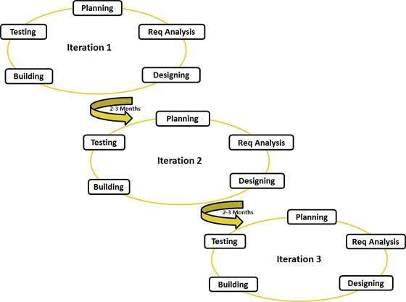

Following are the Agile Manifesto principles

* **Individuals and interactions** - in agile development, self-organization and motivation are important, as are interactions like co-location and pair programming.
* **Working software** - Demo working software is considered the best means of communication with the customer to understand their requirement, instead of just depending on documentation.
* **Customer collaboration** - As the requirements cannot be gathered completely in the beginning of the project due to various factors, continuous customer interaction is very important to get proper product requirements.
* **Responding to change** - agile development is focused on quick responses to change and continuous development.

## Agile Vs Traditional SDLC Models

Agile is based on the adaptive software development methods where as the traditional SDLC models like waterfall model is based on predictive approach.

Predictive teams in the traditional SDLC models usually work with detailed planning and have a complete forecast of the exact tasks and features to be delivered in the next few months or during the product life cycle. Predictive methods entirely depend on the requirement analysis and planning done in the beginning of cycle. Any changes to be incorporated go through a strict change control management and prioritization.

Agile uses adaptive approach where there is no detailed planning and there is clarity on future tasks only in respect of what features need to be developed. There is feature driven development and the team adapts to the changing product requirements dynamically. The product is tested very frequently, through the release iterations, minimizing the risk of any major failures in future.

Customer interaction is the backbone of Agile methodology, and open communication with minimum documentation are the typical features of Agile development environment. The agile teams work in close collaboration with each other and are most often located in the same geographical location.

# SDLC - Overview

## What is SDLC?

SDLC is a process followed for a software project, within a software organization. It consists of a detailed plan describing how to develop, maintain, replace and alter or enhance specific software. The life cycle defines a methodology for improving the quality of software and the overall development process.

The following figure is a graphical representation of the various stages of a typical SDLC.

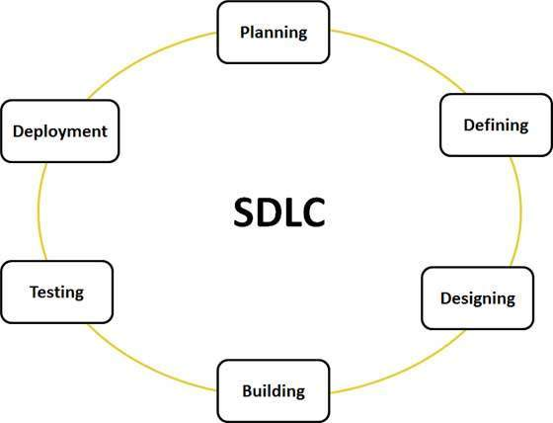

## Stage 1: Planning and Requirement Analysis

Requirement analysis is the most important and fundamental stage in SDLC. It is performed by the senior members of the team with inputs from the customer, the sales department, market surveys and domain experts in the industry. This information is then used to plan the basic project approach and to conduct product feasibility study in the economical, operational, and technical areas.

Planning for the quality assurance requirements and identification of the risks associated with the project is also done in the planning stage. The outcome of the technical feasibility study is to define the various technical approaches that can be followed to implement the project successfully with minimum risks.

## Stage 2: Defining Requirements

Once the requirement analysis is done the next step is to clearly define and document the product requirements and get them approved from the customer or the market analysts. This is done through .SRS. . Software Requirement Specification document which consists of all the product requirements to be designed and developed during the project life cycle.

## Stage 3: Designing the product architecture

SRS is the reference for product architects to come out with the best architecture for the product to be developed. Based on the requirements specified in SRS, usually more than one design approach for the product architecture is proposed and documented in a DDS - Design Document Specification.

This DDS is reviewed by all the important stakeholders and based on various parameters as risk assessment, product robustness, design modularity , budget and time constraints , the best design approach is selected for the product.

A design approach clearly defines all the architectural modules of the product along with its communication and data flow representation with the external and third party modules (if any). The internal design of all the modules of the proposed architecture should be clearly defined with the minutest of the details in DDS.

## Stage 4: Building or Developing the Product

In this stage of SDLC the actual development starts and the product is built. The programming code is generated as per DDS during this stage. If the design is performed in a detailed and organized manner, code generation can be accomplished without much hassle.

## Stage 5: Testing the Product

This stage is usually a subset of all the stages as in the modern SDLC models, the testing activities are mostly involved in all the stages of SDLC. However this stage refers to the testing only stage of the product where products defects are reported, tracked, fixed and retested, until the product reaches the quality standards defined in the SRS.

## Stage 6: Deployment in the Market and Maintenance

Once the product is tested and ready to be deployed it is released formally in the appropriate market. Sometime product deployment happens in stages as per the organizations. business strategy. The product may first be released in a limited segment and tested in the real business environment (UAT- User acceptance testing).

# SDLC - Waterfall Model

The Waterfall Model was first Process Model to be introduced. It is also referred to as a linear-sequential life cycle model. It is very simple to understand and use. In a waterfall model, each phase must be completed before the next phase can begin and there is no overlapping in the phases.

Following is a diagrammatic representation of different phases of waterfall model.

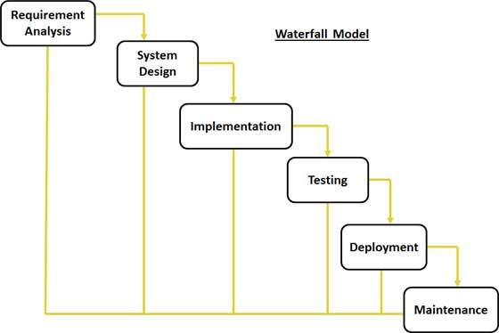

## Waterfall Model Application

Every software developed is different and requires a suitable SDLC approach to be followed based on the internal and external factors. Some situations where the use of Waterfall model is most appropriate are:

* Requirements are very well documented, clear and fixed.
* Product definition is stable.
* Technology is understood and is not dynamic.
* There are no ambiguous requirements.
* Ample resources with required expertise are available to support the product.
* The project is short.

## Waterfall Model Pros & Cons

### Advantage

The advantage of waterfall development is that it allows for departmentalization and control. A schedule can be set with deadlines for each stage of development and a product can proceed through the development process model phases one by one.

Development moves from concept, through design, implementation, testing, installation, troubleshooting, and ends up at operation and maintenance. Each phase of development proceeds in strict order.

### Disadvantage

The disadvantage of waterfall development is that it does not allow for much reflection or revision. Once an application is in the testing stage, it is very difficult to go back and change something that was not well-documented or thought upon in the concept stage.

The following table lists out the pros and cons of Waterfall model:

|  |  |
| --- | --- |
| **Pros** | **Cons** |
| * Simple and easy to understand and use * Easy to manage due to the rigidity of the model . each phase has specific deliverables and a review process. * Phases are processed and completed one at a time. * Works well for smaller projects where requirements are very well understood. * Clearly defined stages. * Well understood milestones. * Easy to arrange tasks. * Process and results are well documented. | * No working software is produced until late during the life cycle. * High amounts of risk and uncertainty. * Not a good model for complex and object-oriented projects. * Poor model for long and ongoing projects. * Not suitable for the projects where requirements are at a moderate to high risk of changing. So risk and uncertainty is high with this process model. * It is difficult to measure progress within stages. * Cannot accommodate changing requirements. * Adjusting scope during the life cycle can end a project. * Integration is done as a "big-bang. at the very end, which doesn't allow identifying any technological or business bottleneck or challenges early. |

# SDLC - Iterative Model

In Iterative model, iterative process starts with a simple implementation of a small set of the software requirements and iteratively enhances the evolving versions until the complete system is implemented and ready to be deployed.

Following is the pictorial representation of Iterative and Incremental model:

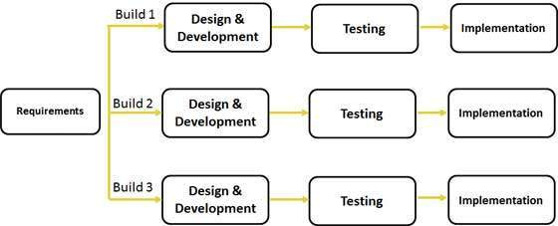

## Iterative Model Application

Like other SDLC models, Iterative and incremental development has some specific applications in the software industry. This model is most often used in the following scenarios:

* Requirements of the complete system are clearly defined and understood.
* Major requirements must be defined; however, some functionalities or requested enhancements may evolve with time.
* There is a time to the market constraint.
* A new technology is being used and is being learnt by the development team while working on the project.
* Resources with needed skill set are not available and are planned to be used on contract basis for specific iterations.
* There are some high risk features and goals which may change in the future.