定语： 用来修饰名语的成分。可以是形容词、名词、介词短语、副词、不定式、分词，也可以是定语从句。

关系代词有：who,whom,whose,that,which等。

关系副词有：when,where,why等。

名语作定语，就是两个名词前在一起，用前面一个名词（定语）修饰后面一个名词。

**冠词**

抽象名词前一般不加冠词。

抽象名词特指时加冠词。

物质名词前一般不加冠词。

物质名词特指时加冠词。

That 和 those 的特殊用法。

That 可代表前面提到的名词防止重复。

Life today is much better than that in the old days.

Those 可代表前面提到的复数名词。

His stories are more interesting than those I told.

疑问代词

Who whom whose what which

连接代词 （差别是引导从句，疑问代词引导问句。 连接代词引导的从句在句中占一个成分。） 主语从句、宾语从语、表语从句。

Who whom whose what which

主语从句

What she saw give her a little fright.

宾语从句

I cannot do what you ask me to do.

表语从句

Your mother’s health is not what it ought to be.

关系代词 (用来引导定语从句 – 代表前面的名词)

Who whom whose that which

I met someone who said he knew you.

The man whom I saw told me to come back today.

A mental patient is one whose mind is diseased.

That 和 which的用法

That可代表东西也可代表人.

The man that I spoke to told me to wait.

The stairs that lead to the cellar are rather slippery.

That在定语从句修饰宾语时常可省略。

This is the best hotel (that) I know.

Which 只能代表东西和动物。 可在定语从句中做主语、宾语和介词宾语。

She was not in the train which arrived just now. 主语

There are the conditions which we have to accept. 宾语

The day on which I saw him was the greatest of my life. 介词宾语

That’s a formality which we have to go through. 介词宾语

Which 在宾语从句修饰宾语和介词宾语时常可省略。

That’s the house (which/that) we built.

There are difficulties (which / that) we got into.

但紧跟介词时只能用which且不能省略。

介词宾语：介词后面的宾语

The city isn’t much different from **what** it was ten years ago.

**限制性定语从句**

从句限制所修饰词的意义，如果把从句拿掉则句子的意义不清楚，甚至失去意义。

That’s the machine he designed.

**非限制性定语从句**

从句拿掉句子也一样完整，对所修饰的词没有限制意义。常用逗号分隔，译成汉语时可译成并列句。只能由Who(m), Whose 和Which引导。

I passed the letter to Helen, who was sitting beside me.

The 8:30 train, which is usually very punctual, was late today.

**Which的特殊用法**

在非限制定句从句中，which可以代表主句的一部分，甚至全部，而不仅仅限于一个名词或代词。

We had to sleep in our wet cloths, which was most uncomfortable.

**Which有时在从句中作定句。**

He advised me to hide behind the door, which advice I took at once.

**Which还可以跟不定式一起用**

She had a little money in the bank, with which to help her mother.

Now he had no pretext on which to stay in the house.

Many, much, few, little



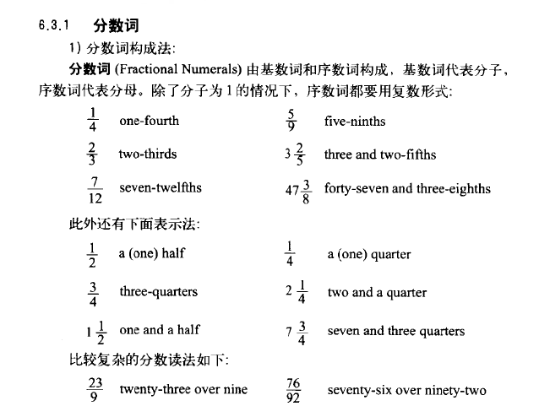

**有些名词 + of 可构成量词如 a lot of, lots of, etc.**

**一些名词可以在结尾加ful表数量， 如handful of, spoonful of, etc.**

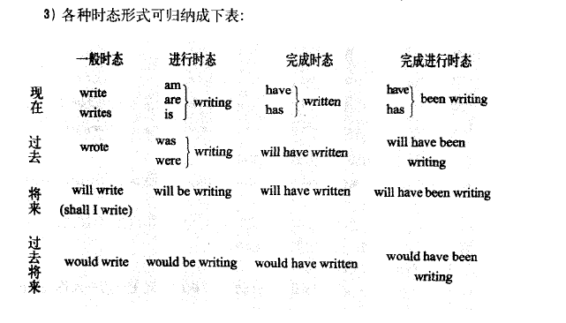

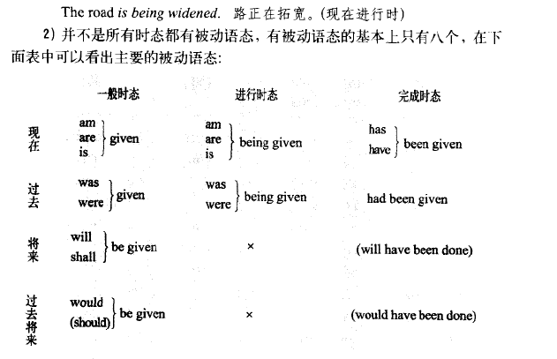

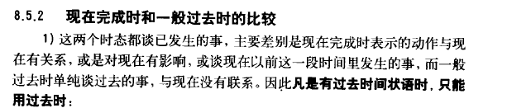

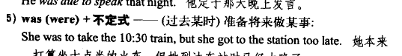

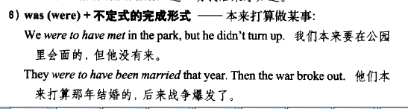

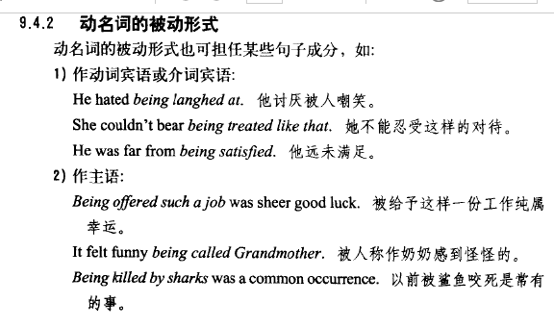

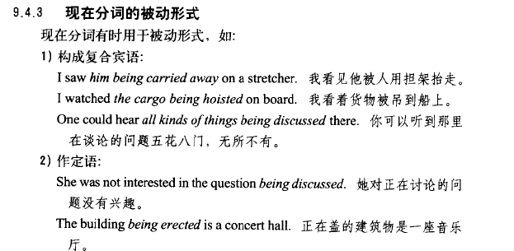

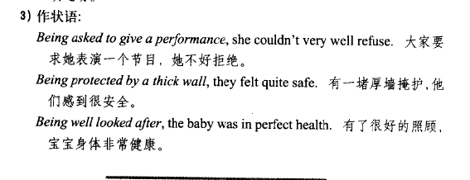

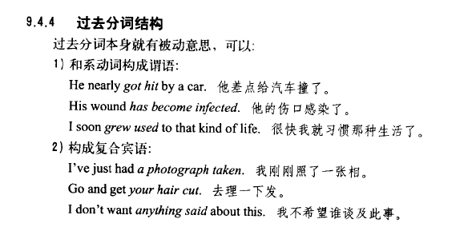

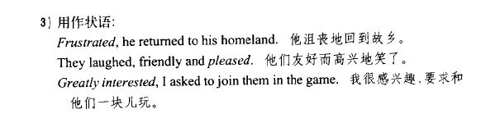

同位语

[编辑](javascript:;)

一个名词(或其它形式)对另一个名词或[代词](http://baike.baidu.com/view/141.htm" \t "_blank)进行解释或补充说明，这个名词（或其它形式）就是同位语。同位语与被它限定的词的格式要一致，并常常紧挨在一起。

### 用法1

由两个或两个以上同一层次的语言单位组成的结构，其中前项与后项所指相同，句法功能也相同，后项是前项的同位语其中常用‘，’连接。

Mr. Smith,our new teacher,is very kind to us.

### 用法2

同位语与其同位成分关系紧密时不用[逗点](http://baike.baidu.com/view/1932212.htm)隔开；同位语对其同位成分只作[补充](http://baike.baidu.com/view/836395.htm)解释时可用逗点隔开。

He told me that his brother John was a world-famous doctor.

### 定句从句和同位语从句区别

that 既可引导同位语从句又可引导定语从句，其区别在于：1.同位语从句由[连接词](http://baike.baidu.com/view/721761.htm)that引导，连接词that本身无意义，在同位语从句中不充当任何成分，不可省略，不可以用其他词替代；2.定语从句由关系代词that引导，关系代词that在从句中充当一定的成分，作宾语时可省略.

由when，where，why引导的 同位语从句和定语从句的区别在于：同位语从句由连接副词只起连接作用，没有指代作用； 定语从句由关系副词引导，关系副词具有指代先行词的作用，常用一个[介词](http://baike.baidu.com/view/84281.htm)加关系代词替换。例如：I will never forget the day when we first met. （定语从句，when为关系副词） That is the special day (which/that) I will never forget. （定语从句，which/that为关系代词，作forget的宾语） This is the house where we lived fifteen years ago. （定语从句，where为关系副词） This is the house which we sold fifteen years ago. （定语从句，which为关系代词，作sold的宾语）.[1]

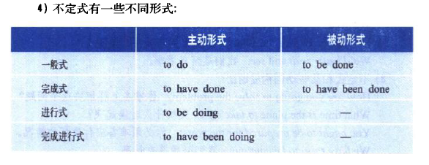

**不定式做主语，避免头重脚轻的方法。**

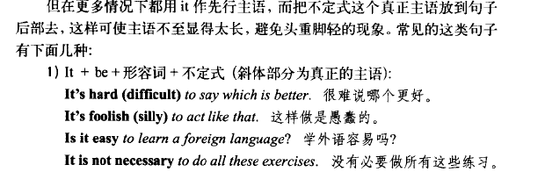

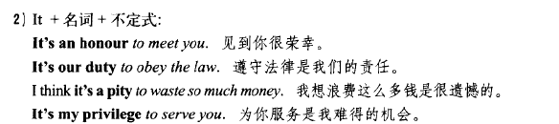

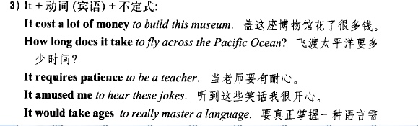

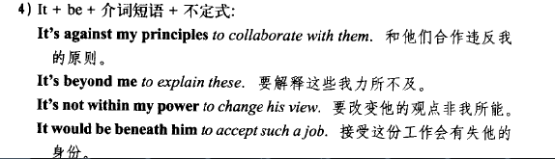

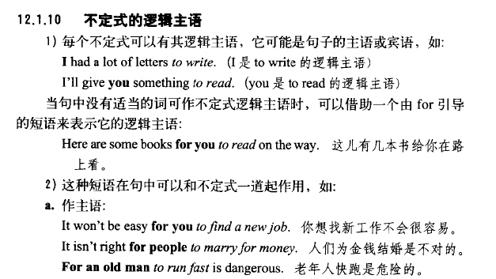

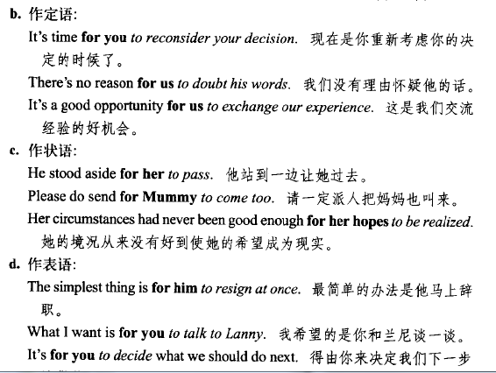

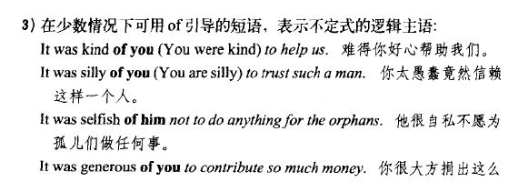

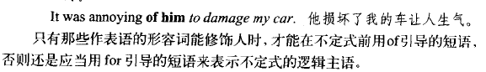

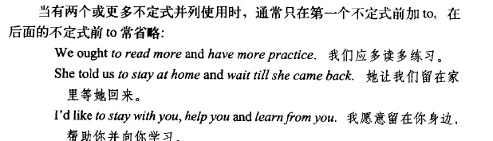

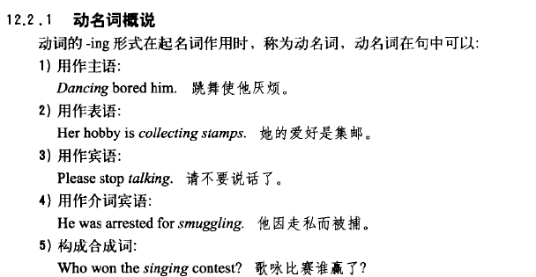

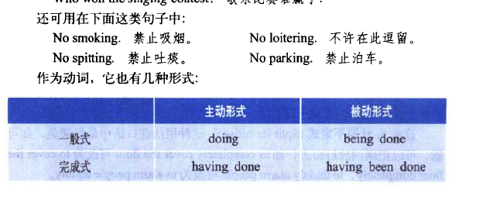

**动名语有动词特性所以可以有宾语和状语。**

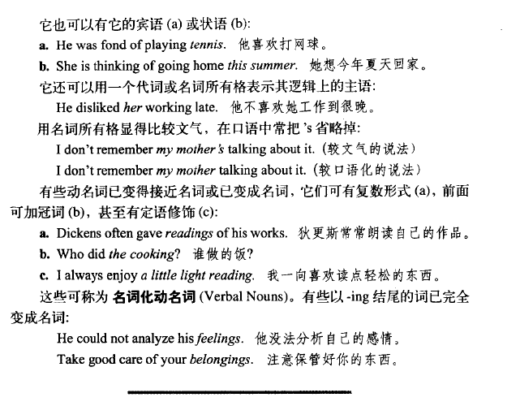

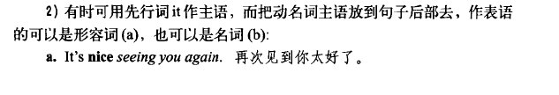

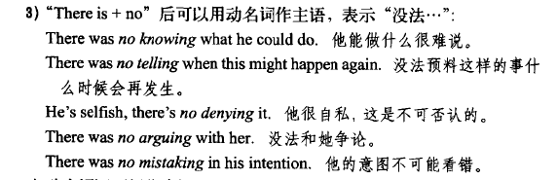

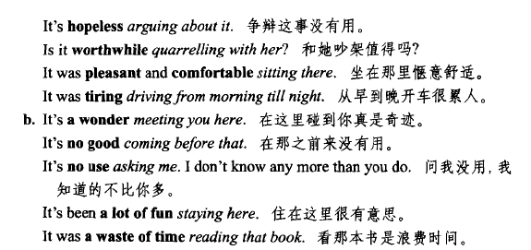

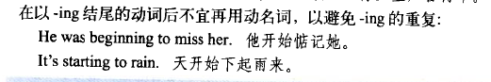

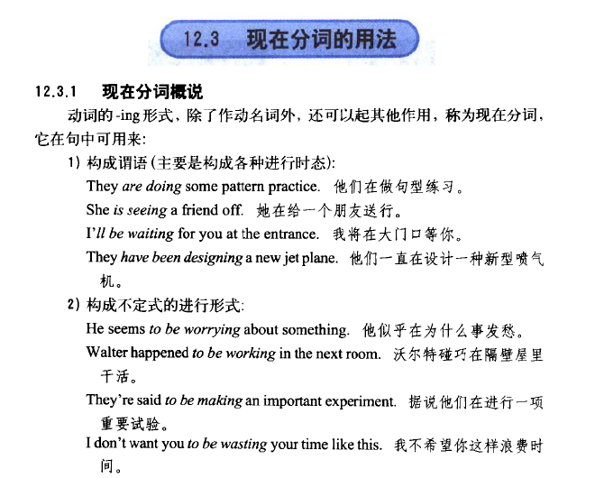

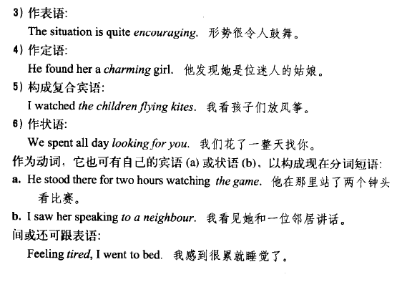

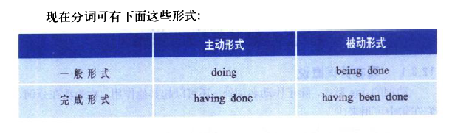

**现在分词 做表语、定句、复合宾语时有形容词的性质。**

**动名词则只有名词的性质。**

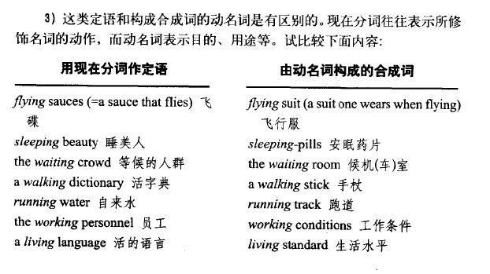

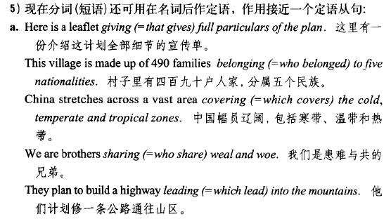

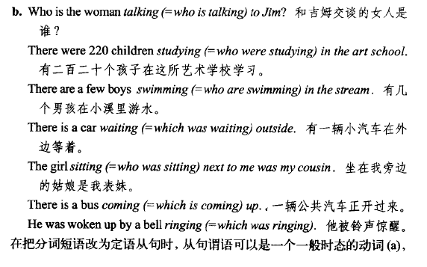



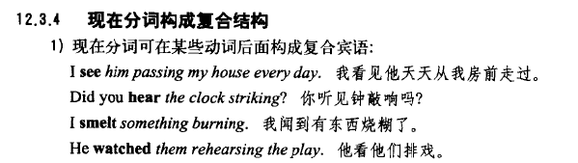

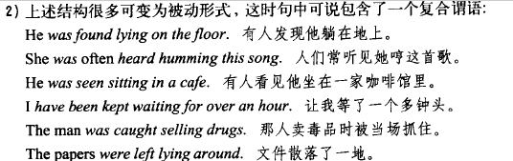

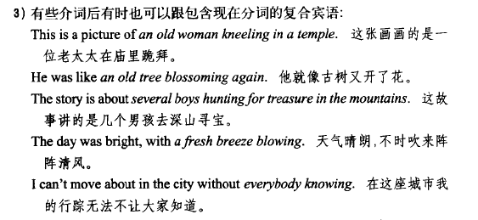

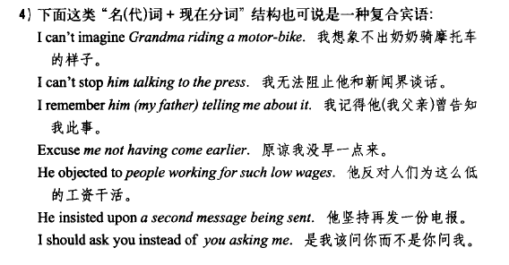



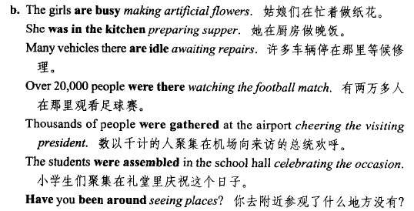

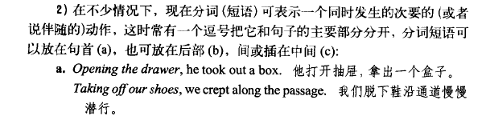

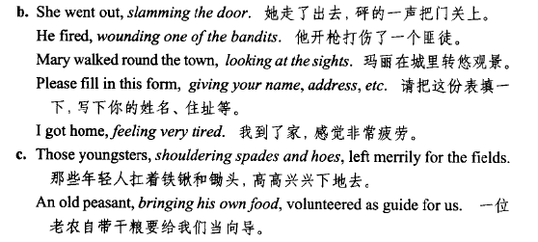

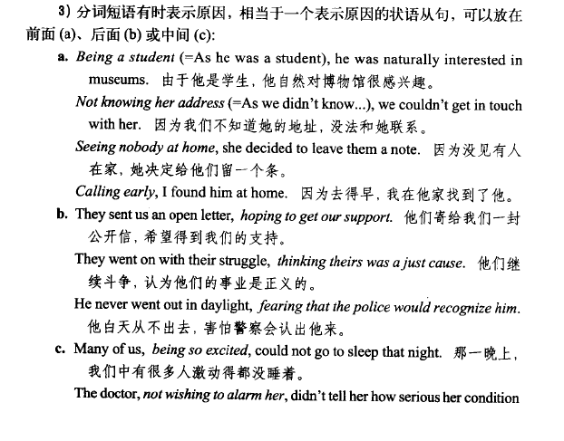

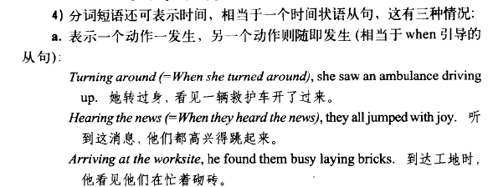

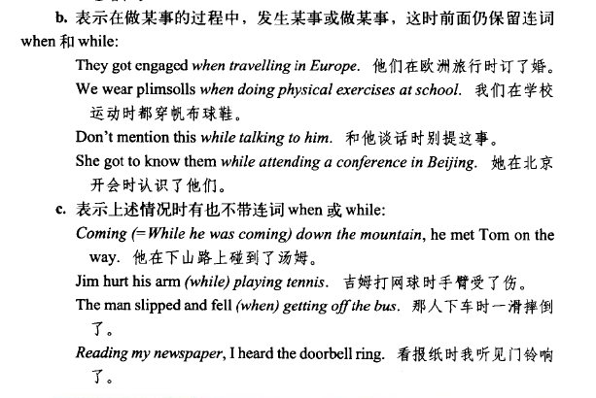

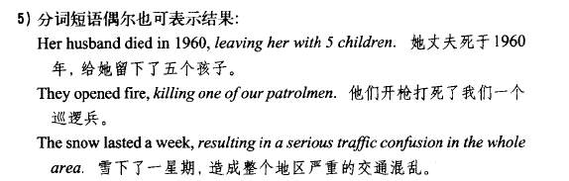

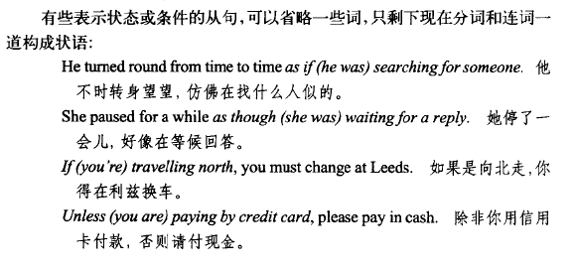

**应该是相同主语的情况下，可省略主语和be动词。**

